SII and SIRI Based pre-operative parametric Nomogram for Predicting All-Cause Mortality in Diabetic patients with the first Myocardial Infarction
Zhi-Qin Fang^{a,b}，Shao-Qiang Qinª, Tian-Shu Guª, Su-Tao Huª,Yu-Kun Zhangª, Xian Shao^{c},Tong Liuª, Kang-Yin Chenª*
a: Tianjin Key Laboratory of Ionic-Molecular Function of Cardiovascular disease, Department of Cardiology, Tianjin Institute of Cardiology, the Second Hospital of Tianjin Medical University, Tianjin, 300211,China
b:Department of Cardiology, Hebei Key Laboratory of Systems Biology and Gene Regulation, The First Affiliated Hospital of Hebei North University, Zhangjiakou, Hebei, China
c: Division of Nephrology, National Clinical Research Center for Kidney Disease, State Key Laboratory of Organ Failure Research, Nanfang Hospital, Southern Medical University, Guangzhou, China

Correspondence author:
Kang-Yin Chen, Tianjin Key Laboratory of Ionic-Molecular Function of Cardiovascular disease, Department of Cardiology, Tianjin Institute of Cardiology, Second Hospital of Tianjin Medical University, Tianjin, China
Email: chenkangyin@vip.126.com

Supplemental Table 1. List of the ICD-10 codes used
Diseases | ICD-10 codes
Acute myocardial infarction | I21.9
ST elevation myocardial infarction | I21.301
Hypertension | I10-11, I13-15, I67.4
Diabetes | E10-14
Diabetic Kidney | E10.2, E11.2, E12.2, E13.2, E14.2, N08.3
DiseaseDiabetic Retinopathy | E10.3, E11.3, E12.3, E13.3, E14.3, H36.0
Diabetic Cataract | E10.3, E11.3, E12.3, E13.3, E14.3, H28.0
Diabetic Peripheral Neuropathy | E10.4, E11.4, E12.4, E13.4, E14.4, G63.2
Diabetic Peripheral Vascular Disease | E10.5, E11.5, E12.5, E13.5, E14.5, I79.2
Diabetic Foot Ulcers | E10.5, E11.5, E12.5, E13.5, E14.5, L97, M14.6
Ischemic stroke | I63, I64
Hemorrhagic stroke | I60, I61, I62, S065, S064, S066, S067
Severe renal isease | I120, I131, N032-37, N052-57, N18.5, N19, N250, Z490, Z491, Z492, Z940, Z992
CKD stage 5 | N18.5,N18.6,
End-Stage Renal Disease | Z99.2
Severe liver isease | I850, I859, I864, I982, K704, K711, K721, K729, K765-67

Supplemental Figure 1. Boxplots of the SII and SIRI showing the distribution in the survival group (n = 3265) and non-survival group (n = 138). SII=Systemic Immune-Inflammation Index; SIRI=Systemic Inflammation Response Index; AISI=Aggregate Index of Systemic Inflammation; NLPR=Neutrophil-to-Lymphocyte Platelet Ratio.
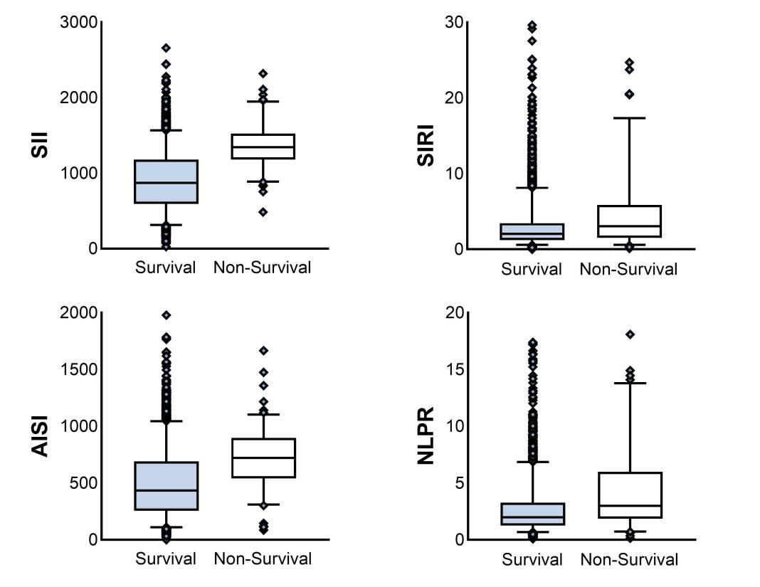
Supplemental Figure 2. Subgroup analysis of the relationships between SII and all-cause mortality in participants with diabetes and acute myocardial infarction.
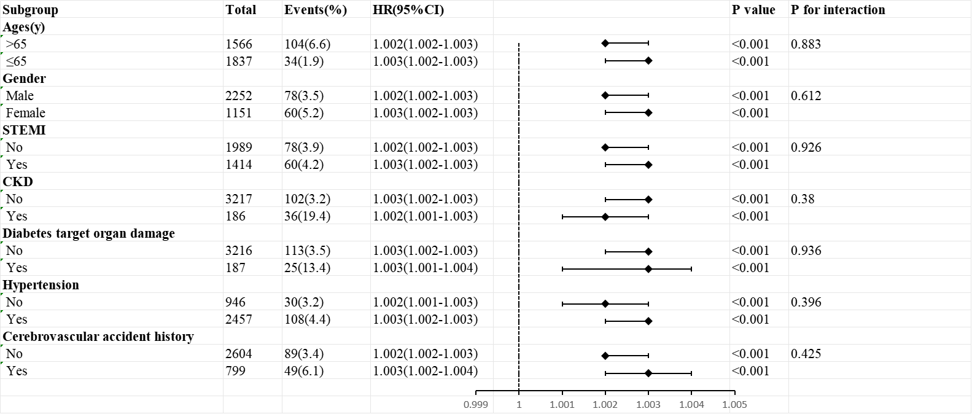

Supplemental Figure 3. Subgroup analysis of the relationships between SIRI and all-cause mortality in participants with diabetes and acute myocardial infarction.
