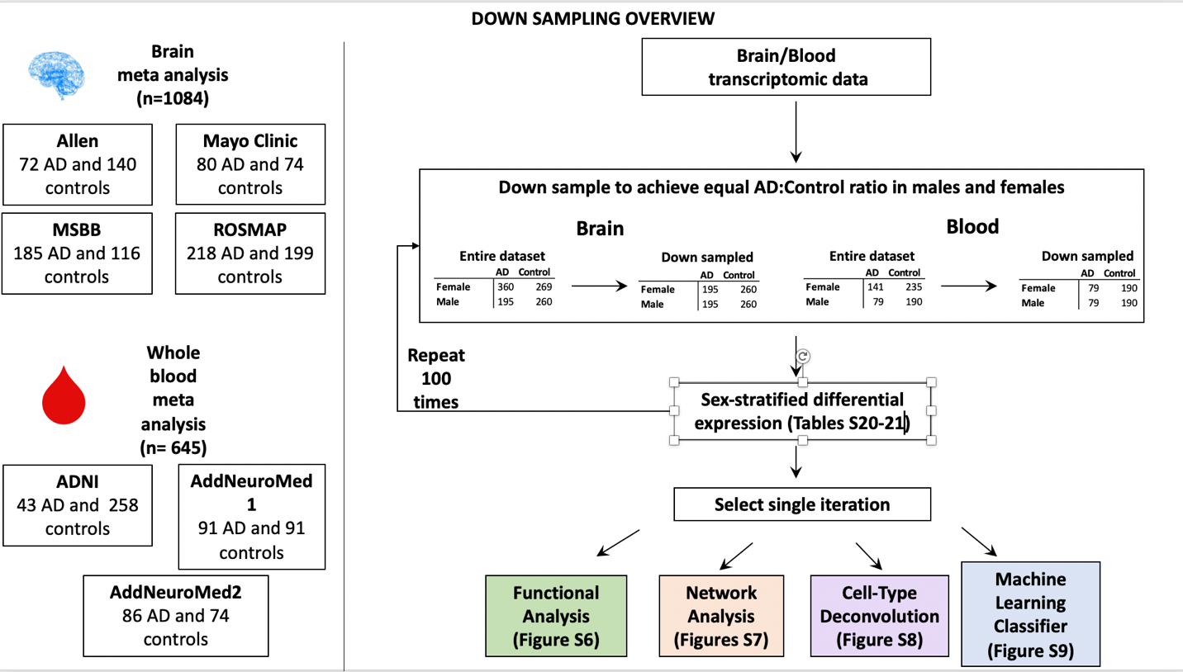

Figure S5: Down sampling overview

