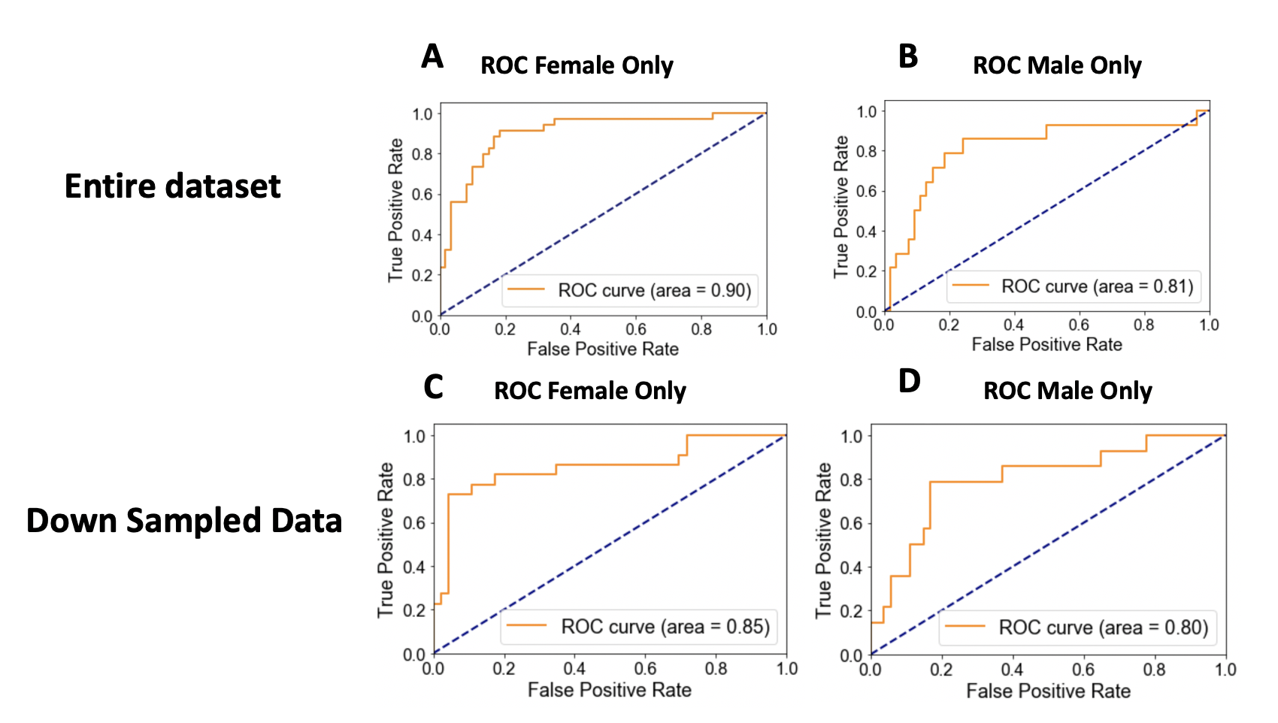

Figure S9: SVM classifier performance in down sampled dataset vs entire dataset

