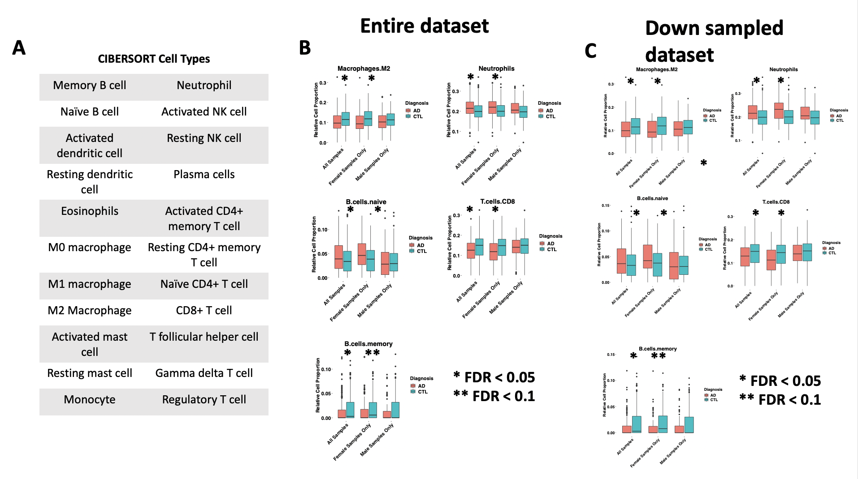

Figure S8: Cell type deconvolution in the down sampled dataset vs entire dataset

