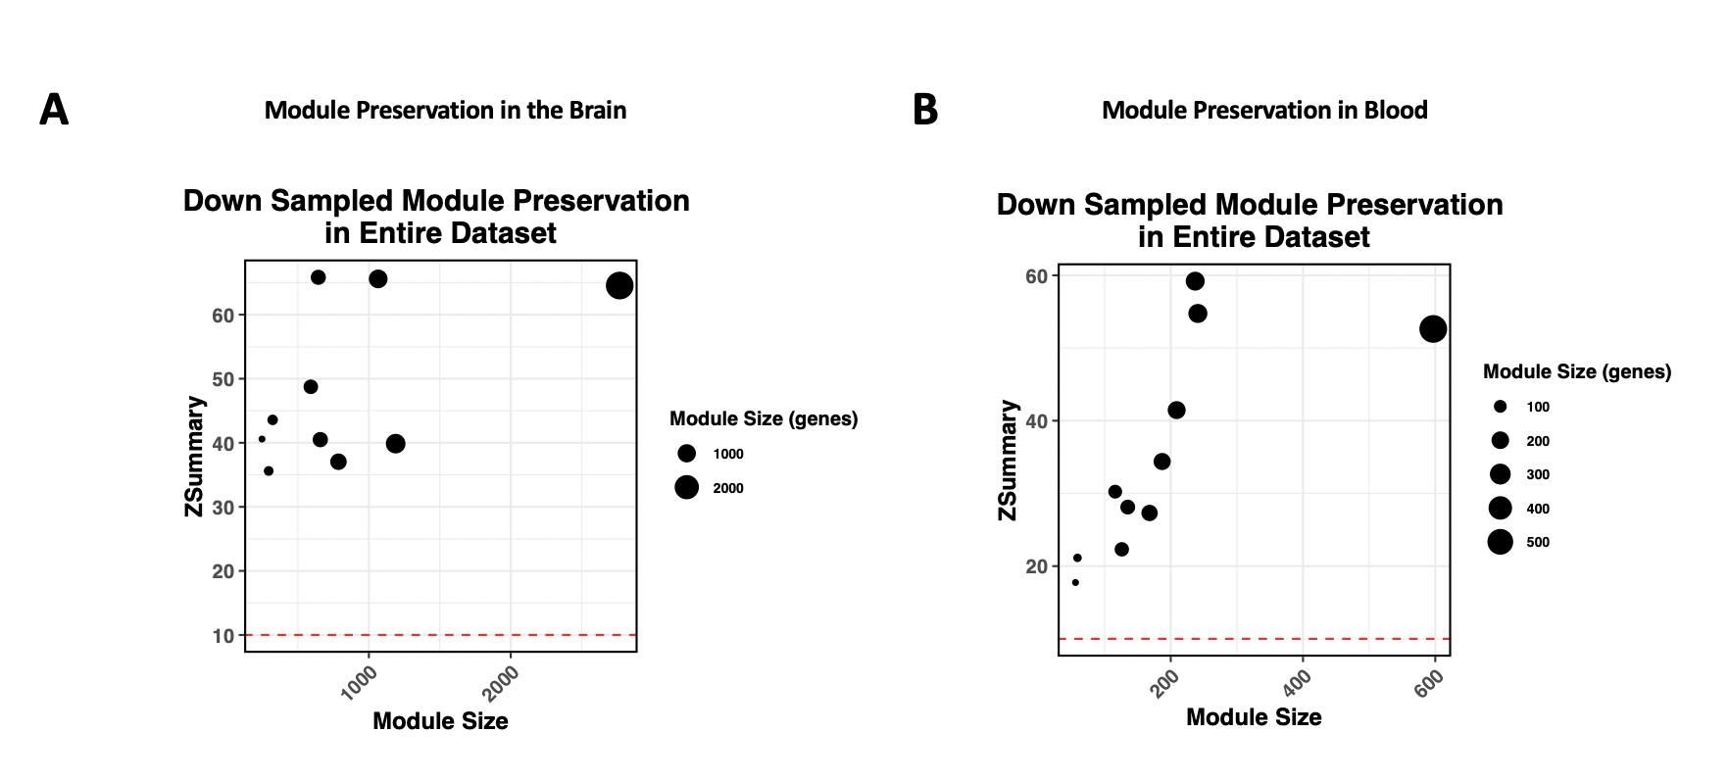
Figure S7: Comparison of network effects in down sampled data vs entire data set

