Supplementary File
Enhanced JAGN1 expression Modulates ER Stress Signaling and Promotes Survival in IRE1-Deficient Arabidopsis

Regina M. Bedgood¹, Karolina M. Pajerowska-Mukhtar*^{1,2}
- Department of Biology, University of Alabama at Birmingham, Birmingham, AL 35294, USA
- Department of Biological Sciences, Clemson University, Clemson, SC 29634, USA

*corresponding author, kmukhta@clemson.edu

Supplemental Figures:

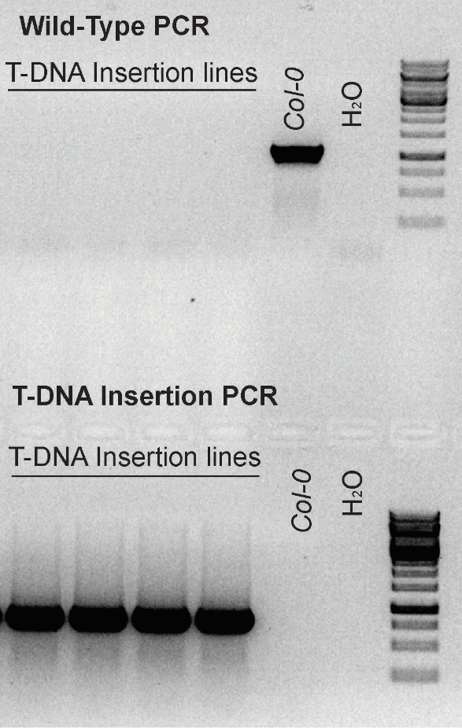
Supplemental Figure 1. Genotyping of T-DNA insertion line for JAGN1. Agarose gel of PCR confirmation for homozygosity of T-DNA insertion. The top row of wells is using the wild type primerset and the bottom row of wells is using the T-DNA insertion specific primers.

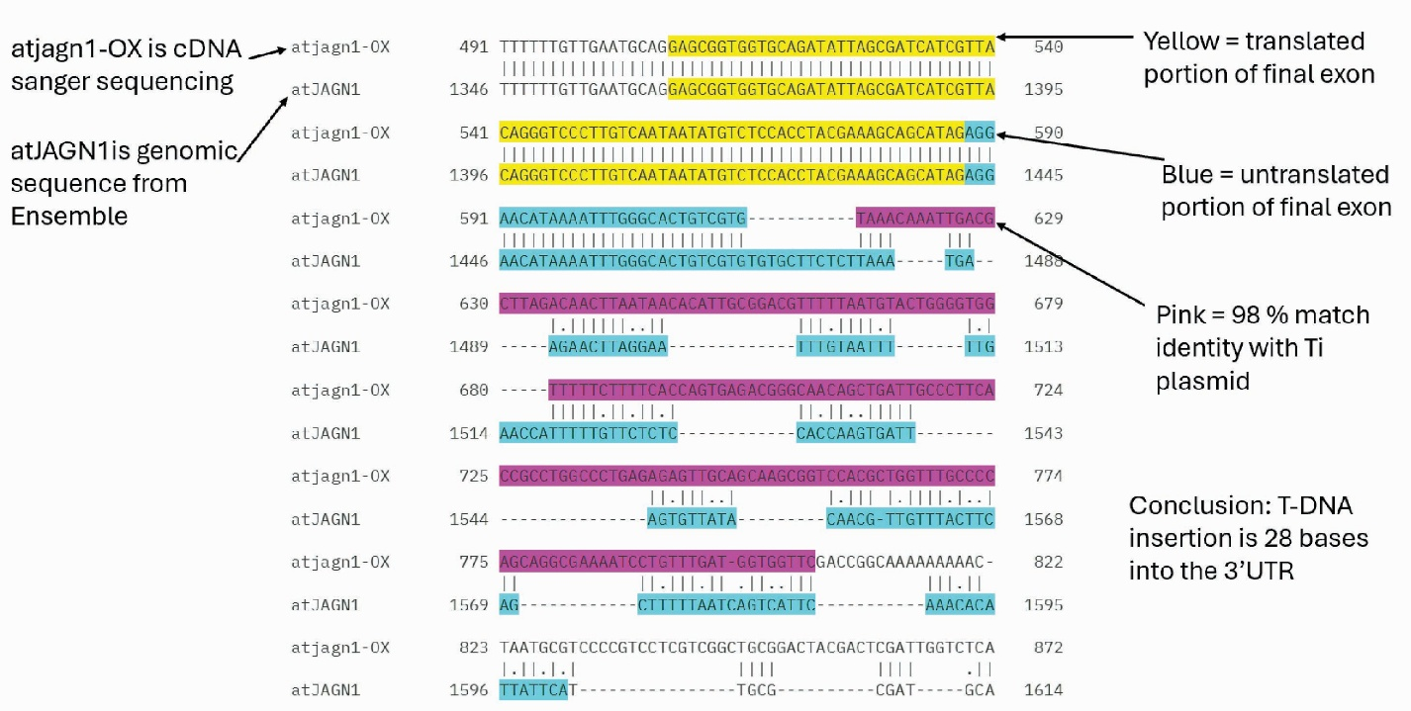
Supplemental Figure 2. Sanger Sequencing results for jagn1-OX line. Top row is the T-DNA insertion line and bottom row is the genomic sequence for JAGN1 in Arabidopsis thaliana.
Supplemental Figure 3. bZIP60 unspliced and spliced expression after stress treatment. bZIP60 unspliced and spliced relative expression to Ubiquitin 5 housekeeping gene.

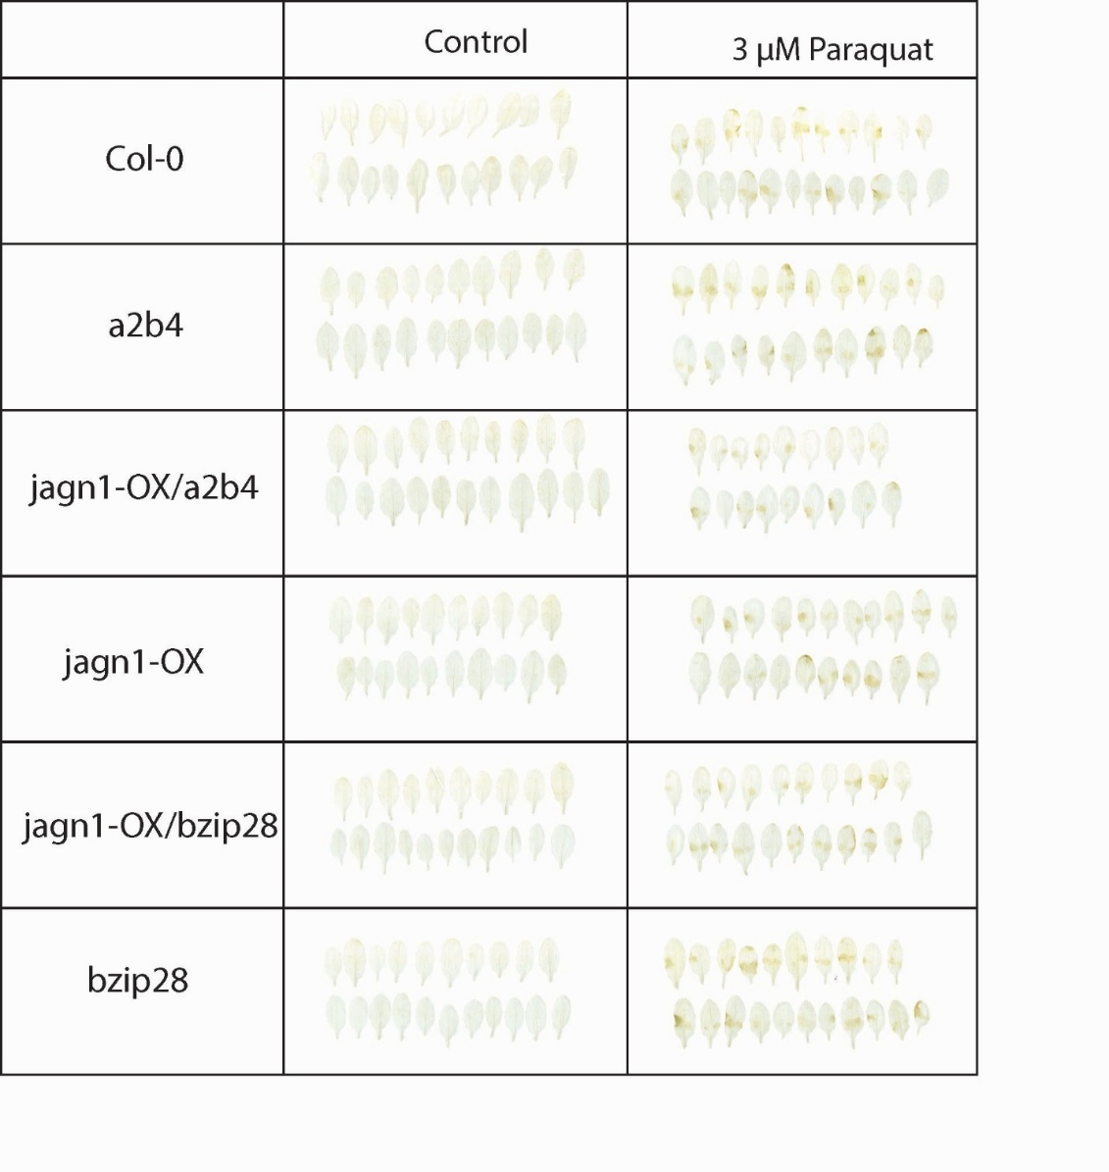
Supplemental figure 4. Paraquat induced H2O2 production. 4-week-old plants were infiltrated with 3 μM PQ, 3 leaves per plant. Plants were left to incubate for 24 hours and were collected for DAB staining.

Supplemental figure 5. MS control plates for survival analysis. These plates were germinated in tandem with the treatment groups for tunicamycin, monensin, and 2-deoxyglucose. Each plate has 30 seeds per genotype.

Supplemental figure 6. Tunicamycin treated seedlings. Each plate has 30 seeds per genotype.

Supplemental figure 7. Monensin treated seedlings. Each plate has 30 seeds per genotype.

Supplemental figure 8. 2-Deoxyglucose treated seedlings. Each plate has 30 seeds per genotype.

Supplemental figure 9. MS control plates for survival analysis. These plates were germinated in tandem with the treatment groups for paraquat and heat. Each plate has 30 seeds per genotype.

Supplemental figure 10. Heat treated seedlings. Each plate has 30 seeds per genotype.

Supplemental figure 11. Paraquat treated seedlings. Each plate has 30 seeds per genotype.

