Evaluating the Effectiveness of a Digital Therapy Intervention (iCARE) to Treat Symptoms of Postpartum Depression: description of intervention in the two—armed randomized controlled trial

Item 1: Name
A self-guided internet-based cognitive behavioral intervention with elements of Acceptance and Commitment Therapy (ACT) called iCARE.

Item 2: Why
The iCARE intervention is designed to reduce symptoms of postpartum depression by providing accessible, evidence‑based psychological support in a self‑guided digital format. It is grounded in cognitive behavioural therapy (CBT), which targets negative thoughts and behaviours associated with depression, and incorporates elements from Acceptance and Commitment Therapy (ACT) to enhance psychological flexibility, emotional regulation, and self‑compassion.
The intervention aims to address barriers commonly faced by postpartum women—such as limited access to therapy, stigma, time constraints, and caregiving demands—by offering a flexible, private, and scalable online treatment that can be completed at home at any preferred time. Through structured modules focusing on behavioural activation, cognitive restructuring, mindfulness, and self‑compassion, iCARE seeks to improve mood, reduce negative thinking patterns, and support maternal well‑being during the postpartum period.

Item 3: What
The iCARE program is a self-guided internet-based cognitive behavioral therapy (iCBT) intervention that also incorporates selected exercises and approaches from Acceptance and Commitment Therapy (ACT). The iCARE program consists of four core modules and four optional modules. The core modules focus on self-care (Module 1), identifying and reframing unrealistic expectations about motherhood with self-compassion (Module 2), increasing positive experiences and countering self-critical thoughts (Module 3), and recognizing and challenging thinking traps (Module 4). Together, these exercises aim to support behavioral activation through self-care, reduce negative thinking, enhance psychological flexibility, and promote well-being in daily life. The additional optional modules provide strategies for practicing being present, communicating needs and asking for support, bonding with the baby, and coping with scary thoughts. In addition, before participants start with the core modules, they are invited to a short introduction (Module 0), where they are introduced to the intervention.
Core Modules
Module 1 – ”Omsorg for dig selv” (Self-care)
Exercises:
- Planning and engaging in pleasant or meaningful activities (CBT – behavioral activation).
- Mindfulness practices using sensory attention to anchor in the present moment (ACT – mindfulness).
Content focus:
- Building small, realistic self-care routines.
- Noticing obstacles or judgments that arise and responding with acceptance.
Goal:
Strengthen self-care habits, support behavioral activation, and foster greater presence and acceptance in everyday life.
Module 2 – ”Forventninger til dig selv” (Expectations of Yourself)
Exercises:
- Identifying unrealistic, rigid, or perfectionistic expectations about motherhood (CBT – cognitive monitoring).
- Reframing these expectations with self-compassion and values-based perspectives (ACT – values / self-compassion) .
Content focus:
- Understanding how expectations influence emotions and behavior.
- Creating more flexible expectations aligned with personal values.
Goal:
Promote kinder, more realistic expectations of oneself.
Module 3 – ”Gode oplevelser i hverdagen” (Positive Experiences in Daily Life)
Exercises:
- Tracking moments of positive affect in daily activities (CBT – activity monitoring / positive reinforcement).
- Identifying self-critical thoughts and formulating more caring, balanced responses (CBT – cognitive restructuring, ACT – self-kindness).
Content focus:
- Becoming more aware of small positive moments.
- Noticing how thoughts shape mood.
- Practicing compassionate self-talk.
Goal:
Increase positive emotions, Reduce self-critical thought.
Module 4 – “Tankefælder” (Thinking Traps)
Exercises:
- Recognizing common cognitive distortions such as catastrophizing or all-or-nothing thinking (CBT – cognitive identification).
- Challenging distortions with structured cognitive restructuring (CBT – reappraisal techniques).
Content focus:
- Understanding how thinking traps influence mood.
- Learning step-by-step tools to question and modify unhelpful thoughts.
- Creating more flexible, realistic thinking patterns.
Goal:
Reduce automatic negative thoughts and strengthen adaptive cognitive responses.

Extra Modules
Module 5 – “Ro gennem mindfulness” (Calm Through Mindfulness)
Exercises:
- Additional guided mindfulness practices for settling the mind (ACT – mindfulness / acceptance).
- Self-compassion exercises for offering oneself care and space (ACT – self-compassion).
Content focus:
- Creating moments of calm in a busy day.
- Strengthening emotional regulation.
Goal:
Increase calm, presence, and acceptance during daily stress.
Module 6 – ”Kommunikation om behov” (Communicating Needs)
Exercises:
- Noticing and naming one’s own needs (ACT – values / self-connection).
- Practicing clear and assertive communication with others (CBT – assertiveness training).
Content focus:
- Recognizing signals of unmet needs.
- Communicating support needs to partners or family.
- Reducing guilt around asking for help.
Goal:
Improve communication skills and strengthen the ability to seek support.
Module 7 – “Nærvær med din baby” (Being Present With Your Baby)
Exercises:
- Mindful interaction and shared attention with the baby
- Practicing simple bonding and communication routines
Content focus:
- Enhancing emotional attunement to the baby.
- Increasing confidence in responding to infant cues.
- Creating moments of connection.
Goal:
Strengthen parent–infant bonding and confidence in caregiving.
Module 8 – ”Bekymringer og ubehagelige tanker” (Worries and Distressing Thoughts)
Exercises:
- Setting daily “worry time” to contain and structure worrying (CBT – worry scheduling).
- Practicing letting distressing/scary thoughts come and go without engaging (ACT – cognitive defusion).
Content focus:
- Understanding how worry affects mood and functioning.
- Learning strategies to create distance from scary intrusive thoughts.
- Reducing the impact of scary or distressing thoughts.
Goal:
Reduce worry-related distress

Item 4: Materials
iCARE intervention platform
The iCARE program is delivered digitally through the secure MindDistrict e-health platform and can be accessed via any modern internet browser on a smartphone, tablet, or computer or through the MindDistrict app. Participants receive access through a secure link sent to their digital mailbox (Digital post).
Intervention content
The program includes written psychoeducational material, graphics, videos, audio clips, and guided CBT/ACT-based exercises. All content is embedded within MindDistrict and accessible only to enrolled participants. The modules also include short audio clips featuring a fictional mother sharing experiences related to symptoms of postpartum depression.
Recruitment materials
To support recruitment, health nurses receive printed informational flyers they can hand out to the mothers (Supplementary material 1), a recruitment manual (Supplementary material 2), explaining study procedures, so the health nurses can use it as a working tool during their conversations with the mothers. Flyers include a QR code linking mothers to the redcap database and screening questionnaire.
Before recruitment begins, the research team also conducts an online PowerPoint introduction session for health nurses. This session provides an overview of study procedures, inclusion criteria, the consent process, and appropriate use of recruitment materials.
Online advertisement materials
Online advertisements and social-media posts (Supplementary material 3) are used to direct mothers to the iCARE study website, where they can access study information and complete the initial screening questionnaire in the redcap database.

Item 5: Procedures
Access to the intervention
Participants in the intervention group receive a secure link via their digital mailbox (Digital Post) granting access to the iCARE program on the MindDistrict platform. There is also a direct link to the iCARE program on the webpage, it can only be used if you already have a user profile on the MindDistrict platform. An introductory module guides participants on how to navigate the program, understand the module structure, and report if symptoms.
Intervention and technical support
The program consists of eight modules (four core, four optional), completed at the participant’s own pace over a two‑month period. A start op call is offered after 7 days, if the participant has accepted contact with the iCARE team and haven’t finished filling out the baseline questionnaire. Also, a brief technical-support phone call is offered approximately two weeks after access is granted to assist with navigation or access issues only.
Safety monitoring
Participants complete the EPDS before each core module. Scores are automatically calculated, and predefined safety procedures are triggered if a participant reports an EPDS score >18 or self‑harm ideation. In these cases, research staff contact the participant by phone to conduct a safety assessment following the internal protocol for assessing suicide risk and determining the need for acute psychiatric intervention, based on the SAFE-T framework and the Columbia Suicide Severity Rating Scale (C-SSRS). Participants are also advised to contact their health nurse or general practitioner if symptoms worsen. A detailed, standardized procedure guides how research staff contact participants to ensure consistent handling of safety concerns, and all contacts with participants are documented in REDCap.
Control group and usual care
Participants in both groups continue to receive treatment as usual (TAU) provided by their municipality and general practitioner, and the research team does not influence or modify usual care.
Assessments
All questionnaires (baseline, 2‑month, 6‑month follow‑up) are administered electronically via REDCap. Participants who have consented receive phone assistance if follow‑up questionnaires are not completed.

Item 6: Who
The iCARE intervention is self-guided, and no direct therapeutic contact is provided. However, several groups contribute to its development, technical implementation, and participant support:
Intervention developers:
iCARE was created by a multidisciplinary research team with expertise in postpartum mental health, cognitive-behavioural therapy, and digital psychiatry. The content was informed by user involvement (interviews with mothers with lived experience) and reviewed by an advisory board of clinicians, researchers, and patient-organisation representatives.
Technical developers:
Graphic designers, software engineers, and platform specialists at the Centre for Digital Psychiatry (CEDIP) programmed and implemented the intervention on the Minddistrict e-health platform in close collaboration with the research team. They also developed the iCARE project webpage with study information.
Support staff:
A project coordinator or trained research staff member provides a brief technical-support phone call just after randomization and approximately two weeks after access is granted. Research staff also monitor daily EPDS alerts and follow predefined safety procedures when thresholds are triggered. Staff are trained in the internal protocol for assessing suicide risk.
Health nurses (recruitment only):
Health nurses identify eligible mothers, provide study information, and support enrolment but do not deliver any part of the intervention.

Item 7: How
The iCARE intervention is delivered entirely online as a self-guided program accessed through a secure link sent to participants’ digital mailbox (Digital post). All modules, exercises, and multimedia materials are completed individually through the MindDistrict platform, with no face-to-face or direct therapeutic contact. Participants progress through the content independently and at their own pace.
Safety monitoring is integrated into the system through automated EPDS scoring and alerts. If a participant reports an EPDS score >18 or self-harm ideation, a research team member contacts them by phone to conduct a safety check following the study’s predefined risk protocol.
Participants continue to receive treatment as usual during the intervention period, and both intervention and control participants may receive follow-up contact if questionnaires are not completed.

Item 8: Where
The iCARE intervention is delivered entirely online through the secure MindDistrict platform, which participants can access from any location using their own smartphone, tablet, or computer.
All safety monitoring and study coordination take place at the Centre for Digital Psychiatry (CEDIP) and the Research Unit of Child and Adolescent Psychiatry in Odense, where research staff oversee EPDS alerts, technical-support calls, and data collection.
Recruitment occurs across 21 Danish municipalities, where health nurses provide information about the study, and participants may also self-refer through the study website. No components of the intervention itself are delivered in municipal settings.

Item 9: When and How much
Participants receive access to the iCARE program immediately after randomisation. The intervention is intended to be completed over two months, during which participants work through eight modules: four core modules completed sequentially and four optional modules that can be completed in any order.
Participants are encouraged to progress at roughly one module per week, spending approximately 20–40 minutes per module. This results in an estimated 2.5–5 hours of direct engagement with the core content, with additional time depending on whether participants choose to complete optional modules or revisit material. Participants retain access to the program until the study ends (mid-2027).

Item 10: Tailoring
Tailoring in iCARE is limited to participant-driven choices. All participants receive access to the same eight modules, including four core modules that are advised to be completed in a fixed sequence. Participants are recommended to do modules 1 to 4 in order, leaving some days in between to be able to practice the exercises, but they can choose to skip a module. This information is provided in Module 0, where the intervention is presented. In addition, the program includes four optional modules, which participants may choose to complete based on their individual needs and preferences. Participants can also progress through the program at their own pace within the two-month access period and pause the modules, if needed. No therapist-led customization or individualized feedback is provided.

Item 11: Modifications
No modifications will be made to the iCARE intervention during the trial. The version used in the RCT reflects the final content developed following extensive usability testing conducted in December 2024 and pilot-testing in 2025. This usability testing involved interviews with mothers with lived experience of postpartum depression and input from an advisory board of clinical researchers, psychologists, and patient-organisation representatives. Their feedback informed adjustments to the content, graphics, structure, and user-friendliness of the program before the pilot study began.
The original version of iCARE (Version 1.0) that was pilot tested differed slightly from the current version. In the initial design, the program consisted of seven modules that participants were required to complete sequentially; one module had to be finished before the next became accessible. In addition, the Edinburgh Postnatal Depression Scale (EPDS) was embedded in every module. The therapeutic content in Version 1.0 focused primarily on cognitive behavioral therapy (CBT) and included only a few Acceptance and Commitment Therapy (ACT) components—specifically one mindfulness exercise, one cognitive defusion exercise, and some compassionate language woven throughout the text.
During the pilot study, we experienced high attrition. We were able to interview only one mother, who reported several challenges: difficulty progressing to the next module, too many references to postpartum depression, and an introduction that felt too long. Furthermore, insights from experts in digital psychiatry and feedback from the initial nine interviews conducted at the beginning of the project (prior to developing Version 1.0) suggested that the program required substantial adjustments.
Based on this feedback, we made the following adaptations to the iCARE content:
- Created four open core modules to reduce participant burden and allow mothers to move freely between modules without needing to complete them in a strict sequence.
- Shortened the text to make the content more accessible and easier to navigate.
- Expanded the ACT component by adding more mindfulness, acceptance, and defusion exercises.
- Limited explicit references to postpartum depression and instead focused on “postpartum reactions,” a term that mothers and nurses preferred and used in their own practice.
These changes were made to improve usability, reduce attrition, and align the content more closely with mothers’ needs and clinical insights from practitioners. To ensure the revised modules would be more intuitive and user-friendly, the new core modules were tested using cognitive walkthroughs with four mothers. Their feedback indicated that the modules were easy to follow and required only minor adjustments to further improve the clarity of the exercises.
These changes were made to improve usability, reduce attrition, and align the content more closely with mothers’ needs and clinical insights from practitioners.

Item 12: How well (actual)
Fidelity is monitored throughout the trial using system-generated data from the MindDistrict platform, including module completion, time spent in modules, and engagement with exercises. Automated EPDS scoring ensures consistent implementation of safety procedures, with the research team completing and documenting follow-up calls when predefined thresholds are triggered (EPDS > 18 or self-harm ideation).
The planned technical-support call is tracked to ensure it is delivered as intended. Completion rates for EPDS check-ins and follow-up questionnaires (2- and 6-month assessments) are monitored to assess participant adherence to study procedures.
A qualitative process evaluation, conducted as an embedded study within the RCT, further explores implementation fidelity, acceptability, contextual influences, and mechanisms of impact. Semi-structured interviews with participants (intervention and control) will examine how iCARE was used, what supported or hindered engagement, and how the program may have influenced thoughts, emotions, and behaviours. This qualitative evaluation provides complementary insight into whether the intervention was delivered and experienced as intended.

Supplementary 1: Informational flyers to mothers
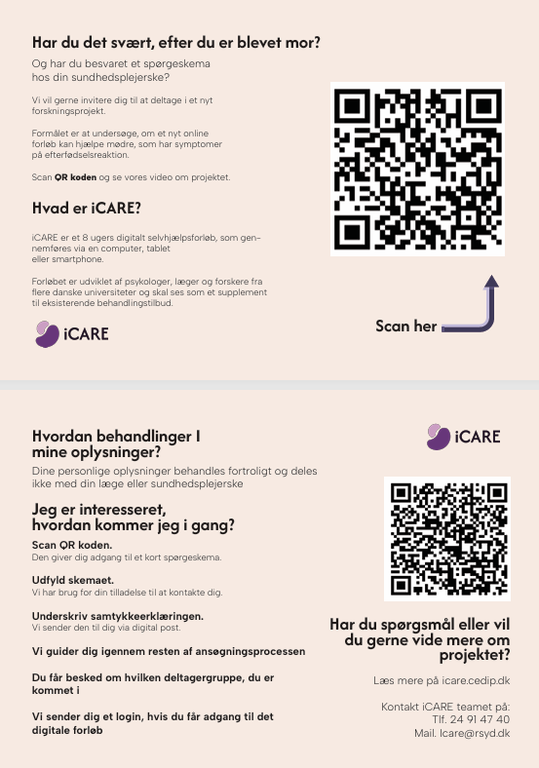

Supplementary 2: Recruitment manual
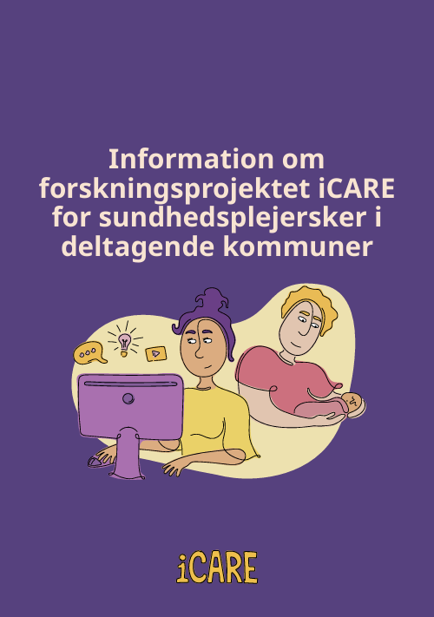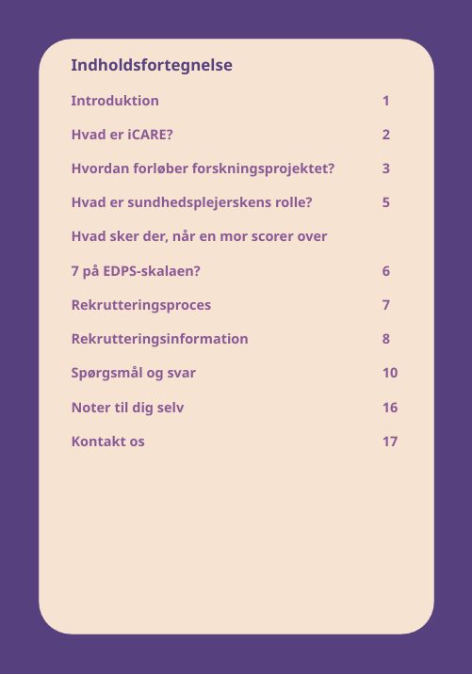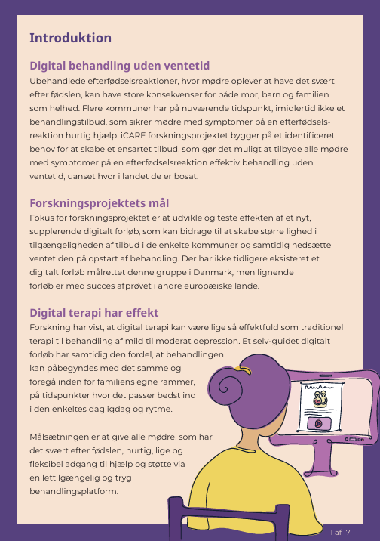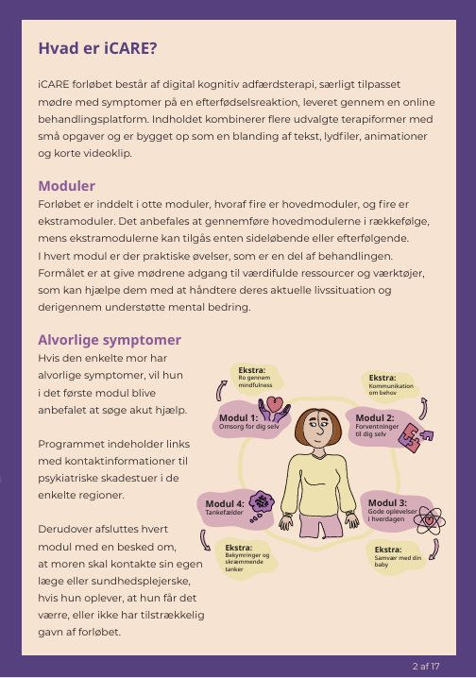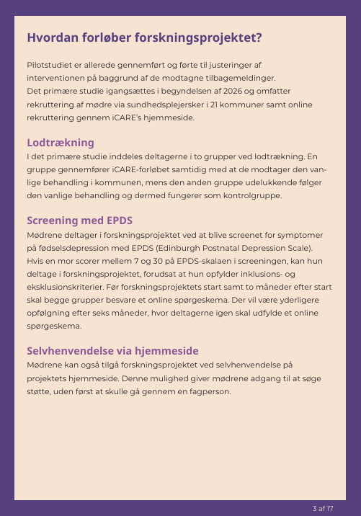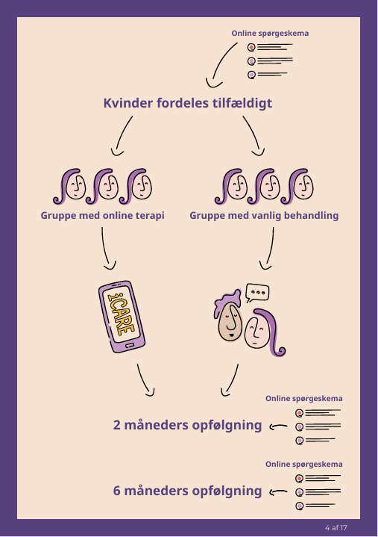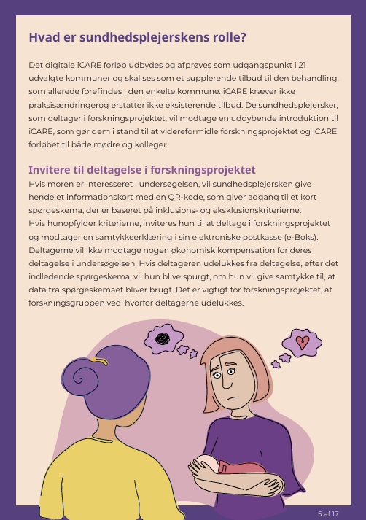
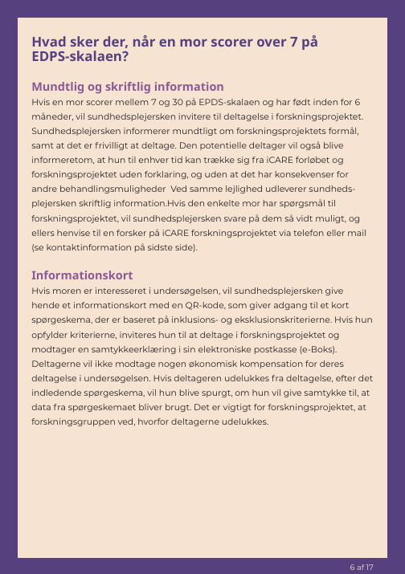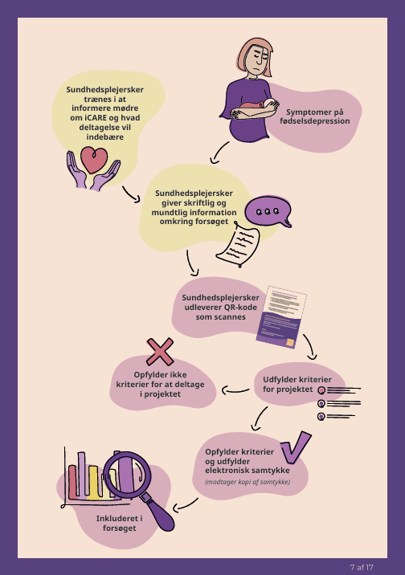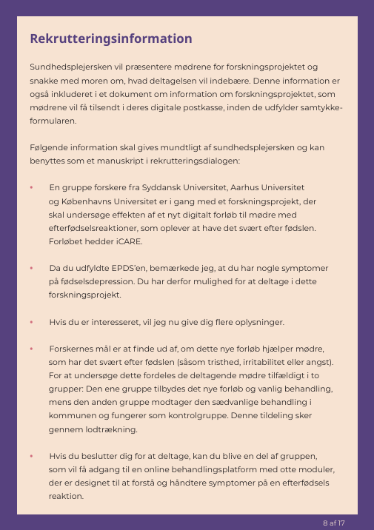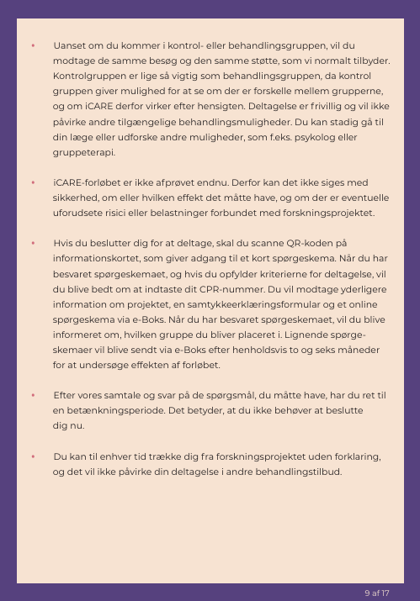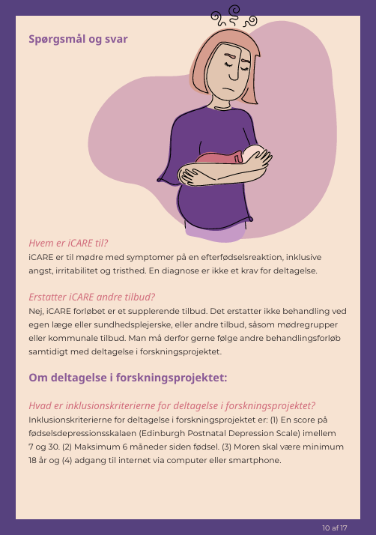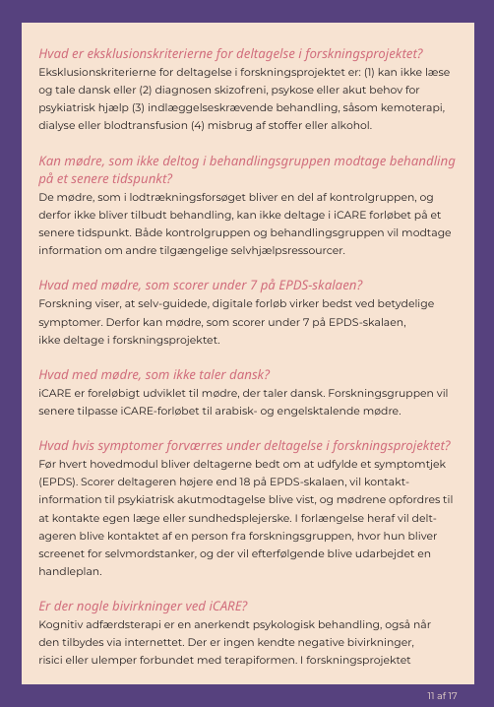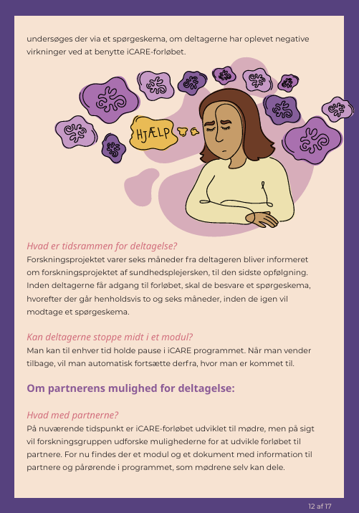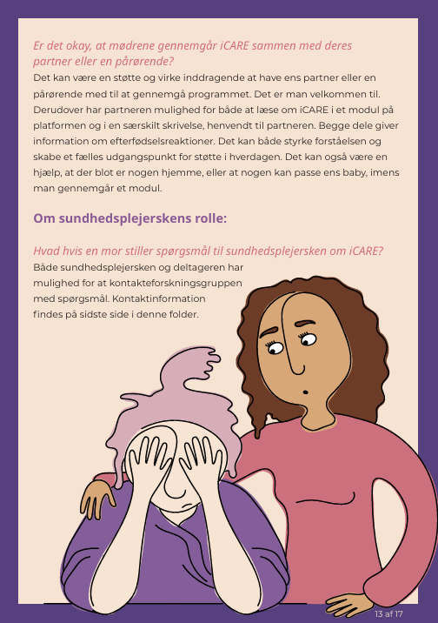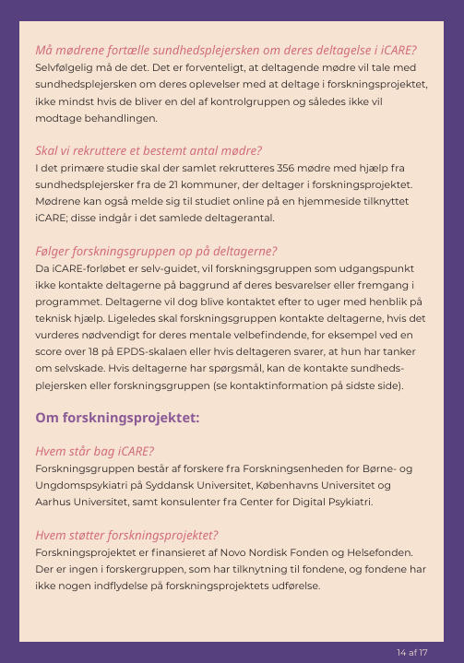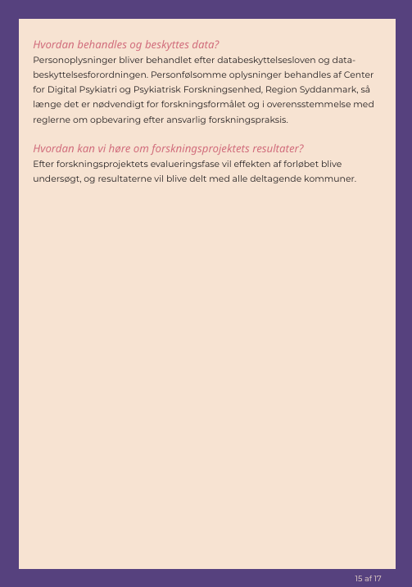
Supplementary 3: Examples of online advertisements and social-media posts