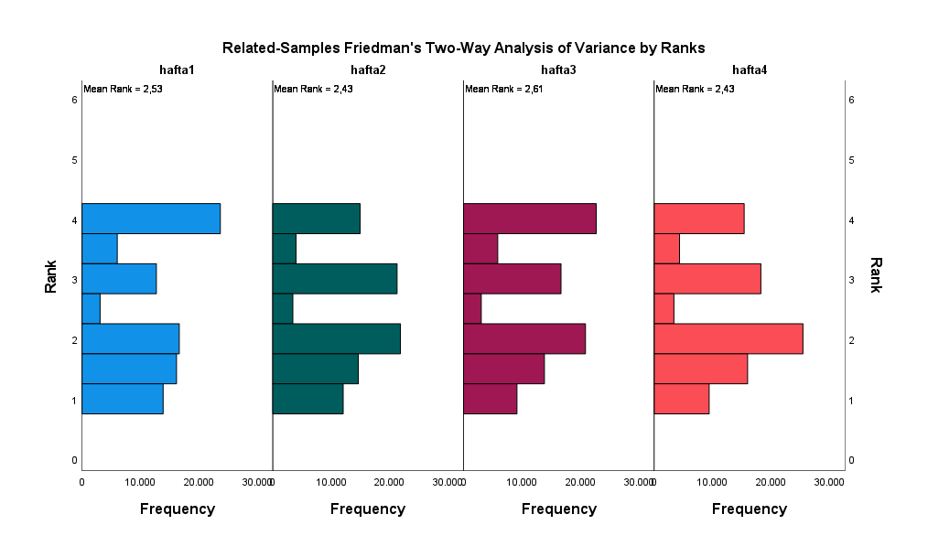
Appendix figure 1. Changes in the average of attention

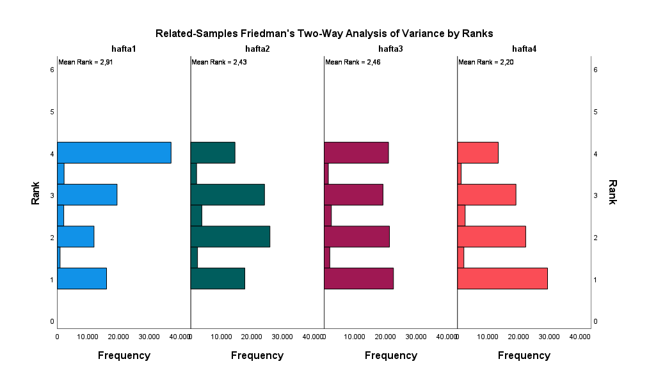
Appendix figure 2. Changes in arousal mean

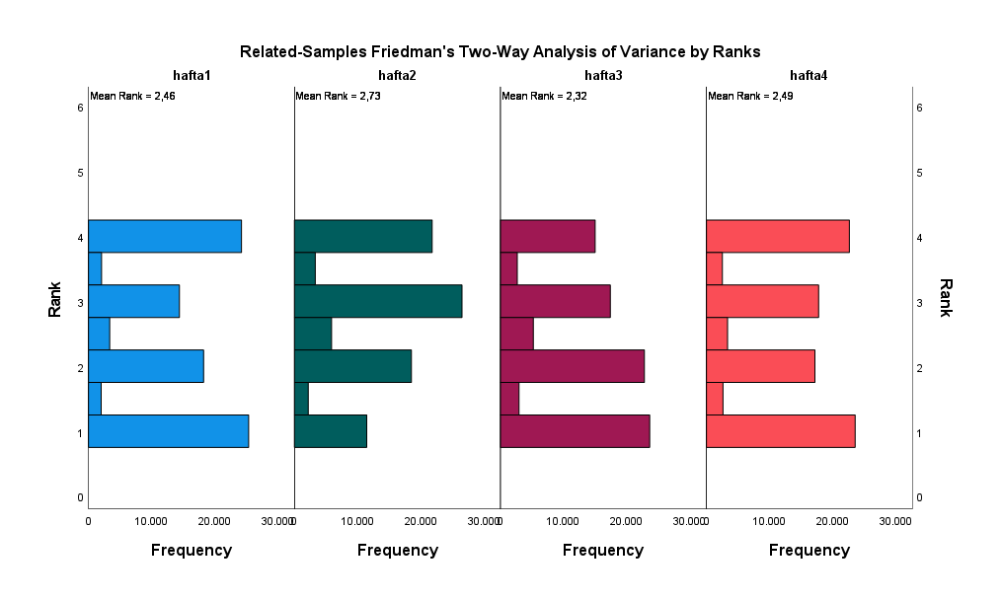
Appendix figure 3. Changes in Valence's average

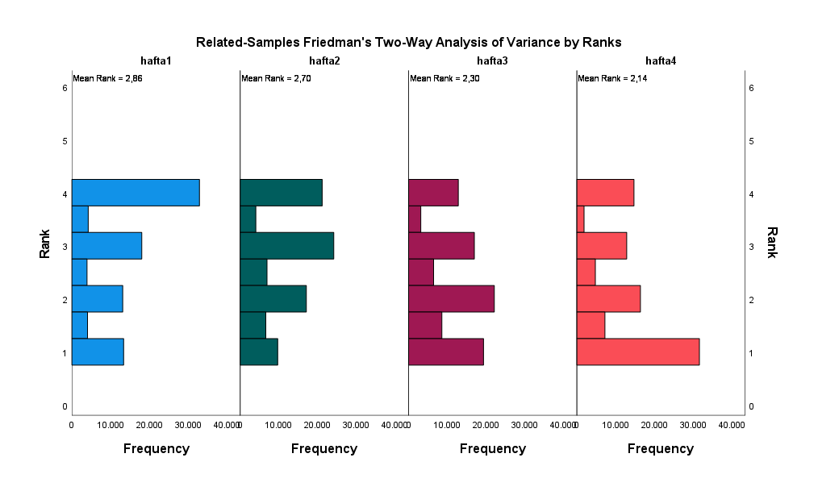
Appendix figure 4. Changes in the positivity mean

