Appendix table 1. Related Examples: Friedman's Summary of Two-Way Analysis of Variance by Rankings
Related-Samples Friedman’s Two-Way Analysis of Variance by Ranks Summary
Total N | 92107
Test Statistic | 1492,568
Degree Of Freedom | 3
Asymptotic Sig. (2-sided test) | ,000

Appendix table 2. Related Examples: Friedman's Summary of Two-Way Analysis of Variance by Rankings
Related-Samples Friedman’s Two-Way Analysis of Variance by Ranks Summary
Total N | 89617
Test Statistic | 14292,791
Degree Of Freedom | 3
Asymptotic Sig. (2-sided test) | ,000

Appendix table 3. Related Examples: Friedman's Summary of Two-Way Analysis of Variance by Rankings
Related-Samples Friedman’s Two-Way Analysis of Variance by Ranks Summary
Total N | 89617
Test Statistic | 4778,610
Degree Of Freedom | 3
Asymptotic Sig. (2-sided test) | ,000

Appendix table 4. Related Examples: Friedman's Summary of Two-Way Analysis of Variance by Rankings
Related-Samples Friedman’s Two-Way Analysis of Variance by Ranks Summary
Total N | 89618
Test Statistic | 19249,705
Degree Of Freedom | 3
Asymptotic Sig. (2-sided test) | ,000

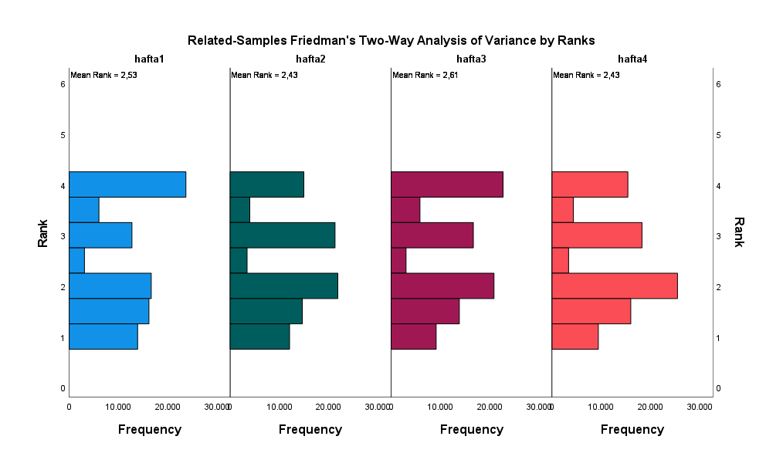
Appendix figure 1. Changes in the average of attention

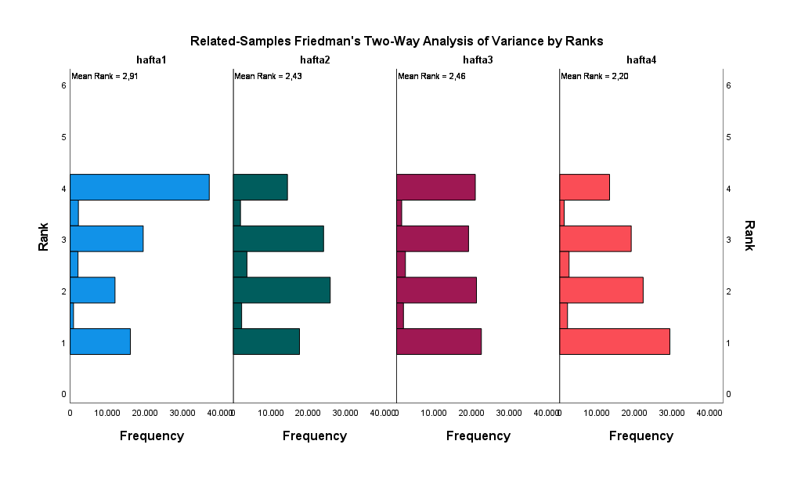
Appendix figure 2. Changes in arousal mean

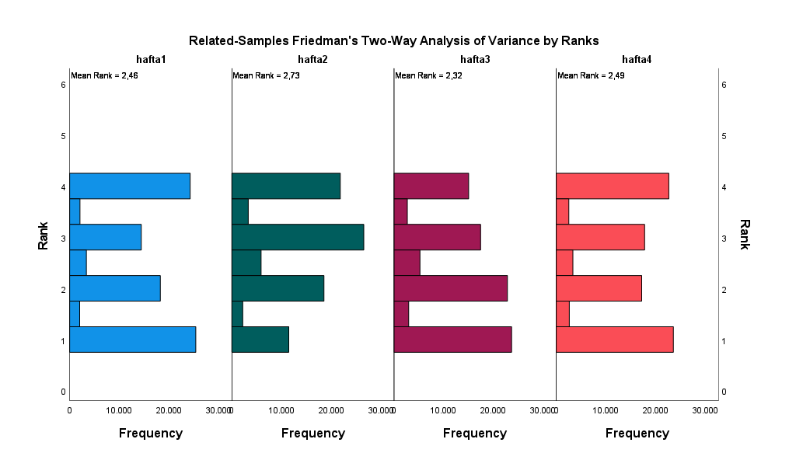
Appendix figure 3. Changes in Valence's average

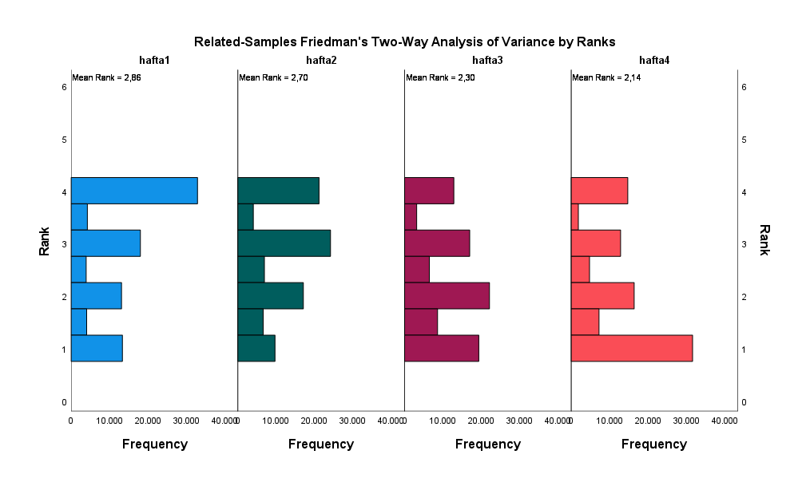
Appendix figure 4. Changes in the positivity mean

