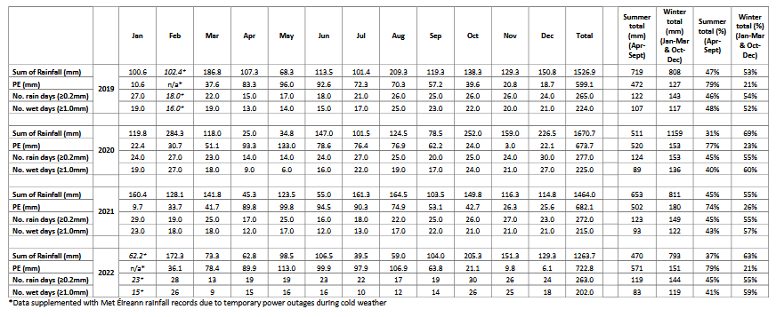
Table I-1 Monthly meteorological data for 2019 to 2022
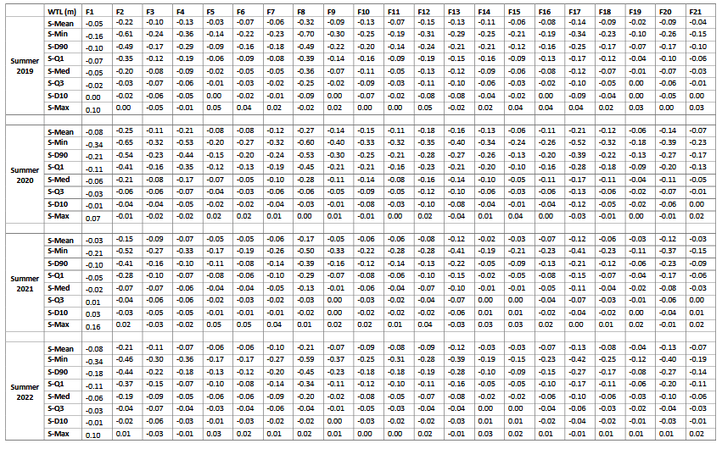
Table I-2 Summary of key water table level (WTL) statistics for summer 2019 to summer 2022

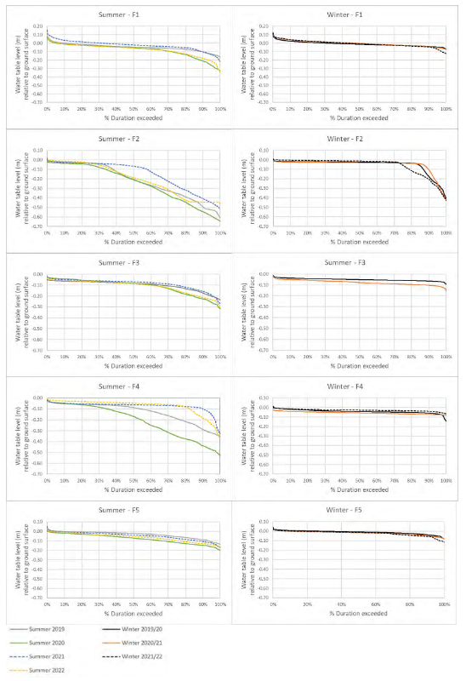
Figure I-1a Fiddandarry (F1 – F5) water level duration curves for summer and winter monitoring periods for illustrating water levels as a function of the proportion of time a particular water level (relative to ground surface) is equalled or exceeded (Negative values indicate depths below ground surface, positive values indicate height above ground surface measured from a fixed point)
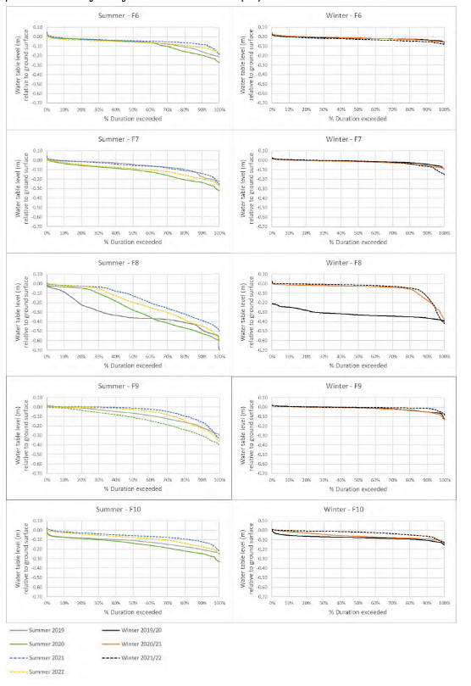
Figure I-1b Fiddandarry (F6-F10) water level duration curves for summer and winter monitoring periods for illustrating water levels as a function of the proportion of time a particular water level (relative to ground surface) is equalled or exceeded (Negative values indicate depths below ground surface, positive values indicate height above ground surface measured from a fixed point)

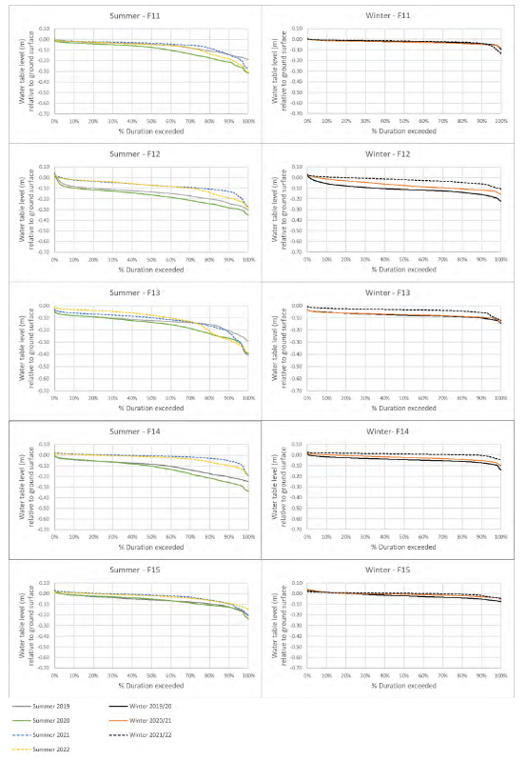
Figure I-1c Fiddandarry (F11-F15) water level duration curves for summer and winter monitoring periods for illustrating water levels as a function of the proportion of time a particular water level (relative to ground surface) is equalled or exceeded (Negative values indicate depths below ground surface, positive values indicate height above ground surface measured from a fixed point)
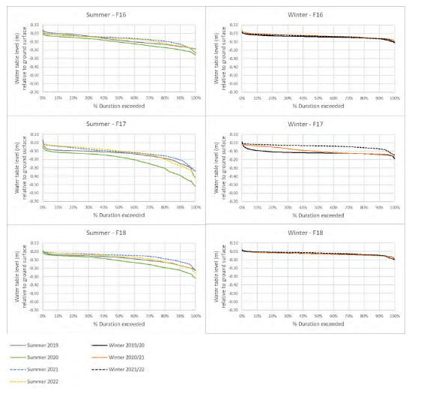Figure I-1d Fiddandarry (F16-F18) water level duration curves for summer and winter monitoring periods for illustrating water levels as a function of the proportion of time a particular water level (relative to ground surface) is equalled or exceeded (Negative values indicate depths below ground surface,
positive values indicate height above ground surface measured from a fixed point.

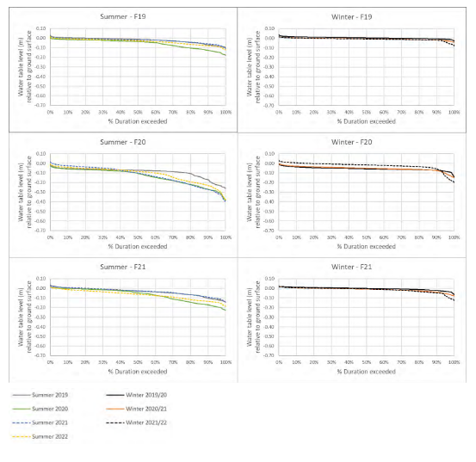
Figure I-1e Fiddandarry (Control wells - F19-F21) water level duration curves for summer and winter monitoring periods for illustrating water levels as a function of the proportion of time a particular water level (relative to ground surface) is equalled or exceeded (Negative values indicate depths below ground surface, positive values indicate height above ground surface measured from a fixed point).

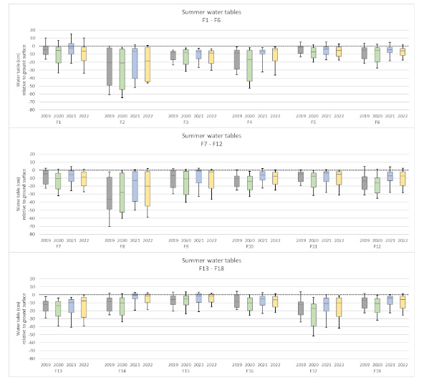

Figure I-2 Fiddandarry Box and whisker plot of summer WTLs at 18 test locations (Note boxes show S-D10, S-Med and S-D90 levels). WTLs were deepest in Summer 2020. Comparison between Summer 2019 and summer 2021
provide an indication in change in WTL associated with ditch blocking

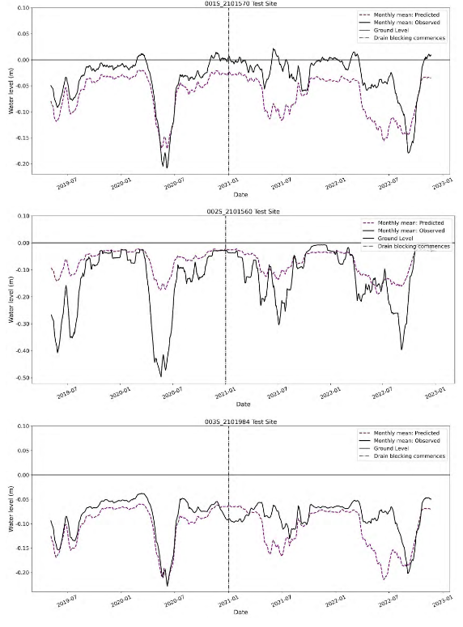
A-131
Figure I-3a Fiddandarry (F1-F3) rolling monthly RF predictions illustrating predicted water table levels and observed water table levels. The vertical dashed line indicates the approximate timeframe of ditch blocking occurring.).

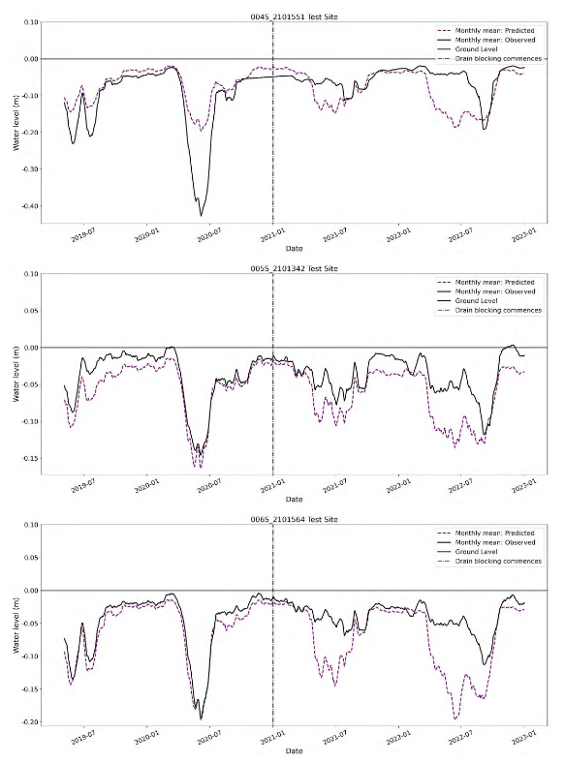
Figure I-3b Fiddandarry (F4-F6) rolling monthly RF predictions illustrating predicted water table levels and observed water table levels. The vertical dashed line indicates the approximate timeframe of ditch blocking occurring.).
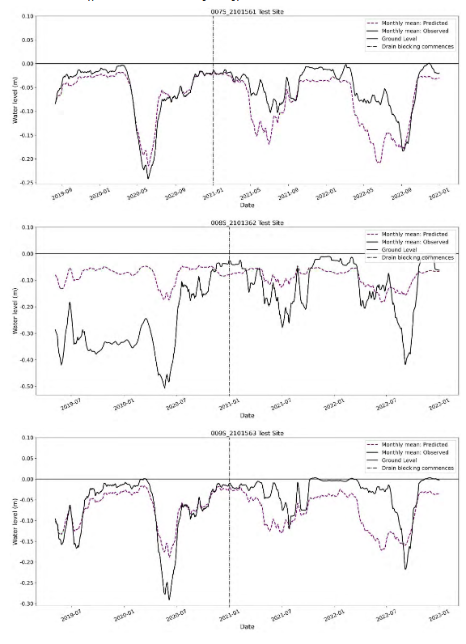

Figure I-3c Fiddandarry (F7-F9) rolling monthly RF predictions illustrating predicted water table levels and observed water table levels. The vertical dashed line indicates the approximate timeframe of ditch blocking occurring.)
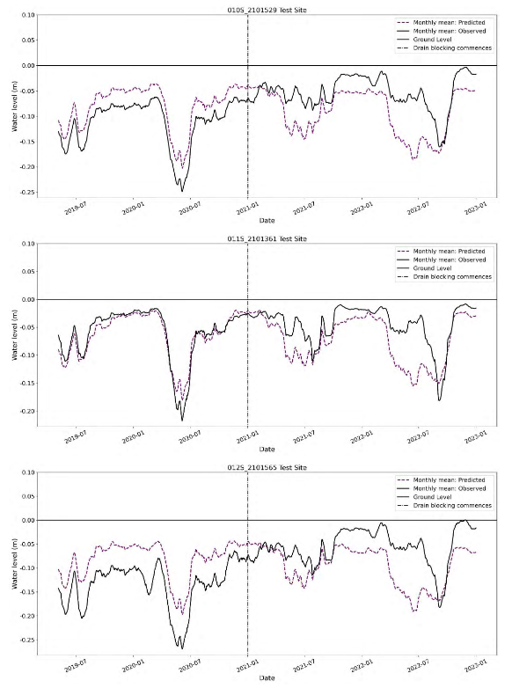
Figure I-3d Fiddandarry (F10-F12) rolling monthly RF predictions illustrating predicted water table levels and observed water table levels. The vertical dashed line indicates the approximate timeframe of ditch blocking occurring.).
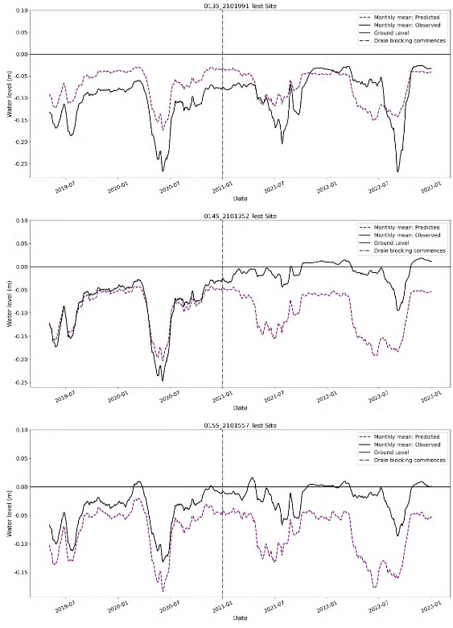

Figure I-3e Fiddandarry (F13-F16) rolling monthly RF predictions illustrating predicted water table levels and observed water table levels. The vertical dashed line indicates the approximate timeframe of ditch blocking occurring.)

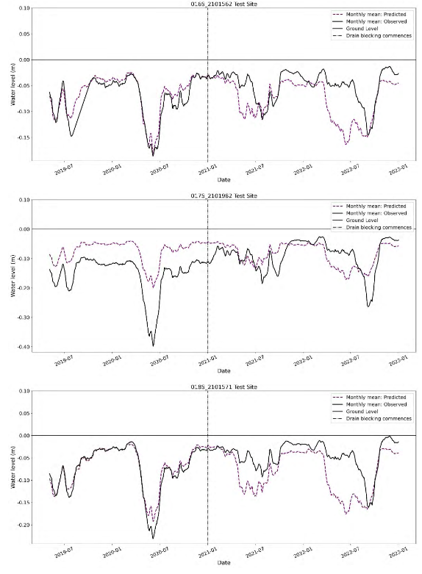Figure I-3e Fiddandarry (F16-F18) rolling monthly RF predictions illustrating predicted water table levels and observed water table levels. The vertical dashed line indicates the approximate timeframe of ditch blocking occurring.).
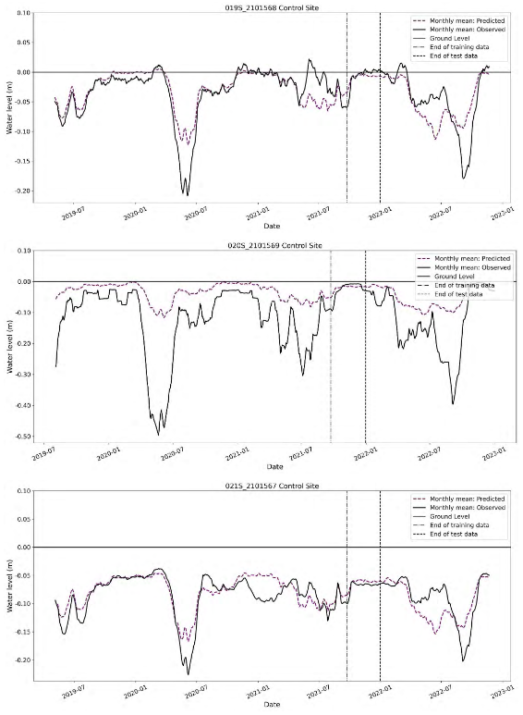
Figure I-3f Fiddandarry (Control wells F19-F21) rolling monthly RF predictions illustrating predicted water table levels and observed water table levels. The vertical dashed line indicates the approximate timeframe of ditch blocking occurring.)

