Supplementary material for

A Multicenter, Interpretable Machine Learning-Based Survival Model for Predicting 28-Day Mortality Risk in Sepsis Patients with Heart Failure: A Retrospective Cohort Study and Performance Comparison with the SOFA Score
Authors: Yucan Zhou, Jian Wang,Yunchong Li, Jiahao Zou, Zhaoxin Huang, Yue Li, Mengyuan Hou, Zhibin Ma, Chunlong Liu
Corresponding Author:
Jian Wang,
Cangzhou Hospital of Integrated Traditional Chinese and Western Medicine in Hebei Province,
Cangzhou 061013, China.
E-mail: wangjianyisheng@126.com.
Table of contents
A Multicenter, Interpretable Machine Learning-Based Survival Model for Predicting 28-Day Mortality Risk in Sepsis Patients with Heart Failure: A Retrospective Cohort Study and Performance Comparison with the SOFA Score 1
Table S2. 28-day mortality risk prediction performance of different models across datasets. 4
Table S3. Feature Importance Scores Across the Four Datasets. 5
Table S4. Performance Comparison of GBM and SOFA-Cox Models for Predicting 28-Day Mortality. 6
Table S5. Risk Stratification Performance and Prognostic Value of GBM and SOFA-Cox Models for 28-Day Mortality. 7
Table S6. Predicted Risk Characteristics and Optimal Thresholds of GBM and SOFA-Cox Models. 8
Table S7. Confusion Matrix of Consistency Between GBM and SOFA-Cox Models for 28-Day Mortality Prediction. 9
Fig S1 Missing value distribution of features across three datasets. 10
Fig S2 28-day time-dependent AUC, ROC, calibration curves and DCA of the four models across four datasets. 11
Fig S3 Cross-dataset comparison of feature SHAP values. SHAP:SHapley Additive exPlanations. 12
Fig S4 Correlation Analysis of Feature Importance Between MIMIC-IV Training Set and Other Datasets. 13

Table S1 ICD code for heart failure.
ICD version | ICD code |  | Long title
9 | 39891 |  | Rheumatic heart failure (congestive)
9 | 402 | 40201 | Malignant hypertensive heart disease with heart failure
9 | 402 | 40211 | Benign hypertensive heart disease with heart failure
9 | 402 | 40291 | Unspecified hypertensive heart disease with heart failure
9 | 404 | 40401 | Hypertensive heart and chronic kidney disease, malignant, with heart failure and with chronic kidney disease stage I through stage IV, or unspecified
9 | 404 | 40403 | Hypertensive heart and chronic kidney disease, malignant, with heart failure and with chronic kidney disease stage V or end stage renal disease
9 | 404 | 40411 | Hypertensive heart and chronic kidney disease, benign, with heart failure and with chronic kidney disease stage I through stage IV, or unspecified
9 | 404 | 40413 | Hypertensive heart and chronic kidney disease, benign, with heart failure and chronic kidney disease stage V or end stage renal disease
9 | 404 | 40491 | Hypertensive heart and chronic kidney disease, unspecified, with heart failure and with chronic kidney disease stage I through stage IV, or unspecified
9 | 404 | 40493 | Hypertensive heart and chronic kidney disease, unspecified, with heart failure and chronic kidney disease stage V or end stage renal disease
9 | 428 | 4280 | Congestive heart failure, unspecified
9 | 428 | 4281 | Left heart failure
9 | 428 | 42820 | Systolic heart failure, unspecified
9 | 428 | 42821 | Acute systolic heart failure
9 | 428 | 42822 | Chronic systolic heart failure
9 | 428 | 42823 | Acute on chronic systolic heart failure
9 | 428 | 42830 | Diastolic heart failure, unspecified
9 | 428 | 42831 | Acute diastolic heart failure
9 | 428 | 42832 | Chronic diastolic heart failure
9 | 428 | 42833 | Acute on chronic diastolic heart failure
9 | 428 | 42840 | Combined systolic and diastolic heart failure, unspecified
9 | 428 | 42841 | Acute combined systolic and diastolic heart failure
9 | 428 | 42842 | Chronic combined systolic and diastolic heart failure
9 | 428 | 42843 | Acute on chronic combined systolic and diastolic heart failure
9 | 428 | 4289 | Heart failure, unspecified
10 | I0981 |  | Rheumatic heart failure
10 | I110 |  | Hypertensive heart disease with heart failure
10 | I13 | I130 | Hypertensive heart and chronic kidney disease without heart failure, with stage 1 through stage 4 chronic kidney disease, or unspecified chronic kidney disease
10 | I13 | I132 | Hypertensive heart and chronic kidney disease with heart failure and with stage 5 chronic kidney disease, or end stage renal disease
10 | I50 | I50 | Heart failure
10 | I50 | I502 | Systolic (congestive) heart failure
10 | I50 | I5020 | Unspecified systolic (congestive) heart failure
10 | I50 | I5021 | Acute systolic (congestive) heart failure
10 | I50 | I5022 | Chronic systolic (congestive) heart failure
10 | I50 | I5023 | Acute on chronic systolic (congestive) heart failure
10 | I50 | I503 | Diastolic (congestive) heart failure
10 | I50 | I5030 | Unspecified diastolic (congestive) heart failure
10 | I50 | I5031 | Acute diastolic (congestive) heart failure
10 | I50 | I5032 | Chronic diastolic (congestive) heart failure
10 | I50 | I5033 | Acute on chronic diastolic (congestive) heart failure
10 | I50 | I504 | Combined systolic (congestive) and diastolic (congestive) heart failure
10 | I50 | I5040 | Unspecified combined systolic (congestive) and diastolic (congestive) heart failure
10 | I50 | I5041 | Acute combined systolic (congestive) and diastolic (congestive) heart failure
10 | I50 | I5042 | Chronic combined systolic (congestive) and diastolic (congestive) heart failure
10 | I50 | I5043 | Acute on chronic combined systolic (congestive) and diastolic (congestive) heart failure
10 | I50 | I508 | Other heart failure
10 | I50 | I5081 | Right heart failure
10 | I50 | I50810 | Right heart failure, unspecified
10 | I50 | I50811 | Acute right heart failure
10 | I50 | I50812 | Chronic right heart failure
10 | I50 | I50813 | Acute on chronic right heart failure
10 | I50 | I50814 | Right heart failure due to left heart failure
10 | I50 | I5082 | Biventricular heart failure
10 | I50 | I5083 | High output heart failure
10 | I50 | I5084 | End stage heart failure
10 | I50 | I5089 | Other heart failure
10 | I50 | I509 | Heart failure, unspecified
10 | I9713 | I9713 | Postprocedural heart failure
10 | I9713 | I97130 | Postprocedural heart failure following cardiac surgery
10 | I9713 | I97131 | Postprocedural heart failure following other surgery
ICD = international classification of diseases; this table lists the diagnostic codes and corresponding full names related to heart failure in the ICD-9 and ICD-10 versions, covering various types of heart failure such as rheumatic, hypertensive, systolic/diastolic, and acute/chronic heart failure.

Table S2. 28-day mortality risk prediction performance of different models across datasets.
Dataset | Model | C-index (95% CI) | 28-day AUC | Brier Score | Intercept | Slope | ENB₁₅₋₃₅
MIMIC-IV Training | RSF | 0.840 (0.827, 0.853) | 0.866 | 0.107 | -0.010 | 1.009 | 0.085
MIMIC-IV Training | Cox | 0.714 (0.696, 0.732) | 0.735 | 0.135 | -0.009 | 1.010 | 0.044
MIMIC-IV Training | XGBoost | 0.794 (0.777, 0.809) | 0.822 | 0.117 | -0.152 | 1.179 | 0.070
MIMIC-IV Training | GBM | 0.774 (0.757, 0.790) | 0.799 | 0.118 | 0.006 | 0.991 | 0.065
MIMIC-IV Test | RSF | 0.830 (0.810, 0.850) | 0.858 | 0.117 | -0.030 | 1.032 | 0.097
MIMIC-IV Test | Cox | 0.718 (0.692, 0.744) | 0.744 | 0.143 | -0.033 | 1.039 | 0.059
MIMIC-IV Test | XGBoost | 0.802 (0.779, 0.822) | 0.833 | 0.120 | -0.122 | 1.144 | 0.084
MIMIC-IV Test | GBM | 0.802 (0.780, 0.824) | 0.833 | 0.116 | -0.006 | 1.004 | 0.087
eICU-CRD | RSF | 0.823 (0.803, 0.844) | 0.855 | 0.126 | -0.068 | 1.097 | 0.124
eICU-CRD | Cox | 0.733 (0.704, 0.761) | 0.758 | 0.151 | -0.114 | 1.159 | 0.093
eICU-CRD | XGBoost | 0.806 (0.782, 0.831) | 0.835 | 0.141 | -0.290 | 1.399 | 0.095
eICU-CRD | GBM | 0.815 (0.789, 0.839) | 0.850 | 0.119 | 0.002 | 1.005 | 0.126
CZHITCM | RSF | 0.750 (0.704, 0.795) | 0.801 | 0.182 | -0.001 | 1.008 | 0.332
CZHITCM | Cox | 0.661 (0.607, 0.708) | 0.699 | 0.216 | -0.010 | 1.021 | 0.304
CZHITCM | XGBoost | 0.898 (0.876, 0.921) | 0.959 | 0.126 | -0.229 | 1.522 | 0.341
CZHITCM | GBM | 0.867 (0.836, 0.896) | 0.933 | 0.102 | -0.059 | 1.121 | 0.389
C-index:concordance index;CI:confidence interval;AUC:area under the curve;ENB₁₅₋₃₅:expected net benefit at 15% to 35% risk threshold

Table S3. Feature Importance Scores Across the Four Datasets.
Feature | MIMIC-IV Training | MIMIC-IV Test | eICU-CRD | CZHITCM
RF | 0.256 | 0.253 | 0.228 | 0.223
Lym% | 0.225 | 0.226 | 0.191 | 0.195
Age | 0.209 | 0.214 | 0.289 | 0.218
Alb | 0.204 | 0.180 | 0.256 | 0.213
Phos | 0.165 | 0.182 | 0.187 | 0.233
AST | 0.089 | 0.088 | 0.186 | 0.083
Lac | 0.070 | 0.103 | 0.221 | 0.166
Na | 0.041 | 0.044 | 0.076 | 0.070
AG | 0.028 | 0.022 | 0.045 | 0.045

Table S4. Performance Comparison of GBM and SOFA-Cox Models for Predicting 28-Day Mortality.
Model | C index (95% CI) | 28-day AUC | OptimalCutoff | Sensitivity | Specificity | Youden Index | Brier | Intercept | Slope | ENB₁₅₋₃₅ | Cox PH Test P
GBM | 0.815 (0.789, 0.839) | 0.850 | 0.100 | 0.766 | 0.766 | 0.532 | 0.119 | 0.002 | 1.005 | 0.126
SOFA-Cox | 0.609 (0.577, 0.641) | 0.624 | 1.026 | 0.615 | 0.580 | 0.195 | 0.171 | -0.019 | 1.037 | 0.048 | 0.784
C-index:concordance index;CI:confidence interval;AUC:area under the curve;Cox PH Test P:cox proportional hazards test p-value.

Table S5. Risk Stratification Performance and Prognostic Value of GBM and SOFA-Cox Models for 28-Day Mortality.
Model | Optimal Cutoff | Log Rank P value | HR(95%CI) | High Risk Sample Count | Low Risk Sample Count
GBM | 0.100159 | < 0.0001 | 7.75(5.91 - 10.18) | 438 | 770
SOFA-Cox | 1.025628 | < 0.0001 | 2.01(1.58 - 2.54) | 564 | 644
HR:hazard ratio;CI:confidence interval.

Table S6. Predicted Risk Characteristics and Optimal Thresholds of GBM and SOFA-Cox Models.
 | GBM | SOFA-Cox
28-day Mortality Risk Prediction Range | 4.8%-459.7% | 63.4%-280.6%
Average Predicted Risk | 50.52% | 105.56%
Actual 28-day Mortality Rate | 46.94% | 46.94%
Optimal Threshold (Youden's Index) | 0.3 (0.741) | 1.11 (0.218)

Table S7. Confusion Matrix of Consistency Between GBM and SOFA-Cox Models for 28-Day Mortality Prediction.
 | SOFA-Cox Correct | SOFA-Cox Incorrect | Total
GBM Correct | 137 (55.9%) | 77 (31.4%) | 214 (87.3%)
GBM Incorrect | 14 (5.7%) | 17 (6.9%) | 31 (12.7%)
Total | 151 (61.6%) | 94 (38.4%) | 245 (100%)

Fig S1 Missing value distribution of features across three datasets.
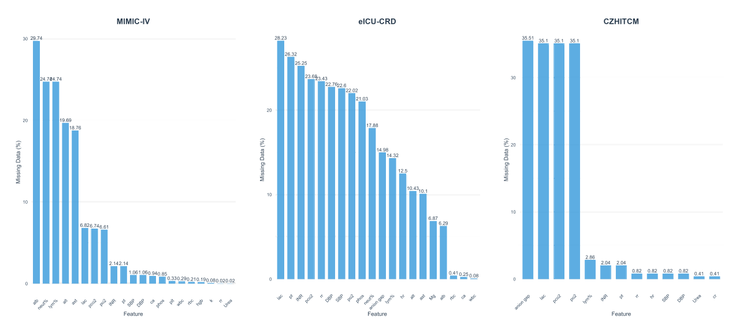

Fig S2 28-day time-dependent AUC, ROC, calibration curves and DCA of the four models across four datasets.
Note: AUC: area under the curve; ROC: receiver operating characteristic; DCA: decision curve analysis.

Fig S3 Cross-dataset comparison of feature SHAP values. SHAP:SHapley Additive exPlanations.
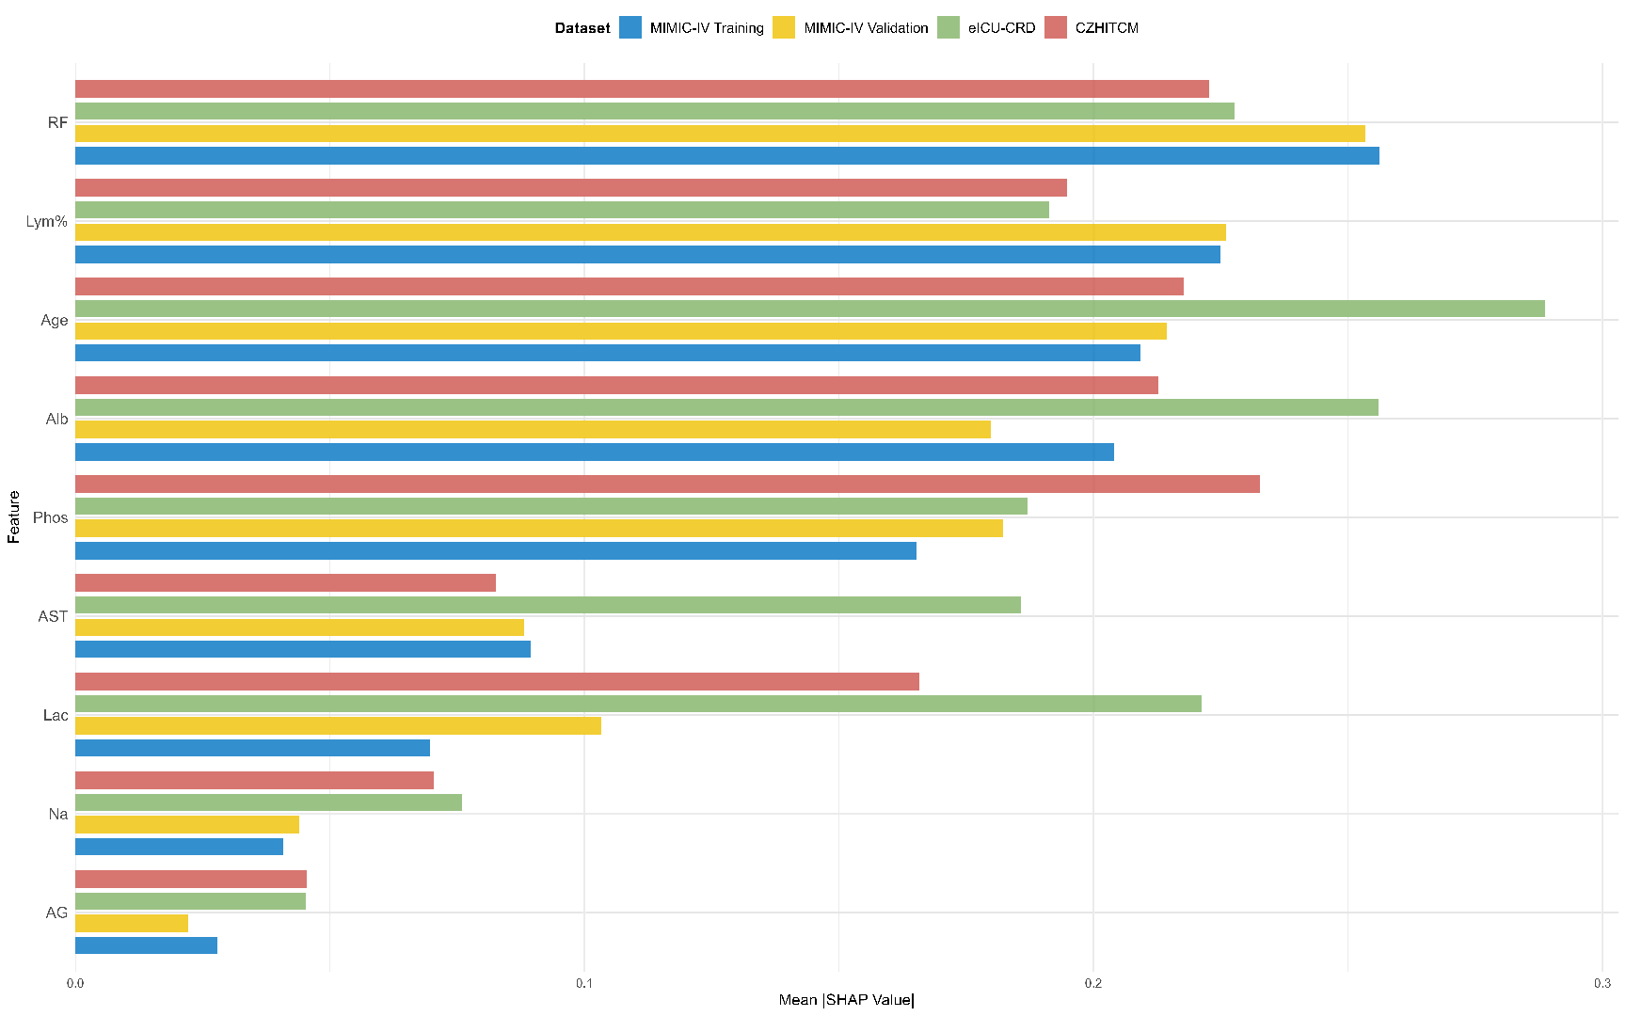

Fig S4 Correlation Analysis of Feature Importance Between MIMIC-IV Training Set and Other Datasets.
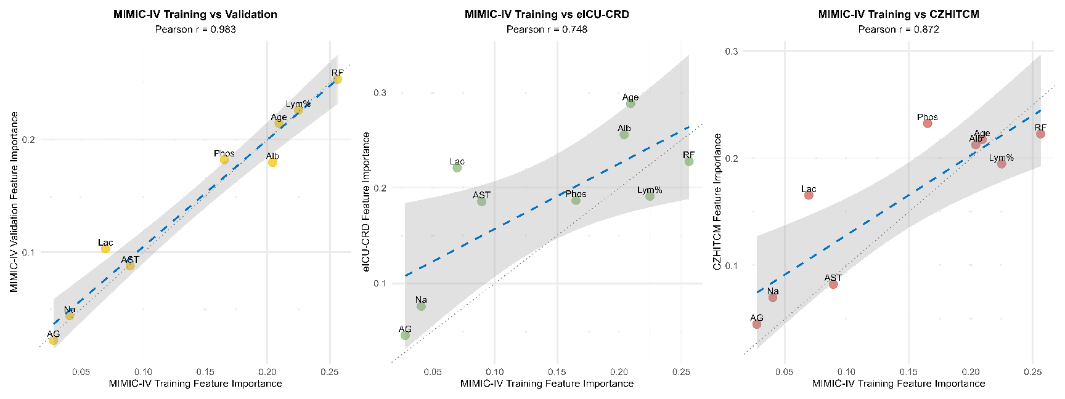
Note: A.Pearson r:Pearson correlation coefficient;B.gray areas indicate 95% confidence intervals.

