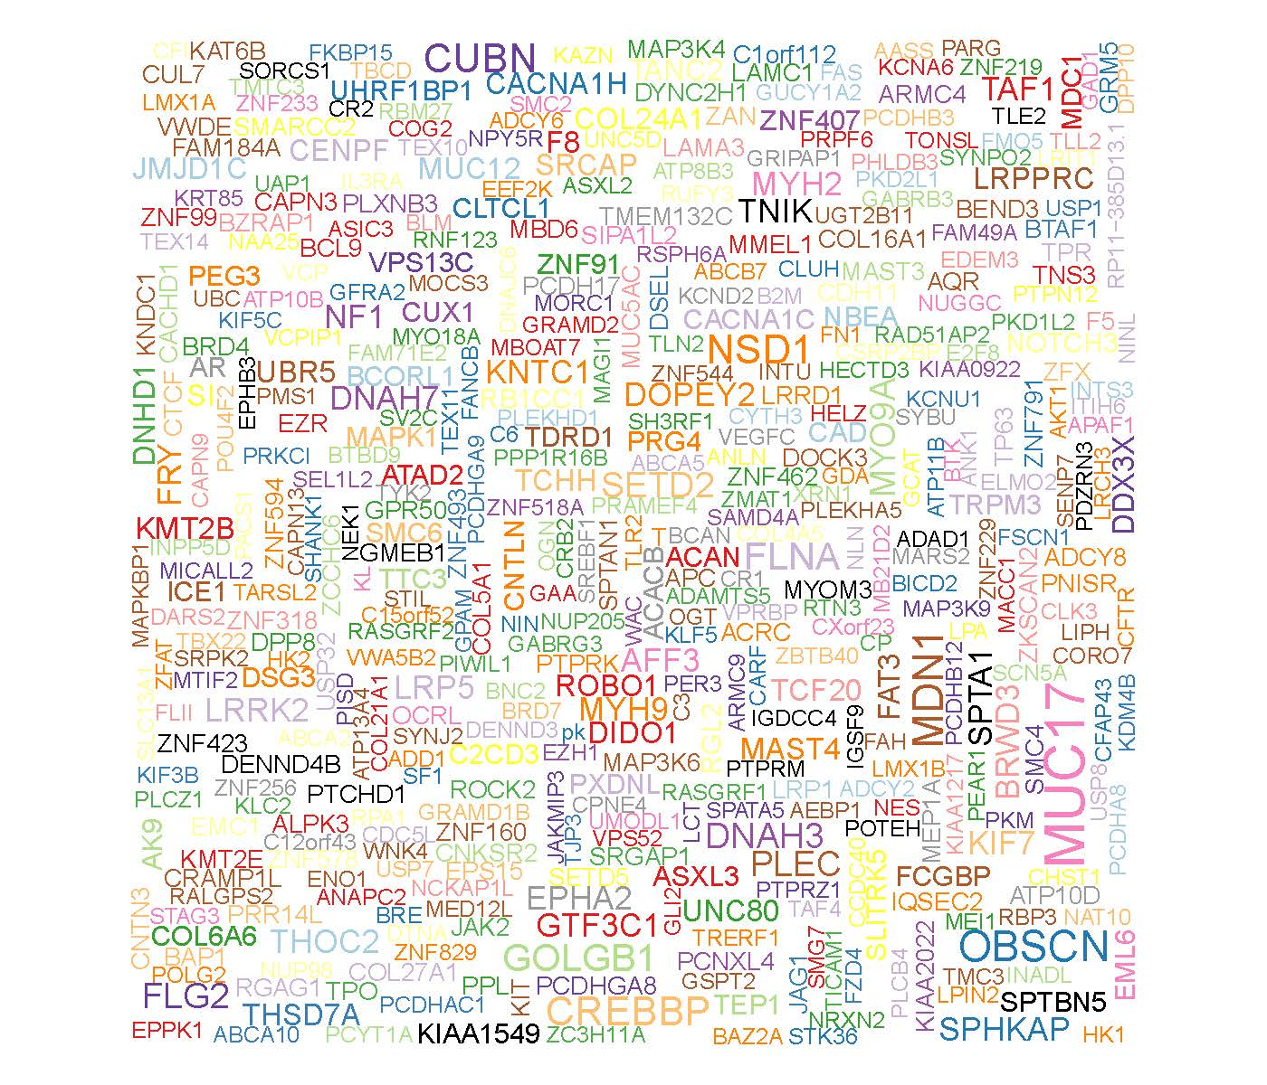
Fig. S1 Genecloud plot showed mutation information of genes in CSCC.

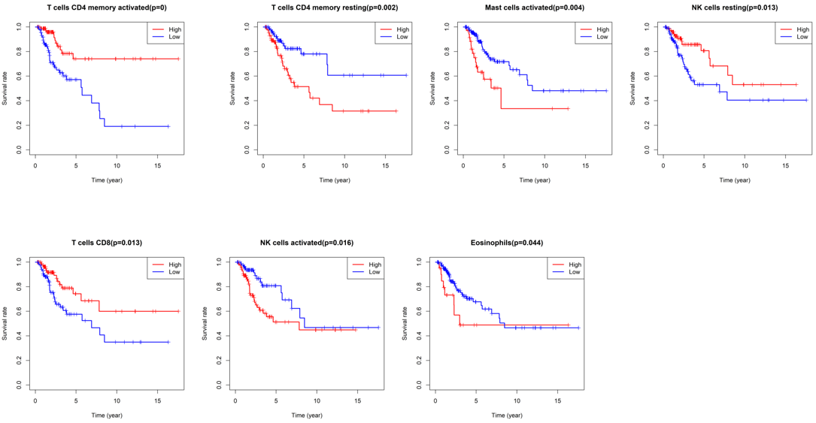
Fig. S2. The Kaplan-Meier survival curve of some significative immune cells in CSCC. Patients with high T cells CD4 memory activated, NK cells resting and T cells CD8 fraction had a higher overall survival whereas T cells CD4 memory resting, Mast cells activated, NK cells activated and Eosinophils were associated with poor prognosis.

