Phosphorus-assisted mitigation of arsenic stress and yield enhancement in rice grown in contaminated soil
Kavita Shukla¹, Saurabh Kumar Pathak¹, Swarnendra Banjerjee² and Sudhakar Srivastava^{1*}
¹Plant Stress Biology Laboratory, Institute of Environment and Sustainable Development (IESD), Banaras Hindu University, Varanasi (UP), India
²Academy of Biology and Medicine, Southern Federal University, Rostov-on-Don 100044, Russia; email: swarnendrab@gmail.com

*Correspondence to: Dr. Sudhakar Srivastava; sudhakar.iesd@bhu.ac.in

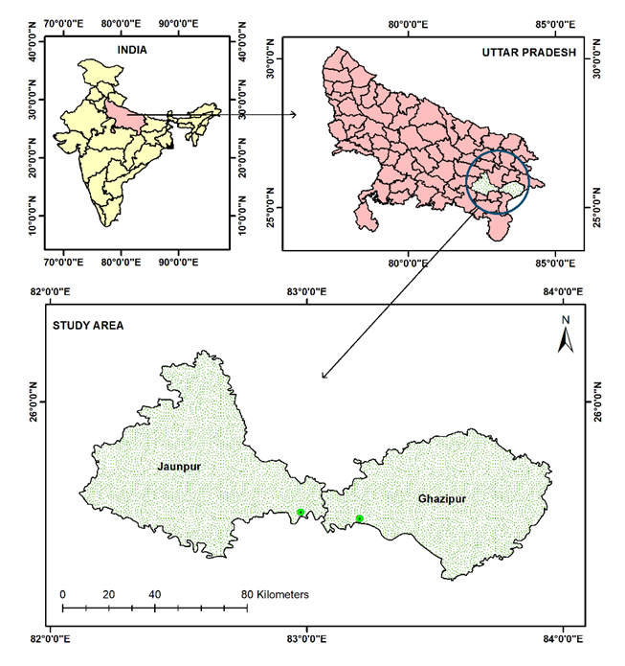
Figure S1: The map represents the selected contaminated field sites for the experiment.

Table S1: Physico-chemical properties of soil at Ghajipur site during transplantation and maturity stages.
 | Ghazipur
 | 1st Sampling (during transplantation ) |  |  |  |  |  | 2nd Sampling (heading phase)
Parameters | Control SK | P1 SK | P2 SK | Control DS | P1 DS | P2 DS | Control SK | P1 SK | P2 SK | Control DS | P1 DS | P2 DS
pH | 7.7±0.05 | 7.6±0.05 | 7.7±0.09 | 7.7±0.05 | 7.7±0.07 | 7.7±0.06 | 6.9±0.07 | 7.0±0.05 | 7.0±0.08 | 7.0±0.05 | 6.2±0.05 | 7.2±0.1
EC (µS) | 104±4.0 | 106±2.0 | 110±3.0 | 109±3 | 113±2 | 112±3.00 | 131±4.0 | 117±3.0 | 122±2.0 | 119±4.0 | 145±4.0 | 116±2.0
Organic carbon(%) | 1.18±0.2 | 1.2±0.1 | 1.2±0.2 | 1.12±03 | 0.89±0.1 | 0.97±0.21 | 1.2±0.3 | 1.1±0.2 | 1.0±0.3 | 0.98±0.21 | 1.3±0.3 | 1.12±0.3
Available phosphorus(kg h⁻¹ ) | 89.62±3.7 | 90.48±1.9 | 85.87±0.79 | 105±1.2 | 98±2.0 | 102±2.0 | 115±1.0 | 100±2.0 | 135±2.0 | 110±2.0 | 95±2.0 | 112±2.0
ORP | 158±4.0 | 167±3.0 | 155±3.0 | 145±2.0 | 162±3.0 | 159±3.0 | 197±2.0 | 165±3.0 | 162±2.0 | 187±3.0 | 174±2.0 | 165±2.0
Soil protease enzyme (µg tyrosine g⁻¹ dwt 2 h⁻¹ ) | 5.0±0.5 | 5.5±0.3 | 5.1±0.2 | 4.5±0.2 | 5.2±0.1 | 5.7±0.20 | 5.2±0.3 | 5.6±0.1 | 5.2±0.3 | 5.5±0.2 | 5.9±0.3 | 5.2±0.3
Soil Acidic MP (p-nitrophenol µg g⁻¹ dw h⁻¹) | 127±1.2 | 121±2.16 | 119±1.03 | 117±1.3 | 115±1.7 | 119±1.60 | 134±1.2 | 130±2.0 | 122±2.0 | 141±2.0 | 163±1.5 | 140±2.0
Soil AlkalineMP (p-nitrophenol µg g⁻¹ dw h⁻¹) | 139±1.5 | 137±2.0 | 132±1.8 | 137±2.0 | 135±1.5 | 140±2.01 | 125±1.5 | 122±1.3 | 131±2.0 | 125±1.5 | 129±1.3 | 134±2.0
Soil P (P2O5) (mg kg⁻¹) | 2450±1.2 | 2410±1.2 | 2550±1.2 | 2530±2.0 | 2510±1.5 | 2620±1.20 | 2930±2.0 | 2780±1.0 | 2970±1.5 | 2870±2.0 | 2650±2.0 | 2870±3
Soil As (mg kg⁻¹) | 17.3±0.03 | 17.3±0.02 | 17.63±0.02 | 17±0.02 | 17.2±0.2 | 17.2±0.31 | 15.0±0.1 | 14.5±0.2 | 15.8±0.2 | 15.7±0.3 | 15.5±0.2 | 16.5±0.2
Table S2: Physico-chemical properties of soil at Ghajipur site during transplantation and maturity stages.
 | Jaunpur
 | 1st Sampling (during transplantation) |  |  |  |  |  | 2nd Sampling (heading phase)
Parameters | Control SK | P1 SK | P2 SK | Control DS | P1 DS | P2 DS | Control SK | P1 SK | P2 SK | Control DS | P1 DS | P2 DS
pH | 8.2±0.02 | 8.5±0.05 | 8.3±0.05 | 8.4±0.05 | 8.7±0.07 | 8.5±0.06 | 7.5±0.05 | 7.8±0.06 | 7.5±0.06 | 6.9±0.05 | 6.5±0.06 | 7.6±0.06
EC (µS) | 110±4.0 | 116±2.0 | 121±3.0 | 109±3.0 | 103±2.0 | 117±3.0 | 143±4.0 | 137±3.0 | 142±2.0 | 131±4.0 | 154±4.0 | 130±2.0
Organic carbon (%) | 1.08±0.2 | 1.0±0.1 | 1.0±0.2 | 1.2±03 | 0.95±0.1 | 1.0±0.2 | 1.0±0.3 | 1.0±0.2 | 0.98±0.3 | 0.95±0.21 | 1.6±0.3 | 1.15±0.3
Available phosphorus (kg h⁻¹) | 96± 3.7 | 97±1.9 | 95±0.79 | 100±1.2 | 104±2.0 | 97±2.0 | 125±1.0 | 98±2.0 | 153±2.0 | 111±2.0 | 98±2.0 | 122±2.0
ORP | 145±4.0 | 156±3.0 | 165±3.0 | 155±2.0 | 152±3.0 | 163±3 | 169±2.0 | 185±3.0 | 152±2.0 | 173±3.0 | 177±2.0 | 165±2.0
Soil protease enzyme (µg tyrosine g⁻¹ dwt 2 h⁻¹) | 7±0.5 | 7.5±0.3 | 7.1±0.2 | 7.3±0.2 | 7.2±0.1 | 7.0±0.2 | 7.5±0.3 | 7.6±0.1 | 7.2±0.3 | 7.5±0.2 | 8.0±0.3 | 7.2±0.3
Soil Acidic MP (p-nitrophenol µg g⁻¹ dw h⁻¹) | 115±2.0 | 120±2.0 | 123±1.03 | 122±1.3 | 125±1.7 | 121±1.6 | 143±1.2 | 140±2.0 | 132±2.0 | 156±2.0 | 176±1.5 | 149±2.0
Soil Alkaline MP (p-nitrophenol µg g⁻¹ dw h⁻¹) | 143±1.5 | 141±2.0 | 142±1.8 | 139±2.0 | 141±1.5 | 146±2.0 | 122±1.5 | 109±1.3 | 129±2.0 | 127±1.5 | 131±1.3 | 137±2.0
Soil P (P2O5) (mg kg⁻¹) | 2470±1.2 | 2450±1.2 | 2560±1.2 | 2540±2.0 | 2560±1.5 | 2610±1.2 | 2890±2.0 | 2770±1.0 | 2890±1.5 | 2790±2.0 | 2595±2.0 | 2845±3.0
Soil As (mg kg⁻¹) | 16.5±0.03 | 16.5±0.02 | 16.7 ±0.02 | 16.1±0.02 | 16.5±0.2 | 16.2±0.3 | 14.5±0.1 | 14.3±0.2 | 14.5±0.2 | 15.9±0.3 | 14.8±0.2 | 15.5±0.2

