Supplementary Information

Mitigation benchmarks from the 2025 community update of global emissions pathways
Keywan Riahi*, Leon Clarke, Tomoko Hasegawa, Daniel Huppmann, Elmar Kriegler, Gunnar Luderer, Joeri Rogelj, Karl Scheifinger, Bas van Ruijven, Philipp Verpoort, et al.
* corresponding author: Keywan Riahi (riahi@iiasa.ac.at)
Table of Contents
1. Criteria for validation and feasibility/sustainability considerations 2
1.1 Validation and vetting for consistency with historic trends 2
1.2 Feasibility, near-term plausibility, and sustainability considerations 3
Hydropower capacity in 2030 4
Nuclear capacity in 2030 4
Total and onshore wind capacity in 2030 5
Solar capacity in 2030 5
Geological storage of CO2 removals in 2030, 2035, and 2040 6
Prudent limit for geological carbon storage 6
Bioenergy use 6
Food availability 7
2. SCI Warming Categorization 7
3. Updated Table SPM.2 – AR6 10
4. Scenarios meeting feasibility and sustainability considerations 11
5. Trade-offs in oil and gas consumption in global emissions scenarios 12
6. Updated scenario benchmarks 13
7. The SCI infrastructure 14
8. Overview of scenarios by model family and project 15
9. Supplementary References 16

Criteria for validation and feasibility/sustainability considerations
All scenarios included in the Scenario Compass database were subjected to a set of validation and vetting criteria and evaluated against a range of feasibility and sustainability considerations (see the Methodology section of the manuscript). This section provides the corresponding numerical values and their rationale.

1.1 Validation and vetting for consistency with historic trends
All scenarios were checked for consistency with global reference values for historical CO2 emissions from energy and industrial processes, total final energy consumption and primary energy consumption by fossil fuel and nuclear for the years 2010, 2015, 2020 and 2025, mostly with a tolerance of ±25%. Given that the COVID19 pandemic induced a decline in energy demand and emissions in 2020, both of which re-aligned with the long-term trend afterwards, a larger range of 40% was given in that year. Reference values for 2025 were extrapolated from the latest available statistical data.

Scenarios where at least one value is outside of the given range are marked with a meta-indicator “Vetting|SCI 2025: failed” in the database. Scenarios that do not report all of these variables are marked as “Vetting|SCI 2025: insufficient reporting” in the database. All benchmark indicators and the default dashboard view in the Scenario Compass Platform at https://scenariocompass.org only show scenarios that pass the vetting and include all the vetting variables in their reporting.

Table SI.1: Quality criteria for global emissions scenarios.
 | Reference value | Range | Pass | Fail | Not reported
Historical emissions data from CEDS 2025 (Hoesly et al., 2025)
CO2 emissions from energy  and industrial processes | 2010: 33460.1 Mt CO2/yr | ±25% | 1490 | - | 105
CO2 emissions from energy  and industrial processes | 2015: 35627.3 Mt CO2/yr | ±25% | 1544 | - | 51
CO2 emissions from energy  and industrial processes | 2020: 26540.25 - 46092.5 Mt CO2/yr | ±25% | 1590 | 1 | 4
CO2 emissions from energy  and industrial processes | 2025: 39383.5 Mt CO2/yr | ±25% | 1406 | 140 | 49
Historical energy balances from Energy Statistics Data Browser (IEA, 2025)
Final energy | 2010: 365.074 EJ/yr | ±25%,  except 2020: ±40% | 1476 | - | 119
Final energy | 2015: 389.56 EJ/yr | ±25%,  except 2020: ±40% | 1529 | - | 66
Final energy | 2020: 395.78 EJ/yr * | ±25%,  except 2020: ±40% | 1576 | - | 19
Final energy | 2025: 443.09 EJ/yr | ±25%,  except 2020: ±40% | 1511 | 20 | 64
Primary energy from coal | 2010: 153.51 EJ/yr | ±25%,  except 2020: ±40% | 1482 | - | 113
Primary energy from coal | 2015: 161.99 EJ/yr | ±25%,  except 2020: ±40% | 1535 | - | 60
Primary energy from coal | 2020: 160.00 EJ/yr | ±25%,  except 2020: ±40% | 1582 | 1 | 12
Primary energy from coal | 2025: 200.43 EJ/yr | ±25%,  except 2020: ±40% | 572 | 966 | 57
Primary energy from gas | 2010: 126.22 EJ/yr | ±25%,  except 2020: ±40% | 1482 | - | 113
Primary energy from gas | 2015: 138.32 EJ/yr | ±25%,  except 2020: ±40% | 1535 | - | 60
Primary energy from gas | 2020: 155.11 EJ/yr * | ±25%,  except 2020: ±40% | 1583 | - | 12
Primary energy from gas | 2025: 164.66 EJ/yr | ±25%,  except 2020: ±40% | 1387 | 151 | 57
Primary energy from oil | 2010: 167.72 EJ/yr | ±25%,  except 2020: ±40% | 1450 | 32 | 113
Primary energy from oil | 2015: 180.60 EJ/yr | ±25%,  except 2020: ±40% | 1513 | 22 | 60
Primary energy from oil | 2020: 173.40 EJ/yr * | ±25%,  except 2020: ±40% | 1583 | - | 12
Primary energy from oil | 2025: 197.75 EJ/yr | ±25%,  except 2020: ±40% | 1462 | 76 | 57
Primary energy from nuclear | 2010: 9.92 EJ/yr | ±25%,  except 2020: ±40% | 1466 | 16 | 113
Primary energy from nuclear | 2015: 9.25 EJ/yr | ±25%,  except 2020: ±40% | 1447 | 88 | 60
Primary energy from nuclear | 2020: 9.63 EJ/yr * | ±25%,  except 2020: ±40% | 1506 | 77 | 12
Primary energy from nuclear | 2025: 8.97 EJ/yr | ±25%,  except 2020: ±40% | 840 | 698 | 57

Feasibility, near-term plausibility, and sustainability considerations
All scenarios were assessed against feasibility and sustainability criteria. The objective was to facilitate the use of scenario information by flagging potentially questionable scenario outcomes.
The criteria are based on scientific literature and underwent open external review. For each criterion, the scenario metadata includes an indicator specifying whether the scenario raises feasibility or sustainability concerns. In addition to upper bounds on near-term developments identifying feasibility challenges, lower bounds were included to flag scenarios that are implausibly low in view of current capacities and near-term projections for wind and solar capacity additions (Weigmann et al., 2025).

Table SI.2: Feasibility and sustainability considerations.
 | Reference values/ Boundaries |  |  | Pass | Fail | Not reported
 | Level | Upper | Lower | Pass | Fail | Not reported
Feasibility considerations
Hydropower capacity in 2030 | Major | 2118 GW | 979 GW | 1232 | 71 | 292
Hydropower capacity in 2030 | Medium | 1607 GW | 1175 GW | 564 | 739 | 292
Nuclear capacity in 2030 | Major | 507 GW | - | 879 | 467 | 249
Nuclear capacity in 2030 | Medium | 442 GW | 320 GW | 452 | 894 | 249
Total wind capacity in 2030 | Major | - | 1220 GW | 1011 | 315 | 269
Total wind capacity in 2030 | Medium | - | 1719 GW | 672 | 654 | 269
Onshore wind capacity in 2030 | Major | 3655 GW | 1220 GW | 652 | 294 | 648
Onshore wind capacity in 2030 | Medium | 2853 GW | 1719 GW | 321 | 626 | 648
Solar capacity in 2030 | Major | 10896 GW | 2683 GW | 906 | 367 | 322
Solar capacity in 2030 | Medium | 8164 GW | 4350 GW | 252 | 1021 | 322
Geological storage of CO2  in 2030 | Major | 458 Mt CO2/yr | - | 1061 | 489 | 35
Geological storage of CO2  in 2030 | Medium | 152 Mt CO2/yr | 44 Mt CO2/yr | 184 | 1366 | 45
in 2035 | Medium | 1300 Mt CO2/yr | - | 986 | 519 | 90
in 2040 | Medium | 4300 Mt CO2/yr | - | 1293 | 257 | 45
Sustainability considerations
Prudent limit for geological carbon storage | Major | 1460 Gt CO2 | - | 1476 | 37 | 82
Prudent limit for geological carbon storage | Medium | 1290 Gt CO2 | - | 1443 | 70 | 82
Bioenergy use | Major | 245 EJ/yr | - | 1322 | 256 | 17
Bioenergy use | Medium | 100 EJ/yr | - | 300 | 1278 | 17
Food availability | Medium | 5000 kcal/cap/day | 2100 kcal/cap/day | 557 | 19 | 1019

Hydropower capacity in 2030
{Database meta-indicator: Feasibility Concern|Hydropower Capacity|World|2030}
Background: Near-term upper and lower capacity projections were derived from existing capacities and from current project announcements and typical project lead times. Robust upper projections take into account that projects require least 5 years to plan and construct and therefore will not be in operation by 2030 if not yet announced by 2025. Robust lower projections can be made based on existing capacities, while assuming retirement rates are low.
Specifically, hydropower plants take 4–7 years for medium-sized projects and up to 15 years for large projects to plan and construct. Small projects that can be completed within less than 4 years make up less than 3% of all projects planned globally in 2021.

For details on hydropower projects, see the Hydropower Special Market Report (IEA, 2021).

Data: Data on hydro power plant projects was published by the IEA in 2021. Details can be found here: https://www.iea.org/data-and-statistics/data-tools/hydropower-data-explorer

The IEA publishes capacities in three categories:
- Capacity operational in 2021
- Capacity expected to be online by 2030
- Capacity that could come online by 2030 given accelerated efforts

Based on this data, we assume the following global thresholds for 2030:
- Lower threshold, major concern: 10% less than operational
- Lower threshold, medium concern: 5% less than expected
- Upper threshold, medium concern: 5% more than expected under accelerated efforts
- Upper threshold, major concern: 45% more than expected under accelerated efforts.

Nuclear capacity in 2030
{Feasibility Concern|Nuclear Capacity|World|2030}
Background: Near-term upper and lower capacity projections were derived from existing capacities and from current project announcements and typical project lead times. Robust upper projections take into account that projects require at least 5 years to plan and construct and therefore will not be operational by 2030 if not yet announced by today. Robust lower projections can be made based on existing capacities, while assuming that retirement rates are low.

Data: Data on nuclear power plant projects was published by the International Atomic Energy Agency in 2021 (IAEA, 2024).

The IAEA publishes capacities in three categories:
- Capacity operational in 2024
- Capacity currently under construction
- Inactive capacity that has been retired

Based on this data, we assume the following global thresholds for 2030:
- Lower threshold, major concern: 30% less than operational
- Lower threshold, medium concern: 15% less than operational
- Upper threshold, medium concern: 5% more than operational plus bringing retired plants in Japan back online plus 75% of plants under construction
- Upper threshold, major concern: 10% more than the highest estimate published by the IAEA (461 GW).

Total and onshore wind capacity in 2030
{Feasibility Concern|Wind Capacity|World|2030, Feasibility Concern|Onshore Wind Capacity|World|2030}

Background: This technology is available at scale and has short project lead times, meaning that there are no fundamental obstacles to fast deployment. Yet its near-term growth can be estimated based on today's market dynamics. While these estimates have their limitations, they can be used to set broad ranges of near-term feasibility.

Data: Existing onshore wind capacities in 2022 are reported by Ember (2024). Yearly additions for 2023–2028 are estimated in a market outlook by the GWEC (2024). This outlook is based on input from regional wind associations, government targets, tender results, announced auction plans, available project pipeline, and input from industry experts.

Based on this data, we assume the following global thresholds for onshore wind production in 2030:

- Lower threshold, major concern: 10% less than existing capacities plus 37.5% of market outlook
- Lower threshold, medium concern: 5% less than existing capacities plus 75% (globally) or 37.5% (regionally) of market outlook
- Upper threshold, medium concern: 5% more than existing capacities plus 150% (globally) or 200% (regionally) of market outlook
- Upper threshold, major concern: 10% more than existing capacities plus 200% of market outlook

We assume that total wind capacity must be at least as large as onshore wind to have a reasonable bound on total installed wind capacity.

Solar capacity in 2030
{Feasibility Concern|Solar PV Capacity|World|2030}
Background: This technology is available at scale and has short project lead times, meaning that there are no fundamental obstacles to fast deployment. Yet, its near-term growth can be estimated based on today's market dynamics. While these estimates have their limitations, they can be used to set broad ranges of near-term feasibility.

Data: Existing capacities in 2023 are reported by Ember (2024). Yearly additions for 2024–2030 are estimated in a market outlook by BNEF (2024).

Based on this data, we assume the following global thresholds for 2030:

- Lower threshold, major concern: 10% less than existing capacities plus 37.5% of market outlook
- Lower threshold, medium concern: 5% less than existing capacities plus 75% of market outlook
- Upper threshold, medium concern: 5% more than existing capacities plus 150% of market outlook
- Upper threshold, major concern: 10% more than existing capacities plus 200% of market outlook

Geological storage of CO2 removals in 2030, 2035, and 2040
{Feasibility Concern|Carbon Capture|World|2030, or 2035, or 2040}
Background: Near-term upper and lower capacity projections can be derived from existing capacities and from current project announcements and known project lead times. Robust upper projections take into account that projects take at least 5 years to plan and construct and therefore will not be operational by 2030 if not yet announced by today. Robust lower projections can be made based on existing capacities and because retirement rates can be assumed to be low.

Data: CCU/S projects are tracked by the IEA and published annually in its CCUS Database (IEA, 2024).

Projects in the CCUS database have one of the following statuses:
- Capacity operational in 2024
- Capacity under construction
- Capacity announced but without final investment decision in 2024

Based on this data, we assume the following global thresholds for 2030:
- Lower threshold, medium concern: 5% less than operational and 50% of projects under construction
- Upper threshold, medium concern: 5% more than operational plus all projects under construction plus 20% of projects planned without FID
- Upper threshold, major concern: 10% more than all projects operational, under construction, and announced.

Note: Because the variable "Carbon Capture" was not consistently reported directly in legacy projects, the criteria are also applied to "Carbon Capture|Geological Storage", which was reported as "Carbon Capture|CCS" in the AR6 database.

Prudent limit for geological carbon storage
{Sustainability Concern|Exceeding Prudent Limit For Geological Carbon Storage|World}
Some scenarios rely strongly on the use of carbon capture and sequestration (CCS). We use geological carbon storage volumes that exceed prudent technical and sustainability limits as upper bounds as quantified by Gidden et al (2025).
- Upper threshold, major concern: exceeding cumulative CCS of 1,460 Gt CO2 until the end of the century, which was identified as the median of the range when combining spatial risk layers.
- Upper threshold, medium concern: exceeding cumulative CCS of 1,290 Gt CO2 until the end of the century, which was identified as the lower bound of the range when combining spatial risk layers.

Bioenergy use
{Sustainability Concern|Unsustainable Bioenergy Use|World}
Background: Bioenergy is primarily generated by burning 2nd generation bioenergy crops, crop and forestry residues, municipal solid waste bioenergy and traditional biomass. Bioenergy can be a drop-in replacement for currently used fossil fuels. Bio-based energy crops can be grown at low cost with readily available technologies, and their lifecycle can be GHG-neutral when grown sustainably.

Owing to its technological maturity and mitigation potential, some decarbonization scenarios assume extensive usage of bioenergy. However, large-scale bioenergy deployment can result in production practices that are no longer GHG-neutral over their life cycle (e.g. through deforestation to expand land for energy crops), or in loss of natural habitats, which raises other sustainability concerns such as biodiversity loss.

Data: Multiple studies assess sustainability limits of bioenergy usage. Creutzig (2015) derived an upper limit for sustainable biomass use of 100–300 EJ/yr. Haberl et al (2010) estimate that the global bio-energy potential in 2050 ranges between 160 –270 EJ/yr. Another study by Deprez (2024) suggests that medium sustainability risks arise at a bioenergy usage above 50 EJ/yr and high risks at above 120 EJ/yr. In the 6th Assessment Report of Working Group 3 of the Intergovernmental Panel on Climate Change (IPCC), 245 EJ/yr is defined as the upper limit of a biomass-based bioenergy production that does not impede food security and environmental considerations (IPCC, 2022).

Based on those studies, we assume the following global thresholds for bioenergy use:
- Lower threshold, major concern: 245 EJ/yr
- Lower threshold, medium concern: 100 EJ/yr

Food availability
{Sustainability Concern|Food Availability|World}
Background: The variable “food availability per capita” represents food consumption in global emissions scenarios. Food consumption is inherently constrained by biological limits of human dietary requirements. However, some scenarios assume future food availability far above or below these nutritional needs. This is problematic because food availability below nutritional needs implies a risk of hunger, whereas food availability above nutritional needs implies unhealthy overconsumption.

Data: According to the Food and Agriculture Organization of the United Nations (FAO) (2020), the Minimum Dietary Energy Requirement is 2,100 kcal per person per day, calculated as the intake level of 1,840 kcal/person/day plus about 10% for non-edible portions. In contrast, the historically highest level of food consumption recorded is 4,000 kcal per person per day.

Based on this data, we assume the following global thresholds:
- Lower threshold, medium concern: 2100 kcal per person per day
- Upper threshold, medium concern: 5000 kcal per person per day

SCI Warming Categorization
Climate responses and emission trajectories are important characteristics of long-term global emissions scenarios.

In light of the updated scenario ensemble and the resulting changes in warming outcomes, we propose a new SCI warming categorization. This framework builds on the warming categorizations used in SR1.5 and AR6, while improving the users’ understanding of the climatic implications of scenarios.

The main categories of the new SCI framework are defined by peak warming, specified as the highest global mean temperature reached in a given emissions scenario. These categories are further subdivided based on global warming trends at the end of the 21st century. Scenarios in which the mean global warming decreases between 2090 and 2100 are labelled DEC (for declining), whereas scenarios in which the mean global warming continues to increase over this period are labelled Non-DEC. This distinction is important, because Non-DEC scenarios carry a higher risk of moving to a higher warming category in the 22nd century.

The assessment of both peak and end-of-century warming is based on median values (PW₅₀ and EoCW₅₀ respectively). The only exception is the GW3 category (“Likely below 2°C”), which is based on a 67% probability of remaining below 2°C (PW₆₇) to maintain continuity with previous warming categorizations.

To inform policy discussions, the SCI warming categorization clearly distinguishes Paris-aligned and non-Paris aligned emissions scenarios. At the same time, the granular sub-categories allow users to construct alternative groupings as needed.

Overall, the SCI categorization maps well onto the AR6 climate categorization while providing additional information and sharper differentiation between categories. This improvement is most evident in GW3a category, which previously corresponded to the upper range of the C2 category.

Table SI.3: PW = Peak warming, EoCW = End of Century warming, DEC = Decreasing temperature at End of Century, NZ = Net-zero GHGs, IMM = short-term warming is constrained by long-term warming limits, TT30 = short-term warming is constraint by near-term trends and targets
Main Category label | Category  sub-label | Peak Warming (PW) | Warming at the end of the century  (EoCW) | Emissions characteristics  NZ= Net zero  NoNZ = Not net zero | Similar category in the IPCC AR6 (C1-C8)
GW0  Below 1.5°C with no overshoot | GW0-I:  1.5°C without overshoot | PW₅₀ < 1.5°C | EoCW₅₀<1.5°C  All scenarios expected to be DEC | NZ  All scenarios expected to be IMM | C0
GW0  Below 1.5°C with no overshoot | GW0-II:  1.5°C without overshoot | PW₅₀ < 1.5°C | EoCW₅₀<1.5°C  DEC | NoNZ  All scenarios expected to be IMM | C0
GW1  Below 1.6°C returning to 1.5°C | GW1-I:  1.5°C with limited overshoot | PW₅₀ < 1.6°C | EoCW₅₀<1.5°C  All scenarios expected to be DEC | NZ  All scenarios expected to be IMM | C1
GW1  Below 1.6°C returning to 1.5°C | GW1-II:  1.5°C with limited overshoot | PW₅₀ < 1.6°C | EoCW₅₀<1.5°C | NoNZ  All scenarios expected to be IMM | C1
GW2a  Below 1.7°C returning to 1.5°C | GW2-I:  1.7°C with no overshoot, likely returning to 1.5°C | PW₅₀ < 1.7°C | EoCW₆₇<1.5°C  All scenarios expected to be DEC | All scenarios expected to be IMM+NZ | lower part C2
GW2a  Below 1.7°C returning to 1.5°C | GW2-II:  1.7°C with no overshoot, returning to 1.5°C with 50% chance | PW₅₀ < 1.7°C | EoCW₅₀<1.5°C All scenarios expected to be DEC | All scenarios expected to be IMM+NZ | Lower-to- middle part of C2
GW2b  Below 1.7°C without returning to 1.5°C | GW2-IIIa:  Towards 1.5°C after 2100 with high overshoot | PW₅₀ < 1.7°C | EoCW₅₀<1.7°C  All scenarios expected to be DEC | NZ  All scenarios expected to be IMM | N/A
GW2b  Below 1.7°C without returning to 1.5°C | GW2-IIIb:  Towards 1.5°C after 2100 with high overshoot | PW₅₀ < 1.7°C | EoCW₅₀<1.7°C  DEC | NoNZ  All scenarios expected to be IMM | N/A
GW2b  Below 1.7°C without returning to 1.5°C | GW2-IIIc:  Towards 1.5°C after 2100 with high overshoot | PW₅₀ < 1.7°C | EoCW₅₀<1.7°C  NoDEC | All scenarios expected to be IMM+NoNZ | N/A
GW3a  Likely below 2°C returning to 1.5°C | GW3-I:  Likely 2°C returning to 1.5°C | PW₆₇ < 2°C | EoCW₅₀<1.5°C  All scenarios expected to be DEC | IMM vs. TT30  All scenarios expected to be NZ | Upper part C2
GW3b  Likely below 2°C without returning to 1.5°C | GW3-IIa:  Likely below 2°C | PW₆₇ < 2°C | EoCW₆₇<2°C  All scenarios expected to be DEC | NZ  IMM vs. TT30 | C3
GW3b  Likely below 2°C without returning to 1.5°C | GW3-IIb:  Likely below 2°C | PW₆₇ < 2°C | EoCW₆₇<2°C  DEC | NoNZ  IMM vs. TT30 | C3
GW3b  Likely below 2°C without returning to 1.5°C | GW3-IIc:  Below 2°C until 2100 with continuing warming | PW₆₇ < 2°C | EoCW₆₇<2°C  NoDEC | IMM vs. TT30  All scenarios expected to be NoNZ | N/A
GW4  Below 2°C | GW4-I:  Below 2°C with efforts to return warming to lower levels in 22nd century | PW₅₀ < 2°C | EoCW₅₀<1.7°C  All scenarios expected to be DEC | All scenarios expected to be NZ. Near term policy assumptions not relevant in this class. | Lower part C4
GW4  Below 2°C | GW4-IIa:  Below 2°C | PW₅₀ < 2°C | EoCW₅₀<2°C  All scenarios expected to be DEC | NZ  Near term: see above | Mid- to upper part C4
GW4  Below 2°C | GW4-IIb:  Below 2°C | PW₅₀ < 2°C | EoCW₅₀<2°C  DEC | NoNZ  Near term: see above | Upper part C4
GW4  Below 2°C | GW4-IIc:  Below 2°C by 2100 with continuing warming | PW₅₀ < 2°C | EoCW₅₀<2°C  NoDEC | All scenarios expected to be NoNZ  Near term: see above | Upper part C4
GW5  Below 2.5°C | GW5-I:  Below 2.5°C | PW₅₀ < 2.5°C | EoCW₅₀<2.5°C  DEC | Net zero and near term policy assumptions not relevant in this class. | C5
GW5  Below 2.5°C | GW5-II:  Below 2.5°C by 2100 with continuing warming | PW₅₀ < 2.5°C | EoCW₅₀<2.5°C  NoDEC | See above | C5
GW6  Below 3.0°C | Below 3°C by 2100 | PW₅₀ < 3°C | EoCW₅₀<3°C  DEC vs. NoDEC not needed, most scenarios will be warming in 2100 | See above | C6
GW7  Below 3.5°C | Below 3.5°C with 50% chance | PW₅₀ < 3.5°C | EoCW₅₀<3.5°C  See above | See above | Lower part of C7
GW8  Above 3.5°C | Above 3.5°C by 2100 | PW₅₀ ≥ 3.5°C | EoCW₅₀ ≥ 3.5°C  See above | See above | Upper part of C7+C8

Updated Table SPM.2 – AR6
Table SI.4: Key characteristics of modelled global emissions pathways. Summary of projected CO2 and GHG emissions, projected net zero timings and the resulting global warming outcomes. Pathways are categorised (rows), according to their likelihood of limiting warming to different peak warming levels (if peak temperature occurs before 2100) and 2100 warming levels. Values shown are for the median [p50] and 5th–95th percentiles [p5–p95], noting that not all pathways achieve net zero CO2 or GHGs.

Scenarios meeting feasibility and sustainability considerations

Table SI.5: Key characteristics of modelled global emissions pathways that meet feasibility and sustainability considerations. Summary of projected CO2 and GHG emissions, projected net zero timings and the resulting global warming outcomes. Pathways are categorised (rows), according to their likelihood of limiting warming to different peak warming levels (if peak temperature occurs before 2100) and 2100 warming levels. Values shown are for the median [p50] and 5th–95th percentiles [p5–p95], noting that not all pathways achieve net zero CO2 or GHGs.

Trade-offs in oil and gas consumption in global emissions scenarios
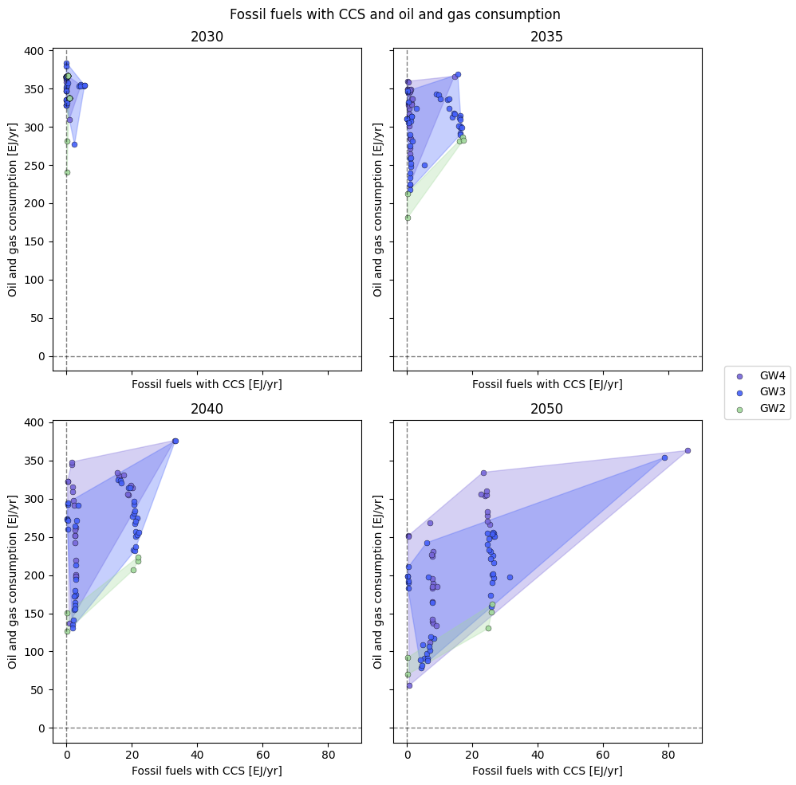
Scenario benchmarks require careful interpretation. In particular, upper and lower bounds across benchmarks cannot be interpreted jointly. It is therefore invalid to define “idealized” scenarios that simultaneously lie at the extremes of multiple benchmarks for decision-making. Figure SI.1 illustrates the trade-offs across benchmarks using deployment of carbon capture and storage (CCS) and oil and gas consumption as an example: within a given climate category, scenarios with relatively higher oil and gas consumption are associated with relatively higher usage of CCS.

Figure SI.1: Comparison of CCS deployment and oil and gas consumption for 2030, 2035, 2040, and 2050 across sustainable and feasible scenarios in GW2, GW3, and GW4 climate categories.

Updated scenario benchmarks
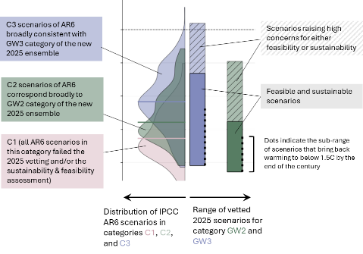
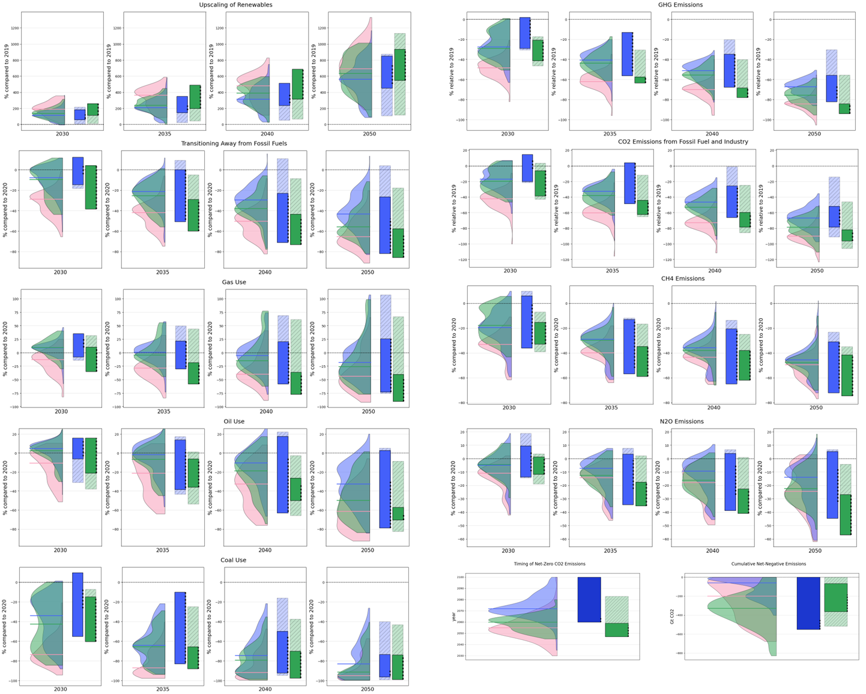
Figure SI. 2: Scenario characteristics and benchmarks for the years 2030, 2035, 2040, and 2050. The scenario distribution from the IPCC AR6 is compared to the sustainable and feasible benchmark ranges of the new 2025 ensemble.

The SCI infrastructure

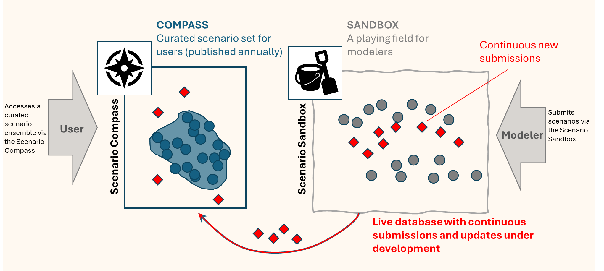
Figure SI.3: The SCI infrastructure. Modelers upload their scenarios via the Scenario Sandbox, and users interact with up-to-date scenario information via the Scenario Compass interface. Modelers can continuously submit new scenarios to the Scenario Sandbox and subsequently release them to the Scenario Compass as soon as the scenarios are featured in a published study.
.

Overview of scenarios by model family and project
Table SI.6: Number of scenarios by model family and project. Scenarios assessed in the IPCC Sixth Assessment Report (AR6) are grouped under “AR6”. Scenarios published since AR6 and submitted to the SCI are grouped by study or project.
Model Family | AR6 Ensemble  or New Project/Study | Submitted Scenarios | Scenarios that passed the SCI 2025 Vetting
AIM | AR6 | 71 | 2
AIM | ENGAGE [Horizon 2020] | 10 | 0
AIM | GEO7 [UNEP] | 1 | 0
C-ROADS | AR6 | 6 | 0
CGEM-ESM | China-NZP [NSFC] | 1 | 0
COFFEE | AR6 | 65 | 0
COFFEE | ENGAGE [Horizon 2020] | 14 | 0
COFFEE | NAVIGATE [Horizon 2020] | 21 | 0
EPPA | AR6 | 7 | 0
GCAM | AR6 | 67 | 10
GCAM | IAM COMPACT [Horizon Europe] | 3 | 0
GCAM | NGFS Phase 5 | 7 | 7
GEM-E3 | AR6 | 41 | 0
GEM-E3 | ENGAGE [Horizon 2020] | 17 | 0
IMACLIM | NAVIGATE [Horizon 2020] | 17 | 0
IMACLIM | PRISMA [Horizon Europe] | 5 | 0
IMAGE | AR6 | 143 | 60
IMAGE | ECEMF [Horizon 2020] | 2 | 1
IMAGE | ENGAGE [Horizon 2020] | 12 | 0
IMAGE | GEO7 [UNEP] | 2 | 0
IMAGE | NAVIGATE [Horizon 2020] | 15 | 8
IMAGE | SHAPE [JPI Climate] | 12 | 0
MERGE-ETL | AR6 | 1 | 0
MESSAGEix and MESSAGEix-GLOBIOM | AR6 | 268 | 8
MESSAGEix and MESSAGEix-GLOBIOM | ECEMF [Horizon 2020] | 2 | 0
MESSAGEix and MESSAGEix-GLOBIOM | ENGAGE [Horizon 2020] | 20 | 0
MESSAGEix and MESSAGEix-GLOBIOM | GENIE [European Research Council] | 21 | 0
MESSAGEix and MESSAGEix-GLOBIOM | NAVIGATE [Horizon 2020] | 12 | 10
MESSAGEix and MESSAGEix-GLOBIOM | NGFS Phase 5 | 7 | 7
MESSAGEix and MESSAGEix-GLOBIOM | SHAPE [JPI Climate] | 4 | 0
MINES | China-NZP [NSFC] | 1 | 0
POLES | AR6 | 114 | 65
POLES | ENGAGE [Horizon 2020] | 9 | 0
PROMETHEUS | ECEMF [Horizon 2020] | 2 | 0
PROMETHEUS | IAM COMPACT [Horizon Europe] | 3 | 0
PROMETHEUS | NAVIGATE [Horizon 2020] | 15 | 0
REMIND and REMIND-MAgPIE | AR6 | 297 | 51
REMIND and REMIND-MAgPIE | ECEMF [Horizon 2020] | 2 | 1
REMIND and REMIND-MAgPIE | ENGAGE [Horizon 2020] | 20 | 0
REMIND and REMIND-MAgPIE | NAVIGATE [Horizon 2020] | 15 | 0
REMIND and REMIND-MAgPIE | NGFS Phase 5 | 7 | 7
REMIND and REMIND-MAgPIE | RESCUE [Horizon Europe] | 8 | 6
REMIND and REMIND-MAgPIE | Rescuing 1.5°C [IKEA Foundation] | 1 | 1
REMIND and REMIND-MAgPIE | SHAPE [JPI Climate] | 12 | 2
TIAM-ECN | AR6 | 45 | 45
TIAM-ECN | ECEMF [Horizon 2020] | 2 | 0
WITCH | AR6 | 131 | 52
WITCH | ECEMF [Horizon 2020] | 2 | 0
WITCH | ENGAGE [Horizon 2020] | 20 | 0
WITCH | NAVIGATE [Horizon 2020] | 15 | 4
Total |  | 1595 | 347

Supplementary References
BloombergNEF. (2024). 3Q 2024 Global PV Market Outlook. BloombergNEF. https://about.bnef.com/blog/3q-2024-global-pv-market-outlook
Creutzig, F., Ravindranath, N. H., Berndes, G., Bolwig, S., Bright, R., Cherubini, F., Chum, H., Corbera, E., Delucchi, M., Faaij, A., Fargione, J., Haberl, H., Heath, G., Lucon, O., Plevin, R., Popp, A., Robledo‐Abad, C., Rose, S., Smith, P., … Masera, O. (2015). Bioenergy and climate change mitigation: An assessment. GCB Bioenergy, 7(5), 916–944. https://doi.org/10.1111/gcbb.12205
Deprez, A., Leadley, P., Dooley, K., Williamson, P., Cramer, W., Gattuso, J.-P., Rankovic, A., Carlson, E. L., & Creutzig, F. (2024). Sustainability limits needed for CO2 removal. Science, 383(6682), 484–486. https://doi.org/10.1126/science.adj6171
Ember. (2024). Yearly Electricity Data [Dataset]. https://ember-energy.org/data/yearly-electricity-data
FAO. (2020). Global Forest Resources Assessment. Food and Agriculture Organization of the United Nations. https://doi.org/10.4060/ca9825en
Gidden, M. J., Joshi, S., Armitage, J. J., Christ, A.-B., Boettcher, M., Brutschin, E., Köberle, A. C., Riahi, K., Schellnhuber, H. J., Schleussner, C.-F., & Rogelj, J. (2025). A prudent planetary limit for geologic carbon storage. Nature, 645(8079), 124–132. https://doi.org/10.1038/s41586-025-09423-y
Global Wind Energy Council. (2024). Global Wind Report 2024. Global Wind Energy Council. https://www.gwec.net/reports/globalwindreport
Haberl, H., Beringer, T., Bhattacharya, S. C., Erb, K.-H., & Hoogwijk, M. (2010). The global technical potential of bio-energy in 2050 considering sustainability constraints. Current Opinion in Environmental Sustainability, 2(5–6), 394–403. https://doi.org/10.1016/j.cosust.2010.10.007
Hoesly, R., Smith, S. J., Ahsan, H., Prime, N., O’Rourke, P., Crippa, M., Klimont, Z., Guizzardi, D., Feng, L., Harkins, C., MCDONALD, B., & Wang, S. (2025). CEDS v_2025_03_18 Aggregate Data (Version v_2025_03_18) [Dataset]. Zenodo. https://doi.org/10.5281/ZENODO.15059443
IAEA. (2024). Energy, Electricity and Nuclear Power Estimates for the Period up to 2050 (No. 1; 44th ed., Reference Data Series). International Atomic Energy Agency. https://doi.org/10.61092/iaea.e3qb-hsrr
IEA. (2021). Hydropower Special Market Report. IEA. https://www.iea.org/reports/hydropower-special-market-report
IEA. (2024). CCUS Projects Database. International Energy Agency. https://www.iea.org/data-and-statistics/data-product/ccus-projects-database
IEA. (2025). World Energy Balances [Dataset]. https://www.iea.org/data-and-statistics/data-product/world-energy-balances
IPCC. (2022). Climate Change 2022 - Mitigation of Climate Change: Working Group III Contribution to the Sixth Assessment Report of the Intergovernmental Panel on Climate Change. Cambridge University Press. https://doi.org/10.1017/9781009157926
Weigmann, P., Mandaroux, R., Lécuyer, F., Merfort, A., Dorndorf, T., Hoppe, J., Muessel, J., Pietzcker, R., Richters, O., Baumstark, L., Kriegler, E., Bauer, N., Benke, F., Gong, C. C., & Luderer, G. (2025). Validation of climate mitigation pathways. Geoscientific Model Development, 18(23), 9897–9912. https://doi.org/10.5194/gmd-18-9897-2025

26540.25 Mt CO2/yr is the actual value with 25% tolerance, 46092.5 Mt CO2/yr is the interpolated value with 25% tolerance, averaged from 2018-2022 to account for the COVID19 pandemic recession and recovery. The upper bound of the range was computed from the interpolated value, the lower bound was computed from the actual data. * Value averaged from 2018-2022 to account for the COVID19 pandemic.

