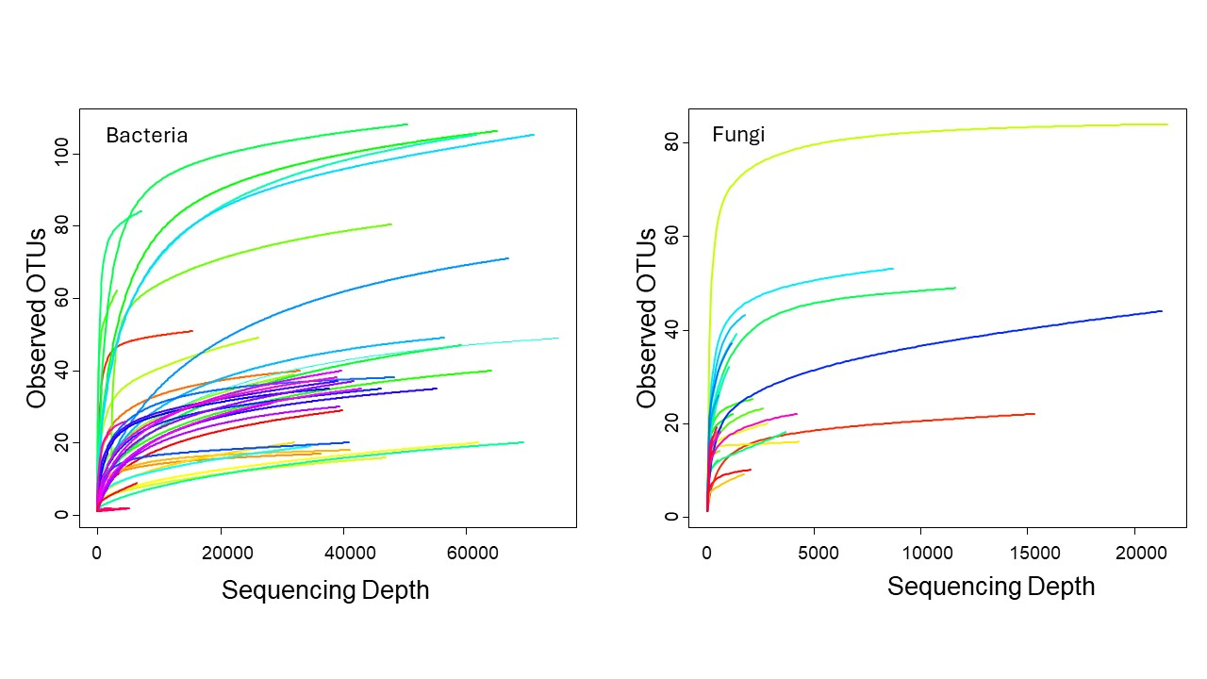
Figure S1. Rarefaction curves of bacterial and fungal communities. Rarefaction plots show the accumulation of observed OTUs with increasing sequencing depth for bacteria (16S rRNA gene; left) and fungi (ITS; right). Each coloured curve represents an individual sample. Curves approaching a plateau indicate that additional sequencing would yield relatively few new OTUs, whereas non-plateauing curves suggest incomplete sampling of richness in some samples.

