Supplementary Information
The continuous and changing impact of affect on risky decision-making

Monetary gambles
The monetary gambles were generated individually. The possible outcomes of a given gamble are selected randomly from a normal distribution (mean = 0SEK, sd = 18SEK; 1SEK ~ $0.1) and rounded to the nearest 5 SEK (e.g., 13.4 ~ 15; and -7.9 ~ -10). Additionally, the following limitations were applied: (1) the maximum possible loss or gain will not exceed 75 SEK, (2) all four possible outcomes of a given gamble will be different, (3) ‘0 SEK’ will not be a possible outcome for a given gamble, and (4) the expected value of any gamble will not exceed ±25 SEK. When generated in this way, expected values come from a normal distribution with 0 SEK mean and 10 SEK standard deviation (Figure S1).
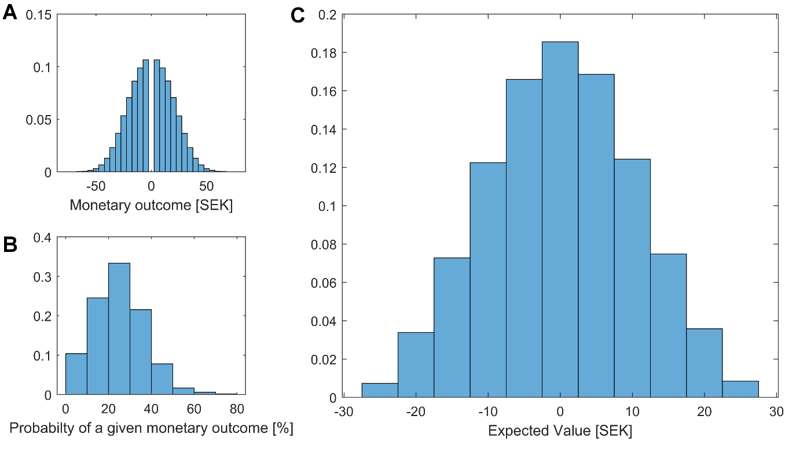
Figure S1. The distribution of monetary outcomes (A) and their probabilities (B). The monetary outcomes and probabilities are matched randomly. Each gamble has four possible outcomes. Panel C shows the distribution of expected value of gambles.

Model parametrizations

Affective experience model
Individual-level parameters were drawn from group-level normal distributions. Additionally, we used a non-centered parametrization to speed up estimation (Ahn et al., 2017; Stan Development Team, 2018). All the weight parameters were parameterized as follows:
 | $$μ_{w} \sim Normal\left(0, 1\right)$$  $$σ_{w} \sim Halfnormal\left(0, 0.2\right)$$  $$\acute{w} \sim Normal(0, 1)$$  $$w=μ_{w}+σ_{w}.\acute{w}$$ | (S1)

Here, $\acute{w}$ represents individual-level variations from the group mean, and w in Eq.S1 is mathematically equivalent to $w \sim Normal(μ_{w}, σ_{w})$.
The forgetting factor (γ) was parametrized similarly with only difference being the individual level parameters were transformed using the inverse probit transformation (the cumulative distribution function of a unit normal distribution) to ensure 0 ≤ γ ≤ 1.
 | $$μ_{γ} \sim Normal\left(0, 1\right)$$  $$σ_{γ} \sim Halfnormal\left(0, 0.2\right)$$  $$\acute{γ} \sim Normal(0, 1)$$  $$γ={{Probit}^{-1}(μ}_{γ}+σ_{γ}.\acute{γ})$$ | (S2)

The observed valence and arousal ratings in the experiment were modeled using a normal distribution, $Normal(μ_{i,t}, σ_{i})$. $μ_{i,t}$ is the individual specific location changing in every trial and calculated according to the model (Eq.4 in the main text). $σ_{i}$ is the individual standard deviation sampled as follows (here the exponential transformation ensures a positive value for the individual level variance).

 | $$μ_{σ} \sim Normal\left(0, 1\right)$$  $$σ_{σ} \sim Halfnormal\left(0, 0.2\right)$$  $$\acute{σ} \sim Normal(0, 1)$$  $$σ={exp(μ}_{σ}+σ_{σ}.\acute{σ})$$ | (S3)

Choice model
We used a non-centered parametrization and individual-level parameters were drawn from group-level normal distributions. Loss aversion was parameterized as follows:
 | $$μ_{λ} \sim Normal\left(0, 1\right)$$  $$σ_{λ} \sim Halfnormal\left(0, 0.2\right)$$  $$\acute{λ} \sim Normal(0, 1)$$  $$λ={{Probit}^{-1}(μ}_{λ}+σ_{λ}.\acute{λ})*5$$ | (S4)

We used $λ={{Probit}^{-1}(μ}_{λ}+σ_{λ}.\acute{λ})*5$ to ensure that 0 ≤ λ ≤ 5. The other parameters, ρ and c, were parametrized similarly with the only differences being $ρ={{Probit}^{-1}(μ}_{ρ}+σ_{ρ}.\acute{ρ})*2$ and $c={{Probit}^{-1}(μ}_{c}+σ_{c}.\acute{c})*20$ to ensure 0 ≤ ρ ≤ 2 and 0 ≤ c ≤ 20.
Influence of affective experience. We introduced regression coefficients to model the degree to which trial-by-trial variations in affective experience influences decision parameters (see Eq8 in the main text). The non-centered parametrization of the regressions was done in the following manner with weekly informative priors on the regression coefficients.
 | $$μ_{λ} \sim Normal\left(0, 1\right)$$  $$σ_{λ} \sim Halfnormal\left(0, 0.2\right)$$  $${\acute{λ}}_{i} \sim Normal(0, 1)$$  $$β_{A} \sim Normal\left(0, 0.1\right)$$  $$β_{V} \sim Normal\left(0, 0.1\right)$$  $$λ_{i,t}={5*Probit}^{-1}\left(μ_{λ}+σ_{λ}.{\acute{λ}}_{i}+β_{A}.Arousal\left(t\right)+β_{V}.Valence(t)\right)$$ | (S5)

Model fitting. We first estimated the parameters of the base model to the choice data without the affective influences (Figure S2). The posterior distribution of the group level parameters suggested that participants on average demonstrated risk averse behavior (95% HDI on ρ = [0.5, 0.61]). Additionally, there was evidence for no loss aversion as the 95% HDI on λ included 1 (95% HDI on λ = [0.96, 1.09]). Finally, participants were not random in their choices (95% HDI on c = [1.44, 2.07]).
Figure S2. The posterior distribution on the parameter estimates of the base choice model.

Next, we fit a full model, in which experienced valence and arousal influence trial-by-trial variations in all decision parameters (Figure S3). This model resulted in similar group level means to the base model. Additionally, the results showed that valence did not reliably influenced any of the parameters, while arousal was negatively associated with ρ (95% HDI on $β_{A}∝ρ$ = [-0.12, -0.03]), and positively associated with both λ (95% HDI on $β_{A}∝λ$ = [0.01, 0.07]) and c (95% HDI on $β_{A}∝c$ = [0.01, 0.57]). This means that increased trial-to-trial arousal leads to slightly higher loss aversion, higher risk aversion, and higher choice-consistency (Figure S3). According to WAIC, full model performed better than the base model without trial-by-trial variations, WAIC_{Full}=2702; WAIC_{Base}=2714. Next, we removed valence modulators from the full model to see whether the model fit would improve. The results showed that this adjusted model performed slightly better than the full model (WAIC_{Adjusted}=2698), and the posterior distributions of the regressors indicated that experienced arousal before the choice influenced loss-aversion, risk-aversion, and choice-consistency (Figure 4 in the main text).
Figure S3. The posterior distribution on the parameter estimates of the full choice model including trial-to-trial influences of valence and arousal on decision parameters. Upper panel shows the posterior distributions and the 95% HDIs for group level parameters. The lower panel shows the posterior distribution of the regression coefficients.

References
Ahn, W. Y., Haines, N., & Zhang, L. (2017). Revealing neurocomputational mechanisms of reinforcement learning and decision-making with the hBayesDM package. Computational Psychiatry 1, 24-57. DOI: https://doi.org/10.1162/CPSY_a_00002
Stan Development Team. (2018). RStan: The R interface to Stan. http://mc-stan.org.

