Supplementary Appendix
Heavy-tail-aware representation learning and dynamic Bayesian state modelling to derive an operational proxy definition of problem gambling risk from routine online gambling data

Appendix overview
This appendix provides extended methodological detail and reporting artefacts for the end-to-end pipeline, including (A) preprocessing and heavy-tail feature engineering with strict cross-split consistency; (A6) feature selection; (B) backlog-aware label inference (BALI) with class-conditional censoring adjustment and cross-fitted evaluation; (C) representation learning using a hierarchical conditional VAE trained in a teacher–student regime with posterior-collapse safeguards; (D) GHMM regime modelling and mapping to a three-class operational definition; (E) additional performance results; (F) operational evaluation, calibration, uncertainty quantification, and baseline/ablation comparisons; and (G) reproducibility artefacts, script order, and run configuration.

A. Data preprocessing and heavy-tail feature engineering
The preprocessing pipeline was designed around a simple principle: fix what is clearly wrong, keep what is genuinely extreme, and represent extremes in a way that helps optimization and interpretability. The approach distinguishes between (i) data-quality errors that generate implausible values and (ii) authentic heavy-tailed behavior.

A1. Cleaning and audit rules
Negative-value audit: for columns that represent reversals (e.g., cancel/refund/delta semantics), negative values were transformed to positive magnitudes; for other metrics, unexpected negative values were set to zero to represent absence of valid activity. Extreme-value handling: a conservative double-percentile rule was used to cap values only when they were implausibly large compared with the training distribution. Thresholds were estimated on the training set to prevent leakage.

A2. Tail thresholding and exceedance representation
For heavy-tailed numerical features, per-feature tail thresholds were selected on cleaned training data. The pipeline performs a stability sweep and uses a Hill-estimator-based criterion to identify a region where tail behavior appears stable; the selected quantile is then used as the tail threshold. (1) Each feature is transformed into (i) an exceedance indicator (whether the day crosses the threshold) and (ii) an exceedance magnitude (the excess above threshold, log1p-transformed). This separates frequency from severity.

A3. Short-horizon summaries (rolling extremes) and momentum (SNPS)
Weekly rolling summaries of exceedances capture persistence and clustering of extreme behavior (e.g., number of extreme-loss days in the last 7 days, maximum excess). Standardized normalized partial sums (SNPS), inspired by CUSUM-style continuous inspection schemes, provide a scale-free momentum signal computed over 7-day and 14-day horizons, rewarding sustained activity relative to bursty single-day spikes. (2)

A4. Tail-dependence interactions (χ lift)
To capture cascades across behavioral domains (e.g., deposit spike followed by loss spike), the pipeline selects a small set of feature pairs exhibiting strong global tail dependence (lift over independence) and then constructs rolling 14-day, lag-1 interaction features. (3) Pair selection and thresholds are performed once on training data and then frozen to avoid drift and leakage.

A5. Consistency manager and feature order freezing
To guarantee that models see an identical feature universe across splits and window types, the pipeline snapshots base feature lists, fill values, selected tail-pairs and thresholds, SNPS window sizes, tail-dependence parameters, and final feature order. These artefacts ensure reproducibility and prevent feature drift when extracting embeddings or fitting GHMM models.

A6. Feature selection (unsupervised + RG-supervised)
After enhanced feature engineering, we performed feature selection to improve computational efficiency and reduce redundancy before representation learning. Feature selection was restricted to normalized and derived columns (raw base columns were excluded), while always retaining the inactivity-gap feature (days_since_last_activity_norm). We scored candidate features using several complementary, sequence-aware unsupervised criteria computed on training windows only: (i) temporal variance and stability across the 30-day window; (ii) temporal correlation structure to down-weight near-duplicates; (iii) Fourier-domain summaries to prioritize features with structured periodicity or burst–recovery patterns; (iv) temporal importance heuristics based on changes across the window; and (v) incremental PCA diagnostics to favor features contributing unique variance. To incorporate weak supervision without circularly using manual analyst labels, we additionally computed RG-supervised relevance scores using the operator’s responsible-gaming outputs (association with continuous RG risk score and category importance from RG category distributions). Unsupervised and RG-supervised scores were combined into a final ranked list with prespecified weighting, and the top-k features per time-scale group were retained. The final selected feature set and its ordering were persisted and applied unchanged to all splits and both window types.

A7. Exceedance diagnostic analyses (association with manual risk labels)
Rationale
The enhanced feature engineering layer explicitly represents heavy-tailed behavior via exceedance frequency and exceedance intensity. To support interpretability and to validate that these representations align with the manual analyst assessment process, we conducted descriptive association analyses between exceedance-derived features and analyst-rated risk categories.
Analysis population and leakage controls
All diagnostics were performed on leakage-audited calendar windows aligned to manual assessment dates and restricted to windows with an observed manual label. No diagnostic used information from windows that contained a label date inside the 30-day window (as defined in the leakage audit). Tail thresholds, imputation values, and feature ordering were estimated on training data only and then applied unchanged to all splits before diagnostics were computed.
Feature set
Diagnostics were restricted to exceedance-derived features, including (i) exceedance indicators and exceedance counts over rolling horizons (frequency) and (ii) log1p-transformed excess-above-threshold summaries (severity), including rolling maxima and aggregated excess magnitudes. For interpretability, results are presented both at the individual-feature level (top features by association strength) and at the level of grouped summaries (frequency versus intensity).
Association measures
We quantified association between each exceedance feature and the five-class manual label using Spearman’s rank correlation (ρ). To avoid selection on the evaluation split, the set of “top” exceedance features for visualization was selected using the validation split only (by absolute Spearman ρ), and the corresponding risk gradients were then displayed on the temporal holdout split as an external temporal check. In addition, we report risk-category ladder plots (class-wise medians and interquartile ranges) to show whether exceedance features exhibit monotone or near-monotone increases with risk categories.
Reporting artefacts
Figure S3 presents per-stream summaries of the strongest exceedance features (rank correlations on validation, with corresponding values shown on temporal holdout). Figure S4 presents ladder plots for the validation-selected top exceedance features, stratified by manual risk category, with temporal holdout shown for comparison. Table S10 lists the top exceedance features per stream, including feature definition (frequency vs intensity), Spearman ρ, and direction of effect.

B. Backlog-aware label inference (BALI)
Manual analyst labels were operationally triaged and therefore sparse. This creates a selective-labels / missing-not-at-random (MNAR) setting in which the probability of observing a manual label depends on behavioral signals and on operational constraints (e.g., review capacity/backlog). (4–6) BALI is a backlog-aware imputation strategy that increases training label coverage while explicitly modelling label availability and preserving manual-only evaluation.

B1. Problem setting and notation
For each 30-day window i we observe an embedding vector X_i and a binary indicator L_i denoting whether a manual label is available. When labeled (L_i=1), an ordinal manual risk class Y_i is observed. When unlabeled (L_i=0), Y_i is missing. BALI treats L_i as an informative censoring indicator and models P(L_i=1 | X_i, B_i), where B_i summarizes backlog and sequencing covariates.

B2. Backlog covariates
We derived backlog covariates B_i to capture operational pressure and within-sequence structure: (i) rolling backlog, defined as the count of recently unlabeled windows within a trailing window; (ii) sequence-level labeled fraction; (iii) within-sequence position; and (iv) local label density. These covariates were computed per stream and per split without using future information.

B3. Labeling hazard model and inverse-probability weights
We fit a labeling hazard model for P(L_i=1 | X_i, B_i) using regularized logistic regression, with predictors comprising a truncated set of embedding dimensions and backlog covariates. From the fitted hazard model we obtained p_unlabeled,i = 1 - P(L_i=1 | X_i, B_i) and computed inverse-probability-of-censoring weights (IPCW) for labeled windows as w_i = 1 / P(L_i=1 | X_i, B_i), with clipping and normalization. (7) These weights were used when training the downstream risk classifier.

B4. Class-conditional censoring rates and Bayes adjustment
A naive Bayes adjustment that multiplies all classes by a sample-level censoring probability cancels after normalization. In BALI v4 we therefore estimate class-conditional censoring rates directly from the hazard model: P(unlabeled | Y=y) is estimated as the mean p_unlabeled,i among labeled samples with class y, using IPCW to approximate the unconditional distribution within each class. For unlabeled windows we compute adjusted probabilities as P(Y=y | unlabeled, X) proportional to P(unlabeled | Y=y) times P(Y=y | X), followed by renormalization.

B5. Cross-fitted evaluation and leakage controls
To obtain an honest estimate of pseudo-label quality, we evaluated BALI with K-fold cross-fitting on the labeled subset: for each fold we trained hazard and risk models on K-1 folds and generated out-of-fold predictions for the held-out fold. (8) We additionally performed a masked-label experiment, temporarily hiding a stratified subset of manual labels and assessing balanced accuracy among recovered windows. Pseudo-labels were used only to augment the training split; all validation/test/holdout evaluation in the main manuscript used original manual labels only.
Implementation notes (final BALI): (i) the Bayes adjustment uses class-conditional censoring rates, so it does not cancel during normalization; (ii) cross-fitted evaluation trains hazard and risk models only on in-fold data before generating out-of-fold predictions; and (iii) pseudo-labels for originally labeled windows (used for diagnostics or semi-supervised iterations) are generated out-of-fold to avoid memorization.

C. Representation learning (hierarchical conditional VAE)
Window-level representations were learned using a hierarchical conditional variational autoencoder (CVAE) (9, 10) that encodes short-, mid-, and long-horizon feature groups with separate causal temporal convolutional encoders (11) and attention pooling (12). Each 30-day window is mapped to a concatenated latent vector z = [z_short, z_mid, z_long], which is used as the embedding for downstream BALI and GHMM modelling. The implementation used three latent blocks (default dimensions 32/24/16 for short/mid/long) and persisted embeddings for each split.

C1. Risk-specific priors and label conditioning
Rather than a single standard normal prior, the CVAE uses risk-specific Gaussian priors—one learned prior N(μ_y, Σ_y) per risk class y and per temporal scale. During training, the KL divergence term is computed against the appropriate class prior, encouraging windows with similar risk profiles to cluster around their class prior while maintaining separation between classes and reducing the label-switching/permutation ambiguity that can occur in unsupervised regime models. At inference time, and specifically during student-phase embedding extraction, an explicit “unknown” conditioning pathway is used: windows are encoded with an unknown-label index so that the encoder cannot rely on oracle manual labels, preventing leakage of the target into the embedding.

C2. Teacher–student training regime and collapse safeguards
Training used a two-phase pretraining/fine-tuning (teacher–student) regime; in addition, we optionally included a knowledge-distillation term aligning student predictions to teacher outputs. (13) Phase 1 (teacher) leveraged the large volume of activity-based windows, using responsible-gaming (RG) outputs as proxy supervision. The teacher objective combined (i) masked reconstruction loss, (ii) KL divergence to the risk-specific priors with annealing/warm-up, and (iii) auxiliary heads predicting RG score (regression) and RG category distribution (distributional loss plus modal class cross-entropy). Phase 2 (student) adapted the representation to calendar-based windows aligned to manual analyst assessments. To reduce overfitting and preserve the learned representation, most of the teacher was frozen; only the manual classification heads and selected final latent projection layers (including the long-scale μ/log-variance projections) were unfrozen and trained using cross-entropy (optionally with an ordinal auxiliary head). Class imbalance in manual labels was handled with a class-balanced sampler rather than aggressive loss reweighting.
Posterior-collapse safeguards and diagnostics were integrated throughout. Posterior collapse is a known failure mode in VAE training. (14, 15) We used KL warm-up/annealing and related scheduling (15), free-bits/minimum-capacity constraints to enforce non-trivial latent utilization (16), and spectral normalization on selected layers to stabilize optimization (17). We additionally applied diversity regularization on batches of latent vectors and monitored latent-space utilization using a participation ratio (PR) diagnostic computed from the eigen-spectrum of the latent covariance: PR = (∑λ)^2 / ∑λ^2, where λ are eigenvalues. PR was tracked on training and validation embeddings each epoch and was used alongside validation loss for checkpoint selection; during resumed training, low-PR checkpoints triggered conservative hyperparameter adjustments (eg, extended warm-up, reduced KL pressure, and temporarily increased learning rate) to escape collapse. All reported embeddings used for downstream analyses were exported from checkpoints with acceptable PR and stable validation losses.

D. GHMM regime modelling and mapping to risk classes
Embeddings were transformed for GHMM fitting using a stabilizing preprocessing stack (dimensionality reduction to 32 dimensions and diagonal covariance). GHMMs were fit with multiple candidate numbers of states; the selected model was the one that maximized balanced accuracy on the validation set after mapping GHMM posteriors to risk classes. (18)

D1. State ordering and risk mapping
After EM convergence, states are re-indexed by increasing severity using an auxiliary risk scorer learned on labelled windows. For downstream risk classification, each window produces GHMM posterior state probabilities and derived risk features. A multinomial logistic regression maps these features to three risk classes (low, medium, high).

D2. Three-class operational definition (label collapse)
Manual analyst ratings were originally recorded in five ordinal categories. For this operational proxy definition, these were collapsed into three action-oriented classes (low, medium, high). We treated the five-to-three collapse as a calibration step: several ordinal-adjacent, operationally interpretable collapse schemes were prespecified, and for each behavioural stream the mapping that maximized balanced accuracy on the validation split was selected and then fixed and applied unchanged to test and temporal hold-out data. This step defines the discrete proxy labels used for reporting and for escalation-event construction; it does not alter learned embeddings or fitted GHMM dynamics, and all reported evaluation results rely exclusively on original manual analyst assessments.

E. Additional performance results
BA = balanced accuracy; Macro F1 = macro-averaged F1-score.

F. Operational evaluation, calibration, and uncertainty analyses
These analyses translate the regime-based proxy definition into explicit decision workflows and quantify uncertainty and calibration, supporting transparent reporting and operational interpretability.

F1. Early warning and lead time evaluation
We evaluated whether the regime-based definition provides actionable early-warning signals before escalation events. For each customer, we defined an escalation event date T* as the first occurrence of a manual analyst assessment mapped to the high-risk class under the stream-specific five-to-three label collapse. We defined model alert dates under two policies: (i) a fixed probability threshold policy that triggers when P(high | window) ≥ τ; and (ii) a capacity-constrained top-K policy that ranks cases by P(high | window) and triggers on the K highest values per day (or per week), reflecting a fixed review budget. (19) Lead time was computed as Δ = T* − T_model for alerts occurring before T*. We summarized lead-time distributions using median and IQR and reported the proportion of escalations detected at least 1, 7, 14, and 30 days in advance.

F2. Capacity-constrained alerting and operating points
To characterize operational trade-offs, we evaluated operating points defined by fixed thresholds and by alert budgets. For each operating point we reported alert volume (alerts per day/week), precision (PPV) with respect to future escalation events within prespecified horizons (1/7/14/30 days), recall for those events, and number needed to review (NNR = 1/PPV). Where appropriate, we additionally reported the median lead time among escalations captured under each budget.

F3. Calibration assessment and recalibration
We assessed calibration of the three-class probabilities output by the final multinomial mapper. Calibration was evaluated on the validation set using reliability plots and expected calibration error (ECE), with binning performed on P(high) for high-risk decision support. When miscalibration was detected, we applied temperature scaling (or isotonic regression for one-vs-rest probabilities) fit on the validation split only and then evaluated calibrated performance on the held-out test split. (20)

F4. Uncertainty quantification (customer-level bootstrap)
To quantify uncertainty while respecting within-customer dependence, we used customer-level bootstrap resampling. Customers were resampled with replacement within each split, and all windows from selected customers were included in each bootstrap replicate. We recomputed headline metrics (balanced accuracy, macro F1, AUPRC for high risk) and key operational metrics (lead time summaries and operating-point PPV/recall) across replicates and reported 95% percentile confidence intervals. (21)

F5. Baseline ladder and targeted ablations
To contextualize the value of temporal regime modelling and heavy-tail-aware representations, we compared the final GHMM-based definition with a baseline ordinal risk scorer trained on labelled windows alone and with non-temporal classifiers trained on the same window embeddings. We also conducted targeted ablations: (i) removing heavy-tail feature groups (exceedances, SNPS, tail dependence) before representation learning; (ii) training without BALI pseudo-label augmentation; and (iii) replacing GHMM regime modelling with a non-temporal mapping from embeddings to risk classes. All comparisons used the same leakage-safe splits and manual-only evaluation.

G. Reproducibility artefacts and run configuration
Public code repository: https://github.com/SamAndersson-C/definition-study-epjds (release tag: v0.1.0). Archived release: https://doi.org/10.5281/zenodo.18653580.
The pipeline is implemented as a sequence of executable scripts with persisted artefacts between stages. The primary order of operations used for the final results was:
1) preprocessing_final_script_dates_thread_safe_final.py (data cleaning, hybrid customer/temporal splits, and activity/calendar window construction with leakage audits);
2) enhanced_feature_engineering_final_script_final_use.py (heavy-tail feature engineering with frozen thresholds, tail-pairs, SNPS windows, fill values, and feature ordering);
3) feature_selection_prototype.py (unsupervised + RG-supervised feature selection; persisted selected feature list);
4) train_hierarchical_risk_priors_check_v3.py (base hierarchical CVAE with risk-specific priors and anti-collapse safeguards);
5) prototype_teacher_student_version_october_27_final.py (teacher–student training, embedding export for all splits);
6) bali_for_bets_v2.py (BALI: labeling hazard model, class-conditional censoring rates, Bayes adjustment, cross-fitted evaluation, and conservative pseudo-label export);
7) ghmm_improved_v5_3class_optimized.py (GHMM fitting, state ordering, best 5→3 collapse selection on validation, and final three-class mapping/evaluation).
Each stage writes versioned outputs (eg, consistency parameters, selected feature lists, model checkpoints, embeddings, enhanced labels, and results JSON) to support exact reruns and ablations.

Supplementary Tables and Figures

Table S1: Label coverage by split and behavioural stream.
Stream | Split | N | N Labeled | Coverage
transactions | train | 438895 | 13004 | 0.030
transactions | val | 64763 | 2606 | 0.040
transactions | test | 51966 | 2780 | 0.053
transactions | holdout | 53726 | 3111 | 0.058
sessions | train | 465817 | 267764 | 0.575
sessions | val | 72800 | 3673 | 0.050
sessions | test | 68472 | 4340 | 0.063
sessions | holdout | 55363 | 4109 | 0.074
payments | train | 181104 | 155447 | 0.858
payments | val | 24310 | 1635 | 0.067
payments | test | 24858 | 1922 | 0.077
payments | holdout | 22776 | 1389 | 0.061
bets | train | 66100 | 53703 | 0.812
bets | val | 9324 | 536 | 0.057
bets | test | 12297 | 753 | 0.061
bets | holdout | 6554 | 313 | 0.048

Table S2: BALI class-conditional censoring probabilities. Hazard-based estimates of P(unlabeled | Y=y) used for BALI weighting (original five-class analyst labels).
Stream | Class | P(unlabeled|Y=y) | Source
transactions | 0 | 0.472 | hazard_model
transactions | 1 | 0.221 | hazard_model
transactions | 2 | 0.161 | hazard_model
transactions | 3 | 0.057 | hazard_model
transactions | 4 | 0.087 | hazard_model
sessions | 0 | 0.490 | hazard_model
sessions | 1 | 0.379 | hazard_model
sessions | 2 | 0.317 | hazard_model
sessions | 3 | 0.236 | hazard_model
sessions | 4 | 0.239 | hazard_model
payments | 0 | 0.421 | hazard_model
payments | 1 | 0.099 | hazard_model
payments | 2 | 0.309 | hazard_model
payments | 3 | 0.132 | hazard_model
payments | 4 | 0.184 | hazard_model
bets | 0 | 0.432 | hazard_model
bets | 1 | 0.388 | hazard_model
bets | 2 | 0.402 | hazard_model
bets | 3 | 0.226 | hazard_model
bets | 4 | 0.217 | hazard_model

Table S3: Performance by split (train/validation/test/holdout) evaluated on labelled windows only.
Stream | Split | N Total | N Labeled | BA | F1
transactions | train | 438895 | 13004 | 0.446 | 0.361
transactions | val | 64763 | 2606 | 0.349 | 0.308
transactions | test | 51966 | 2780 | 0.380 | 0.318
transactions | holdout | 53726 | 3111 | 0.405 | 0.341
sessions | train | 465817 | 267764 | 0.441 | 0.142
sessions | val | 72800 | 3673 | 0.482 | 0.243
sessions | test | 68472 | 4340 | 0.515 | 0.289
sessions | holdout | 55363 | 4109 | 0.489 | 0.314
payments | train | 181104 | 155447 | 0.538 | 0.093
payments | val | 24310 | 1635 | 0.596 | 0.226
payments | test | 24858 | 1922 | 0.624 | 0.198
payments | holdout | 22776 | 1389 | 0.550 | 0.231
bets | train | 66100 | 53703 | 0.650 | 0.442
bets | val | 9324 | 536 | 0.602 | 0.368
bets | test | 12297 | 753 | 0.601 | 0.543
bets | holdout | 6554 | 313 | 0.634 | 0.437

Table S4: Class-wise precision, recall, and F1 on labelled windows (three-class mapping).
Stream | Class | Split | Precision | Recall | F1 | Support
transactions | Low | test | 0.274 | 0.728 | 0.399 | 698
transactions | Medium | test | 0.624 | 0.251 | 0.358 | 1639
transactions | High | test | 0.263 | 0.160 | 0.199 | 443
sessions | Low | test | 0.814 | 0.175 | 0.288 | 3571
sessions | Medium | test | 0.350 | 0.614 | 0.446 | 510
sessions | High | test | 0.073 | 0.757 | 0.133 | 259
payments | Low | test | 0.314 | 0.846 | 0.458 | 514
payments | Medium | test | 0.045 | 1.000 | 0.086 | 22
payments | High | test | 0.700 | 0.025 | 0.049 | 1386
bets | Low | test | 0.193 | 0.229 | 0.209 | 140
bets | Medium | test | 0.593 | 0.935 | 0.726 | 92
bets | High | test | 0.756 | 0.641 | 0.694 | 521

Table S5: Lead time under alternative alerting policies (fixed thresholds, top-K queues, and persistence gates).
Stream | Method | N Escalations | N Detected | Detection Rate | Det. 95% CI | Median Lead | Median 95% CI | Mean Lead | IQR Lead | % ≥7d (uncond) | ≥7d 95% CI | % ≥14d (uncond) | % ≥30d (uncond)
transactions | threshold_0.3 | 85 | 60 | 0.706 | [59.7%, 80.0%] | 224.5 | [93, 333] | 436.5 | [52, 770] | 0.682 | [57.2%, 77.9%] | 0.647 | 0.612
transactions | threshold_0.5 | 85 | 29 | 0.341 | [24.2%, 45.2%] | 56.0 | [34, 165] | 159.8 | [22, 245] | 0.294 | [20.0%, 40.3%] | 0.271 | 0.247
transactions | threshold_0.7 | 85 | 0 | 0.000 | [0.0%, 4.2%] | — | -- | — | -- | 0.000 | [0.0%, 0.0%] | 0.000 | 0.000
transactions | topk_5 | 85 | 38 | 0.447 | [33.9%, 55.9%] | 255.0 | [68, 584] | 523.8 | [38, 865] | 0.400 | [29.5%, 51.2%] | 0.388 | 0.353
transactions | topk_10 | 85 | 47 | 0.553 | [44.1%, 66.1%] | 290.0 | [142, 690] | 541.3 | [52, 858] | 0.541 | [43.0%, 65.0%] | 0.518 | 0.459
transactions | topk_20 | 85 | 55 | 0.647 | [53.6%, 74.8%] | 296.0 | [155, 519] | 519.5 | [52, 830] | 0.612 | [50.0%, 71.6%] | 0.600 | 0.565
transactions | persist_0.5_2of3 | 85 | 23 | 0.271 | [18.0%, 37.8%] | 38.0 | [29, 164] | 129.3 | [19, 196] | 0.235 | [15.0%, 34.0%] | 0.212 | 0.165
transactions | persist_0.3_2of3 | 85 | 49 | 0.576 | [46.4%, 68.3%] | 108.0 | [61, 236] | 328.8 | [41, 507] | 0.541 | [43.0%, 65.0%] | 0.529 | 0.459
transactions | persist_0.5_2of4 | 85 | 23 | 0.271 | [18.0%, 37.8%] | 38.0 | [29, 164] | 129.3 | [19, 196] | 0.235 | [15.0%, 34.0%] | 0.212 | 0.176
sessions | threshold_0.3 | 57 | 45 | 0.789 | [66.1%, 88.6%] | 55.0 | [32, 78] | 164.6 | [24, 99] | 0.737 | [60.3%, 84.5%] | 0.684 | 0.526
sessions | threshold_0.5 | 57 | 32 | 0.561 | [42.4%, 69.3%] | 60.5 | [43, 87] | 193.0 | [24, 306] | 0.491 | [35.6%, 62.7%] | 0.456 | 0.386
sessions | threshold_0.7 | 57 | 0 | 0.000 | [0.0%, 6.3%] | — | -- | — | -- | 0.000 | [0.0%, 0.0%] | 0.000 | 0.000
sessions | topk_5 | 57 | 13 | 0.228 | [12.7%, 35.8%] | 54.0 | [15, 285] | 227.2 | [15, 285] | 0.193 | [10.0%, 31.9%] | 0.175 | 0.123
sessions | topk_10 | 57 | 22 | 0.386 | [26.0%, 52.4%] | 42.0 | [20, 57] | 180.0 | [16, 62] | 0.333 | [21.4%, 47.1%] | 0.298 | 0.246
sessions | topk_20 | 57 | 33 | 0.579 | [44.1%, 70.9%] | 44.0 | [24, 63] | 174.8 | [22, 295] | 0.509 | [37.3%, 64.4%] | 0.474 | 0.368
sessions | persist_0.5_2of3 | 57 | 27 | 0.474 | [34.0%, 61.0%] | 60.0 | [34, 246] | 209.9 | [24, 324] | 0.421 | [29.1%, 55.9%] | 0.386 | 0.333
sessions | persist_0.3_2of3 | 57 | 44 | 0.772 | [64.2%, 87.3%] | 52.0 | [32, 74] | 154.2 | [22, 89] | 0.719 | [58.5%, 83.0%] | 0.667 | 0.509
sessions | persist_0.5_2of4 | 57 | 27 | 0.474 | [34.0%, 61.0%] | 60.0 | [34, 246] | 209.9 | [24, 324] | 0.421 | [29.1%, 55.9%] | 0.386 | 0.333
payments | threshold_0.3 | 165 | 89 | 0.539 | [46.0%, 61.7%] | 89.0 | [46, 215] | 320.2 | [19, 433] | 0.491 | [41.2%, 57.0%] | 0.461 | 0.358
payments | threshold_0.5 | 165 | 6 | 0.036 | [1.3%, 7.7%] | 146.0 | [2, 858] | 335.3 | [26, 292] | 0.024 | [0.7%, 6.1%] | 0.024 | 0.024
payments | threshold_0.7 | 165 | 1 | 0.006 | [0.0%, 3.3%] | 1392.0 | -- | 1392.0 | [1392, 1392] | 0.006 | [0.0%, 3.3%] | 0.006 | 0.006
payments | topk_5 | 165 | 56 | 0.339 | [26.8%, 41.7%] | 142.0 | [70, 326] | 347.3 | [34, 520] | 0.315 | [24.5%, 39.2%] | 0.297 | 0.255
payments | topk_10 | 165 | 79 | 0.479 | [40.1%, 55.8%] | 84.0 | [50, 124] | 278.6 | [18, 390] | 0.430 | [35.4%, 51.0%] | 0.394 | 0.321
payments | topk_20 | 165 | 107 | 0.648 | [57.0%, 72.1%] | 72.0 | [40, 115] | 276.5 | [16, 380] | 0.570 | [49.0%, 64.6%] | 0.521 | 0.424
payments | persist_0.5_2of3 | 165 | 2 | 0.012 | [0.1%, 4.3%] | 97.5 | -- | 97.5 | [50, 145] | 0.006 | [0.0%, 3.3%] | 0.006 | 0.006
payments | persist_0.3_2of3 | 165 | 87 | 0.527 | [44.8%, 60.5%] | 76.0 | [44, 124] | 311.0 | [18, 440] | 0.479 | [40.1%, 55.8%] | 0.461 | 0.339
payments | persist_0.5_2of4 | 165 | 2 | 0.012 | [0.1%, 4.3%] | 97.5 | -- | 97.5 | [50, 145] | 0.006 | [0.0%, 3.3%] | 0.006 | 0.006
bets | threshold_0.3 | 53 | 34 | 0.642 | [49.8%, 76.9%] | 242.0 | [127, 430] | 399.3 | [63, 653] | 0.566 | [42.3%, 70.2%] | 0.566 | 0.566
bets | threshold_0.5 | 53 | 34 | 0.642 | [49.8%, 76.9%] | 241.5 | [86, 430] | 393.0 | [46, 652] | 0.547 | [40.4%, 68.4%] | 0.547 | 0.547
bets | threshold_0.7 | 53 | 13 | 0.245 | [13.8%, 38.3%] | 231.0 | [93, 354] | 329.3 | [93, 354] | 0.245 | [13.8%, 38.3%] | 0.245 | 0.245
bets | topk_5 | 53 | 24 | 0.453 | [31.6%, 59.6%] | 347.5 | [121, 616] | 426.3 | [96, 712] | 0.453 | [31.6%, 59.6%] | 0.453 | 0.415
bets | topk_10 | 53 | 33 | 0.623 | [47.9%, 75.2%] | 212.0 | [68, 428] | 364.9 | [37, 616] | 0.566 | [42.3%, 70.2%] | 0.528 | 0.491
bets | topk_20 | 53 | 38 | 0.717 | [57.7%, 83.2%] | 206.0 | [82, 395] | 371.3 | [44, 596] | 0.679 | [53.7%, 80.1%] | 0.642 | 0.585
bets | persist_0.5_2of3 | 53 | 33 | 0.623 | [47.9%, 75.2%] | 231.0 | [85, 428] | 369.6 | [41, 616] | 0.528 | [38.6%, 66.7%] | 0.528 | 0.528
bets | persist_0.3_2of3 | 53 | 33 | 0.623 | [47.9%, 75.2%] | 250.0 | [164, 429] | 410.0 | [72, 664] | 0.566 | [42.3%, 70.2%] | 0.566 | 0.566
bets | persist_0.5_2of4 | 53 | 33 | 0.623 | [47.9%, 75.2%] | 250.0 | [123, 428] | 401.4 | [58, 662] | 0.547 | [40.4%, 68.4%] | 0.547 | 0.547

Table S6: Capacity metrics under alternative review budgets and horizons (including persistence gates).
Stream | Config | K (reviews/week) | Horizon (days) | N Alerts | N TP Alerts | PPV | PPV 95% CI | N Escalations | N Caught | Recall | Recall 95% CI | Alerts per Caught
transactions | k5_h14 | 5 | 14 | 2087 | 11 | 0.005 | [0.3%, 0.9%] | 85 | 10 | 0.118 | [5.8%, 20.6%] | 208.7
transactions | k5_h30 | 5 | 30 | 2087 | 20 | 0.010 | [0.6%, 1.5%] | 85 | 14 | 0.165 | [9.3%, 26.1%] | 149.1
transactions | k5_h60 | 5 | 60 | 2087 | 29 | 0.014 | [0.9%, 2.0%] | 85 | 18 | 0.212 | [13.1%, 31.4%] | 115.9
transactions | k10_h14 | 10 | 14 | 4007 | 21 | 0.005 | [0.3%, 0.8%] | 85 | 14 | 0.165 | [9.3%, 26.1%] | 286.2
transactions | k10_h30 | 10 | 30 | 4007 | 40 | 0.010 | [0.7%, 1.4%] | 85 | 20 | 0.235 | [15.0%, 34.0%] | 200.3
transactions | k10_h60 | 10 | 60 | 4007 | 55 | 0.014 | [1.0%, 1.8%] | 85 | 26 | 0.306 | [21.0%, 41.5%] | 154.1
transactions | k20_h14 | 20 | 14 | 7296 | 36 | 0.005 | [0.3%, 0.7%] | 85 | 22 | 0.259 | [17.0%, 36.5%] | 331.6
transactions | k20_h30 | 20 | 30 | 7296 | 69 | 0.009 | [0.7%, 1.2%] | 85 | 28 | 0.329 | [23.1%, 44.0%] | 260.6
transactions | k20_h60 | 20 | 60 | 7296 | 109 | 0.015 | [1.2%, 1.8%] | 85 | 35 | 0.412 | [30.6%, 52.4%] | 208.5
transactions | persist2of3_t0.5_h30 | Persist | 30 | 1457 | 24 | 0.016 | [1.1%, 2.4%] | 85 | 14 | 0.165 | [9.3%, 26.1%] | 104.1
transactions | persist2of3_t0.5_h60 | Persist | 60 | 1457 | 39 | 0.027 | [1.9%, 3.6%] | 85 | 17 | 0.200 | [12.1%, 30.1%] | 85.7
transactions | persist2of3_t0.3_h30 | Persist | 30 | 3188 | 56 | 0.018 | [1.3%, 2.3%] | 85 | 23 | 0.271 | [18.0%, 37.8%] | 138.6
transactions | persist2of3_t0.3_h60 | Persist | 60 | 3188 | 90 | 0.028 | [2.3%, 3.5%] | 85 | 30 | 0.353 | [25.2%, 46.4%] | 106.3
sessions | k5_h14 | 5 | 14 | 1155 | 6 | 0.005 | [0.2%, 1.1%] | 57 | 5 | 0.088 | [2.9%, 19.3%] | 231.0
sessions | k5_h30 | 5 | 30 | 1155 | 9 | 0.008 | [0.4%, 1.5%] | 57 | 7 | 0.123 | [5.1%, 23.7%] | 165.0
sessions | k5_h60 | 5 | 60 | 1155 | 10 | 0.009 | [0.4%, 1.6%] | 57 | 7 | 0.123 | [5.1%, 23.7%] | 165.0
sessions | k10_h14 | 10 | 14 | 2310 | 11 | 0.005 | [0.2%, 0.9%] | 57 | 7 | 0.123 | [5.1%, 23.7%] | 330.0
sessions | k10_h30 | 10 | 30 | 2310 | 18 | 0.008 | [0.5%, 1.2%] | 57 | 12 | 0.211 | [11.4%, 33.9%] | 192.5
sessions | k10_h60 | 10 | 60 | 2310 | 26 | 0.011 | [0.7%, 1.6%] | 57 | 16 | 0.281 | [17.0%, 41.5%] | 144.4
sessions | k20_h14 | 20 | 14 | 4620 | 23 | 0.005 | [0.3%, 0.7%] | 57 | 15 | 0.263 | [15.5%, 39.7%] | 308.0
sessions | k20_h30 | 20 | 30 | 4620 | 36 | 0.008 | [0.5%, 1.1%] | 57 | 19 | 0.333 | [21.4%, 47.1%] | 243.2
sessions | k20_h60 | 20 | 60 | 4620 | 51 | 0.011 | [0.8%, 1.4%] | 57 | 25 | 0.439 | [30.7%, 57.6%] | 184.8
sessions | persist2of3_t0.5_h30 | Persist | 30 | 3040 | 24 | 0.008 | [0.5%, 1.2%] | 57 | 13 | 0.228 | [12.7%, 35.8%] | 233.8
sessions | persist2of3_t0.5_h60 | Persist | 60 | 3040 | 34 | 0.011 | [0.8%, 1.6%] | 57 | 18 | 0.316 | [19.9%, 45.2%] | 168.9
sessions | persist2of3_t0.3_h30 | Persist | 30 | 4620 | 36 | 0.008 | [0.5%, 1.1%] | 57 | 20 | 0.351 | [22.9%, 48.9%] | 231.0
sessions | persist2of3_t0.3_h60 | Persist | 60 | 4620 | 51 | 0.011 | [0.8%, 1.4%] | 57 | 26 | 0.456 | [32.4%, 59.3%] | 177.7
payments | k5_h14 | 5 | 14 | 1155 | 29 | 0.025 | [1.7%, 3.6%] | 165 | 23 | 0.139 | [9.0%, 20.2%] | 50.2
payments | k5_h30 | 5 | 30 | 1155 | 47 | 0.041 | [3.0%, 5.4%] | 165 | 30 | 0.182 | [12.6%, 24.9%] | 38.5
payments | k5_h60 | 5 | 60 | 1155 | 73 | 0.063 | [5.0%, 7.9%] | 165 | 35 | 0.212 | [15.2%, 28.2%] | 33.0
payments | k10_h14 | 10 | 14 | 2310 | 73 | 0.032 | [2.5%, 4.0%] | 165 | 50 | 0.303 | [23.4%, 37.9%] | 46.2
payments | k10_h30 | 10 | 30 | 2310 | 114 | 0.049 | [4.1%, 5.9%] | 165 | 58 | 0.352 | [27.9%, 43.0%] | 39.8
payments | k10_h60 | 10 | 60 | 2310 | 162 | 0.070 | [6.0%, 8.1%] | 165 | 64 | 0.388 | [31.3%, 46.7%] | 36.1
payments | k20_h14 | 20 | 14 | 4523 | 136 | 0.030 | [2.5%, 3.5%] | 165 | 80 | 0.485 | [40.6%, 56.4%] | 56.5
payments | k20_h30 | 20 | 30 | 4523 | 210 | 0.046 | [4.0%, 5.3%] | 165 | 84 | 0.509 | [43.0%, 58.8%] | 53.8
payments | k20_h60 | 20 | 60 | 4523 | 293 | 0.065 | [5.8%, 7.2%] | 165 | 90 | 0.545 | [46.6%, 62.3%] | 50.3
payments | persist2of3_t0.5_h30 | Persist | 30 | 3 | 0 | 0.000 | [0.0%, 70.8%] | 165 | 0 | 0.000 | [0.0%, 2.2%] | —
payments | persist2of3_t0.5_h60 | Persist | 60 | 3 | 0 | 0.000 | [0.0%, 70.8%] | 165 | 0 | 0.000 | [0.0%, 2.2%] | —
payments | persist2of3_t0.3_h30 | Persist | 30 | 3260 | 131 | 0.040 | [3.4%, 4.8%] | 165 | 53 | 0.321 | [25.1%, 39.8%] | 61.5
payments | persist2of3_t0.3_h60 | Persist | 60 | 3260 | 193 | 0.059 | [5.1%, 6.8%] | 165 | 60 | 0.364 | [29.0%, 44.2%] | 54.3
bets | k5_h14 | 5 | 14 | 1144 | 15 | 0.013 | [0.7%, 2.2%] | 53 | 11 | 0.208 | [10.8%, 34.1%] | 104.0
bets | k5_h30 | 5 | 30 | 1144 | 32 | 0.028 | [1.9%, 3.9%] | 53 | 12 | 0.226 | [12.3%, 36.2%] | 95.3
bets | k5_h60 | 5 | 60 | 1144 | 51 | 0.045 | [3.3%, 5.8%] | 53 | 15 | 0.283 | [16.8%, 42.3%] | 76.3
bets | k10_h14 | 10 | 14 | 2065 | 35 | 0.017 | [1.2%, 2.3%] | 53 | 20 | 0.377 | [24.8%, 52.1%] | 103.2
bets | k10_h30 | 10 | 30 | 2065 | 66 | 0.032 | [2.5%, 4.0%] | 53 | 23 | 0.434 | [29.8%, 57.7%] | 89.8
bets | k10_h60 | 10 | 60 | 2065 | 105 | 0.051 | [4.2%, 6.1%] | 53 | 23 | 0.434 | [29.8%, 57.7%] | 89.8
bets | k20_h14 | 20 | 14 | 2728 | 49 | 0.018 | [1.3%, 2.4%] | 53 | 28 | 0.528 | [38.6%, 66.7%] | 97.4
bets | k20_h30 | 20 | 30 | 2728 | 82 | 0.030 | [2.4%, 3.7%] | 53 | 29 | 0.547 | [40.4%, 68.4%] | 94.1
bets | k20_h60 | 20 | 60 | 2728 | 129 | 0.047 | [4.0%, 5.6%] | 53 | 30 | 0.566 | [42.3%, 70.2%] | 90.9
bets | persist2of3_t0.5_h30 | Persist | 30 | 2113 | 59 | 0.028 | [2.1%, 3.6%] | 53 | 20 | 0.377 | [24.8%, 52.1%] | 105.7
bets | persist2of3_t0.5_h60 | Persist | 60 | 2113 | 98 | 0.046 | [3.8%, 5.6%] | 53 | 21 | 0.396 | [26.5%, 54.0%] | 100.6
bets | persist2of3_t0.3_h30 | Persist | 30 | 2439 | 62 | 0.025 | [2.0%, 3.2%] | 53 | 20 | 0.377 | [24.8%, 52.1%] | 122.0
bets | persist2of3_t0.3_h60 | Persist | 60 | 2439 | 106 | 0.043 | [3.6%, 5.2%] | 53 | 21 | 0.396 | [26.5%, 54.0%] | 116.1

Table S7: Calibration bins underlying reliability diagrams (mean predicted confidence vs observed event rate).
Stream | Bin | N | Mean predicted P(high) | Observed high-risk rate | Calibration error
transactions | [0.0, 0.1) | 133 | 0.074 | 0.173 | 0.098
transactions | [0.1, 0.2) | 310 | 0.179 | 0.113 | 0.066
transactions | [0.2, 0.3) | 4215 | 0.256 | 0.161 | 0.095
transactions | [0.3, 0.4) | 847 | 0.333 | 0.242 | 0.091
transactions | [0.4, 0.5) | 190 | 0.443 | 0.395 | 0.048
transactions | [0.5, 0.6) | 148 | 0.555 | 0.291 | 0.264
transactions | [0.6, 0.7) | 48 | 0.611 | 0.396 | 0.216
sessions | [0.0, 0.1) | 768 | 0.076 | 0.029 | 0.048
sessions | [0.1, 0.2) | 792 | 0.153 | 0.030 | 0.123
sessions | [0.2, 0.3) | 1169 | 0.259 | 0.035 | 0.224
sessions | [0.3, 0.4) | 1594 | 0.354 | 0.092 | 0.262
sessions | [0.4, 0.5) | 3086 | 0.448 | 0.084 | 0.364
sessions | [0.5, 0.6) | 918 | 0.533 | 0.088 | 0.445
sessions | [0.6, 0.7) | 105 | 0.641 | 0.038 | 0.602
sessions | [0.7, 0.8) | 16 | 0.745 | 0.000 | 0.745
sessions | [0.8, 0.9) | 1 | 0.827 | 0.000 | 0.827
payments | [0.0, 0.1) | 15 | 0.084 | 0.800 | 0.716
payments | [0.1, 0.2) | 873 | 0.148 | 0.829 | 0.681
payments | [0.2, 0.3) | 526 | 0.259 | 0.662 | 0.402
payments | [0.3, 0.4) | 1582 | 0.349 | 0.700 | 0.351
payments | [0.4, 0.5) | 311 | 0.424 | 0.701 | 0.277
payments | [0.5, 0.6) | 4 | 0.525 | 0.750 | 0.225
bets | [0.0, 0.1) | 140 | 0.060 | 0.571 | 0.512
bets | [0.1, 0.2) | 60 | 0.130 | 0.400 | 0.270
bets | [0.2, 0.3) | 13 | 0.246 | 0.692 | 0.446
bets | [0.3, 0.4) | 52 | 0.369 | 0.865 | 0.496
bets | [0.4, 0.5) | 231 | 0.457 | 0.749 | 0.292
bets | [0.5, 0.6) | 373 | 0.547 | 0.761 | 0.214
bets | [0.6, 0.7) | 143 | 0.640 | 0.874 | 0.234
bets | [0.7, 0.8) | 54 | 0.734 | 0.981 | 0.247

Table S8: Customer-level bootstrap uncertainty for key metrics (mean, SD, and 95% CI).
Stream | Metric | Mean | Std | CI Lower | CI Upper
transactions | ba | 0.395 | 0.015 | 0.368 | 0.423
transactions | macro_f1 | 0.331 | 0.021 | 0.287 | 0.368
transactions | recall_low | 0.747 | 0.035 | 0.686 | 0.813
transactions | recall_medium | 0.248 | 0.020 | 0.211 | 0.290
transactions | recall_high | 0.189 | 0.028 | 0.131 | 0.239
sessions | ba | 0.497 | 0.021 | 0.459 | 0.539
sessions | macro_f1 | 0.296 | 0.021 | 0.257 | 0.331
sessions | recall_low | 0.183 | 0.018 | 0.152 | 0.220
sessions | recall_medium | 0.563 | 0.058 | 0.469 | 0.671
sessions | recall_high | 0.743 | 0.044 | 0.634 | 0.818
payments | ba | 0.560 | 0.045 | 0.464 | 0.625
payments | macro_f1 | 0.219 | 0.026 | 0.168 | 0.258
payments | recall_low | 0.838 | 0.037 | 0.748 | 0.895
payments | recall_medium | 0.820 | 0.125 | 0.529 | 0.986
payments | recall_high | 0.023 | 0.004 | 0.016 | 0.030
bets | ba | 0.599 | 0.041 | 0.510 | 0.650
bets | macro_f1 | 0.504 | 0.047 | 0.395 | 0.568
bets | recall_low | 0.264 | 0.037 | 0.208 | 0.337
bets | recall_medium | 0.889 | 0.124 | 0.624 | 1.000
bets | recall_high | 0.643 | 0.045 | 0.555 | 0.710

Table S9: Ablations and comparator baselines on held-out labelled test set. Includes proxy-only model.
Stream | Variant | BA | Macro F1 | Delta BA
transactions | Full Pipeline | 0.380 | 0.318 | 0.000
transactions | Embeddings + LogReg (No GHMM) | 0.399 | 0.325 | 0.019
transactions | RG Proxy Only | 0.481 | 0.374 | 0.102
sessions | Full Pipeline | 0.515 | 0.289 | 0.000
sessions | Embeddings + LogReg (No GHMM) | 0.493 | 0.265 | -0.022
sessions | RG Proxy Only | 0.360 | 0.362 | -0.155
payments | Full Pipeline | 0.624 | 0.198 | 0.000
payments | Embeddings + LogReg (No GHMM) | 0.527 | 0.258 | -0.096
payments | RG Proxy Only | 0.627 | 0.301 | 0.003
bets | Full Pipeline | 0.601 | 0.543 | 0.000
bets | Embeddings + LogReg (No GHMM) | 0.543 | 0.443 | -0.059
bets | RG Proxy Only | 0.587 | 0.374 | -0.015

Table S10: Top exceedance features by stream (Spearman ρ vs manual risk category on validation and holdout).
Stream | Feature | Type | Definition (heuristic) | Spearman rho (validation) | Spearman rho (holdout) | Direction
transactions | mean_delta_transaction_frequency_norm_snps_7d | Frequency | Mean Delta transaction frequency normalised SNPS (7d) | 0.297 | -0.042 | Positive
transactions | mean_delta_transaction_frequency_norm_snps_14d | Frequency | Mean Delta transaction frequency normalised SNPS (14d) | 0.296 | -0.035 | Positive
transactions | max_E_total_sum_norm_snps_14d | Intensity | Max excess total sum normalised SNPS (14d) | 0.282 | 0.071 | Positive
transactions | mean_E_total_sum_norm_snps_14d | Intensity | Mean excess total sum normalised SNPS (14d) | 0.278 | 0.075 | Positive
transactions | mean_E_total_sum_norm | Intensity | Mean excess total sum normalised | 0.271 | 0.054 | Positive
transactions | max_E_total_sum_norm | Intensity | Max excess total sum normalised | 0.27 | 0.061 | Positive
transactions | max_delta_transaction_frequency_norm_snps_14d | Frequency | Max Delta transaction frequency normalised SNPS (14d) | 0.267 | -0.06 | Positive
transactions | std_E_total_sum_norm | Intensity | SD excess total sum normalised | 0.259 | 0.054 | Positive
transactions | std_E_total_sum_norm_snps_14d | Intensity | SD excess total sum normalised SNPS (14d) | 0.245 | 0.039 | Positive
transactions | max_delta_transaction_frequency_norm_snps_7d | Frequency | Max Delta transaction frequency normalised SNPS (7d) | 0.244 | -0.034 | Positive
sessions | min_total_duration_norm_snps_14d | Intensity | Min total duration normalised SNPS (14d) | 0.319 | 0.135 | Positive
sessions | mean_total_duration_norm_snps_7d | Intensity | Mean total duration normalised SNPS (7d) | 0.297 | 0.14 | Positive
sessions | mean_total_duration_norm_snps_14d | Intensity | Mean total duration normalised SNPS (14d) | 0.289 | 0.158 | Positive
sessions | max_total_duration_norm_snps_14d | Intensity | Max total duration normalised SNPS (14d) | 0.283 | 0.208 | Positive
sessions | min_total_sum_norm_snps_14d | Intensity | Min total sum normalised SNPS (14d) | 0.281 | 0.136 | Positive
sessions | mean_total_sum_norm_snps_7d | Intensity | Mean total sum normalised SNPS (7d) | 0.275 | 0.155 | Positive
sessions | min_total_duration_norm_snps_7d | Intensity | Min total duration normalised SNPS (7d) | 0.27 | 0.085 | Positive
sessions | mean_total_sum_norm_snps_14d | Intensity | Mean total sum normalised SNPS (14d) | 0.268 | 0.174 | Positive
sessions | mean_total_duration_norm | Intensity | Mean total duration normalised | 0.261 | 0.159 | Positive
sessions | max_total_sum_norm_snps_14d | Intensity | Max total sum normalised SNPS (14d) | 0.258 | 0.229 | Positive
payments | mean_E_total_withdrawal_canceled_sum_norm_snps_7d | Intensity | Mean excess total withdrawal cancelled sum normalised SNPS (7d) | 0.416 | 0.237 | Positive
payments | mean_total_withdrawal_canceled_sum_counts_7d | Frequency | Mean total withdrawal cancelled sum count (7d) | 0.412 | 0.242 | Positive
payments | std_E_total_deposit_sum_norm | Intensity | SD excess total deposit sum normalised | 0.41 | 0.258 | Positive
payments | max_total_withdrawal_canceled_sum_counts_7d | Frequency | Max total withdrawal cancelled sum count (7d) | 0.41 | 0.242 | Positive
payments | std_total_withdrawal_canceled_sum_counts_7d | Frequency | SD total withdrawal cancelled sum count (7d) | 0.403 | 0.239 | Positive
payments | max_E_total_withdrawal_canceled_sum_norm_snps_7d | Intensity | Max excess total withdrawal cancelled sum normalised SNPS (7d) | 0.403 | 0.242 | Positive
payments | std_E_total_withdrawal_canceled_sum_norm | Intensity | SD excess total withdrawal cancelled sum normalised | 0.397 | 0.251 | Positive
payments | mean_E_total_withdrawal_canceled_sum_norm | Intensity | Mean excess total withdrawal cancelled sum normalised | 0.397 | 0.247 | Positive
payments | max_E_total_withdrawal_canceled_sum_norm | Intensity | Max excess total withdrawal cancelled sum normalised | 0.395 | 0.223 | Positive
payments | max_total_withdrawal_canceled_sum_norm | Intensity | Max total withdrawal cancelled sum normalised | 0.394 | 0.234 | Positive
bets | mean_delta_bet_frequency_norm_snps_14d | Frequency | Mean Delta bet frequency normalised SNPS (14d) | 0.38 | -0.103 | Positive
bets | std_total_turnover_cash_sum_counts_7d | Frequency | SD total turnover cash sum count (7d) | -0.374 | 0.062 | Negative
bets | max_bet_frequency_norm_snps_7d | Frequency | Max bet frequency normalised SNPS (7d) | 0.36 | 0.042 | Positive
bets | max_total_bets_norm_snps_7d | Intensity | Max total bets normalised SNPS (7d) | 0.36 | 0.042 | Positive
bets | min_bet_frequency_norm_snps_7d | Frequency | Min bet frequency normalised SNPS (7d) | 0.353 | 0.089 | Positive
bets | min_total_bets_norm_snps_7d | Intensity | Min total bets normalised SNPS (7d) | 0.353 | 0.089 | Positive
bets | mean_total_bets_norm_snps_14d | Intensity | Mean total bets normalised SNPS (14d) | 0.343 | 0.047 | Positive
bets | mean_bet_frequency_norm_snps_14d | Frequency | Mean bet frequency normalised SNPS (14d) | 0.343 | 0.047 | Positive
bets | mean_E_total_turnover_cash_num_norm | Frequency | Mean excess total turnover cash count normalised | -0.343 | 0.24 | Negative
bets | mean_delta_bet_frequency_norm_snps_7d | Frequency | Mean Delta bet frequency normalised SNPS (7d) | 0.34 | -0.087 | Positive

Supplementary Figures
Figure S2. Reliability diagrams by stream (calibration of predicted high-risk probabilities on labelled windows).
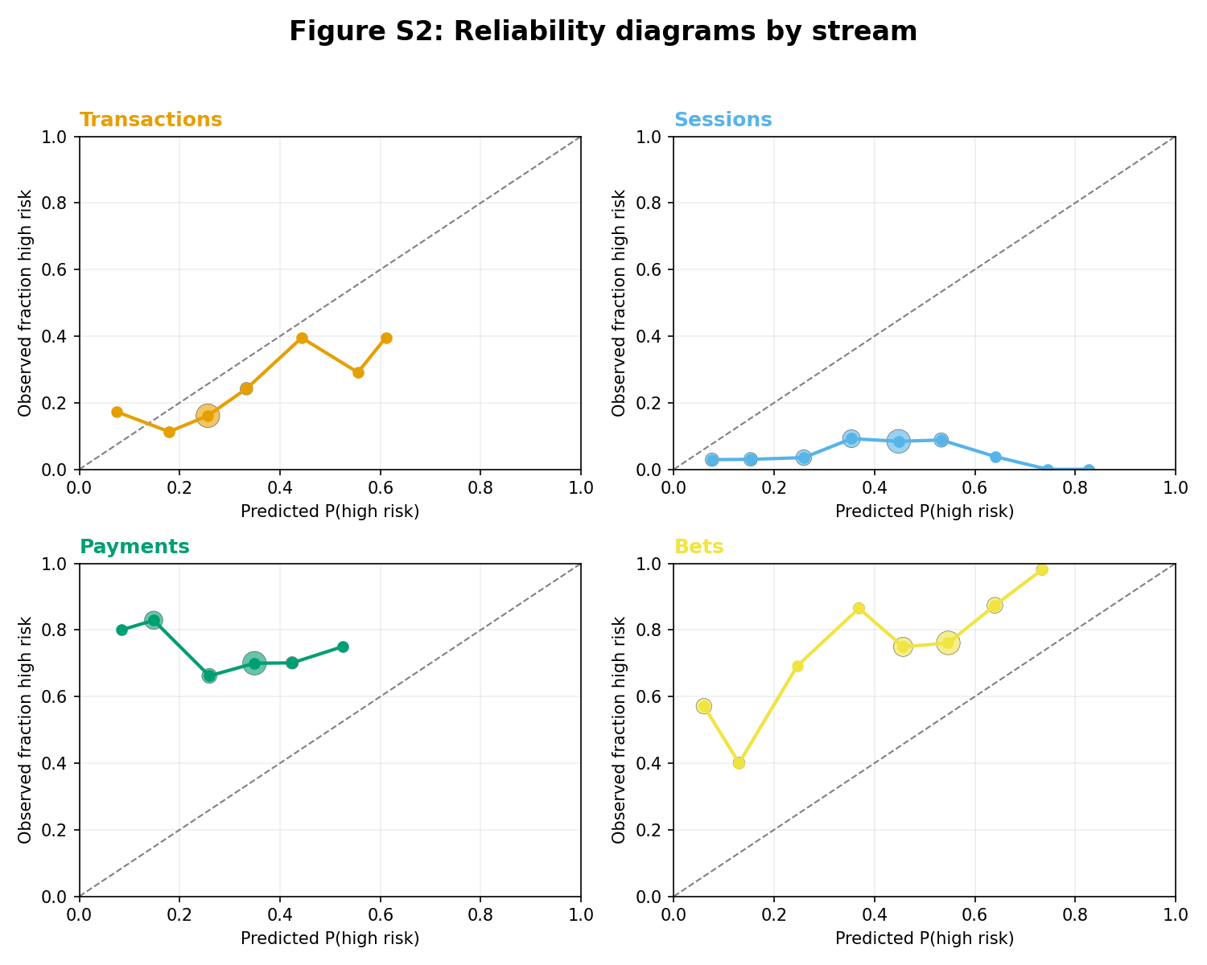

Figure S3. Top exceedance features by association with manual risk category. Bars show Spearman ρ between exceedance-derived features and ordinal manual risk category, computed on the validation split (feature selection) and replicated on the temporal holdout split.
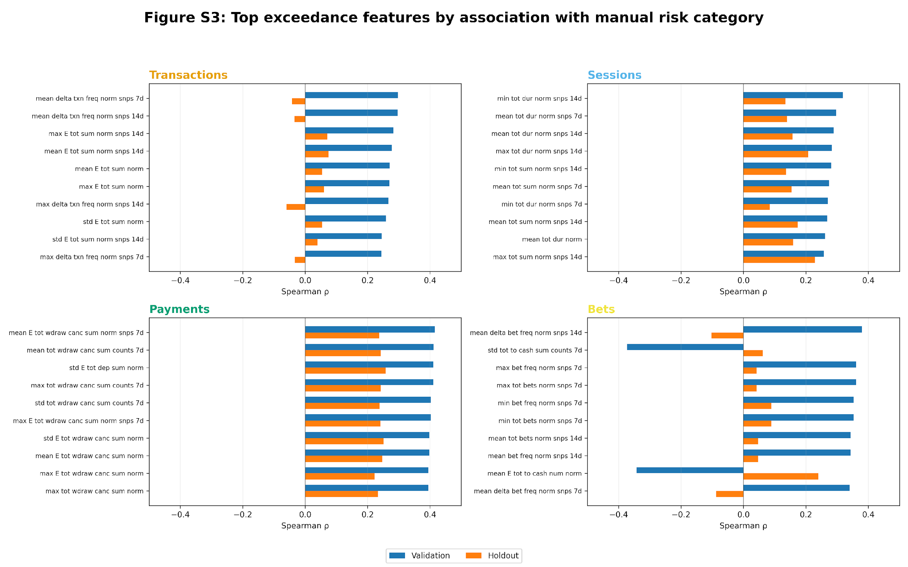

Figure S4. Exceedance ladder plots by manual risk category. Lines show mean feature value by manual risk category for the top validation-selected exceedance feature per stream; ρ indicates Spearman correlation on the validation split.
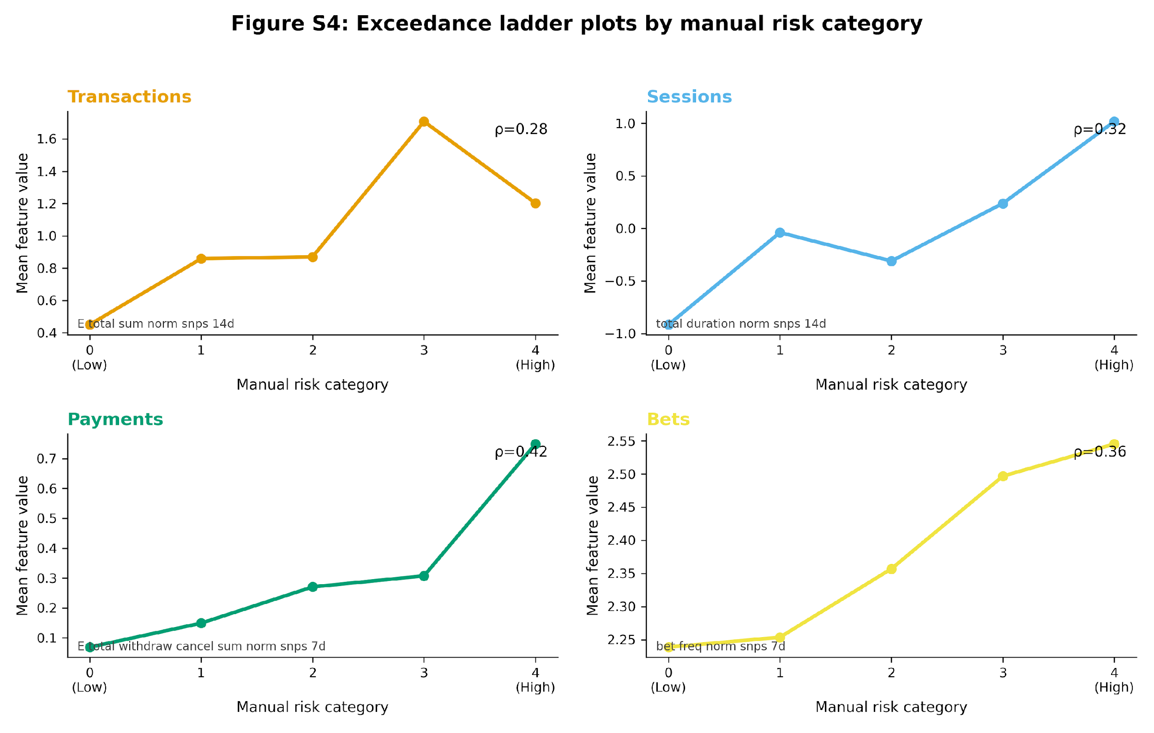

Figure S5. BALI diagnostics. Panel A: label coverage by risk category before and after pseudo-labelling. Panel B: pseudo-label quality on the holdout split (balanced accuracy and ECE) across confidence thresholds.
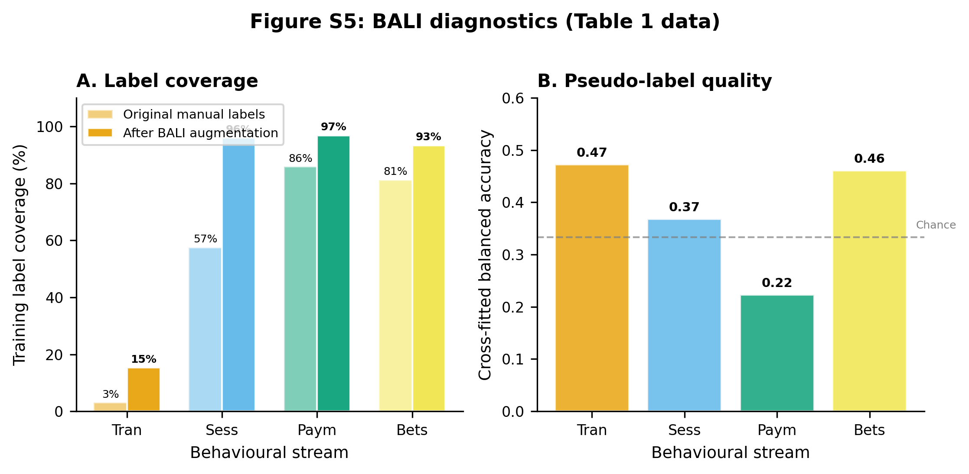

Figure S6. GHMM transition matrices by stream. Heatmaps show state-to-state transition probabilities (one-step; one-day shift). Red boxes highlight self-transition probabilities.
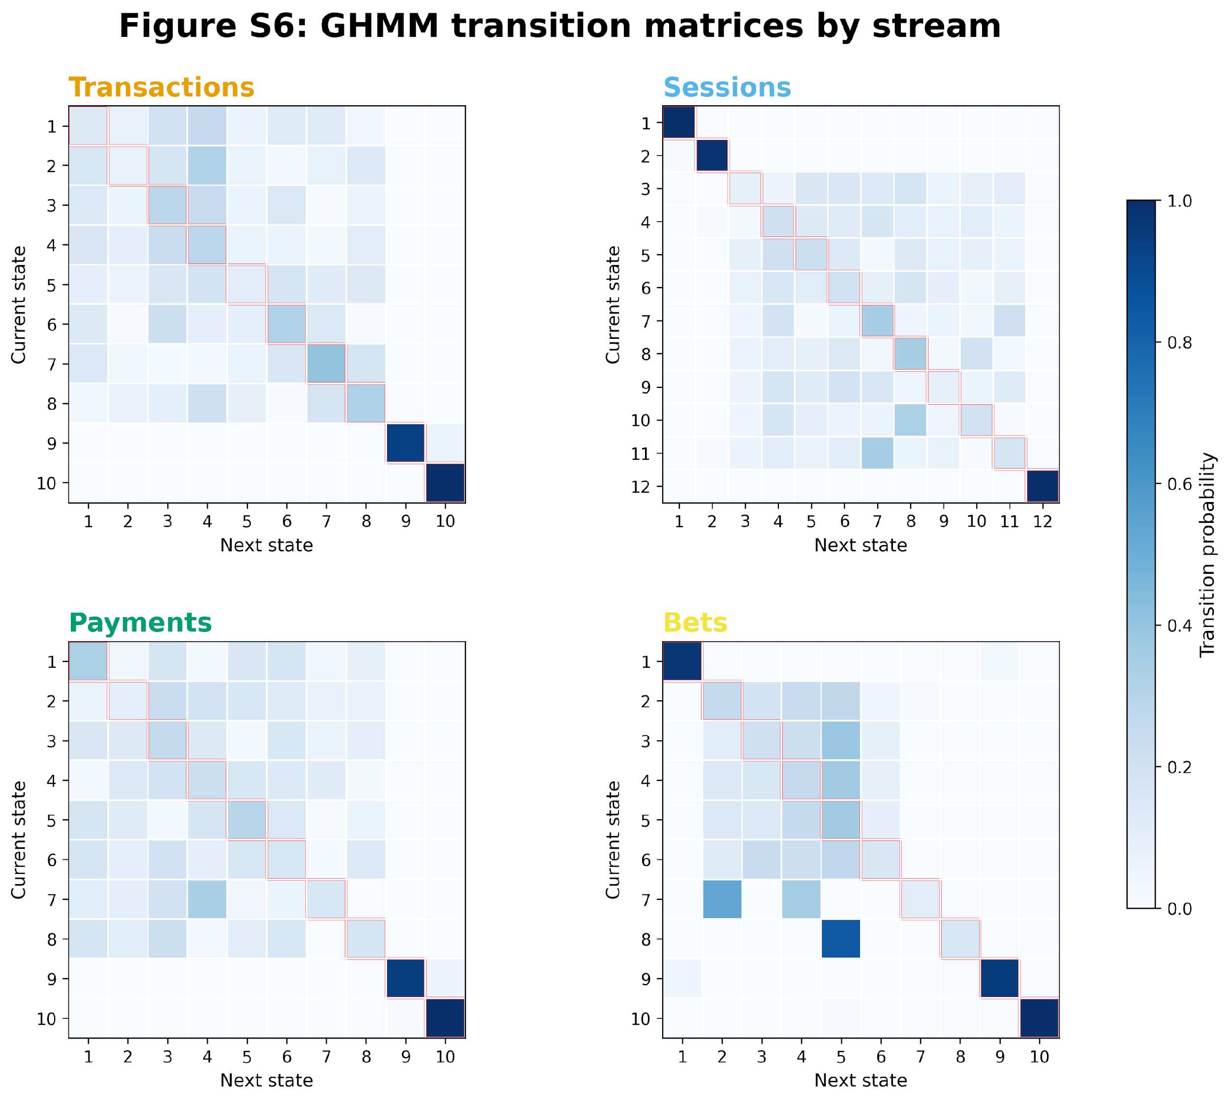

Figure S7. Temporal portability. Discrimination (balanced accuracy) and calibration (ECE) on the combined labelled evaluation set (test+holdout) and temporal holdout, using a frozen pipeline trained on the original training period.
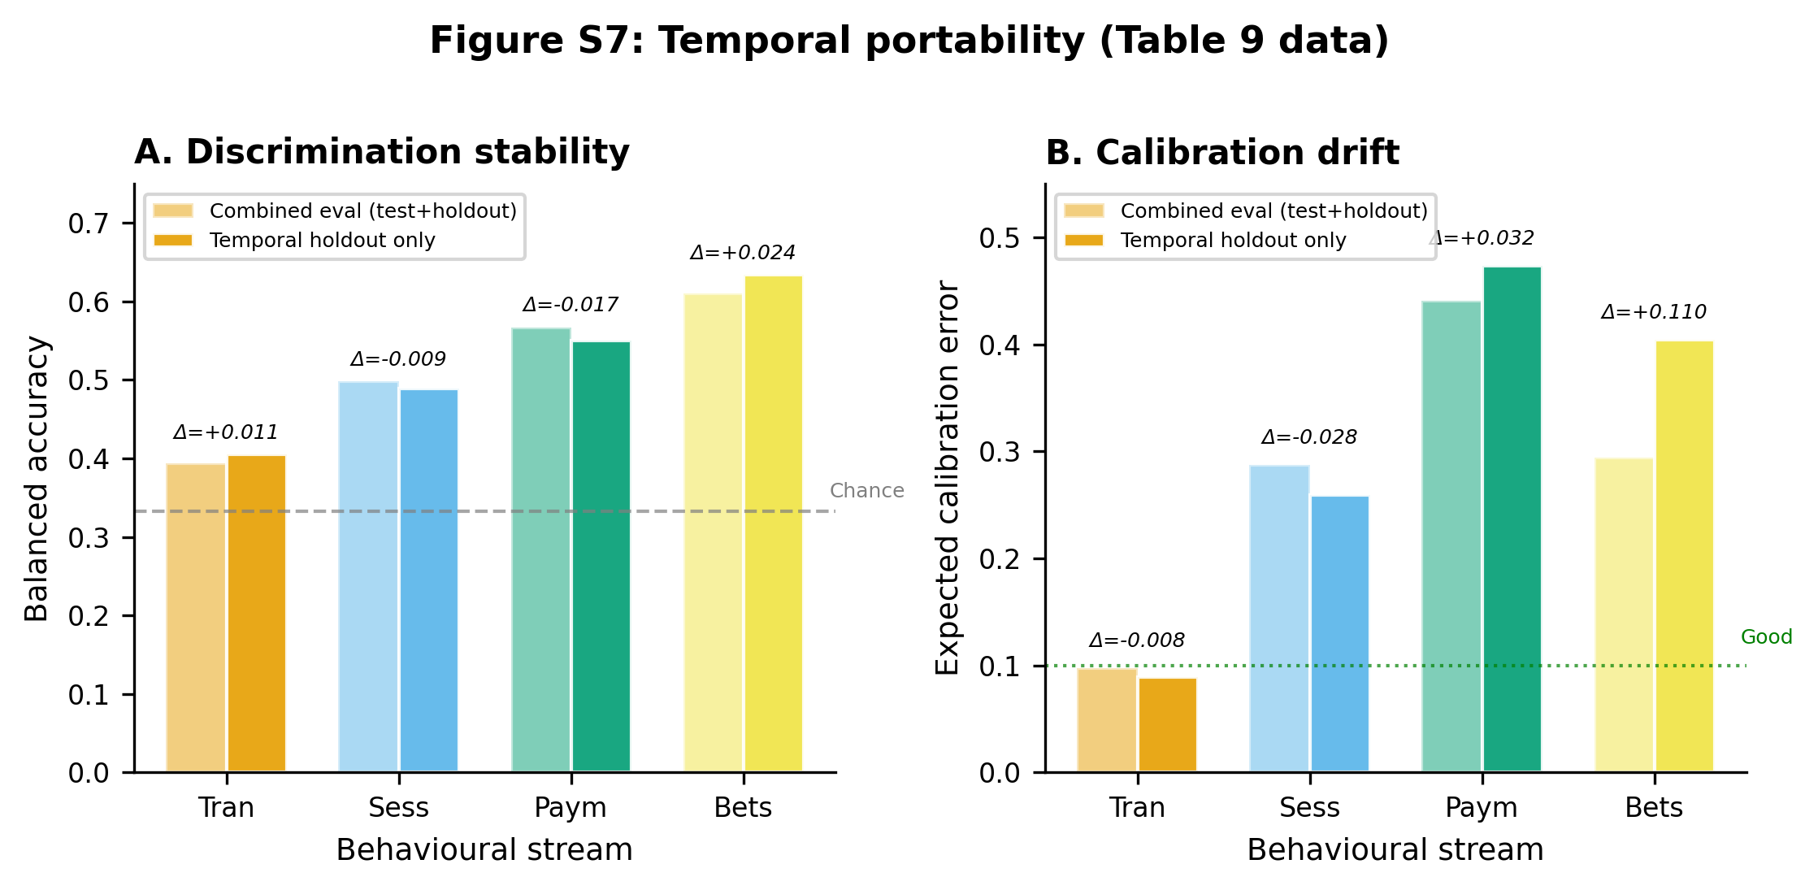

Figure S8. Embedding diagnostics: class-centroid cosine similarity (holdout split). Heatmaps show cosine similarity between class centroids in the learned embedding space across manual risk categories 0–4, stratified by stream. Higher similarity indicates less separation between categories.
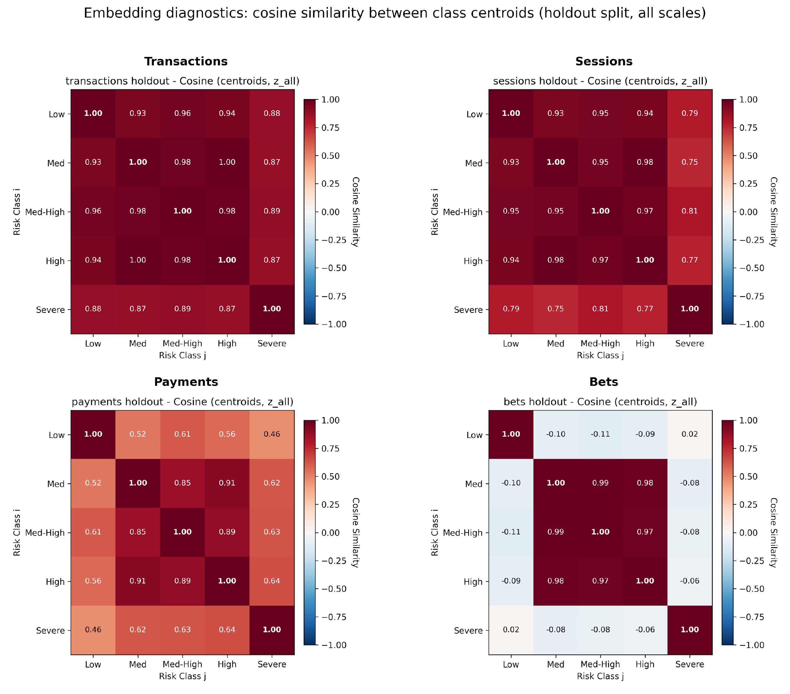

Figure S9. Embedding diagnostics: ordinal monotonicity summary (holdout split). Bars summarise ordinal monotonicity scores (Spearman ρ) evaluating whether embedding structure preserves the manual risk ordering across temporal scales (All, Short, Mid, Long) for each stream.
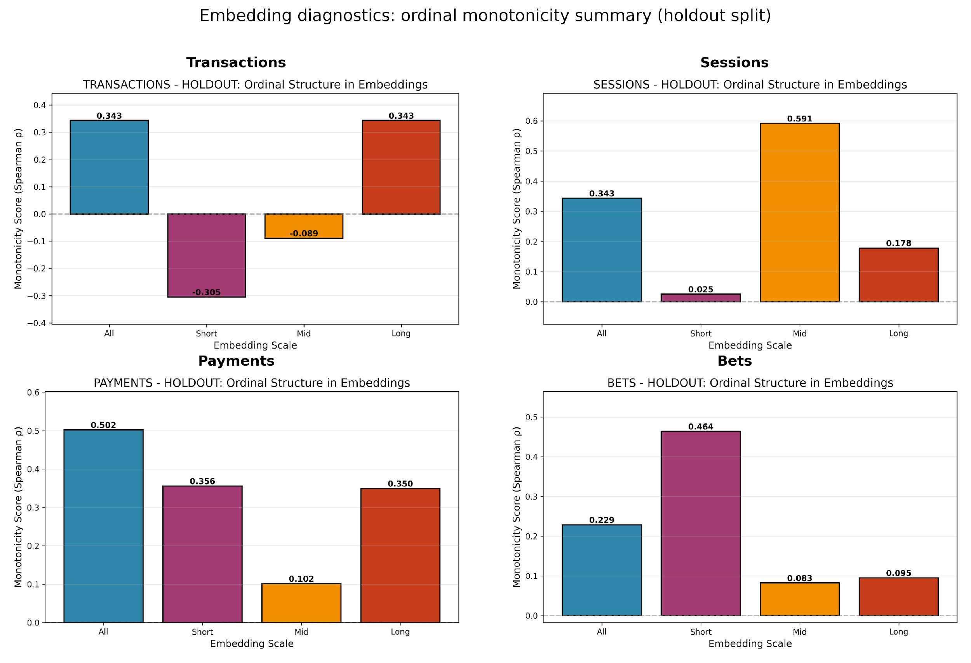

References
1. Hill BM (1975) A simple general approach to inference about the tail of a distribution. Ann Stat 3(5):1163–1174. https://doi.org/10.1214/aos/1176343247
2. Page ES (1954) Continuous inspection schemes. Biometrika 41(1–2):100–115. https://doi.org/10.1093/biomet/41.1-2.100
3. Coles SG, Heffernan J, Tawn JA (1999) Dependence measures for extreme value analyses. Extremes 2(4):339–365. https://doi.org/10.1023/A:1009963131610
4. Lakkaraju H, Kleinberg J, Leskovec J, Ludwig J, Mullainathan S (2017) The selective labels problem: evaluating algorithmic predictions in the presence of unobservables. In: Proc 23rd ACM SIGKDD Int Conf Knowl Discov Data Min (KDD ’17), pp 275–284. https://doi.org/10.1145/3097983.3098066
5. De-Arteaga M, Dubrawski A, Chouldechova A (2018) Learning under selective labels in the presence of expert consistency. arXiv:1807.00905
6. Rubin DB (1976) Inference and missing data. Biometrika 63(3):581–592. https://doi.org/10.1093/biomet/63.3.581
7. Seaman SR, White IR (2013) Review of inverse probability weighting for dealing with missing data. Stat Methods Med Res 22(3):278–295. https://doi.org/10.1177/0962280210395740
8. Chernozhukov V, Chetverikov D, Demirer M, Duflo E, Hansen C, Newey W, Robins JM (2018) Double/debiased machine learning for treatment and structural parameters. Econometrics J 21(1):C1–C68. https://doi.org/10.1111/ectj.12097
9. Kingma DP, Welling M (2013) Auto-encoding variational Bayes. arXiv:1312.6114
10. Sohn K, Lee H, Yan X (2015) Learning structured output representation using deep conditional generative models. Adv Neural Inf Process Syst 28:3483–3491.
11. Bai S, Kolter JZ, Koltun V (2018) An empirical evaluation of generic convolutional and recurrent networks for sequence modeling. arXiv:1803.01271
12. Vaswani A, Shazeer N, Parmar N, et al (2017) Attention is all you need. arXiv:1706.03762
13. Hinton G, Vinyals O, Dean J (2015) Distilling the knowledge in a neural network. arXiv:1503.02531
14. He J, Spokoyny D, Neubig G, Berg-Kirkpatrick T (2019) Lagging inference networks and posterior collapse in variational autoencoders. In: Proc Int Conf Learn Represent (ICLR). arXiv:1901.05534
15. Bowman SR, Vilnis L, Vinyals O, Dai AM, Jozefowicz R, Bengio S (2016) Generating sentences from a continuous space. In: Proc 20th SIGNLL Conf Comput Nat Lang Learn (CoNLL), pp 10–21. https://doi.org/10.18653/v1/K16-1002
16. Kingma DP, Salimans T, Jozefowicz R, Chen X, Sutskever I, Welling M (2016) Improving variational inference with inverse autoregressive flow. arXiv:1606.04934
17. Miyato T, Kataoka T, Koyama M, Yoshida Y (2018) Spectral normalization for generative adversarial networks. arXiv:1802.05957
18. Rabiner LR (1989) A tutorial on hidden Markov models and selected applications in speech recognition. Proc IEEE 77(2):257–286. https://doi.org/10.1109/5.18626
19. Kleinberg J, Lakkaraju H, Leskovec J, Ludwig J, Mullainathan S (2018) Human decisions and machine predictions. Q J Econ 133(1):237–293. https://doi.org/10.1093/qje/qjx032
20. Guo C, Pleiss G, Sun Y, Weinberger KQ (2017) On calibration of modern neural networks. In: Proc 34th Int Conf Mach Learn (ICML). PMLR 70:1321–1330.
21. Efron B, Tibshirani RJ (1993) An introduction to the bootstrap. Chapman & Hall, New York. https://doi.org/10.1201/9780429246593

