Supplementary figures
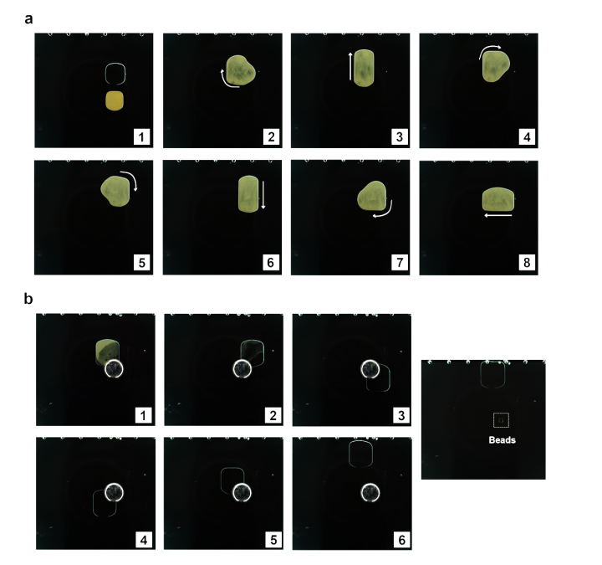
Supplementary figure1 Magnetic bead mixing and analytical workflow on-AM-DMF. a, Images captured from a video recording, illustrating the active mixing process of SPRI beads within a reagent droplet via programmed electrode actuation; b, Sequential images demonstrating the efficient magnetic separation and collection of beads at a designated chip location following the wash steps.
Supplementary figure2 Optimization of PCR cycling parameters for AM-DMF library preparation. a, Fragment size distribution of libraries amplified from 5 ng of Promega human male gDNA under different PCR cycle numbers. Over-amplification artifacts are observed at 10 and 12 cycles; b, Library concentration corresponding to different cycle numbers using 5 ng of Promega human male gDNA as input; c, Concentration of fragments in the 300–400 bp region for libraries prepared with 5 ng of Promega human male gDNA across different PCR cycles.
Supplementary figure3 Performance evaluation of the AM-DMF platform at 3 ng and 5 ng inputs. a, A 2 × 2 contingency table comparing pathogen detection outcomes between on-AM-DMF libraries prepared from 3 ng and 5 ng inputs. Sensitivity (SEN) and specificity (SPN) were calculated as SEN = TP / (TP + FN) and SPN = TN / (TN + FP), where TP is true positive, FN false negative, TN true negative, and FP false positive. b, Paired t‑test comparison of the duplication rate (left) and uniquely mapped read rate (right) for libraries from 10 clinical samples prepared on-AM-DMF at 3 ng versus 5 ng inputs. c, Bland–Altman plots assessing the agreement of log₁₀‑transformed pathogen RPM values between on-AM-DMF libraries (3 ng input, left; 5 ng input, right) and their matched off-AM-DMF (manual) counterparts. The central solid line indicates the mean difference (bias), and the dashed lines represent the 95% limits of agreement.

Supplementary Table
Table1
Steps | Component | Manual Protocol | AM-DMF Protocol
Fragmentation | Input DNA | 5-20 ng | 1-25 ng
Fragmentation | Reaction mix-1 | 10 μL | 1 μL
Fragmentation | Nuclease-Free Water | To 60 μL | To 6 μL
Fragmentation | Total Volume | 60 μL | 6 μL
Adapter Ligation | Reaction mix-2 | 35 μL | 3.5 μL
Adapter Ligation | adapter | 5 μL | 1 μL
Adapter Ligation | Total Volume | 100 μL | 10.5 μL
Bead-Based Cleanup | SPRI Beads | 80 μL | 8 μL
Washing | 80% Ethanol | 200 μL | 10 μL
Elution | Nuclease-Free Water | 23 μL | 2.5 μL
PCR Amplification | PCR mix | 25 μL | 2.5 μL
PCR Amplification | UDI Primer | 4 μL | 0.4 μL
PCR Amplification | Total Volume | 50 μL | 5.4 μL
Beads Clean-up | Beads | 63 μL | 4.5 μL
Washing | 80% Ethanol | 200 μL | 10 μL
Elution | Nuclease-Free Water | 20 μL | 10 μL
Supplementary Table 1. Reagent consumption comparison between manual and on‑AM‑DMF library preparation protocols.

Supplementary Videos
Supplementary Video 1: Automated droplet manipulation and library preparation on the AM‑DMF chip.

