Supporting Information
SPP1 knockdown inhibits invasion, migration and paclitaxel-induced Epithelial-Mesenchymal Transition in Cervical Cancer Cells through the TGF-β/Akt/Snail pathway

Qianqian Cao, Yayin Lin, Huiwen Guan, Chunlin Dong, Yunjun Ge, Min Li, Qian Zhang, Shuhui Guo, Mingyu Qin, Jinjin Yu, Guosheng Wu

Supplementary Figure 1. SPP1 was a risk factor for cervical cancer.

Supplementary Figure 2. IHC was used to detect the expression level of SPP1 protein in cervical cancer tissues (T) and adjacent normal tissues (ANT).

Supplementary Figure 3. Validations of SPP1 knockdown in C-33A and SiHa cells using RT-qPCR.

Supplementary Figure 4. The mRNA level of Smad7 was detected using RT-qPCR.

Supplementary Figure 5. The histopathological H&E staining results of representative samples of liver, spleen, kidney and heart of mice after treatment in each group.

Supplementary Table 1. Our cervical cancer cohorts.

Supplementary Table 2. List of antibodies.
Supplementary Figure 1. SPP1 was a risk factor for cervical cancer. A The forest plot showed the risk scores of the top 14 genes related to prognosis in the TCGA_CESC dataset. B, C The survival analysis related to the ESTIMATE immune score suggested that SPP1 had the potential to become an independent prognostic biomarker.

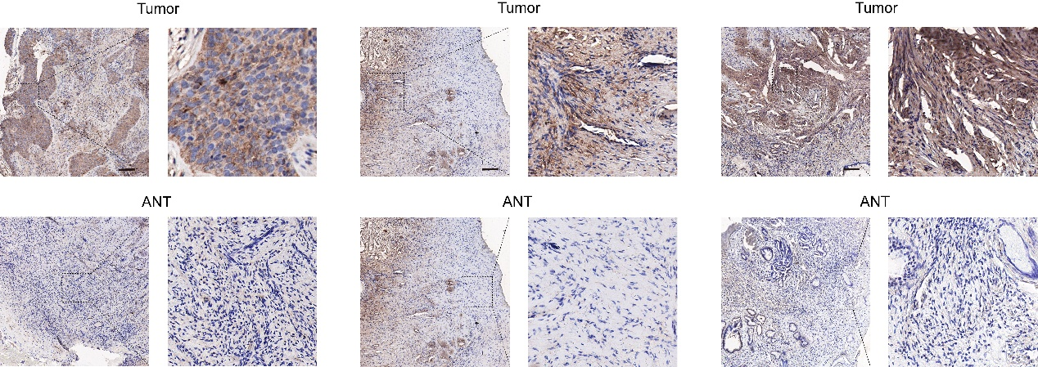
Supplementary Figure 2. IHC was used to detect the expression level of SPP1 protein in cervical cancer tissues (T) and adjacent normal tissues (ANT); scale bar = 100 μm.

Supplementary Figure 3. Validations of SPP1 knockdown in C-33A (A) and SiHa (B) cells using RT-qPCR.
Supplementary Figure 4. The mRNA level of Smad7 was detected using RT-qPCR.

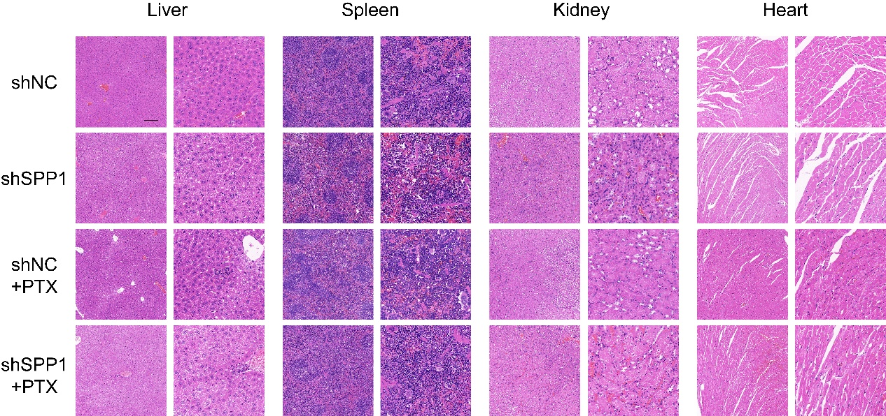
Supplementary Figure 5. The histopathological H&E staining results of representative samples of liver, spleen, kidney and heart of mice after treatment in each group; scale bar = 100 μm.

Supplementary Table 1. Our cervical cancer cohorts.
 | IHC score of SPP1 |  | P value
 | Low | High | P value
N | 10 | 45
Age (years)  ＜60 | 3 (30.0%) | 36 (80.0%) | 0.375
≥60 | 7 (70.0%) | 9 (20.0%)
TBS (%) |  |  | 0.002
LSIL | 7 (70.0%) | 1 (2.2%)
HSIL | 1 (10.0%) | 38 (82.2%)
Clinical stage (%) |  |  | 0.195
Stage I | 0 (0.0%) | 2 (4.4%)  4 (8.9%)
Stage II | 0 (0.0%) | 2 (4.4%)  4 (8.9%)
Histologic type (%) |  |  | 0.000
Adenocarcinoma | 2 (20.0%) | 0 (0.0%)
Squamous cell carcinoma | 8 (80.0%) | 45 (100.0%)

Supplementary Table 2. List of antibodies.
 | Antibodies | Company | Catalog No. | Dilution
 | SPP1 | Proteintech | 22952-1-AP | WB: 1:2000  IHC: 1:500
 | p-Smad2/3 | Cell Signaling Technology (CST) | 8828T | WB: 1:1000
 | Total-Smad2/3 | CST | 3102S | WB: 1:1000
 | TGF-β1 | HuaBio | HA721143 | WB: 1:2500
 | p-AKT | CST | 4060P | WB: 1:2000
 | Total-AKT | CST | 4691P | WB: 1:1000
 | E-cadherin | CST | 3195P | WB: 1:1000
 | N-cadherin | CST | 4061P | WB: 1:1000
 | Snail | CST | 3879P | WB: 1:1000
Vimentin |  | CST | 5741P | WB: 1:1000
GAPDH |  | CST | 5174T | WB: 1:1000
 | β-actin | absin | abs137975 | WB: 1:4000

