Voltage-Driven Growth of Phosphorus Tribofilms
Yun Zhaoª, Jie Zhangª, Hugh A. Spikesª, & Janet S.S. Wong^{a, *}
ª Department of Mechanical Engineering, Imperial College London, London SW7 2AZ, UK
*Email: j.wong@imperial.ac.uk (Janet S.S. Wong)

Figure S1. Friction coefficient of 800 ppm BEPite in PAO2 under different applied voltages.

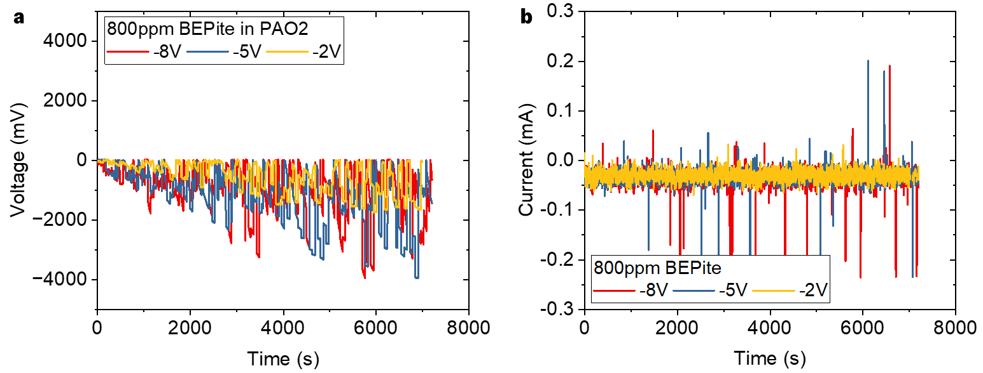
Figure S2. Real-time (a) voltage and (b) current recorded under various applied voltage conditions.
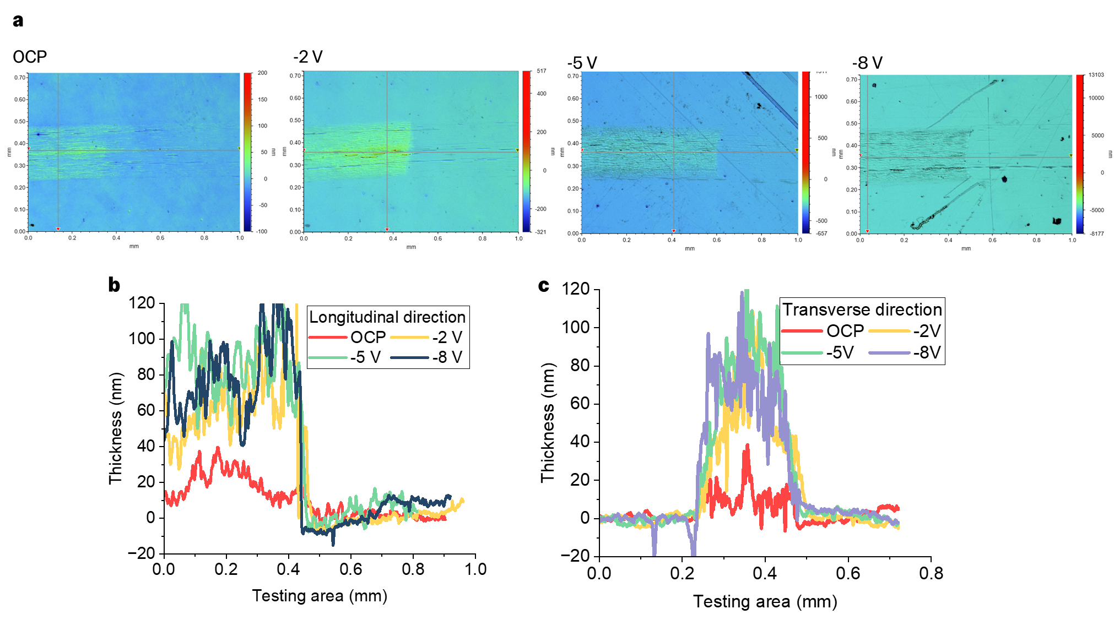
Figure S3. Tribofilm thickness profiles across the wear track formed under different applied voltages.

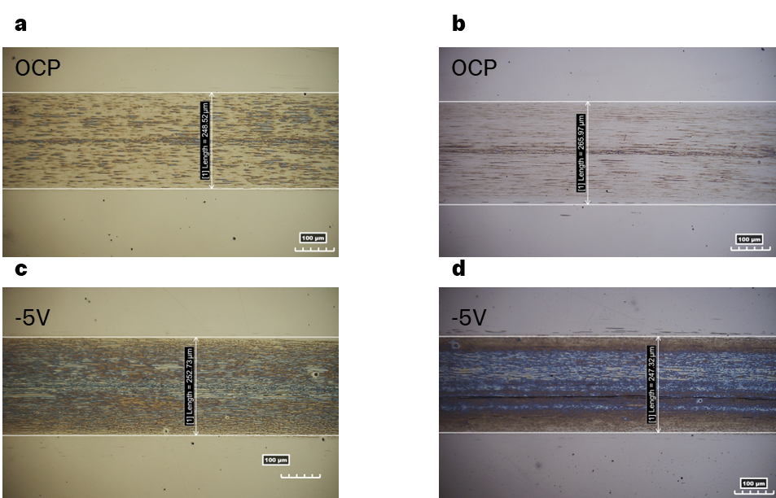
Figure S4. Two sets of repeat tests: (a, b) optical microscope images of wear tracks generated under OCP conditions, and (c, d) wear tracks generated under -5 V.

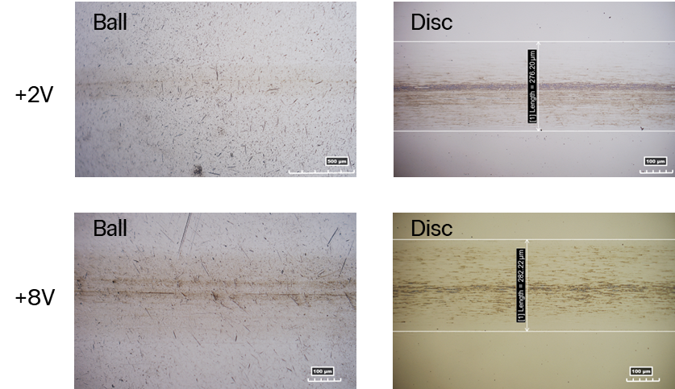
Figure S5. Optical microscope images of the ball and disc surfaces under positive voltage conditions. 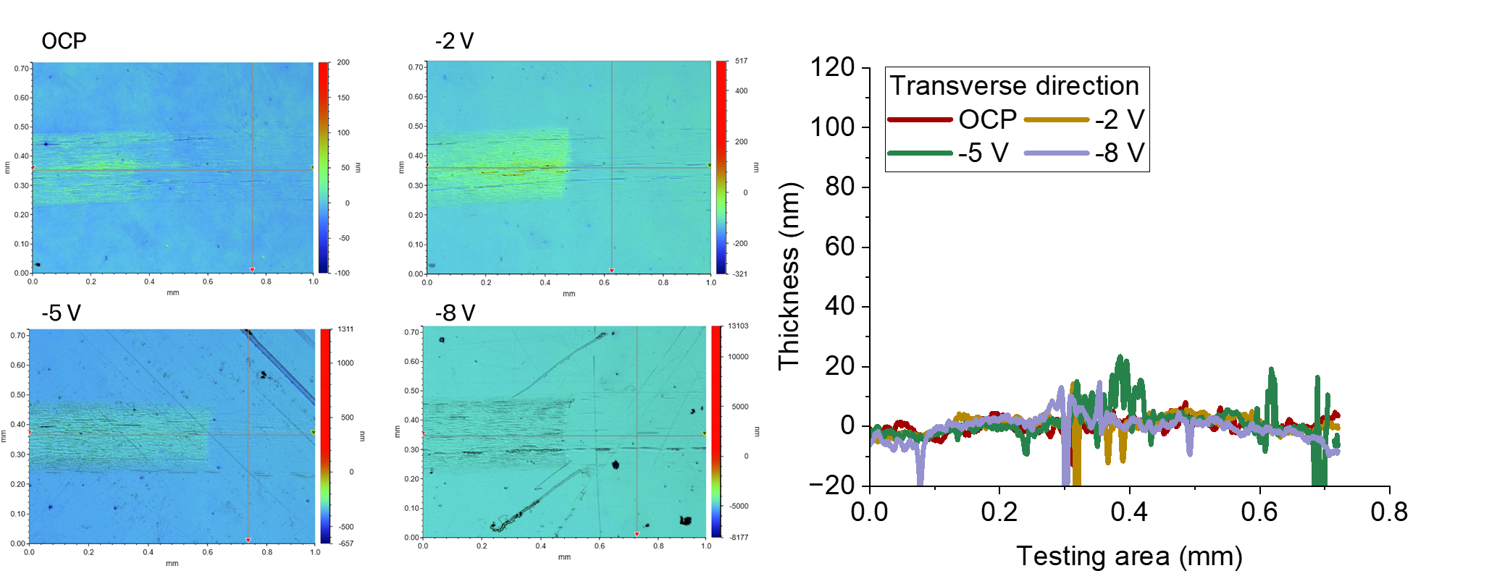
Figure S6. Tribofilm results of BEPite in PAO2 rubbing for 120 mins under applied voltage conditions.

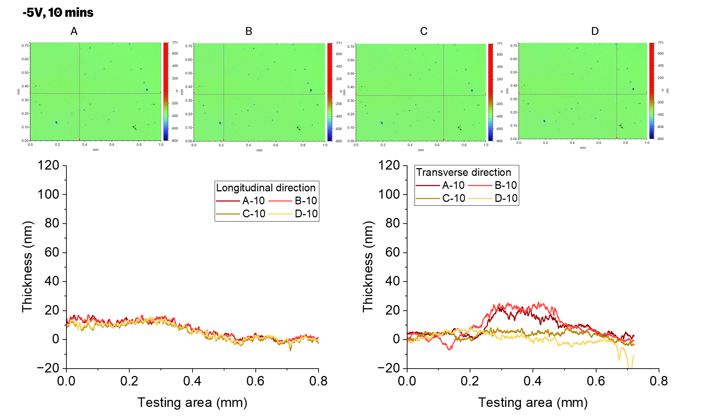
Figure S7. Tribofilm results of BEPite in PAO2 rubbing for 10 mins under -5V.
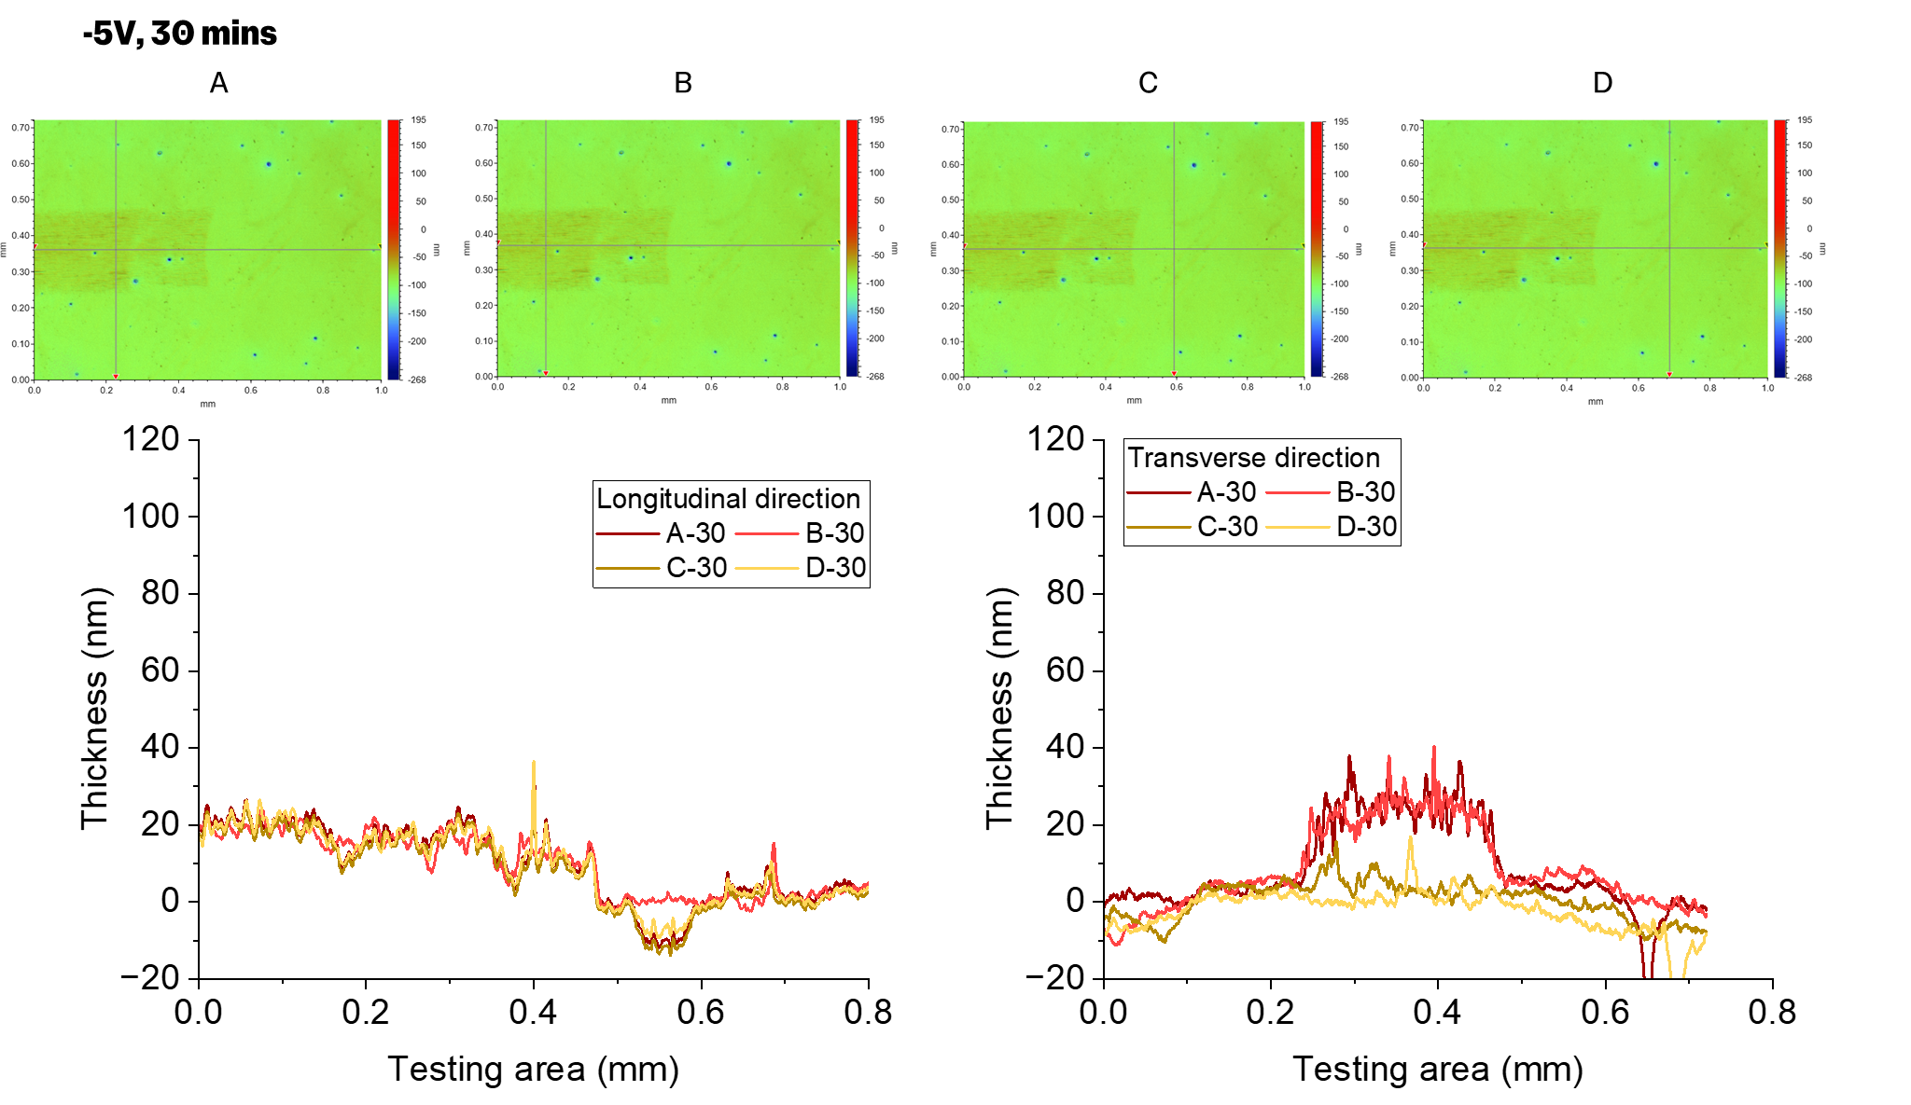
Figure S8. Tribofilm results of BEPite in PAO2 rubbing for 30 mins under -5V.
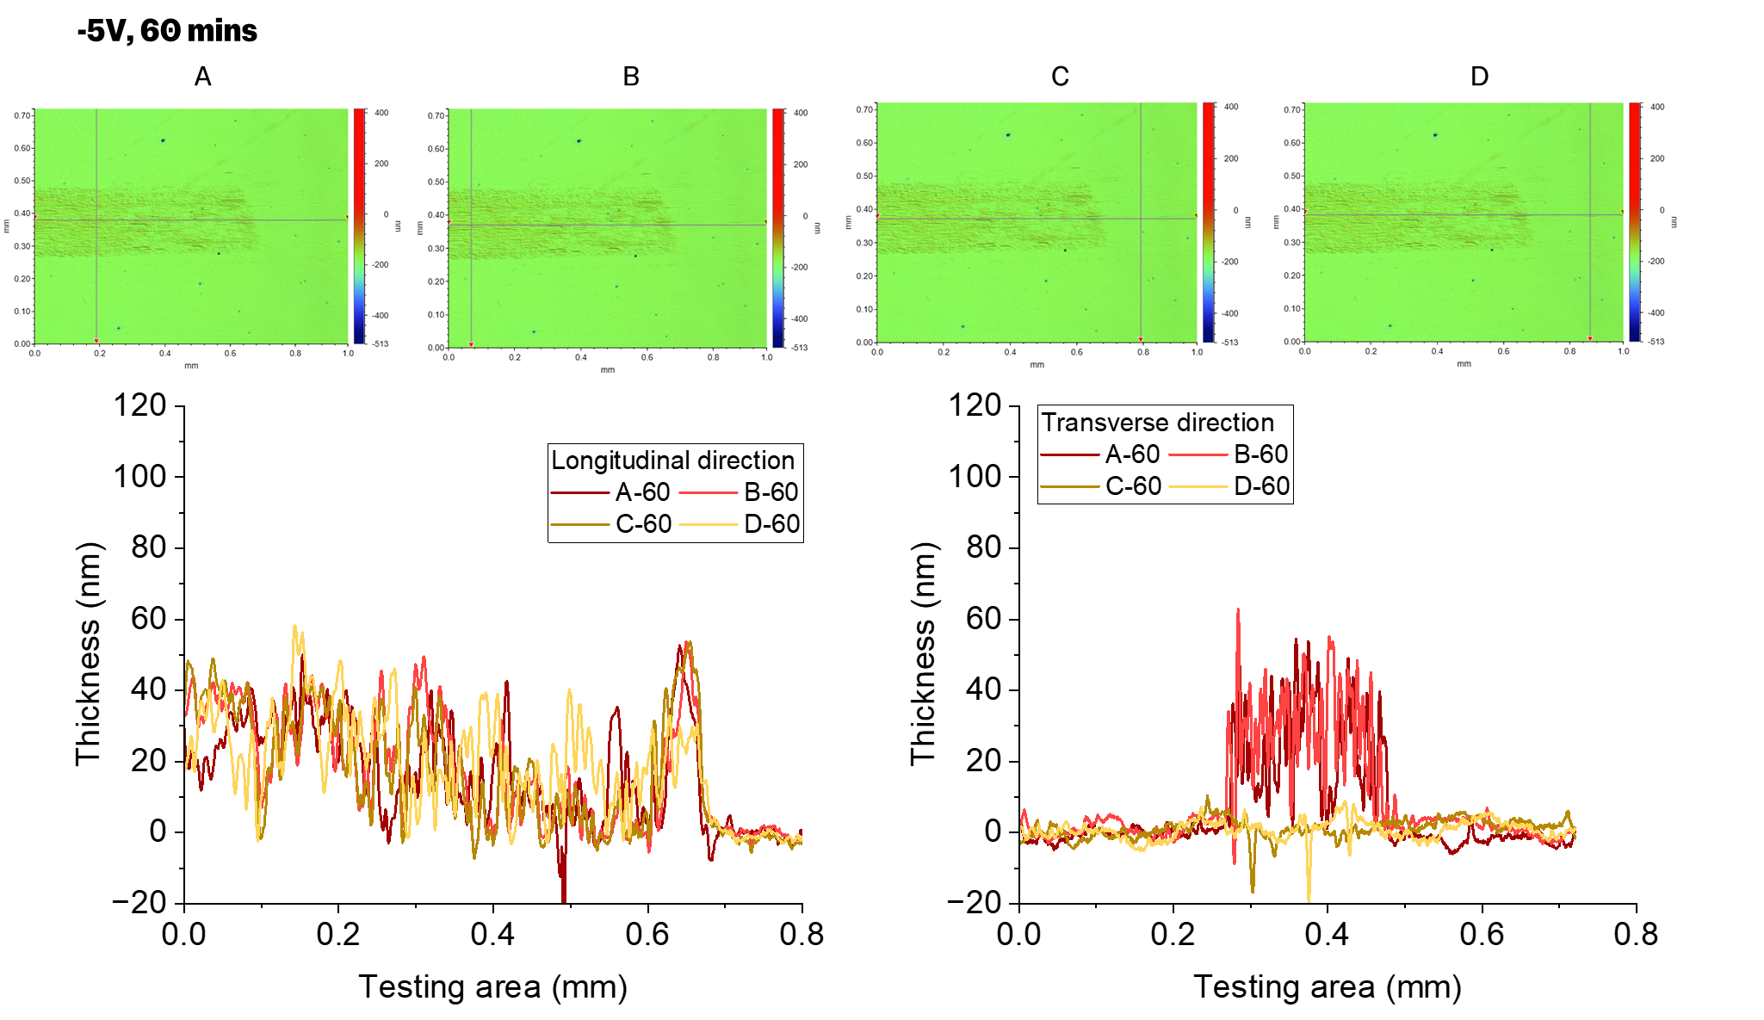
Figure S9. Tribofilm results of BEPite in PAO2 rubbing for 60 mins under -5V.
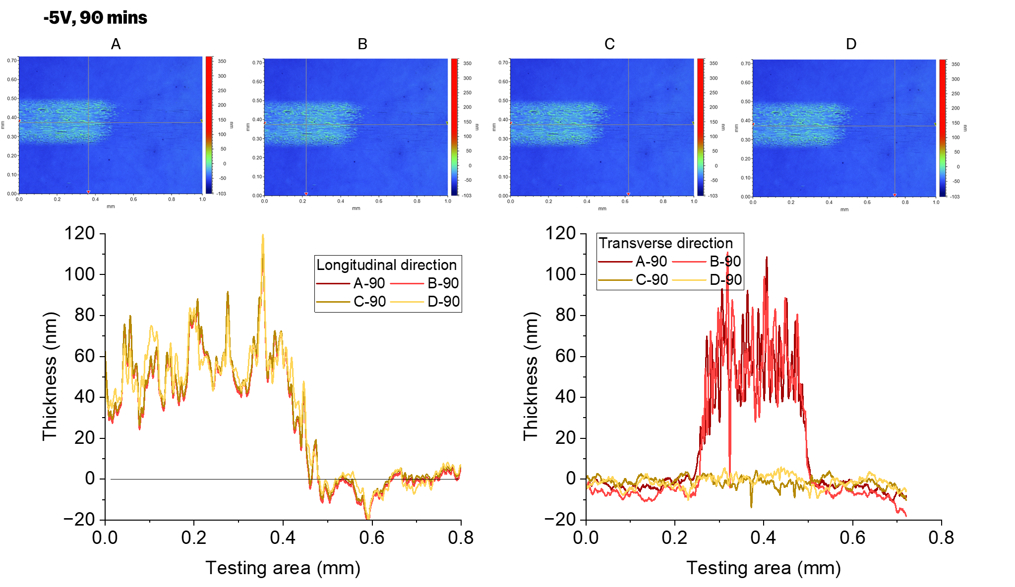
Figure S10. Tribofilm results of BEPite in PAO2 rubbing for 90 mins under -5V.
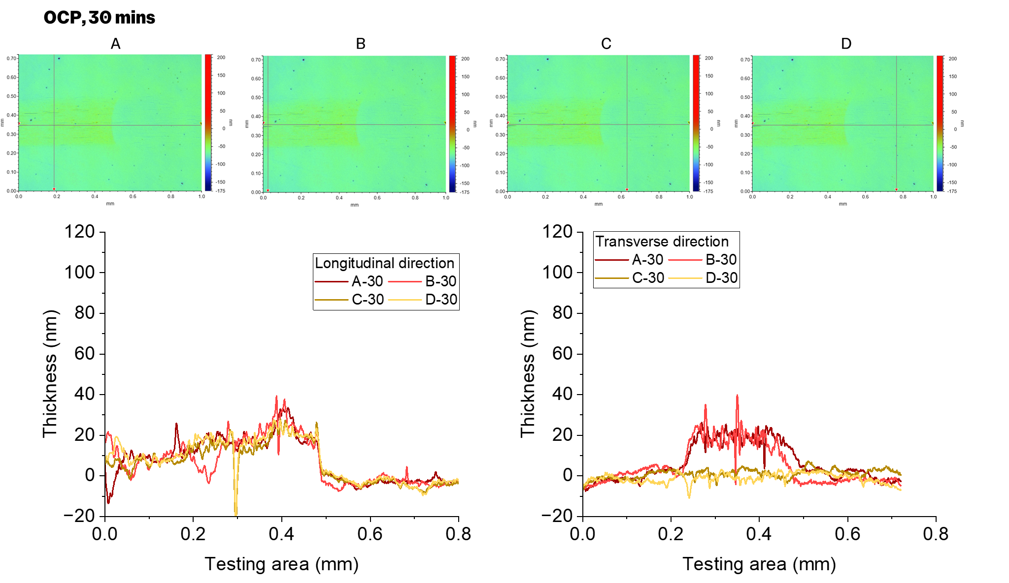
Figure S11. Tribofilm results of BEPite in PAO2 rubbing for 30 mins under OCP.
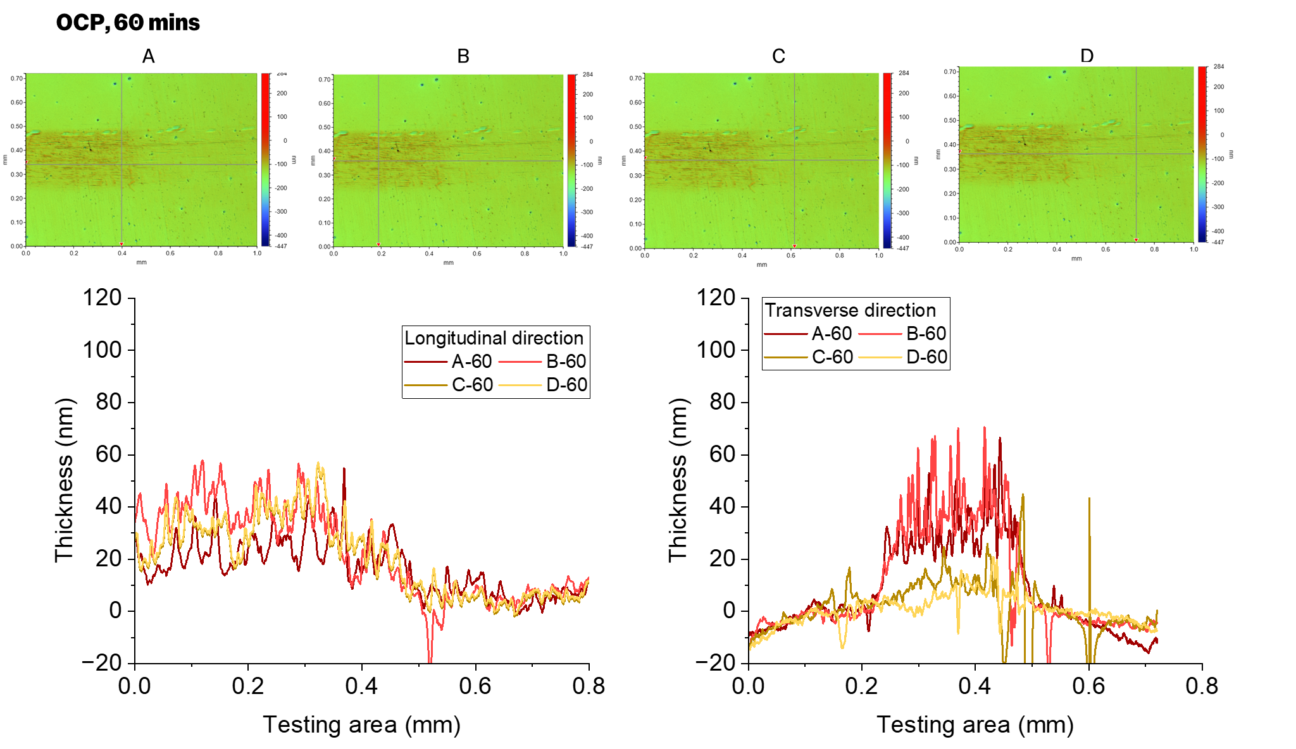
Figure S12. Tribofilm results of BEPite in PAO2 rubbing for 60 mins under OCP.
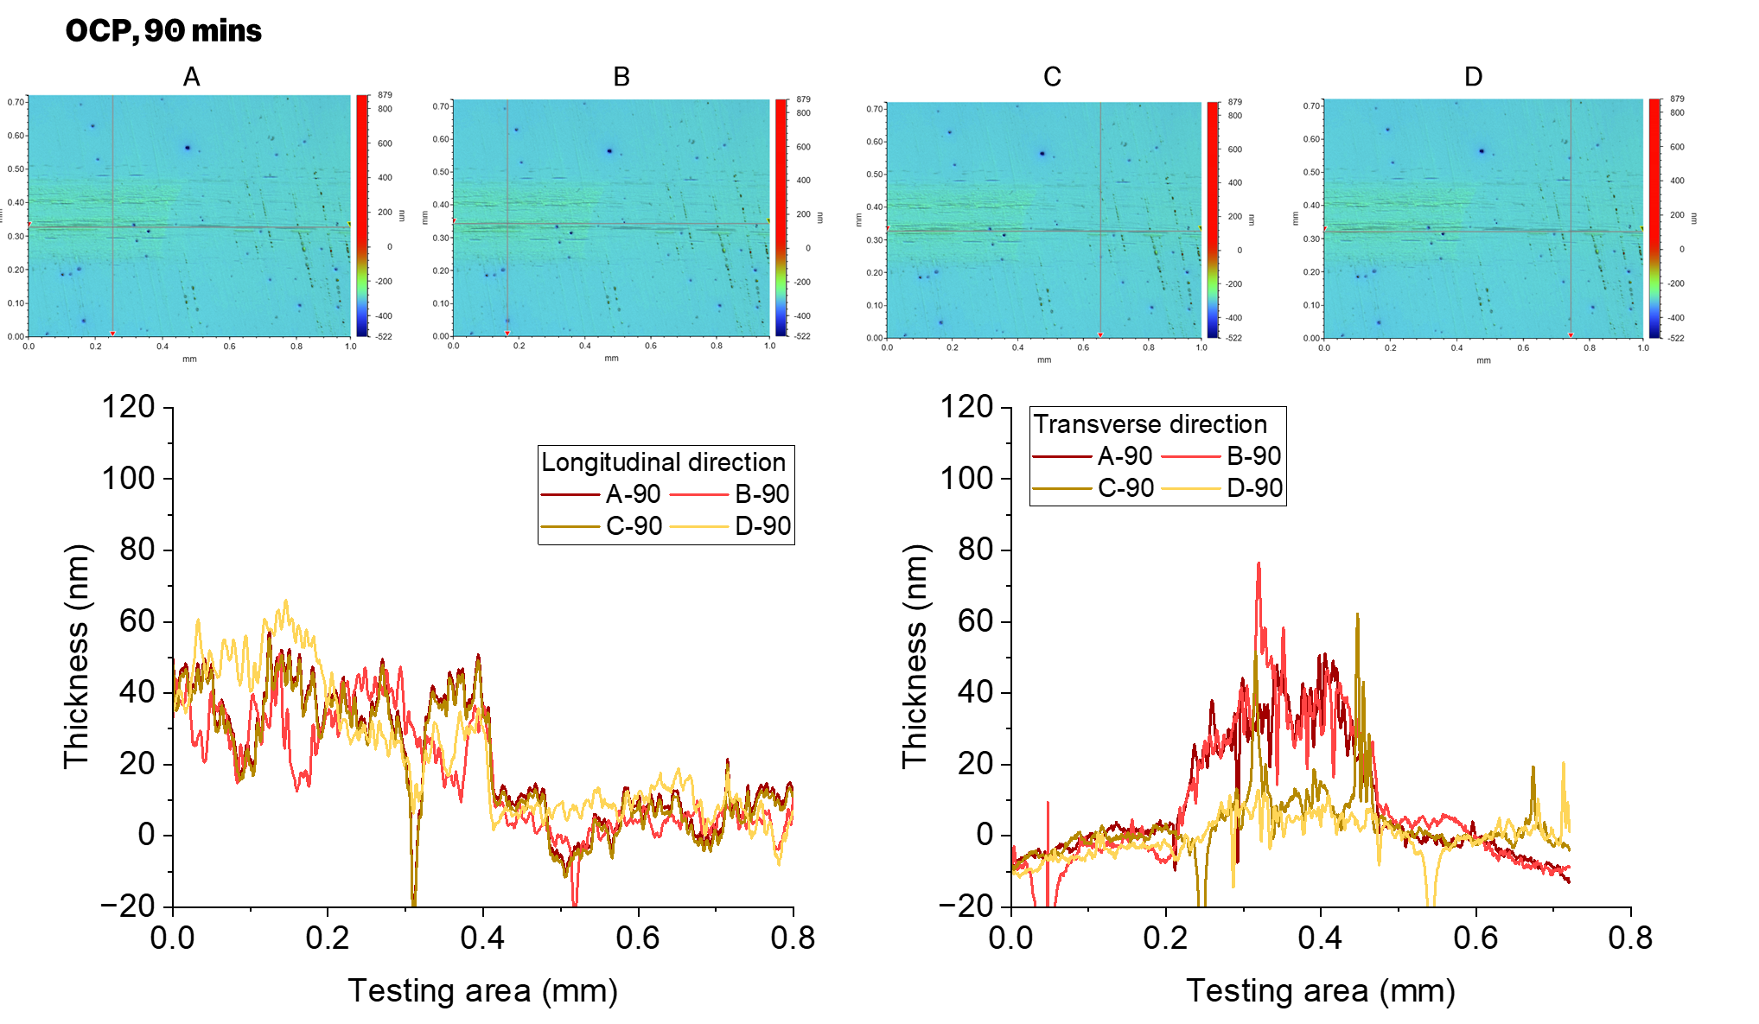
Figure S13. Tribofilm results of BEPite in PAO2 rubbing for 90 mins under OCP.
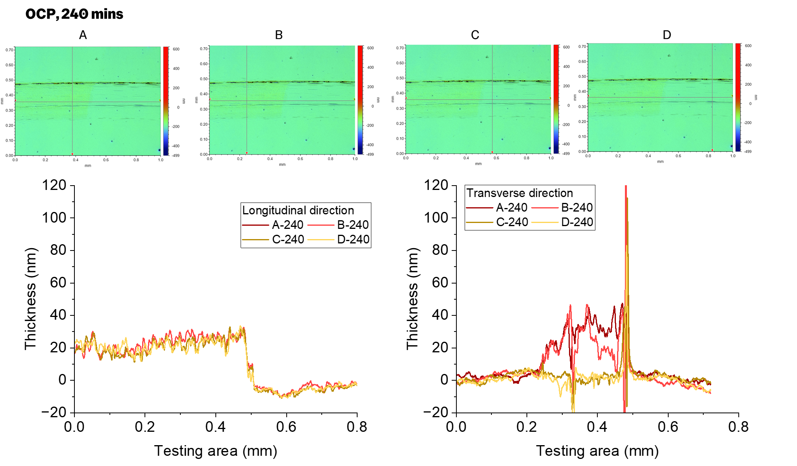
Figure S14. Tribofilm results of BEPite in PAO2 rubbing for 240 mins under OCP.
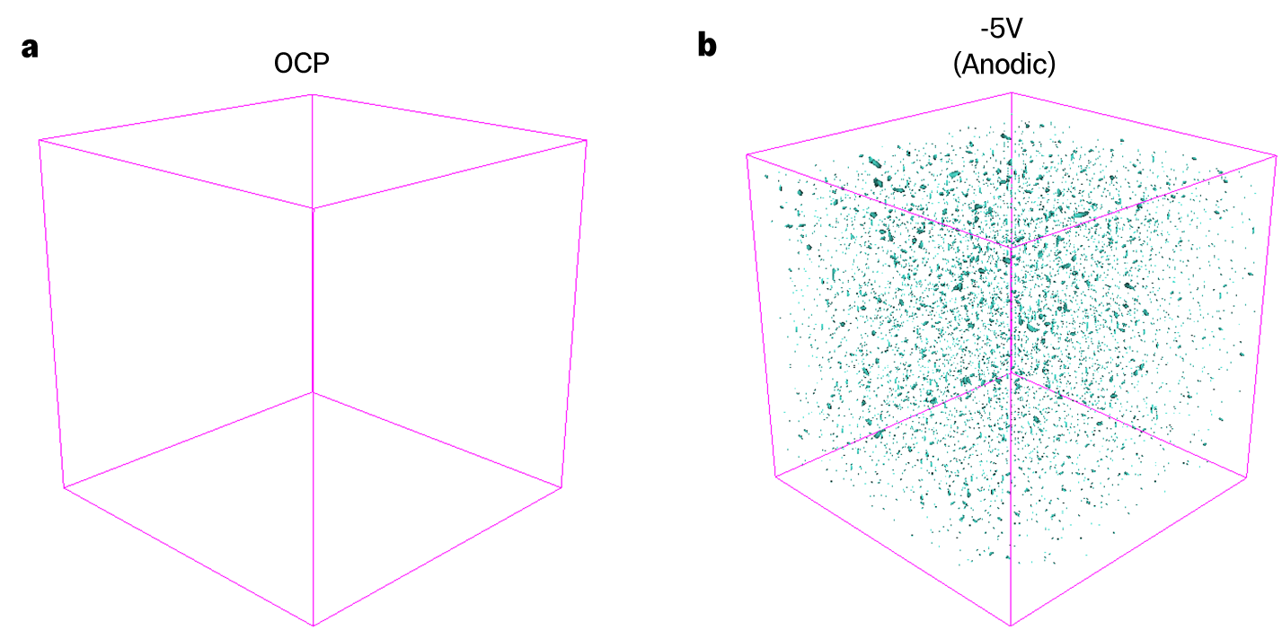
Figure S15. 3D TOF-SIMS tomographic reconstruction of PO₄⁻ distribution of discs treated at OCP (a) and -5V (b).
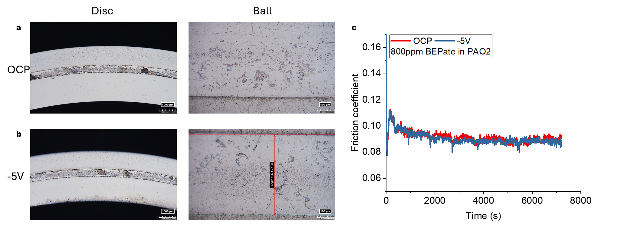
Figure S16. a. Wear track of diisopropyl phosphite in PAO2 at OCP. b. Wear track of diisopropyl phosphite in PAO2 at -5V. c. COF results of diisopropyl phosphite in PAO2.

Figure S17. Raman spectroscopy of discs treated at applied voltage conditions.
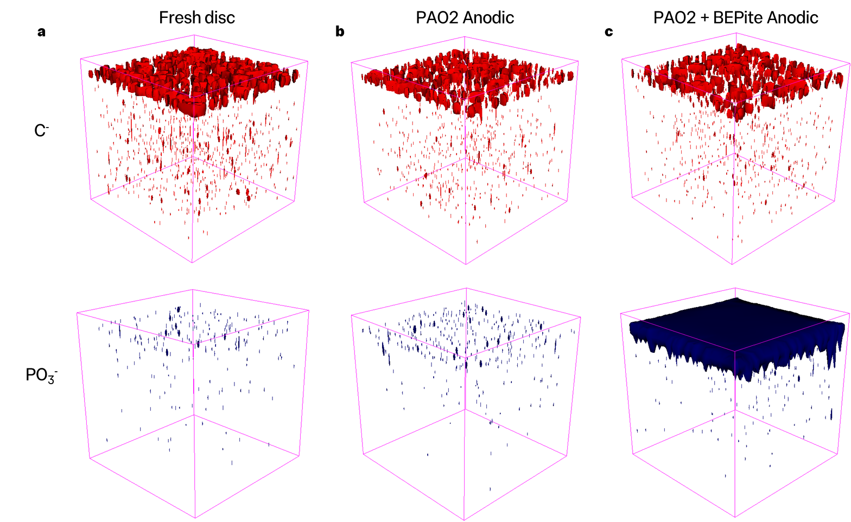
Figure S18. 3D TOF-SIMS tomographic reconstruction of C⁻ and PO₃⁻ distribution of discs. a. Fresh disc. b. Disc treated in PAO2 at -5 V. c. Disc treated in BEPite in PAO2 at -5 V.
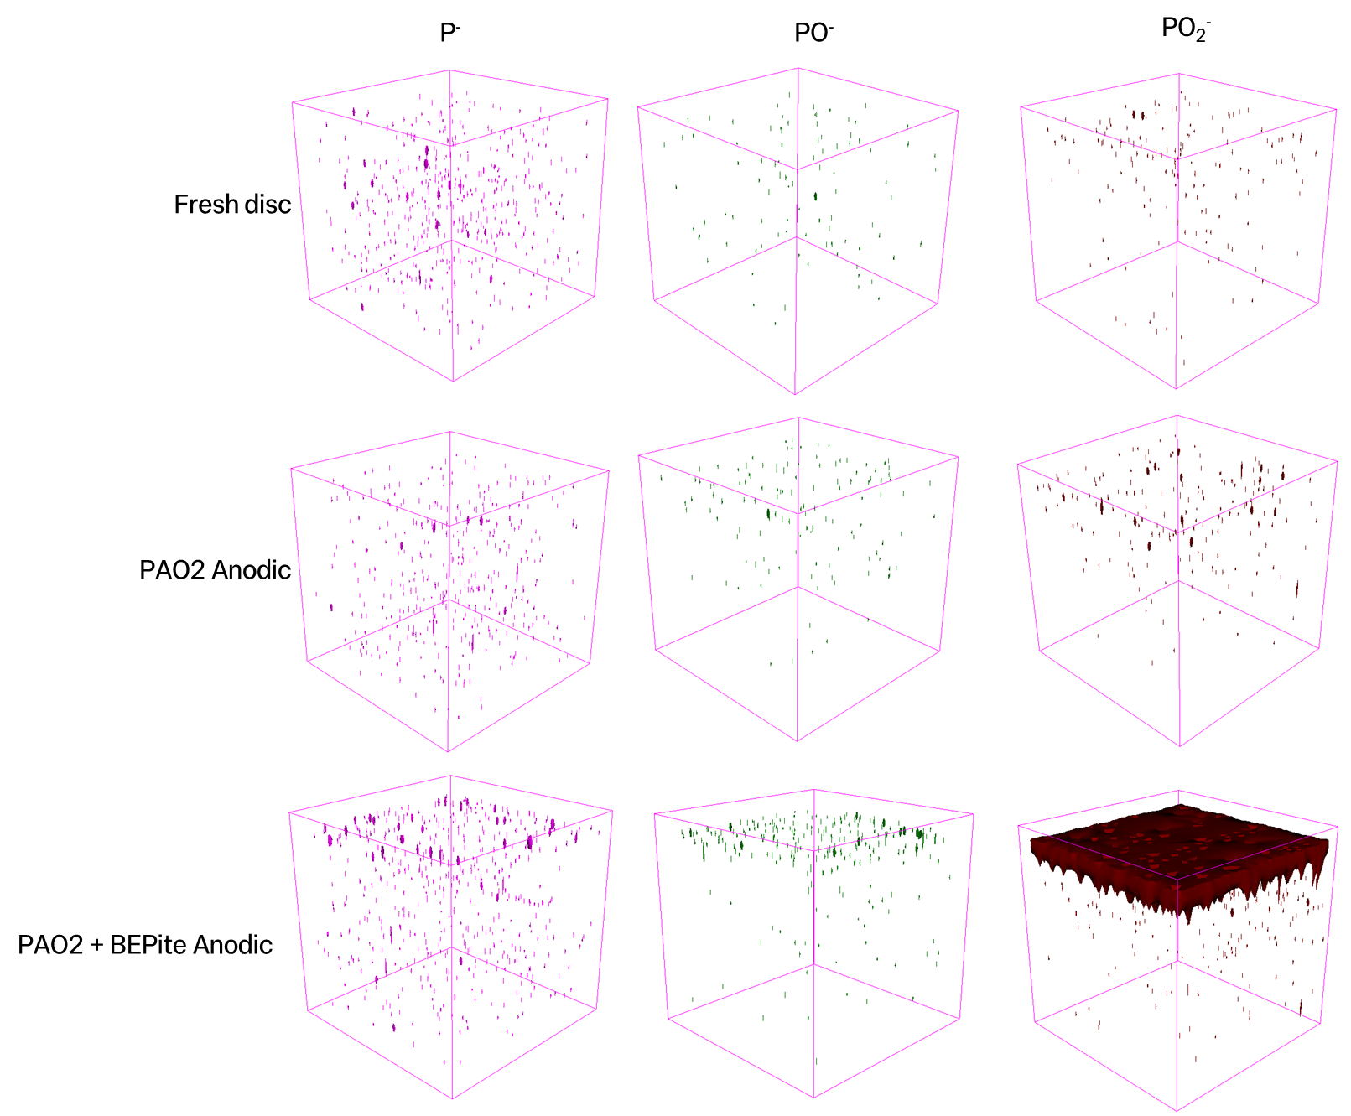

Figure S19. 3D TOF-SIMS tomographic reconstruction of P⁻, PO⁻ and PO₂⁻ distribution of discs.

