Balancing Power Harvesting and Data Reception in Inverted Perovskite SLIPT Receivers
Himal Muwanwella¹, Matthew Anderson², Antonio J. Riquelme³, Bahattin Bademci¹, Huiming Luo⁴, Siming Huang⁴, Jonathon Harwell⁵, John Buckeridge¹, Steven Dunn¹, Harald Haas², Mojtaba Abdi-Jalebi^{4*}, Iman Tavakkolnia^{2*}, Muhammad Tariq Sajjad^{1*}
¹School of Engineering and Design, London South Bank University, 103 Borough Road, London, SE1 0AA, UK
Email: sajjadt@lsbu.ac.uk; web: tariq-lab.com
²LiFi R&D Centre, Electrical Engineering Department, University of Cambridge, Trumpington Street, CB2 1PZ, Cambridge, UK
Email: it360@cam.ac.uk
³Université Grenoble Alpes, CEA, CNRS, Grenoble-INP, IRIG-SyMMES, 17 avenue des Martyrs, Grenoble, 38000 France
⁴Institute for Materials Discovery, University College London, Malet Place, WC1E 7JE, London, UK
Email: m.jalebi@ucl.ac.uk
⁵James Watt School of Engineering, University of Glasgow, Glasgow, G12 8QQ, UK

- Parameters extracted from JV characterizations for solar cells under different illumination
Table S1: Photovoltaic parameters extracted from J–V measurements of perovskite solar cells incorporating different HTLs under AM1.5G (100 mW cm⁻²), indoor illumination (1000 lux, 0.3 mW cm⁻²), and 650 nm laser excitation (16 mW cm⁻²).
HTL Type | 1 sun AM1.5G (100mW/cm²) |  |  |  | Indoor Light (1000lux 0.3mW/cm²) |  |  |  |  |  | 650nm Laser (16mW/cm²)
HTL Type | Voc  V | Jsc mA/cm² | FF  % | PCE  % |  | Voc  V | Jsc mA/cm² | FF  % | PCE  % | Voc  V |  | Jsc mA/cm² | FF  % | PCE  %
PEDOT: PSS | 0.76 | 22.10 | 74.99 | 12.65 |  | 0.75 | 0.13 | 65.00 | 20.66 | 0.70 |  | 9.45 | 60.41 | 30.73
MeO-2PACz | 1.02 | 25.49 | 75.25 | 19.49 |  | 0.82 | 0.14 | 80.68 | 30.10 | 0.98 |  | 10.05 | 71.27 | 54.00
PTAA | 0.90 | 25.22 | 63.87 | 14.56 |  | 0.74 | 0.14 | 65.67 | 22.56 | 0.92 |  | 8.47 | 56.93 | 33.96
PTAA: F4TCNQ | 0.91 | 25.46 | 67.63 | 15.75 |  | 0.75 | 0.15 | 67.44 | 23.60 | 0.94 |  | 10.42 | 53.76 | 40.69

- Structural Characterisation
  - X-ray diffraction (XRD) analysis
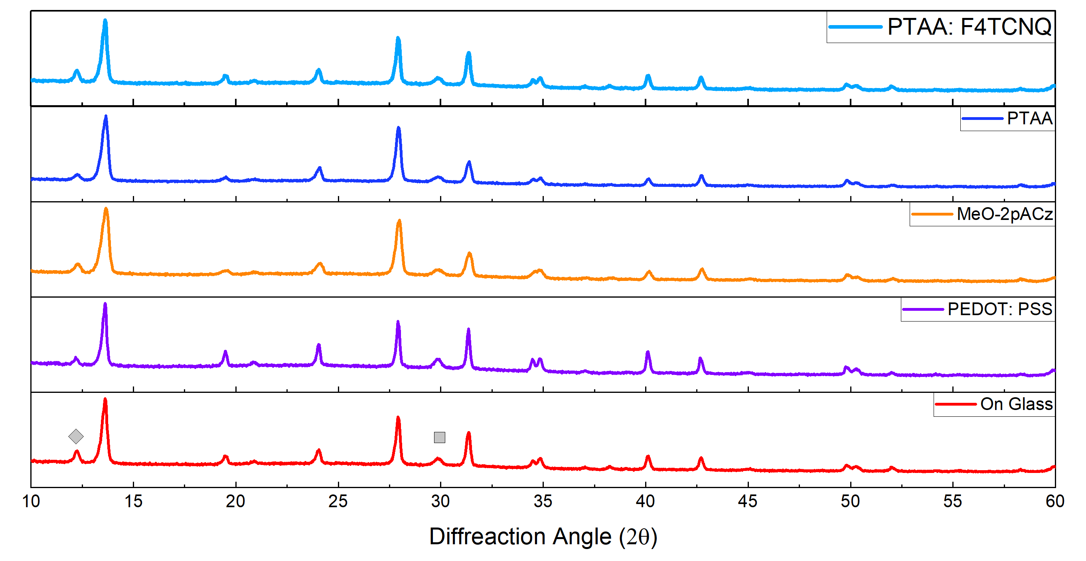

Figure S1: X-ray diffraction (XRD) spectra of perovskite films deposited on different HTLs.

Understanding defect formation in the perovskite layer is crucial for efficient charge generation and extraction. To examine whether different HTLs influence perovskite film formation, structural characterisation was performed.
The XRD spectra of perovskite films grown on different HTLs are shown in Figure S1. Nearly identical diffraction patterns are observed, including for films deposited on glass substrates, which are expected to exhibit highly passivated and well-crystallised structures[1]. This indicates that all HTLs support the formation of perovskite films with comparable crystal structures. Minor variations at the 12.8° (2θ) peak (marked with a diamond) are attributed to residual PbI₂[2], likely arising from sample-to-sample variation rather than HTL-dependent effects. The peak at 30° (marked with a square) originates from the ITO substrate and is used for alignment.
- Time-Resolved Photoluminescence (TRPL)
Table S2: TRPL fitting parameters obtained using a bi-exponential decay model for perovskite films deposited on different substrates.
Perovskite deposited on | τ₁ | τ₂ | % of B₁ | % of B₂ | <τ>_{amp} | Chi2
Glass | 53.1 | 1165.5 | 14.49 | 85.51 | 1004.4 | 1.24
PEDOT: PSS | 21.6 | 134.3 | 60.60 | 39.40 | 66.0 | 1.84
MeO-2PACz | 65.3 | 891.0 | 42.97 | 57.03 | 536.1 | 1.12
PTAA | 87.9 | 860.6 | 56.67 | 43.33 | 422.7 | 1.09
PTAA: F4TCNQ | 56.8 | 826.1 | 39.25 | 60.75 | 524.1 | 1.19

The TRPL spectra of perovskite films deposited on different HTLs (Figure 2b in the main manuscript) were fitted using a bi-exponential decay model. The average lifetime was calculated as:
$⟨τ⟩_{amp}=\frac{B_{1}τ_{1}+B_{2}τ_{2}}{B_{1}+ B_{2}}$
where τ₁ and τ₂ represent the fast and slow decay components, respectively, and B₁ and B₂ denote their corresponding amplitude weights. The presence of multicomponent decay behaviour indicates multiple recombination pathways, including possible back-transfer of holes from the HTL to the perovskite, resulting in a delayed decay component.
The difference between TRPL lifetime trends and communication bandwidth can be rationalised by considering operating conditions. TRPL probes recombination under negligible internal electric field, similar to open-circuit conditions. In contrast, under SLIPT operation near the MPP, the internal electric field assists carrier separation, reducing the influence of delayed recombination and weakening correlations between lifetime and bandwidth.
- Materials and Device Fabrication
  - Materials
Cesium iodide (CsI, 99.5%), [2-(3,6-dimethoxy-9H-carbazol-9-yl)ethyl]phosphonic acid (MeO-2PACz), Lead (II) iodide (PbI2, 99.99%), and Lead(II) Chloride (PbCl2, 99.0%) were purchased from TCI. N, N-dimethylformamide (DMF, 99.8%), dimethyl sulfoxide (DMSO, 99.8%), Isopropanol (IPA, 99.8%), toluene (99.8%), Chlorobenzene (CB, 99.9%), methanol (MeOH, 99.8%) and ethanol (EtOH, 99.8%) were purchased from Sigma Aldrich. Methylammonium iodide (MAI, 99.5%), Methylammonium bromide (MABr, 99.5%) and formamidinium iodide (FAI, 99.5%) were purchased from Greatcell Solar. PC60BM was purchased from 1-Material. Indium tin oxide (ITO, 15 Ω/sq) from Yingkou Shangsheng Business Co. Ltd, and Bathocuproine (BCP) were purchased, poly[bis(4-phenyl)(2,4,6-trimethylphenyl)amine (PTAA), 2,3,5,6-tetrafluoro-7,7,8,8-tetracyanoquinodimethane (F4-TCNQ) from Osilla Ltd, poly[(9,9-bis(3′-((N,N-dimethyl)-N-ethylammonium)-propyl)-2,7-fluorene)-alt-2,7-(9,9-dioctylfluorene)] dibromide (PFN-Br), poly(3,4-ethylenedioxythiophene) polystyrene sulfonate (PEDOT: PSS) From Merck. All chemicals were used as received without further purification.
  - Preparation
The PTAA solution with concentration of 1.5 mg/mL were prepared by dissolving it in toluene. The MeO-2PACz solution with concentration of 0.5 mg/mL were prepared by dissolving in EtOH. The 1.6 M perovskite precursor solution with the composition of FA0.8MA0.15Cs0.05PbI3 (bandgap: 1.55 eV) was prepared by fully dissolving CsI: 20.8 mg, MABr: 7.6 mg, MAI: 38.1 mg, FAI: 234 mg, PbI2: 738 mg, PbCl2:18 mg in a mixed solvent of DMF: 770 μL, DMSO:230 μL.
  - Solar Cell Fabrication
The inverted device architecture was ITO/SAMs/PVK/PC60BM/BCP/Ag. The ITO was washed with detergent, deionized water, acetone, and ethanol in sequence for 30 minutes. After that, the cleaned ITO substrate was dried by N₂ gas and then treated with plasma for 15 minutes. The 100 μL PEDOT: PSS was spin-coated on ITO for 30 s at 3000 rpm, and then annealed at 130 °C for 10 minutes. The 100 μL PTAA was spin-coated on ITO for 30 s at 3000 rpm, and then annealed at 100 °C for 10 minutes. The 100 μL PTAA doped with 3% F4TCNQ on the weight was spin-coated on ITO for 30 s at 3000 rpm, and then annealed at 100 °C for 10 minutes. The 100 μL MeO-2PACz was spin-coated on ITO for 30 s at 3000 rpm, and then annealed at 100 °C for 10 minutes. To prevent non-wetting issues, an ultra-thin layer of PFN-Br (0.4 mg mL⁻¹ in methanol) was spin-coated onto the Poly-TPD and PTAA films at 5000 rpm dynamically. Subsequently, 60 μL perovskite precursor was deposited on the HTL. The perovskite solution was spin-coated with 1000 rpm for 10 s, and 5000 rpm for 30 s. At 16 s before the end of the procedure, 150 μL CB as the antisolvent was dripped into the precast film surface. After that, the substrates were quickly transferred to a hot plate with 100 °C for 50 min annealing. After annealing 20mg/ml PC60BM in CB was spin-coated at 2500rpm on the PVK layer and annealed at 100oC followed by 0.5mg/ml BCP in anhydrous IPA (no annealing). The spin-coating processes were all conducted at room temperature (about 25 ℃) in a N2-filled glovebox. Finally, a 100 nm Ag electrode was thermally evaporated at a rate of 1.0 Å s⁻¹ under high vacuum (< 4 × 10⁻⁴ Torr).
  - Device characterization
4.4.1. Current–voltage (J–V) measurements
J–V measurement of the perovskite solar cells was determined using a Keithley 2400 source meter under simulated AM 1.5G illumination with an intensity of 100 mW/cm² from a solar simulator (Photo Emission Tech SS80 AAA) in ambient conditions. All J-V results are measured by scanning along the reverse and forward scans in the range of -0.2 V to 1.2 V with a step volt of 0.02 V and a delay time of 10 ms. Before testing, the light intensity was calibrated using a standard Si reference cell (Newport 91150-KG5). The device area was defined and characterized as 0.09 cm2 by a metal shadow mask. The same cells were then encapsulated and tested under indoor light (1000 lux, 0.3 mW/cm²) and 650 nm laser illumination (13 mW/cm²). The irradiance was measured using a spectroradiometer (MSC15 Spectral Light Meter Gigahertz-Optik).
    - Electrochemical impedance spectroscopy (EIS)
EIS measurements were performed using a Biologic potentiostat in a two-electrode configuration. A 10 mV AC perturbation was applied while sweeping frequencies from 4 MHz to 100 mHz under 650 nm illumination. At high frequencies, ionic motion is effectively frozen, and the response reflects electronic transport and recombination processes within the perovskite and at its interfaces.
$$f_{3dB}=\frac{1}{2πR_{tot}C_{tot}}$$
The −3 dB frequency response is inversely proportional to the RC product, where R includes series resistance (Rₛ) contributions and C corresponds primarily to the geometric capacitance Cg

Equivalent circuit used to fit the Nyquist plot
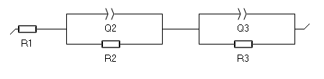

Figure S2: Equivalent circuit used to fit the Nyquist plots obtained from EIS measurements.

Evolution of the Nyquist spectra with operational point
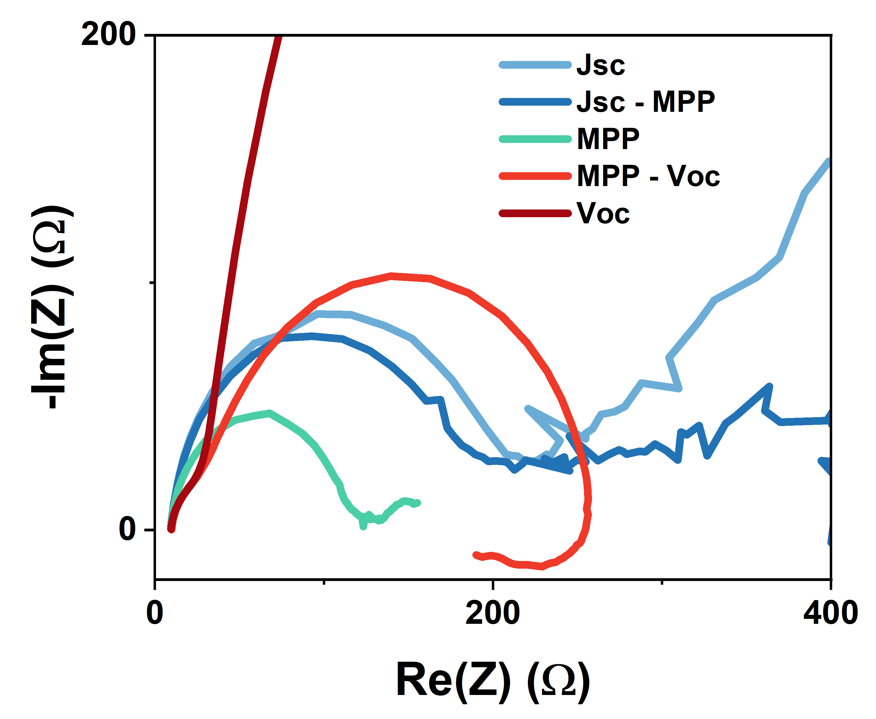
Figure S3: Evolution of Nyquist spectra as a function of applied bias. Blue shades indicate the transition from short circuit to MPP, green corresponds to MPP, and red indicates the transition from MPP to open circuit.
4.4.3 Geometric capacitance estimation
Bandwidth is strongly influenced by device capacitance, which can be estimated as:
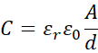
Since the active area (A) and perovskite thickness (d ≈ 500 nm) are identical for all devices, and the perovskite composition is unchanged, differences in capacitance primarily arise from variations in HTL material properties.
  - Communication measurements
The experimental setup for characterizing the PSCs for the SNR and data rates consists of a ~1 m free-space optical link using a 650 nm laser diode (LD), The LD is modulated by an arbitrary waveform generator (AWG). The laser beam is collimated at the transmitter and focused by a second lens onto the perovskite receiver. The receiver’s AC output is amplified by a low-noise amplifier (Mini-Circuits ZFL-1000LN+, +20 dB gain) before being recorded by an oscilloscope (Keysight MSO7104B). Both the oscilloscope and AWG (Keysight 33600A) are controlled by a PC, which also collects the measurement data. The oscilloscope’s 20 MHz low-pass filter is enabled. The AWG operates at its maximum sampling frequency of 1 GSa/s, with 25 samples per symbol and a 750 mV drive signal for laser modulation. Schematic of the setup used is shown in the. For simultaneous energy harvesting, a bias-tee was introduced to separate AC and DC components. Schematic is shown in Figure S4: Port 1 serves as the device input, port 2 outputs the RF signal through a capacitor (blocking DC), and port 3 extracts the DC component via an inductor that suppresses RF signals.
Figure S4: Bias-tee configuration
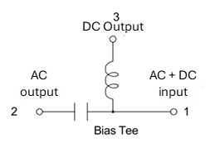
Data transmission is conducted with direct-current biased optical orthogonal frequency-division multiplexing (DCO-OFDM) the chosen modulation technique, owing to spectral efficiency. Moreover, the achievable data-rate is maximised using an adaptive bit and power loading algorithm to ensure the economical allocation of frequency resources, optimizing the bandwidth utilization under varying signal-to-noise ratio (SNR) conditions.
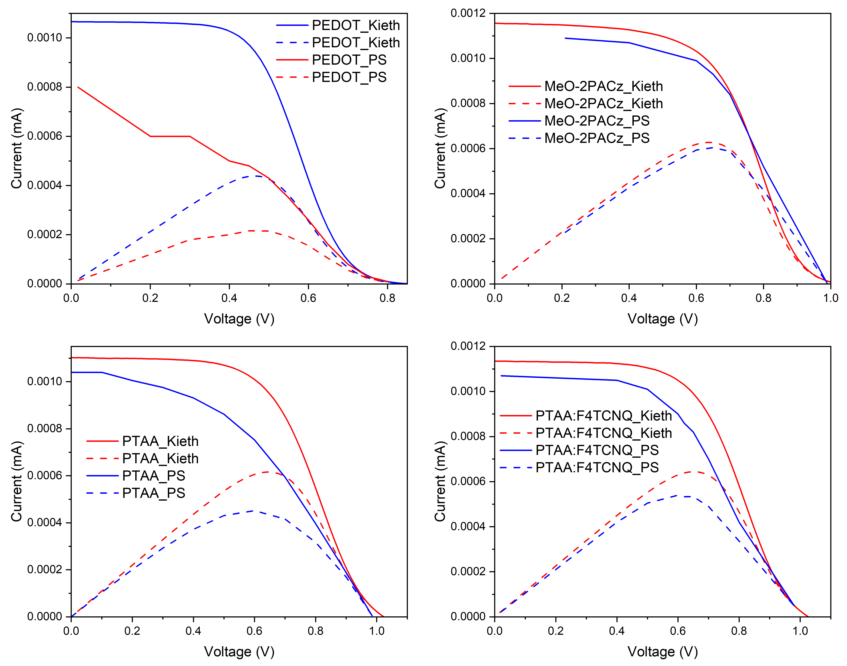
- Comparison of the power form JV curve and power measure from SLIPT
Figure S5: Comparison of harvested power measured during SLIPT operation and extracted from J–V curves
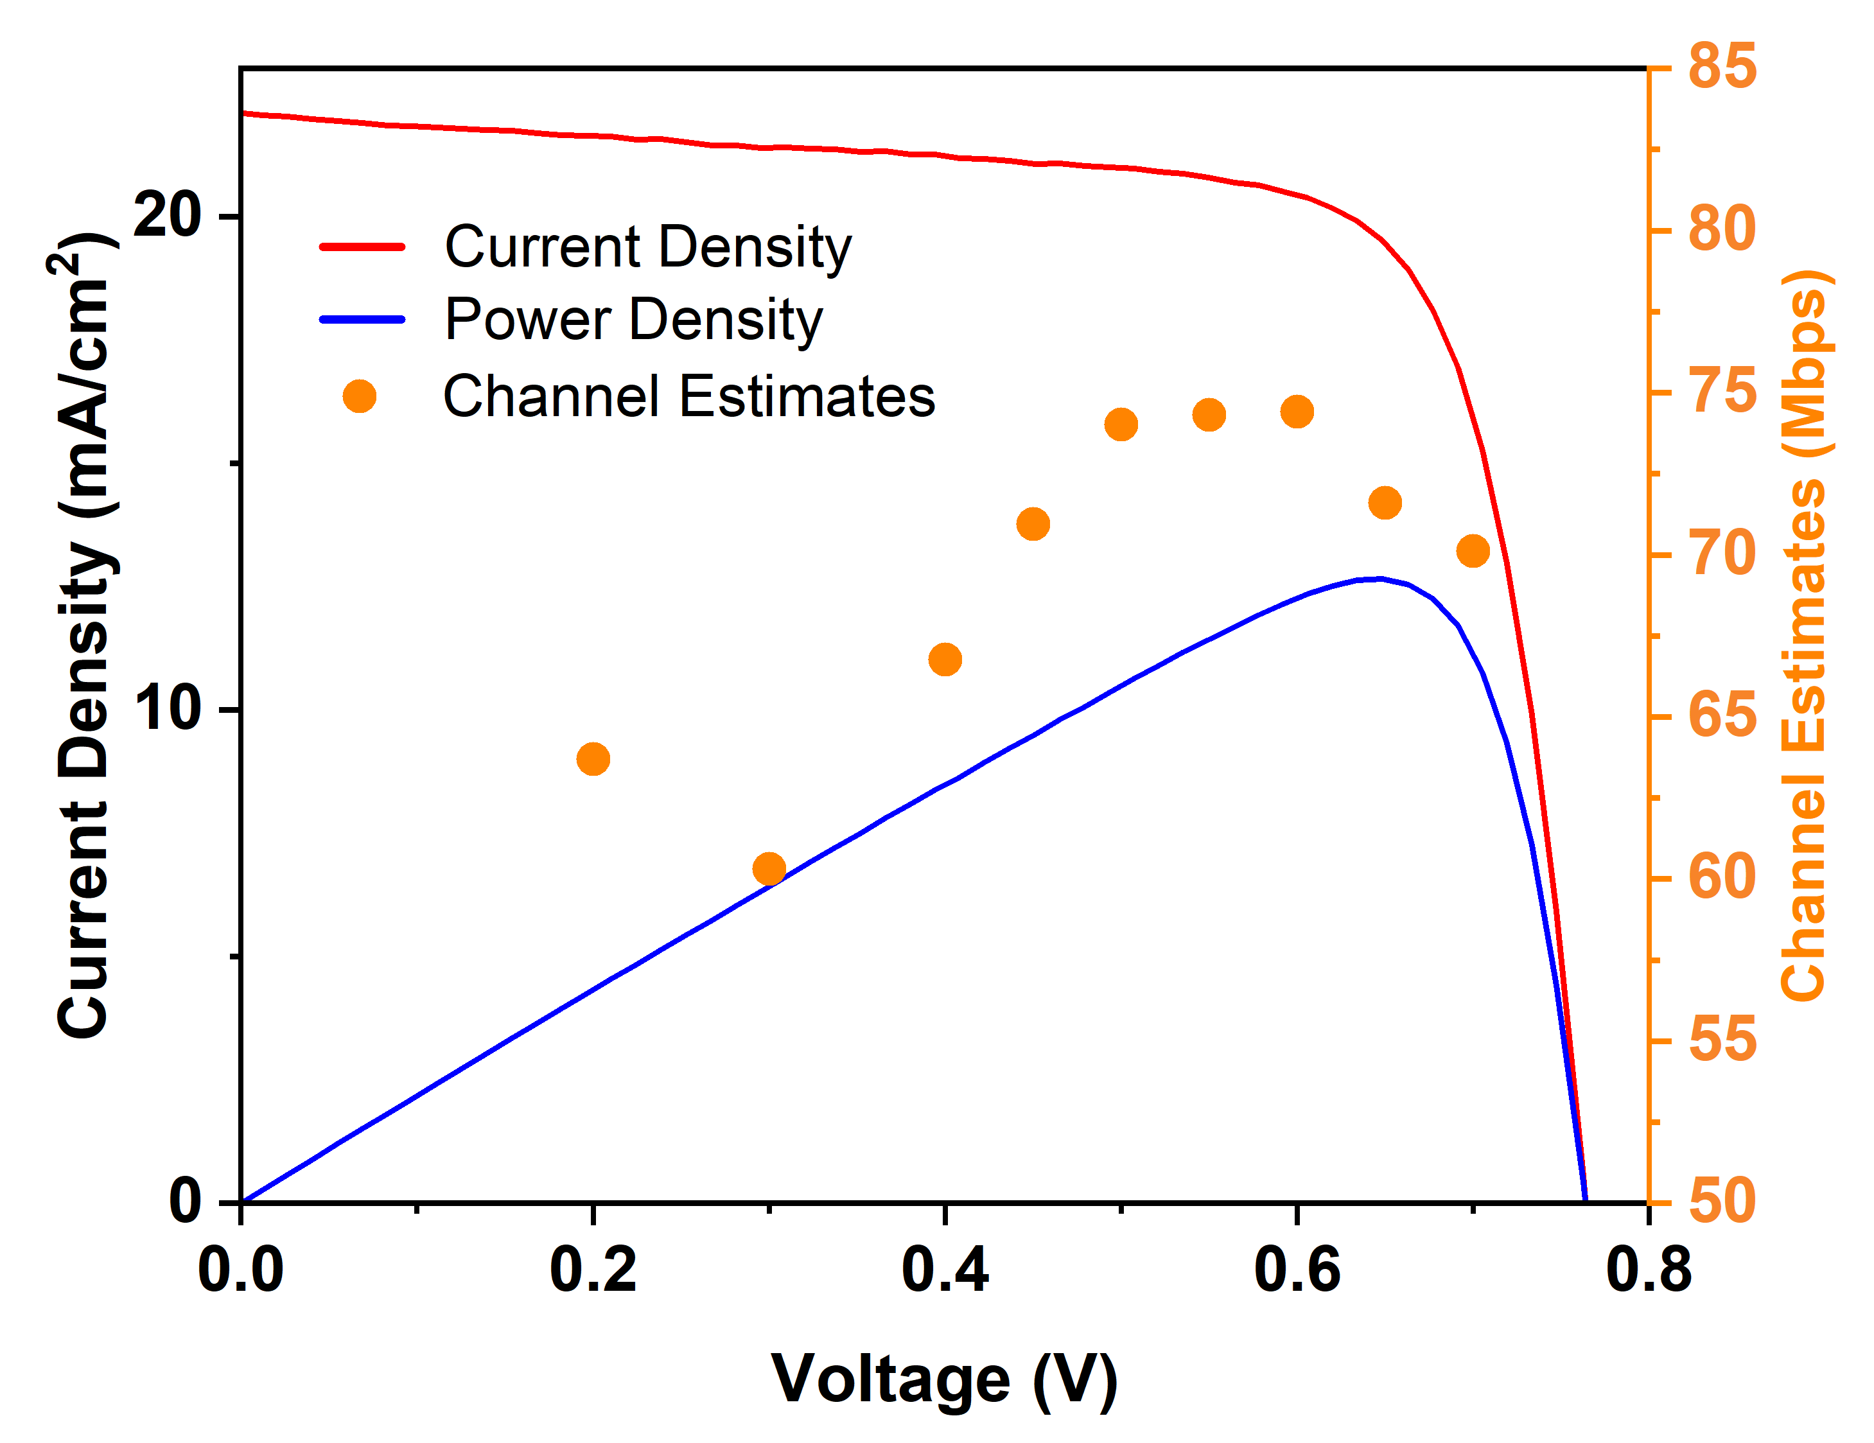
Power harvesting during SLIPT operation was measured using a variable load. The SLIPT power curves (blue) are based on discrete measurement points and exhibit lower accuracy compared to the J–V-derived power curves (red), which were obtained using a source-measurement unit. Both methods show consistent trends; therefore, J–V-derived power values were used for analysis.

Figure S6: Data rates and power generated at different operational points.
The data rates at different operational points are shown in Figure S6. As the bias is swept from J_{SC} toward the maximum power point (MPP), the data rate initially decreases until ~0.3 V, followed by an increase as the bias approaches the MPP (~0.7 V). Moving further towards V_{OC}, a slight reduction in data rate is observed. This trend is consistent with our discussion in the main text, where the internal RC dynamics partially compensate for the reduction in internal electric field as the bias shifts from J_{SC} toward V_{OC}.
Stability measurement
6.1 Maximum power point tracking (MPPT)
Devices were operated under maximum power point tracking for 500 hours while monitoring data rate and harvested power
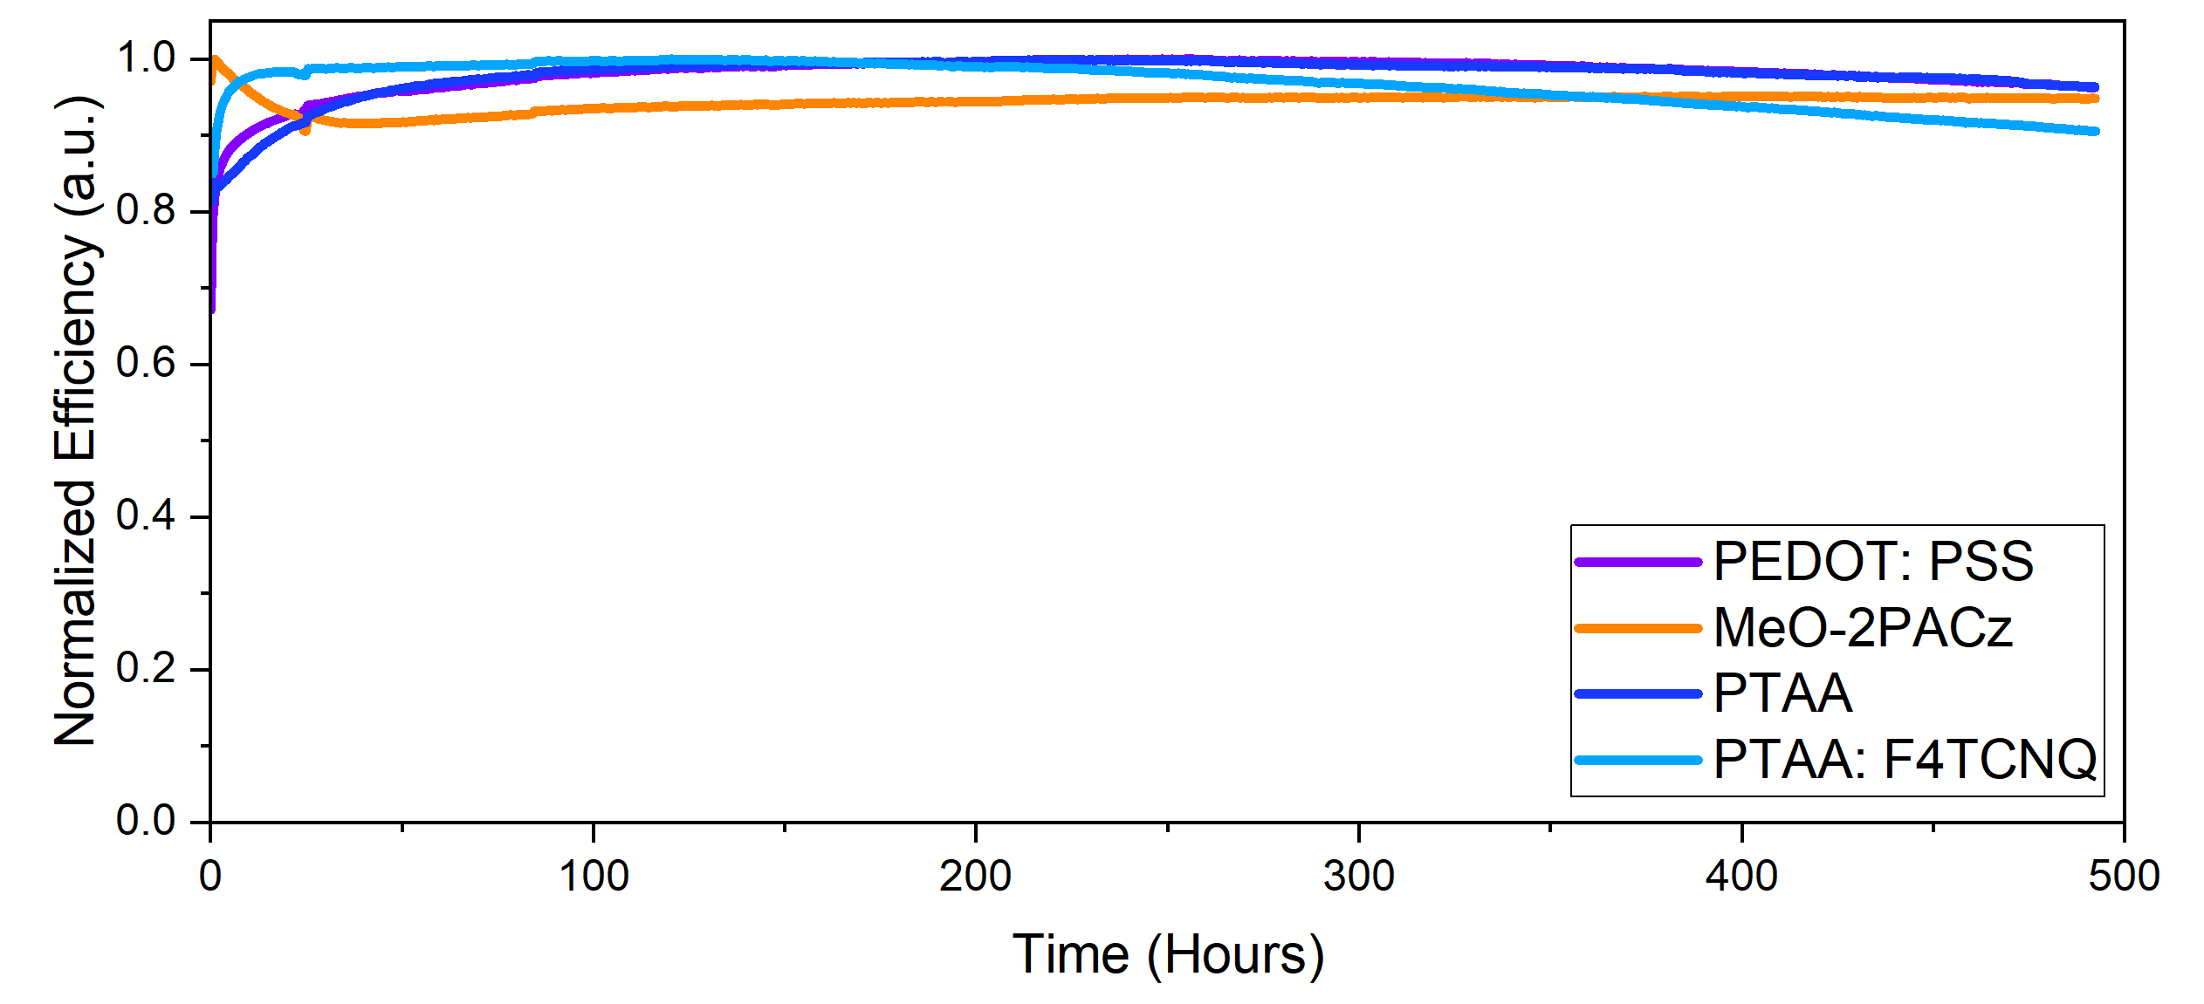
Figure S7: Maximum power point tracking (MPPT) stability measurements for devices incorporating different HTLs.

References
[1] M. Stolterfoht et al., ‘Visualization and suppression of interfacial recombination for high-efficiency large-area pin perovskite solar cells’, Nat. Energy, vol. 3, no. 10, pp. 847–854, Oct. 2018, doi: 10.1038/s41560-018-0219-8.
[2] P. Gratia et al., ‘The Many Faces of Mixed Ion Perovskites: Unraveling and Understanding the Crystallization Process’, ACS Energy Lett., vol. 2, no. 12, pp. 2686–2693, Dec. 2017, doi: 10.1021/acsenergylett.7b00981.

