Supplementay figure:
Supplementary Figure 1:
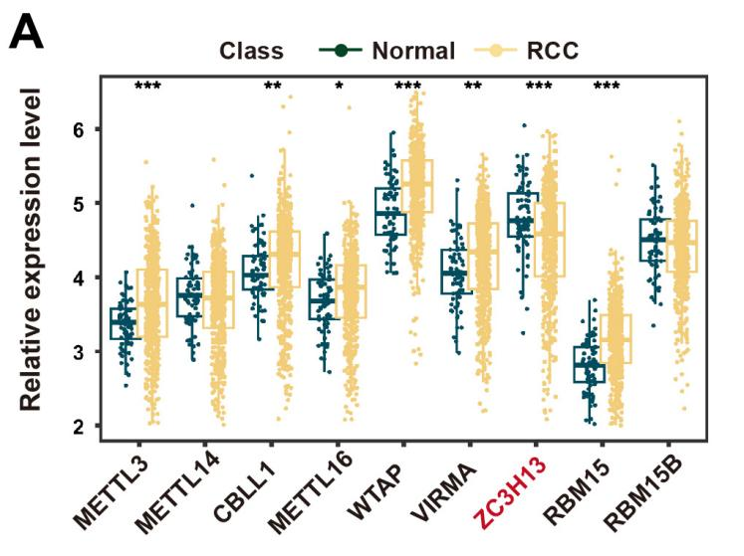
Supplementary Figure 1: Expression profiles of nine m⁶A methyltransferases ("writers") in RCC and normal samples in TCGA cohort. ns, not significant, *p < 0.05, **p < 0.01, ***p < 0.001. Analysis of 2-tailed t test [A]).
Supplementary Figure 2:
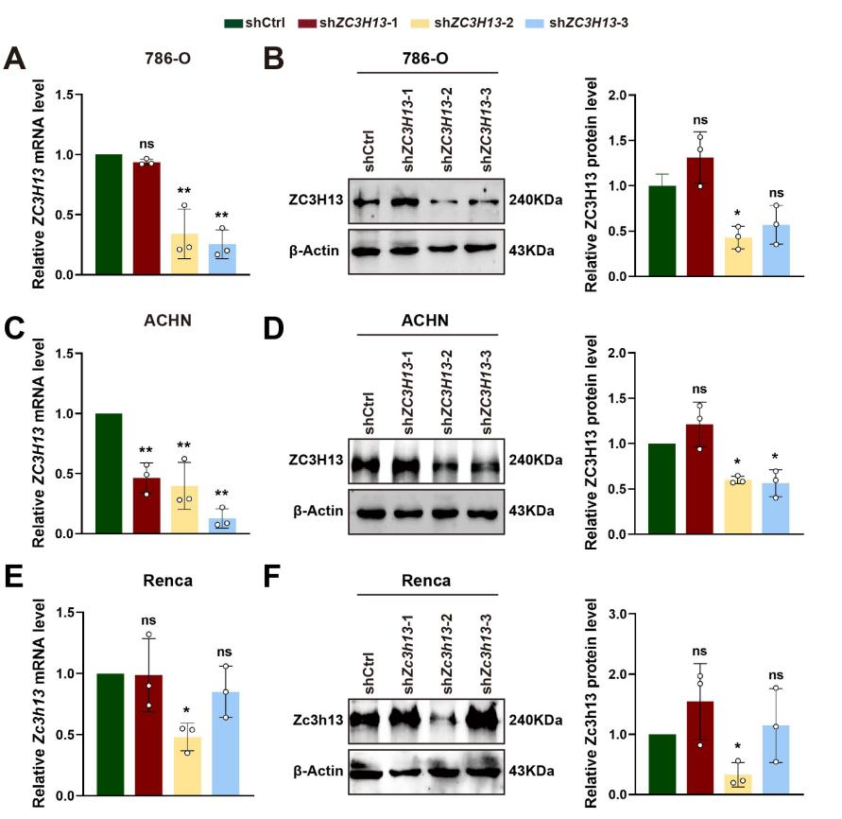
Supplementary Figure 2: Validation of ZC3H13 knockdown efficiency in renal cell carcinoma cell lines. (A) Knockdown efficiency of ZC3H13 was verified by qPCR and western blot in 786-O cells; (B) Knockdown efficiency of ZC3H13 was verified by qPCR and western blot in ACHN cells; (C) Knockdown efficiency of ZC3H13 was verified by qPCR and western blot in Renca cells. All histogram chart data are presented as the mean ± SD. Statistical analyses were performed by Graphpad Prism 9.5. n = 3 biological replicates. ns, not significant, *p < 0.05, **p < 0.01. Analysis of one-way ANOVA [A-F].
Supplementary Figure 3:
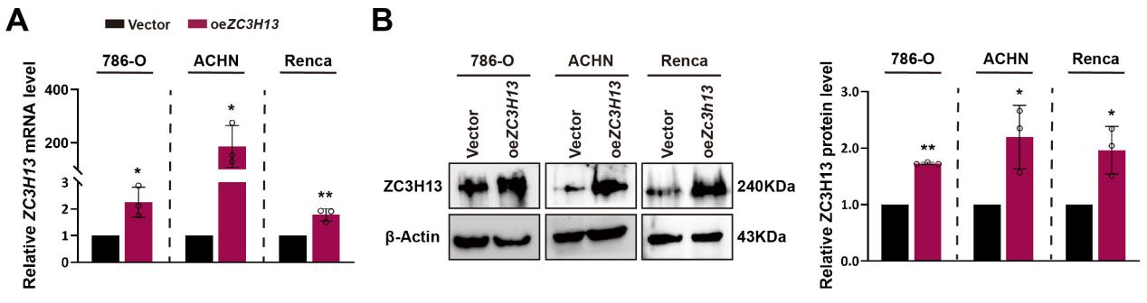
Supplementary Figure 3: Validation of ZC3H13 overexpression efficiency via qPCR and western blot in renal cell carcinoma cell lines. All histogram chart data are presented as the mean ± SD. Statistical analyses were performed by Graphpad Prism 9.5. n = 3 biological replicates. ns, not significant, *p < 0.05, **p < 0.01. Analysis of 2-tailed t test [A, B]).
Supplementary Figure 4:
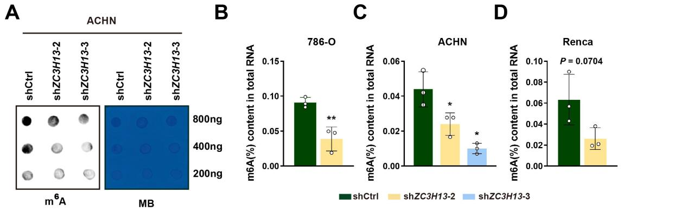
Supplementary Figure 4: Global m⁶A modification levels are altered by ZC3H13 manipulation. (A) Effects of ZC3H13 knockdown on m⁶A modification levels in ACHN cells, as determined by dot blot analysis. (B-D) Effects of ZC3H13 knockdown on m⁶A modification levels in 786-O/ACHN/Renca cells, as measured by ELISA. All histogram chart data are presented as the mean ± SD. Statistical analyses were performed by Graphpad Prism 9.5. n = 3 biological replicates. ns, not significant, *p < 0.05, **p < 0.01. Analysis of one-way ANOVA [C]; 2-tailed t test [B, D]).
Supplementary Figure 5:
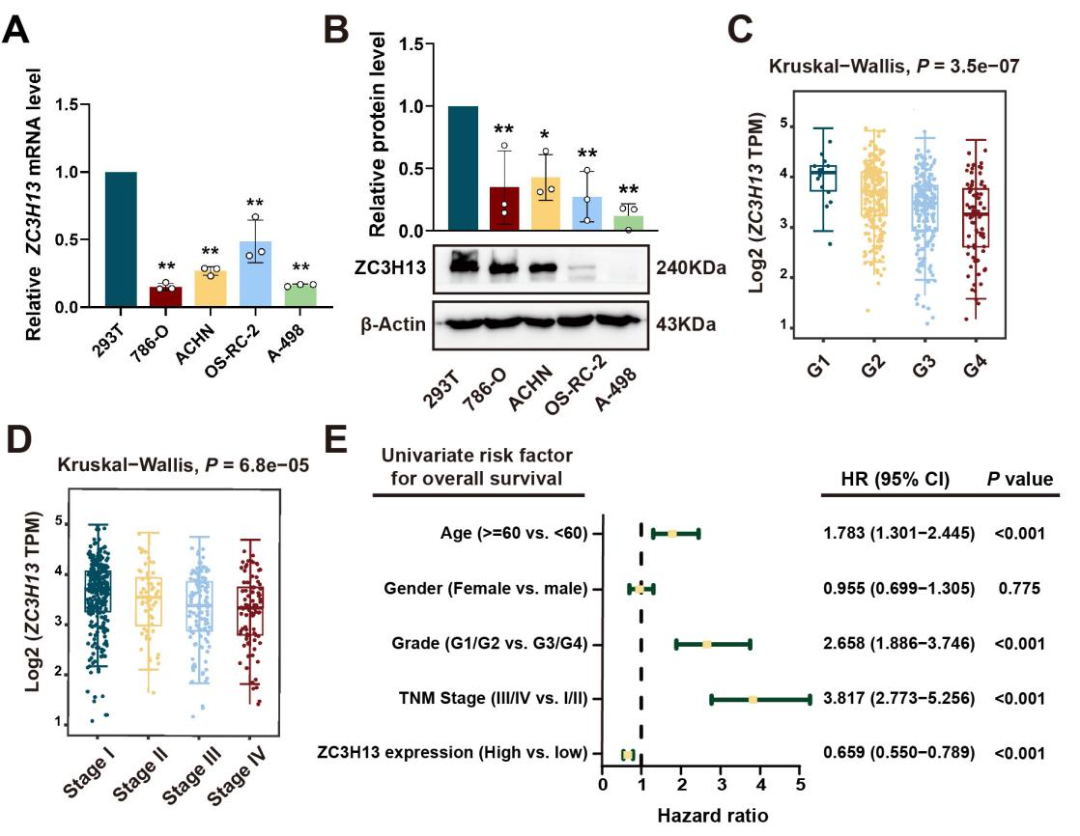
Supplementary Figure 5: ZC3H13 Expression in Renal Cell Carcinoma Cell Lines and Its Correlation with Pathological Grade, Stage, and Prognosis. (A-B) ZC3H13 expression in 293T and human RCC cell lines was measured by qPCR and western blot. (C-D) Box plots showing ZC3H13 expression across pathological grades and stages. (E) Univariate analyses were performed in the TCGA-KIRC cohort. All the bars correspond to 95% confidence intervals (CI); HR: hazard rate. All histogram chart data are presented as the mean ± SD. Statistical analyses were performed by Graphpad Prism 9.5. n = 3 biological replicates. ns, not significant, *p < 0.05, **p < 0.01. Analysis of one-way ANOVA [A, B]; Kruskal-Wallis test [C, D], Cox regression [E].
Supplementary Figure 6:
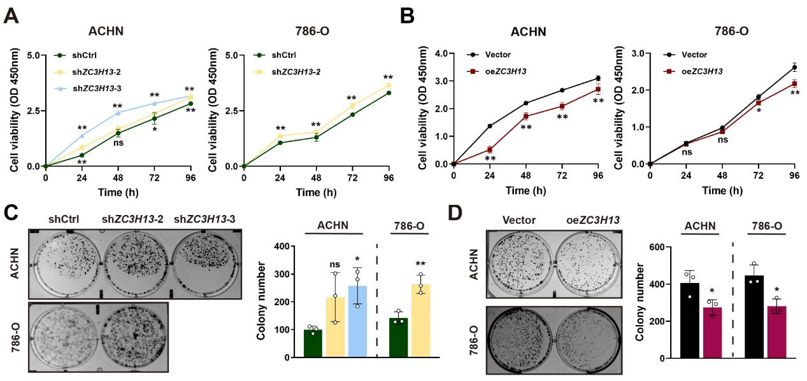
Supplementary Figure 6. ZC3H13 modulates RCC cell proliferation. (A, C) Knockdown of ZC3H13 enhanced cell proliferation as assessed by CCK-8 assay (A) and colony formation assay (C). (B, D) Overexpression of ZC3H13 attenuated cell proliferation, evaluated by CCK-8 assay (B) and colony formation assay (D). All histogram chart data are presented as the mean ± SD. Statistical analyses were performed by Graphpad Prism 9.5. n = 3 biological replicates. ns, not significant, *p < 0.05, **p < 0.01. Analysis of one-way ANOVA [A, B, C-ACHN], 2-tailed t test [C-786-O, D]).
Supplementary Figure 7:
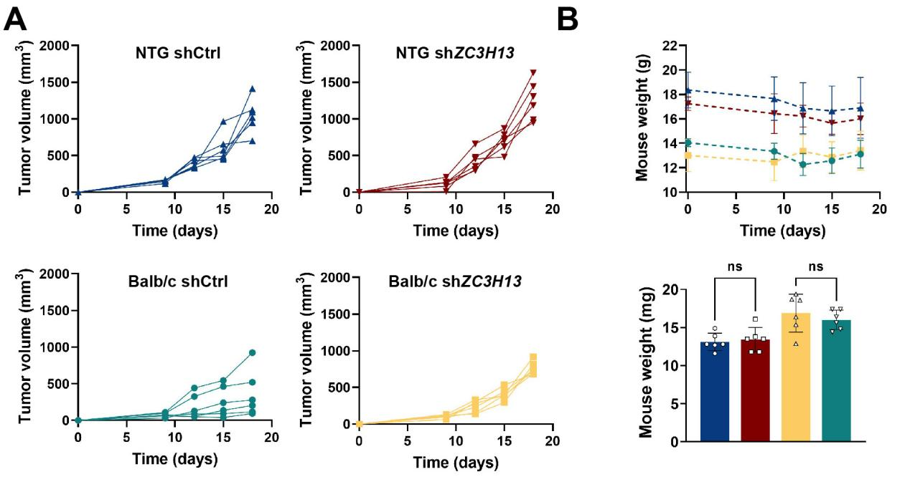
(A) Tumor growth curves of the four experimental groups (n=6). (B) Body weights of mice across the four experimental groups. All histogram chart data are presented as the mean ± SD. Statistical analyses were performed by Graphpad Prism 9.5. n = 3 biological replicates. ns, not significant, *p < 0.05, **p < 0.01. Analysis of one-way ANOVA [B].
Supplementary Figure 8:
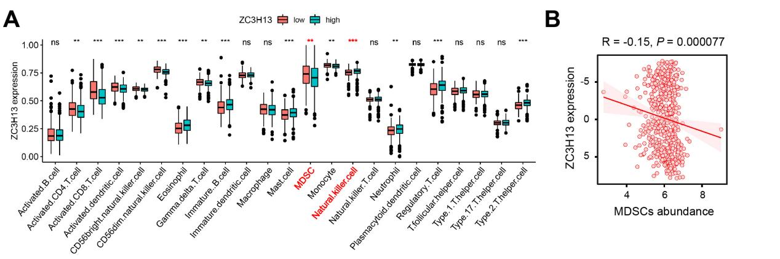Supplementary Figure 8: Low ZC3H13 expression group exhibited increased infiltration of MDSCs. (A) ssGSEA assessing the relationship between ZC3H13 mRNA expression and the infiltration levels of 23 immune cell types in the renal cancer immune microenvironment; (B) Analysis of the correlation between ZC3H13 expression and MDSCs infiltration in renal cell carcinoma using the TSIDB database. ns, not significant, *p < 0.05, **p < 0.01. Analysis of 2-tailed t test [A]), Pearson χ² test [B]).
Supplementary Figure 9:
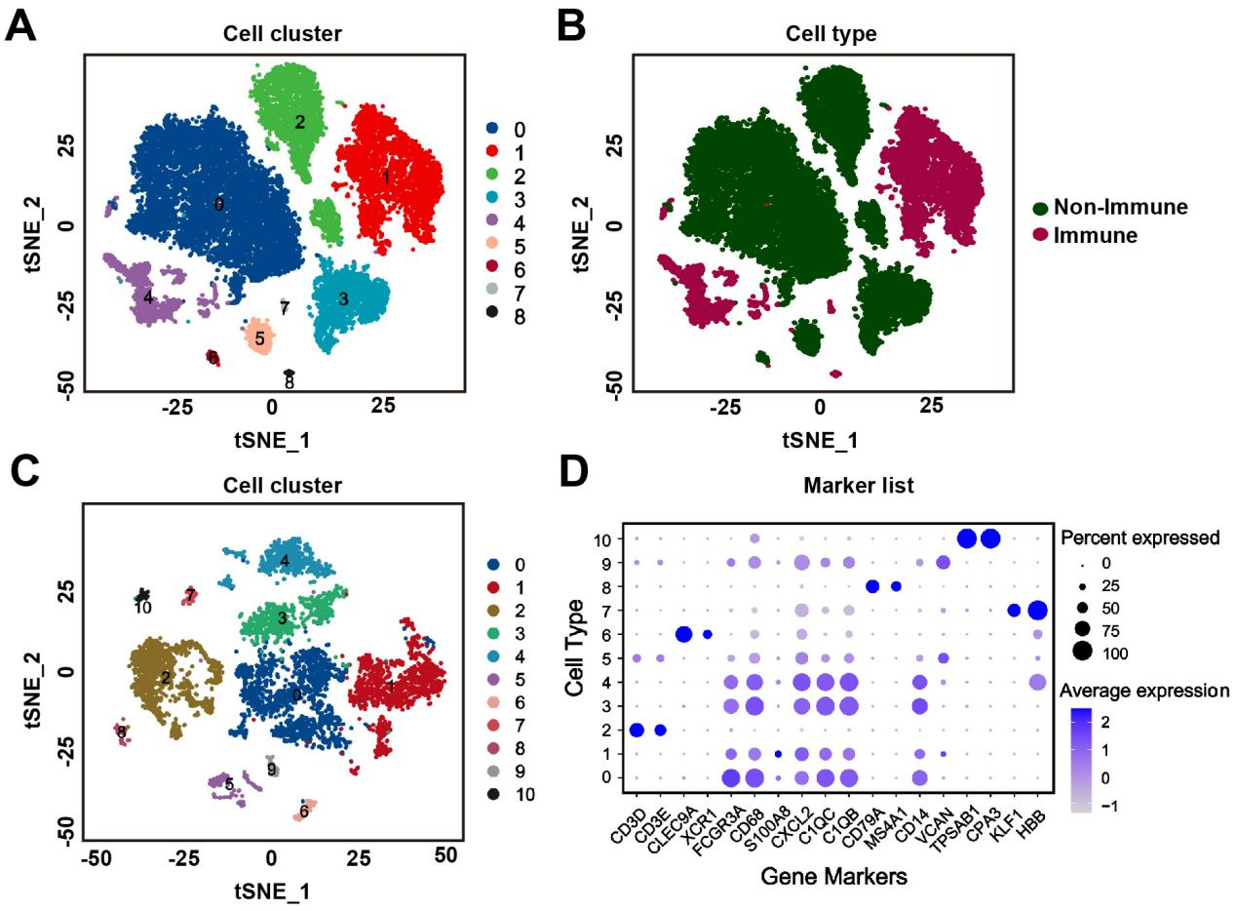
Supplementary Figure 9: . Overview of Single Cells Derived from GSE159115. (A-B) tSNE plot of all the single cells, with each color coded for (A) 8 major cell types, and (B) immune cell (CD45+ ) or non-immune cell (CD45-). (C) tSNE plot of immune cells, with each color coded for 10 major cell types. (D) Top two marker genes of 10 major cell types identified in this profile.
Supplementary Figure 10:
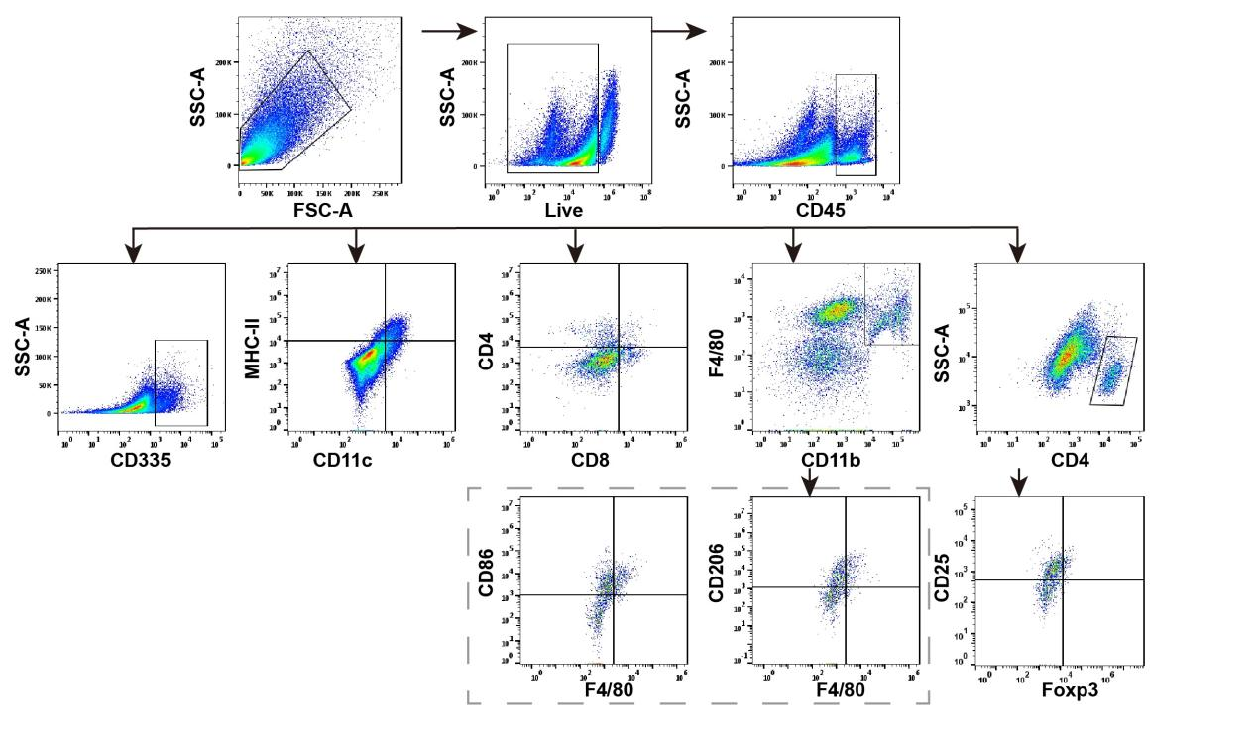
Supplementary Figure 10: Comprehensive profiling of immune cell infiltration in allograft tumors. Gating strategy of tumor infiltrating immune cells, including Helper T cell (CD45+CD4+), Cytotoxic T cell (CD45+CD8+), NK cell (CD335+), MDSCs (CD11b+Gr-1+), dendritic cell (CD11c+MHCII+), M1 macrophage (CD11b+F4/80+CD86+) , M2 macrophage (CD11b+F4/80+CD206+) and regulatory T cells (Tregs, CD4+CD25+Foxp3+).
Supplementary Figure 11:
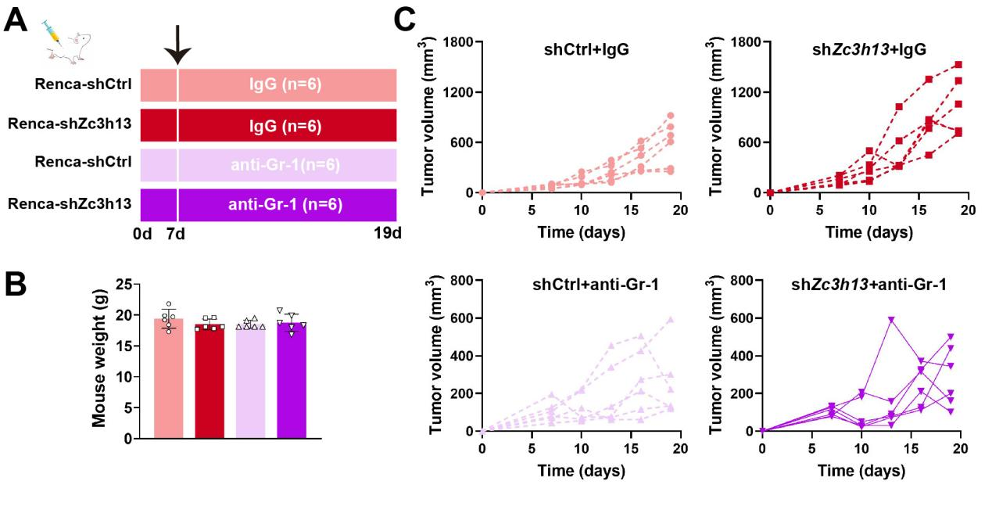
Supplementary Figure 11: (A) Schematic model depicting the experimental design of anti-Gr-1 treatment or IgG in Renca-shCtrl and Renca-shZc3h13 allograft-bearing mice. (B) Body weights of mice across the four experimental groups. (C) Tumor growth curves of the four experimental groups.
Supplementary Figure 12:
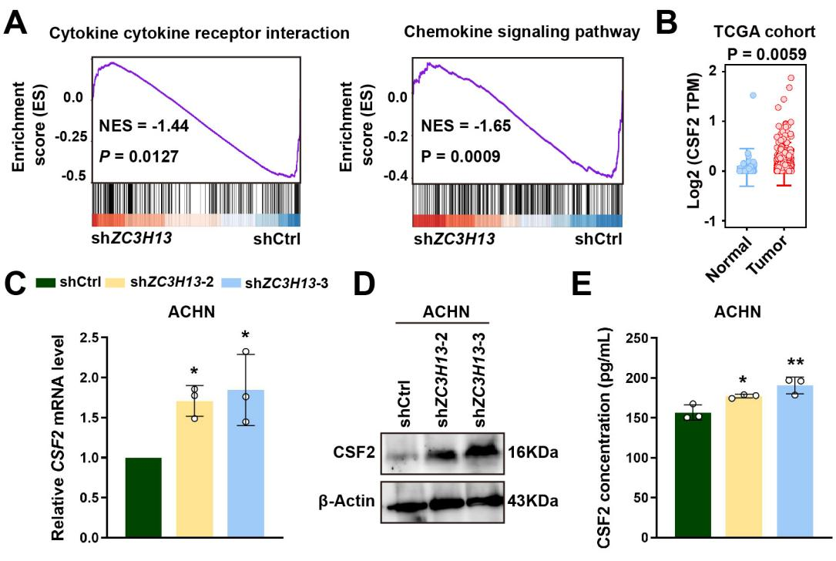
Supplementary Figure 12: Screening identifies CSF2 as a key cytokine downstream of ZC3H13. (A) GSEA enrichment plots for cytokine and cytokine receptor pathways and chemokine signaling pathways. (B) Expression profiles of CSF2 in RCC and normal samples of TCGA cohort. (C-D) The mRNA and protein expression levels of CSF2 following ZC3H13 knockdown in ACHN cells were detected by qPCR and western blot. (E) ELISA analysis of CSF2 secretion in the supernatant of ACHN cells with or without ZC3H13 knockdown. All histogram chart data are presented as the mean ± SD. Statistical analyses were performed by Graphpad Prism 9.5. n = 3 biological replicates. ns, not significant, *p < 0.05, **p < 0.01. Analysis of ANOVA test [C, E]; 2-tailed t test [B]).
Supplementary Figure 13:
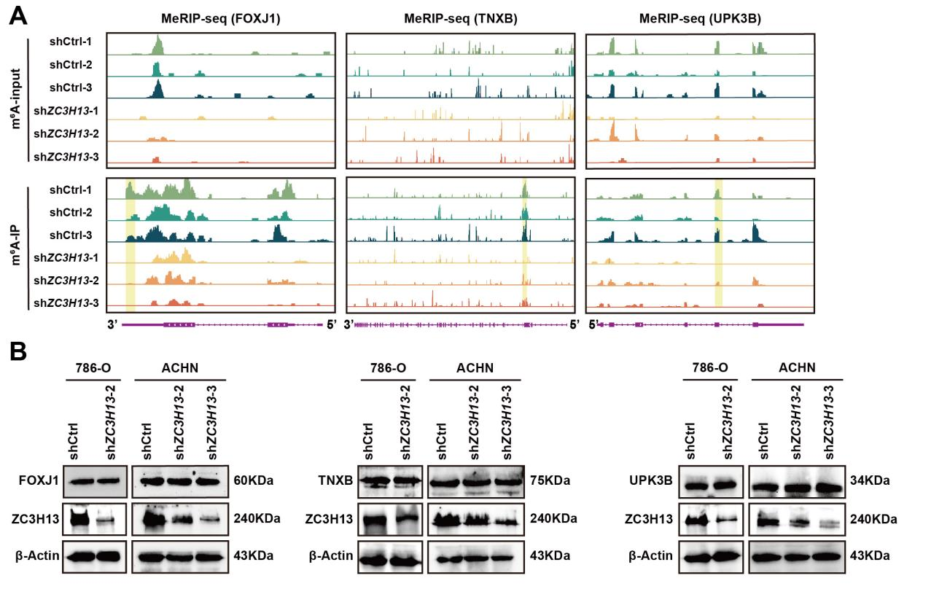
Supplementary Figure 13: Screening and validation of downstream targets of ZC3H13. (A) IGV visualization of MeRIP-seq reads along indicated mRNAs. (B) Protein levels of TNXB, UPK3B, and FOXJ1 following ZC3H13 knockdown in 786-O/ACHN/RenCa cells.
Supplementary Figure 14:

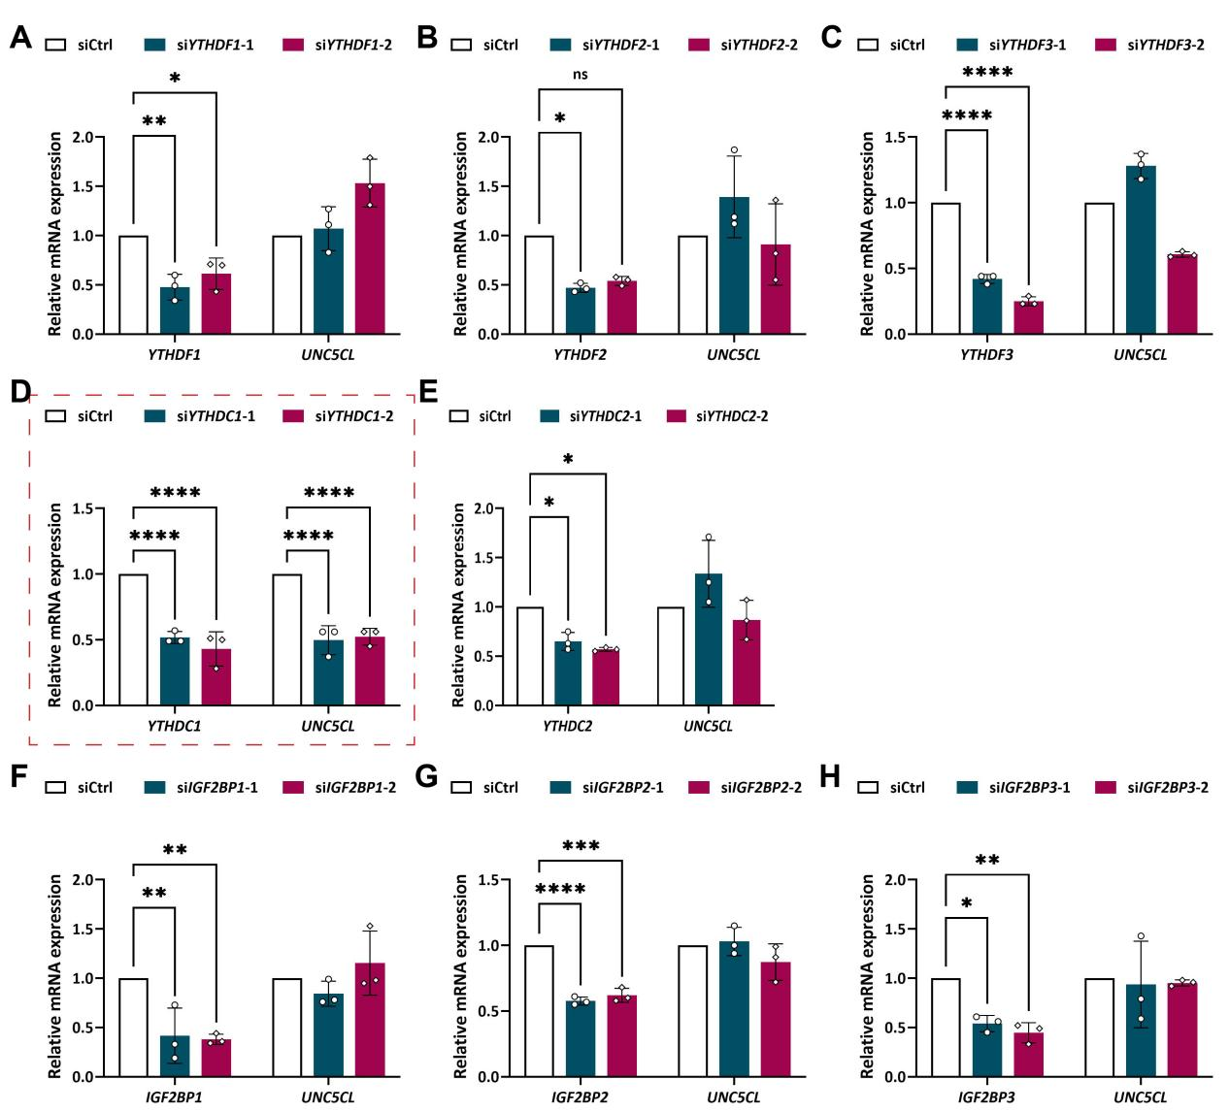
Supplementary Figure 14: YTHDC1-mediated stabilization of UNC5CL transcripts. (A-C) Effect of m⁶A reader (YTHDF1/2/3) silencing on UNC5CL mRNA levels in 786-O cells. (D-E) Effect of m⁶A reader (YTHDC1/2) silencing on UNC5CL mRNA levels in 786-O cells. (F-H) Effect of m⁶A reader (IGF2BP1/2/3) silencing on UNC5CL mRNA levels in 786-O cells. All histogram chart data are presented as the mean ± SD. Statistical analyses were performed by Graphpad Prism 9.5. n = 3 biological replicates. ns, not significant, *p < 0.05, **p < 0.01. Analysis of one way ANOVA test [A-H].
Supplementary Figure 15:
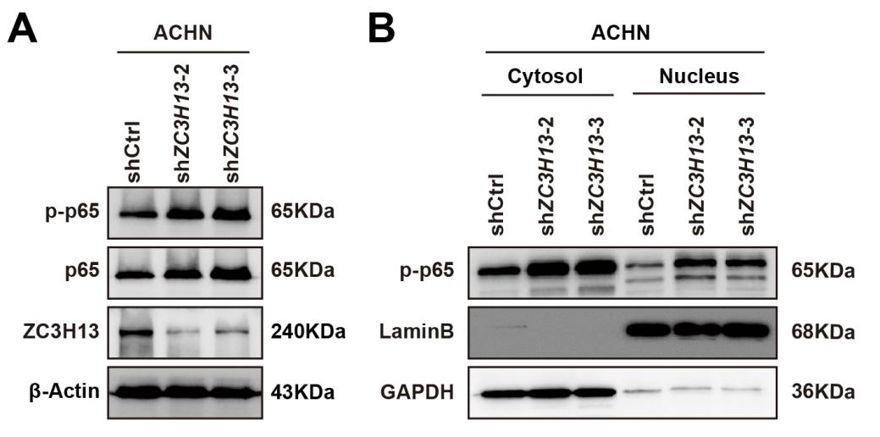
Supplementary Figure 15: Loss of ZC3H13 activates the NF-κB-CSF2 signaling axis. (A) Western blot analysis of p65 and p-p65 expression following ZC3H13 knockdown in ACHN cells. (B) Nuclear and cytoplasmic fractionation assays were conducted to determine the subcellular distribution of p-p65 after ZC3H13 knockdown.

Supplementary tables
Table S1. Target sequences of siRNAs or shRNAs
 | sense（5'-3'） | antisense（5'-3'）
siYTHDF1-1 | GGCUGGAGAAUAACGACAATT | UUGUCGUUAUUCUCCAGCCTT
siYTHDF1-2 | GGAUACAGUUCAUGACAAUTT | AUUGUCAUGAACUGUAUCCTT
siYTHDF2-1 | GGUGGAUGGUAAUGGAGUATT | UACUCCAUUACCAUCCACCTT
siYTHDF2-2 | GCUCUGGAUAUAGUAGCAATT | UUGCUACUAUAUCCAGAGCTT
siYTHDF3-1 | CAUACAUCGUUCCAUUAAATT | UUUAAUGGAACGAUGUAUGTT
siYTHDF3-2 | GUCAGUGCUUCACCUUCUATT | UAGAAGGUGAAGCACUGACTT
siYTHDC1-1 | GCUCUGCAUCAGAGUCAUATT | UAUGACUCUGAUGCAGAGCTT
siYTHDC1-2 | GCAAGGAGUGUUAUCUUAATT | UUAAGAUAACACUCCUUGCTT
siYTHDC2-1 | GGCAGAGAACUGUUCUAAATT | UUUAGAACAGUUCUCUGCCTT
siYTHDC2-2 | GCAUCCUGUUUGAUGACAATT | UUGUCAUCAAACAGGAUGCTT
siIGF2BP1-1 | GAGAUGGUGCAGGUGUUUATT | UAAACACCUGCACCAUCUCTT
siIGF2BP1-2 | CGGUGAACGAGUUGCAGAATT | UUCUGCAACUCGUUCACCGTT
siIGF2BP2-1 | CAGUUUGAGAACUACUCCUTT | AGGAGUAGUUCUCAAACUGTT
siIGF2BP2-2 | GUGAAUCUCUUCAUCCCAATT | UUGGGAUGAAGAGAUUCACTT
siIGF2BP3-1 | GCUGAGAAGUCGAUUACUATT | UAGUAAUCGACUUCUCAGCTT
siIGF2BP3-2 | GCUAGACAAGCACUAGACATT | UGUCUAGUGCUUGUCUAGCTT
shZC3H13-1 | CCTCACAATCAGGATCATCTA | TAGATGATCCTGATTGTGAGG
shZC3H13-2 | GAAAGTTCTCGTACGGAAATA | TATTTCCGTACGAAGACTTTC
shZC3H13-3 | CCTCTCCTTATCCTTCACATT | AATGTGAAGGATAAGGAGAGG
shZc3h13-1 | GCAGCTGCCTCTATGGAAACACTC | GAGTGTTTCCATAGAGGCAGCTGC
shZc3h13-2 | GATTCTGACAATGGAGATATTCTC | GAGAATATCTCCATTGTCAGAATC
shZc3h13-3 | GCTAGGGATGCTCGGGATATTCTC | GAGAATATCCCGAGCATCCCTAGC
Table S2. Primer sequences
Quantitative real-time PCR
ZC3H13-F | TCTGATAGCACATCCCGAAGA
ZC3H13-R | CAGCCAGTTACGGCACTGT
Zc3h13-F | GATGACCAGGGTAGTCGGAAG
Zc3h13-R | GGTTCTCCACGCTTTAACTGA
UNC5CL-F | CGGAGAAAAGCAGCCGATGA
UNC5CL-R | ATCCTGGAAGGTGTGCATGG
Unc5cl-F | AAGGCAGCCAATGGGAATGA
Unc5cl -R | CAGGTCTCTTCCTCCGATGC
CSF2-F | CTGGAGCTGTACAAGCAGGG
CSF2-R | CACAGGAAGTTTCCGGGGTT
Csf2-F | GGGTCTACGGGGCAATTTCA
Csf2-R | CACAGTCCGTTTCCGGAGTT
GAPDH-F | AGAAGGCTGGGGCTCATTTG
GAPDH-R | AGGGGCCATCCACAGTCTTC
Gapdh-F | AGGTCGGTGTGAACGGATTTG
Gpadh-R | GGGGTCGTTGATGGCAACA
YTHDF1-F | TGGACACCCAGAGAACAAAAGG
YTHDF1-R | CCAATGGACGGCGGGTAATA
YTHDF2-F | CTGTTGGTAGCGGGTCCATT
YTHDF2-R | GCCCAAGATGCTGGTTTTGG
YTHDF3-F | TGTGGGAATTGGGGGTTCTG
YTHDF3-R | GGAGCCTTTACCACTGACCC
YTHDC1-F | TATGGTCCACGCTCCCTGTA
YTHDC1-R | GCTGGAAGCACCCAGTGTAT
YTHDC2-F | AAAAGAGTCAGGACTGGGGC
YTHDC2-R | ACGTTCCCATAACTGGAGCA
IGF2BP1-F | ATCGGCAACCTCAACGAGAG
IGF2BP1-R | GTTTCGATGGCCTTCATCGC
IGF2BP2-F | CTACGCCTTCGTGGACTACC
IGF2BP2-R | TGTTGACTTGTTCCACATTCTCC
IGF2BP3-F | ACTGCACGGGAAACCCATAG
IGF2BP3-R | TCCCACTGTAAATGAGGCGG
iNos-F | GTTCTCAGCCCAACAATACAAGA
iNos-R | GTGGACGGGTCGATGTCAC
Arg1-F | CTCCAAGCCAAAGTCCTTAGAG
Arg1-R | AGGAGCTGTCATTAGGGACATC
PD-L1-F | GCTCCAAAGGACTTGTACGTG
PD-L1-R | TGATCTGAAGGGCAGCATTTC
Asns-F | GCAGTGTCTGAGTGCGATGAA
Asns-R | TCTTATCGGCTGCATTCCAAAC
IL-10-F | GCTCTTACTGACTGGCATGAG
IL-10-R | CGCAGCTCTAGGAGCATGTG
MeRIP-qPCR
UNC5CL-F | TAGTTCTGGATGGCGGAGGC
UNC5CL-R | TGCTCCTACACCCTTCTCTTCCT
Table S3. Antibody list
β-Actin | TransGen | HC201-02
ZC3H13 | Abcam | ab70802
ZC3H13 | Bioss | bs-18461R
UNC5CL | Invitrogen | PA5-30917
UNC5CL | origin | TA337008
p65 | CST | 8242S
p-p65 | CST | 3033S
GM-CSF | absin | abs124774
CSF2 | absin | abs143539
YTHDC1 | proteintech | 29441-1-AP
NCR1 | Affinity | DF7599
GAPDH | Bioworld | AP0066
Lamin B1 | Bioworld | AP6001
N6-Methyladenosine | CST | 56593S
CD33 | Abcam | ab270942
FOXJ1 | Immunoway | YT1751
TNXB | FineTest | FNab08596
UPK3B | ABclonal | A22120
CMA1 | HUABIO | ET7107-19
FcR | Invitrogen | 14-0161-82
CD45 | invitrogen | 69-0451-82
CD3 | BioLegend | 100234
CD4 | Invitrogen | 64-0042-82
CD25 | Invitrogen | 17-0251-82
Foxp3 | invitrogen | 12-4774-42
CD8a | Invitrogen | 46-0081-82
Granzyme B | invitrogen | 17-8898-82
CD335 | Invitrogen | 12-3351-82
CD11b | invitrogen | 78-0112-82
F4/80 | Invitrogen | 48-4801-82
CD206 | invitrogen | 12-2061-82
CD86(B7-2) | Invitrogen | 12-0862-82
CD11c | Invitrogen | 17-0114-81
MHCII | Proteintech | AB-65122
Ly6G/Ly6C | Invitrogen | 46-5931-82
Ly6G | invitrogen | 17-9668-82
Fixable Viability Dye eFluor™ 780 | invitrogen | 65-0865-14

