Supplementary Material

Supplementary Figure S1. Overview of patient app versions and clinician dashboard.
Representative screenshots illustrating study-specific patient-facing app interfaces for symptom tracking and related functions, and the clinician dashboard used for patient overview and longitudinal review.

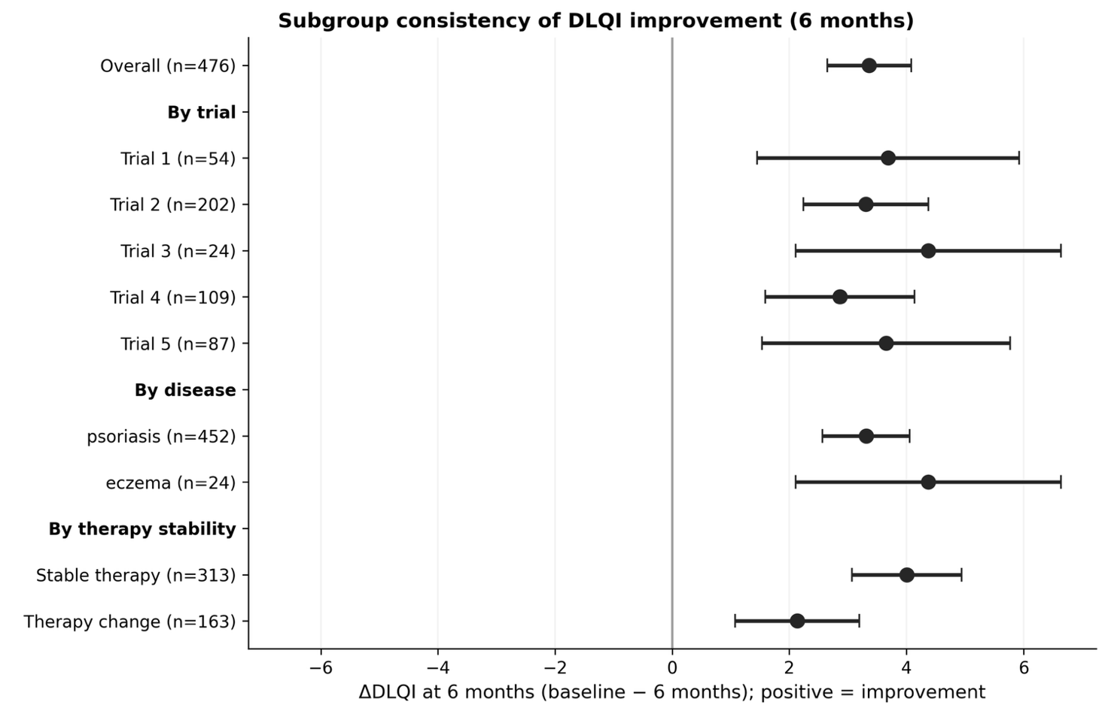
Supplementary Figure S2: Subgroup consistency of DLQI improvement at 6 months.
Forest plot showing mean ΔDLQI (baseline − 6 months; positive values indicate improvement) with 95% confidence intervals across subgroups: overall, by trial, by disease (psoriasis vs eczema), and by therapy stability (stable therapy vs therapy change). Sample sizes for each subgroup are shown in the labels.

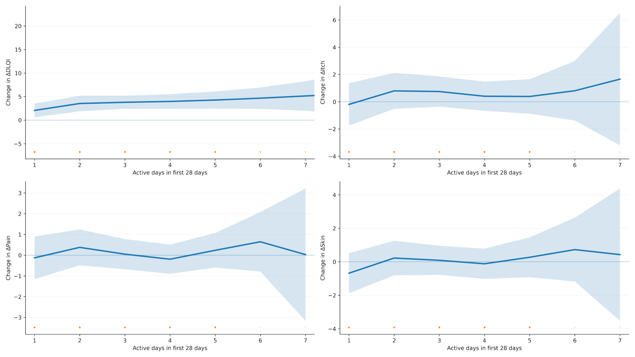

Supplementary Figure S3: Early engagement and change outcomes.
Model-based estimates of adjusted change plotted against early engagement intensity (active days with ≥1 app entry during the first 28 days after first use). The DLQI panel shows visit-based 6-month improvement (baseline − 6 months; positive values indicate improvement). Symptom panels (itch, pain, skin) show EMA-derived change proxies comparing mean symptom levels in weeks 0–3 versus weeks 23–26 after first use (positive values indicate improvement). Solid lines represent fitted values and shaded areas indicate 95% confidence intervals; uncertainty widens at higher engagement levels owing to fewer observations.

