Supplementary Materials for

Large-scale iontronic skins with neural-hierarchical processing architecture

Zhibin Li^{1,6}, Binxu Da^{2,6}, Junli Shi^{2,6}, Taihong Wang^{1,}*, Wenlong Si¹, Bowen Li¹, Hanxiang He³, Zelong Liao², Tianyu Wu⁴, Xudong Han⁴, Chaoyang Song^{5,}*, Chuan Fei Guo^{2,}*
¹The State Key Laboratory of Quantum Functional Materials, Department of Electronic and Electrical Engineering, Southern University of Science and Technology, Shenzhen 518055, China.
²Department of Materials Science and Engineering, Southern University of Science and Technology, Shenzhen 518055, China.
³School of Information and Electronics, Beijing Institute of Technology, Beijing 100081, China.
⁴School of Design, Southern University of Science and Technology, Shenzhen 518055, China.
⁵School of Information and Electronics, Beijing Institute of Technology, Beijing 100081, China.
⁶These authors contributed equally to this work.
*To whom correspondence should be addressed. Email: wangth@sustech.edu.cn (T.W.), Chaoyang.Song@mbzuai.ac.ae (C.S.), guocf@sustech.edu.cn (C.F.G.).

This PDF file includes:
Supplementary Notes 1 to 3
Supplementary Figures 1 to 16
Supplementary Table 1

Other Supplementary Materials for this manuscript include the following:
Supplementary Movies 1 to 8

Supplementary Notes

Supplementary Note 1. Theoretical analysis of sensing response based on the AC impedance method.
Under a constant AC voltage excitation $V_{i}$, the output current $I_{i}$ through the sensing capacitance $C_{i}$ is given by:

$$\begin{aligned}I_{i}=\frac{V_{i} }{Z_{i}}=jω_{i}C_{i}⋅V_{i}\#\left(1-1\right)\end{aligned}$$

where $Z_{i}$ is the impedance of the $i$-th circuit, $ω_{i}$ is the angular frequency of the excitation source. The current–voltage (C/V) converter aggregates the currents from multiple capacitive sensing paths and converts them into an output voltage, which can be expressed as (21):
$$\begin{aligned}V_{o}^{'}=\sum_{i=1}^{Num}{-\frac{R_{f}}{jω_{i}C_{f}R_{f}+1}⋅I_{i}}\#\left(1-2\right)\end{aligned}$$

where $V_{o}^{'}\left(t\right)$ is the output signal of the C/V converter on the row interface number $o$. $R_{f}$ and $C_{f}$ are the feedback resistance and capacitance, respectively set to 20 kΩ and 40 pF. According to Eqs. (1-1) and (1-2), the relationship between the output voltage and the sensing capacitance is given as follows:

$$\begin{aligned}V_{o}^{'}=\sum_{i=0}^{Num}{-\frac{R_{f}}{jω_{i}C_{f}R_{f}+1}⋅jω_{i}C_{i}⋅V_{i}}\#\left(1-3\right)\end{aligned}$$
$C_{i}$ is the capacitance on the different location addresses being measured, which can be expressed by solving the corresponding frequency-coded path voltage amplitude:
$$\begin{aligned}C_{i}=\left|-\frac{jω_{i}C_{f}R_{f}+1}{jω_{i}V_{i}\left(t\right)R_{f}}\right|⋅V_{o}^{i}=\frac{\sqrt{{\left(ω_{i}C_{f}R_{f}\right)}^{2}+1}}{{ω_{i}R}_{f}}⋅\frac{A_{o}^{i}}{A_{i}}\#\left(1-4\right)\end{aligned}$$

where $A_{i}$ is the amplitude of the input AC excitation voltage signal $V_{i}$ with angular frequency $ω_{i}$, and $A_{o}^{i}$ is the amplitude of the output AC signal $V_{o}^{i}$ with angular frequency $ω_{i}$. $A_{o}^{i}$ can be obtained by performing fast Fourier transform (FFT) to extract the amplitude at the corresponding frequency, thereby enabling the calculation of $C_{i}$ at $i$-path.

Supplementary Note 2. Object design and fabrication.
Using a Bambu Lab X1-Carbon 3D printer (Bambu Lab, China), we created four target objects of equal size but different edge curvatures, defined by the edge blend radius. Each object has a width of 45 mm, with curvatures ranging from flat to sharp. The radius of curvature, $R_{c}$, of the leading edge can be modified by the body power law exponent, $n$, where (38):
$$\begin{aligned}R_{c}=\frac{1}{\left|nA\left(n-1\right)\right|}{\left[x^{\frac{2\left(2-n\right)}{3}}+{\left(nA\right)}^{2}x^{\frac{2\left(2n-1\right)}{3}}\right]}^{\frac{2}{3}}\#\left(2-1\right)\end{aligned}$$
$A$ is the power law constant, dependent on $n$, and $x$ represents the position along the Cartesian axis in physical space. To ensure discrimination was based on curvature rather than overall size, the objects were designed to maintain a constant width, $w$ = 45 mm and a height $H$= 15 mm. (Supplementary Fig. 15a). The four objects had power law exponents of ($n$ = 1/4), ($n$ = 1/2), ($n$ = 3/4), and ($n$ = 1), and were labeled as object 1, object 2, and object 3, object 4, respectively. Further details on the power law–shaped edges can be found in references. See (38, 42) for more details.

Supplementary Note 3. Quantitative regression model for pain-level prediction.
We can clearly observe that as the stimulus intensity increased, both the maximum pressure and the pressure gradient increased, while the number of activated sensing elements decreased. The increase in pressure and sharpness generally leads to stronger pain perception, which is consistent with common physiological patterns. Accordingly, we established a Logit model to approximate the perceived pain degree $P$ using three features: maximum pressure $x_{1}$, number of activated elements $x_{2}$, and maximum pressure gradient $x_{3}$.

$$\begin{aligned}P=\frac{1}{1+e^{-z}}\#\left(3-1\right)\end{aligned}$$

$$\begin{aligned}z=β_{0}+β_{1}∙x_{1}+β_{2}∙x_{2}+β_{3}∙x_{3}\#\left(3-2\right)\end{aligned}$$
We used the pain degrees (0–100%) induced by stimuli of different sharpness, as shown in Supplementary Fig. 10, to determine the model coefficients $β_{0}$, $β_{1}$, $β_{2}$, and $β_{3}$. In practical robotic feedback control, the estimated pain level $P$ is used to trigger the robotic self-protective response.

Supplementary Figures

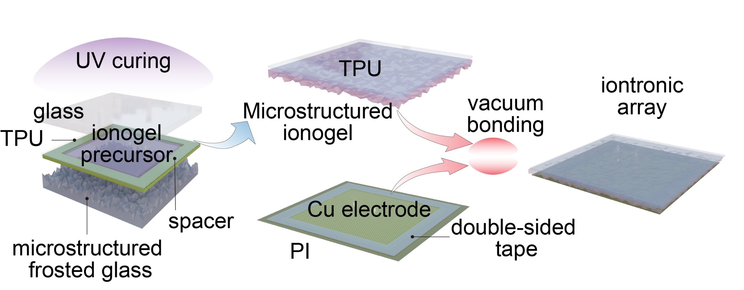

Supplementary Figure 1. Schematic fabrication process of NI-skin. We developed a layered assembly array structure for fabricating the NI-skin. Microstructured ionogel films were synthesized via soft lithography, while bilayer flexible printed electrodes were configured into a coplanar cross-matrix layout. Finally, the high-density electrode array and the entire ionogel film were encapsulated together through vacuum thermo-compression.

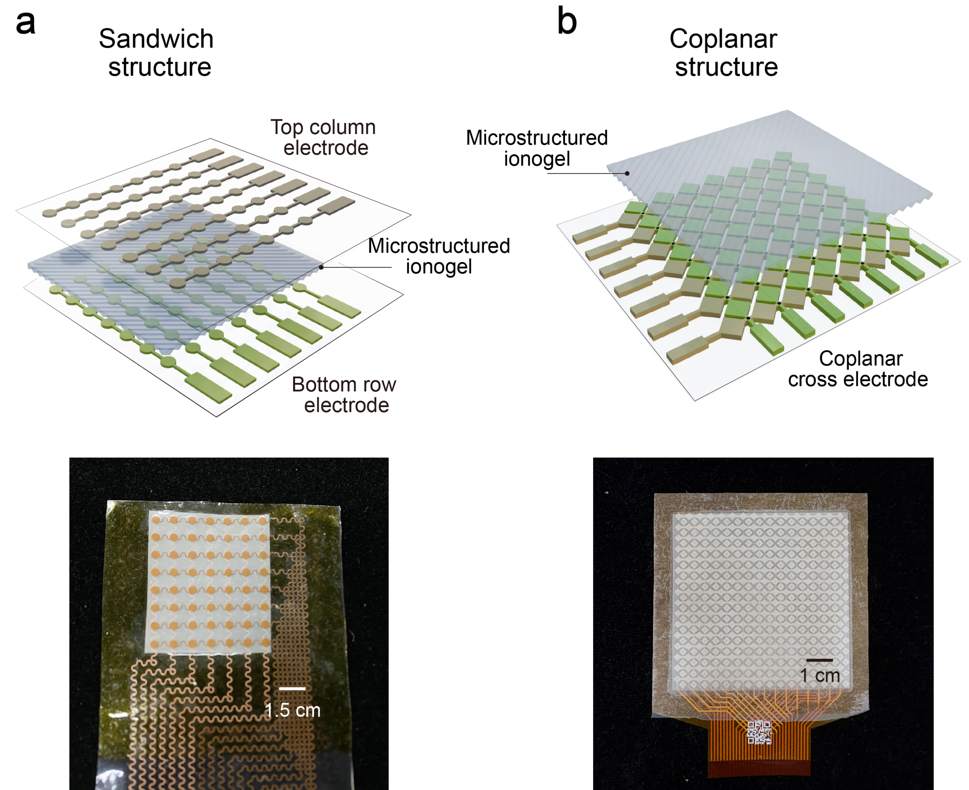

Supplementary Figure 2. Schematic comparison of the coplanar structure and the multilayer sandwich structure. Compared with the multilayer configuration, the coplanar cross-electrode design can be fabricated using double-layer flexible printed circuits, thereby simplifying the manufacturing process of high-density electrodes. (a) Illustration of the multilayer sandwich structure. (b) Illustration of the coplanar cross-electrode structure.

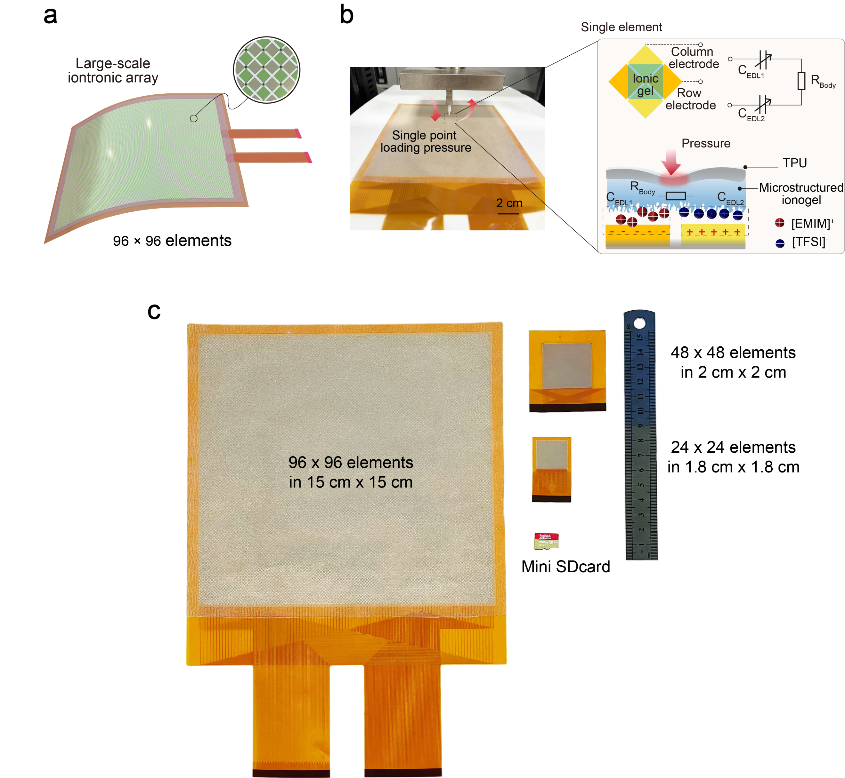

Supplementary Figure 3. Schematic comparison of the coplanar structure and the multilayer sandwich structure. Compared with the multilayer configuration, the coplanar cross-electrode design can be fabricated using double-layer flexible printed circuits, thereby simplifying the manufacturing process of high-density electrodes. (a) Illustration of the multilayer sandwich structure. (b) Illustration of the coplanar cross-electrode structure.

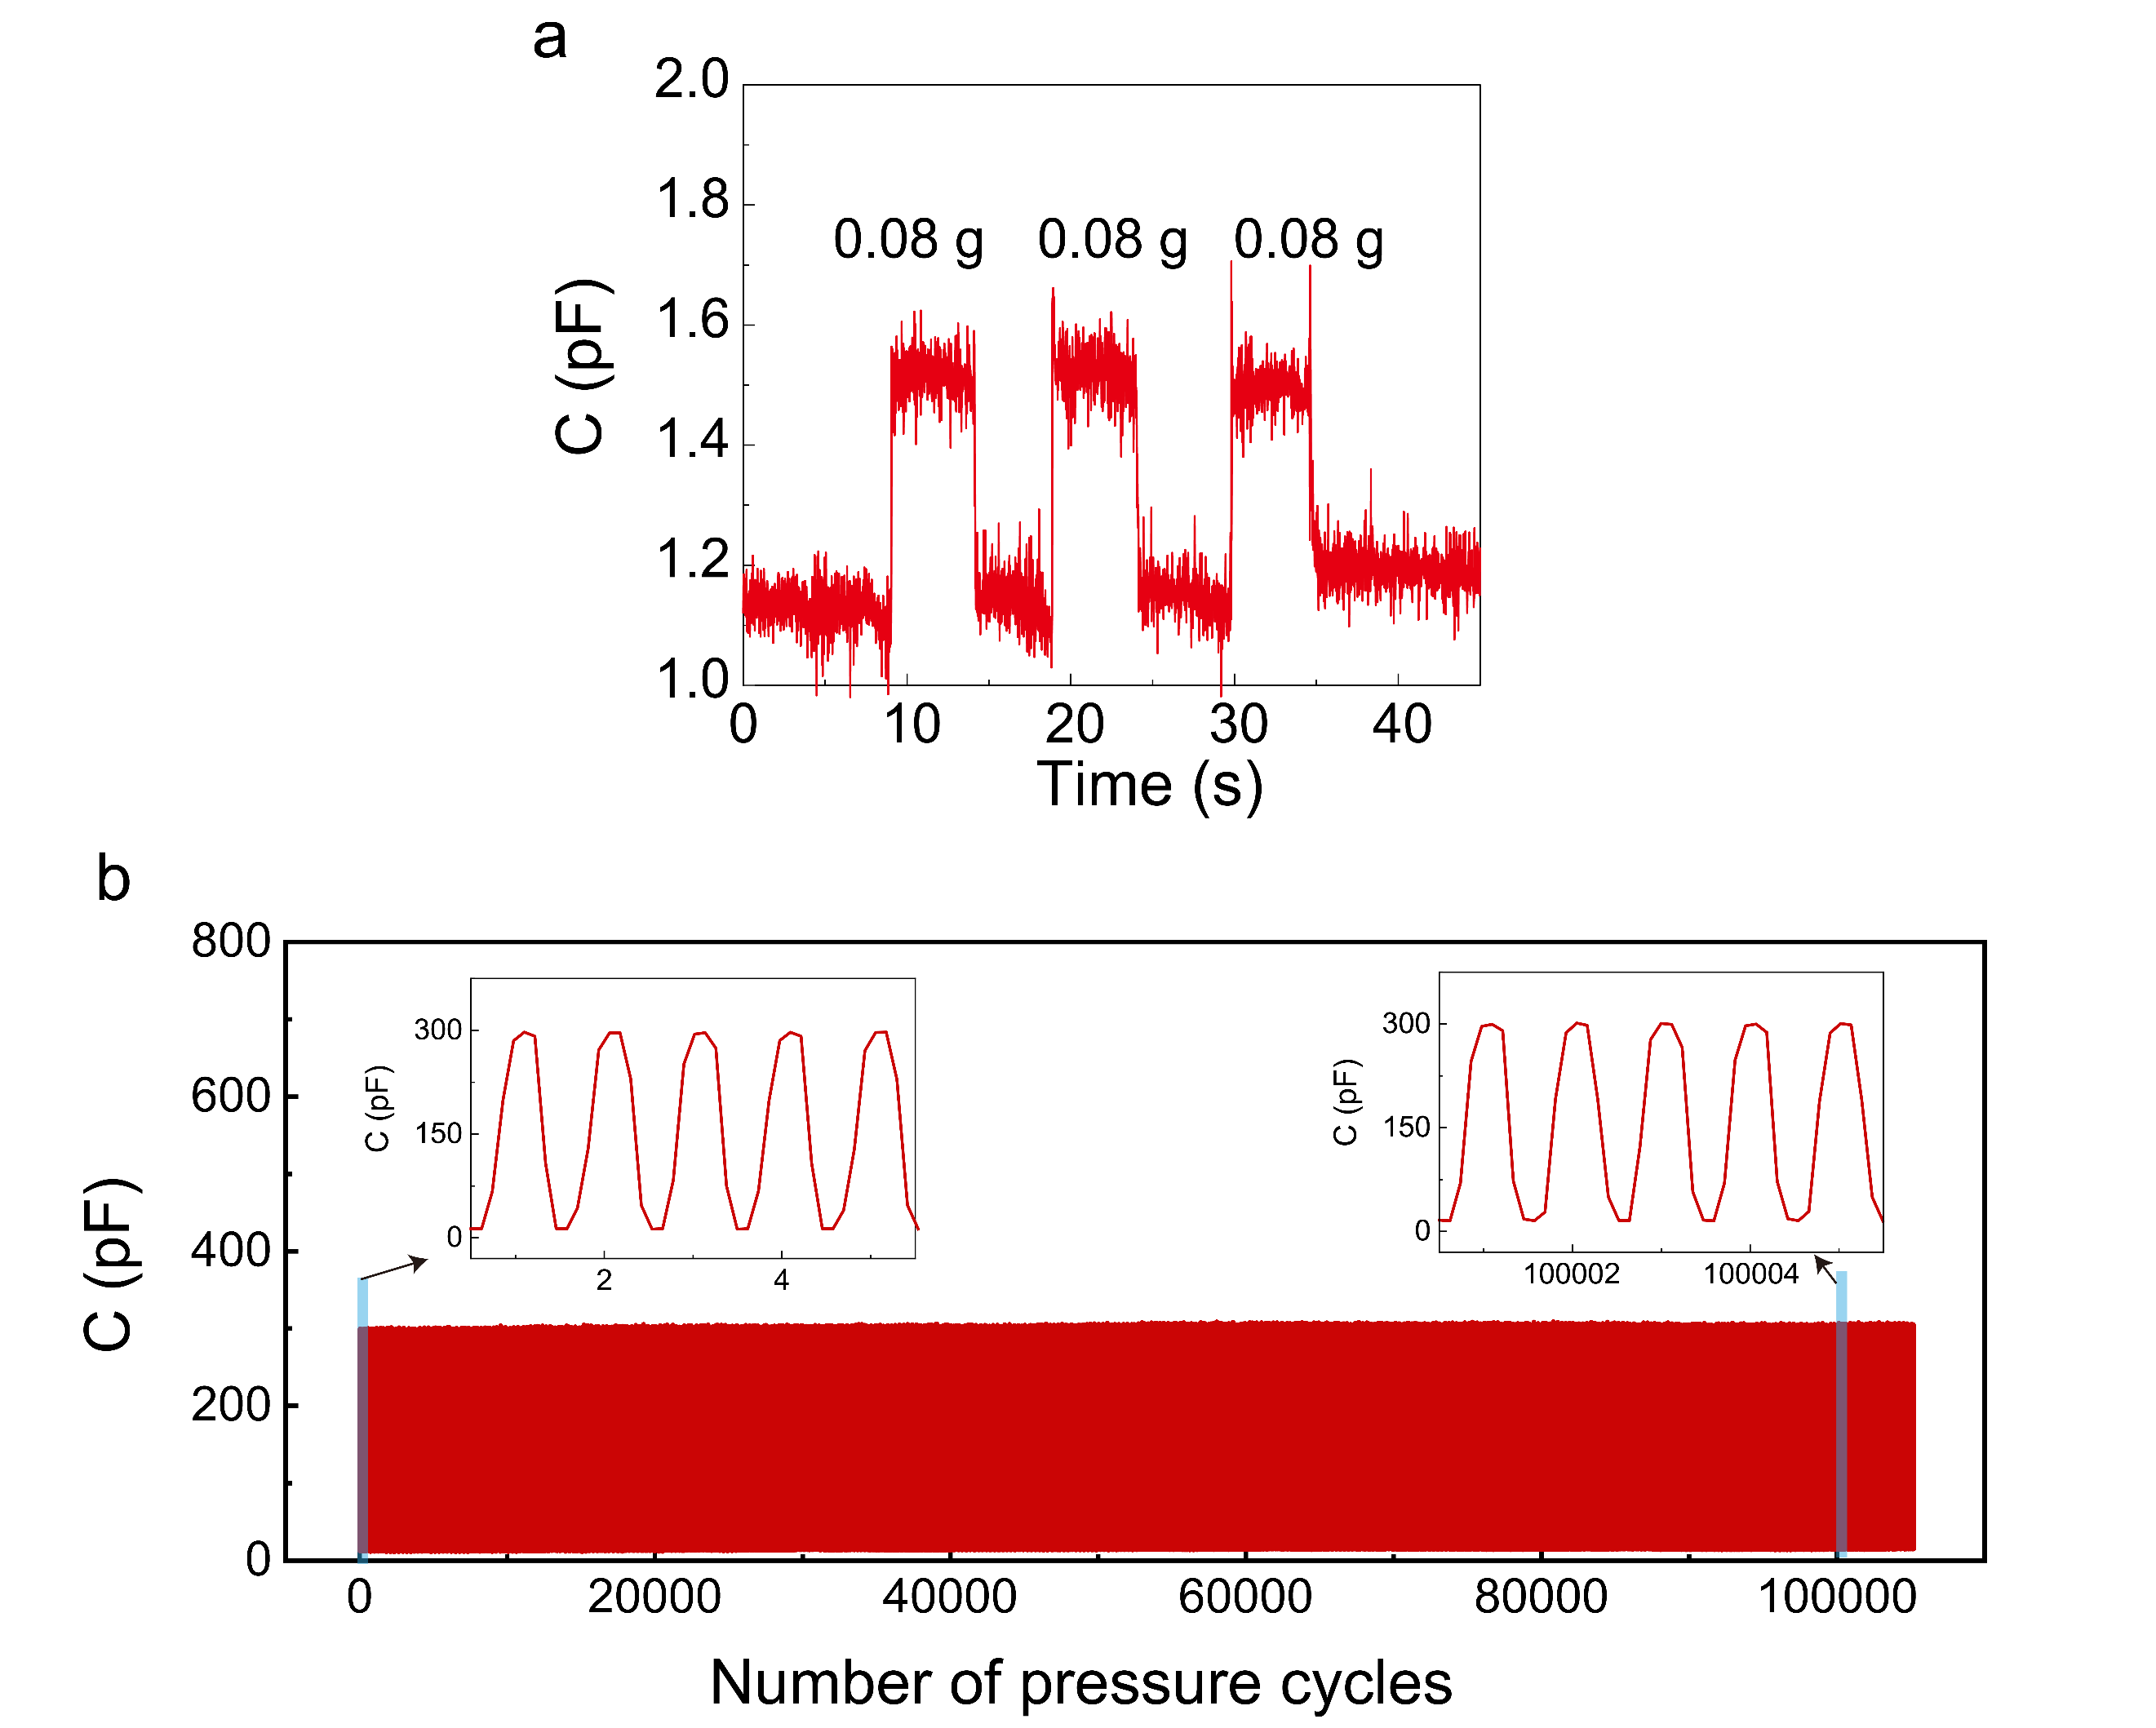

Supplementary Figure 4. Sensory performance characterization of the NI-skin receptors. (a) Limit of detection less to 0.08 g. (b) Durability performance of the NI-skin unit under cyclic loading. No failure was observed after 100,000 cycles at 40 kPa.

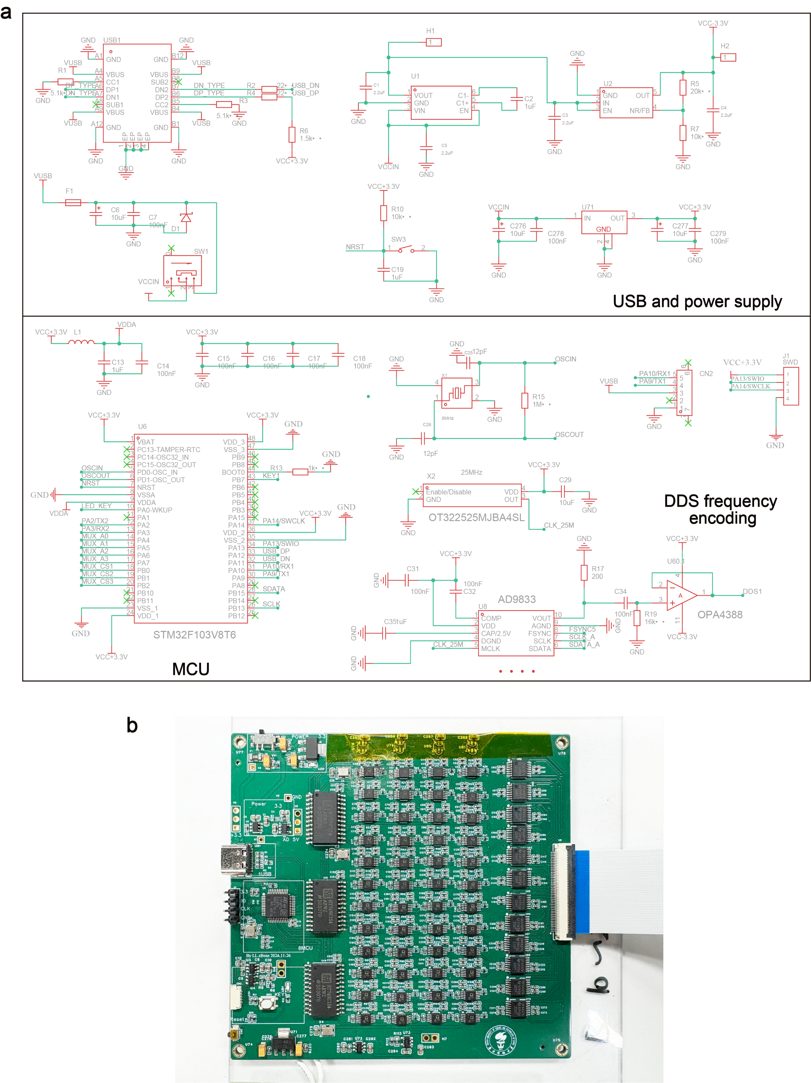

Supplementary Figure 5. The design of the encoding circuit. (a) Schematic diagram of core components in the encoding circuit. (b) Physical PCB layout of the encoding circuit board.

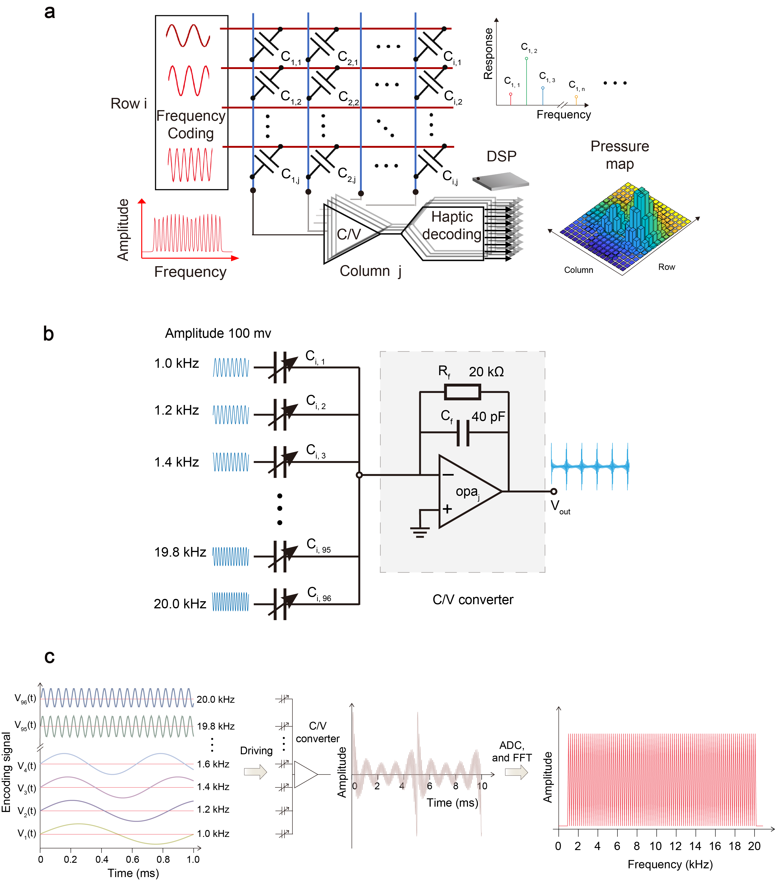

Supplementary Figure 6. Parallel measurement workflow of receptor signals in the frequency-encoded architecture. (a) System-level block diagram of the frequency-encoding structure. (b) Schematic illustration of the current-to-voltage (C/V) converter used for signal aggregation within the neural bundle. In the practical circuit implementation, the reference resistor was realized using a programmable digital potentiometer (TPL0501-100) to achieve dynamically adjustable output voltage gain. (c) Flowchart of the FFT decoding algorithm executed on the digital signal processor (DSP).

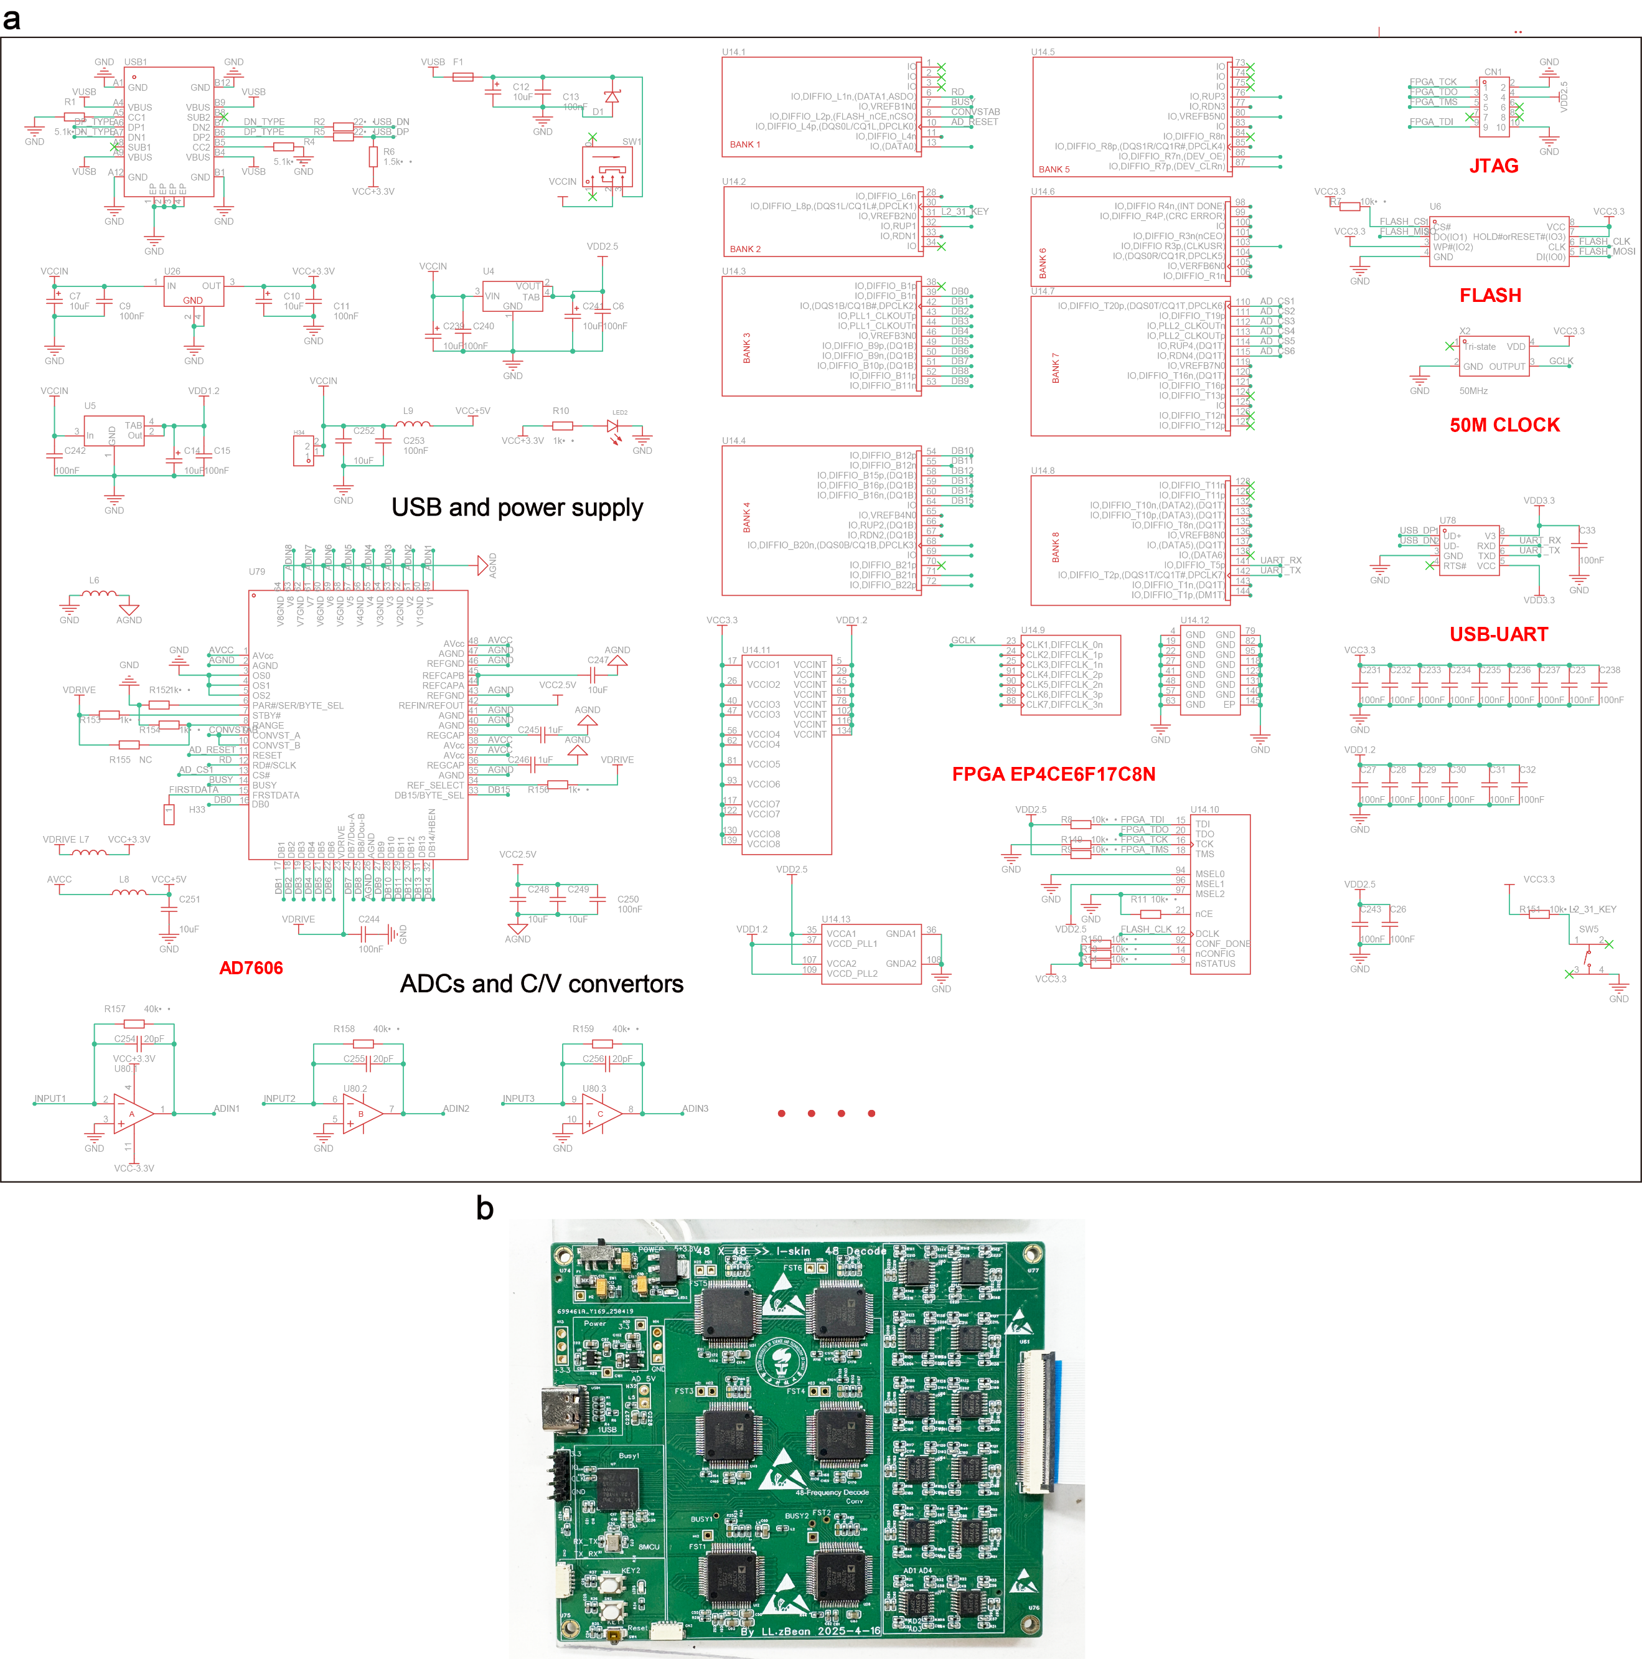

Supplementary Figure 7. The design of the decoding circuit and computation block. (a) Schematic diagram of core components in the decoding circuit. (b) Physical PCB layout of the decoding circuit board.

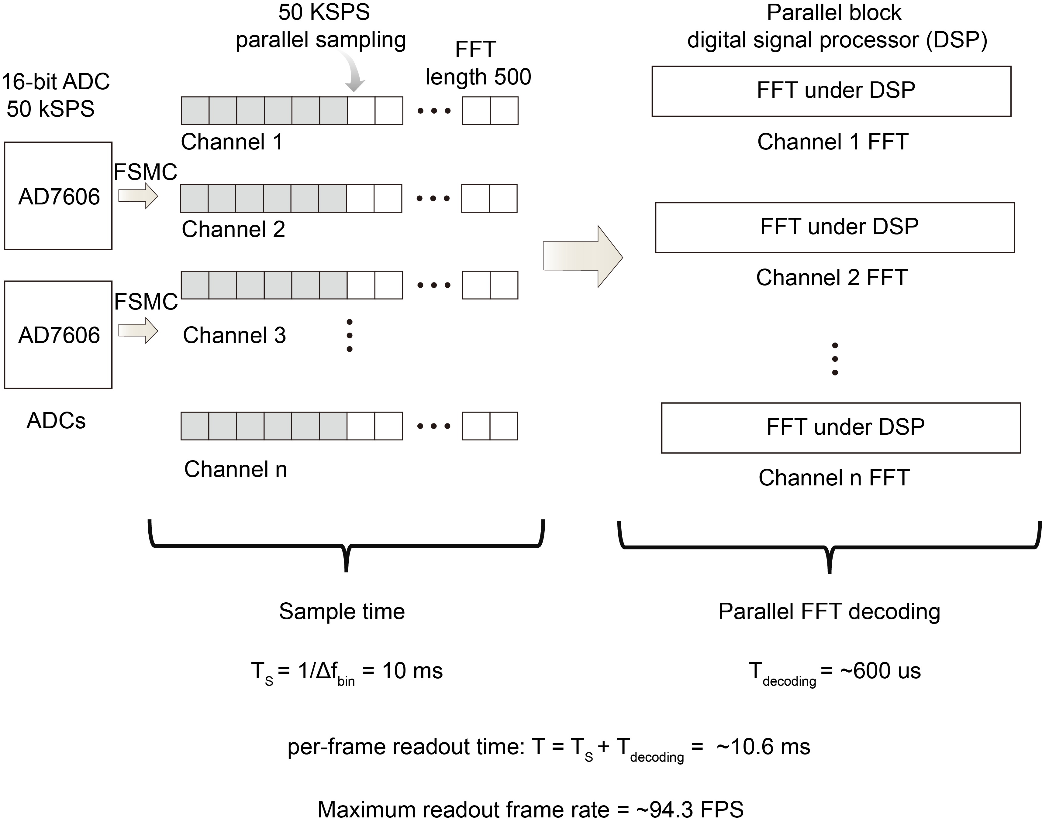

Supplementary Figure 8. The time cost of NI-skin signal decoding and readout. According to Eq. (1) in the main article, $T_{s}=1/Δf_{bin}$, when frequency-bin resolution is 100 Hz, $T_{s}=10 ms$. With an ADC sampling rate of 50 kHz, the corresponding sampling length is 500 points. In addition, the parallel DSP computation occupies approximately 600 µs. Consequently, the designed system achieves a maximum total readout time of ~10.6 ms per frame.

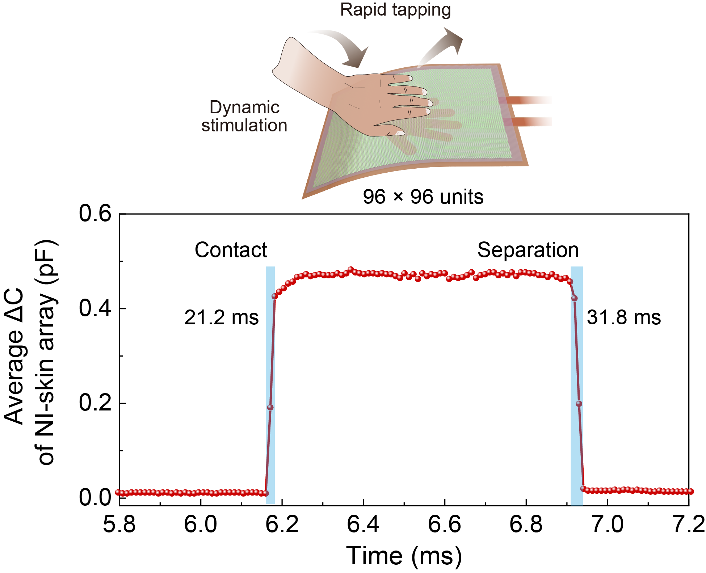

Supplementary Figure 9. Response time of the NI-skin array to external dynamic stimuli.

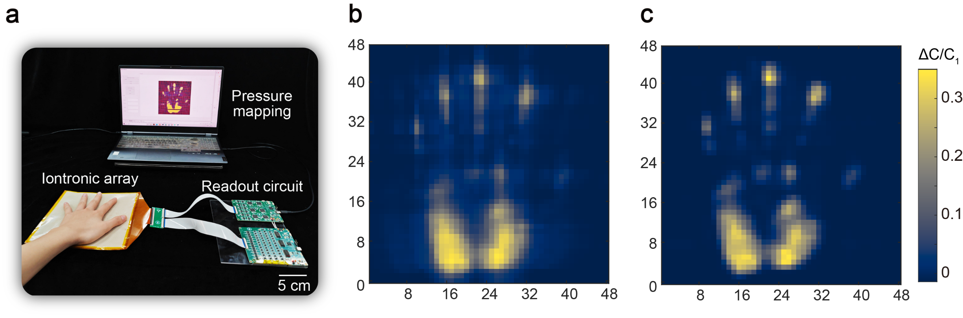

Supplementary Figure 10. Comparison of crosstalk suppression effects. (a) Photograph of the NI-skin tactile response under human touch. (b) Tactile response mapping under time-division multiplexed scanning without crosstalk suppression. (c) Tactile response mapping with crosstalk suppression under the parallel zero-potential (PZP) design, where the hand contour is rendered with higher precision.

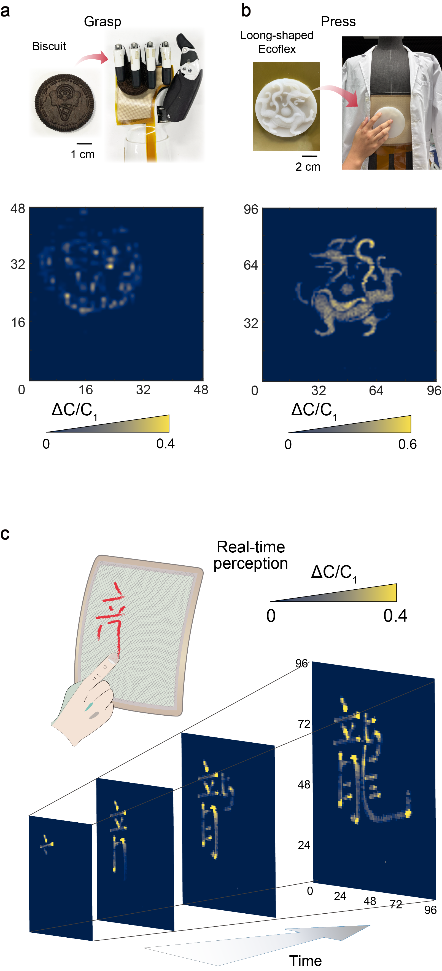

Supplementary Figure 11. High spatiotemporal-resolution tactile responses of NI-skins. (a) Tactile texture mapping during cookie grasping by a dexterous robotic hand. (b) Fine perception of object texture and contours by the robot’s body-mounted skin. (c) Real-time recording of dynamic tactile interactions using large-area robotic skin.

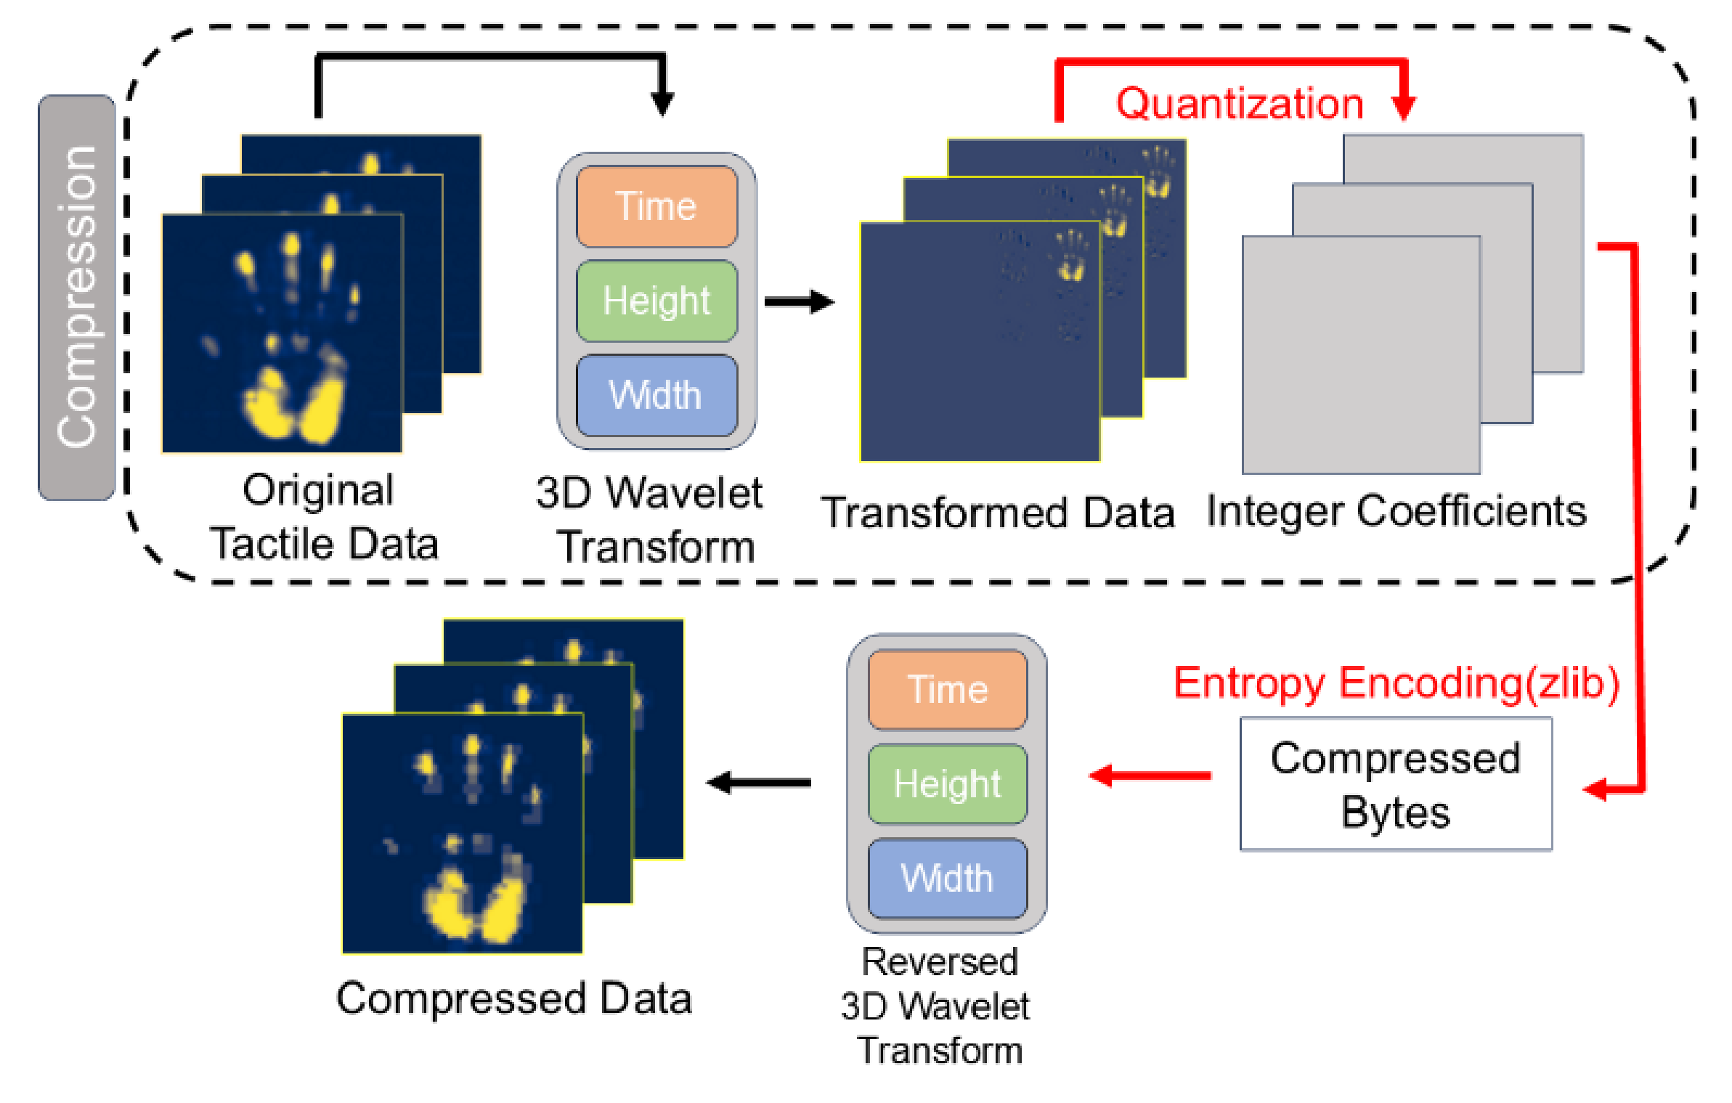

Supplementary Figure 12. The overall process of the three-dimensional wavelet transform (3D-DWT) compression algorithm. First, the three-dimensional tactile data are decomposed into multiple layers of frequency-domain coefficients via wavelet transformation, separating primary features from fine details. The coefficients are then quantized to reduce data precision and enhance sparsity through rounding operations. Finally, entropy coding is applied to further minimize data volume. During decompression, the algorithm performs inverse decoding, dequantization, and wavelet reconstruction to achieve efficient data recovery.

The 3D-DWT block designed in the spinal layer enables highly sparse and compact tactile representation, achieving real-time transmission and perception with minimal bandwidth loss. The three-dimensional data are decomposed into multiple layers of frequency-domain coefficients through wavelet transformation, where the quantization factor $Q$ converts the wavelet coefficients into integers. This quantization process enhances sparsity by removing redundant features, allowing controllable precision loss and achieving a high compression ratio without compromising critical tactile information.

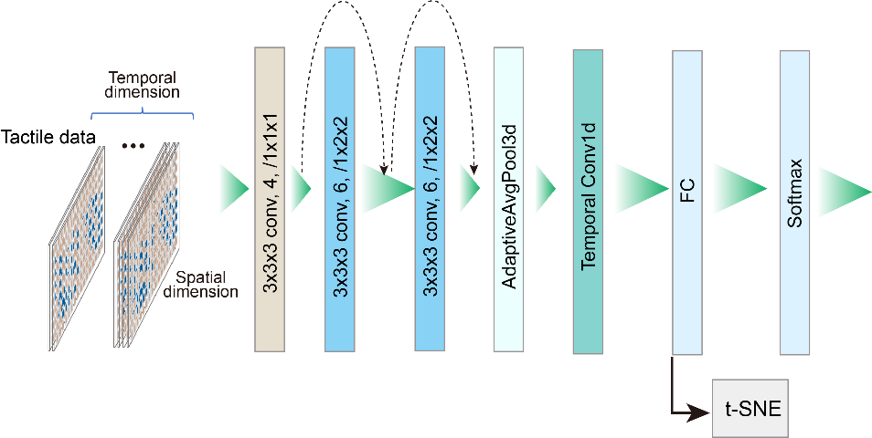

Supplementary Figure 13. The structure of a 3D-CNN (3D Convolutional Neural Network). This network leverages 3D convolutions to process spatiotemporal data, with residual blocks for deep feature extraction and a temporal head to focus on important time-dependent features. It's lightweight and designed for efficiency while retaining high performance for classification tasks.

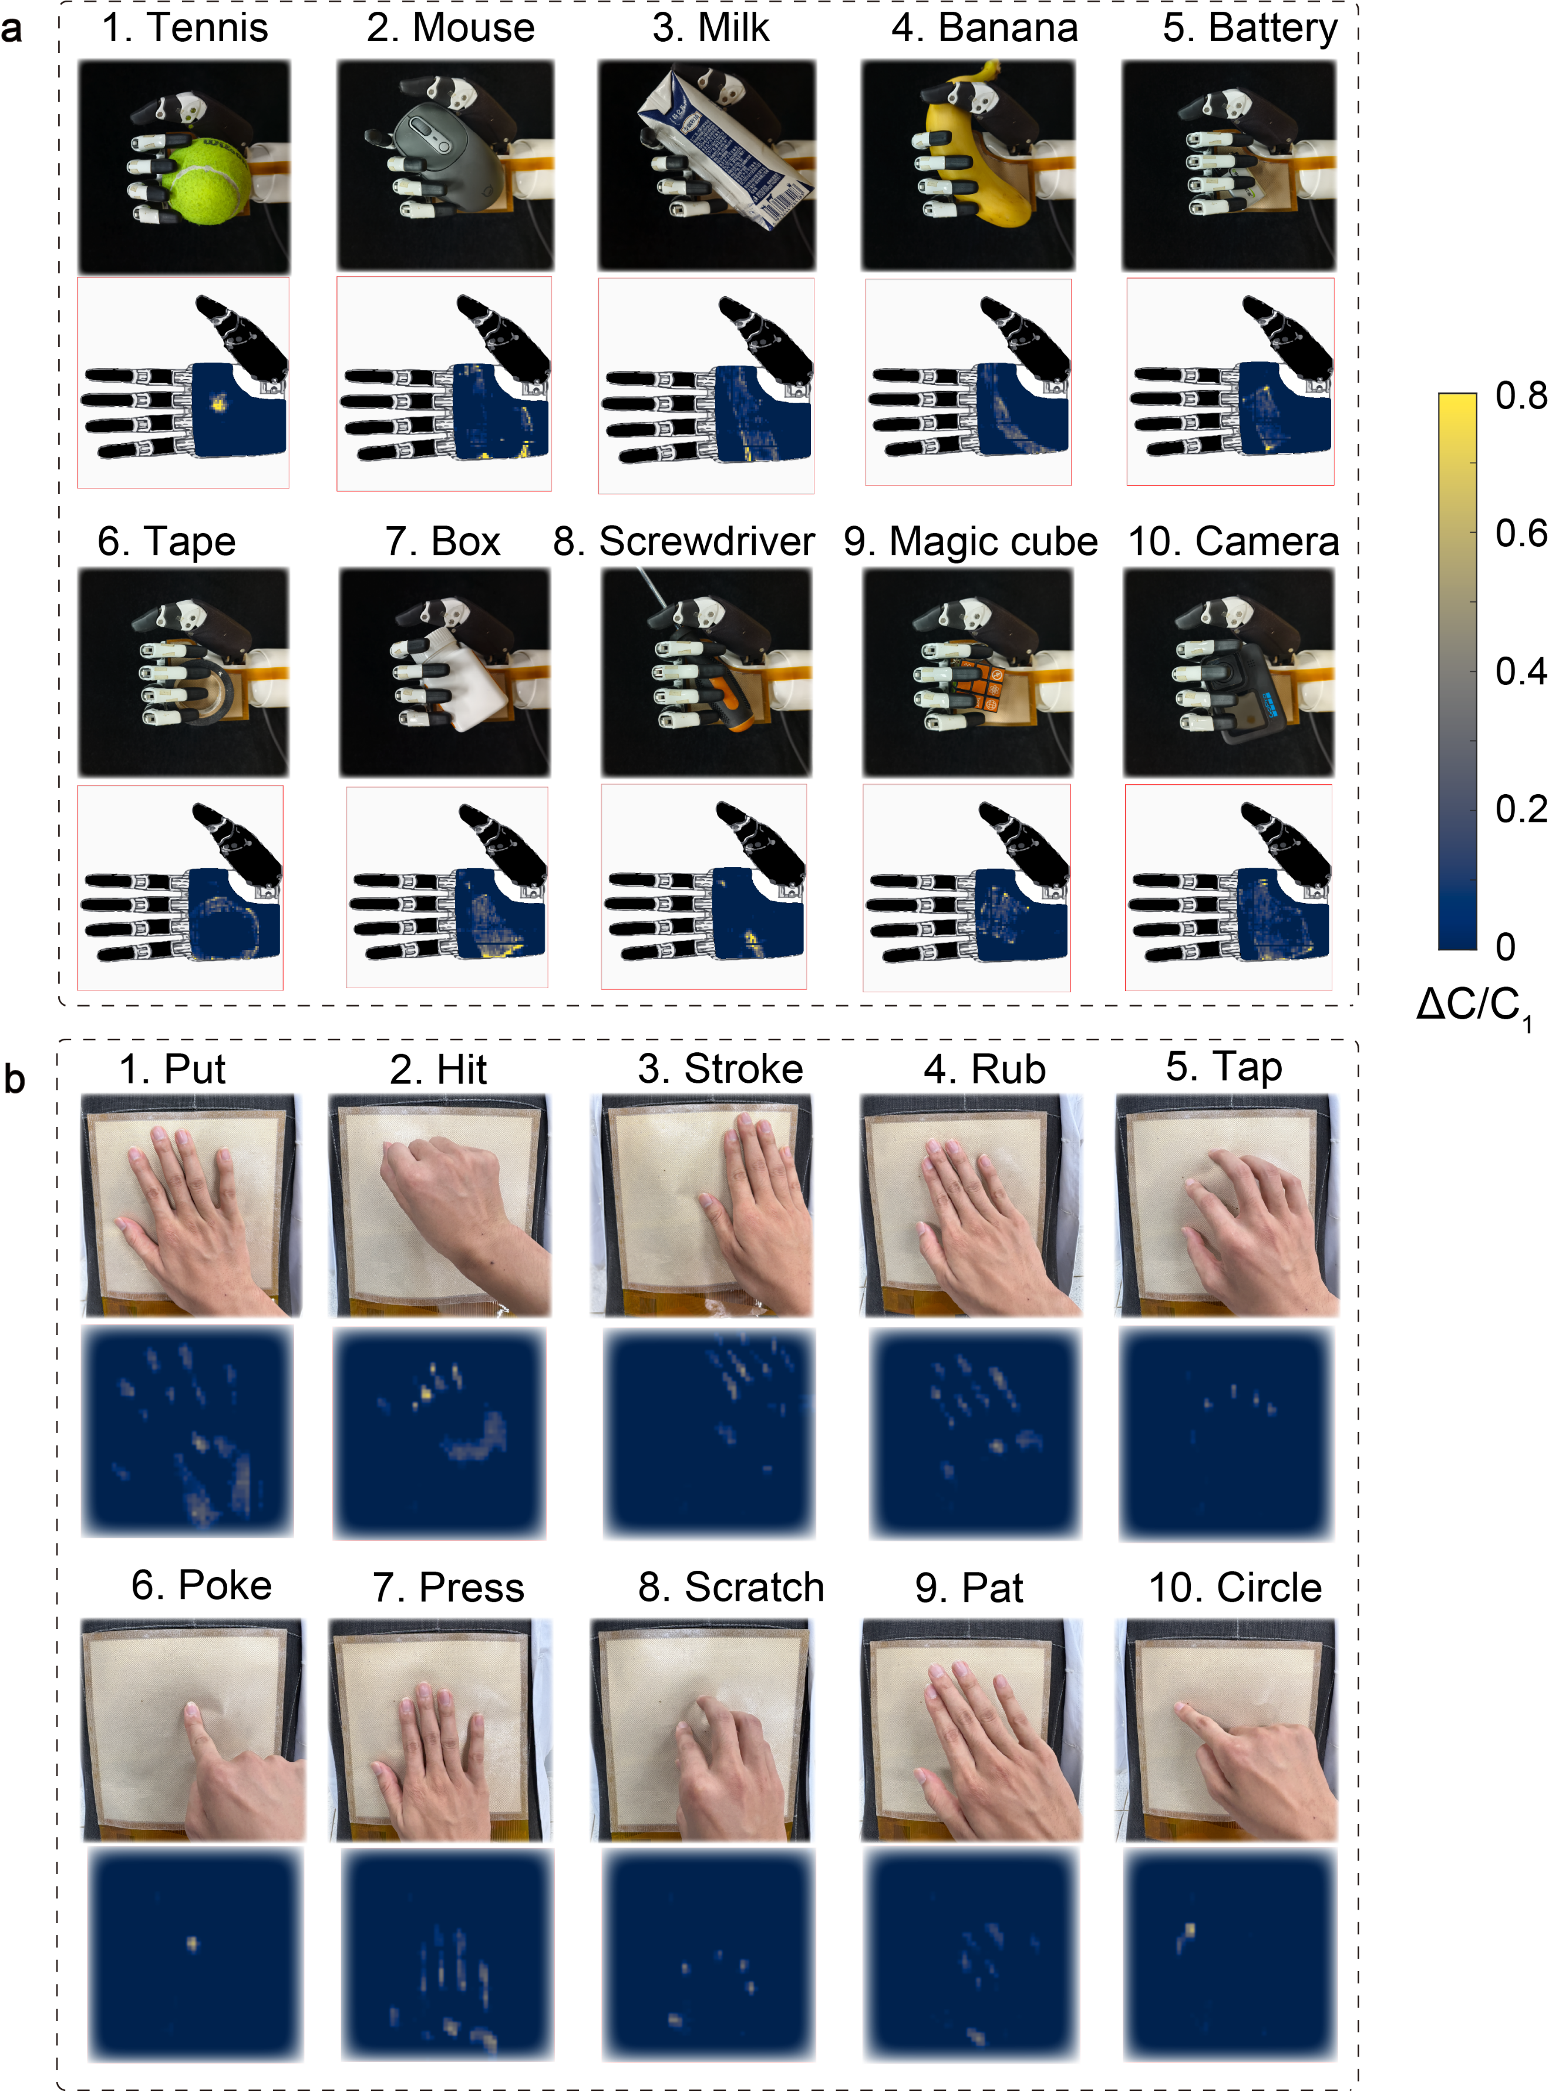

Supplementary Figure 14. Tactile responses under different interaction tasks. (a) A dataset showcasing grasping of 10 object categories, capturing responses during the manipulation process. (b) A dataset with 10 touch gestures, capturing responses during touch interactions.

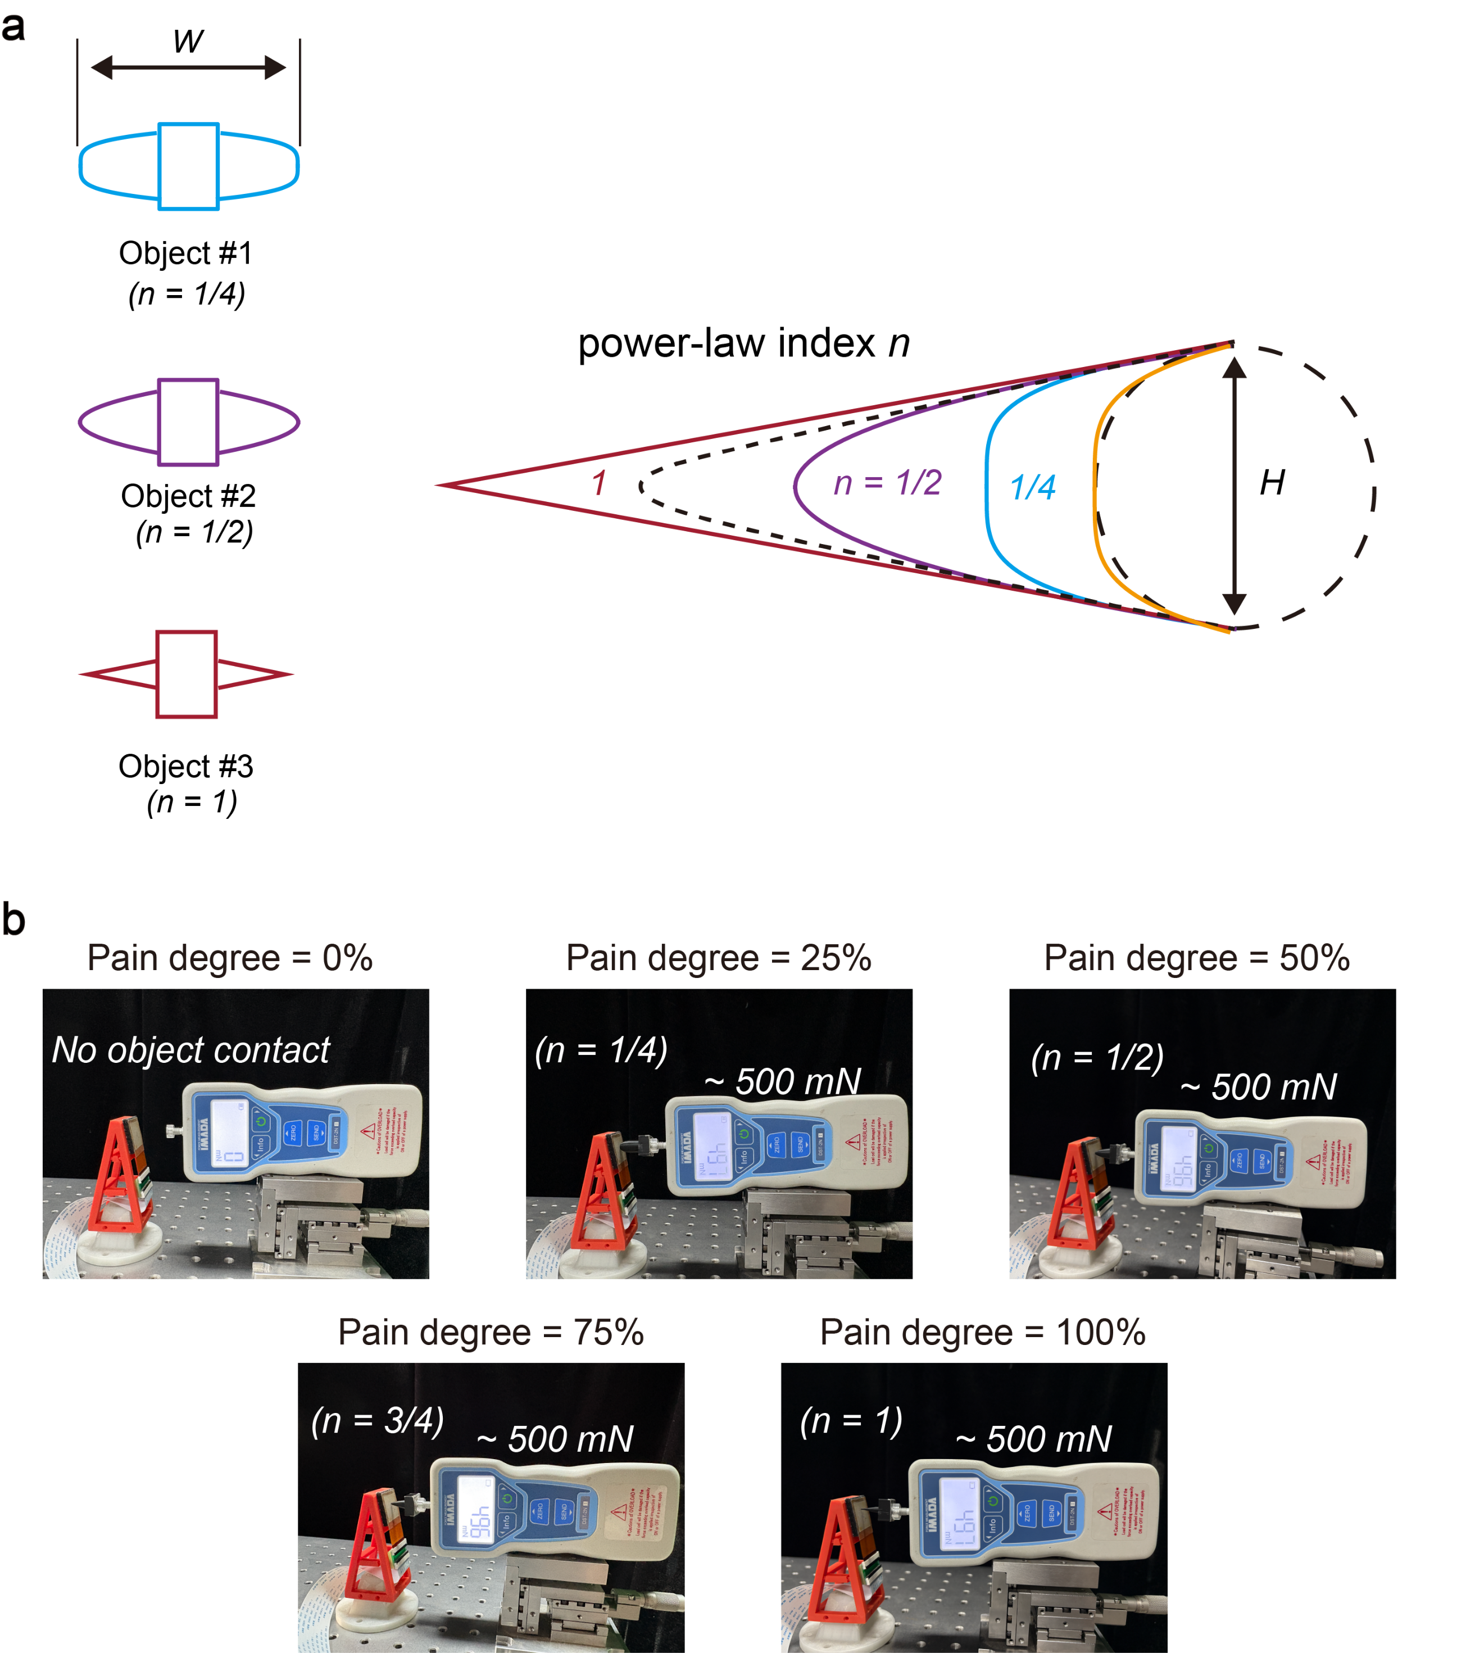

Supplementary Figure 15. Quantitative calibration of pain intensity. (a) Adjustment of stimulus sharpness. The sharpness of the object was modulated by the power-law index $n$ ( $0≤n≤1$) (38), where a larger $n$ indicates a sharper and more localized contact. All stimuli were designed with a width $w$ = 45 mm and a height $H$= 15 mm. (b) The NI-skin on the robotic gripper was stimulated with objects of different sharpness under a constant force of ~500 mN, generating distinct tactile responses. The pain intensity was quantitatively defined based on the sharpness of the stimulus (power-law index) and normalized from 0% to 100%.

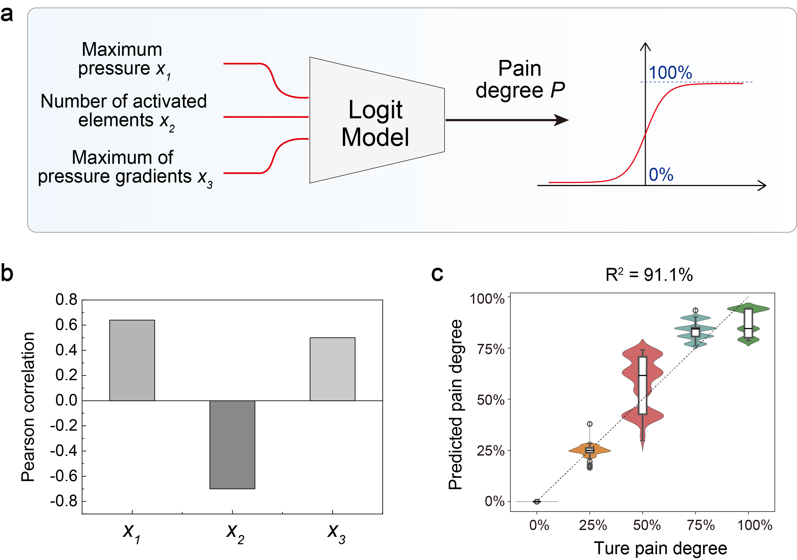

Supplementary Figure 16. Establishment and analysis of the pain-intensity regression model. (a) A Logit model is established to regress the perceived pain degree based on three input features via maximum pressure, number of activated sensing elements, and maximum pressure gradient. (b) Pearson correlation analysis between the three tactile features sensed by the NI-skin (maximum pressure, number of activated sensing units, and maximum pressure gradient) and the pain intensity. The maximum pressure and maximum pressure gradient show strong positive correlations with pain degree, whereas the number of activated sensing elements exhibits a strong negative correlation. (c) In the pain-perception test set, the Logit model achieved a pain-intensity regression accuracy of 91.1%.

Supplementary Tables

Table S1. Comparison of NI-skin with representative existing works and human skin in terms of total number of sensing units, temporal resolution, and spatial resolution. The NI-skin demonstrates superior overall performance across all three metrics, marking a significant advancement in artificial tactile skin technology.
Sensing type | Spatial resolution (elements/${cm}^{2}$) | Temporal resolution (Hz) | Total number of elements | Reference
Human skin | ~150 | 250 | ~200,000 | Deflorio, Front. Hum. Neurosci., 2022 (6);  Weber, Proc. Natl. Acad. Sci. USA, 2013 (7);  Johansson, Nat. Rev. Neurosci., 2009 (8);  Corniani, J. Neurophysiol., 2020 (5);
TDMA-based | 1,000 | 100 | 256 | Oh, Sci. Adv., 2020 (10)
TDMA-based | ~10 | 7.3 | 548 | Sundaram, Nature, 2019 (15)
TDMA-based | 8 | ~40 | 784 | Shi, Sci. Adv., 2023 (16)
Sensory-encoding-based | ~100 | 1000 | 240 | Lee, Sci. Robot., 2019 (20)
Sensory-encoding-based | 132 | ~200 | 529 | Kim, Sci. Robot., 2022 (9)
Sensory-encoding-based | 1 | 64 | 25 | Long, Sci. Adv., 2023 (27)
Sensory-encoding-based | 4 | 500 | 64 | Li, npj Flex. Electron., 2024 (21)
Our work | 156 | 94.3 | >10,000 | This work

Supplementary Movie 1.
Demonstration of fine surface tactile perception using NI-skin integrated on the robotic body.

Supplementary Movie 2.
Dynamic tactile sensing recordings of NI-skin integrated on the robotic body.

Supplementary Movie 3.
NI-skin on the robotic palm perceiving contact contours and sharp stimuli.

Supplementary Movie 4.
Demonstration of high spatiotemporal-resolution tactile perception of NI-skin.

Supplementary Movie 5.
Demonstration of stable grasping of a 0.5-mm pencil lead.

Supplementary Movie 6.
Demonstration of stable grasping of a soft 0.2-mm solder wire.

Supplementary Movie 7.
Demonstration of adaptive and safe grasping of a spiny chestnut.

Supplementary Movie 8.
Demonstration of self-protection triggered by external noxious stimuli.

