Meat intake frequency and its associations with incident dementia and cognitive performance: Findings from the UK Biobank

Johannes Volkmer^{1,2}, Lisa Reisinger^{1,2}, Nathan Weisz^{1,2,3}, Ya-Ping Chen^{1,2*}

1. Department of Psychology, University of Salzburg, Salzburg, Austria
2. Centre for Cognitive Neuroscience, University of Salzburg, Salzburg, Austria
3. Neuroscience Institute, Christian Doppler University Hospital, Paracelsus Medical University, Salzburg, Austria

* Corresponding author: ya-ping.chen@plus.ac.at

Table of Contents
Supplementary Methods 2
1. Determination of the minimal adjustment set 2
2. Covariates 4
2.1 Dietary variables 4
2.2 Socio-demographics 5
2.3 Lifestyle related and other covariates 6
Supplementary Figure 1 9
Supplementary Tables 10

Supplementary Methods

1. Determination of the minimal adjustment set
We used directed acyclic graphs (DAGs; Figure S-DAG) to guide covariate selection and to identify a minimally sufficient adjustment set for estimating the association between baseline meat consumption frequency (exposure) and incident dementia (outcome) . The DAG was constructed a priori based on temporality and existing evidence on demographic, socioeconomic and lifestyle determinants of diet and dementia risk. Using the implied conditional independencies in the DAG, we applied the backdoor criterion (via the dagitty package in R; Textor et al., 2016) to derive the minimal adjustment set that blocks all non-causal (backdoor) paths between exposure and outcome while avoiding adjustment for variables that may lie on the causal pathway. The resulting minimally sufficient adjustment set comprised age, sex, ethnicity, education, and area-level deprivation (Townsend deprivation index). In additional models we further adjusted for lifestyle factors (smoking, alcohol intake, physical activity, and sleep) and baseline cardiometabolic conditions/adiposity as sensitivity analyses to assess robustness to residual confounding and potential reverse causation.
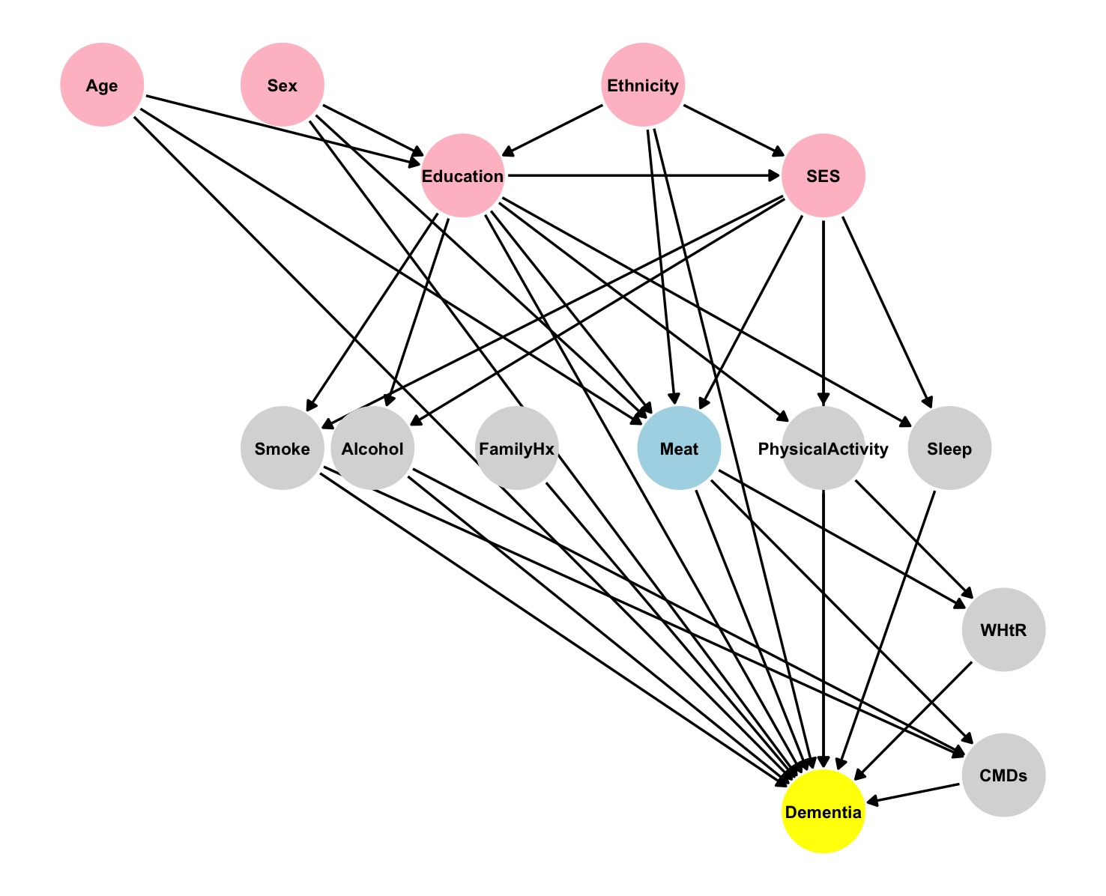
Figure S-DAG. Directed acyclic graph (DAG) used to identify the minimally sufficient adjustment set for estimating the association between baseline meat consumption frequency (exposure) and incident dementia (outcome). Pink nodes denote variables that are ancestors of both the exposure (blue) and the outcome (yellow); grey nodes denote variables that are ancestors of the outcome only. FamilyHx: Family history of dementia; CMDs: History of Cardiometabolic diseases (including diabetes, heart attack, angina, stroke, and high-blood pressure). WHtR: Waist-to-height ratio.

2. Covariates

2.1 Dietary variables
The baseline touchscreen questionnaire was designed to collect basic dietary information on commonly consumed foods. In general, we followed Zhang et al. (2021) and grouped participants into four categories for each food group based on the distribution of responses to obtain approximately equal-sized groups. “Prefer not to answer” and “Do not know” categories were retained to represent missing values for each covariate. Two food groups—total fish and fruit and vegetables—that could confound the association between meat consumption and dementia risk were included in the fully adjusted models as categorical variables.

2.1.1 Oily fish and other fish
There were two questions on fish consumption (e.g., “How often do you eat oily fish?”), covering oily fish (e.g., sardines, salmon, mackerel, and herring) and other types of fish (e.g., cod, tinned tuna, and haddock). Participants selected from eight response options: never, less than once a week, once a week, 2–4 times a week, 5–6 times a week, once or more daily, do not know, and prefer not to answer. Consumption frequencies were assigned values to approximate times per week (never = 0, <1 time/week = 0.5, 1 time/week = 1, 2–4 times/week = 3, 5–6 times/week = 5.5, and ≥1 time daily = 7). We summed oily fish and other fish to derive total fish intake, and then grouped weekly total fish frequency into four categories: ≤1.0, 1.5, 2–3, and >3 times per week.

2.1.2 Fresh fruit, dried fruit, cooked vegetables, and salad or raw vegetables
Participants were asked to either direct input the specific daily numbers of consumed pieces of fresh fruit (one apple, one banana, 10 grapes etc as one piece), pieces of dried fruit (one prune, one dried apricot, 10 raisins etc as one piece), heaped tablespoons of cooked vegetables and heaped tablespoons of salad/raw vegetables, or select ‘less than one’, ‘do not know’ or ‘prefer not to answer’ over four separate questions. One piece of fresh fruit, two ‘pieces’ of dried fruit, two heaped tablespoons of cooked vegetables, and two heaped tablespoons of salad/raw vegetables were counted as one serving respectively. These four items were summed into one ‘fruits and vegetables’, and then we grouped the daily servings of fruits and vegetables into four categories as follows: 1-2, 3-4, 5-6, and >6 servings per day.

2.2 Socio-demographics

2.2.1 Ethnicity
Participants were asked to select their ethnic group from the following options: ‘White’ (including British, Irish, any other White background), ‘Mixed’ (including White and Black Caribbean, White and Black African, White and Asian, any other mixed background), ‘Asian or Asian British’ (including Indian, Pakistani, Bangladeshi, any other Asian background), ‘Black or Black British’ (including Caribbean, African, any other Black background), ‘Chinese’, ‘Other ethnic group’, ‘Do not know’ or ‘Prefer not to answer’. We regrouped ethnicity into five categories: White (White, British, Irish or any other white background); Asian or Asian British (Asian or Asian British, Chinese, Indian, Pakistani, Bangladeshi or any other Asian background); Black or Black British (Black or Black British, Caribbean, African or any other Black background); Mixed (White and Black Caribbean, White and Black African, White and Asian, any other mixed background, or Other ethnic group); and Missing (included participants who responded ‘Do not know’ or ‘Prefer not to answer’).

2.2.2 Townsend deprivation index
The Townsend deprivation index (TDI) is an area-based measure of material socioeconomic deprivation that’s assigned to people based on where they live (their postcode area). The index combines four indicators from census data for a small geographic area: unemployment, non-car ownership, non-home ownership, and household overcrowding (Townsend et al., 2023). The index was calculated immediately prior to UK Biobank recruitment using data from the preceding national census output areas. Each participant was assigned the score corresponding to the output area in which their postcode was located; higher scores indicate greater deprivation. We categorized TDI into three equal-sized groups: low (-6.26 to -3.15), moderate (-3.16 to -0.59), and high deprivation (-0.58 to 11). To minimize the risk of over-adjustment, we included TDI as the sole indicator of socioeconomic status and did not additionally adjust for employment status or household income.

2.2.3 Education
Participants were asked to select their acquired qualifications among ‘College or University degree’, ‘A levels/AS levels or equivalent’, ‘O levels/GCSEs or equivalent’, ‘CSEs or equivalent’, ‘NVQ or HND or HNC or equivalent’, ‘Other professional qualifications e.g.: nursing, teaching’, ‘None of the above’ and ‘Prefer not to answer’. We regrouped these qualifications into ‘with college/university degree’ and ‘without college/university degree’.

2.3 Lifestyle related and other covariates

2.3.1 Smoking status
The data was from UK Biobank Field 20116, which derived using variables "Current tobacco smoking" (Field 1239) and "Past tobacco smoking" (Field 1249). Participants were regrouped into ‘Current’ (meaning smoking in current days either most of all days or only occasionally), ‘Past’ (meaning smoking in previous days only but not in current days), and ‘Never’ (mean no smoking in either current days or previous days).

2.3.2 Alcohol drinker status
The data was from UK Biobank Field 20117, which derived using variables "Alcohol intake frequency" (Field 1558) and "Former alcohol drinker" (Field 3731). Participants were regrouped into ‘Current’ (meaning alcohol intake in current days either daily or special occasions only), ‘Past’ (meaning alcohol intake in previous days only but not in current days), and ‘Never’ (mean no alcohol intake in either current days or previous days).

2.3.3 Physical activity
Participants were asked a series of questions about their usual physical activity at baseline, derived from the International Physical Activity Questionnaire (IPAQ) short form. Physical activity was calculated and categorised into three levels (low, moderate, and high) (Craig et al., 2003).

2.3.4 Sleep duration
Participants were asked about their sleep duration using the question: “About how many hours sleep do you get in every 24 hours? (please include naps)”. Responses of <1 hour or >23 hours were rejected, and responses of <3 hours or >12 hours required confirmation. Following Zhang et al. (2021), we categorized sleep duration into <7, 7–8, and >8 hours/day based on the data distribution and used it as a categorical covariate in the adjustment models.

2.3.5 Family history of dementia
Participants were asked to report whether their family members (father, adopted father, mother, adopted mother, brothers or sisters, adopted brothers or sisters) have ever suffered from any of a list of illnesses (including Alzheimer’s disease/dementia, heart disease, stroke and diabetes), with multiple selections allowed. Participants reporting Alzheimer’s disease/dementia in any biological family members were classified as having a family history of dementia.

2.3.6 Waist-to-height ratio
Waist-to-height ratio (WHtR) was used as an indicator of central adiposity. Waist circumference and standing height were measured at baseline using standardized procedures. WHtR was calculated as waist circumference divided by height (with both measurements in the same units). We categorized WHtR into three groups according to National Institute for Health and Care Excellence (NICE) guidance: healthy central adiposity (0.40–0.49), increased central adiposity (0.50–0.59), and high central adiposity (≥0.60).

2.3.7 History of cardiometabolic diseases
History of diabetes was obtained from UK Biobank Field 2443, based on the question: “Has a doctor ever told you that you have diabetes?” History of heart attack, angina, stroke, or high blood pressure was obtained from UK Biobank Field 6150, where participants reported whether they had ever had any of these conditions (multiple selections allowed). Participants reporting any of the above conditions were classified as having a history of cardiometabolic disease.

Craig, C. L., Marshall, A. L., Sjöström, M., Bauman, A. E., Booth, M. L., Ainsworth, B. E., Pratt, M., Ekelund, U., Yngve, A., Sallis, J. F., & Oja, P. (2003). International physical activity questionnaire: 12-country reliability and validity. Medicine and Science in Sports and Exercise, 35(8), 1381–1395. https://doi.org/10.1249/01.MSS.0000078924.61453.FB
Textor, J., van der Zander, B., Gilthorpe, M. S., Liśkiewicz, M., & Ellison, G. T. (2016). Robust causal inference using directed acyclic graphs: The R package ‘dagitty.’ International Journal of Epidemiology, 45(6), 1887–1894. https://doi.org/10.1093/ije/dyw341
Townsend, P., Phillimore, P., & Beattie, A. (2023). Health and Deprivation: Inequality and the North. Routledge. https://doi.org/10.4324/9781003368885

Supplementary Figure 1
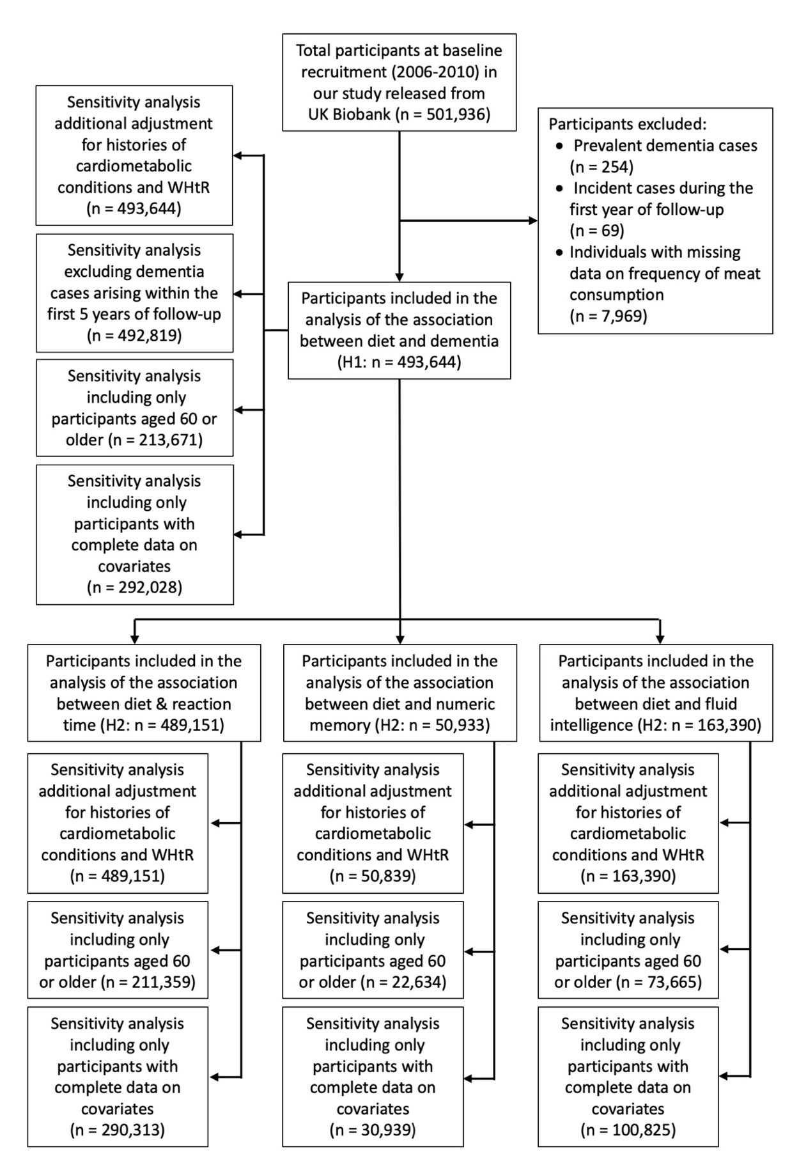
Supplementary Figure 1 Flowchart of participants in the UK Biobank cohort study. WHtR: Waist-to-height ratio.

Supplementary Tables
Supplementary Table 1 Baseline characteristics of participants stratified by frequency of meat consumption in the UK Biobank cohort study
Characteristic | All Participants1  N = 493,644 | High-frequency  meat consumption1  N = 30,270 | Low-frequency  meat consumption1  N = 463,374 | P value2 | SMD3
Dementia Incidence during follow-up | 10,952 (2.2%) | 740 (2.4%) | 10,212 (2.2%) | 0.006 | 0.02
Age at baseline (year) | 56.5 ± 8.1 | 55.1 ± 8.4 | 56.6 ± 8.1 | < 0.001 | 0.19
Duration of follow-up (year) | 14.7 ± 2.4 | 14.6 ± 2.7 | 14.8 ± 2.4 | < 0.001 | 0.07
Sex |  |  |  | < 0.001 | 0.40
Male | 224,646 (45.5%) | 19,280 (63.7%) | 205,366 (44.3%)
Female | 268,998 (54.5%) | 10,990 (36.3%) | 258,008 (55.7%)
Ethnicity |  |  |  | < 0.001 | 0.18
White | 466,623 (94.5%) | 27,430 (90.6%) | 439,193 (94.8%)
Asian or Asian British | 10,762 (2.2%) | 906 (3.0%) | 9,856 (2.1%)
Black or Black British | 7,463 (1.5%) | 1,130 (3.7%) | 6,333 (1.4%)
Mixed/Others | 7,138 (1.4%) | 667 (2.2%) | 6,471 (1.4%)
Missing | 1,658 (0.3%) | 137 (0.5%) | 1,521 (0.3%)
Education |  |  |  | < 0.001 | 0.05
With college/university degree | 159,948 (32.4%) | 9,140 (30.2%) | 150,808 (32.5%)
Without college/university degree | 329,994 (66.8%) | 20,932 (69.2%) | 309,062 (66.7%)
Missing | 3,702 (0.7%) | 198 (0.7%) | 3,504 (0.8%)
Townsend deprivation index |  |  |  | < 0.001 | 0.18
Low deprivation (-6.26 -3.15) | 165,490 (33.5%) | 8,660 (28.6%) | 156,830 (33.8%)
Moderate deprivation (-3.14 -0.59) | 165,367 (33.5%) | 9,250 (30.6%) | 156,117 (33.7%)
High deprivation (-0.58 11) | 162,180 (32.9%) | 12,308 (40.7%) | 149,872 (32.3%)
Missing | 607 (0.1%) | 52 (0.1%) | 555 (0.1%)
Total Fish |  |  |  | < 0.001 | 0.21
≤1 times/wk | 126,906 (25.7%) | 10,112 (33.4%) | 116,794 (25.2%)
1.1-1-9 times/wk | 107,186 (21.7%) | 6,503 (21.5%) | 100,683 (21.7%)
2-3 times/wk | 121,365 (24.6%) | 5,689 (18.8%) | 115,676 (25.0%)
> 3 times/wk | 135,025 (27.4%) | 7,628 (25.2%) | 127,397 (27.5%)
Missing | 3,162 (0.6%) | 338 (1.1%) | 2,824 (0.6%)
Vegetables and Fruits |  |  |  | < 0.001 | 0.26
0-2 servings/d | 48,803 (9.9%) | 5,159 (17.0%) | 43,644 (9.4%)
2.1-4 servings/d | 153,564 (31.1%) | 9,791 (32.3%) | 143,773 (31.0%)
4.1-6 servings/d | 150,644 (30.5%) | 7,482 (24.7%) | 143,162 (30.9%)
More than 6 servings/d | 128,399 (26.0%) | 6,874 (22.7%) | 121,525 (26.2%)
Missing | 12,234 (2.5%) | 964 (3.2%) | 11,270 (2.4%)
Physical activity level |  |  |  | < 0.001 | 0.07
Low | 70,859 (14.4%) | 4,822 (15.9%) | 66,037 (14.3%)
Moderate | 155,392 (31.5%) | 8,815 (29.1%) | 146,577 (31.6%)
High | 155,858 (31.6%) | 9,512 (31.4%) | 146,346 (31.6%)
Missing | 111,535 (22.6%) | 7,121 (23.5%) | 104,414 (22.5%)
Sleep duration |  |  |  | < 0.001 | 0.12
7-8 hour/day | 332,574 (67.4%) | 18,875 (62.4%) | 313,699 (67.7%)
< 7 hour/day | 129,840 (26.3%) | 9,411 (31.1%) | 120,429 (26.0%)
> 8 hour/day | 31,230 (6.3%) | 1,984 (6.6%) | 29,246 (6.3%)
Smoking status |  |  |  | < 0.001 | 0.16
Never | 269,413 (54.6%) | 15,420 (50.9%) | 253,993 (54.8%)
Previous | 170,769 (34.6%) | 10,058 (33.2%) | 160,711 (34.7%)
Current | 51,744 (10.5%) | 4,693 (15.5%) | 47,051 (10.2%)
Missing | 1,718 (0.3%) | 99 (0.3%) | 1,619 (0.3%)
Alcohol drinker status |  |  |  | < 0.001 | 0.08
Never | 21,391 (4.3%) | 1,681 (5.6%) | 19,710 (4.3%)
Previous | 17,605 (3.6%) | 1,390 (4.6%) | 16,215 (3.5%)
Current | 454,179 (92.0%) | 27,149 (89.7%) | 427,026 (92.2%)
Missing | 473 (0.1%) | 50 (0.2%) | 423 (0.1%)
Family history of dementia |  |  |  | 0.251 | 0.01
Yes | 57,718 (11.7%) | 3,365 (11.1%) | 54,353 (11.7%)
No | 318,990 (64.6%) | 18,992 (62.7%) | 299,998 (64.7%)
Missing | 116,936 (23.7%) | 7,913 (26.1%) | 109,023 (23.5%)
History of cardiometabolic diseases |  |  |  | < 0.001 | 0.07
Yes | 154,521 (31.3%) | 10,406 (34.4%) | 144,115 (31.1%)
No | 337,576 (68.4%) | 19,697 (65.1%) | 317,879 (68.6%)
Missing | 1,547 (0.3%) | 167 (0.6%) | 1,380 (0.3%)
Waist-Height Ratio |  |  |  | < 0.001 | 0.21
0.4 to 0.49 (healthy) | 153,694 (31.1%) | 7,156 (23.6%) | 146,538 (31.6%)
0.5 to 0.59 (increased risk) | 240,422 (48.7%) | 15,346 (50.7%) | 225,076 (48.6%)
≥ 0.6 (high risk) | 89,993 (18.2%) | 7,309 (24.1%) | 82,684 (17.8%)
Missing | 9,535 (1.9%) | 459 (1.5%) | 9,076 (2.0%)
Cognitive Function (High-frequency meat consumption/Total)
Reaction Time (29,783/489,179) | 558.9 ± 117.0 | 558.7 ± 126.5 | 558.9 ± 116.3 | < 0.001 | 0.001
Numeric Memory (3,162/50,933) | 8.13 ± 1.68 | 8.08 ± 1.78 | 8.13 ± 1.68 | 0.08 | 0.03
Fluid Intelligence (10,329/163,391) | 5.42 ± 2.02 | 5.31 ± 2.12 | 5.42 ± 2.02 | < 0.001 | 0.06
1 Mean ± SD; n (%)
2 P values from t-tests for continuous variables with a normal distribution, Wilcoxon tests for continuous variables with a nonnormal distribution, or chi-square tests for categorical variables.
3 Standardized mean differences (SMDs) of approximately 0.1 indicate a small difference, 0.2 a moderate difference, and values ≥ 0.5 a large difference.

Supplementary Table 2 Hazard ratios (95% confidence interval) for the association between meat intake frequency and incident dementia in sensitivity analyses
Criteria  (events/N) | HR (95% CI) for high-frequency meat consumptionª | P value
Additional adjustment for histories of cardiometabolic conditions and waist-to-height ratio (10,952/493,644) | 1.20 (1.12, 1.30) | < 0.001
Excluding dementia cases within the first 5 years of follow-up (10,127/492,819) | 1.20 (1.11, 1.30) | < 0.001
Restricted to participants aged ≥ 60 years at baseline (9,554/213,671) | 1.23 (1.14, 1.34) | < 0.001
Restricted to participants with complete covariate data (5,279/292,028) | 1.17 (1.04, 1.31) | 0.006
ª Compared to low-frequency meat consumption. All models used age as the time scale.

Supplementary Table 3 Linear regression coefficients (95% confidence interval) for the association between meat intake frequency and cognitive performance in sensitivity analyses
Reaction Time (n) | β (95% CI) for log-transformed reaction time (z-score)ª | P value
Additional adjustment for histories of cardiometabolic conditions and waist-to-height ratio (489,151) | 0.022 (0.008, 0.037) | 0.002
Restricted to participants aged ≥ 60 years at baseline (211,359) | 0.035 (0.016, 0.054) | < 0.001
Restricted to participants with complete covariate data (290,313) | 0.022 (0.008, 0.037) | 0.002
Numeric Memory (n) | β (95% CI), difference in numeric memory scoreª | P value
Additional adjustment for histories of cardiometabolic conditions and waist-to-height ratio (50,933) | -0.117 (-0.109, 0.002) | 0.058
Restricted to participants aged ≥ 60 years at baseline (22,634) | 0.021 (-0.077, 0.119) | 0.670
Restricted to participants with complete covariate data (30,939) | -0.034 (-0.111, 0.042) | 0.375
Fluid Intelligence (n) | β (95% CI), difference in fluid intelligence scoreª | P value
Additional adjustment for histories of cardiometabolic conditions and waist-to-height ratio (163,390) | -0.022 (-0.060, 0.058) | 0.241
Restricted to participants aged ≥ 60 years at baseline (73,665) | -0.001 (-0.059, 0.065) | 0.981
Restricted to participants with complete covariate data (100,825) | -0.007 (-0.056, 0.041) | 0.754
ª β represents the adjusted mean difference for high-frequency vs low-frequency meat intake (reference).

