Spontaneous Closed-Loop Inert Lithium Species Rejuvenation via Element-Structure-Driven Redox Mediator Screening
Authors:
Ruixing Li¹, Yusheng Ye^{1,2,3,4*}, Yilizhati Kelimu², Hao Liu¹, Limin Tao², Yuying Jiao⁵, Yongji Gong⁵, Xin Gao⁶, Renjie Chen^{1,2,3,4*}
Affiliations:
1. Beijing Key Laboratory of Environmental Science and Engineering, School of Materials Science and Engineering, Beijing Institute of Technology, Beijing 100081, China.
2. Beijing Institute of Technology, Zhuhai 519088, China.
3. Shandong Key Laboratory of Advanced Chemical Energy Storage and Intelligent Safety, Advanced Technology Research Institute, Beijing Institute of Technology, Jinan 250300, China.
4. Collaborative Innovation Center of Electric Vehicles in Beijing, Beijing 100081, China.
5. School of Materials Science and Engineering, Beihang University, Beijing 100191, China.
6. School of Materials Science and Engineering, Peking University, Beijing 100871, China.
*Email: ysye@bit.edu.cn; chenrj@bit.edu.cn

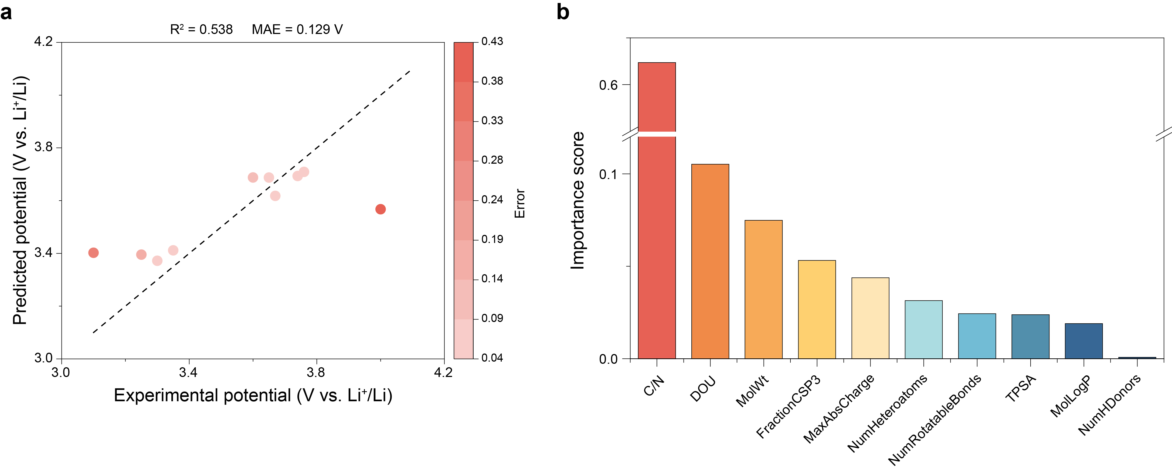
Supplementary Figure 1. Rational prediction of N-containing redox mediators guided by the element-structure-driven model. a, Predicted versus experimental redox potentials. b, Feature importance ranking. Definitions of the abbreviations in the figure are given in Supplementary Disc. 1.
Feature-importance ranking identifies the C/N ratio and degree of unsaturation (DOU) as the dominant descriptors governing redox potential, consistent with Spearman correlation analysis.
*The model is intended to capture qualitative trends and underlying relationships rather than high-precision predictions; therefore, R² alone is not a complete performance metric. The relatively low R² can be primarily attributed to the extremely limited sample size (n = 10), which leads to insufficient statistical robustness and high sensitivity to individual data points.

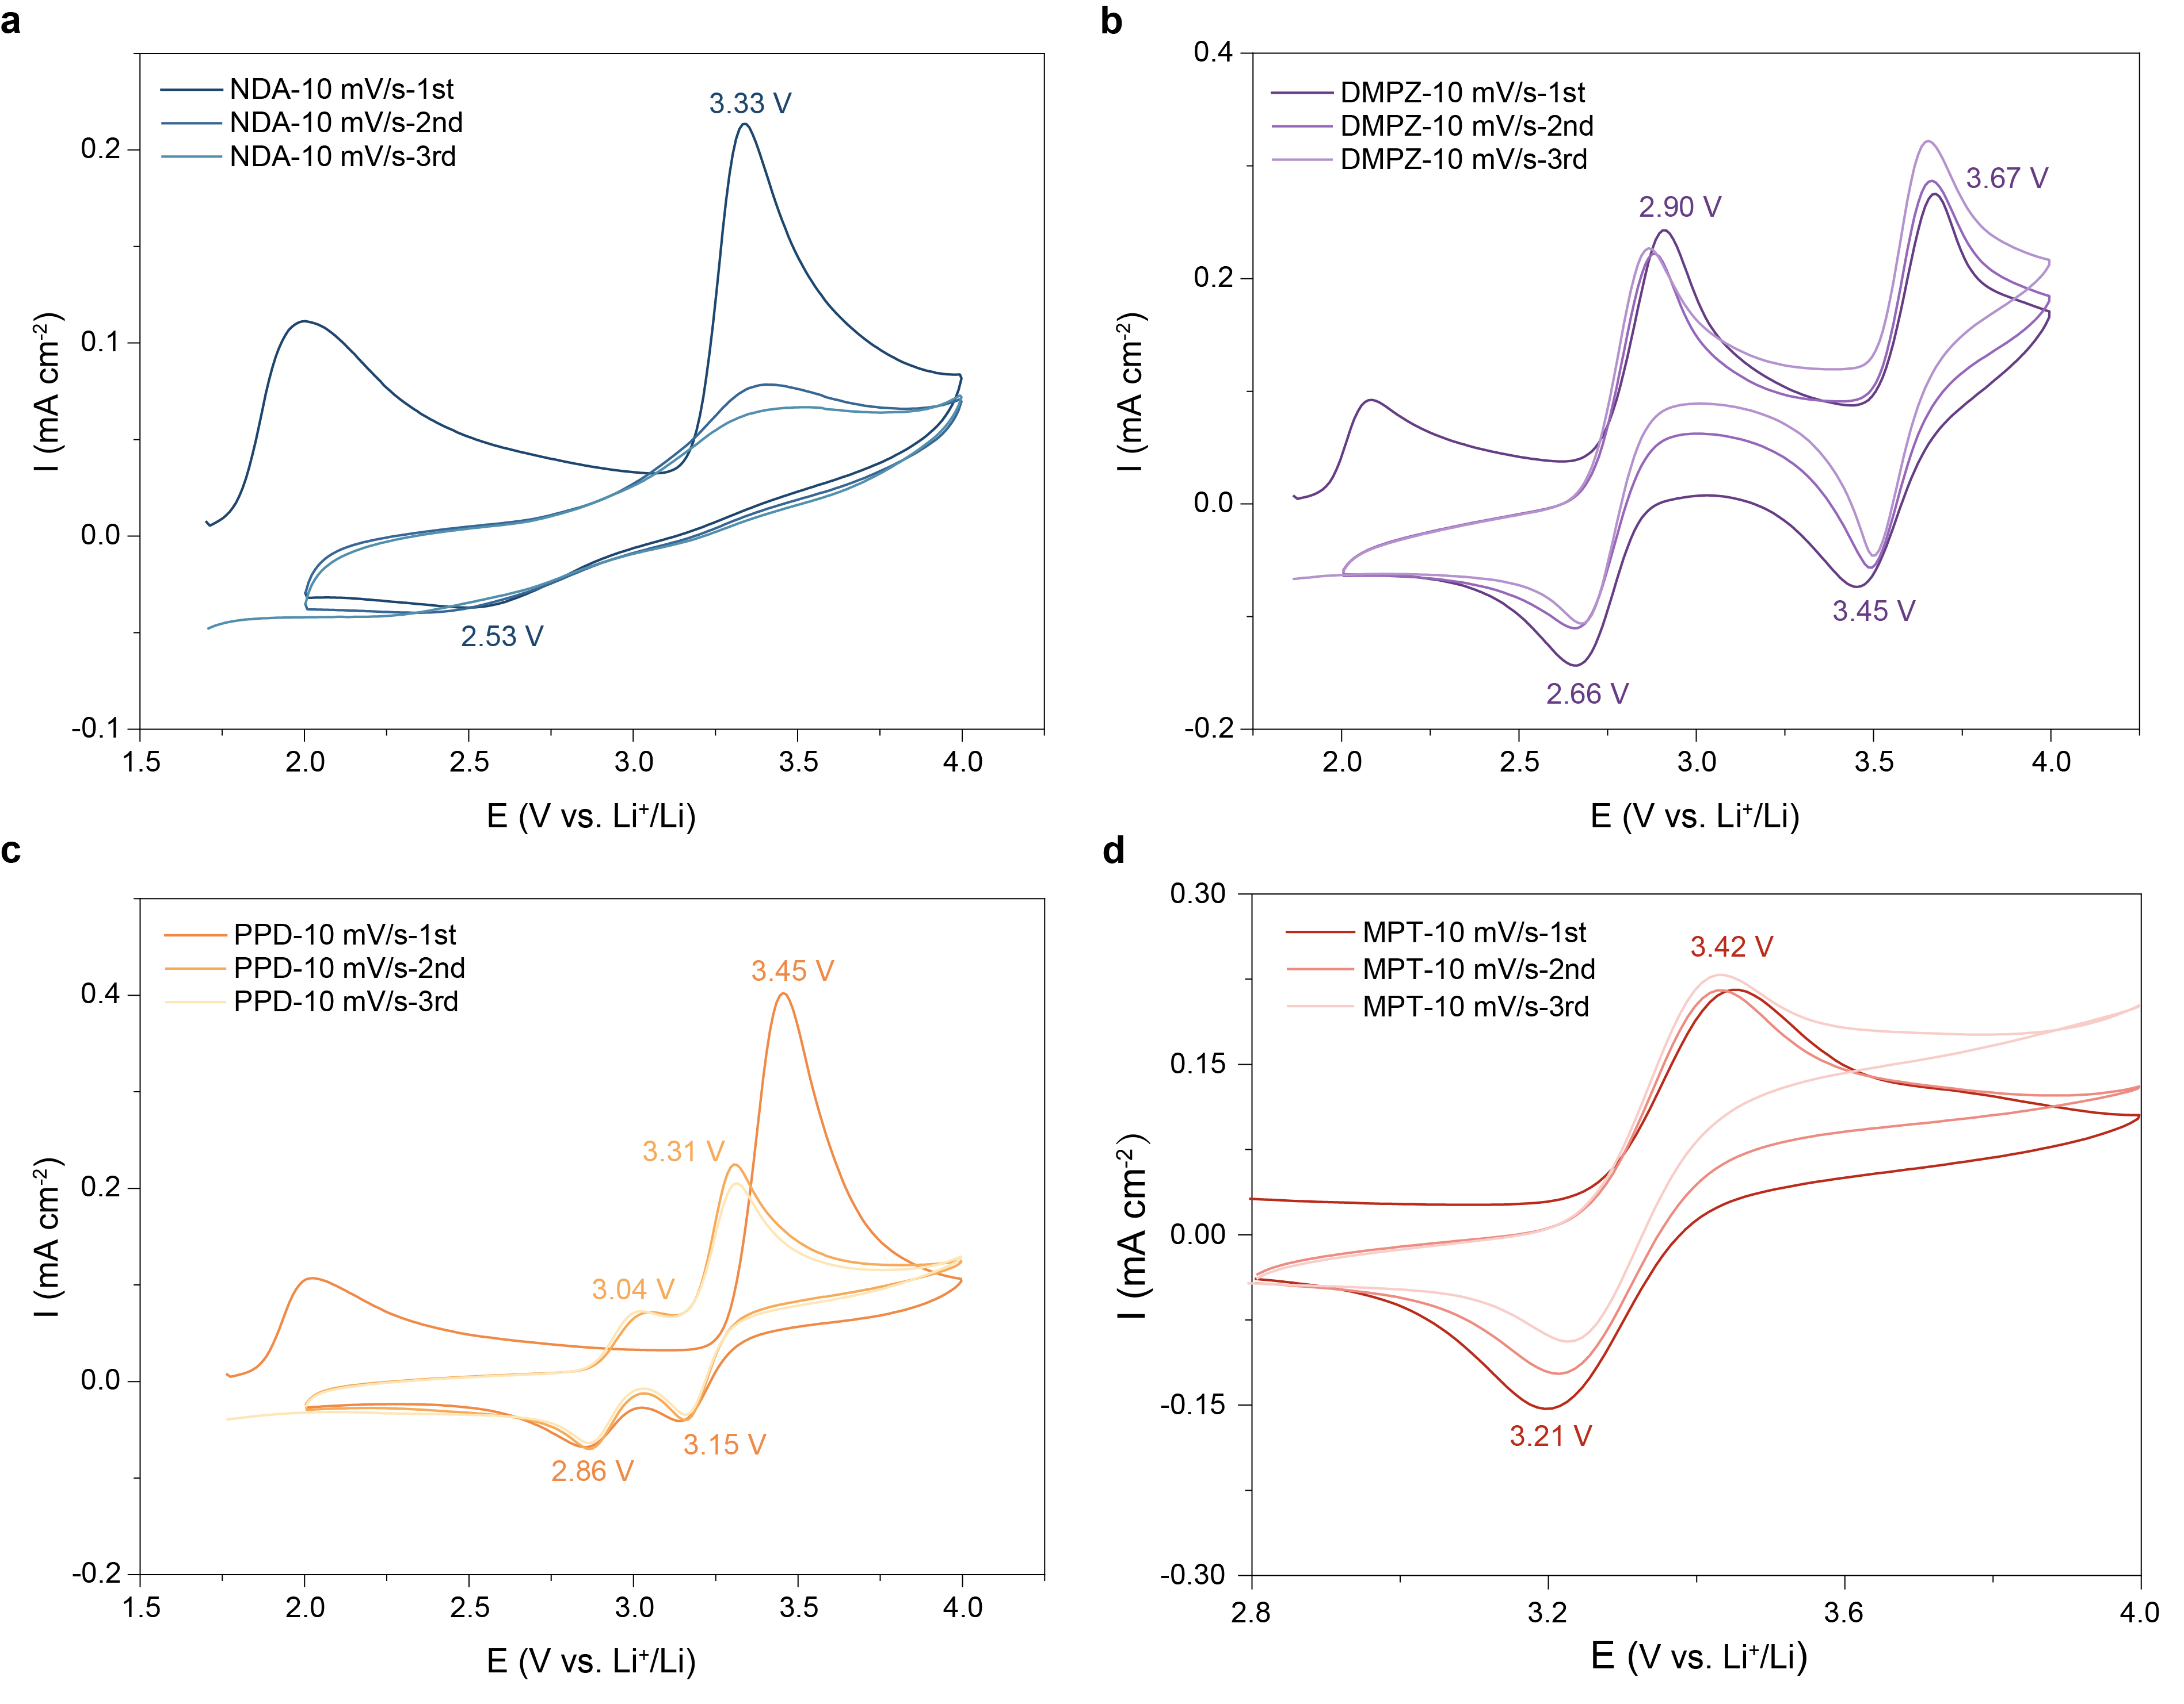
Supplementary Figure 2. Cyclic voltammetry of four representative candidates. a, 1,5-Naphthyldiamine (NDA, blue region). b, 5,10-Dimethyldihydrophenazine (DMPZ, purple region). c, 1-Phenylpyrrolidine (PPD, yellow region). d, 10-Methylphenothiazine (MPT, red region).
NDA and MPT exhibited a single anodic-cathodic peak, indicative of a one-electron redox process, whereas DMPZ and PPD showed two redox couples, consistent with two-electron transfer. Pronounced discrepancies between the first and subsequent oxidation cycles for NDA and PPD indicated limited reversibility, while DMPZ and MPT displayed good electrochemical reversibility. Despite these differences, all four representative candidates exhibited relatively low redox potentials, which fail to meet the required criteria.

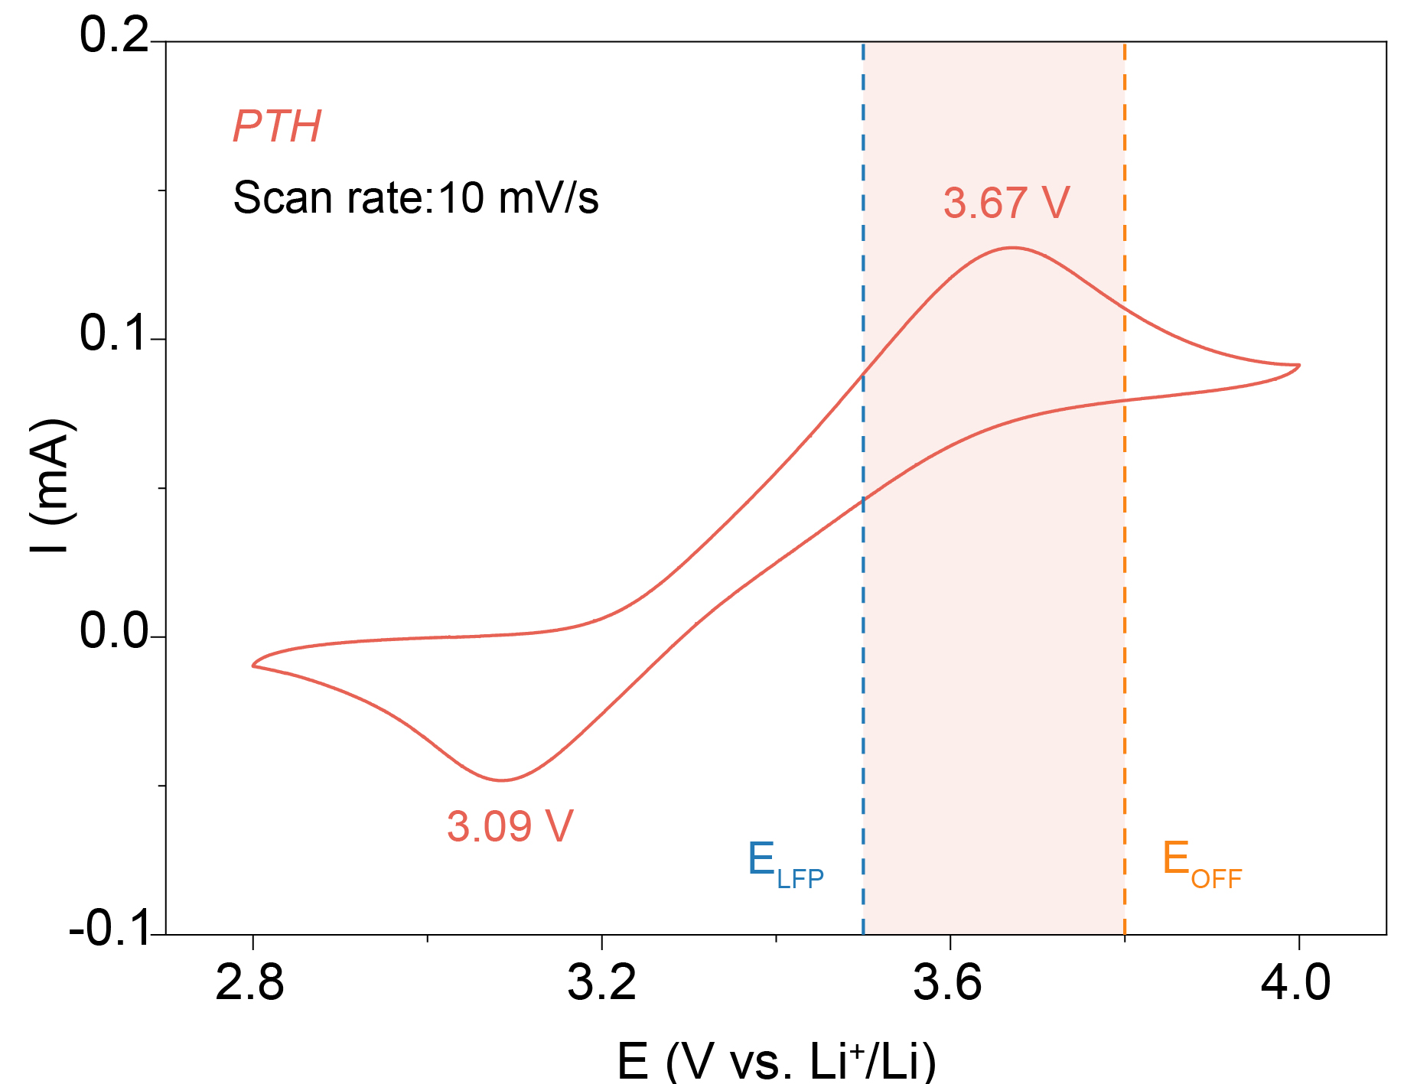
Supplementary Figure 3. Cyclic voltammetry of screened PTH.
PTH exhibited a pair of well-defined, nearly symmetric anodic and cathodic peaks, indicating a highly reversible single-electron redox process. Its redox potential (3.67 V vs. Li⁺/Li) lay above that of LiFePO₄ while below the upper cut-off voltage, satisfying the design requirements.

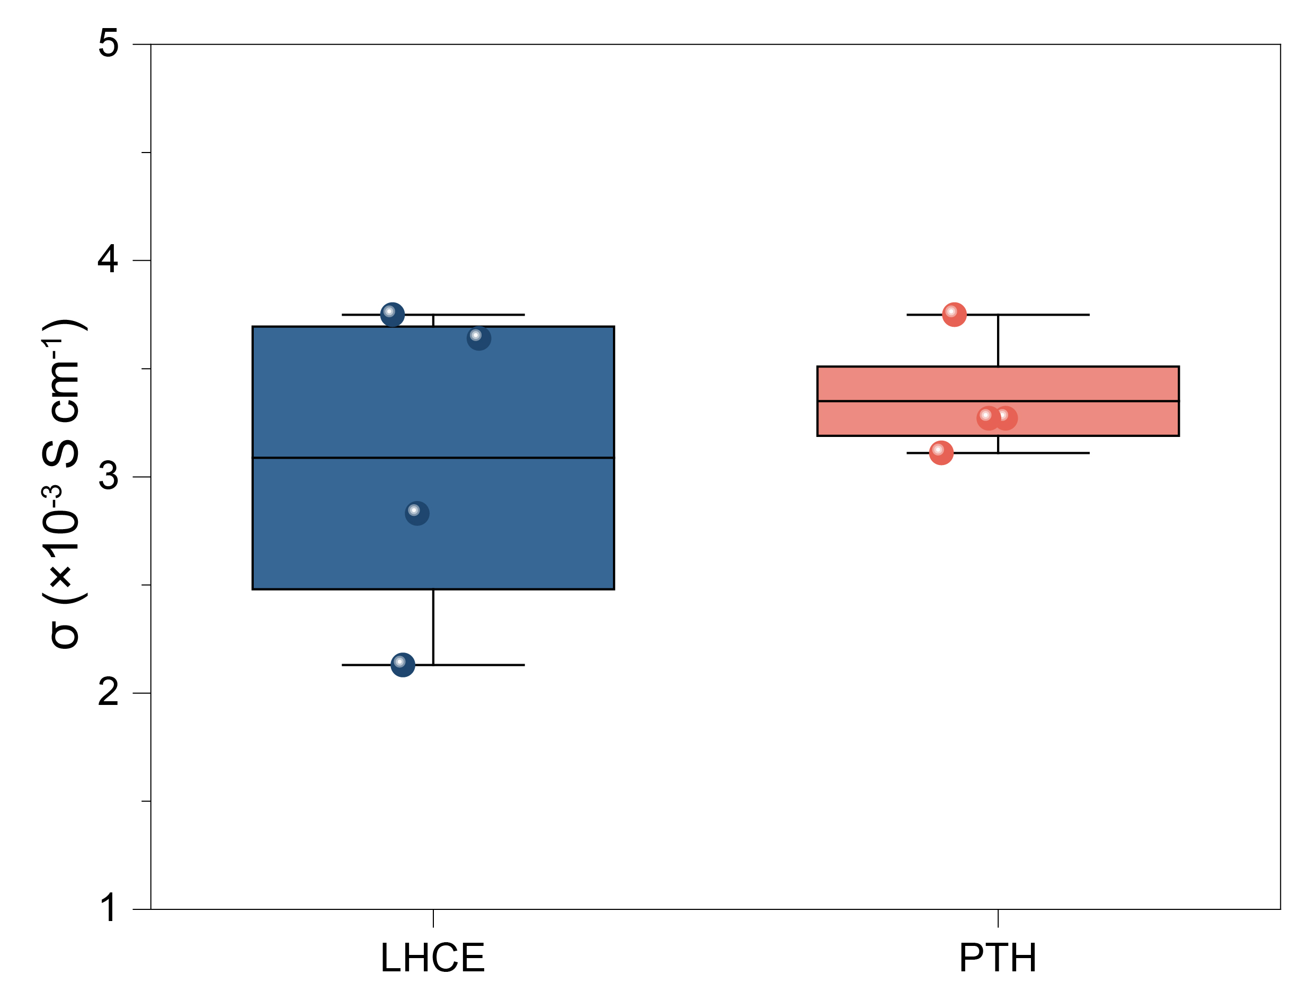
Supplementary Figure 4. Ionic conductivity statistics of LHCE and PTH electrolyte. Each point in the figure corresponds to an individual measurement, while the box spans the 25-75% interval, with the central horizontal line indicating the mean conductivity.
Ionic conductivity was evaluated by impedance measurements using steel-steel cells. The statistical result demonstrated that incorporation of PTH did not measurably affect the ionic conductivity of the electrolyte.

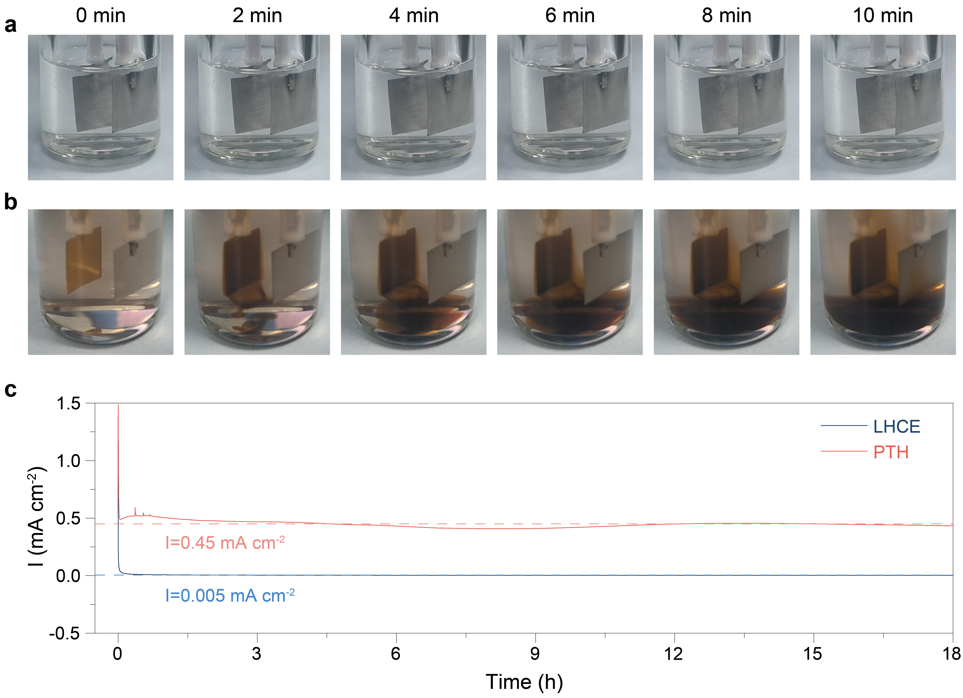
Supplementary Figure 5. The electrochemical pre-oxidation experiment. a,b, Time-series snapshots of LHCE (a) and PTH (b) electrolyte at 4 V (vs. Ref.). c, Current-time curves of the two electrolytes at 4 V (vs. Ref.).
The LHCE electrolyte showed no visible color change and only a minimal current response, indicating its electrochemical inertness. In contrast, the PTH electrolyte developed a distinct brown coloration at the working electrode upon voltage application and displays a markedly higher oxidation current (~0.45 mA cm⁻²), nearly two orders of magnitude greater than that of LHCE. This strong response reflected the rapid oxidation of PTH into its electroactive cationic species, evidencing its high redox activity and fast electron-transfer kinetics.

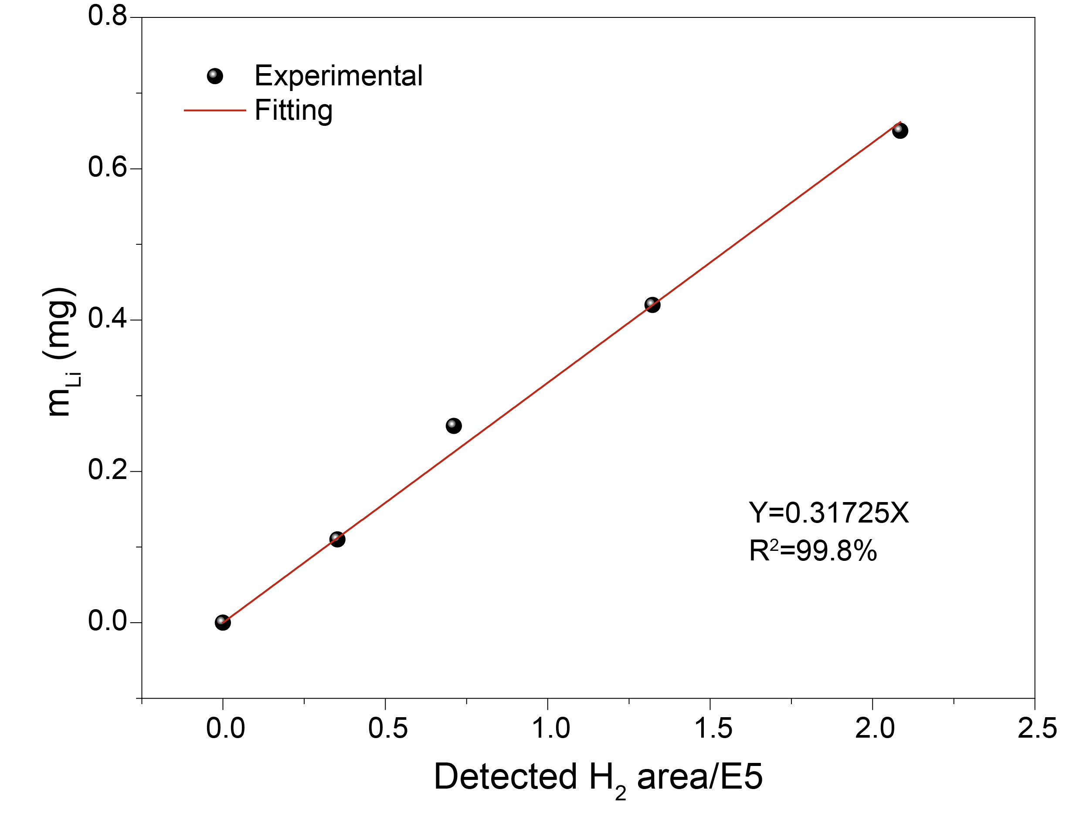
Supplementary Figure 6. Standard calibration curve of TGC.
This curve relating the lithium metal mass to the H₂ peak area measured by gas chromatograph, obtained under identical instrumental and operating conditions prior to sample analysis.

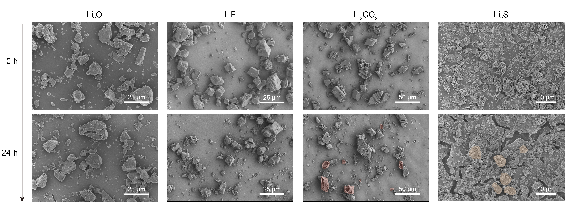
Supplementary Figure 7. Large-scale SEM images of Li₂O, LiF, Li₂CO₃, and Li₂S in the pristine state and after 24-hour immersion in PTH⁺ electrolyte.
Large-scale SEM images showed that PTH⁺ induces negligible changes in Li₂O and LiF, whereas Li₂CO₃ and Li₂S underwent pronounced dissolution. This trend was consistently observed across multiple regions, confirming that the effect was general rather than an occasional phenomenon limited to individual particles.

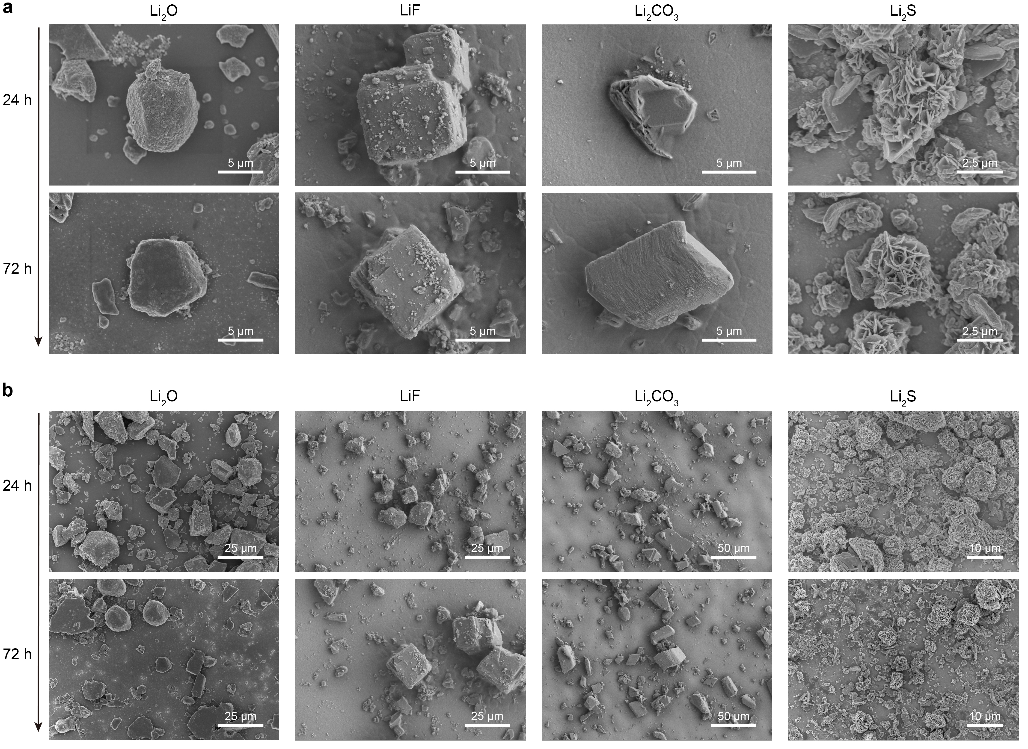
Supplementary Figure 8. SEM images of Li₂O, LiF, Li₂CO₃, and Li₂S after 24-hour and 72-hour immersion in LHCE electrolyte. a, SEM image of an individual particle. b, Large-scale SEM image.
None of four particle types exhibited noticeable dissolution after 24 or even 72 hours of immersion in the LHCE electrolyte, confirming that the dissolution of Li₂CO₃ and Li₂S in PTH⁺ electrolyte did not originate from the solvent environment.

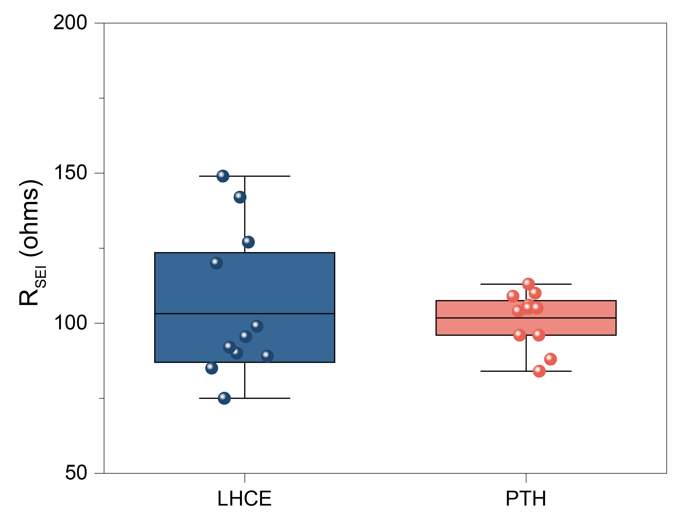
Supplementary Figure 9. Statistical results of interface impedance. Interfacial impedance of Li||Li cells measured across three independent batches (four cells per batch for each electrolyte; n = 12). Each dot denotes an individual measurement, with box boundaries indicating the 25%-75% range and the central line representing the mean impedance.
No measurable change in interfacial resistance was observed upon PTH addition without electrochemical activation.

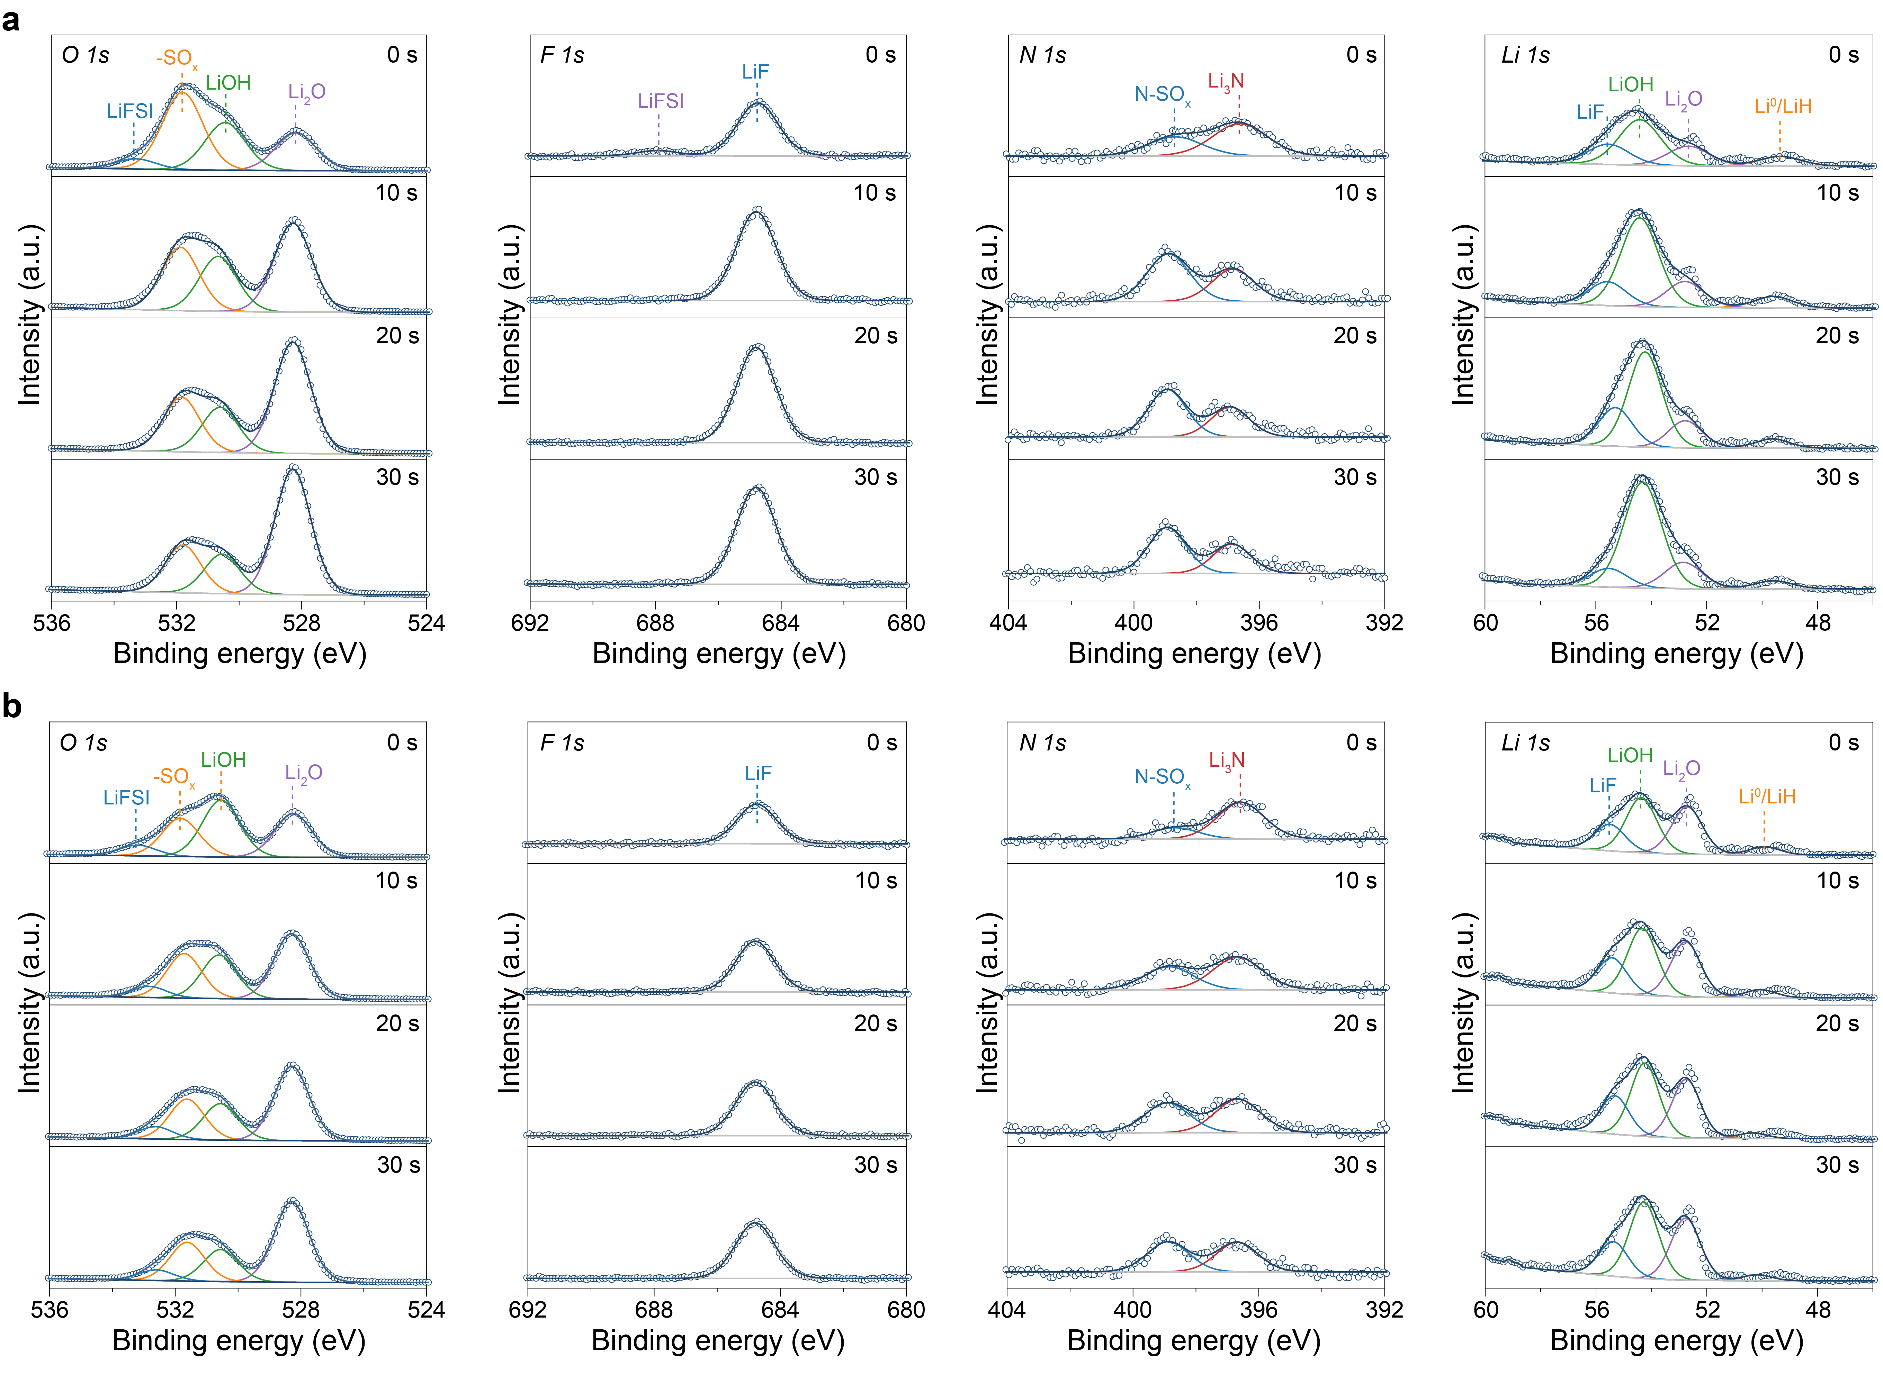
Supplementary Figure 10. High-resolution XPS spectra of O 1s, F 1s, N 1s, and Li 1s regions for Cu||LFP cells using LHCE (a) and PTH (b) electrolyte.
XPS spectra showed O 1s s peaks corresponding to LiFSI (533.3 eV), SO_{x} (531.6 eV), LiOH (530.7 eV) and Li₂O (528.2 eV), and F 1s peaks assigned to LiFSI (688 eV) and LiF (684.8 eV). The N 1s spectra exhibited two peaks at ~398 eV and 396.2 eV, attributable to an N-SO_{x} intermediate containing a single N-S bond and Li₃N species, respectively. Li 1s spectra were deconvoluted into four distinct components: LiF (~55.4 eV), LiOH (54.5 eV), and Li₂O (53.5 eV), and the lowest binding-energy peak (~52.1 eV) from either LiH formed via solvent/water reduction or metallic lithium generated by Li underpotential deposition.

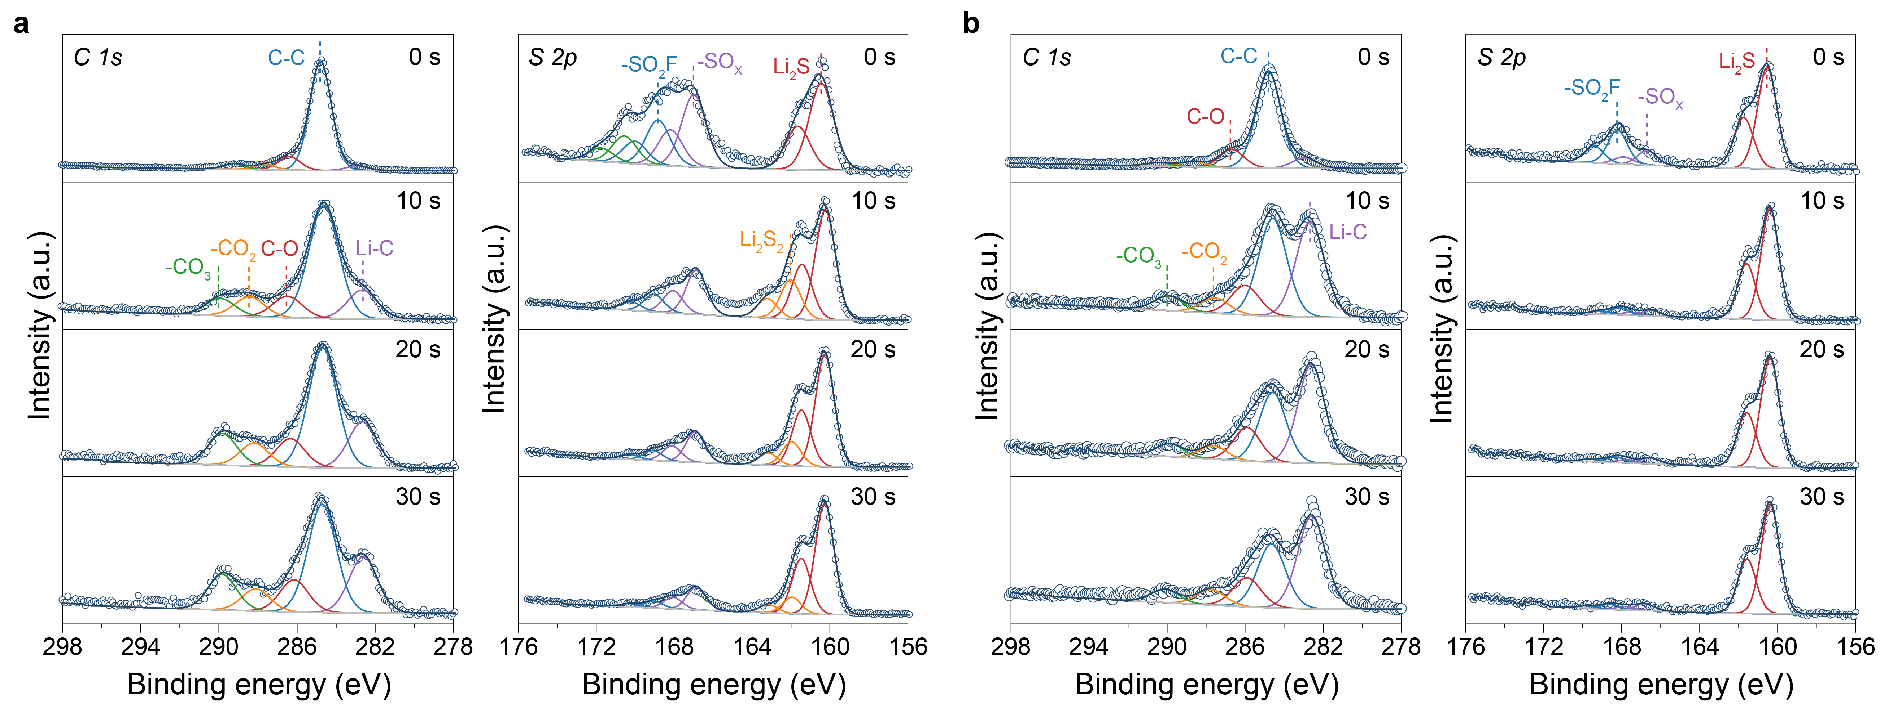
Supplementary Figure 11. High-resolution XPS spectra of C 1s and S 2p regions for Li||Cu cells using LHCE (a) and PTH (b) electrolyte, corresponding to the case without electrochemical activation of PTH.
The results showed no significant deviation from those of the anode-free cells under electrochemically activated conditions.

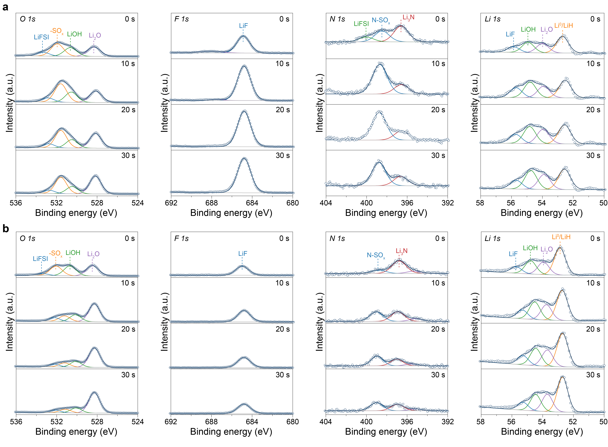
Supplementary Figure 12. High-resolution XPS spectra of O 1s, F 1s, N 1s, and Li 1s regions for Li||Cu cells using LHCE (a) and PTH (b) electrolyte, corresponding to the case without electrochemical activation of PTH.
The results showed no significant difference from those of the anode-free cells under electrochemically activated conditions.

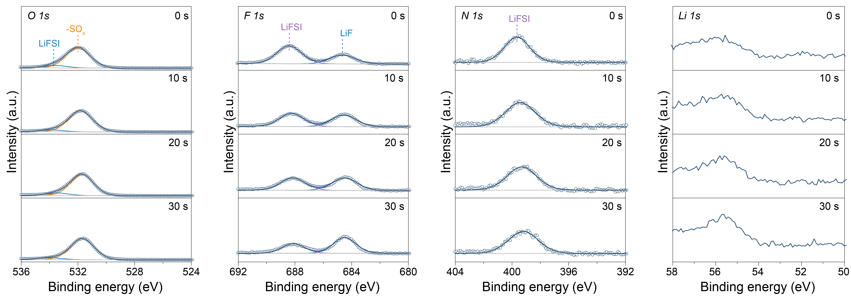
Supplementary Figure 13. High-resolution XPS spectra of O 1s, F 1s, N 1s, and Li 1s regions for Cu||LFP cells after 24 h immersion in the PTH⁺ electrolyte.
The results demonstrated near-complete disappearance of inorganic lithium species.

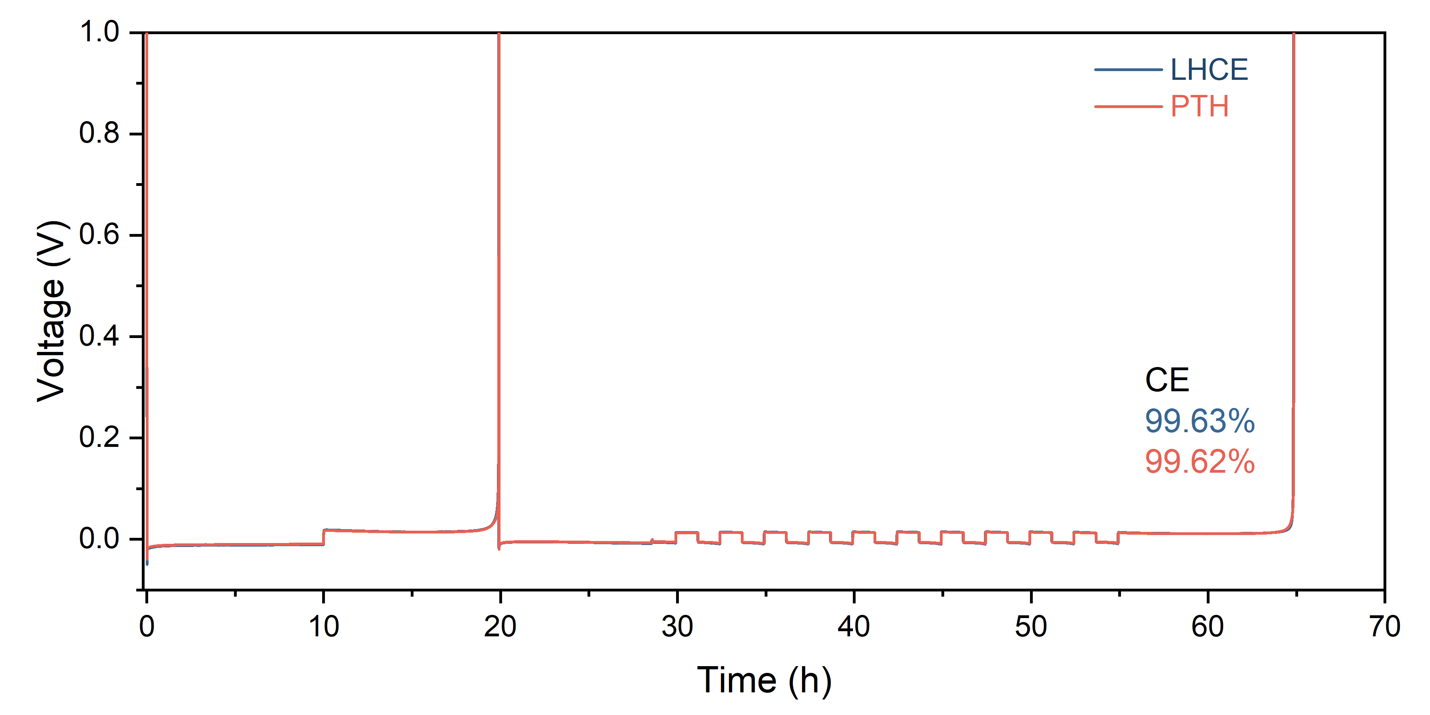
Supplementary Figure 14. Coulombic efficiency of LHCE and PTH electrolyte measured by the Aurbach method without electrochemical activation of PTH.
The coulombic efficiencies of LHCE and PTH electrolytes were 99.63% and 99.62%, respectively, with no significant difference.

Supplementary Table 1 | Redox mediator library.
Number | Material | Molecular formula | SMILES | Degree of unsaturation (DOU) | Oxidation potential (vs. Li⁺/Li) | Reference
1 | N,N,N',N'-Tetramethyl-p-phenylenediamine (TMPD) | C₁₀H₁₆N₂ | CN(C)C1=CC=C(C=C1)N(C)C | 4 | 3.35 V | Ref.¹
2 | 1,5-Naphthalenediamine (NDA) | C₁₀H₁₀N₂ | C1=CC2=C(C=CC=C2N)C(=C1)N | 7 | 3.3 V | Ref.²
3 | 5,10-Dimethyldihydrophenazine (DMPZ) | C₁₄H₁₄N₂ | CN1C2=CC=CC=C2N(C3=CC=CC=C31)C | 9 | 3.25 V | Ref.³
4 | Tris[4-(diethylamino)phenyl]amine (TDPA) | C₃₀H₄₂N₄ | CCN(CC)C1=CC=C(C=C1)N(C2=CC=C(C=C2)N(CC)CC)C3=CC=C(C=C3)N(CC)CC | 12 | 3.1 V | Ref.⁴
5 | 1-Phenylpyrrolidine (PPD) | C₁₀H₁₃N | C1CCN(C1)C2=CC=CC=C2 | 5 | 4 V | Ref.²
6 | 2-Azaadamantane-N-oxyl (AZADO) | C₉H₁₄NO | C1C2CC3CC1CC(C2)N3[O] | 3.5 | 3.65 V | Ref.⁵
7 | 1-Methyl-2-aza-adamantane-N-oxyl (Me-AZADO) | C₁₀H₁₆NO | CC12CC3CC(CC(C3)N1[O])C2 | 3.5 | 3.6 V | Ref.⁵
8 | 2,2,6,6-Tetramethylpiperidinyl-1-oxide (TEMPO) | C₉H₁₈NO | CC1(CCCC(N1[O])(C)C)C | 1.5 | 3.74 V | Ref.⁵⁻⁷
9 | 4-Methoxy-2,2,6,6-tetramethylpiperidinyl-1-oxyl (Me-TEMPO) | C₁₀H₂₀NO₂ | CC1(CC(CC(N1[O])(C)C)OC)C | 1.5 | 3.76 V | Ref.⁵
10 | 10-Methylphenothiazine (MPT) | C₁₃H₁₁NS | CN1C2=CC=CC=C2SC3=CC=CC=C31 | 9 | 3.67 V | Ref.^{6,8}
11 | 1,4-Naphthoquinone (NQ) | C₁₀H₆O₂ | C1=CC=C2C(=O)C=CC(=O)C2=C1 | 8 | 2.6 V | Ref.⁹
12 | Anthraquinone (AQ) | C₁₄H₈O₂ | C1=CC=C2C(=C1)C(=O)C3=CC=CC=C3C2=O | 11 | ~ 2.4 V | Ref.¹⁰
13 | Anthraquinone-2-carboxylic acid (AQC) | C₁₅H₈O₄ | C1=CC=C2C(=C1)C(=O)C3=C(C2=O)C=C(C=C3)C(=O)O | 12 | ~ 2.4 V | Ref.¹⁰
14 | 1,5-Bis(2-(2-(2-methoxyethoxy)ethoxy)ethoxy)anthra-9,10-quinon (AQT) | C₂₈H₃₆O₁₀ | COCCOCCOCCOC1=CC=CC2=C1C(=O)C3=C(C2=O)C(=CC=C3)OCCOCCOCCOC | 11 | ~ 2.5 V | Ref.¹⁰
15 | 2,5-Dichloro-1,4-benzoquinone (DCBQ) | C₆H₂Cl₂O₂ | C1=C(C(=O)C=C(C1=O)Cl)Cl | 5 | ~ 3 V | Ref.¹⁰
16 | 2,5-Di-tert-butyl-1,4-benzoquinone (DBBQ) | C₁₄H₂₀O₂ | CC(C)(C)C1=CC(=O)C(=CC1=O)C(C)(C)C | 5 | 2.55 V | Ref.¹¹
17 | Tetrathiafulvalene (TTF) | C₆H₄S₄ | C1=CSC(=C2SC=CS2)S1 | 5 | 3.38 V | Ref.¹
18 | Thianthrene (Th) | C₁₂H₈S₂ | C1=CC=C2C(=C1)SC3=CC=CC=C3S2 | 9 | 4.1 V | Ref.⁶
19 | 10-Phenylphenothiazine (PTH) | C₁₈H₁₃NS | C1=CC=C(C=C1)N2C3=CC=CC=C3SC4=CC=CC=C42 | 13 | 3.67 V | This work
*It must be noted that the oxidation potentials of these redox mediators are influenced by factors including scan rate, solvent environment, salt concentration and so on. Therefore, reported values serve only as references, and experimentally determined potentials should guide practical use.
The DOU was calculated according to the following formula:
$$DOU=\frac{2C+N-H-X+2}{2}$$
Where C, N, H, and X denote the numbers of carbon, nitrogen, hydrogen, and halogen atoms in the molecule, respectively.

Supplementary Discussion 1. Molecular descriptor types
We selected 10 molecular descriptors to characterize the redox mediators. Their respective meanings are shown below. These molecular descriptors can be directly calculated or accessed in RDKit cheminformatics software (version 2025.03.6).
- Wt: The relative molecular weight of a molecule.
- NumHeteroatoms: The number of heteroatoms in the molecule.
- C/N ratio: The ratio of carbon atoms to nitrogen atoms in the molecule.
- FractionCSP3: The proportion of sp³ hybridized carbon atoms in a molecule.
- DOU: Degree of unsaturation of a molecule, defined as the total number of rings and double-bond equivalents.
- NumRotatableBonds: The number of rotatable bonds in the molecule.
- MaxAbsCharge: The maximum absolute value of the atomic partial charges, serving as a quantitative molecular descriptor for the degree of charge inhomogeneity within a molecule.
- Topological Polar Surface Area (TPSA): The polar surface area of a molecule calculated based on its topological structure.
- LogP: The partition coefficient of a molecule, which describes its distribution behavior between oil and water phases. It can be used to evaluate the hydrophobicity of a molecule.
- NumHDonors: The number of hydrogen acceptors and hydrogen donors in the molecule.

References
1 Chen, Y., Freunberger, S. A., Peng, Z., Fontaine, O. & Bruce, P. G. Charging a Li-O₂ battery using a redox mediator. Nature Chemistry 5, 489-494 (2013).
2 Lim, H.-D. et al. Rational design of redox mediators for advanced Li-O₂ batteries. Nature Energy 1, 16066 (2016).
3 Lee, S. H., Park, J.-B., Lim, H.-S. & Sun, Y.-K. An advanced separator for Li-O₂ batteries: maximizing the effect of redox mediators. Advanced Energy Materials 7, 1602417 (2017).
4 Kundu, D., Black, R., Adams, B. & Nazar, L. F. A highly active low voltage redox mediator for enhanced rechargeability of lithium-oxygen batteries. ACS Central Science 1, 510-515 (2015).
5 Bergner, B. J. et al. Understanding the fundamentals of redox mediators in Li-O₂ batteries: a case study on nitroxides. Physical Chemistry Chemical Physics 17, 31769-31779 (2015).
6 Chen, J. et al. Selection of redox mediators for reactivating dead Li in lithium metal batteries. Advanced Energy Materials 12, 2201800 (2022).
7 Zhang, Y. et al. Reactivating the dead Lithium by redox shuttle to promote the efficient utilization of lithium for anode free lithium metal batteries. Advanced Functional Materials 33, 2301332 (2023).
8 Feng, N., He, P. & Zhou, H. Enabling catalytic oxidation of Li₂O₂ at the liquid-solid interface: the evolution of an aprotic Li-O₂ battery. ChemSusChem 8, 600-602 (2015).
9 Matsuda, S., Hashimoto, K. & Nakanishi, S. Efficient Li₂O₂ formation via aprotic oxygen reduction reaction mediated by quinone derivatives. The Journal of Physical Chemistry C 118, 18397-18400 (2014).
10 Tsao, Y. et al. Designing a quinone-based redox mediator to facilitate Li₂S oxidation in Li-S batteries. Joule 3, 872-884 (2019).
11 Liu, T. et al. The effect of water on quinone redox mediators in nonaqueous Li-O₂ batteries. Journal of the American Chemical Society 140, 1428-1437 (2018).

