Supplementary Material

Figure S1. Synthetic route of HB-pDMA.

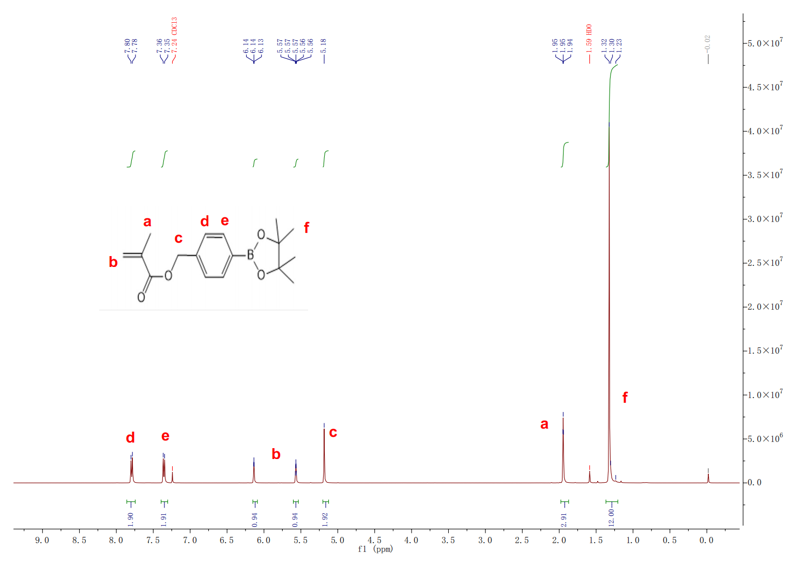
Figure S2. ¹H NMR spectrum of HB. (CDCl₃, 400MHz)

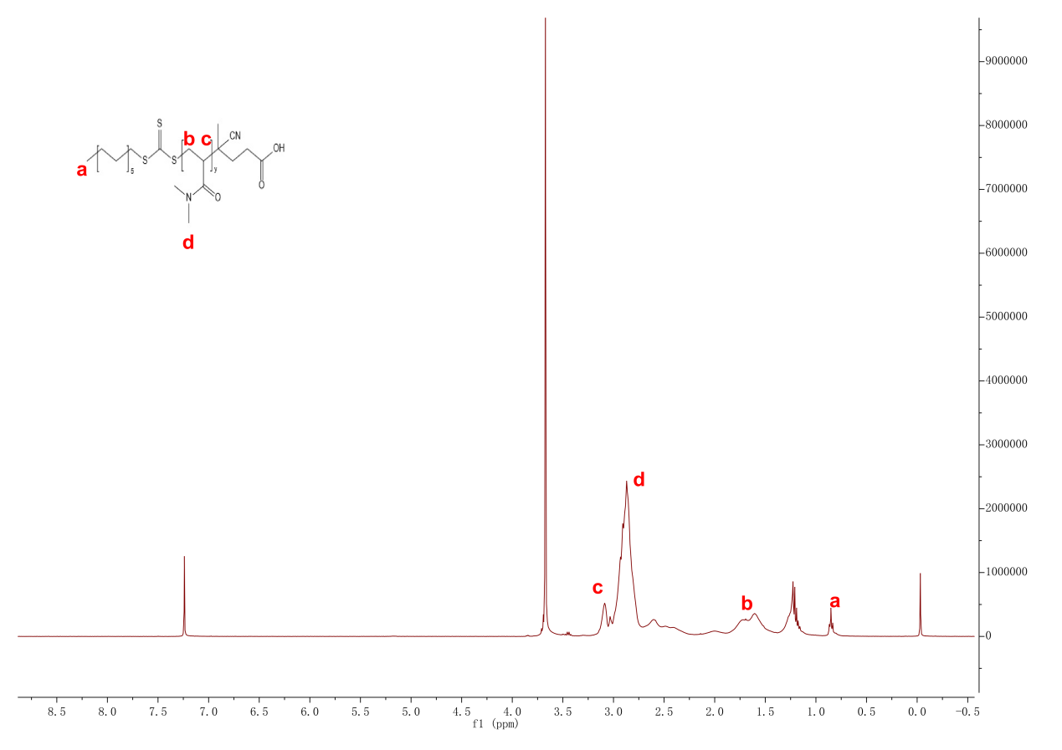
Figure S3. ¹H NMR spectrum of pDMA. (CDCl₃, 400MHz)
Figure S4. ¹H NMR spectrum of HB-pDMA. (CDCl₃, 400MHz)

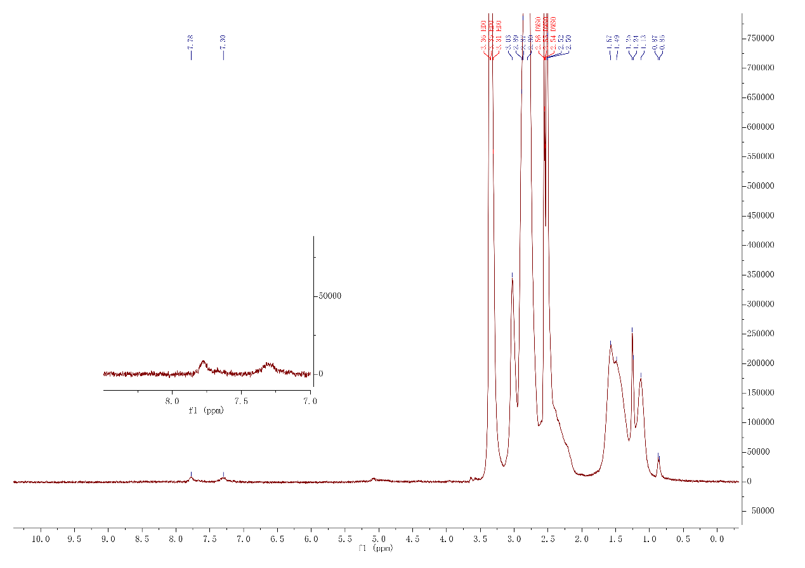
Figure S5. ¹H NMR spectrum of HB-pDMA-CTB. (DMSO-d6, 400MHz)

Figure S6. Encapsulation Efficiency of Nanoparticles. Data are presented as the mean ± SD (n = 3).

Figure S7. Immunofluorescence analysis of TRPV4 expression in retinal sections from normal rats with or without NP-CTB treatment. (A–B) Representative immunofluorescence images showing TRPV4 expression in retinal sections from normal rats treated with or without NP-CTB, with quantification of TRPV4 fluorescence intensity. TRPV4 is shown in red, and nuclei are counterstained with DAPI (blue). Scale bar, 50 μm. Statistical analysis was performed using unpaired Student’s t-test (B) and data are presented as mean ± SD (n = 3). ns, not significant.

