Table S1 Experimental design of intercropping patterns
Planting patterns | Symbolic | Plant number
P. vittata monoculture | PM | 4
S. alfredii monoculture | SM | 4
H. spectabile monoculture | HM | 4
P. vittata/S. alfredii | PS | 2+2
P. vittata/H. spectabile | PH | 2+2

Table S2 The bacterial α-diversity indices in rhizosphere soil of the monoculture and intercropping treatments
Treatments | Coverage | ACE | Chao 1 | Shannon
PM | 0.9820±0.0015 | 3898±28a | 3898±46a | 6.24±0.07b
SM | 0.9820±0.0014 | 3801±118b | 3848±143b | 6.21±0.09b
HM | 0.9814±0.0017 | 3586±82c | 3562±107c | 6.15±0.11c
PS | 0.9800±0.0020 | 3860±52ab | 3856±61ab | 6.40±0.16a
PH | 0.9803±0.0010 | 3870±140ab | 3895±130a | 6.45±0.11a
Different letters within the same column indicate significant differences (P < 0.05) between the intercropping treatment and corresponding monoculture. Values are shown as means ± SD (n=4).

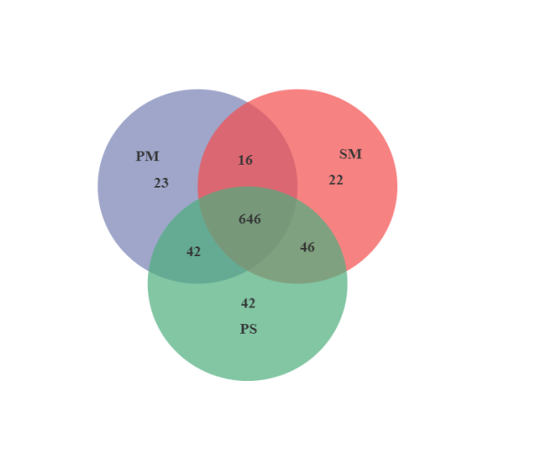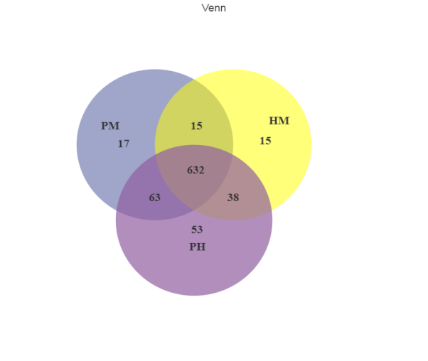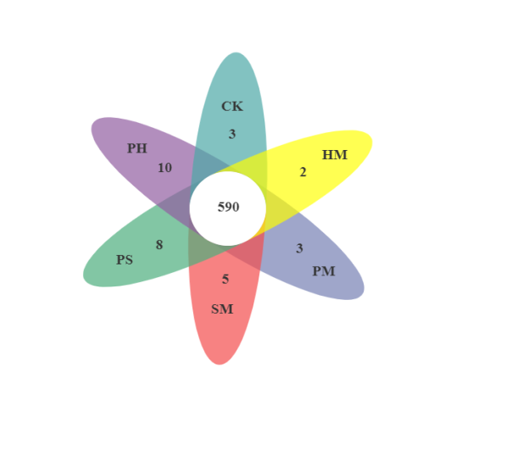
(a)
(c)
(b)
Fig. S1 The Venn diagram showing the numbers of unique and common OTUs in rhizosphere soils under different treatments.

Graphical abstract：
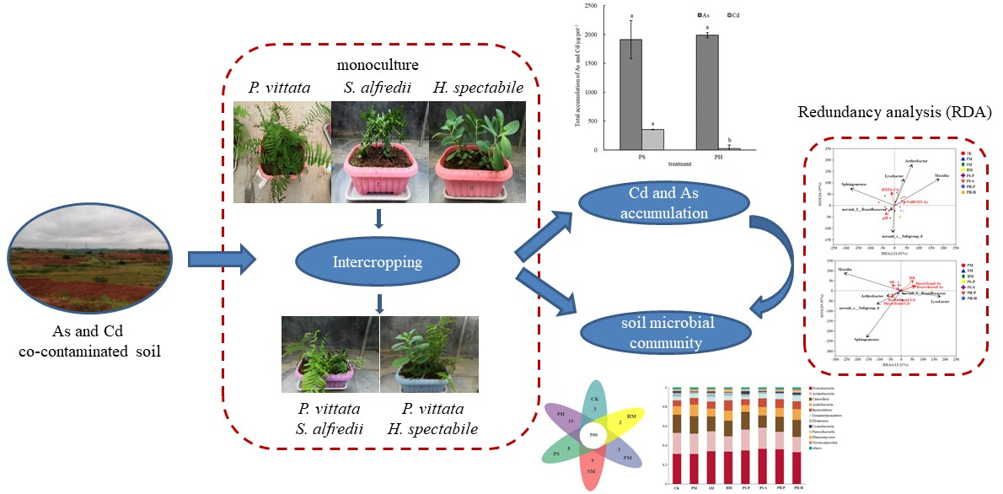

Highlights:
1. As and Cd phytoextraction by intercropping hyperaccumulators/accumulator was investigated.
2. Intercropping P. vittata with S. alfredii acquired the maximum As and Cd accumulation.
3. Soil microbial community diversity was improved by intercropping and important for heavy metal uptake.

