Supplemental Online Content

Contents
eTable 1. Search strings
eTable 2. Characteristics of Included Studies
eFigure 1. PRISMA Flow Diagram
eFigure 2. Risk of bias assessment
eFigure 3. Hazard Ratios for Time to Deterioration of Fatigue(A), Pain(B) and Dyspnea(C) according to Experimental Treatment Groups.
eFigure 4. Hazard Ratios for Time to Deterioration of Cough(A), Hemoptysis(B), Nausea and/or Vomiting(C) and the composite endpoint of cough, chest pain, or dyspnea(D) according to Experimental Treatment Groups.
eFigure 5. Hazard Ratios for Time to Deterioration of Appetite Loss according to Experimental Treatment Groups.
eFigure 6. Leave-one-out Forest Plot for TTD of Appetite Loss(A)Baujat graph for TTD of Appetite Loss(B)Forest plot for TTD of Appetite Loss(C) after removal of influential studies.Leave-one-out Forest Plot for TTD of Pain(D)Baujat graph for TTD of Pain(E)Forest plot for TTD of Pain(F) after removal of influential studies.Leave-one-out Forest Plot for TTD of Nausea and/or Vomiting(G)Baujat graph for TTD of Nausea and/or Vomiting(H)Forest plot for TTD of Nausea and/or Vomiting(I) after removal of influential studies.
eFigure 7. Correlation between hazard ratio (HR) of OS and HR of the composite endpoint of cough, chest pain, or dyspnea(A) and EF(B) in the RCTs of ICI-based therapies.

eTable 1 String search for PubMed(2025/9/23):
Search number | Query | Results
1 | Carcinoma, Non-Small-Cell Lung[Mesh] | 80,370
2 | NSCLC[Title/Abstract] | 73,358
3 | Non-small[Title/Abstract] OR non small[Title/Abstract] | 101,919
4 | Lung[Title/Abstract] | 834,953
5 | cancer*[Title/Abstract] OR carcin*[Title/Abstract] OR neoplasm*[Title/Abstract] OR tumour*[Title/Abstract] OR tumour*[Title/Abstract] | 3,506,973
6 | ((Non-small[Title/Abstract] OR non small[Title/Abstract]) AND (Lung[Title/Abstract])) AND (cancer*[Title/Abstract] OR carcin*[Title/Abstract] OR neoplasm*[Title/Abstract] OR tumour*[Title/Abstract] OR tumour*[Title/Abstract]) | 101,060
7 | ((Carcinoma, Non-Small-Cell Lung[Mesh]) OR (NSCLC[Title/Abstract])) OR (((Non-small[Title/Abstract] OR non small[Title/Abstract]) AND (Lung[Title/Abstract])) AND (cancer*[Title/Abstract] OR carcin*[Title/Abstract] OR neoplasm*[Title/Abstract] OR tumour*[Title/Abstract] OR tumour*[Title/Abstract])) | 119,865
8 | Immune Checkpoint Inhibitors[Mesh] OR Programmed Cell Death 1 Receptor[Mesh] OR CTLA-4 Antigen[Mesh] | 33,642
9 | immune checkpoint inhibitors[Title/Abstract] OR immune checkpoint inhibitor[Title/Abstract] OR Programmed Cell Death 1 Receptor[Title/Abstract] OR Programmed Cell Death 1 Protein[Title/Abstract] OR PD-1[Title/Abstract] OR PD-L1[Title/Abstract] OR CTLA-4[Title/Abstract] | 87,367
10 | pembrolizumab [Supplementary Concept] OR camrelizumab [Supplementary Concept] OR tislelizumab [Supplementary Concept] OR sintilimab [Supplementary Concept] OR toripalimab [Supplementary Concept] OR "penpulimab" [Supplementary Concept] OR atezolizumab [Supplementary Concept] OR sugemalimab [Supplementary Concept] OR tremelimumab [Supplementary Concept] OR Ipilimumab[Mesh] OR cemiplimab[Supplementary Concept] | 11,238
11 | MK3475[Title/Abstract] OR Keytruda[Title/Abstract] OR lambrolizumab[Title/Abstract] OR SCH-900475[Title/Abstract] OR pembrolizumab[Title/Abstract] OR camrelizumab[Title/Abstract] OR SHR-1210[Title/Abstract] OR SHR 1210[Title/Abstract] OR tislelizumab[Title/Abstract] OR tislelizumab-jsgr[Title/Abstract] OR BGB-A317[Title/Abstract] OR JHL-2108[Title/Abstract] OR JHL2108[Title/Abstract] OR tevimbra[Title/Abstract] OR sintilimab[Title/Abstract] OR IBI 308[Title/Abstract] OR IBI308[Title/Abstract] OR IBI-308[Title/Abstract] OR toripalimab[Title/Abstract] OR toripalimab-tpzi[Title/Abstract] OR Serplulimab[Title/Abstract] OR HLX10[Title/Abstract] OR penpulimab[Title/Abstract] OR penpulimab-kcqx[Title/Abstract] OR atezolizumab[Title/Abstract] OR anti-PDL1[Title/Abstract] OR MPDL3280A[Title/Abstract] OR MPDL-3280A[Title/Abstract] OR Tecentriq[Title/Abstract] OR RG7446[Title/Abstract] OR RG-7446[Title/Abstract] OR sugemalimab[Title/Abstract] OR tremelimumab[Title/Abstract] OR CP-675,206[Title/Abstract] OR CP 675206[Title/Abstract] OR CP-675206[Title/Abstract] OR CP675206[Title/Abstract] OR CP 675[Title/Abstract] OR CP-675[Title/Abstract] OR CP675 cpd[Title/Abstract] OR ticilimumab[Title/Abstract] OR Ipilimumab[Title/Abstract] OR Anti-CTLA-4 MAb Ipilimumab[Title/Abstract] OR Anti CTLA 4 MAb Ipilimumab[Title/Abstract] OR Ipilimumab[Title/Abstract] OR Anti-CTLA-4 MAb[Title/Abstract] OR MDX 010[Title/Abstract] OR MDX 010[Title/Abstract] OR MDX010[Title/Abstract] OR MDX-CTLA-4[Title/Abstract] OR MDX CTLA 4[Title/Abstract] OR Yervoy[Title/Abstract] OR cemiplimab[Title/Abstract] OR REGN2810[Title/Abstract] | 22,848
12 | "Patient Reported Outcome Measures"[Mesh] OR "Quality of Life"[Mesh] | 324,266
13 | quality of life[Title/Abstract] OR QoL[Title/Abstract] OR HRQoL[Title/Abstract] OR patient reported outcome*[Title/Abstract] OR PRO[Title/Abstract] OR PROs[Title/Abstract] OR EORTC QLQ*[Title/Abstract] OR FACT*[Title/Abstract] OR EQ-5D[Title/Abstract] OR patient experience*[Title/Abstract] OR symptom burden[Title/Abstract] OR functional status[Title/Abstract] OR well-being[Title/Abstract] OR health status[Title/Abstract] | 5,883,983
14 | ("Patient Reported Outcome Measures"[Mesh] OR "Quality of Life"[Mesh]) OR (quality of life[Title/Abstract] OR QoL[Title/Abstract] OR HRQoL[Title/Abstract] OR patient reported outcome*[Title/Abstract] OR PRO[Title/Abstract] OR PROs[Title/Abstract] OR EORTC QLQ*[Title/Abstract] OR FACT*[Title/Abstract] OR EQ-5D[Title/Abstract] OR patient experience*[Title/Abstract] OR symptom burden[Title/Abstract] OR functional status[Title/Abstract] OR well-being[Title/Abstract] OR health status[Title/Abstract]) | 5,935,130
15 | ("Randomized Controlled Trial"[pt] OR "Controlled Clinical Trial"[pt] OR randomized[tiab] OR randomised[tiab] OR placebo[tiab] OR randomly[tiab] OR trial[tiab] OR "Clinical Trial, Phase III"[pt] OR "phase 3"[tiab] OR "phase III"[tiab]) | 1,963,041
16 | first line[Title/Abstract] OR first-line[Title/Abstract] OR frontline[Title/Abstract] OR treatment naive[Title/Abstract] OR previously untreated[Title/Abstract] OR advanced metastatic[Title/Abstract] | 182,999
18 | #8 OR #9 OR #10 OR #11 | 102,309
19 | #7 AND #18 AND #14 AND #15 AND #16 | 219

eTable 2 Characteristics of Included Studies
Study(year), Country | Masked | Arm (number of patients) | HR-QoL  questionnaire(s) | Publication of HRQoL  analysis | Definition of HRQoL deterioration
EMPOWER-Lung 3 part 2(2023), USA | Double-blinded | cemiplimab+CT:312  placebo+CT:154 | EORTC QLQ-C30; EORTC QLQ-LC13 | Main paper: partial. | We defined definitive clinically meaningful deterioration in GHS/QoL and functioning scales as the time from randomization to the first observation with a greater than or equal to 10‐point decrease and no subsequent observations with a less than 10‐point decrease from baseline or until patient drop‐out resulting in missing data.We defined definitive clinically meaningful deterioration in the symptom scales as the time from randomization to the first  observation with a greater than or equal to 10‐point increase and  no subsequent observations with a less than 10‐point increase from baseline or until patient drop‐out resulting in missing data. Established 10‐point threshold value for minimally important differences from the patient perspective were used
KEYNOTE-024, (2017), USA | Open-label | pembrolizumab:151  CT:148 | EORTC QLQ-LC13 | Exploratory analysis: full. | defined as time to first onset of a 10-point or greater decrease from baseline in cough, chest pain, or dyspnoea, confirmed by a second adjacent 10-point or greater decrease from baseline in any of these three symptoms
MK-3475-407/KEYNOTE-407(2021), China | Double-blinded | pembrolizumab+CT:65  placebo+CT:60 | EORTC QLQ-LC13 | Main paper: partial. | TTD was defined as the time to first onset of greater than or equal to 10-point increase from baseline and confirmed by another adjacent greater than or equal to 10-point increase in any of the three symptoms under the right-censoring rule
KEYNOTE-189(2020), USA | Double-blinded | pembrolizumab+CT:402 placebo+CT:200 | EORTC QLQ-LC13 | Exploratory analysis: full. | time to deterioration (defined as the time to first onset of a ≥10-point increase from baseline score, confirmed by a second consecutive increase of ≥10 points from baseline) in the composite endpoint of cough (QLQ-LC13, question 1), chest pain (QLQ-LC13, question 10), or dyspnoea (QLQ-C30, question 8)
POSEIDON(2023), USA | Open-label | temelimumab+durvalumab+CT:325 durvalumab+CT:326  CT:321 | EORTC QLQ-C30; EORTC QLQ-LC13 | Exploratory analysis: full. | TTD was defined as the time from randomization to the first clinically meaningful deterioration that was confirmed at a subsequent assessment, or death from any cause in the absence of clinically meaningful deterioration
MYSTIC(2021), USA | Open-label | durvalumab:286  durvalumab + tremelimumab:268  CT:255 | EORTC QLQ-C30; EORTC QLQ-LC13 | Exploratory analysis: full. | TTD was defined as the time from randomization until the date of the first clinically meaningful deterioration (≥10-point increase for symptoms
EMPOWER-Lung 1(2023), Australia | Open-label | cemiplimab:265  CT:239 | EORTC QLQ-C30; EORTC QLQ-LC13 | Exploratory analysis: full. | Time to definitive deterioration was defined as the time from randomization to clinically meaningful worsening (i.e., ≥10-point change) from baseline that was sustained at all subsequent time points or followed by patient withdrawal after worsening, resulting in missing data
IPSOS(2023), Argentina | Open-label | atezolizumab:302  CT:151 | EORTC QLQ-C30; EORTC QLQ-LC13 | Main paper: partial. | Time-to-confirmed-deterioration was defined as the time from randomisation to the first confirmed clinically meaningful deterioration in EORTC function or symptom scores that were maintained for two consecutive assessments, or an initial clinically meaningful deterioration from baseline followed by death from any cause within 6 weeks from the last assessment through week 48 or within 9 weeks from the last assessment from week 48 thereafter
ORIENT-11(2025), China | Double-blinded | sintilimab+CT:252  placebo+CT:123 | EORTC QLQ-C30; LCSS | Exploratory analysis: full. | TTD is defined as the time intervals from baseline to the first deterioration (≥10 points change) with confirmation by a second adjacent deterioration or death
KEYNOTE-407, 2020 | Double-blinded | pembrolizumab+CT:276 placebo+CT:278 | EORTC QLQ-LC13 | Exploratory analysis: full. | Time to deterioration in the composite of cough, chest pain, or dyspnea was defined as time to first onset of ≥ 10-point increase from baseline with confirmation by a second adjacent ≥ 10-point increase in any of the 3 symptoms under the right-censoring rule
CheckMate 9LA(2023), USA | Open-label | nivolumab+ipilimumab+CT:361 CT:358 | EQ-5D-3L; LCSS | Exploratory analysis: full. | Time to definitive deterioration (time from randomisation until first deterioration in PRO score from baseline when the changes in PRO scores at all subsequent assessments also reach or exceed the MID) was selected as an outcome measure in the primary analysis to minimise potential bias from transient deteriorations in PROs caused by temporary treatment side-effects and to align with prior publications
CheckMate 227 Part 1(2021), USA | Open-label | nivolumab+ipilimumab:342  CT:354 | EQ-5D-3L; LCSS | Exploratory analysis: full. | Disease-related symptom deterioration or improvement was defined as a change in score from baseline meeting or exceeding the MID; patients without a deterioration or improvement event before death were censored at their last PRO assessment
IMpower110(2020), USA | Open-label | atezolizumab:107  CT:98 | EORTC QLQ-LC13 | Abstract | TTD in patient-reported lung cancer symptoms, defined as time from randomization to deterioration (10-point change) in any of the following symptom subscales (cough, dyspnea [multi-item scale], and chest pain), whichever occurs first, as measured by the EORTC QLQ-LC13
Abbreviations: CT, Chemtherapy. EORTC QLQ-C30, the European Organization for Research and Treatment of Cancer Quality of Life Questionnaire core 30 items. EORTC QLQ-LC13, the European Organization for Research and Treatment of Cancer Quality of Life Questionnaire-Lung Cancer module. LCSS, Lung Cancer Symptom Scale. EQ-5D-3L, European Quality of Life-5 Dimensions-3 Level .

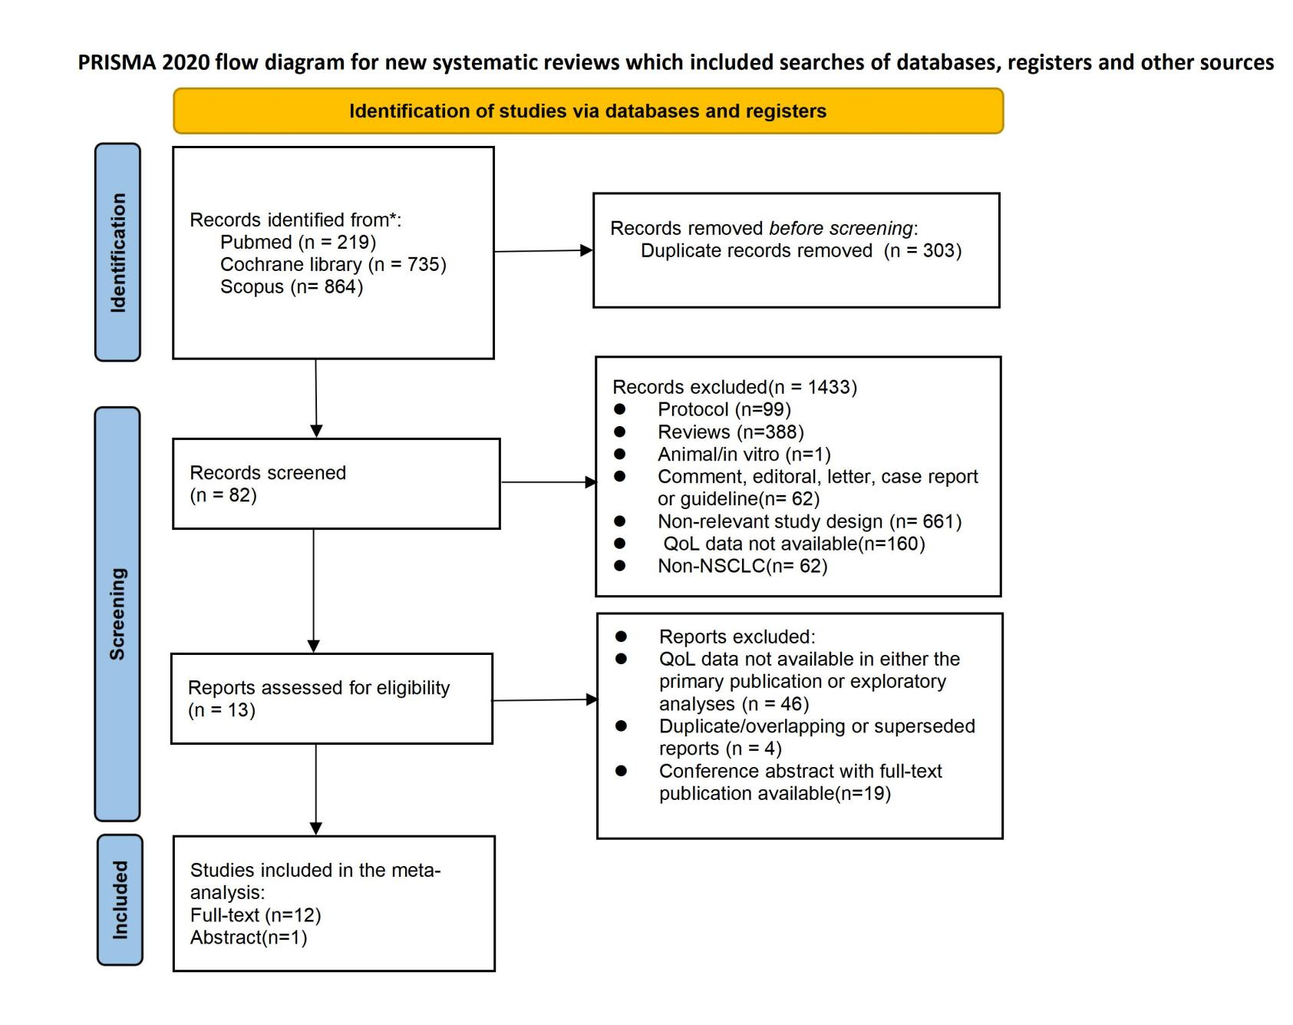
eFigure 1. The PRISMA flowchart summarising the process for the identification of the eligible studies.

eFigure 2. Risk of bias assessment

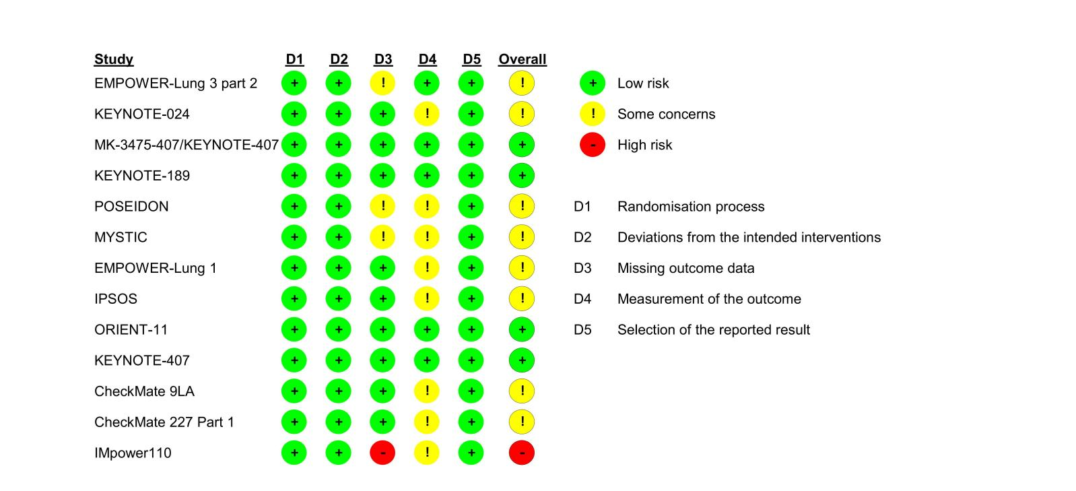

eFigure 3. Hazard Ratios for Time to Deterioration of Fatigue(A), Pain(B) and Dyspnea(C) according to Experimental Treatment Groups.
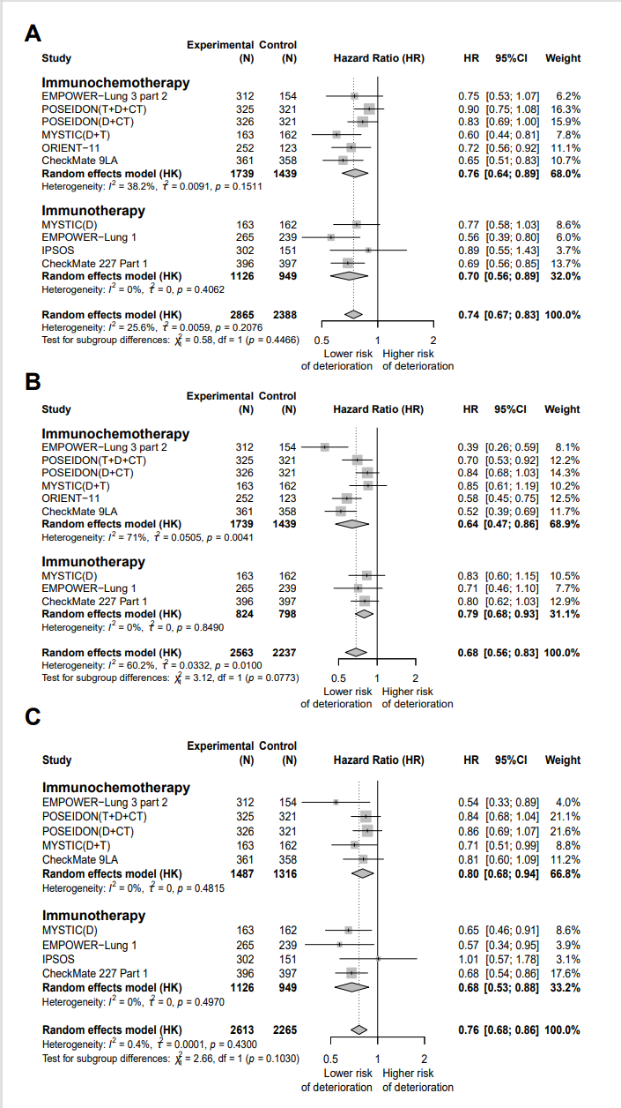

eFigure 4. Hazard Ratios for Time to Deterioration of Cough(A), Hemoptysis(B), Nausea and/or Vomiting(C) and the composite endpoint of cough, chest pain, or dyspnea(D) according to Experimental Treatment Groups.
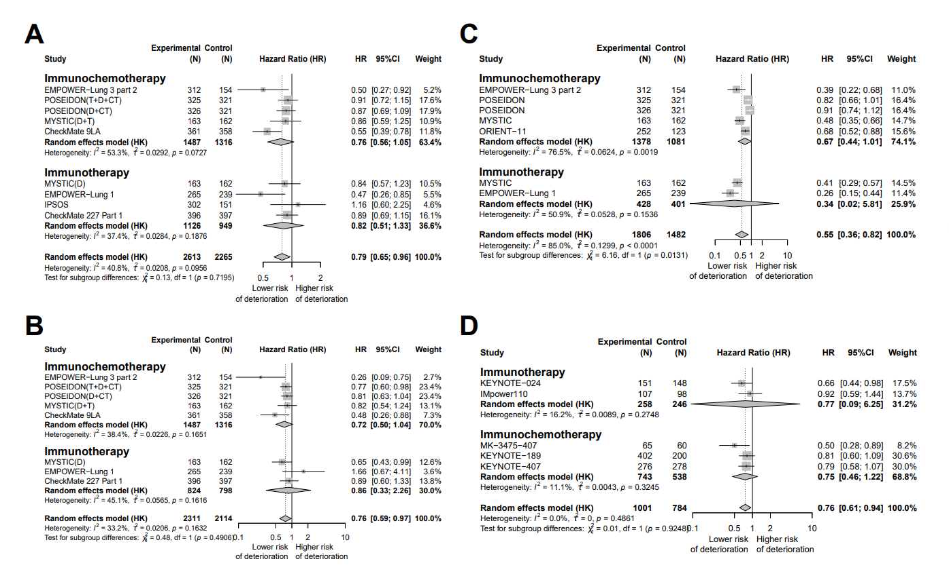

eFigure 5. Hazard Ratios for Time to Deterioration of Appetite Loss according to Experimental Treatment Groups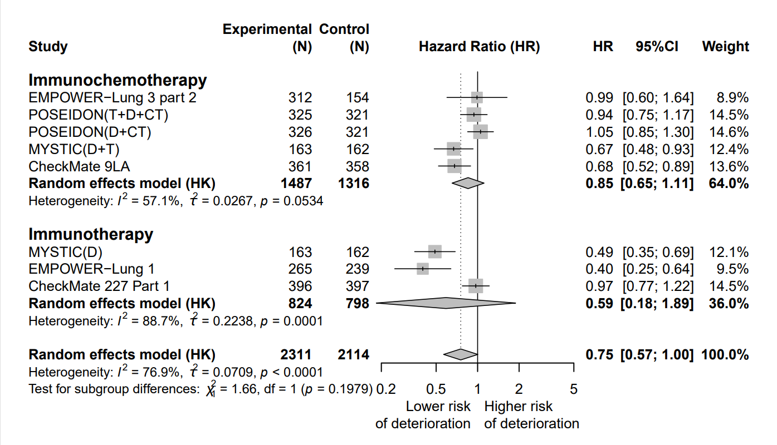

eFigure 6. Leave-one-out Forest Plot for TTD of Appetite Loss(A)Baujat graph for TTD of Appetite Loss(B)Forest plot for TTD of Appetite Loss(C) after removal of influential studies.Leave-one-out Forest Plot for TTD of Pain(D)Baujat graph for TTD of Pain(E)Forest plot for TTD of Pain(F) after removal of influential studies.Leave-one-out Forest Plot for TTD of Nausea and/or Vomiting(G)Baujat graph for TTD of Nausea and/or Vomiting(H)Forest plot for TTD of Nausea and/or Vomiting(I) after removal of influential studies.
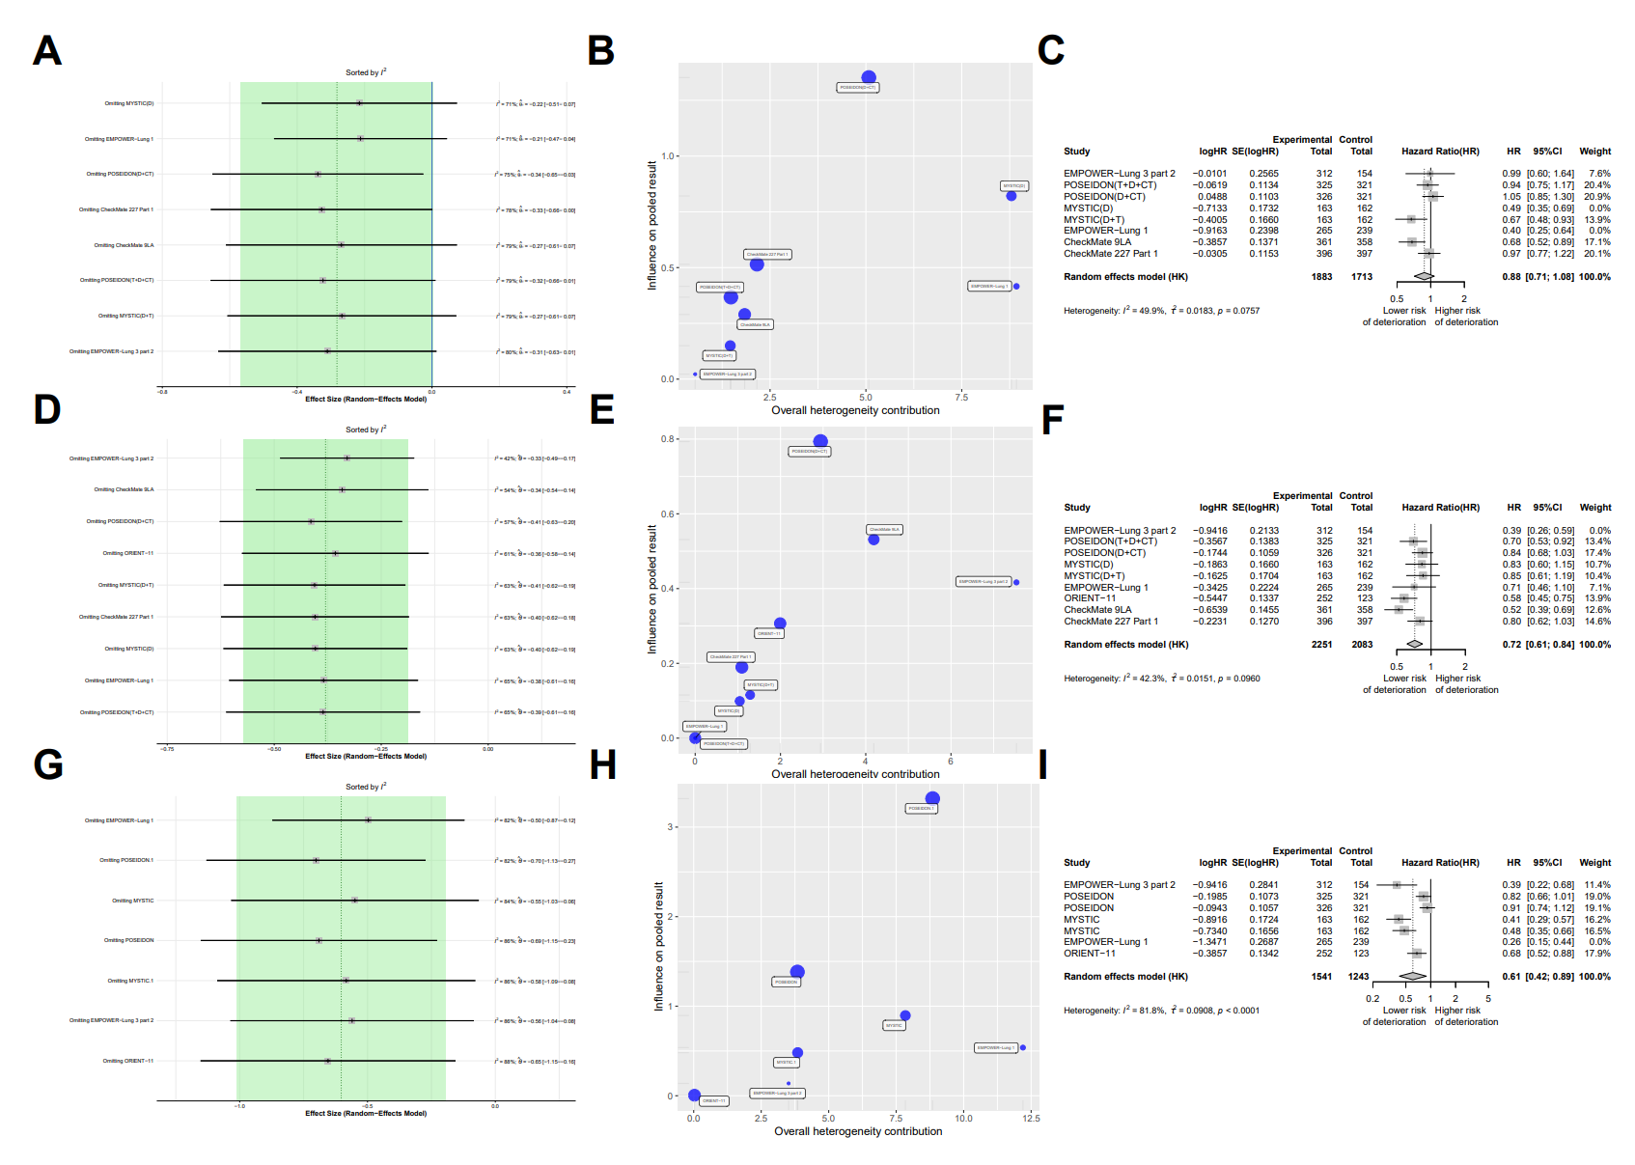
eFigure 7. Correlation between hazard ratio (HR) of OS and HR of the composite endpoint of cough, chest pain, or dyspnea(A) and EF(B) in the RCTs of ICI-based therapies.
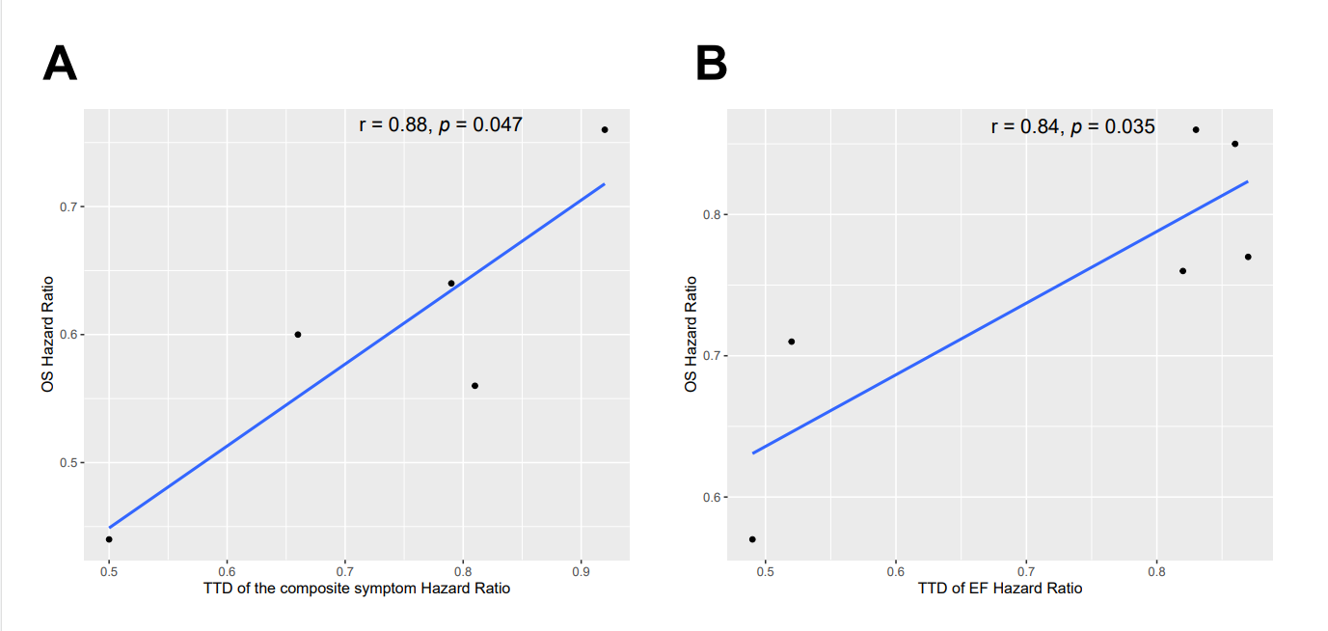
EF:emotional functioning

