Supplementary Information
Solvothermal synthesis and efficient visible light-driven photocatalytic property of 2-D iodoargentate hybrid directed by solvated Fe(III) cation
Hongjin Zhu, and Dingxian Jia*
College of Chemistry, Chemical Engineering and Materials Science, Soochow University, Suzhou 215123, People’s Republic of China.

Table S1. Crystallographic data of 1
CCDC | 2528821
Empirical formula | C₁₂H₃₆Ag₁₀FeI₁₃O₆S₆
Formula weight | 3253.02
Crystal system | Monoclinic
Space group | P2₁/c
a (Å) | 11.9829(7)
b (Å) | 19.7853(12)
c (Å) | 24.8204(15)
α (°) | 90
β (°) | 91.480(2)
γ (°) | 90
V (Å³) | 5882.6(6)
Z | 4
T (K) | 296(2)
2θ (max) (deg) | 50.70
Total reflections | 160166
Unique reflections | 10767
R_{int} | 0.1261
Reflections with [I > 2σ(I)] | 8495
No. of parameters | 448
R₁ [I > 2σ(I)] | 0.0359
wR₂ [I > 2σ(I)] | 0.0752
GOF on F² | 1.032

Table S2. Selected Bond Lengths (Å) and Angles (deg) for 1
Ag(1)–I(3) | 2.7895(9) | Ag(1)–I(1) | 2.8634(9)
Ag(1)–I(2) | 2.8301(9) | Ag(1)–I(4) | 2.9613(9)
Ag(2A)–I(1) | 3.1727(15) | Ag(2A)–I(11)#4 | 2.8207(12)
Ag(2A)–I(13)#6 | 2.7919(12) | Ag(2A)–I(2) | 2.8022(12)
Ag(2B)–I(2) | 2.884(8) | Ag(2B)–I(10)#4 | 3.234(11)
Ag(2B)–I(11)#4 | 2.838(8) | Ag(2B)–I(13)#6 | 2.755(8)
Ag(3)–I(5) | 2.7867(10) | Ag(3)–I(4) | 2.8834(9)
Ag(3)–I(1) | 2.8122(9) | Ag(3)–I(11)#4 | 2.8884(10)
Ag(4)–I(8) | 2.7637(9) | Ag(4)–I(6) | 2.8787(9)
Ag(4)–I(3) | 2.7720(9) | Ag(4)–I(4) | 2.9360(9)
Ag(5)–I(6) | 2.8350(9) | Ag(5)–I(7)#3 | 2.8669(9)
Ag(5)–I(1) | 2.8470(10) | Ag(6)–I(5) | 2.8405(9)
Ag(5)–I(7) | 2.8611(10) | Ag(6)–I(6) | 2.9649(9)
Ag(6)–I(9) | 2.7811(9) | Ag(7)–I(4) | 2.8990(10)
Ag(6)–I(7) | 2.8163(9) | Ag(7)–I(5) | 2.9344(10)
Ag(7)–I(10) | 2.8424(9) | Ag(8)–I(8) | 2.7511(10)
Ag(7)–I(6) | 2.8630(9) | Ag(8)–I(12) | 2.8095(10)
Ag(8)–I(11) | 2.9974(10) | Ag(9A)–I(9) | 2.7532(17)
Ag(8)–I(10) | 2.8623(9) | Ag(9A)–I(10) | 2.8973(13)
Ag(9A)–I(11) | 2.9738(19) | Ag(9A)–I(2)#1 | 2.9369(18)
Ag(9B)–I(11) | 2.889(13) | Ag(9B)–I(2)#1 | 2.871(13)
Ag(10)–I(13) | 2.8502(11) | Ag(10)–I(12) | 2.7426(11)
Ag(2A)–Ag(9A)#4 | 3.062(2) | Ag(10)–I(13)#5 | 2.8490(11)
Ag(2B)–Ag(10)#4 | 2.965(8) | Ag(2B)–Ag(9B)#4 | 2.912(15)
Ag(5)–Ag(5)#3 | 2.9841(14) | Ag(9A)–Ag(2A)#1 | 3.062(2)
Ag(10)–Ag(2B)#1 | 2.965(8) | Ag(10)–Ag(10)#5 | 3.295(2)
Fe(1)–O(1) | 1.988(5) | Fe(1)–O(2) | 2.032(6)
Fe(1)–O(3) | 1.995(6) | Fe(1)–O(4) | 1.981(6)
Fe(1)–O(5) | 1.992(6) | Fe(1)–O(6) | 1.983(5)
I(3)–Ag(1)–I(2) | 114.04(3) | I(3)–Ag(1)–I(4) | 111.81(3)
I(3)–Ag(1)–I(1) | 114.78(3) | I(2)–Ag(1)–I(4) | 98.70(3)
I(2)–Ag(1)–I(1) | 112.84(3) | I(1)–Ag(1)–I(4) | 102.90(3)
I(13)#6–Ag(2A)–I(2) | 112.33(4) | I(2)–Ag(2A)–I(11)#4 | 118.08(4)
Ag(2B)–Ag(2A)–I(11)#4 | 80.6(4) | I(13)#6–Ag(2A)–I(1) | 90.61(3)
I(13)#6–Ag(2A)–I(11)#4 | 121.86(4) | I(2)–Ag(2A)–I(1) | 104.93(4)
I(11)#4–Ag(2A)–I(1) | 102.27(4) | I(13)#6–Ag(2B)–I(11)#4 | 122.6(3)
I(11)#4–Ag(2B)–I(2) | 114.8(2) | I(2)–Ag(2B)–I(10)#4 | 96.1(3)
I(13)#6–Ag(2B)–I(10)#4 | 120.3(3) | I(13)#6–Ag(2B)–I(2) | 111.0(3)
I(11)#4–Ag(2B)–I(10)#4 | 87.4(2) | I(5)–Ag(3)–I(11)#4 | 110.55(3)
I(5)–Ag(3)–I(1) | 115.64(3) | I(1)–Ag(3)–I(11)#4 | 110.07(3)
I(5)–Ag(3)–I(4) | 111.91(3) | I(4)–Ag(3)–I(11)#4 | 101.44(3)
I(1)–Ag(3)–I(4) | 106.23(3) | I(8)–Ag(4)–I(4) | 102.00(3)
I(8)–Ag(4)–I(3) | 123.80(3) | I(3)–Ag(4)–I(4) | 113.10(3)
I(8)–Ag(4)–I(6) | 95.99(3) | I(6)–Ag(4)–I(4) | 101.79(3)
I(3)–Ag(4)–I(6) | 116.71(3) | I(6)–Ag(5)–I(1) | 114.12(3)
I(6)–Ag(5)–I(7) | 108.41(3) | I(7)–Ag(5)–I(7)#3 | 117.21(3)
I(1)–Ag(5)–I(7) | 110.00(3) | I(1)–Ag(5)–I(7)#3 | 101.52(3)
I(6)–Ag(5)–I(7)#3 | 105.63(3) | I(9)–Ag(6)–I(7) | 115.53(3)
I(9)–Ag(6)–I(5) | 113.63(3) | I(9)–Ag(6)–I(6) | 98.66(3)
I(7)–Ag(6)–I(5) | 109.58(3) | I(7)–Ag(6)–I(6) | 106.07(3)
I(10)–Ag(7)–I(6) | 120.24(3) | I(5)–Ag(6)–I(6) | 112.75(3)
I(10)–Ag(7)–I(4) | 104.38(3) | I(10)–Ag(7)–I(5) | 107.67(3)
I(6)–Ag(7)–I(4) | 103.09(3) | I(6)–Ag(7)–I(5) | 113.01(3)
I(8)–Ag(8)–I(12) | 103.22(3) | I(4)–Ag(7)–I(5) | 107.31(3)
I(8)–Ag(8)–I(10) | 121.55(3) | I(8)–Ag(8)–I(11) | 112.02(3)
I(12)–Ag(8)–I(10) | 116.21(3) | I(12)–Ag(8)–I(11) | 112.12(3)
I(9)–Ag(9A)–I(2)#1 | 105.97(5) | I(10)–Ag(8)–I(11) | 91.70(3)
I(10)–Ag(9A)–I(11) | 91.49(5) | I(9)–Ag(9A)–I(10) | 123.86(6)
I(9)–Ag(9A)–I(11) | 121.62(6) | I(2)#1–Ag(9A)–I(11) | 109.33(6)
I(9)–Ag(9B)–I(11) | 132.8(5) | I(10)–Ag(9A)–I(2)#1 | 102.63(5)
I(2)#1–Ag(9B)–I(11) | 113.7(4) | I(9)–Ag(9B)–I(2)#1 | 113.3(5)
I(12)–Ag(10)–I(13) | 121.30(4) | I(13)#5–Ag(10)–I(13) | 109.34(3)
I(12)–Ag(10)–I(13)#5 | 112.37(4) | Ag(3)–I(1)–Ag(2A) | 67.09(3)
Ag(3)–I(1)–Ag(5) | 96.60(3) | Ag(5)–I(1)–Ag(2A) | 159.94(3)
Ag(3)–I(1)–Ag(1) | 74.62(3) | Ag(1)–I(1)–Ag(2A) | 65.48(3)
Ag(5)–I(1)–Ag(1) | 99.83(3) | Ag(2A)–I(2)–Ag(1) | 71.10(4)
Ag(1)–I(2)–Ag(2B) | 91.5(2) | Ag(1)–I(2)–Ag(9B)#4 | 88.0(4)
Ag(1)–I(2)–Ag(9A) | 101.51(3) | Ag(4)–I(3)–Ag(1) | 65.79(2)
Ag(3)–I(4)–Ag(7) | 65.75(3) | Ag(3)–I(4)–Ag(4) | 104.03(3)
Ag(7)–I(4)–Ag(4) | 74.75(2) | Ag(3)–I(4)–Ag(1) | 72.11(2)
Ag(7)–I(4)–Ag(1) | 107.32(3) | Ag(4)–I(4)–Ag(1) | 61.62(2)
Ag(3)–I(5)–Ag(6) | 98.39(3) | Ag(3)–I(5)–Ag(7) | 66.48(3)
Ag(6)–I(5)–Ag(7) | 63.45(2) | Ag(5)–I(6)–Ag(7) | 99.41(3)
Ag(5)–I(6)–Ag(4) | 98.63(3) | Ag(7)–I(6)–Ag(4) | 76.18(3)
Ag(5)–I(6)–Ag(6) | 65.80(2) | Ag(7)–I(6)–Ag(6) | 62.80(2)
Ag(4)–I(6)–Ag(6) | 131.39(3) | Ag(6)–I(7)–Ag(5) | 67.45(2)
Ag(6)–I(7)–Ag(5)#3 | 121.01(3) | Ag(5)–I(7)–Ag(5)#3 | 62.79(3)
Ag(8)–I(8)–Ag(4) | 114.23(3) | Ag(9A)–I(9)–Ag(6) | 102.71(4)
Ag(9B)–I(9)–Ag(6) | 116.9(4) | Ag(7)–I(10)–Ag(9A) | 87.97(4)
Ag(7)–I(10)–Ag(8) | 93.64(3) | Ag(7)–I(10)–Ag(2B)#1 | 136.92(12)
Ag(8)–I(10)–Ag(9A) | 89.11(4) | Ag(2A)#1–I(11)–Ag(3)#1 | 71.13(4)
Ag(8)–I(10)–Ag(2B)#1 | 73.30(15) | Ag(3)#1–I(11)–Ag(9B) | 85.2(4)
Ag(2B)#1–I(11)–Ag(3)#1 | 91.6(2) | Ag(2A)–I(11)–Ag(9A) | 63.73(4)
Ag(2B)#1–I(11)–Ag(9B) | 61.1(3) | Ag(3)#1–I(11)–Ag(9A) | 98.64(3)
Ag(2A)#1–I(11)–Ag(8) | 96.81(4) | Ag(2B)#1–I(11)–Ag(8) | 77.40(19)
Ag(3)#1–I(11)–Ag(8) | 163.61(3) | Ag(9B)–I(11)–Ag(8) | 99.7(4)
Ag(9A)–I(11)–Ag(8) | 85.18(3) | Ag(10)–I(12)–Ag(8) | 69.58(3)
Ag(2B)#2–I(13)–Ag(10)#5 | 63.87(19) | Ag(2A)#2–I(13)–Ag(10) | 121.17(4)
Ag(2A)#2–I(13)–Ag(10)#5 | 83.75(4) | Ag(10)#5–I(13)–Ag(10) | 70.65(3)
O(4)–Fe(1)–O(6) | 90.4(2) | O(6)–Fe(1)–O(3) | 93.4(2)
O(4)–Fe(1)–O(1) | 89.2(2) | O(1)–Fe(1)–O(3) | 90.0(2)
O(6)–Fe(1)–O(1) | 176.5(2) | O(5)–Fe(1)–O(3) | 88.0(3)
O(4)–Fe(1)–O(5) | 179.0(2) | O(4)–Fe(1)–O(2) | 90.4(2)
O(6)–Fe(1)–O(5) | 88.7(2) | O(6)–Fe(1)–O(2) | 88.8(2)
O(1)–Fe(1)–O(5) | 91.7(2) | O(1)–Fe(1)–O(2) | 87.7(2)
O(4)–Fe(1)–O(3) | 91.6(3) | O(5)–Fe(1)–O(2) | 90.0(2)
O(3)–Fe(1)–O(2) | 176.9(3)
Symmetry transformations used to generate equivalent atoms: #5 x, –y+1, z–1/2; #7 –x, y+1/2, –z+1/2; #8 –x, y–1/2, –z+1/2; #9 –x, –y, –z+1; #10 –x, –y, –z; #11 –x, –y+1/2, z+1/2.

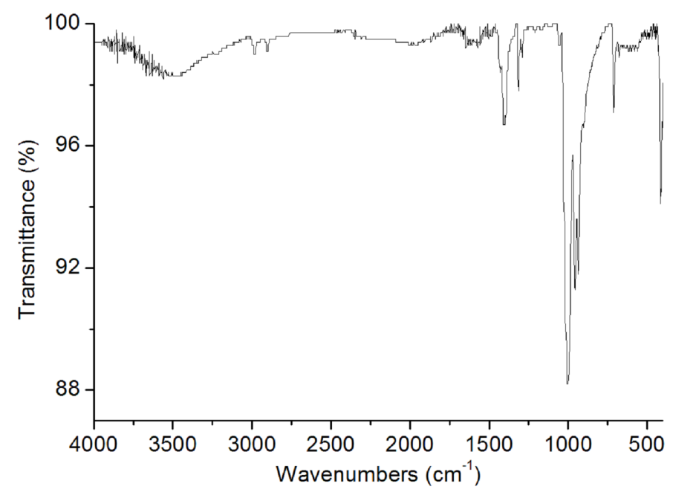
Fig. S1. IR spectrum of 1.

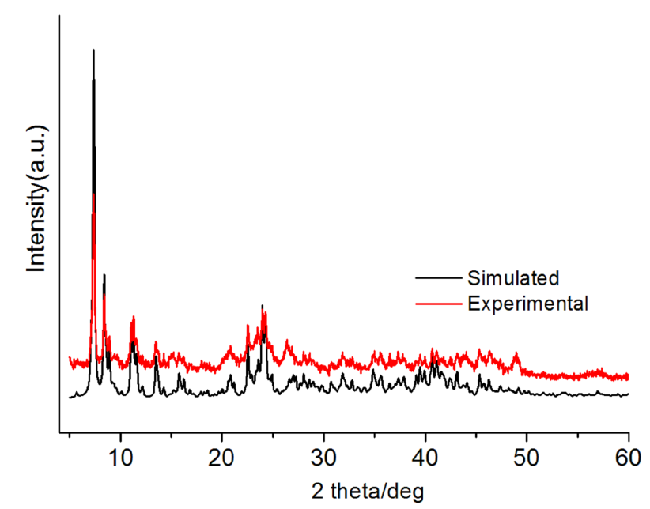
Fig. S2. Simulated powder XRD patterns based on single crystal data of compound 1, and experimental powder XRD patterns of compound 1.

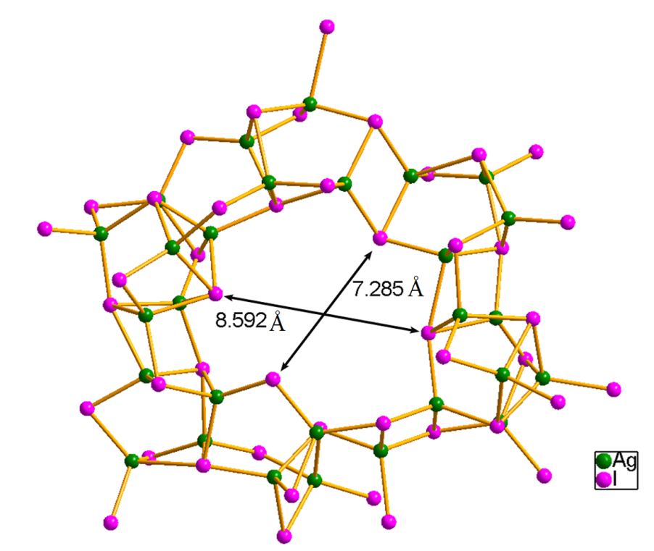
Fig. S3. The Ag₇I₇ circle in the [Ag₁₀I₁₃]_{n}^{3n–} layer showing sectional dimension in 1.

