Supplementary Information – Nanoscale geometrical patterning for junctionless thermoelectrics
Sergio Gonzalez-Munoz,¹ Peng Xiao², Charalambos Evangeli,¹ Elisa Castanon,³, Stuart Finch¹, Matthew Hamer,³ Johanna Zultak, ³ Olga Kazakova,⁴ Kimberley Siret,¹ Edward McCann,¹ Roman Gorbachev³, Oleg Kolosov,*¹ Alexandros El Sachat*⁵
¹Physics Department, Lancaster University, Lancaster, UK
²Laboratoire Ondes et Matière d'Aquitaine (LOMA)-UMR 5798, CNRS, F-33400, Talence, France
³National Graphene Institute, University of Manchester, UK
⁴National Physics Laboratory, Teddington, UK
⁵Institute of Nanoscience and Nanotechnology, National Center for Scientific Research “Demokritos”, 15341 Agia Paraskevi, Athens, Greece

*Corresponding authors: o.kolosov@lancaster.ac.uk, a.elsachat@inn.demokritos.gr

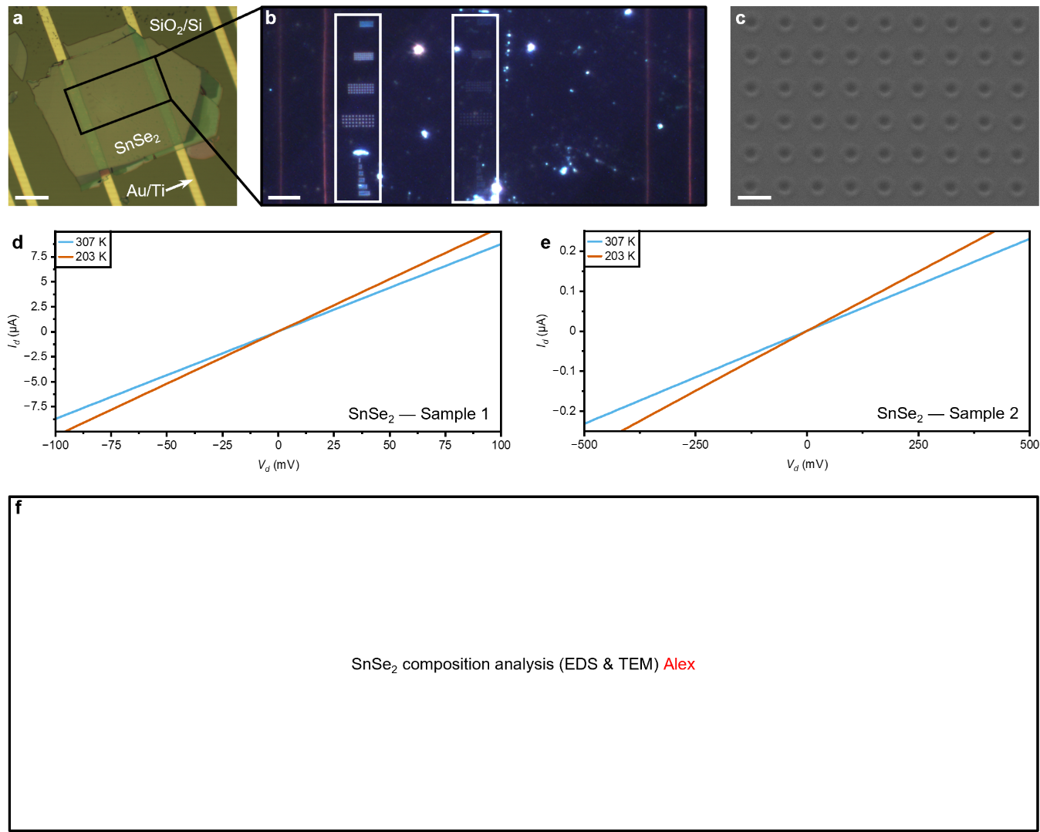
Fig. S1 | Morphological analysis and electrical transport characteristics of the SnSe₂ flakes. a, Optical image of sample 2 SnSe2 flake deposited on Au/Ti electrodes and SiO2/Si substrate. Scale bar, 50 µm. b, Dark-field magnified optical image highlighting the patterns with different pitch and number of holes inside the white rectangles. Scale bar, 10 µm. c, SEM magnified image of the ribbon-shaped pattern in sample 1. Scale bar, 400 nm. d,e, Device current vs voltage plots of samples 1 and 2, respectively, at room- (307 K) and low-temperature (203 K).
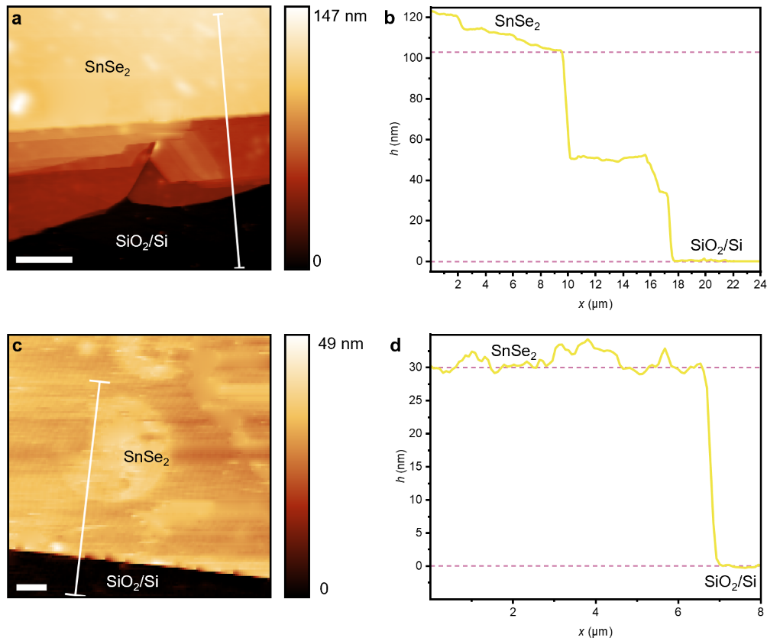
Fig. S2 | AFM topographical thickness analysis of the SnSe₂ flakes. a,c, AFM topography maps of samples 1 and 2 flakes’ contrasting with their supporting SiO₂/Si substrates, respectively. Scale bars, 5 and 1 µm, respectively. b,d, AFM topography profiles extracted from the lines in a,c, respectively. Note that the pink dashed lines denote the height corresponding to the SnSe₂ flakes and the SiO₂/Si substrates.
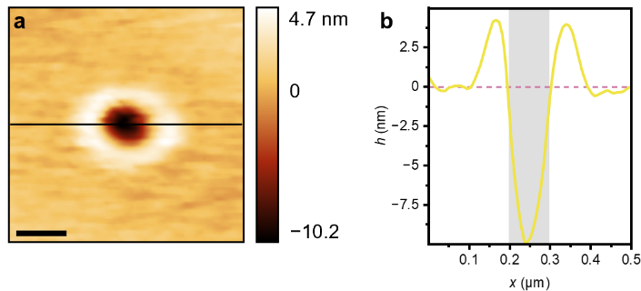
Fig. S3 | AFM topographical analysis of a single-hole pattern in the SnSe2. a, AFM topography map of a single-hole pattern, showing the higher amorphous region surrounding it. Scale bar, 100 nm. b, AFM topography profile extracted from the horizontal line in a. Note that the grey rectangle represents the hole-patterned region, while the pink dashed line denotes the topography corresponding to the unpatterned areas of the material.
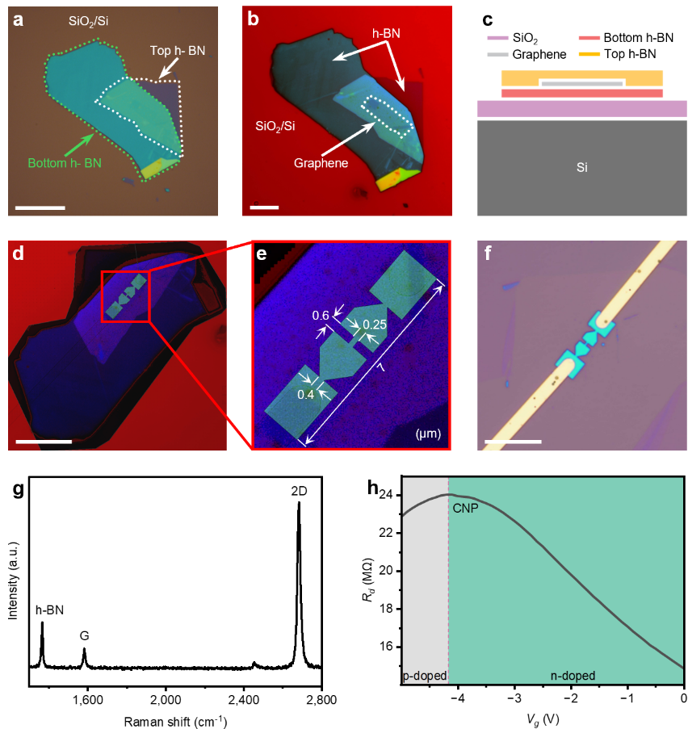
Fig. S4 | Morphological and compositional analysis of the encapsulated graphene heterostructure. a, Optical image of the “sandwich” heterostructure supported on a SiO₂/Si substrate where only the top and bottom h-BN flakes are visible. Scale bar, 20 µm. b, Contrast-enhanced optical image of the heterostructure where the encapsulated graphene is visible. Scale bar, 10 µm. c, Layers’ side-view cross-sectional scheme of the heterostructure and its supporting substrate. d, Contrast-enhanced optical image showing the positioning and design of the patterned structure over the layers before the lithography is performed. Scale bar, 7 µm. e, magnified optical image from d of the pattern design showing the critical dimensions in µm. f, Optical image of the fabricated pattern with the deposited Au/Cr electrodes. Scale bar, 12.5 µm. g, Raman spectrum of the patterned heterostructure. h, Device resistance vs gate voltage curve showing the different doping regions and the charge neutrality point.
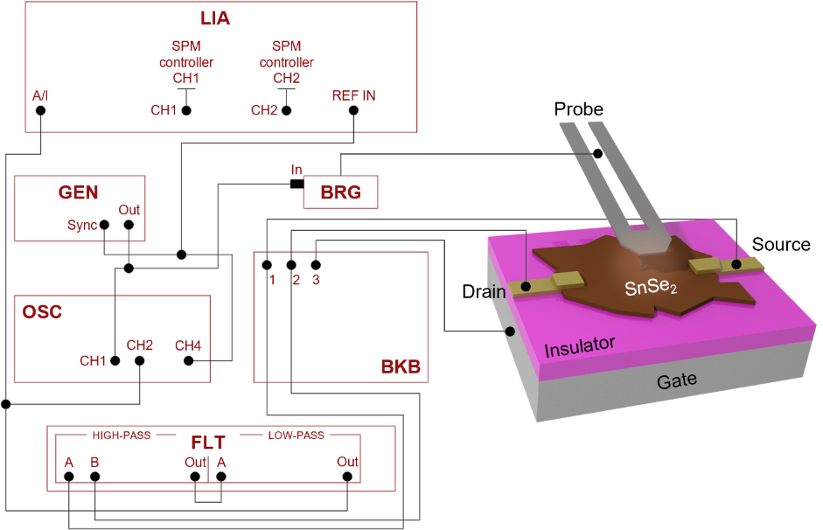
Fig. S5 | STGM custom-built setup. GEN, BRG, OSC, LIA, BKB and FLT are the generator, bridge, oscilloscope, lock-in amplifier, breakout box and filter, respectively.
Note SN1. Derivation of the thermovoltage response.
The thermovoltage between two electrodes placed at x₀ and x₁ is created by the temperature and Seebeck coefficients distributions along the x axis connecting the electrodes, T(x) and S(x), respectively, can be presented as $V_{TV}=\int_{x_{0}}^{x_{1}}{ }S(x)\frac{dT(x)}{dx}dx$.¹ Using integration by parts and noting that the temperature rise is fully localized under the tip area and there is no temperature rise at the electrodes at x₀ and x₁, and therefore T(x₀) = T(x₁), this integral can be written as $V_{TV}=-\int_{x_{0}}^{x_{1}}{ }T\left(x\right)\frac{dS\left(x\right)}{dx}dx$.
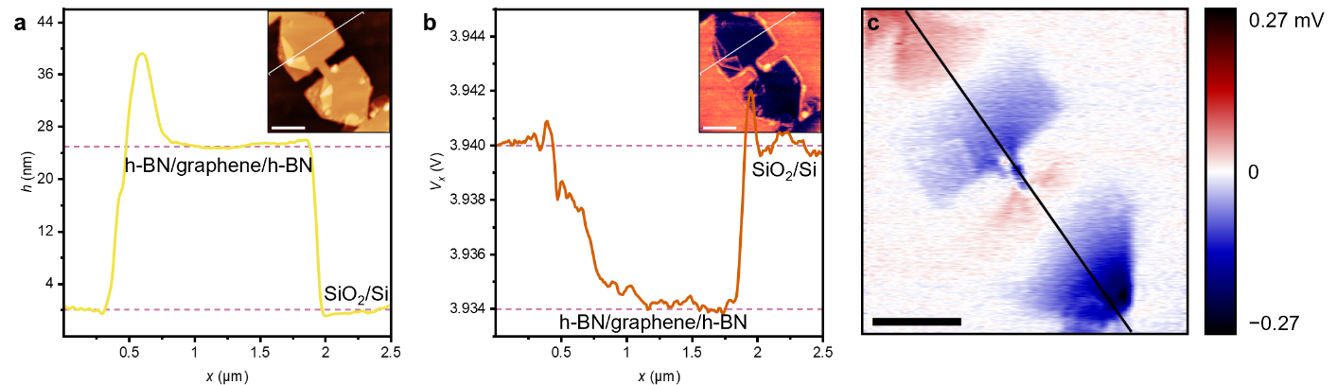
Fig. S6 | Encapsulated graphene heterostructure SPM additional measurements. a,b, AFM and SThM respective topography and thermal signal profiles of the heterostructure extracted from the diagonal lines in the corresponding maps shown in the insets. Note that the pink dashed lines denote the height and thermal signal corresponding to the heterostructure and the SiO₂/Si substrate. c, STGM thermovoltage map of the heterostructure under a p-type doping regime. Scale bars, 750 nm.
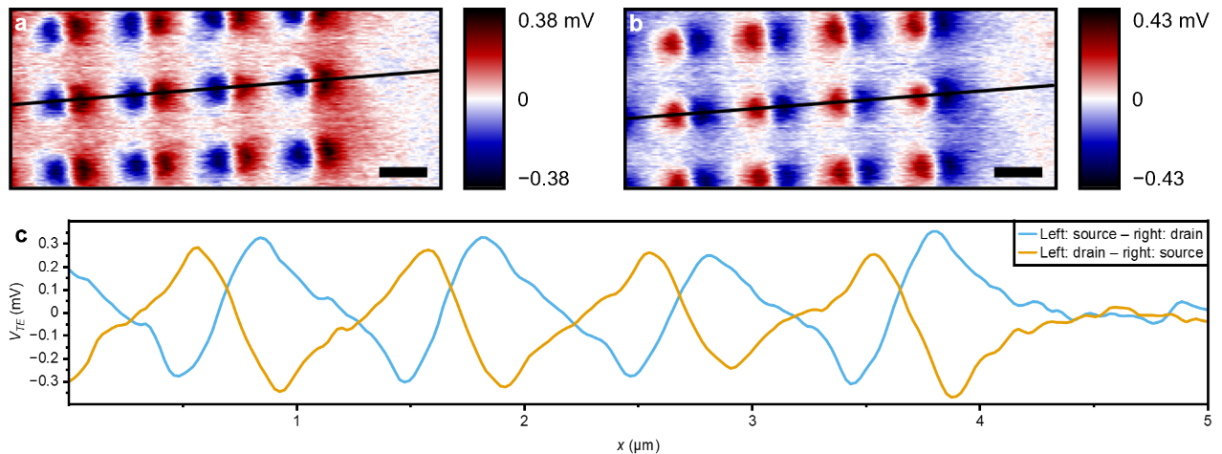
Fig. S7 Source-drain thermovoltage polar switching analysis. STGM thermovoltage maps of the 1,000 nm pitch patterns with a configuration of a, source on the left and drain on the right and b, source on the right and drain on the left. c, left source and right drain and vice versa STGM thermovoltage profiles extracted from the lines in a,b, respectively. Scale bars, 500 nm.

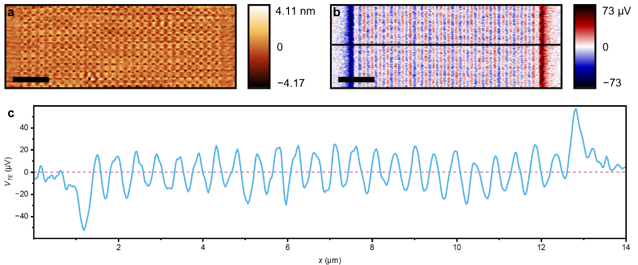
Fig. S8 | Ribbon-shaped pattern topographic and thermovoltage analysis. a,b, AFM and STGM respective topography and thermovoltage maps of the ribbon-shaped hole patterns. c, STGM thermovoltage profile extracted from the horizontal line in b. Scale bars, 1 µm.
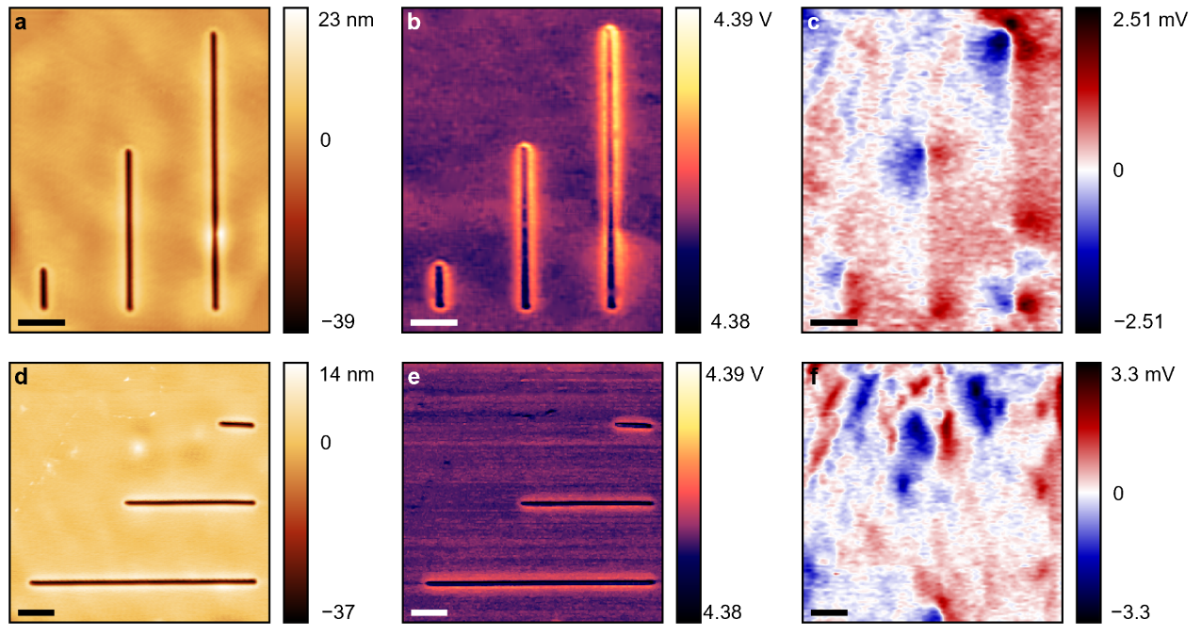
Fig. S9 | Line patterns on SnSe₂ SPM measurements. a–c, AFM, SThM and STGM respective topography, thermal signal and thermovoltage maps of the vertical line patterns on SnSe₂. d–f, AFM, SThM and STGM respective topography, thermal signal and thermovoltage maps of the horizontal line patterns on SnSe₂. Scale bars, 1 µm.

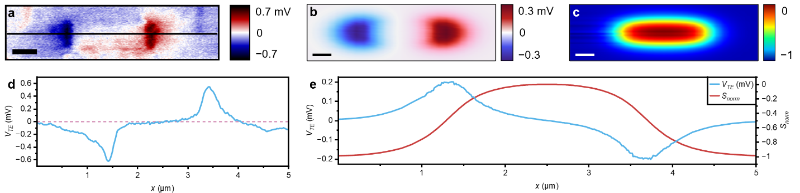
Fig. S10 | Thermoelectric analysis of the 200 nm pitch and Ø70 nm patterned SnSe₂. a, STGM thermovoltage map of the pattern. b,c, Thermovoltage and normalised Seebeck coefficient simulated maps of the pattern, respectively. Models were performed on COMSOL Multiphysics®. d, STGM thermovoltage profile extracted from the horizontal line in a. e, Thermovoltage and normalised Seebeck coefficient line profiles extracted horizontally along the centre of the simulated maps in b,c, respectively. Scale bars, 500 nm.
Fig. S11 | Finite element modelling of the thermovoltage maps in patterned SnSe₂. a–f, Thermovoltage simulated maps of patterns varying the number of hole columns as 3 × 1, 3 × 2, 3 × 3, 3 × 4, 3 × 6 and 3 × 8, respectively. g–j, Thermovoltage simulated maps of patterns varying the inter-hole pitch as 400, 600, 800 and 1,000 nm, respectively. Models were performed on COMSOL Multiphysics®. Scale bars, 1 µm.
Fig. S12 | Finite element modelling of the normalised Seebeck coefficient maps in patterned SnSe₂. a–f, Normalised Seebeck coefficient simulated maps of patterns varying the number of hole columns as 3 × 1, 3 × 2, 3 × 3, 3 × 4, 3 × 6 and 3 × 8, respectively. g–j, Normalised Seebeck coefficient simulated maps of patterns varying the inter-hole pitch as 400, 600, 800 and 1,000 nm, respectively. Models were performed on COMSOL Multiphysics®. Scale bars, 1 µm.
Note SN2. Analytical model for cooling rate and length estimations
Estimates of the electronic cooling rate and length in SnSe₂. Electrons with temperatures slightly above that of the lattice will cool by electron-phonon collisions over typical scales of the cooling time $τ_{c}$ and the cooling length $l_{c}=v_{F}τ_{c}$ where the Fermi velocity $v_{F}$ characterizes ballistic electronic transport in the in-plane direction. For an order-of-magnitude estimate of their values, we consider the cooling rate $τ_{c}^{-1}$ for intraband scattering of electrons in the conduction band with acoustic phonon^{2,3} as:
$τ_{c}^{-1}\sim \frac{m^{*}D^{2}k_{B}T}{2ℏ^{3}Wρc^{2}}$ (S1)
where $m^{*}$ is the effective mass of electrons near the conduction band minima, $D$ and $c$ are the deformation potential and speed of acoustic phonons, respectively, $ρ$ is the mass density of the film and $W$ is its thickness. Using $W=70$nm for our sample, and typical values from the literature of $m^{*}=0.41m_{e}$⁴ for free electron mass $m_{e}$, $D=25$eV,⁴ $c=5140$m$s^{-1}$,⁵ and $ρ=5.937$g${cm}^{-3}$,⁶ we find $τ_{c}^{-1}\sim {10}^{12}s^{-1}$ or $τ_{c}\sim 1$ps. Since the conduction band minima is at the M point of the hexagonal Brillouin zone, there is threefold valley degeneracy, and the Fermi velocity $v_{F}=\left(ℏ/m\right)\sqrt{{2πn}/3}$ for ballistic transport in the in-plane direction, where $n$ is the carrier density. With $n=2×{10}^{13}{cm}^{-2}$ and $v_{F}\sim 2×{10}^{5}$m$s^{-1}$ (see estimates below), the corresponding cooling length is $l_{c}=v_{F}τ_{c}\sim 0.2 μ$m, that is lower but the same order of magnitude as observed in our experiments, that is significantly larger than a few tens of nm for the thermal transport modification.
The expression S1 is obtained in the following way: In Eq. (3.36) of Ref [2] the scattering rate for intraband scattering of electrons with acoustic phonons in a thin film is given as
$$τ_{c}^{-1}=\frac{3m^{*}D^{2}k_{B}T}{2ℏ^{3}WC_{L}} \text{(S2)}$$
where $W$ is the thickness of the film and $C_{L}$ is the elastic constant for acoustic phonons. With the speed of acoustic phonons as $c=\sqrt{{C_{L}}/ρ}$, expression (S2) is
$$τ_{c}^{-1}=\frac{3m^{*}D^{2}k_{B}T}{2ℏ^{3}Wρc^{2}} \text{(S3)}$$
Alternatively, the cooling rate in bilayer graphene at “high” temperature (i.e., the electron and lattice temperatures are above the Bloch-Gruneisen temperature) is given by Eq. (22) of Ref. [3] as
$$τ_{c}^{-1}=\frac{γ_{1}D^{2}k_{B}T}{4ℏ^{3}ρ_{2D}v^{2}c^{2}} \text{(S4)}$$
where $v$ is the Fermi velocity of monolayer graphene, $γ_{1}$ is the interlayer coupling parameter of bilayer graphene, and $ρ_{2D}$ is the mass density per unit area of bilayer graphene. With the substitutions $m^{*}={γ_{1}}/{2v^{2}}$ and $ρ_{2D}=Wρ$, then expression (S4) is
$$τ_{c}^{-1}=\frac{m^{*}D^{2}k_{B}T}{2ℏ^{3}Wρc^{2}} \text{(S5)}$$
Expressions (S3) and (S5) differ by a numerical factor of $3$ which may, perhaps, be attributed to the inclusion of different numbers of phonon branches or anisotropic scattering of chiral electrons in bilayer graphene. However, given a large degree of uncertainty over the numerical values of the parameters for SnSe₂, our aim is simply to obtain an order of magnitude estimate of the cooling rate as given by the estimate Eq. (S1). For the estimate of the speed of ballistic electrons in the in-plane direction, we use a two-dimensional (2D) expression for the Fermi velocity $v_{F}$ as
$$v_{F}=\frac{ℏ}{m^{*}}\sqrt{\frac{4πn}{g_{s}}} \text{(S6)}$$
where $n$ is 2D carrier density and $g_{s}$ is a factor accounting for spin and valley degeneracy. As the conduction band minima in SnSe₂ are located at the M points of the hexagonal Brillouin zone, we use $g_{s}=6$. Typical estimates of the measured carrier density in the literature range from $n=1.1×{10}^{13}{cm}^{-2}$ [Ref. 7 ] to $n=5.8×{10}^{13}{cm}^{-2}$ [Ref. 8], and, in our estimate in the main text, we use $n=2×{10}^{13}{cm}^{-2}$.
References
1. Harzheim, A., Evangeli, C., Kolosov, O. V & Gehring, P. Direct mapping of local Seebeck coefficient in 2D material nanostructures via scanning thermal gate microscopy. 2d Mater. 7, 041004 (2020).
2. Ridley, B. K. Hot electrons in low-dimensional structures. Reports on Progress in Physics 54, 169 (1991).
3. Viljas, J. K. & Heikkilä, T. T. Electron-phonon heat transfer in monolayer and bilayer graphene. Phys. Rev. B 81, 245404 (2010).
4. Wu, Y. et al. Promising thermoelectric performance in van der Waals layered SnSe2. Materials Today Physics 3, 127–136 (2017).
5. Nautiyal, H. & Scardi, P. First principles study of SnX2 (X = S, Se) and Janus SnSSe monolayer for thermoelectric applications. Nanotechnology 33, 325402 (2022).
6. Pham, A.-T. et al. High-Quality SnSe2 Single Crystals: Electronic and Thermoelectric Properties. ACS Appl. Energy Mater. 3, 10787–10792 (2020).
7. Guo, C. et al. Field-effect transistors of high-mobility few-layer SnSe₂, Appl. Phys. Lett. 109, 203104 (2016).
8. Huang, Y. et al. E. Sutter, B. A. Parkinson, and P. Sutter, High Mobility, High Carrier Density SnSe₂ Field-Effect Transistors with Ultralow Subthreshold Swing and Gate-Controlled Photoconductance Switching, Adv. Electron. Mater. 11, 2400691 (2025).

