Supplementary Information for
The substantial role of May soil temperature over Central Asia for summer surface air temperature variation and prediction over Northeastern China
Zhanmei Yang^{1,2}, Jingyong Zhang^{2,3}, Ye Liu⁴, Li Kai⁵
¹School of Resources and Environment, Hunan University of Technology and Business, Changsha, 410205, China
²Center for Monsoon System Research, Institute of Atmospheric Physics, Chinese Academy of Sciences, Beijing 100029, China
³University of Chinese Academy of Sciences, Beijing 100029, China
⁴Pacific Northwest National Laboratory, Richland, WA, USA
⁵Key Laboratory of Regional Climate and Environment for Temperate East Asia, Institute of Atmospheric Physics, Chinese Academy of Sciences, Beijing 100029, China

Correspondence
Prof. Jingyong Zhang
Center for Monsoon System Research, Institute of Atmospheric Physics, Chinese Academy of Sciences, Beijing 100029, China
Email: zjy@mail.iap.ac.cn
This file includes
Figure. S1
Experiment Description
Figure. S2
Figure. S3
Figure. S4
Figure. S5
Table. S1
Table. S2

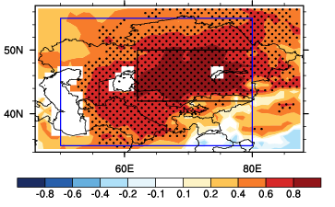
Figure. S1 Spatial pattern of correlations coefficients between soil temperature averaged over the key region of Central Asia (42 °N–50 °N, 62 °E–80 °E, KRCA) and soil temperature over Central Asia in May during the period of 1979-2018. The black and blue boxes denote the key region of Central Asia (42 °N–50 °N, 62 °E–80 °E, KRCA) and the region (35 °N -55 °N, 50 °E -80 °E) adopted to perform Weather Research and Forecasting (WRF) model experiments in the Supplementary Information. The stippling areas denote correlation coefficient are significant at the 99% confidence level.

Experiment Description
In order to enhance the explanation of physical processes involved, the Weather Research and Forecasting (WRF) model with the Advanced Research WRF (ARW) dynamic core in version 3.7.1 is applied to perform model experiments in this study (Skamarock et al. 2008). Lambert projection is used in the WRF model experiments with standard latitudes of 30 °N and 50 °N and the center point of 40 °N, 90 °E (Fig. S1). There are 27 vertical layers with the highest layer of 50 hPa, and the horizontal resolution is 45 km × 45 km in the model experiments. The main physical process parameterization schemes of the model experiments are shown in Table S1 (Niu et al, 2011; Grell and Freitas, 2014; Hong et al, 2004; Collins et al, 2004; Hong et al, 2006). The driving data for the WRF model experiments were taken from the NCEP FNL (Final) Operational Global Analysis data, with a spatial resolution of 1 ° × 1 ° and 6-hour time resolution (NCEP, 2000).
The model experiments include control cases and sensitive cases. The control cases were conducted from January 1, 2000 to December 31, 2015 and the first six years was taken as the spin-up time. The control cases can reproduce the surface atmospheric temperature, precipitation and atmospheric circulation field well over the study area for the period of 2006 to 2015, which are not shown in detail here. The sensitive cases were from May 1 to September 1 of each year from 2006 to 2015. The initial fields on May 1 of the sensitive cases were obtained from the restart files on May 1of the corresponding control cases. The soil temperature over the region (35 °N -55 °N, 50 °E -80 °E) from the second to fourth layer (0.1-2 m) at the beginning of each hour in each sensitive case was imposed +5 K anomalies based on the soil temperature at the same time in the corresponding control case. The differences between the sensitive cases and control cases are attributed to the warm anomalies of soil temperature over the Central Asia. The subsurface soil temperature memory is the basis for the warm soil temperature over Central Asia to influence the summer high temperature. The +5 K anomalies of subsurface soil temperature in the sensitive cases are fixed from May to August in order to reproduce the warm soil temperature in May over Central Asia can be remembered until summer (Fig. S2).
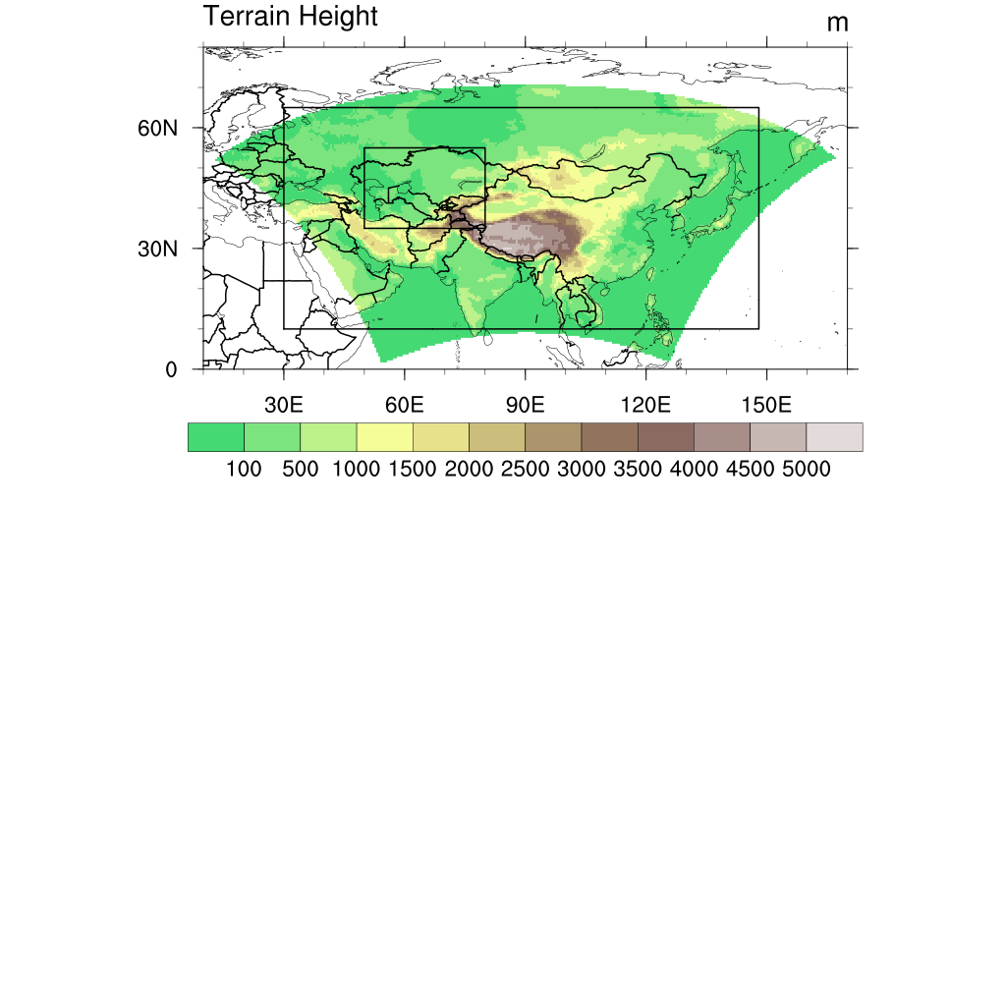
Figure. S2 Model simulation area and altitude distribution. Small and big box denote the region (35 °N -55 °N, 50 °E -80 °E) to represent the Central Asia and study area in Weather Research and Forecasting (WRF) model experiments in the Supplementary.

physical process | parameterization scheme
Land-surface model | Noah-MP
Cumulus convection | Grell-Freitas
microphysics | WSM 3
Longwave | CAM
Shortwave | CAM
Planetary boundary layer | YSU

Table. S1 Selections of physical process parameterization schemes in Weather Research and Forecasting (WRF) model experiments in the Supplementary Information.
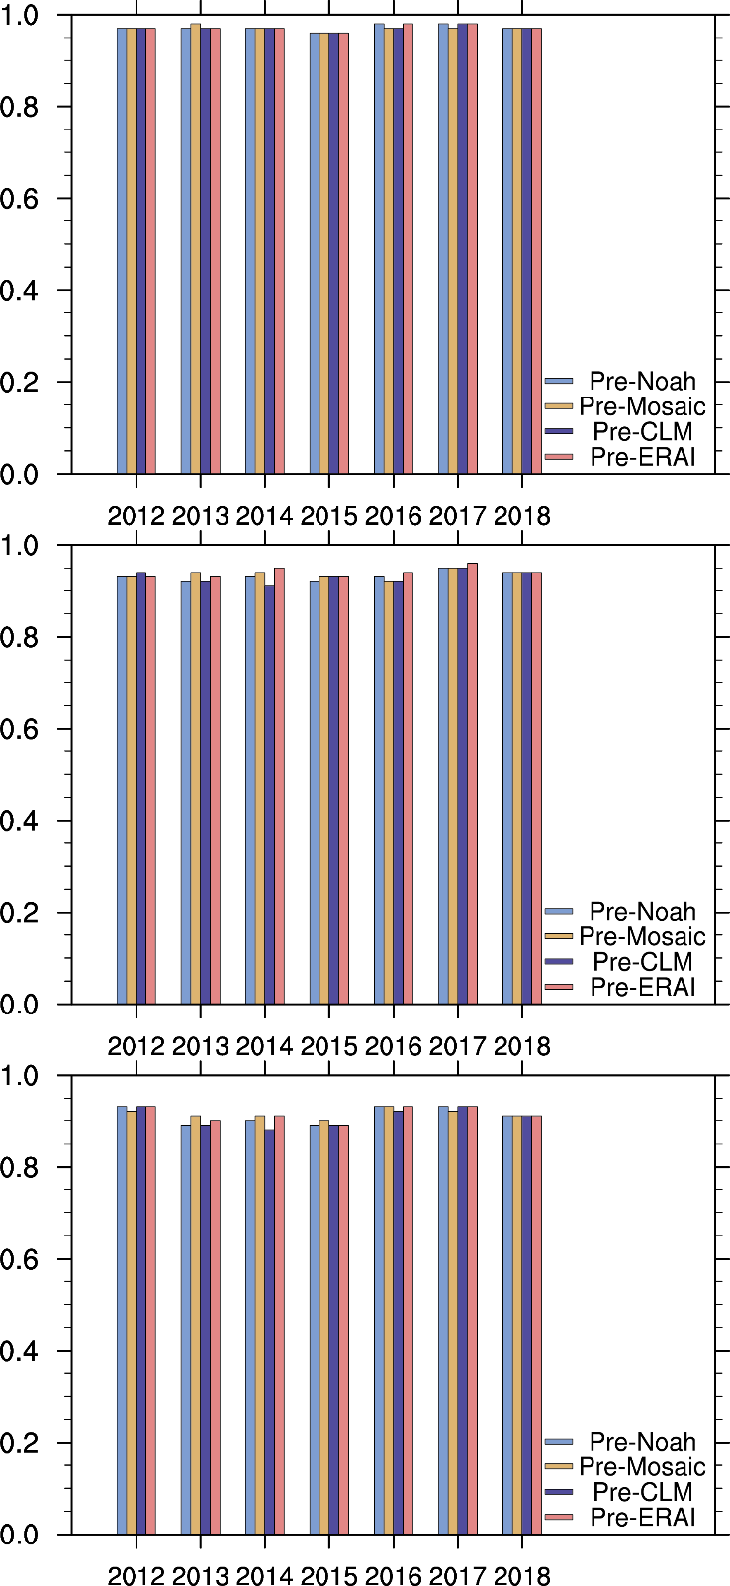
Figure. S3 Spatial pattern correlation coefficients between observed and predicted surface air temperature (upper column), daily maximum temperature (middle column) and hot days (lower column) for 2012-2018. Predictions are the hindcasts using soil temperature from Noah (blue bar), Mosaic (yellow bar), CLM (purple bar) and ERA-interim (red bar).

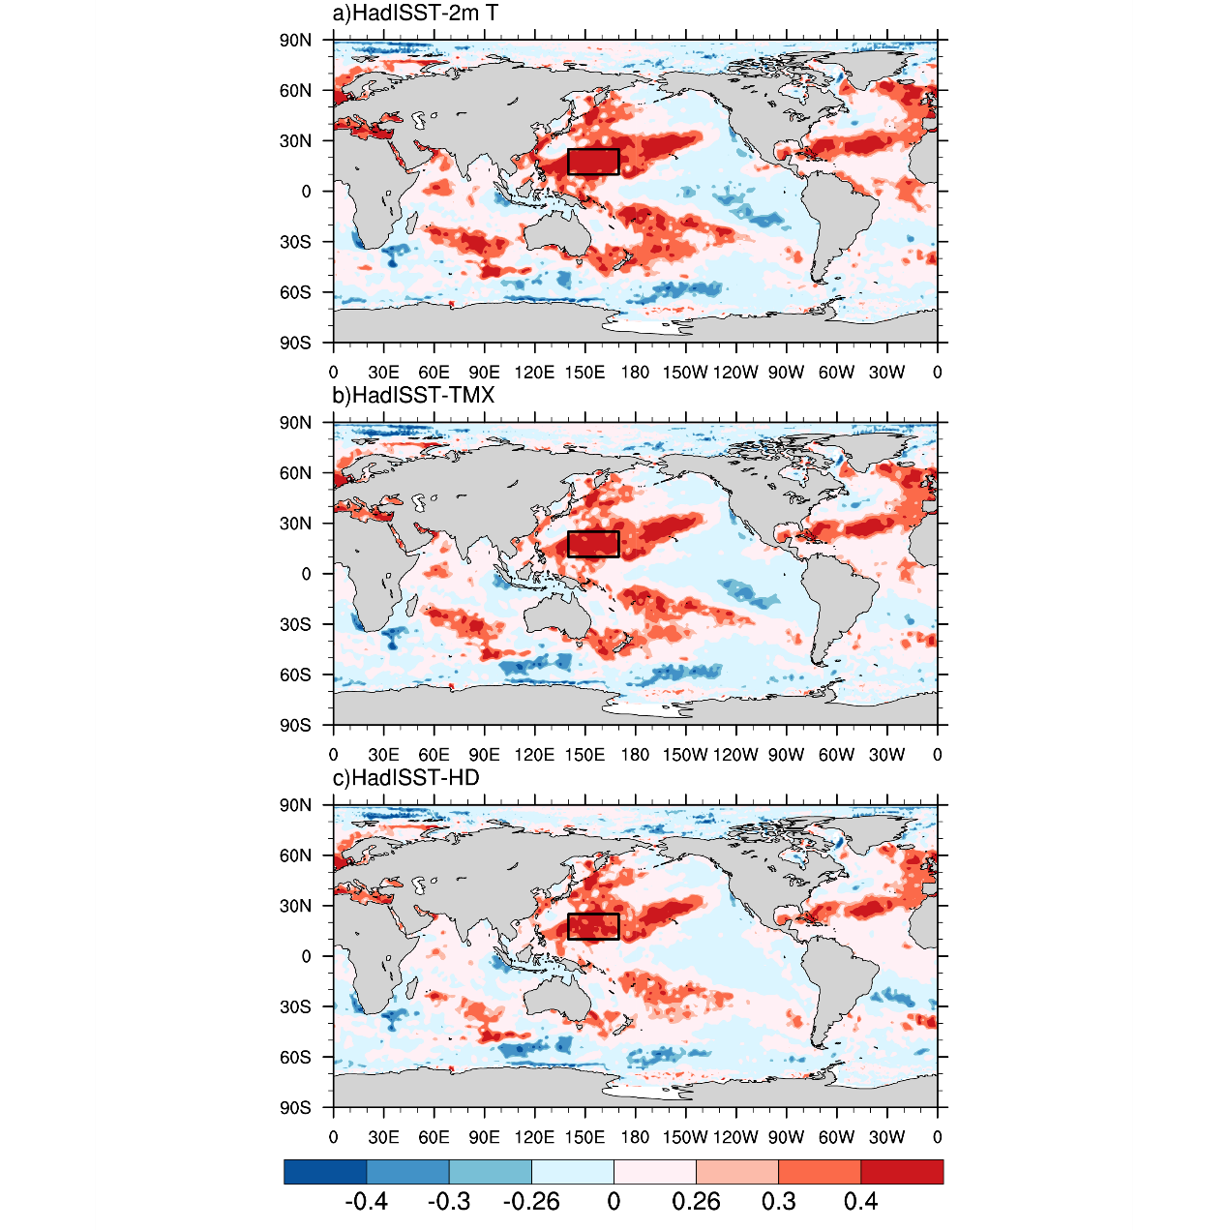
Figure. S4 Spatial pattern correlation coefficients between summer surface air temperature (upper column), daily maximum temperature (middle column) and hot days (lower column) averaged over the Northeastern China and May sea surface temperature for 1979-2018. The black boxes (10 °N -25 °N, 140 °E -170 °E) denote the key region of May sea surface temperature for summer surface temperature variables over the Northeastern China. The sea surface temperature is from Hadley Centre Sea Ice and Sea Surface Temperature dataset (HadISST) Version 1.1 (Rayner et al, 2003).

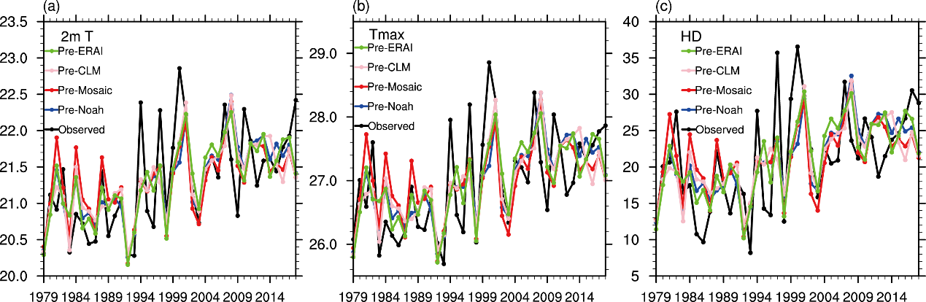
Figure. S5 Observed and predicted time series of surface air temperature (a), daily maximum temperature (b) and hot days (c) averaged over Northeastern China in summer for the period of 1979-2018. Predictions are conducted using soil temperature from Noah, Mosaic, CLM and ERA-interim and sea surface temperature from HadISST through leave-one-out cross validation.

 | Noah | Mosaic | CLM | ERA-interim
2m T | 0.68** | 0.66** | 0.68** | 0.71**
TMAX | 0.67** | 0.64** | 0.67** | 0.69**
HD | 0.61** | 0.59** | 0.56** | 0.67**
Table. S2 Correlation coefficients between observed and predicted time series of summer surface air temperature, daily maximum temperature and hot days averaged over Northeastern China for the period of 1979-2018. Predictions are conducted using soil temperature from Noah, Mosaic, CLM and ERA-interim and sea surface temperature from HadISST through leave-one-out cross validation. The superscript * and ** indicate that the correlation coefficients are significant at 95% and 99% confidence level, respectively.

References
Skamarock WC, Klemp JB, Dudhia J et al (2008) A description of the advanced research WRF version 3. NCAR technical note, NCAR/TN-475+STR, National Center for Atmospheric Research, Boulder
Niu GY, Yang ZL, Mitchell KE, et al (2011) The community Noah land surface model with multiparameterization options (Noah-MP): 1. Model description and evaluation with local-scale measurements[J]. Journal of Geophysical Research: Atmospheres, 116, D12109. doi:10.1029/2010JD015139.
Grell GA, Freitas SR (2014). A scale and aerosol aware stochastic convective parameterization for weather and air quality modeling[J]. Atmospheric Chemistry and Physics, 13(9): 5233-5250.
Hong SY, Dudhia J, Chen SH (2004) A Revised Approach to Ice Microphysical Processes for the Bulk Parameterization of Clouds and Precipitation[J]. Monthly Weather Review, 132(1): 103-120.
Collins W, Rasch PJ, Boville BA et al (2004) Description of the NCAR Community Atmosphere Model (CAM 3.0)[M]. University Corporation for Atmospheric Research. 214 pp.
Hong SY, Noh Y, Dudhia J (2005). A New Vertical Diffusion Package with an Explicit Treatment of Entrainment Processes[J]. Monthly Weather Review, 134(9): 2318.
National Centers for Environmental Prediction/National Weather Service/NOAA/U.S. Department of Commerce (2000) NCEP FNL Operational Model Global Tropospheric Analyses, continuing from July 1999[M]. Boulder, CO: Research Data Archive at the National Center for Atmospheric Research, Computational and Information Systems Laboratory. Retrieved from https://doi.org/10.5065/D6M043C6.
Rayner N A, Parker D E, Horton E B et al (2003). Global analyses of sea surface temperature, sea ice, and night marine air temperature since the late nineteenth century. Journal of Geophysical Research: Atmospheres. 108(D14), 4407, https://doi.org/10.1029/2002JD002670.

