Supplementary Materials for

Growth rate-dependent lithium isotope fractionation derived from machine learning-enabled molecular simulation

Qin Li et al.

*Corresponding author. Email: Xiancai Lu (xcljun@nju.edu.cn)

This PDF file includes:

Supplementary Text
Figures. S1 to S8
Tables S1 to S2
Supplementary References

S1. Collective variable used in the metadynamic simulations
To systematically explore all possible reaction pathways for water exchange around hydrated Li⁺, we employed following collective variables: (i) the Li⁺-target water oxygen distance (r), and (ii) the coordination number of Li⁺ excluding the target water molecule. The coordination number contribution (s(r)) for each water molecule was calculated using a switching function:
(S1)
where d₀ and r₀ are 1.5 and 1.4 Å, respectively. This formulation yields s(r) = 1.0 at r = 2.0 Å (Fig. S2a), corresponding to an inner-sphere coordination, as confirmed by the first peak position in the Li-O radial distribution function (Fig. S2b). Increasing the Li-O distance to 4.0 gradually transform the inner-sphere complex to an outer-sphere complex, thus the value of s(r) decreases to 0.0 at a Li-O distance of 4.0. In particular, the s(r) value of 0.5 occurs at a Li-O distance of 2.7 Å, which is consistent with the position of first minimum in the RDF profile.

S2. Variations in Li isotope fractionation during clay precipitation across pH conditions are not attributable to changes in Li⁺ aqueous speciation
The observed variation in fractionation factors during clay precipitation across different pH conditions may arise from either kinetic fractionation effects or changes in Li⁺ speciation¹. Our surface kinetic model demonstrates consistency with previous experimental results (Fig. 3). Regarding Li⁺ speciation, alkaline conditions favor the formation of Li⁺-OH⁻ complexes over Li⁺-H₂O coordination, as governed by the hydrolysis reaction of aqueous Li⁺:
(S2)
Due to the four-fold coordination structure of the solvated Li⁺, the main Li⁺ species in aqueous solution are considered to be Li(H₂O)₄⁺ and Li(OH)(H₂O)₃. Using the hydrolysis constant of Li⁺ ion, i.e., -13.84 in², we calculate the relative proportions of these species across pH conditions (Fig. S4). Our calculations reveal that Li(H₂O)₄⁺ maintains dominance (>99%) throughout a wide pH range (0-12.0), suggesting minimal changes in Li⁺ speciation occur under previous experimental conditions. In addition, first-principles calculations indicates an enrichment of ⁶Li in the Li(OH)(H₂O)₃ compared to Li(H₂O)₄⁺ speciation (lnα⁷Li = -7.62‰)³. It is inferred that higher pH values would decrease the 1000lnβ⁷Li of aqueous Li⁺ due to more speciation of Li(OH)(H₂O)₃. Since clay minerals typically exhibit lower 1000lnβ⁷Li values, this speciation effect would theoretically weaken the Li isotope fractionation between clay mineral and solution, which contracts to experimental observations¹. Therefore, pH-dependent clay precipitation kinetic, rather than Li⁺ speciation change, governs Li isotope behaviors across varying pH conditions.

S3. Batch fractionation and Rayleigh fractionation model
In an open flow-through river system, Li is released in a dissolved form by primary mineral dissolution and removed from fluid by incorporation into secondary minerals. At steady state, all dissolution and precipitation input and output flux as well as the isotope composition are balanced, corresponding to batch fractionation conditions. The evolution of riverine δ⁷Li can be described by:
(S3)
where δ⁷Li_{river} and δ⁷Li₀ are the Li isotope composition of the river water and its initial value, respectively, and the δ⁷Li₀ corresponds to the mean δ⁷Li_{rock} of the weathered rock due to no isotope fractionation during mineral dissolution⁴. The term 1000lnα is the isotope fractionation factor between secondary mineral and the dissolved load (1000lnα = δ⁷Li_{mineral} - δ⁷Li_{river}). f denotes the proportion of Li initially dissolved remaining in solution after secondary mineral precipitation, which can be evaluated by:
(S4)
where Li/Na_{water} and Li/Na₀ are the Li/Na ratios in river water and its initial value, respectively. A f value of 0 means that all the Li dissolved from the primary mineral has been re-incorporated into the secondary mineral, and a value of 1 indicates no incorporation of Li in the secondary mineral.
When secondary mineral does not re-dissolve, the secondary mineral and Li isotopes are considered to be continuously removed out of the river system, thus the Rayleigh fractionation occurs. The isotopic composition of river in Rayleigh fractionation can evolve towards higher δ⁷Li_{water} values compared the batch fractionation model:
(S5)

S4. Limited Li isotope fractionation factor due to concentration effect of Li content in clay minerals
To examine Li concentration effects on isotope fractionation between clay minerals and fluids, we computed β factors for four Li concentrations (0.25, 0.5, 1.0, and 2.0 Li atoms/unit cell) in mica models. Since all Li⁺ occupy identical octahedral sites, anharmonic effects cancel when comparing relative β factors, making the harmonic approximation method appropriate for this analysis. The β factor was obtained according to the Urey model or Bigeleisen-Mayer equation^{5, 6}:
(S6)
where , heavy and light represent the ⁷Li and ⁶Li, respectively. N=3n-3, which denotes the number of phonon modes for a mica model containing n atoms. h, v_{i}, k_{B}, and T denote the Planck constant, phonon frequency, the Boltzmann constant, and temperature, respectively. The calculation of phonon modes including cell-optimization at 400 Ry (Table S2), geometry optimization at 1000 Ry, and phonon frequencies calculation. All these calculations were performed by BLYP exchange correlation functional with van der Walls correlations (i.e., BLYP-D3).
As the Li concentration decreases, the β factor of Li decreases (Fig. S5a), which is similar to the Li concentration effect in diopside⁷. Linear extrapolation to environmentally relevant concentrations yields a limiting β factor of 54.2‰, indicating maximal concentration effects of merely ~0.2‰ difference in isotope fractionation for natural extremely low Li concentrations in secondary clay minerals (i.e., < 0.25 Li/unit cell). This negligible variation demonstrate that concentration effects play an insignificant role in Li isotope fractionation under geological conditions.

S5. Deep potential (DP) construction and computational details
A DP generation scheme, including Deepmd-kit⁸ and DP-GEN⁹, was employed to construct the DP models. The workflow of DP training is an automatic iterative scheme and contains four processes (i.e., initialization, exploration, labeling, and training). For the initialization stage, we performed 10 ps first principle molecular dynamics (FPMD) simulations for the mica and aqueous solution, respectively. Then, 500 structures for each system were randomly selected where corresponding potential energies and atomic forces were collected as the initial training data. For the training stage in Deepmd-kit, the deep neural networks for embedding and fitting were (32, 64, 128) and (240, 240, 240), respectively. The training step was set to 400,000 steps. For each system, 4 different DP models were trained using the same training data but with different initial parameters. Then, in exploration stage, one of the 4 DP models was used to drive deep potential molecular dynamic (DPMD) simulations with the revised LAMMPS software¹⁰. Along the DPMD trajectories, maximum force deviations () were computed according to the 4 DP models. Trajectories with were labelled as candidate configurations, whereand represent the specified low threshold and high threshold, respectively. The reasonable value for being the training error andbeing , herein, eV/Å and eV/Å were adopted. Then energies and forces of the candidate configurations were recalculated with DFT and added to the training data set for the next iteration. The iterative training would finish when 99.9% structures along the DPMD trajectories were accurately described by the DP model.
DFT calculations were carried out with freely available CP2K/Quickstep package^{11, 12}. The electronic structures were described by Goedecher-Teter-Hutter (GTH) pseudopotentials¹³ and BLYP exchange correlation functional^{14, 15}, van der Waals were taken into account with DFT-D3¹⁶. In FPMD simulations, a double-ζ with polarization (DZVP) Gaussian-type orbital basis set¹⁷ was employed with a cutoff of 400 Ry to represent the electron density. BLYP-D3 functional has shown reliable performance in dealing with the nuclear quantum effects of aqueous solution¹⁸⁻²⁰.
In DP-PIMD simulations, i-pi program²¹ was used for the path integral evolution, and dp-ipi shipped with Deepmd-kit was used as a client for force calculations. The DP-PIMD simulations for mica and aqueous solution were conducted in a NVT ensemble under 300 K, with 1,000,000 steps per system and a timestep of 0.5 fs. Each atom was represented by 32 ring polymer beads using a white noise langevin thermostat²². The last 400.0 ps of the production run was used to obtain the average quantum kinetic energy of ⁷Li.

S6. Diffusive Li isotope fractionation is negligible in clay precipitation. Diffusive fractionation of Li isotopes in aqueous solutions results from mass-dependent differences in isotopic mobility, with ⁶Li exhibiting faster diffusion than ⁷Li. The diffusive fractionation factor can be expressed as:
(S7)
where D_{H} and D_{L} denotes the diffusion coefficients of the ⁷Li and ⁶Li, respectively. M_{L} and M_{H} corresponds to their atomic mass, and β is the factor of mass dependence of isotopes during diffusion. Recent experimental determinations yield β = 0.02510 at 298 K, corresponding to α_{diffuse} = 0.996139²³. However, this diffusive fractionation factor does not represent the difference in isotopic composition between clay mineral and solution due to diffusion effect. During clay precipitation, Li isotope fractionation via diffusion effect can be evaluated according to a crystal-growth model²⁴:
(S8)
where R is the growth rate, and B is the boundary-layer thickness during clay growth. K denotes the equilibrium partition coefficient between clay mineral and the clay-fluid interface. For compatible elements (K > 1), diffusion through a boundary-layer towards a growing crystal results in an enrichment of light isotopes at the clay surface and is inherited by the growing crystal. We set the growth rate of clay minerals to 10⁻⁹ m/s, and width of the boundary-layer was set to a typical value of 200 μm²⁵. The partition coefficient of Li between clay and solution is about 5.0 under room temperature²⁶. The diffusive isotope fractionation ∆_{diffuse} is estimated to be about 0.1‰, which is orders of magnitude smaller than both equilibrium and kinetic fractionation effects^{1, 27, 28}. This confirms that diffusive processes contribute minimally to Li isotope fractionation during clay precipitation.

Figures and Tables

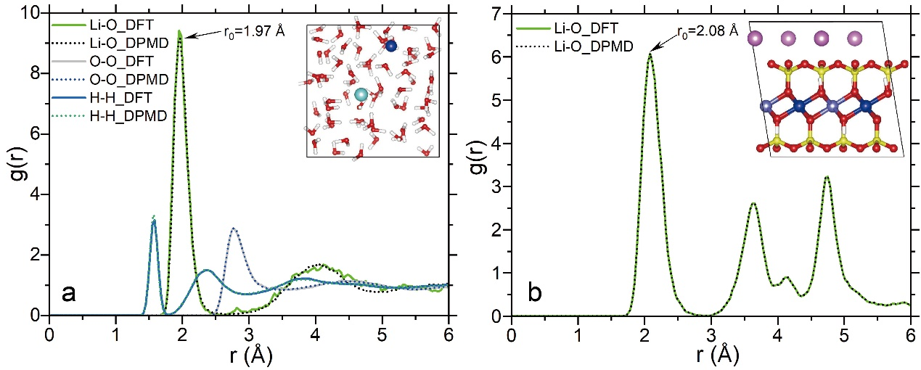
Fig. S1. Radial distribution functions in aqueous solution (a) and mica (b) derived from DP models at 300 K and compared with DFT calculations.

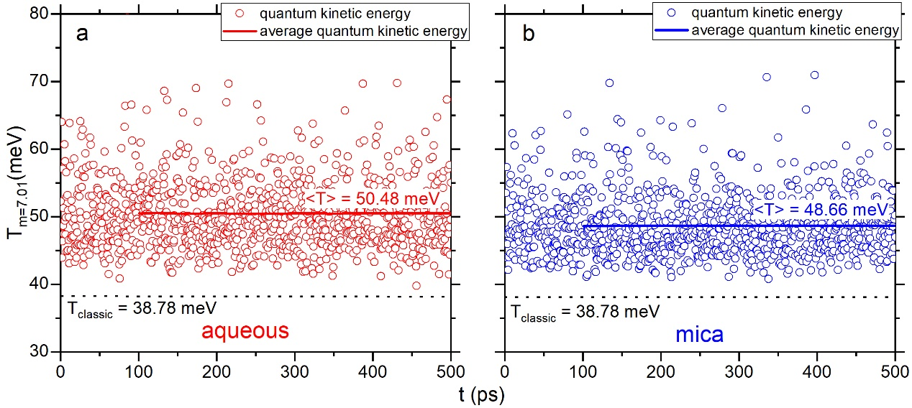
Fig. S2. The quantum kinetic energy of ⁷Li in aqueous solution (a) and mica structural sites (b). The average values are also shown in solid lines with respect to time, and the classical kinetic energy located at 38.78 meV is plotted in dashed lines.

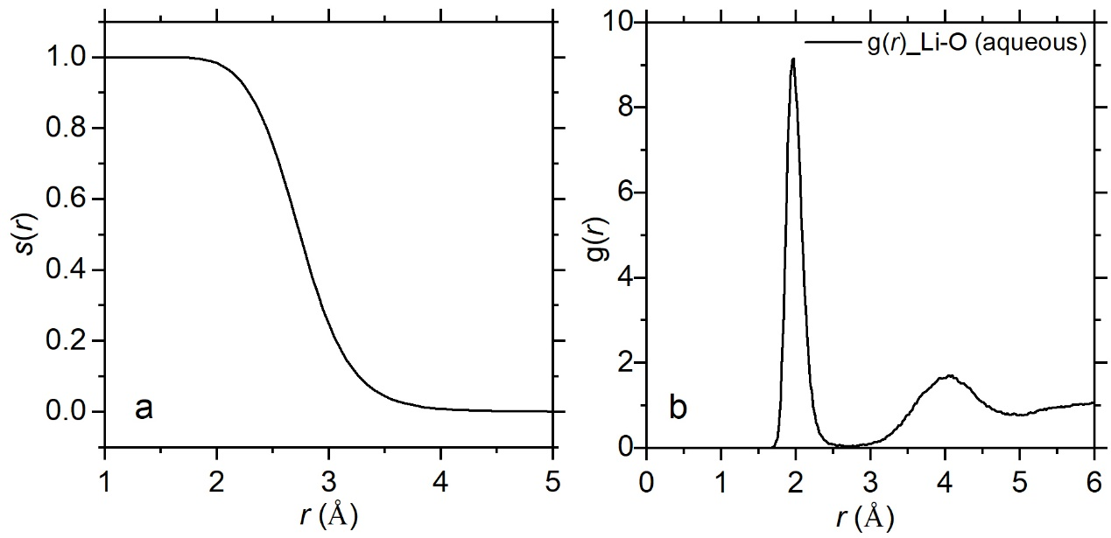
Fig. S3. Function of coordination number (s(r)) of an arbitrary water molecule around the Li⁺ (a), and radial distribution functions of water molecule around Li⁺ in aqueous solution (b).
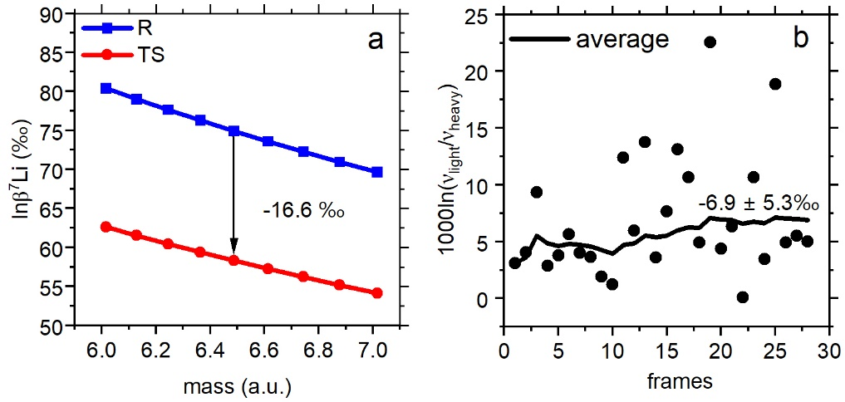
Fig. S4. Kinetic Li isotope fractionation in water exchange reaction around the solvated Li⁺. Energy term and decomposition frequency term are shown in a, b, respectively.

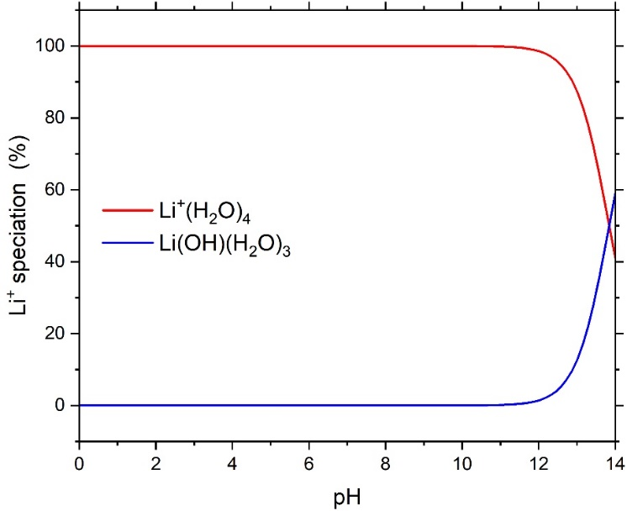
Fig. S5. Relative proportions of Li(H2O)₄⁺ and Li(OH)(H2O)₃ species across varying pH conditions.

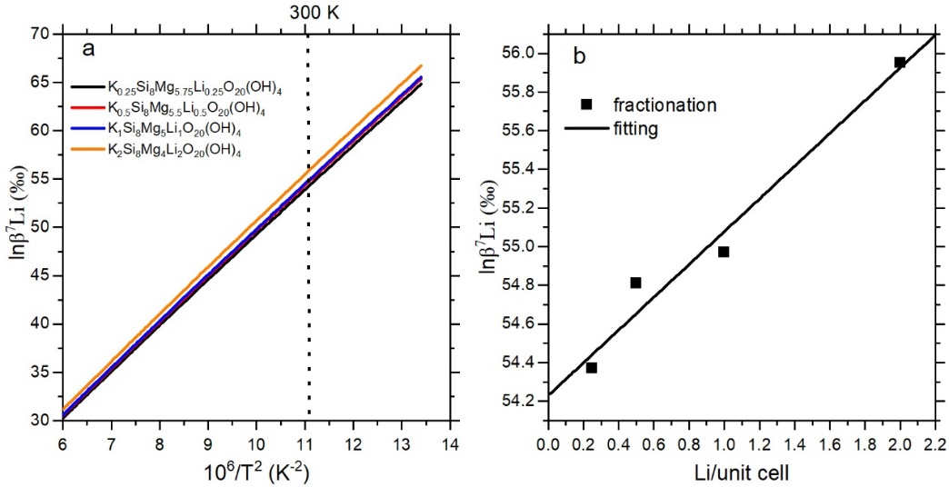
Fig. S6. Li isotope β factors of mica under different Li concentrations (a), and linear fitting of β factors at different Li concentrations (b).

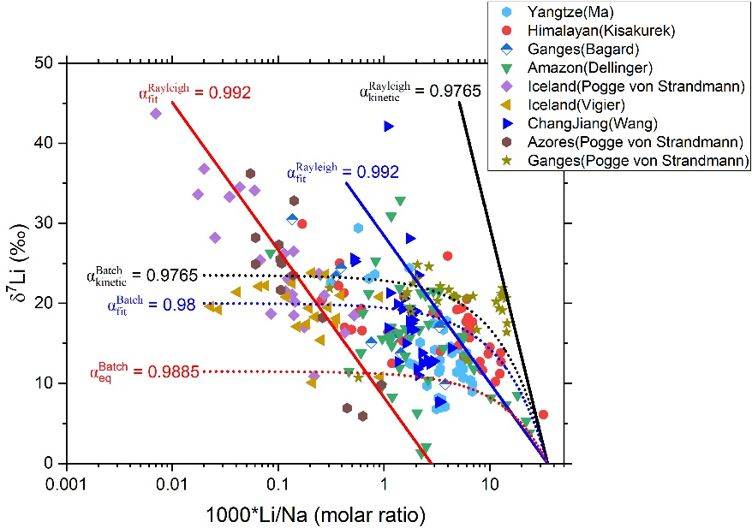
Fig. S7. Dissolved Li/Na molar ratios against δ⁷Li field data for different rivers. The solid and dashed lines are Rayleigh fractionation and Batch fractionation, respectively. Plotted data refers to the data of Yangtze River²⁹, Himalayan rivers³⁰, Ganges rivers^{31, 32}, Amazon rivers³³, Iceland rivers^{34, 35}, ChangJiang river³⁶, and Azores river³⁷.

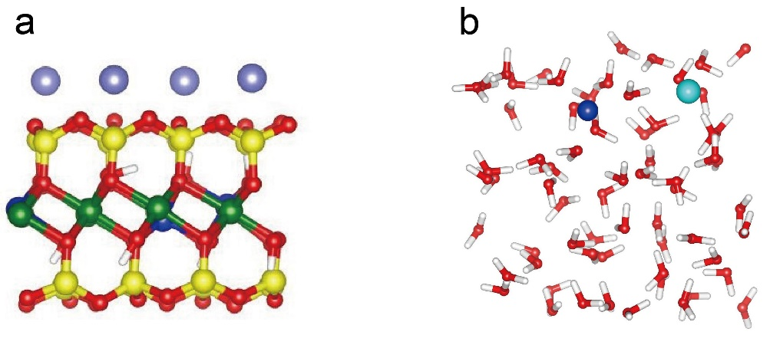
Fig. S8. Model configuration of Li⁺ in mica (a) and aqueous solution (b).

Table S1. Calculated 1000lnβ⁷Li and 1000lnα⁷Li for Li in aqueous solution and mica.
 | aqueous lnβ⁷Li (‰) | mica lnβ7Li (‰) | lnα⁷Limica-aqueous (‰)
DFT-PIMDª | 74.1 | 63.7 | -10.4
DP-PIMD | 74.9 | 63.4 | -11.5
a. Li isotope fractionation between mica and aqueous solution calculated from DFT based PIMD simulations³⁸.

Table S2. Lattice parameters of the optimized mica model.
system | a (Å) | b (Å) | c (Å) | β (⸰)
Optimized model | 5.273 | 9.170 | 10.330 | 99.671
Experimental measurementª | 5.316 | 9.201 | 10.310 | 99.891
a. Single-crystal X-ray diffraction³⁹.

Supplementary References

1. R. S. Hindshaw, R. Tosca, T. L. Goût, I. Farnan, N. J. Tosca, E. T. Tipper, Experimental constraints on Li isotope fractionation during clay formation. Geochimica et Cosmochimica Acta 250, 219-237 (2019).
2. P. L. Brown, C. Ekberg, "Alkali Metals" in Hydrolysis of Metal Ions. (Wiley‐VCH Verlag GmbH & Co. KGaA, Weinheim, 2016), pp. 135-154.
3. S. Bogatko, P. Claeys, F. De Proft, P. Geerlings, Li⁺ speciation and the use of 7Li/6Li isotope ratios for ancient climate monitoring. Chemical Geology 357, 1-7 (2013).
4. J. S. Pistiner, G. M. Henderson, Lithium-isotope fractionation during continental weathering processes. Earth and Planetary Science Letters 214, 327-339 (2003).
5. J. Bigeleisen, M. G. Mayer, Calculation of Equilibrium Constants for Isotopic Exchange Reactions. The Journal of Chemical Physics 15, 261-267 (1947).
6. H. C. Urey, The thermodynamic properties of isotopic substances. Journal of the Chemical Society (Resumed) 10.1039/JR9470000562, 562-581 (1947).
7. S. Liu, Y. Li, J. Liu, Y. Ju, J. Liu, Z. Yang, Y. Shi, Equilibrium lithium isotope fractionation in Li-bearing minerals. Geochimica et Cosmochimica Acta 235, 360-375 (2018).
8. H. Wang, L. Zhang, J. Han, W. E, DeePMD-kit: A deep learning package for many-body potential energy representation and molecular dynamics. Computer Physics Communications 228, 178-184 (2018).
9. Y. Zhang, H. Wang, W. Chen, J. Zeng, L. Zhang, H. Wang, W. E, DP-GEN: A concurrent learning platform for the generation of reliable deep learning based potential energy models. Computer Physics Communications 253, 107206 (2020).
10. A. P. Thompson, H. M. Aktulga, R. Berger, D. S. Bolintineanu, W. M. Brown, P. S. Crozier, P. J. in 't Veld, A. Kohlmeyer, S. G. Moore, T. D. Nguyen, R. Shan, M. J. Stevens, J. Tranchida, C. Trott, S. J. Plimpton, LAMMPS - a flexible simulation tool for particle-based materials modeling at the atomic, meso, and continuum scales. Computer Physics Communications 271, 108171 (2022).
11. J. Hutter, M. Iannuzzi, F. Schiffmann, J. VandeVondele, cp2k: atomistic simulations of condensed matter systems. WIREs Computational Molecular Science 4, 15-25 (2014).
12. J. VandeVondele, M. Krack, F. Mohamed, M. Parrinello, T. Chassaing, J. Hutter, Quickstep: Fast and accurate density functional calculations using a mixed Gaussian and plane waves approach. Computer Physics Communications 167, 103-128 (2005).
13. S. Goedecker, M. Teter, J. Hutter, Separable dual-space Gaussian pseudopotentials. Physical Review B 54, 1703-1710 (1996).
14. A. D. Becke, Density-functional exchange-energy approximation with correct asymptotic behavior. Physical Review A 38, 3098-3100 (1988).
15. C. Lee, W. Yang, R. G. Parr, Development of the Colle-Salvetti correlation-energy formula into a functional of the electron density. Physical Review B 37, 785-789 (1988).
16. S. Grimme, J. Antony, S. Ehrlich, H. Krieg, A consistent and accurate ab initio parametrization of density functional dispersion correction (DFT-D) for the 94 elements H-Pu. The Journal of Chemical Physics 132, 154104 (2010).
17. J. VandeVondele, J. Hutter, Gaussian basis sets for accurate calculations on molecular systems in gas and condensed phases. The Journal of Chemical Physics 127, 114105 (2007).
18. M. Machida, K. Kato, M. Shiga, Nuclear quantum effects of light and heavy water studied by all-electron first principles path integral simulations. The Journal of Chemical Physics 148, 102324 (2017).
19. L. Wang, M. Ceriotti, T. E. Markland, Quantum kinetic energy and isotope fractionation in aqueous ionic solutions. Physical Chemistry Chemical Physics 22, 10490-10499 (2020).
20. L. Wang, M. Ceriotti, T. E. Markland, Quantum fluctuations and isotope effects in ab initio descriptions of water. The Journal of Chemical Physics 141, 104502 (2014).
21. V. Kapil, M. Rossi, O. Marsalek, R. Petraglia, Y. Litman, T. Spura, B. Cheng, A. Cuzzocrea, R. H. Meißner, D. M. Wilkins, B. A. Helfrecht, P. Juda, S. P. Bienvenue, W. Fang, J. Kessler, I. Poltavsky, S. Vandenbrande, J. Wieme, C. Corminboeuf, T. D. Kühne, D. E. Manolopoulos, T. E. Markland, J. O. Richardson, A. Tkatchenko, G. A. Tribello, V. Van Speybroeck, M. Ceriotti, i-PI 2.0: A universal force engine for advanced molecular simulations. Computer Physics Communications 236, 214-223 (2019).
22. M. Ceriotti, M. Parrinello, T. E. Markland, D. E. Manolopoulos, Efficient stochastic thermostatting of path integral molecular dynamics. The Journal of Chemical Physics 133, 124104 (2010).
23. W. Li, Z. Ji, X. Luo, Y. Li, Isotope fractionation of alkaline and alkaline-earth elements (Li, K, Rb, Mg, Ca, Sr, Ba) during diffusion in aqueous solutions. Geochimica et Cosmochimica Acta 370, 104-112 (2024).
24. E. B. Watson, T. Müller, Non-equilibrium isotopic and elemental fractionation during diffusion-controlled crystal growth under static and dynamic conditions. Chemical Geology 267, 111-124 (2009).
25. M. A. Antonelli, T. Mittal, A. McCarthy, B. Tripoli, J. M. Watkins, D. J. DePaolo, Ca isotopes record rapid crystal growth in volcanic and subvolcanic systems. Proceedings of the National Academy of Sciences 116, 20315-20321 (2019).
26. A. Decarreau, N. Vigier, H. Pálková, S. Petit, P. Vieillard, C. Fontaine, Partitioning of lithium between smectite and solution: An experimental approach. Geochimica et Cosmochimica Acta 85, 314-325 (2012).
27. N. Vigier, A. Decarreau, R. Millot, J. Carignan, S. Petit, C. France-Lanord, Quantifying Li isotope fractionation during smectite formation and implications for the Li cycle. Geochimica et Cosmochimica Acta 72, 780-792 (2008).
28. E. Hofmann Amy, C. Bourg Ian, J. DePaolo Donald, Ion desolvation as a mechanism for kinetic isotope fractionation in aqueous systems. Proceedings of the National Academy of Sciences 109, 18689-18694 (2012).
29. T. Ma, M. Weynell, S.-L. Li, Y. Liu, B. Chetelat, J. Zhong, S. Xu, C.-Q. Liu, Lithium isotope compositions of the Yangtze River headwaters: Weathering in high-relief catchments. Geochimica et Cosmochimica Acta 280, 46-65 (2020).
30. B. Kısakűrek, R. H. James, N. B. W. Harris, Li and δ7Li in Himalayan rivers: Proxies for silicate weathering? Earth and Planetary Science Letters 237, 387-401 (2005).
31. M.-L. Bagard, A. J. West, K. Newman, A. R. Basu, Lithium isotope fractionation in the Ganges–Brahmaputra floodplain and implications for groundwater impact on seawater isotopic composition. Earth and Planetary Science Letters 432, 404-414 (2015).
32. P. A. E. Pogge von Strandmann, P. J. Frings, M. J. Murphy, Lithium isotope behaviour during weathering in the Ganges Alluvial Plain. Geochimica et Cosmochimica Acta 198, 17-31 (2017).
33. M. Dellinger, J. Gaillardet, J. Bouchez, D. Calmels, P. Louvat, A. Dosseto, C. Gorge, L. Alanoca, L. Maurice, Riverine Li isotope fractionation in the Amazon River basin controlled by the weathering regimes. Geochimica et Cosmochimica Acta 164, 71-93 (2015).
34. P. A. E. Pogge von Strandmann, K. W. Burton, R. H. James, P. van Calsteren, S. R. Gíslason, F. Mokadem, Riverine behaviour of uranium and lithium isotopes in an actively glaciated basaltic terrain. Earth and Planetary Science Letters 251, 134-147 (2006).
35. N. Vigier, S. R. Gislason, K. W. Burton, R. Millot, F. Mokadem, The relationship between riverine lithium isotope composition and silicate weathering rates in Iceland. Earth and Planetary Science Letters 287, 434-441 (2009).
36. Q.-L. Wang, B. Chetelat, Z.-Q. Zhao, H. Ding, S.-L. Li, B.-L. Wang, J. Li, X.-L. Liu, Behavior of lithium isotopes in the Changjiang River system: Sources effects and response to weathering and erosion. Geochimica et Cosmochimica Acta 151, 117-132 (2015).
37. P. A. E. P. von Strandmann, K. W. Burton, R. H. James, P. van Calsteren, S. R. Gislason, Assessing the role of climate on uranium and lithium isotope behaviour in rivers draining a basaltic terrain. Chemical Geology 270, 227-239 (2010).
38. Q. Li, X. Lu, M. Chen, L. Zhang, Y. Cheng, X. Liu, Z. Yin, Lithium partition and isotopic fractionation for cation exchange in clay: Insights from molecular simulations. Geochimica et Cosmochimica Acta 358, 148-161 (2023).
39. G. J. Redhammer, G. Roth, Single-crystal structure refinements and crystal chemistry of synthetic trioctahedral micas KM₃(Al³⁺,Si⁴⁺)₄O₁₀(OH)₂, where M = Ni²⁺, Mg²⁺, Co²⁺, Fe²⁺, or Al³⁺. American Mineralogist 87, 1464-1476 (2002).

