 | PF | RP | BP | GH | VT | SF | RE | MH | PHQ9 | GAD7 | PHQ15 | PSQI
PF |  | .623** | .628** | .587** | .381** | .500** | .454** | .296** | -.335** | -.300** | -.316** | -.305**
RP |  |  | .574** | .541** | .415** | .521** | .662** | .374** | -.357** | -.323** | -.336** | -.316**
BP |  |  |  | .610** | .484** | .572** | .525** | .408** | -.461** | -.419** | -.501** | -.476**
GH |  |  |  |  | .596** | .565** | .471** | .507** | -.414** | -.382** | -.347** | -.347**
VT |  |  |  |  |  | .526** | .512** | .768** | -.667** | -.630** | -.542** | -.580**
SF |  |  |  |  |  |  | .578** | .528** | -.546** | -.533** | -.407** | -.437**
RE |  |  |  |  |  |  |  | .522** | -.477** | -.453** | -.384** | -.410**
MH |  |  |  |  |  |  |  |  | -.698** | -.706** | -.505** | -.566**
PHQ9 |  |  |  |  |  |  |  |  |  | .846** | .611** | .590**
GAD7 |  |  |  |  |  |  |  |  |  |  | .588** | .576**
PHQ15 |  |  |  |  |  |  |  |  |  |  |  | .631**
PSQI
Table S1. Correlation between scores of PHQ-9, GAD-7, PHQ-15, PSQI, and 8 domains of SF-36. Pearson correlation, **, p< 0.01 (2-tailed).

 | SQ | SL | SD | SE | Dis | SM | DD | PSQI
SQ |  | .571** | .485** | .315** | .568** | .279** | .595** | .813**
SL |  |  | .331** | .255** | .509** | .177** | .449** | .728**
SD |  |  |  | .498** | .377** | .159** | .400** | .697**
SE |  |  |  |  | .217** | .131** | .187** | .561**
Dis |  |  |  |  |  | .216** | .585** | .737**
SM |  |  |  |  |  |  | .189** | .393**
DD |  |  |  |  |  |  |  | .744**
PSQI
Table S2. Correlation between scores of PSQI and its 7 domains. Pearson correlation, **, p< 0.01 (2-tailed).

PHQ-9 | CAH<NF (-5.543, p=0.004), undiagnosed (-4.493, p=0.002)
GAD-7 | CAH<Dravet (-6.696, p=0.048), NF (-5.508, p<0.0001), undiagnosed (-4.798, p<0.0001)
GAD-7 | Hemophilia<NF (-4.527, p=0.031)
GAD-7 | PKU<NF (-5.760, p=0.016), undiagnosed (-2.109, p=0.049)
GAD-7 | Other<undiagnosed (-5.050, p=0.031)
PSQI | CAH<NF (-2.553, p=0.014)
PF | CAH>DMD (55.130, p<0.0001), hemophilia (30.266, p=0.002), MPS (53.510, p<0.0001), other (34.438, p<0.0001)
PF | DMD<hemophilia (-24.864, p=0.012), neurofibromatosis (-45.953, p<0.0001), PKU (-34.858, p=0.001), undiagnosed (-42.687, p<0.0001), other (-20.693, p=0.001)
PF | MPS<NF (-44.311, p=0.001), undiagnosed (-41.067, p=0.001)
PF | Other<NF (-25.239, p<0.0001), undiagnosed (-21.994, p<0.0001)
RP | CAH>DMD (51.131, p<0.0001), Dravet (53.093, p=0.041), hemophilia (62.844, p<0.0001), MPS (61.948, p=0.006), other (47.042, p<0.0001), undiagnosed (40.342, p<0.0001)
RP | Hemophilia<NF (-41.802, p=0.002), PKU (-47.094, p=0.011)
RP | Other<NF (-26.000, p=0.013)
BP | CAH>DMD (29.047, p<0.0001), hemophilia (36.521, p<0.0001), other (21.564, p<0.0001), and undiagnosed (16.765, p=0.045)
BP | Hemophilia<NF (-25.195, p=0.003), PKU (-29.004, p=0.021), undiagnosed (-19.756, p=0.020)
SF | CAH>DMD (24.621, p<0.0001), Dravet (32.447, p=0.008), hemophilia (20.627, p=0.015), other (16.835, p=0.002), undiagnosed (20.965, p<0.0001)
SF | PKU>DMD (24.513, p=0.015), Dravet (32.338, p=0.034), undiagnosed (20.857, p=0.028)
RE | CAH>DMD (43.151, p=0.001), Dravet (62.577, p=0.007), hemophilia (44.432, p=0.003), other (45.237, p<0.0001), undiagnosed (42.651, p<0.0001)
MH | CAH>NF (17.980, p=0.011), undiagnosed (13.928, p=0.036)
MH | Hemophilia>NF (18.401, p=0.019)

Table S3. The impact of disease on scores of PHQ-9, GAD-7, PSQI, PHQ-15, and SF-36.
Since there were 104 types of diseases, to simplify the analysis, diseases were categorized into PKU, MPS, DMD, neurofibromatosis (NF), Dravet, CAH, undiagnosed, and other. Data were represented as mean difference and adjusted p value. Only comparisons with statistical significance were shown.

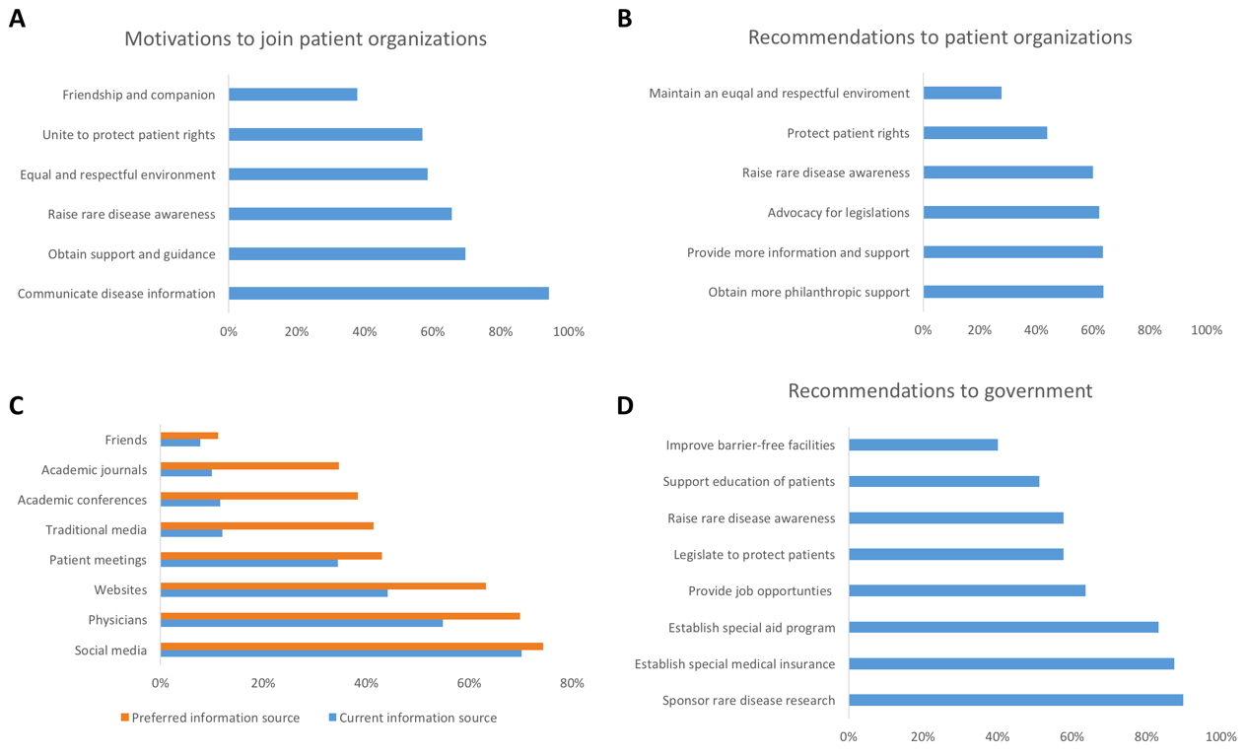

Fig.S1. Attitude of patients and care-givers towards patient organizations, information needs, and government. (A) The motivation of patients and care-givers to join a certain patient organizations. (B) Recommendations to patient organizations on how to improve performance. (C) Current information source and preferred information source. (D) Recommendations to government.

