Supporting information
Title: Salinity shifts trait-mediated photosynthetic response to flooding in salt-sensitive mangrove under sea-level rise

Muwen Niu^{1, 2#}, Yasong Chen^{1, 2#}, Dan Peng^{3*}, Ling Jin^{1, 2}, Karyne M. Rogers⁴, Xin Song³, Hao Wu^{1, 2}, Yihui Zhang^{1, 2*}

Appendix S1: Additional Information for Methods

Leaf trait measurements
Pn, Gs, and Ci were measured using a LI-6800 portable photosynthesis system (LI-COR Inc., Lincoln, NE, USA) between 9:00 and 11:00 AM on sunny days. Measurements were conducted under controlled conditions: chamber temperature of 25℃, CO₂ concentration of 400 ppm, photosynthetic photon flux of 800 µmol·m⁻²·s⁻¹, and relative humidity of 60%. LT was determined using a vernier caliper with an accuracy of 0.01 mm. Leaf area was determined using a portable leaf area meter (YMJ-CH, Lvbo, China), and leaf fresh mass was measured using an analytical balance (ES1035A, D&T, China). Leaf dry mass was obtained after oven-drying at 65 ℃ for 72 h to a constant weight. Then, SLA was calculated as the ratio of leaf area to leaf dry mass, and LDMC was calculated as the ratio of leaf fresh mass to dry mass (Pérez-Harguindeguy et al., 2016).

Plant height measurement
At the time of leaf sampling, plant height was measured as the vertical distance from the soil surface to the highest point of the plant (Pérez-Harguindeguy et al., 2016).

Soil porewater salinity and soil water content measurements
Sediment samples were collected from three mesocosms at each elevation to assess soil porewater salinity across different zones at low tide, approximately once per month, beginning in August, one month after propagule planting (n=21, comprising seven sampling dates and three replicates per elevation). Soil porewater salinity was measured by rehydrating dried soil samples with a known volume of tap water (0 PSU), measuring the salinity of the resulting supernatant, and back-calculating to the original porewater salinity (Pennings & Richards, 1998). Soil water content was calculated as the mass of water divided by the total mass of the fresh soil sample.

Appendix S2: Supplementary Table

Table S1 The relationships among environmental factors and leaf traits that have been used in the structural equation modelling and supporting references.
Path | Supporting reference
(1) Flooding duration → Leaf thickness | (Voesenek and Bailey-Serres, 2015)
(2) Flooding duration → Leaf dry matter content | (Voesenek and Bailey-Serres, 2015)
(3) Flooding duration →Specific leaf area | (Voesenek and Bailey-Serres, 2015)
(4) Flooding duration → Stomatal conductance | (Kozlowski et al., 1997)
(5) Flooding duration → Net photosynthetic rate | (Voesenek and Bailey-Serres, 2015)
(6) Leaf thickness → Specific leaf area | (Poorter et al., 2009)
(7) Leaf dry matter content → Specific leaf area | (Shipley et al., 2006)
(8) Specific leaf area → Stomatal conductance | (Onoda et al., 2017)
(9) Specific leaf area → Net photosynthetic rate | (Onoda et al., 2017)
(10) Stomatal conductance → Net photosynthetic rate | (Harrison et al., 2020)

Table S2 Pearson correlation coefficients between leaf traits of Acanthus ilicifolius in the two salinity zones. The upper-right and lower-left matrix show the correlation coefficients in oligohaline and mesohaline salinity zone, respectively. P-value in bold indicates a statistically significantly result (P < 0.05). Pn: net photosynthetic rate, Gs: stomatal conductance, Ci: Intercellular CO₂ concentration, SLA: specific leaf area, LT: leaf thickness, LDMC: leaf dry matter content.
 | Pn | Ci | Gs | LDMC | LT | SLA
Pn |  | 0.40 | 0.90 | -0.26 | -0.08 | 0.16
Ci | -0.93 |  | 0.70 | -0.22 | -0.14 | 0.24
Gs | 0.91 | -0.75 |  | -0.32 | -0.15 | 0.26
LDMC | 0.69 | -0.61 | 0.66 |  | 0.31 | -0.84
LT | 0.66 | -0.71 | 0.59 | 0.30 |  | -0.69
SLA | -0.86 | 0.84 | -0.81 | -0.75 | -0.815

Appendix S3: Supplementary Figure

Figure S1 (a) Average daily temperature and total monthly rainfall; (b) Seawater salinity in the oligohaline and mesohaline zones of Zhangjiang Estuary during the experimental period (June 2023–March 2024).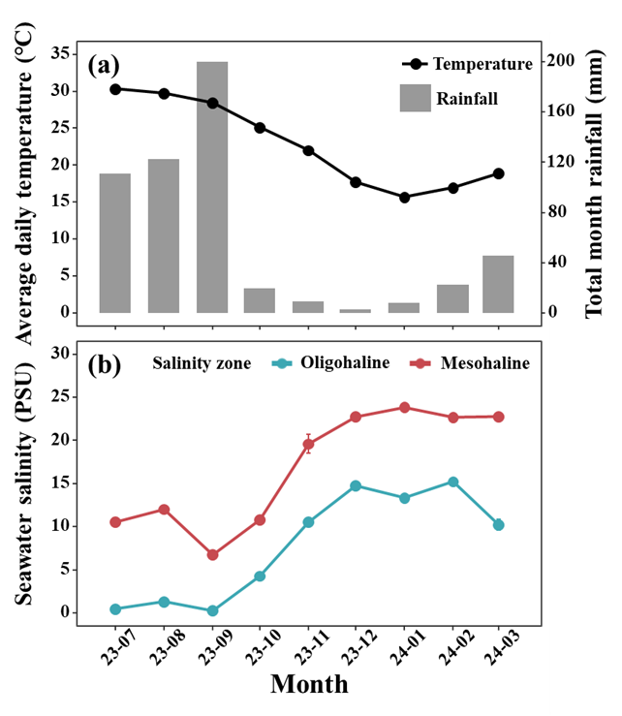

Figure S2 Variations in (a) soil porewater salinity and (b) soil water content with tidal elevation across oligohaline and mesohaline zones. Results of two-way ANOVA are shown, including main effects and interactions. Significance levels: ***P < 0.001, **P < 0.01, *P < 0.05, ·P < 0.1, ns P > 0.1.
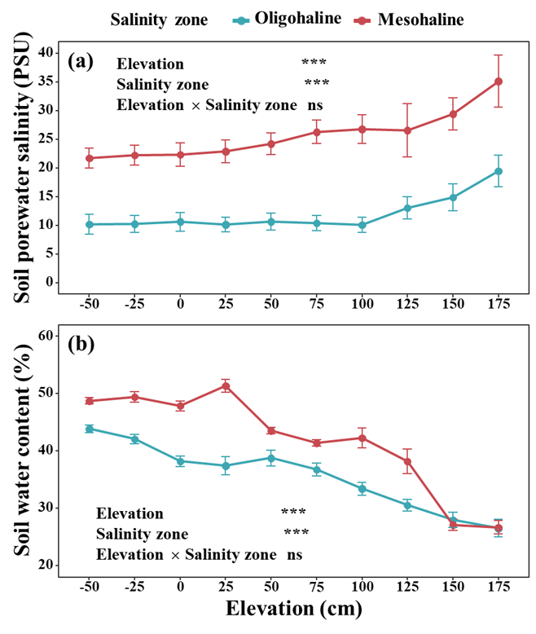

Figure S3 The initial full model of possible links of the predicted effects of flooding duration on capacity based on prior knowledge on directions of causality in plant.
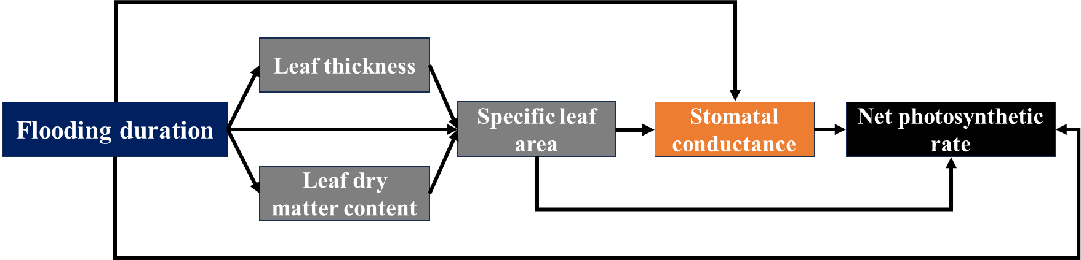

References
Harrison EL, Arce Cubas L, Gray JE, Hepworth C (2020) The influence of stomatal morphology and distribution on photosynthetic gas exchange. Plant J 101:768–779. https://doi.org/10.1111/tpj.14560
Kozlowski TT (1997) Responses of woody plants to flooding and salinity. Tree Physiol 17:490. https://doi.org/10.1093/treephys/17.7.490
Onoda Y, Wright IJ, Evans JR, et al (2017) Physiological and structural tradeoffs underlying the leaf economics spectrum. New Phytol 214:1447–1463. https://doi.org/10.1111/nph.14496
Pennings SC, Richards CL (1998) Effects of wrack burial in salt-stressed habitats: Batis maritima in a southwest Atlantic salt marsh. Ecography 21:630–638. https://doi.org/10.1111/j.1600-0587.1998.tb00556.x
Pérez-Harguindeguy N, Díaz S, Garnier E, et al (2016) New handbook for standardised measurement of plant functional traits worldwide. Aust J Bot 64:715–716. https://doi.org/10.1071/bt12225_co
Poorter H, Niinemets Ü, Poorter L, et al (2009) Causes and consequences of variation in leaf mass per area (LMA): a meta-analysis. New Phytol 182:565–588. https://doi.org/10.1111/j.1469-8137.2009.02830.x
Shipley B, Lechowicz MJ, Wright I, Reich PB (2006) Fundamental trade-offs generating the worldwide leaf economics spectrum. Ecology 87:535–541. https://doi.org/10.1890/05-1051
Voesenek LACJ, Bailey-Serres J (2015) Flood adaptive traits and processes: an overview. New Phytol 206:57–73. https://doi.org/10.1111/nph.13209

