Supplementary Information

Adaptable personalized thermoregulation through rational design of passive and active heat transfer

Dong Hyun Kim†¹ , Farooq Khan¹, Jeuk Lee¹, In Chul Shin¹, Jinwoo Na¹, Taeho Yoo¹, Yeongju Jung²*, Seung Hwan Ko^{3,4,5}*, Jinwoo Lee¹*
¹ Department of Mechanical, Robotics, and Energy Engineering, Dongguk University, 30 Pildong-ro 1-gil, Jung-gu, Seoul, 04620, South Korea
² Department of Automotive Engineering, Kookmin University, 77 Jeongneung-ro, Seongbuk-gu, Seoul 02707, Republic of Korea
³ Department of Mechanical Engineering, Seoul National University, 1 Gwanak-ro, Gwanak-gu, Seoul, 08826, Republic of Korea
⁴ Institute of Advanced Machinery and Design (SNU-IAMD), Seoul National University, Gwanak-ro, Gwanak-gu, Seoul, 08826, South Korea
⁵ Institute of Engineering Research, Seoul National University, 1 Gwanak-ro, Gwanak-gu, Seoul, 08826, South Korea

*Correspondence to
Prof. Jinwoo Lee (jlee484@dgu.ac.kr), Prof. Seung Hwan Ko (maxko@snu.ac.kr), and Prof. Yeongju Jung (yeongju_jung@kookmin.ac.kr)

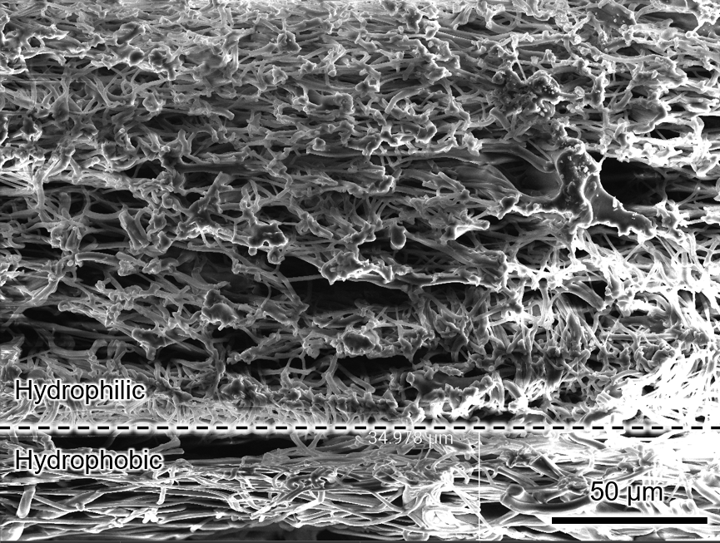
Supplementary Fig. 1 | Cross-sectional SEM image of the SH-EC layer showing thickness asymmetry between the hydrophilic and hydrophobic bilayers. The interface between the two sublayers is indicated by the red line. The total membrane thickness of the entire bilayer is ~200 μm, and the hydrophobic sublayer thickness is 34.978 μm, with the thickness ratio of ~4.7:1 (hydrophilic: hydrophobic).

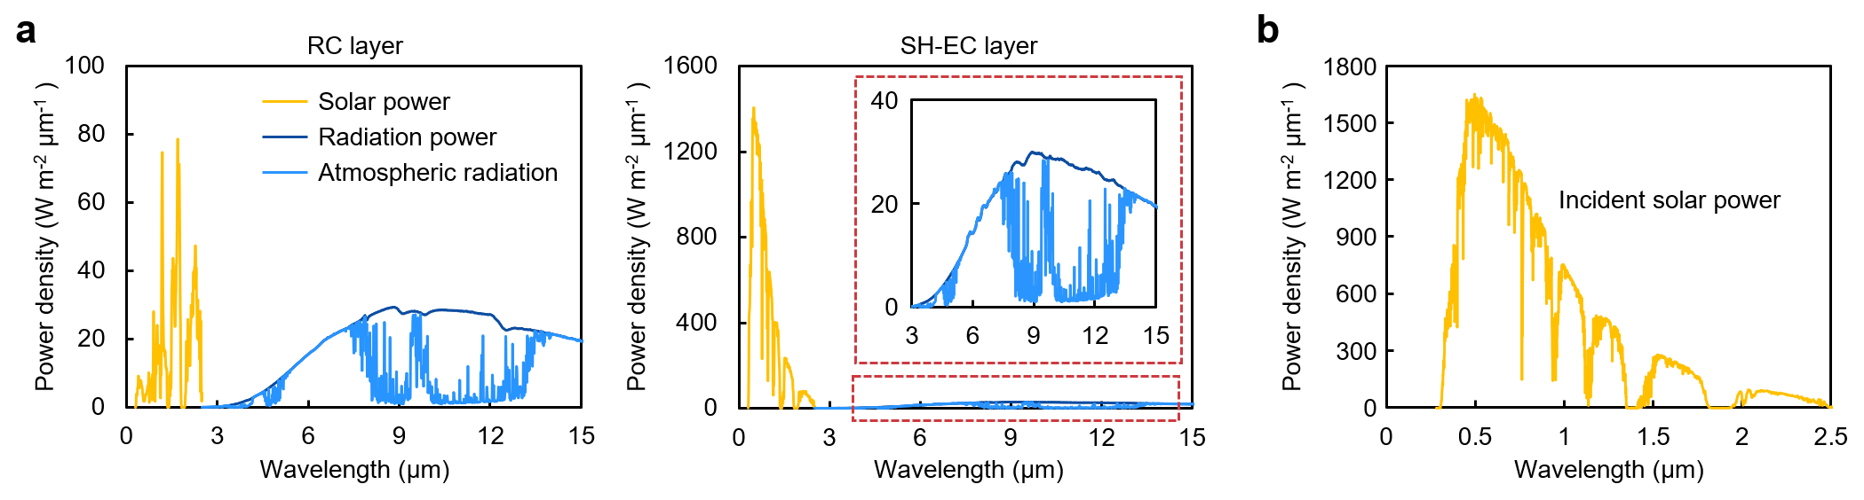
Supplementary Fig. 2 | The simulated power distribution. a Power distribution for the RC and SH-EC layer. The red dotted box shows a magnified view of spectral heat flux between 3 μm and 5 μm. b AM 1.5G spectrum

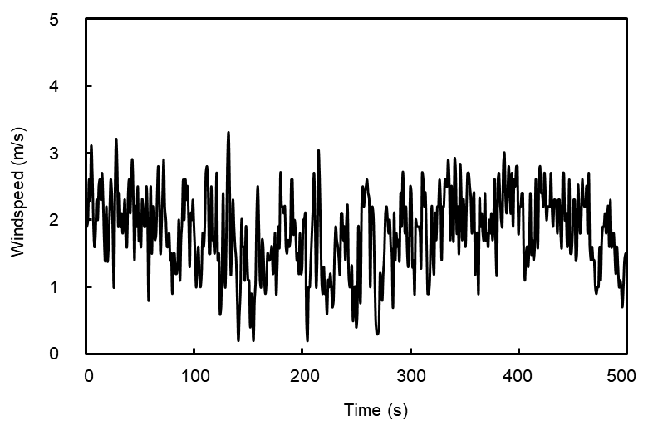
Supplementary Fig. 3 | Wind speed profile during the outdoor test. Wind speed for 500 min starting from 11:10, 26 September 2025, in Seoul. The data was provided by the Korea Meteorological Administration (KMA).

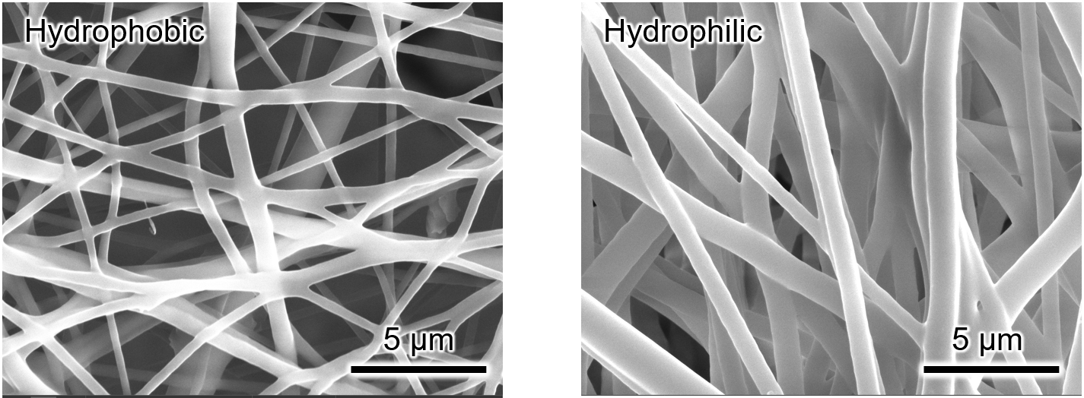
Supplementary Fig. 4 | SEM micrographs of the hydrophobic and hydrophilic sides show distinct fiber-network morphologies. The hydrophilic side exhibits a denser fiber architecture than the hydrophobic side, which is consistent with enhanced moisture uptake and transport.

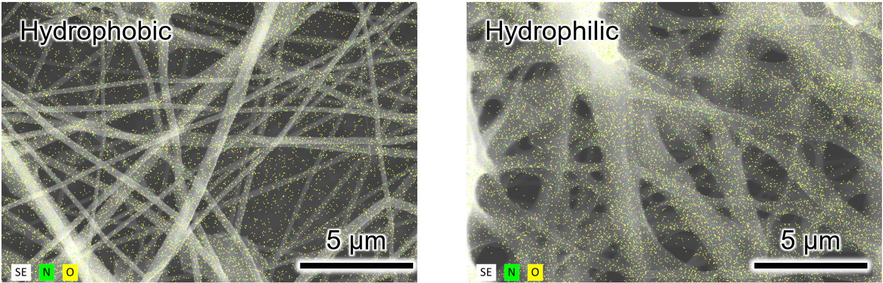
Supplementary Fig. 5 | SEM–EDS characterization of the SH-EC layer surfaces. SEM images with EDS elemental maps (N and O) compare the hydrophobic (graphene + TPU) and hydrophilic (graphene + TPU + F127) sides (scale bars: 5 μm). EDS quantification shows a higher O/N atomic ratio on the hydrophilic side (3.02) than on the hydrophobic side (2.09) due to the high content of O in F127.
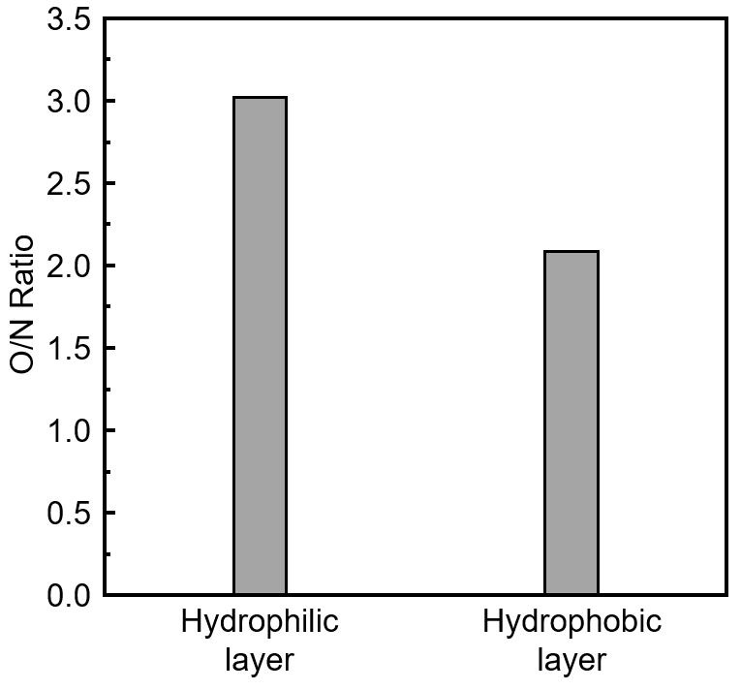
Supplementary Fig. 6 | EDS-derived O/N ratio of the SH-EC layer. Bar plot comparing the O/N ratio extracted from EDS analysis for the hydrophilic and hydrophobic sides of the SH-EC layer, showing a higher O/N ratio for the hydrophilic side (3.02) than for the hydrophobic side (2.09).

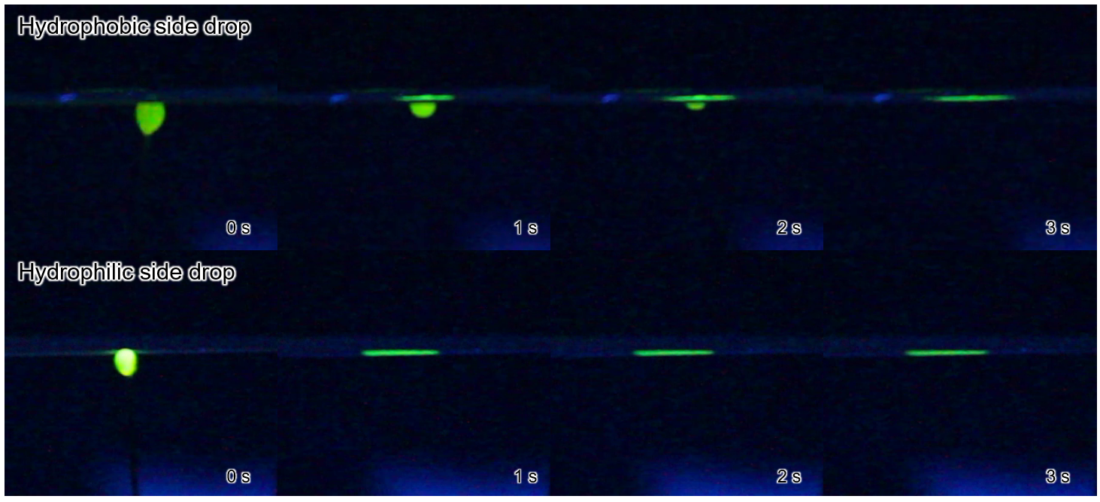
Supplementary Fig. 7 | Anti-gravity moisture transport test. Anti-gravity moisture transport test. Time-lapse photographs of the SH-EC layer demonstrating rapid capillary-driven moisture transport against gravity. A water droplet (~100 μL, 0.1 g) was placed at the lower edge, and the transport front propagated upward within 3 s: t = 0 s, 1 s, 2 s, and 3 s.
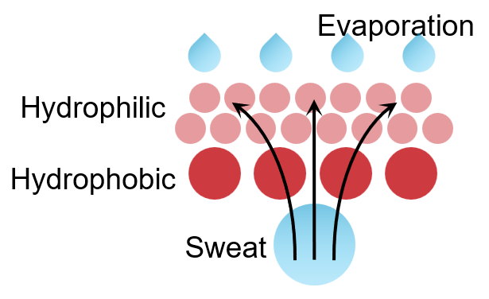

Supplementary Fig. 8 | Schematic illustrating evaporative cooling driven by sweat. Liquid sweat penetrates into the porous membrane and is redistributed through capillary transport, while water vapor diffuses outward and evaporates from the outer surface. The phase change of liquid removes latent heat from the skin–device interface, providing cooling. Arrows indicate moisture transport pathways and vapor release.

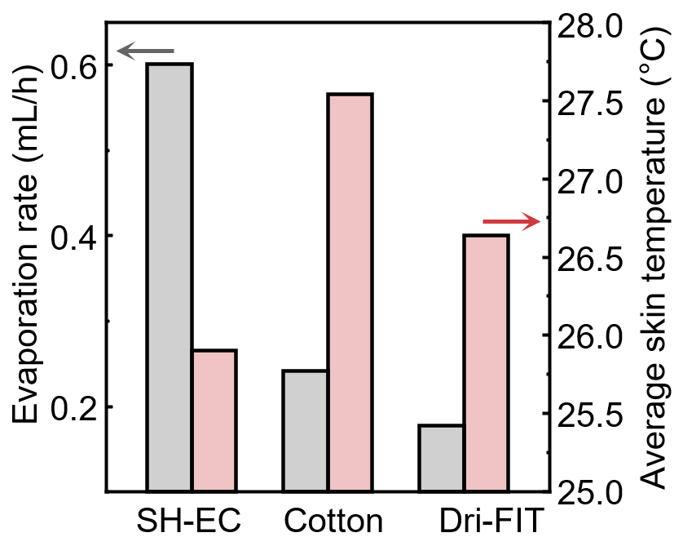
Supplementary Fig. 9 | Evaporation cooling flux and power of SH-EC layer and other commercially available fabrics. To quantitatively compare the cooling performance of each material, we calculated the evaporative cooling flux and cooling power. A single DI water droplet ($m_{0}$) was dispensed onto the sample placed on a PID-controlled skin simulator (heated plate) maintained at 35 °C, while the temperature trace $T(t)$ was continuously recorded ¹. The drying time ($t_{dry}$) was defined as the inflection point where $T(t)$ transitions from a low, quasi-steady regime to a rapid rise, indicating depletion of evaporative cooling. The average evaporation rate was calculated as $E=(m_{0}/t_{dry})×3600$(mL·h⁻¹, $ρ≈1$g·mL)⁻¹ The average skin temperature was obtained by averaging $T(t)$ over the stabilized pre-drying interval. The results demonstrated that the SH-EC layer exhibits a cooling flux of 1440 W·m⁻², which is 4.15- and 4.30-fold higher than those of cotton and Dri-FIT, respectively. Likewise, the cooling power of the SH-EC film exhibits 0.575 W, corresponding to 4.13- and 4.29-fold greater performance than those of commercial textiles.

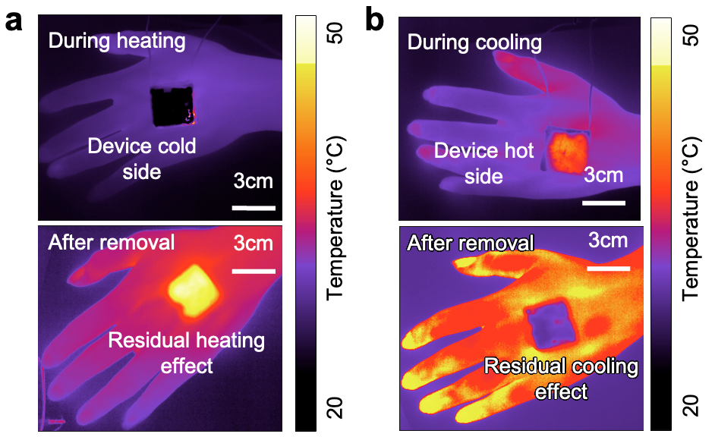
Supplementary Fig. 10 | Residual thermal effect after applying thermoelectric module. a IR images of the human subject’s hand during and after applying heating. b IR images of the human subject’s hand during and after applying cooling.
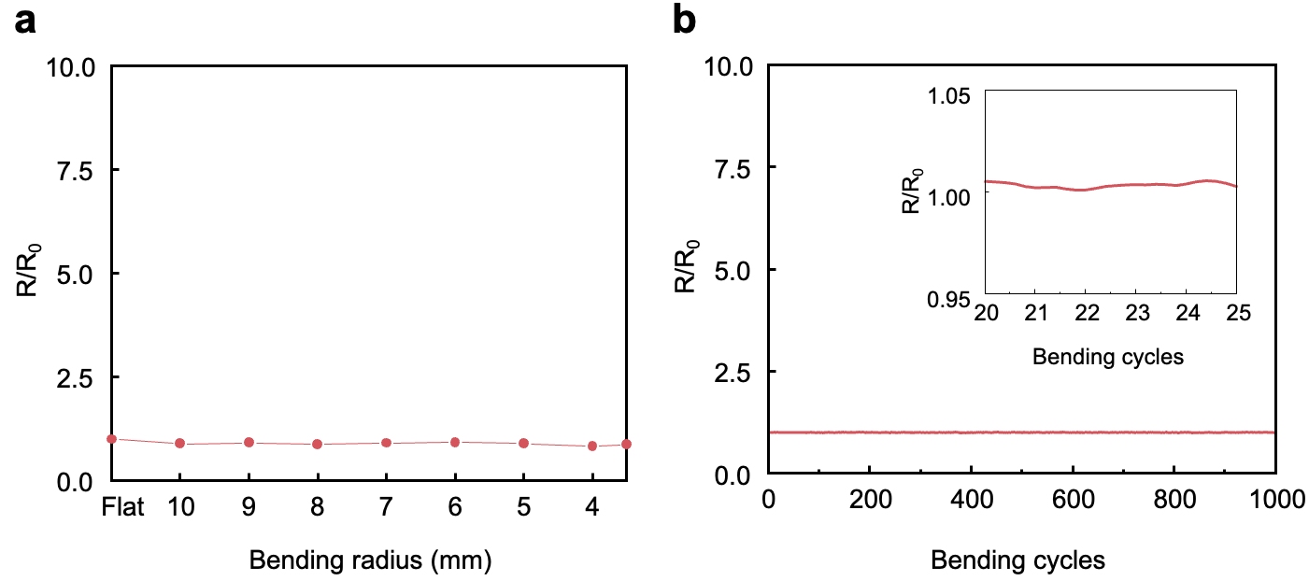
Supplementary Fig. 11 | Normalized resistance change in response to bending stress. a Normalized resistance change when the bending radius was decreased from the flat state (0 mm) to 4.5 mm. b Normalized resistance change under repeated bending cycles of 1000 times.

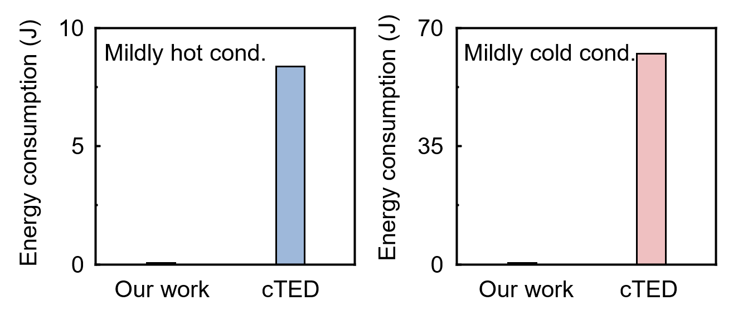
Supplementary Fig. 12 | Eco-mode energy use under mild conditions. Energy consumed by the thermoelectric control while bringing the device–skin interface into the comfort temperature zone. The conventional device required 8.61 J over 170 s, until the RC side reached the comfort zone without energy input. The conventional device used 63.10 J over 70 s until the SH side reached the comfort zone without energy input.

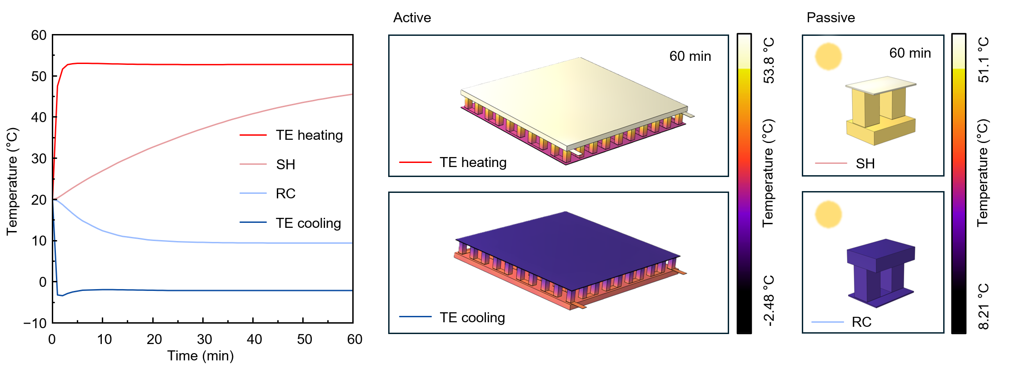
Supplementary Fig. 13 | Temperature response from a Multiphysics simulation over 60 min in passive and active modes. Multiphysics simulations compare the transient temperatures during active TE heating, active TE cooling, radiative cooling (RC), and solar heating (SH) over a 60 min period under identical boundary conditions. Specifically, at the end of the 60 min simulation, TE cooling operated at −2 V reached −2.12 °C, whereas TE heating operated at 1.5 V increased the temperature to 58.82 °C. Under passive modes, RC decreased the temperature to 9.37 °C, while SH raised it to 45.56 °C.

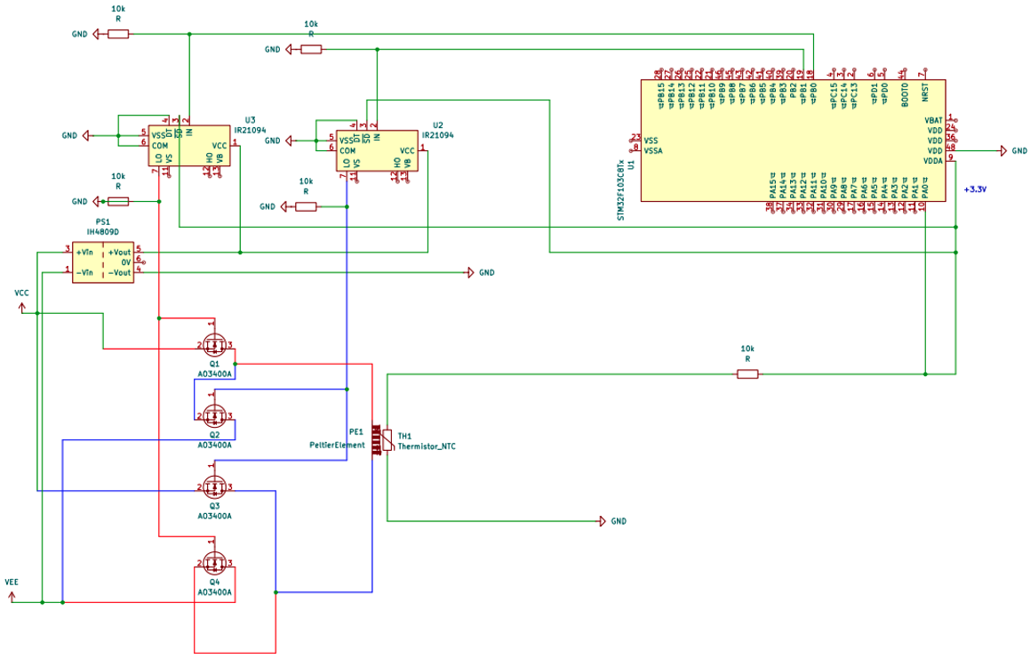
Supplementary Fig. 14 | MOSFET-based PID control circuit for TE actuation. Circuit schematic of the PID-controlled driver used to regulate the thermoelectric module. An MCU generates PWM control signals to an H-bridge MOSFET stage for bidirectional current switching (heating/cooling), while an NTC thermistor provides temperature feedback for closed-loop control.

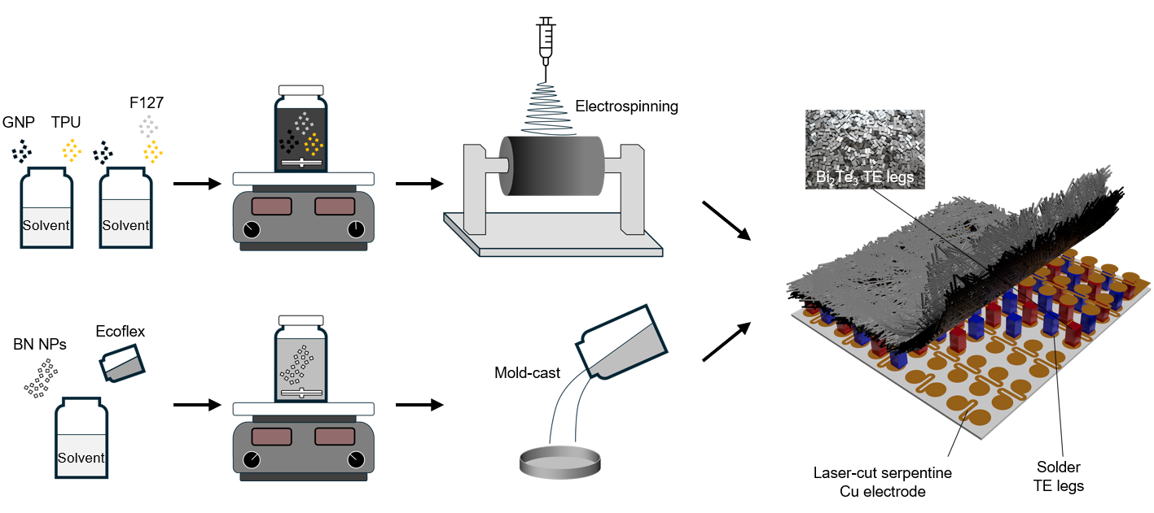
Supplementary Fig. 15 | Fabrication workflow of the RC/TE/SH-EC stacked device. The SH-EC layer was prepared by dissolving TPU and dispersing graphene nanoplatelets with a hydrophilic surfactant (F127) in the solvent, followed by homogenization and electrospinning to form a nanofiber membrane (top route). Meanwhile, the RC layer was prepared by dispersing h-BN nanoparticles in a solvent, mixing them with Ecoflex, and mold-casting the mixture (bottom route). The two layers were integrated through an embedded TE array: A copper sheet was laser-patterned into serpentine electrodes, and vertically aligned Bi₂Te₃ TE legs were soldered to complete the stacked architecture.

References
1 Peng, Y. et al. Integrated cooling (i-Cool) textile of heat conduction and sweat transportation for personal perspiration management. Nature Communications 12, 6122 (2021). https://doi.org/10.1038/s41467-021-26384-8

