Supplementary Materials

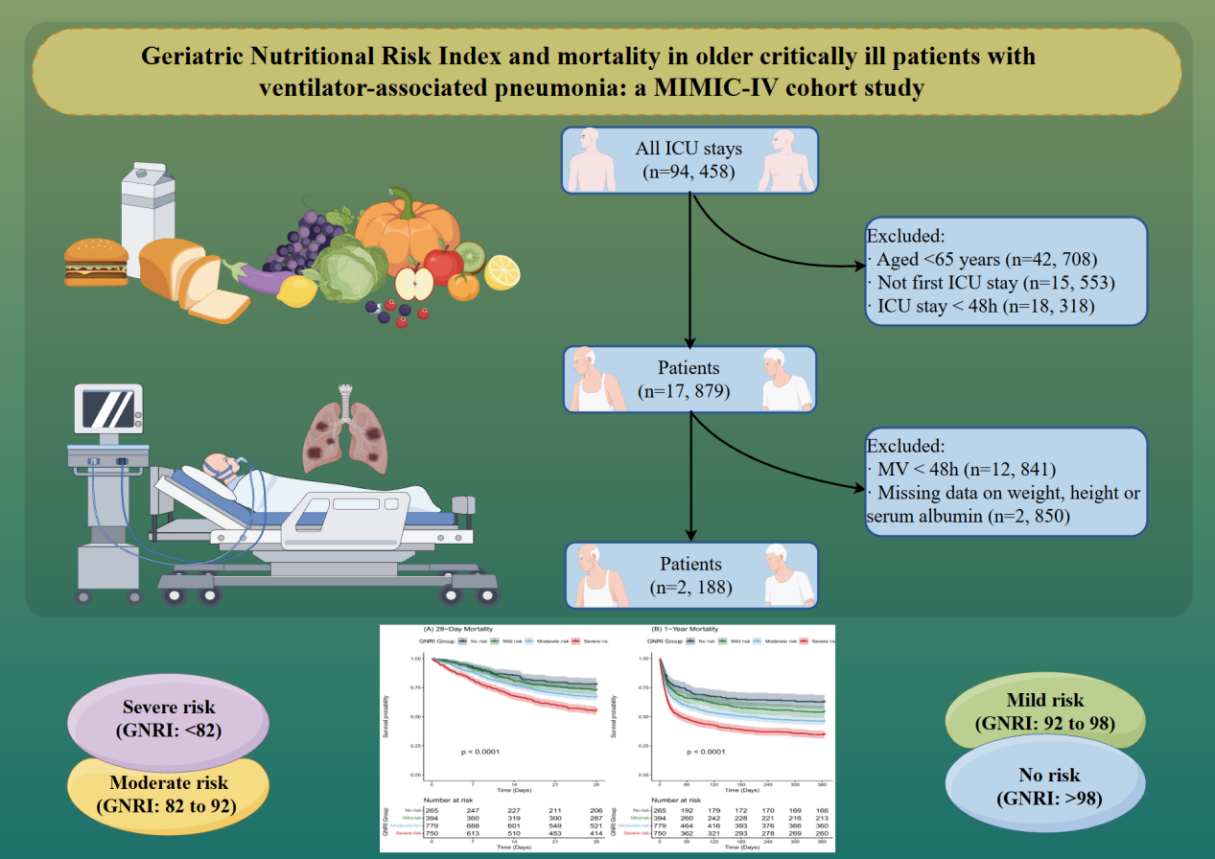
Figure S1 Study population selection flowchart.

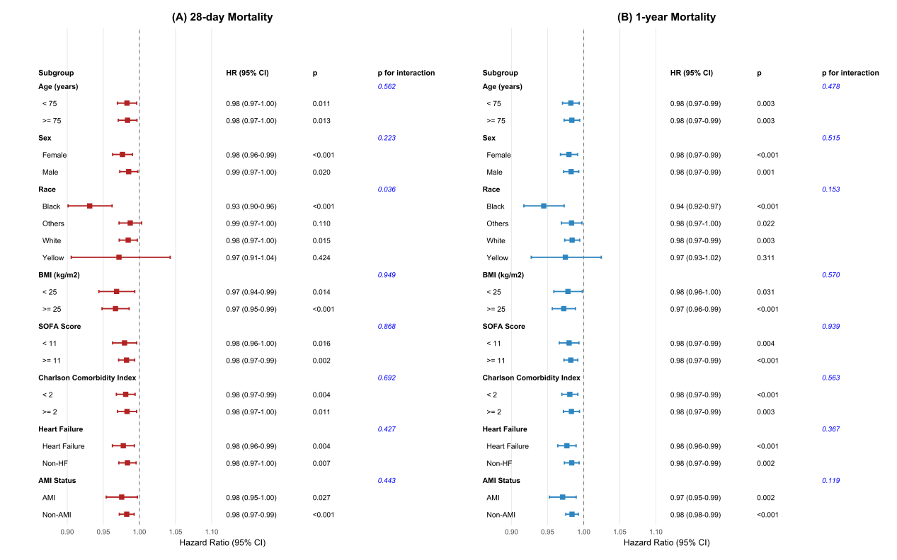
Figure S2 Subgroup analyses of the association between GNRI and mortality in older ICU patients with ventilator-associated pneumonia.

Table S1 Incremental prognostic value of adding GNRI to a base model for 28-day and 1-year mortality.
Outcome | Base C-index | +GNRI C-index | ΔC-index  (bootstrap 95%CI) | LR χ²(df) | P (LRT) | P  (ΔC bootstrap)
28-day mortality | 0.561 | 0.584 | 0.023 (0.009–0.048) | 18.77 (1) | 1.47e−05 | 0.001
1-year mortality | 0.557 | 0.582 | 0.025 (0.010–0.044) | 24.64 (1) | 6.92e−07 | <0.001
Base model included age and SOFA group; the augmented model additionally included GNRI. ΔC-index and its 95% CI were estimated using bootstrap resampling (N=4 resamples). P value for ΔC-index was derived from the bootstrap distribution. Nested models were compared using the LRT. Abbreviations: C-index, Harrell’s concordance index; LRT, likelihood ratio test; CI, confidence interval.

