Supplementary Materials

Supplementary Table S1. Univariate Analysis of Candidate Features Associated with SA-AKI
Feature | Coefficient | p-value
Age | 0.012 | 0.089
Gender (Female) | -0.125 | 0.342
BMI | 0.021 | 0.076
Tumor TNM stage (III-IV vs. I-II) | 0.458 | 0.031
Diabetes | 0.287 | 0.063
Hypertension | 0.198 | 0.125
Chronic liver disease | 0.215 | 0.098
Chronic kidney disease | 0.326 | 0.047
Cardiovascular disease | 0.203 | 0.105
Number of comorbidities | 0.187 | 0.082
APACHE II score | 0.095 | <0.001
SOFA score | 0.087 | <0.001
Mechanical ventilation | 0.542 | 0.023
NK cell activity | -0.042 | <0.001
TCR clonality | -0.876 | <0.001
CRP | 0.015 | <0.001
IFN-γ expression in NK cells | -0.002 | <0.001
Serum creatinine | 0.003 | 0.012
BUN | 0.056 | 0.008
Lactate | 0.218 | 0.003
WBC | 0.032 | 0.067
Neutrophil ratio | 0.011 | 0.091
Platelet | -0.001 | 0.214
Albumin | -0.058 | 0.078
ESR | 0.009 | 0.052
IgA | 0.102 | 0.136
IgG | 0.035 | 0.089
IgM | 0.157 | 0.093

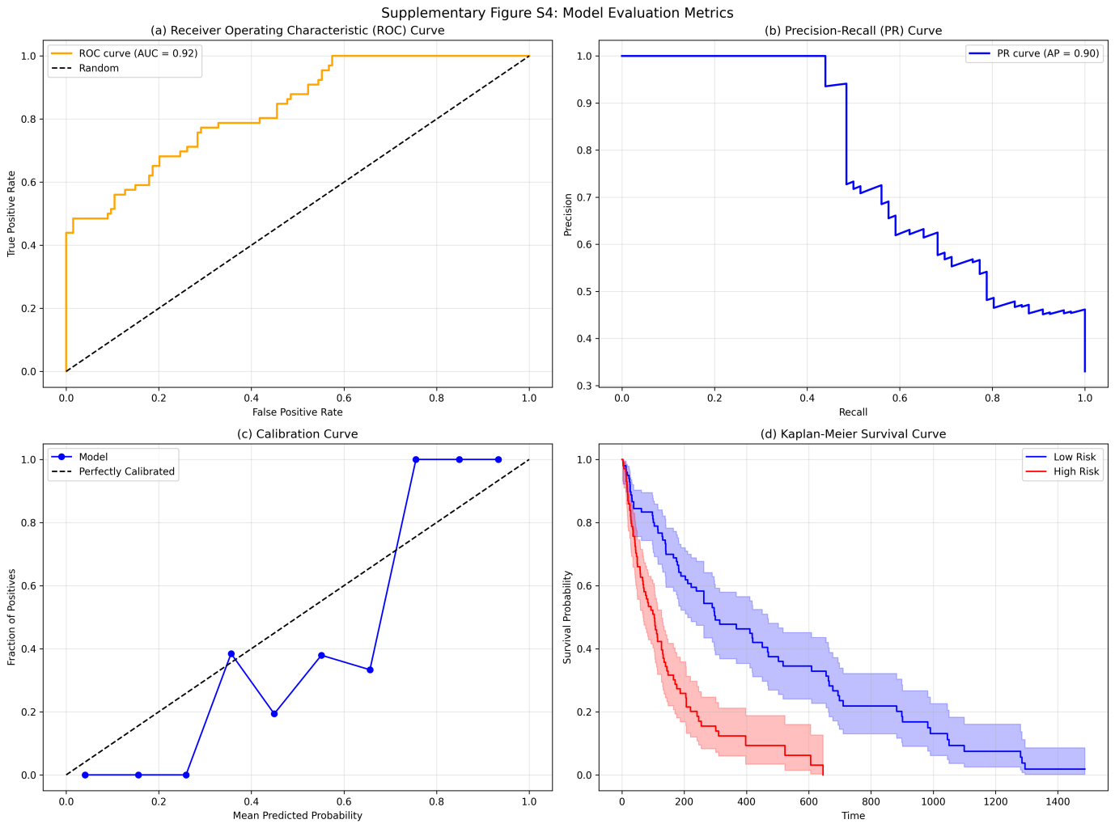

Supplementary Figure S1. Performance of the XGBoost Model in the Internal Validation Set
- ROC curve of the XGBoost model (AUC=0.923, 95% CI: 0.887-0.959). (B) Precision-recall curve of the XGBoost model (AUPRC=0.905, 95% CI: 0.862-0.948). (C) Calibration curve of the XGBoost model (10 bins). (D) Decision curve analysis (DCA) of the XGBoost model.
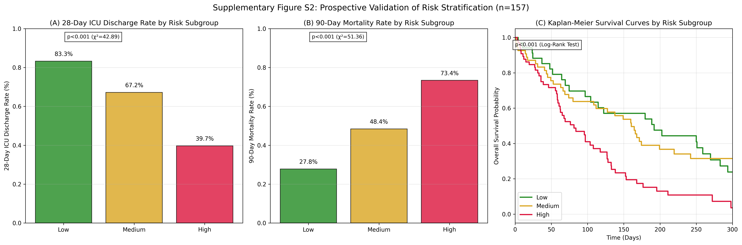

Supplementary Figure S2. Prospective Validation of Risk Stratification
- 28-day ICU discharge rate by risk subgroup in the prospective cohort (83.3% vs. 67.2% vs. 39.7%, p<0.001). (B) 90-day mortality rate by risk subgroup in the prospective cohort (27.8% vs. 48.4% vs. 73.4%, p<0.001). (C) Kaplan-Meier survival curves by risk subgroup in theprospective cohort (log-rank test, p<0.001).
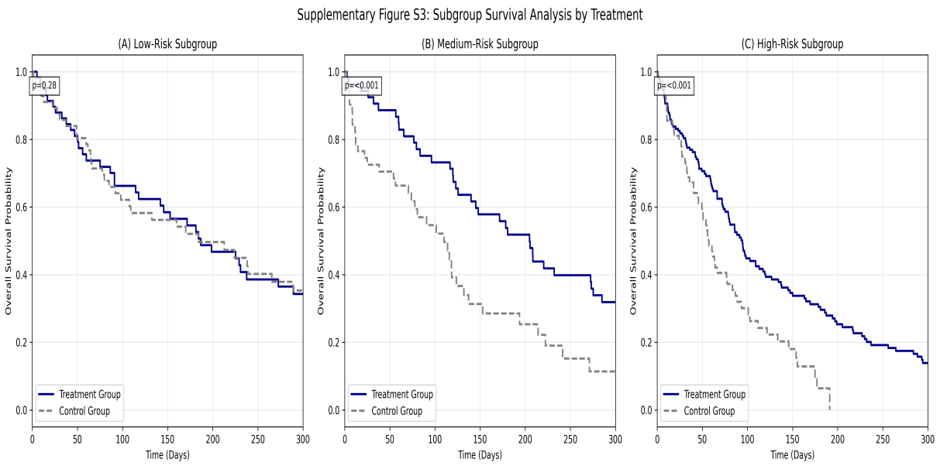

Supplementary Figure S3. Subgroup Survival Analysis by Treatment
(A) Kaplan-Meier survival curves for low-risk patients (treatment vs. control, p=0.28). (B) Kaplan-Meier survival curves for medium-risk patients (treatment vs. control, p<0.001). (C) Kaplan-Meier survival curves for high-risk patients (treatment vs. control, p<0.001).

Supplementary Methods: Detailed Experimental Procedures for TCR Sequencing and NK Cell scRNA-seq

TCR Sequencing
- RNA Extraction: Total RNA was extracted from PBMCs using the RNeasy Mini Kit (Qiagen, Germany) according to the manufacturer’s instructions. RNA quality was assessed using the Agilent 2100 Bioanalyzer (Agilent Technologies, USA), with an RNA Integrity Number (RIN) ≥7.0 required for further analysis.
- cDNA Amplification: The TCR β-chain variable (V), diversity (D), and joining (J) regions were amplified using nested PCR. The first round of PCR used forward primers targeting the Vβ region and reverse primers targeting the Cβ region. The second round of PCR added Illumina adapter sequences and sample barcodes.
- Library Construction: PCR products were purified using the AMPure XP Beads (Beckman Coulter, USA) and quantified using the Qubit 3.0 Fluorometer (Thermo Fisher Scientific, USA). Libraries were normalized to 4 nM and pooled for sequencing on the Illumina NovaSeq 6000 platform with 150 bp paired-end reads.
- Data Analysis: Raw sequencing data were processed using MiXCR software (version 4.0). Sequences were trimmed to remove adapter sequences and low-quality reads (Phred score <20). TCR clonality was calculated as the sum of the squares of the frequencies of each unique TCR clone. Expanded clones were defined as clones with a frequency ≥0.01.

NK Cell scRNA-seq
- NK Cell Isolation: PBMCs were isolated from peripheral blood using Ficoll-Paque Plus (GE Healthcare, USA). NK cells were sorted using the CD56+CD3- magnetic bead separation kit (Miltenyi Biotec, Germany) according to the manufacturer’s instructions. The purity of sorted NK cells was ≥95% as confirmed by flow cytometry.
- Single-Cell Library Construction: Single-cell suspensions were adjusted to a concentration of 1000 cells/μL. Libraries were constructed using the Single Cell 3’ Reagent Kit v3 (10x Genomics, USA) according to the manufacturer’s protocol. Briefly, cells were partitioned into droplets using the 10x Genomics Chromium Controller, followed by reverse transcription to generate cDNA. cDNA was amplified, fragmented, and ligated with Illumina adapters and sample barcodes.
- Sequencing: Libraries were quantified using the Qubit 3.0 Fluorometer and the Agilent 2100 Bioanalyzer. Sequencing was performed on the Illumina NovaSeq 6000 platform with 150 bp paired-end reads. A minimum of 50,000 reads per cell was targeted.
- Data Analysis: Raw sequencing data were processed using Cell Ranger software (version 6.0, 10x Genomics) to generate gene-cell matrices. Seurat software (version 4.0) was used for downstream analysis. Cells with <200 detected genes, >20% mitochondrial reads, or >5000 detected genes were filtered out. Data were normalized using the LogNormalize method, and variable features were identified using the FindVariableFeatures function. Principal component analysis (PCA) was performed on variable features, and cells were clusteredusing the FindClusters function with a resolution of 0.6. Differential gene expression analysis was performed using the FindMarkers function to identify marker genes for each cluster. NK cell subgroups were defined based on the expression of marker genes: functional (IFN-γ+GZMB+), exhausted (PD-1+), and naive (low expression of functional and exhausted markers).

Supplementary Methods: NK Cell Expansion and TCR-T Cell Engineering

NK Cell Expansion
- PBMC Isolation: Peripheral blood (50 mL) was collected from patients, and PBMCs were isolated using Ficoll-Paque Plus (GE Healthcare, USA).
- NK Cell Enrichment: NK cells were enriched using the CD56+CD3- magnetic bead separation kit (Miltenyi Biotec, Germany) to a purity of ≥90%.
- In Vitro Expansion: Enriched NK cells were cultured in RPMI 1640 medium supplemented with 10% fetal bovine serum (FBS), 1% penicillin-streptomycin, IL-2 (1000 IU/mL), and IL-15 (50 ng/mL) (PeproTech, USA) at 37°C with 5% CO2. Medium was refreshed every 2-3 days, and cells were passaged when the density reached 1×10^6 cells/mL. After 14 days of culture, NK cell number and viability were assessed using trypan blue staining. The viability of expanded NK cells was ≥90%.
- Functional Validation: The cytotoxicity of expanded NK cells was assessed using the CytoTox 96 Non-Radioactive Cytotoxicity Assay (Promega, USA) against K562 cells at effector-to-target ratios of 10:1, 5:1, and 2.5:1. The cytotoxicity of expanded NK cells was ≥70% at an effector-to-target ratio of 10:1.

TCR-T Cell Engineering
- TCR Clone Identification: Tumor-specific TCR clones were identified from TCR sequencing data of responders. Clones with high frequency and correlation with clinical response were selected for TCR-T cell engineering.
- TCR Gene Cloning: TCR α and β chain genes were amplified from cDNA of PBMCs using specific primers. The amplified genes were cloned into the pCDH lentiviral vector (System Biosciences, USA) containing a CD8α leader sequence and a 2A peptide linker.
- Lentivirus Production: HEK293T cells were cotransfected with the pCDH-TCR vector, psPAX2, and pMD2.G using Lipofectamine 3000 (Thermo Fisher Scientific, USA). Supernatants containing lentivirus were collected 48-72 hours after transfection, filtered through a 0.45 μm filter, and concentrated using ultracentrifugation. Lentiviral titer was determined using the Lenti-X GoStix Plus (Takara Bio, USA).
- T Cell Transduction: PBMCs were activated with anti-CD3/CD28 beads (Thermo Fisher Scientific, USA) in RPMI 1640 medium supplemented with 10% FBS and IL-2 (500 IU/mL) for 48 hours. Activated T cells were transduced with lentivirus at a multiplicity of infection (MOI) of 5. Transduced T cells were cultured for an additional 7 days, with medium refreshed every 2-3 days.
- Functional Validation: The expression of the transduced TCR was confirmed by flow cytometry using TCR Vβ-specific antibodies. The cytotoxicity of TCR-T cells was assessed against pancreatic cancer cell lines (PANC-1, MiaPaCa-2) at effector-to-target ratios of 10:1, 5:1, and 2.5:1 using the CytoTox 96 Non-Radioactive Cytotoxicity Assay. The cytotoxicity of TCR-T cells was ≥60% at an effector-to-target ratio of 10:1.

