Table S1. Validation of ERA5-Land reanalysis data against Meteorological station observations
Station | Variable | Bias | RMSE | R | NSE | Station |  | Variable | Bias | RMSE | R | NSE
Al-Ahsa | Precipitation | -1.02 | 8.42 | 0.79 | 0.61 |  | Wadi Al-Dawasser | Precipitation | -0.34 | 5.83 | 0.61 | 0.35
Al-Ahsa | Tmin | -1.67 | 1.80 | 1.00 | 0.94 |  | Wadi Al-Dawasser | Tmin | -0.85 | 1.08 | 1.00 | 0.97
Al-Ahsa | Tmax | -1.75 | 1.80 | 1.00 | 0.96 |  | Wadi Al-Dawasser | Tmax | -1.52 | 1.58 | 1.00 | 0.95
Al-Olaa | Precipitation | -3.74 | 9.08 | 0.85 | 0.33 |  | Al-Baha | Precipitation | 1.11 | 16.84 | 0.62 | 0.28
Al-Olaa | Tmin | -4.53 | 4.59 | 0.99 | 0.57 |  | Al-Baha | Tmin | -1.49 | 1.63 | 0.99 | 0.89
Al-Olaa | Tmax | -2.12 | 2.14 | 1.00 | 0.92 |  | Al-Baha | Tmax | -0.75 | 0.90 | 0.99 | 0.96
Hafr Al-Batin | Precipitation | 0.02 | 9.78 | 0.83 | 0.70 |  | Bisha | Precipitation | -2.41 | 11.17 | 0.71 | 0.44
Hafr Al-Batin | Tmin | -0.42 | 0.83 | 1.00 | 0.99 |  | Bisha | Tmin | -0.95 | 1.34 | 0.99 | 0.95
Hafr Al-Batin | Tmax | -1.07 | 1.26 | 1.00 | 0.98 |  | Bisha | Tmax | -1.58 | 1.70 | 0.99 | 0.88
KFIA | Precipitation | -0.73 | 9.35 | 0.83 | 0.68 |  | Gizan | Precipitation | -2.10 | 22.67 | 0.76 | 0.56
KFIA | Tmin | -0.16 | 0.62 | 1.00 | 0.99 |  | Gizan | Tmin | 0.49 | 0.99 | 0.96 | 0.89
KFIA | Tmax | -1.09 | 1.20 | 1.00 | 0.98 |  | Gizan | Tmax | -2.70 | 2.75 | 0.98 | 0.07
Madinah | Precipitation | -1.69 | 8.71 | 0.71 | 0.48 |  | Khamis Mushait | Precipitation | 12.61 | 25.03 | 0.71 | 0.10
Madinah | Tmin | -3.49 | 3.60 | 0.99 | 0.71 |  | Khamis Mushait | Tmin | 0.58 | 0.98 | 0.98 | 0.93
Madinah | Tmax | -1.15 | 1.27 | 1.00 | 0.97 |  | Khamis Mushait | Tmax | -1.49 | 1.74 | 0.97 | 0.79
Qaisumah | Precipitation | 0.16 | 8.74 | 0.88 | 0.77 |  | Najran | Precipitation | -3.98 | 12.88 | 0.77 | 0.35
Qaisumah | Tmin | -1.30 | 1.43 | 1.00 | 0.97 |  | Najran | Tmin | -1.77 | 2.02 | 0.99 | 0.88
Qaisumah | Tmax | -1.68 | 1.75 | 1.00 | 0.97 |  | Najran | Tmax | -2.49 | 2.55 | 0.99 | 0.75
Arafat | Precipitation | -2.90 | 15.30 | 0.53 | 0.25 |  | Sharorah | Precipitation | -3.93 | 13.13 | 0.48 | 0.08
Arafat | Tmin | -1.15 | 1.40 | 0.99 | 0.89 |  | Sharorah | Tmin | -1.41 | 1.65 | 0.99 | 0.92
Arafat | Tmax | -3.31 | 3.36 | 0.99 | 0.53 |  | Sharorah | Tmax | -2.37 | 2.43 | 1.00 | 0.82
Dawadami | Precipitation | -0.65 | 8.01 | 0.92 | 0.85 |  | Al-Jouf | Precipitation | -0.86 | 5.62 | 0.89 | 0.78
Dawadami | Tmin | -0.82 | 0.93 | 1.00 | 0.98 |  | Al-Jouf | Tmin | -2.21 | 2.33 | 1.00 | 0.91
Dawadami | Tmax | -1.40 | 1.45 | 1.00 | 0.96 |  | Al-Jouf | Tmax | -1.54 | 1.62 | 1.00 | 0.97
Gassim | Precipitation | -2.16 | 13.04 | 0.77 | 0.58 |  | Arar | Precipitation | 0.20 | 8.00 | 0.77 | 0.59
Gassim | Tmin | -1.10 | 1.31 | 1.00 | 0.97 |  | Arar | Tmin | -1.28 | 1.42 | 1.00 | 0.97
Gassim | Tmax | -1.55 | 1.73 | 1.00 | 0.96 |  | Arar | Tmax | -2.04 | 2.21 | 1.00 | 0.95
Hail | Precipitation | 0.97 | 8.42 | 0.76 | 0.45 |  | Guriat | Precipitation | -0.02 | 6.43 | 0.65 | 0.41
Hail | Tmin | -0.17 | 0.98 | 0.99 | 0.98 |  | Guriat | Tmin | 0.40 | 0.71 | 1.00 | 0.99
Hail | Tmax | -1.18 | 1.24 | 1.00 | 0.98 |  | Guriat | Tmax | -1.72 | 1.78 | 1.00 | 0.96
Jeddah KAIA | Precipitation | 1.18 | 10.36 | 0.66 | 0.36 |  | Rafha | Precipitation | 0.99 | 7.96 | 0.77 | 0.50
Jeddah KAIA | Tmin | -1.07 | 1.59 | 0.95 | 0.81 |  | Rafha | Tmin | -0.52 | 1.16 | 0.99 | 0.98
Jeddah KAIA | Tmax | -1.58 | 1.78 | 0.98 | 0.77 |  | Rafha | Tmax | -1.63 | 1.80 | 1.00 | 0.96
Makkah | Precipitation | 2.49 | 16.93 | 0.58 | 0.07 |  | Tabuk | Precipitation | -0.79 | 5.79 | 0.67 | 0.38
Makkah | Tmin | -3.36 | 3.44 | 0.99 | 0.28 |  | Tabuk | Tmin | -2.43 | 2.62 | 1.00 | 0.87
Makkah | Tmax | -2.73 | 2.83 | 0.99 | 0.63 |  | Tabuk | Tmax | -1.13 | 1.18 | 1.00 | 0.98
Riyadh | Precipitation | -1.13 | 8.20 | 0.82 | 0.66 |  | Turaif | Precipitation | 0.41 | 6.32 | 0.80 | 0.61
Riyadh | Tmin | -1.02 | 1.27 | 0.99 | 0.97 |  | Turaif | Tmin | -0.40 | 0.63 | 1.00 | 0.99
Riyadh | Tmax | -1.38 | 1.51 | 1.00 | 0.97 |  | Turaif | Tmax | -0.91 | 1.00 | 1.00 | 0.99
Taif | Precipitation | 0.31 | 15.30 | 0.70 | 0.48 | Wejh |  | Precipitation | 0.36 | 6.70 | 0.71 | 0.43
Taif | Tmin | -0.18 | 1.08 | 0.98 | 0.96 |  |  | Tmin | 0.36 | 0.60 | 0.99 | 0.98
Taif | Tmax | -1.41 | 1.49 | 1.00 | 0.90 |  |  | Tmax | -0.65 | 1.24 | 0.98 | 0.88

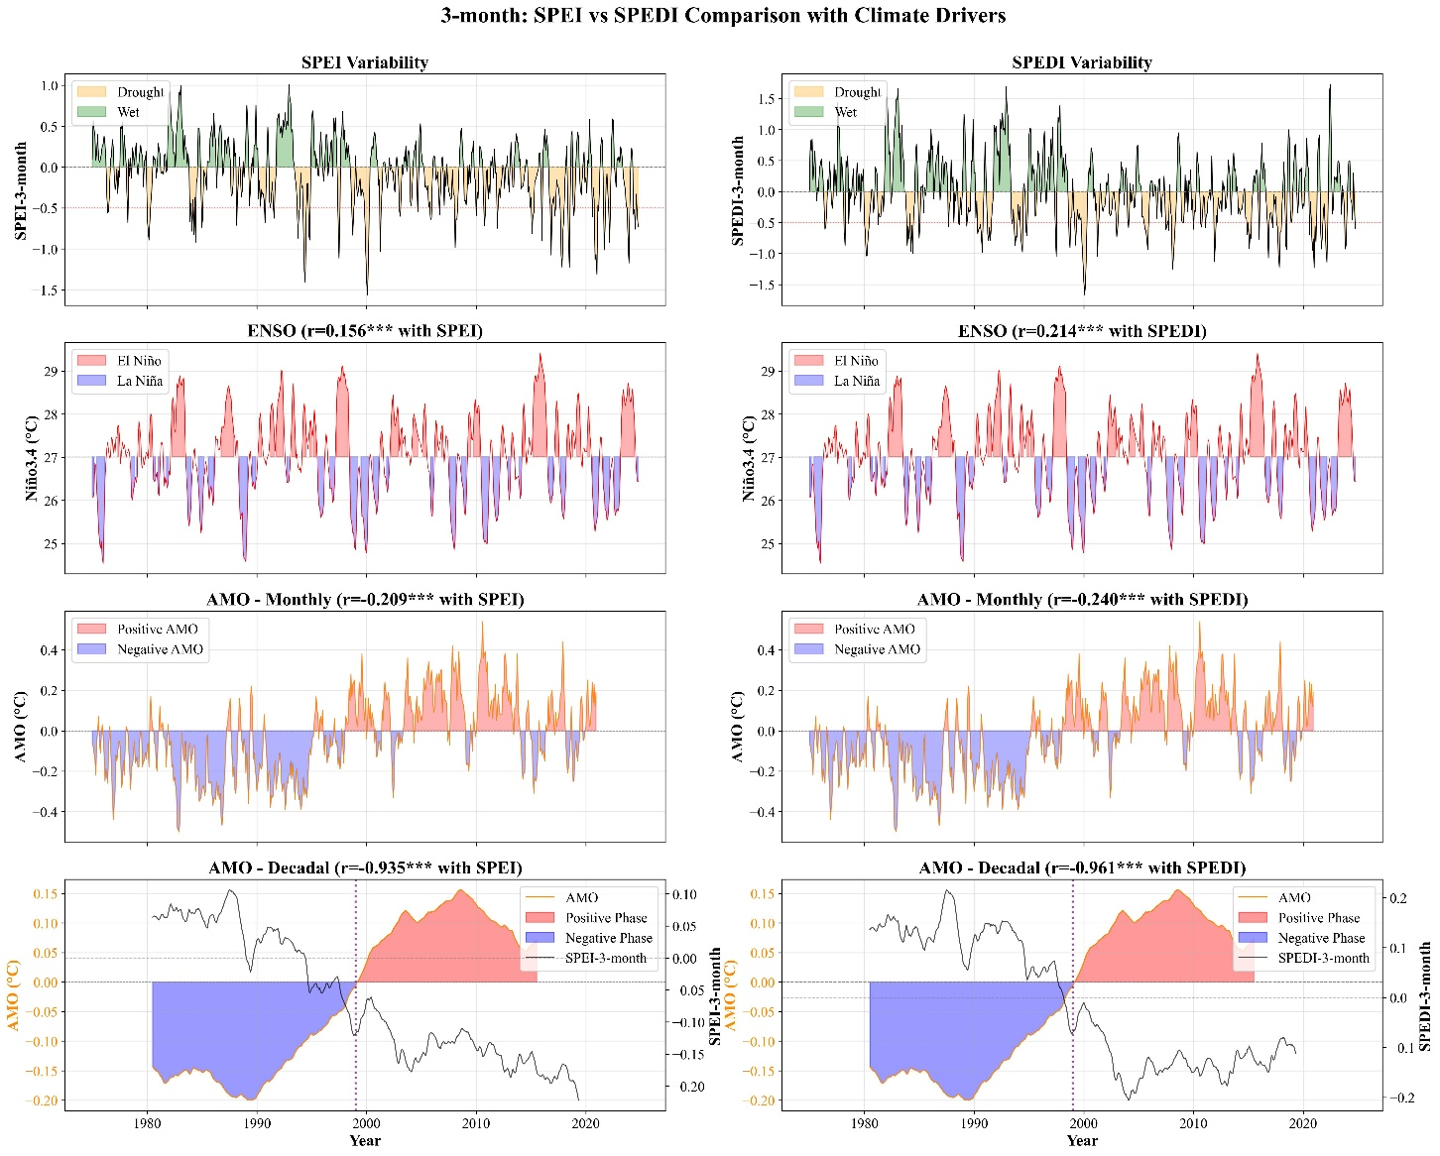
Figure S1. Comparison of 3-month SPEI and SPEDI variability with ENSO (Niño3.4 SST anomalies) and both monthly and decadal phases of the AMO over the Arabian Peninsula

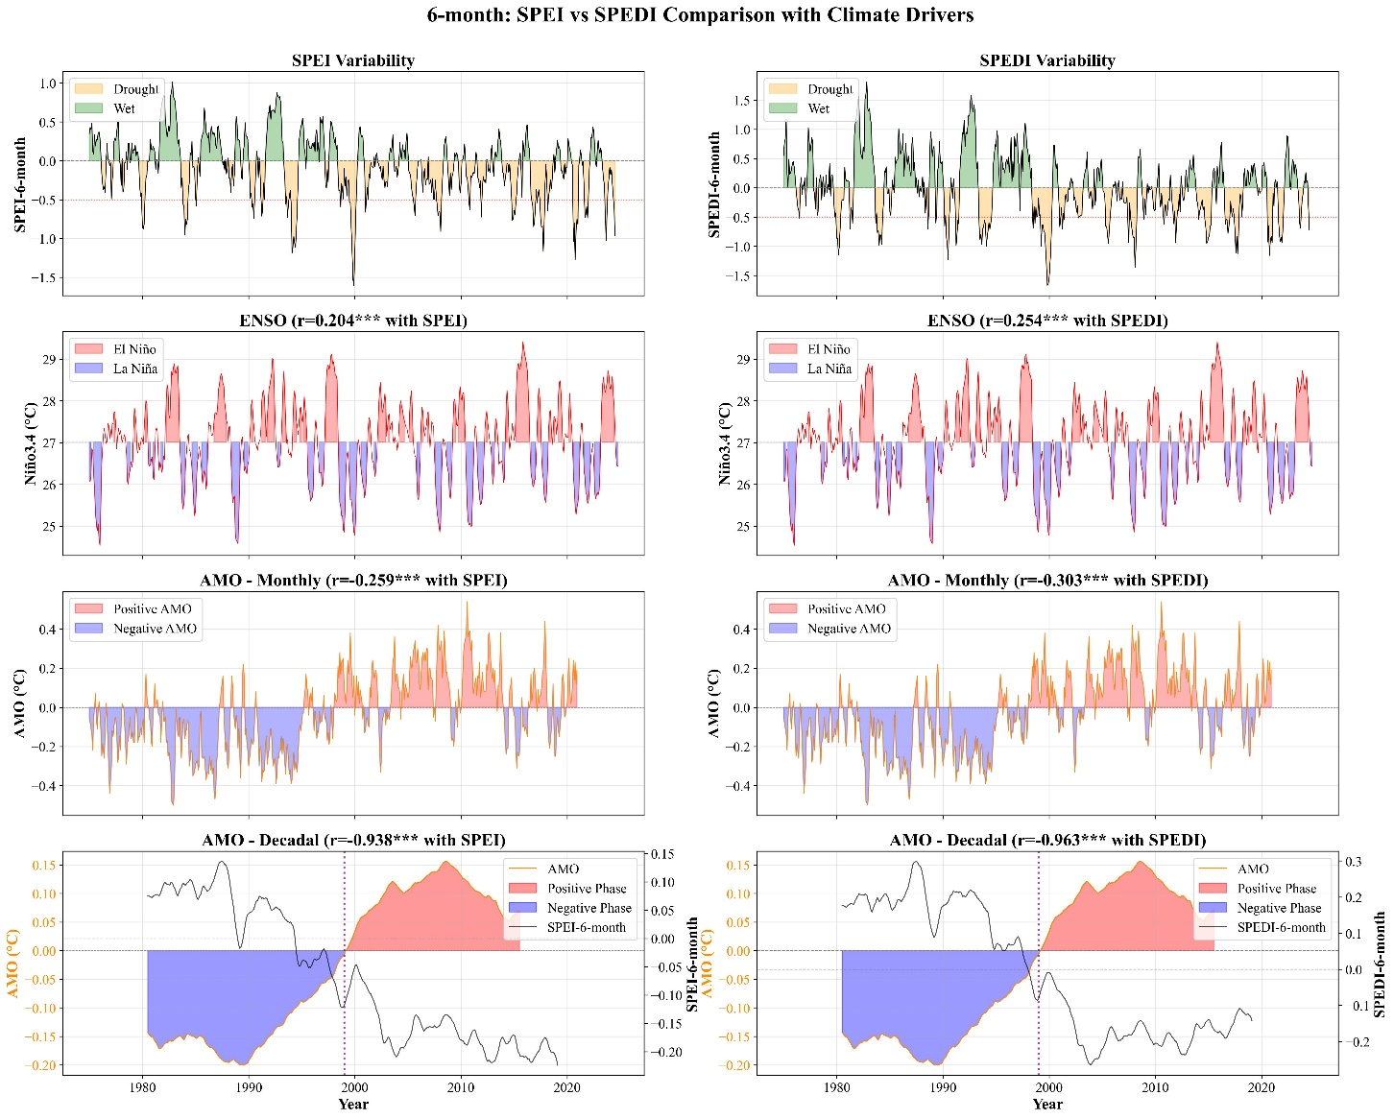
Figure S2. Comparison of 6-month SPEI and SPEDI variability with ENSO (Niño3.4 SST anomalies) and both monthly and decadal phases of the AMO over the Arabian Peninsula

