Supplementary Information
An intelligent E-skin with spatiotemporal vibrotactile cues enable personalized gait rehabilitation in Parkinson's disease
Authors: Tiefeng Cheng^{a,c#}, Ying Kong^{b#}, Ke Wu^{a#}, Ziyang Liang^{a,d#}, Bo Yang^{c}, Jiantao Li^{e}, Tianshi Liuª, Chongxue Chenª, Haofan Yangª, Baogeng Pan^{a,f}, Jia Cheng^{c*}, Fuhao MO^{a*}
Affiliations:
ª Intelligent Diagnostics and Therapeutic Equipment Innovation Center, College of Mechanical and Vehicle Engineering, Hunan University, Changsha, Hunan 410082
^{b} Department of Rehabilitation, The Second Xiangya Hospital, Central South University, Changsha 410000, China
^{c} State Key Laboratory of Tribology in Advanced Equipment, Department of Mechanical Engineering, Tsinghua University, Beijing 100084, China
^{d} Department of Tuina and Spinal Orthopaedics in Chinese Medicine, The Fourth Clinical Medical College of Guangzhou University of Chinese Medicine, Shenzhen 518033, China
^{e} Department of Orthopedics, The Fourth Medical Center of Chinese PLA General Hospital, Beijing, China; National Clinical Research Center for Orthopedics, Sports Medicine and Rehabilitation, Beijing 100048, China
^{f} Department of Advanced Manufacturing and Robotics, College of Engineering, Peking University, Beijing, 100871, China

#These authors contributed equally to this work.
*Corresponding authors.
Email address:
chengjia@tsinghua.edu.cn (J Cheng), fuhaomo@hnu.edu.cn (F MO)

Table of contents
Supplementary Note 1. Circuit design of the flexible spatiotemporal vibration patch 2
Supplementary Note 2. Fabrication and encapsulation process 6
Supplementary Note 3. Reference-free quality scoring framework for orientation filters 8
Supplementary Note 4. Dynamic time-warping–based similarity analysis 12
Supplementary Note 5. Gait analysis and computational methods 14
Supplementary Note 6. Joint-angle analysis and computational methods 17
Supplementary Note 7. EMG analysis and computational methods 20
Supplementary Table 1. Clinical characteristics of the patients 23

Supplementary Note 1. Circuit design of the flexible spatiotemporal vibration patch
Overall architecture
Supplementary Fig. 1a shows the complete schematic of the control board used in the flexible spatiotemporal vibration patch, and Supplementary Fig. 1b presents the corresponding 3D rendering of the PCB implemented in JLCEDA. The hardware follows the block diagram described in the main text, and can be divided into four tightly integrated modules: (i) an MCU-centered sensing and communication core, (ii) a power management module (PMM) for battery charging and voltage regulation, (iii) low-side drivers for the four vibration motors (VIB1–VIB4), and (iv) auxiliary circuits including the inertial measurement unit (IMU), an RGB status indicator, and an ADC channel for battery monitoring. All components are powered from a single-cell Li-ion battery and operate at a nominal 3.3 V logic rail.

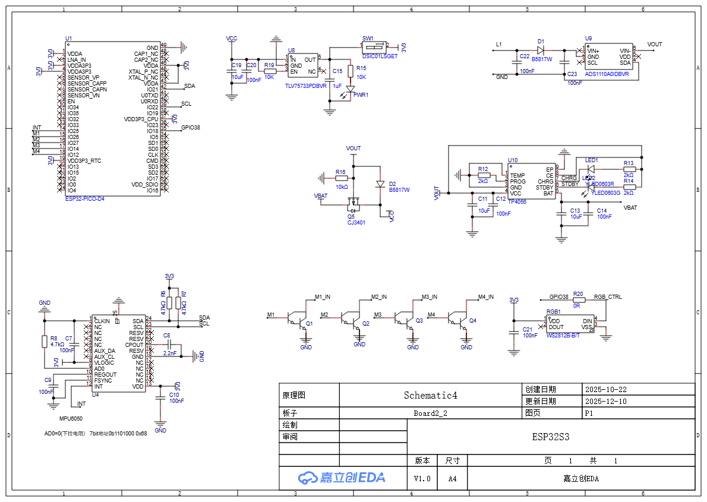
Supplementary Fig. 1a Circuit schematic of the flexible spatiotemporal vibration patch.
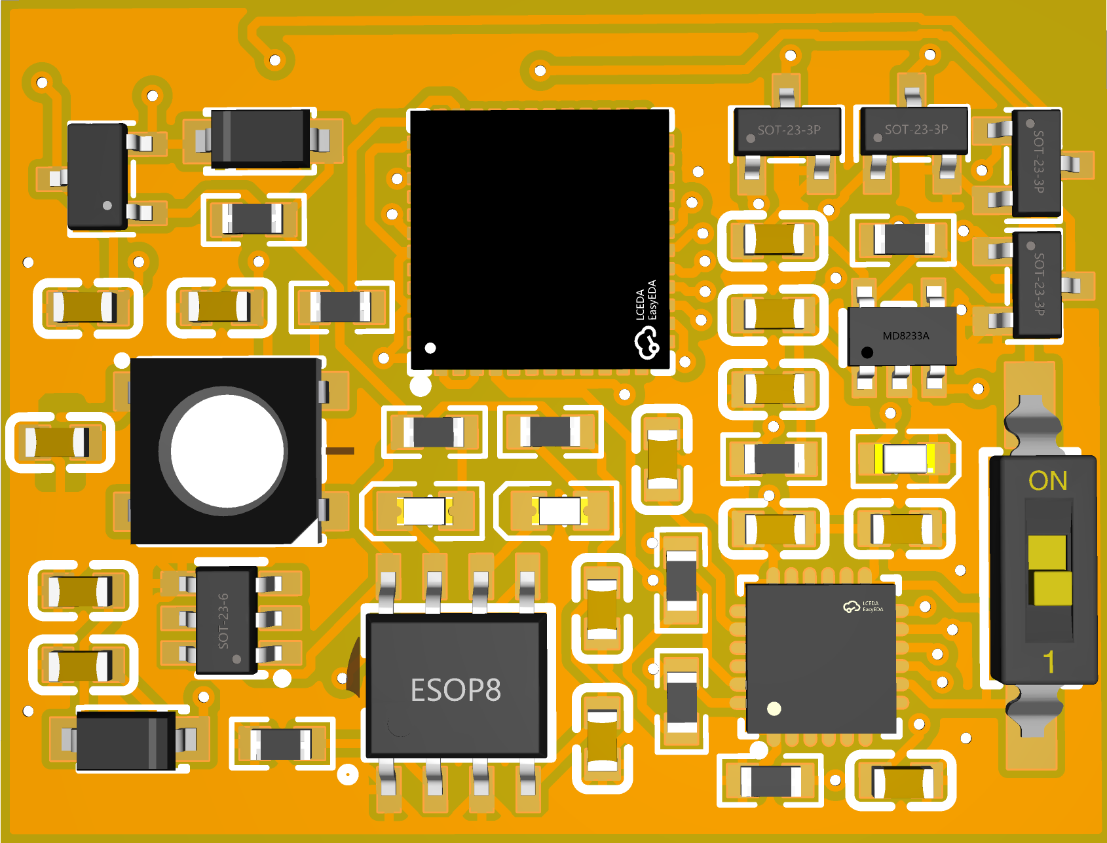
Supplementary Fig. 1b JLCEDA 3D rendering of the compact PCB implementation of the control board
MCU and sensor interface
At the heart of the board (U1 in Supplementary Fig. 1a) is an ESP32-PICO-D4 system-in-package, which integrates a dual-core 32-bit MCU, embedded flash, and Bluetooth Low Energy (BLE) communication. This device executes the Gait Phase Adaptive algorithm, maintains the personalized gait database, and handles wireless communication with the smartphone app. All high-speed digital signals are confined to the interior of the board to minimize loop area and electromagnetic interference.
The IMU (U4, MPU6050) is connected to the MCU through a shared I²C bus (SDA/SCL). Decoupling capacitors and pull-up resistors on the I²C lines ensure signal integrity and stable operation under motion. The INT pin of the MPU6050 is routed to a dedicated GPIO of the ESP32, allowing the MCU to wake up or timestamp new samples with low latency when configured in interrupt-driven mode. This configuration matches the signal-flow diagram in the main text: raw tri-axial acceleration and angular velocity are sampled by the IMU, transmitted to the MCU over I²C, and then processed by the on-board Gait Phase Adaptive algorithm to reconstruct thigh motion angle in real time.
An additional I²C-compatible 16-bit ADC (U9, ADS1110) is used to monitor the battery voltage and other analog nodes if required. The ADC shares the same SDA/SCL bus as the IMU, enabling flexible expansion of analog sensing channels without increasing the number of MCU pins. This configuration allows the patch to log battery status, implement protection thresholds, or support future expansion to additional sensors.
Power management module (PMM)
The PMM is responsible for energy harvesting/charging, battery protection, and regulated supply generation. The system is powered by a single-cell Li-ion battery connected to the VBAT node. Charging is implemented by a linear Li-ion charger (U10, TP4056), whose PROG resistor (R12) sets the charging current. Status pins (CHRG and STDBY) drive LED1 through resistors R13 and R14, providing visual indication of charging and full-charge states. Input and output capacitors (C11–C14) stabilize the charging loop and reduce ripple.
VBAT is connected to the main system rail VOUT through a P-channel MOSFET (Q5, CJ3401) configured as an ideal-diode / reverse-blocking element, together with a Schottky diode (D2, B5817W) for surge and reverse-polarity protection. This arrangement prevents reverse current from the system into the battery when external power is removed and isolates the battery during charging.
From VOUT, a low-dropout regulator (U8, TLV75733) generates the 3.3 V digital rail (3V3) used by the MCU, IMU, ADC and digital peripherals. A slide switch SW1 on the 3.3 V line acts as the user-accessible power switch, allowing the entire logic domain to be disconnected while keeping the battery and charging circuit intact. Multiple ceramic capacitors (C19–C23 and C15) are placed close to the regulator input and output pins to reduce high-frequency noise and ensure stable operation under pulsed motor loads.
Vibration motor driver and RGB indicator
The four vibration channels VIB1–VIB4 are implemented using discrete low-side switches (Q1–Q4) driven by MCU GPIOs (M1_IN–M4_IN). Each transistor is biased through a suitable base/gate resistor to limit drive current, and the emitters/sources are tied to the global ground plane. In the final patch, each VIB output is connected to a coin-type or cylindrical eccentric-rotating-mass vibration motor embedded in the PDMS layer. By driving these transistors with PWM, the MCU can modulate both the amplitude and timing of each channel independently, enabling the spatiotemporal vibration patterns used in the rehabilitation protocol.
An addressable RGB LED (RGB1, WS2812B) is added as a compact visual indicator of device state. The data input is connected to a single MCU pin (GPIO38, RGB_CTRL) through a series resistor (R20), and the LED is powered directly from the 3.3 V rail with local decoupling capacitor C21. The RGB LED is used to display pairing status, battery level or stimulation mode without increasing the footprint or adding multiple discrete LEDs.
PCB implementation and mechanical layout
Supplementary Fig. 1b illustrates the 3D rendering of the assembled board generated in JLCEDA. The layout is optimized for compactness and mechanical compatibility with the 48 mm × 38 mm flexible patch. The ESP32 system-in-package is placed near the center of the board to minimize trace length to the IMU and drivers, and to distribute mass uniformly so that bending does not introduce excessive mechanical strain on the solder joints. The IMU package is located close to the geometric center of the board (bottom-left in the rendering), which reduces rotational artifacts and ensures that the measured acceleration and angular velocity approximate the motion of the thigh segment rather than local board vibrations.
The PMM (charger and regulator, including the ESOP-8 package in the lower middle region) is concentrated along the lower edge of the PCB, where copper pours and via stitching are used to enhance thermal dissipation during battery charging. High-current paths between battery connector, charging IC, and regulator are kept short and wide to reduce resistive losses and voltage drop. The slide switch is located at the right edge of the board, allowing convenient tactile access even after encapsulation in the PDMS layer.
On the right-hand side of the PCB, a row of SOT-23-3 packages houses the discrete transistor drivers for the vibration motors, together with their associated diodes and resistors. Grouping these devices reduces crosstalk between the motor lines and simplifies routing of the motor harness toward the periphery of the patch. The RGB LED is placed close to the board edge, ensuring that its light is clearly visible through the semi-transparent PDMS.
All components are arranged on a single copper layer with short interconnects and generous ground fills to enhance signal integrity, reduce electromagnetic interference and support the high-frequency operation of the Bluetooth radio. The compact board is subsequently encapsulated in a soft PDMS substrate with through-holes for the battery and vibration motors, forming the flexible spatiotemporal vibration patch described in the main text.

Supplementary Note 2. Fabrication and encapsulation process
Control circuitry preparation and mold design
First, the ESP32 microcontroller, power-management components, IMU, vibration-motor drivers, and peripheral devices were assembled using hot-air reflow and conventional hand soldering. All modules were tested on the bare PCB and programmed with the final firmware to ensure stable operation.
According to the device dimensions used in the main text (48 mm × 38 mm), we designed a single-cavity encapsulation mold in 3D CAD software and fabricated it by 3D printing. Several small cylindrical pillars with a diameter of approximately 1.0 mm were evenly distributed on the bottom of the mold. During PDMS casting, these pillars generate through-holes in the elastomer, so that the final patch maintains mechanical integrity while providing air and moisture permeability, which is beneficial for long-term skin contact.
Before encapsulation, the populated control board was temporarily fixed at the center of the mold cavity using double-sided tape or a small amount of uncured silicone. This ensures sufficient PDMS thickness between the PCB and the mold walls for mechanical protection.
Preparation and casting of the PDMS substrate
The flexible substrate was made from a commonly used two-component PDMS system, for example Sylgard 184 Silicone Elastomer (Dow Corning, now Dow). Base and curing agent were mixed thoroughly at a mass ratio of 10:1, stirring slowly with a spatula or glass rod to minimize bubble formation. The mixture was then placed in a vacuum desiccator and degassed at approximately −0.09 MPa for 15–30 min until most visible bubbles had been removed.
The degassed PDMS prepolymer was slowly poured into the 3D-printed mold until the control board and the bottom micro-pillars were completely covered, taking care to avoid trapping air at sharp component edges. To further eliminate small bubbles introduced during pouring, the mold was briefly subjected to a second vacuum-degassing step until no new bubbles emerged. After degassing, the mold was transferred to a temperature-controlled oven for curing. A conventional laboratory forced-convection oven (e.g., Memmert or Binder) was used, with the temperature set to 60–70 °C and a curing time of about 5 h. These conditions are consistent with typical curing parameters for Sylgard 184 and yield an elastomer with stable mechanical properties and minimal shrinkage.
After curing, the mold was cooled to room temperature and the PDMS-encapsulated assembly was carefully demolded to obtain the PDMS patch with the integrated control board. The top surface of the patch is a flat PDMS layer, while the bottom side locally exposes the regions for the vibration motors and battery pads. The small cylindrical pillars in the mold form a regular array of through-holes in the PDMS, providing a defined pattern of ventilation pores.
Preparation of the polyurethane pressure-sensitive adhesive layer
To achieve reliable and comfortable skin adhesion, a medical-grade PU-PSA laminate was applied to the back side of the PDMS patch. The laminate consists of three layers: a polyurethane film substrate (PU film), a coated pressure-sensitive adhesive (PSA) layer, and a temporary release liner. PU-based medical PSAs are widely used in wound dressings and wearable patches because they combine good conformability and breathability with gentle adhesion to skin.
In brief, medical-grade polyurethane film was cut to a size slightly larger than the back side of the PDMS patch. Depending on the selected PSA system (e.g., a polyurethane- or acrylic-based medical adhesive solution or prepolymer), the adhesive was prepared to the appropriate solids content and viscosity following the manufacturer’s instructions. The PU film was fixed on the chuck of a spin-coating or centrifugal-coating device, and a defined volume of PSA solution was dispensed onto the surface. The film was then spun at several hundred to about one thousand revolutions per minute for 20–60 s, allowing the adhesive to spread under centrifugal force and form a uniform, thickness-controlled coating. By tuning the spin speed and coating time, the adhesive thickness and thus the trade-off between adhesion strength and breathability can be precisely adjusted.
After coating, the adhesive-covered PU film was placed in an oven at 40–60 °C for tens of minutes to drive off residual solvent and partially crosslink the PSA. At this stage the surface remains slightly tacky but does not flow. A silicone-treated release liner (e.g., PET or paper-based) was then laminated onto the adhesive side. The release liner can be easily peeled off later, protecting the PSA from contamination or premature adhesion during storage and handling.
Lamination and final cutting
Once the PU–PSA–liner laminate was prepared, it was flipped so that the adhesive side faced the back side of the PDMS patch. To improve interfacial bonding, the PDMS surface was cleaned with anhydrous ethanol and, if needed, mildly activated by oxygen plasma to increase its surface energy. The laminate was then pressed onto the PDMS using a vacuum laminator or manual roller, applying uniform pressure to ensure intimate contact and to expel any trapped air at the interface. The release liner remained on the outermost surface, protecting the adhesive during storage and transportation.
Finally, the multilayer structure was trimmed to the desired outline, leaving dedicated openings for the battery leads and vibration-motor wiring. This yielded the completed flexible spatiotemporal vibration patch. During use, the user simply peels off the outer release liner and attaches the PU–PSA side to the skin over the thigh. The entire fabrication process ensures that the patch maintains high flexibility and breathability while providing reliable electrical performance and long-term skin adhesion.

Supplementary Note 3. Reference-free quality scoring framework for orientation filters
To quantitatively compare the proposed Gait Phase Adaptive (GPA) filter with existing orientation-estimation methods in a reference-free manner, we designed a multi-metric quality scoring framework. The framework does not require any external ground truth; instead, it evaluates the internal coherence and signal quality of the reconstructed thigh-angle trajectories themselves. This makes it applicable to heterogeneous gait patterns and subject groups, including slow or irregular gait in older adults and patients with Parkinson’s disease.
1. Pre-processing and gait-cycle normalization
For each algorithm $f$, the input is the raw tri-axial accelerometer and gyroscope signals, and the output is a uniaxial flexion–extension angle trajectory ${\hat{θ}}_{f}(t)$. For a given recording $d$, we first detect heel-strike events from the vertical acceleration signal and obtain a sequence of heel-strike times
$$\{t_{h}^{\left(1\right)},t_{h}^{\left(2\right)},…,t_{h}^{\left(N_{d} + 1\right)}\}.$$Very short or very long intervals are discarded to eliminate turns and detection errors. Each valid interval $\left[t_{h}^{\left(c\right)} , t_{h}^{\left(c + 1\right)}\right]$is treated as one gait cycle $c$.
Within each cycle we resample ${\hat{θ}}_{f}(t)$to 101 equally spaced phase points $ϕ_{j}∈[0,1]$, $j=0,…,100$, to obtain the normalized cycle waveform
$${\hat{θ}}_{f}^{\left(c\right)}(ϕ_{j})={\hat{θ}}_{f} \text{,}\left(t_{h}^{\left(c\right)}+ϕ_{j}(t_{h}^{\left(c + 1\right)}-t_{h}^{\left(c\right)})\right).$$For each algorithm $f$and recording $d$, we then compute the cycle-averaged template and its standard deviation
$${\overset{ˉ}{θ}}_{f,d}(ϕ_{j})=\frac{1}{N_{d}}\sum_{c=1}^{N_{d}}{{\hat{θ}}_{f}^{\left(c\right)}}(ϕ_{j}),σ_{f,d}(ϕ_{j})=\sqrt{\frac{1}{N_{d}-1}\sum_{c=1}^{N_{d}}{(}{\hat{θ}}_{f}^{\left(c\right)}(ϕ_{j})-{\overset{ˉ}{θ}}_{f,d}(ϕ_{j}))^{2}}.$$All subsequent quality metrics are derived from ${\hat{θ}}_{f}^{\left(c\right)}(ϕ_{j})$, ${\overset{ˉ}{θ}}_{f,d}(ϕ_{j})$and $σ_{f,d}(ϕ_{j})$.
2. Definition of the five quality metrics
For each algorithm $f$and recording $d$, five complementary quality metrics are computed. In what follows we drop the explicit index $d$for brevity.
(i) Stability
Stability quantifies cycle-to-cycle variability of key discrete gait features. For each cycle $c$, we extract three landmarks from ${\hat{θ}}_{f}^{\left(c\right)}(ϕ)$: peak flexion $Θ_{max}^{⁡}$, peak extension $Θ_{min}^{⁡}$, and mid-stance angle $Θ_{ms}^{\left(c\right)}$. Denote the feature vector
$$x^{\left(c\right)}=\left[\begin{aligned}Θ_{max}^{⁡} \\ Θ_{min}^{⁡} \\ Θ_{ms}^{\left(c\right)}\end{aligned}\right].$$We compute the mean and standard deviation across cycles,
$$\overset{ˉ}{x}=\frac{1}{N}\sum_{c=1}^{N}{x^{\left(c\right)}},σ_{x}=\sqrt{\frac{1}{N-1}\sum_{c=1}^{N}{(}x^{\left(c\right)}-\overset{ˉ}{x})⊙(x^{\left(c\right)}-\overset{ˉ}{x})},$$where $⊙$denotes element-wise multiplication. The (dimensionless) coefficient of variation is
$$CV=\frac{1}{3}\sum_{k=1}^{3}{\frac{σ_{x_{k}}}{∣{\overset{ˉ}{x}}_{k}∣+ϵ}},$$with $ϵ$a small constant to avoid division by zero. The raw stability index is defined as
$$S_{f}^{stab}=1-CV,$$so that lower relative variability corresponds to higher stability.
(ii) Consistency
Consistency assesses how well individual cycles match the average waveform produced by the same filter. For each cycle we compute the Pearson correlation between ${\hat{θ}}_{f}^{\left(c\right)}(ϕ_{j})$and ${\overset{ˉ}{θ}}_{f}(ϕ_{j})$,
$$ρ^{\left(c\right)}=\frac{\sum_{j}{(}{\hat{θ}}_{f}^{\left(c\right)}(ϕ_{j})-μ^{\left(c\right)})({\overset{ˉ}{θ}}_{f}(ϕ_{j})-\overset{ˉ}{μ})}{\sqrt{\sum_{j}{(}{\hat{θ}}_{f}^{\left(c\right)}(ϕ_{j})-μ^{\left(c\right)})^{2}} \sqrt{\sum_{j}{(}{\overset{ˉ}{θ}}_{f}(ϕ_{j})-\overset{ˉ}{μ})^{2}}},$$where $μ^{\left(c\right)}$and $\overset{ˉ}{μ}$denote the means of ${\hat{θ}}_{f}^{\left(c\right)}(ϕ_{j})$and ${\overset{ˉ}{θ}}_{f}(ϕ_{j})$over $j$. The consistency index is the cycle-averaged correlation
$$S_{f}^{cons}=\frac{1}{N}\sum_{c=1}^{N}{ρ^{\left(c\right)}}.$$Values close to 1 indicate that all cycles closely follow a common template, whereas irregular or distorted cycles result in lower consistency.
(iii) Drift suppression
Drift suppression reflects how effectively an algorithm prevents slow accumulation of orientation error over the duration of a recording. For each trial we fit a straight line
$${\hat{θ}}_{f}(t)≈a_{f}t+b_{f}$$by least squares and take $∣a_{f}∣$as a measure of long-term drift. To normalize for movement amplitude, we compute the mean peak-to-peak range
$$A_{f}=\frac{1}{N}\sum_{c=1}^{N}{(}\underset{ϕ}{max⁡}{\hat{θ}}_{f}^{\left(c\right)}(ϕ)-\underset{ϕ}{min⁡}{\hat{θ}}_{f}^{\left(c\right)}(ϕ)).$$The dimensionless drift index is then
$$D_{f}=\frac{∣a_{f}∣}{A_{f}+ϵ},$$and the drift-suppression score is defined as
$$S_{f}^{drift}=1-D_{f},$$so that trajectories with negligible trend over time receive higher scores.
(iv) Noise reduction
Noise reduction quantifies suppression of high-frequency fluctuations that are unlikely to be of physiological origin. We estimate the power spectral density $P_{f}(ω)$of ${\hat{θ}}_{f}(t)$and compute the spectral power ratio
$$R_{f}=\frac{\int_{ω_{HF}}^{ω_{max}}{P_{f}}(ω) dω}{\int_{0}^{ω_{HF}}{P_{f}}(ω) dω+ϵ},$$where $ω_{HF}$is a cut-off frequency (e.g., 10 Hz) chosen above the main gait-related band. The noise-reduction score is then
$$S_{f}^{noise}=1-R_{f},$$such that trajectories with relatively little high-frequency content achieve higher values.
(v) Smoothness
Smoothness characterizes local temporal regularity and penalizes jerky behavior. From ${\hat{θ}}_{f}(t)$we compute angular velocity and acceleration via numerical differentiation,
$${\dot{θ}}_{f}(t)=\frac{d}{dt}{\hat{θ}}_{f}(t),{\ddot{θ}}_{f}(t)=\frac{d^{2}}{dt^{2}}{\hat{θ}}_{f}(t).$$Over sliding windows of length $T_{w}$we calculate the root-mean-square (RMS) velocity and acceleration,
$${RMS}_{\dot{θ}}=\sqrt{\frac{1}{T_{w}}\int_{t}^{t+T_{w}}{{\dot{θ}}_{f}^{2}}(τ) dτ},{RMS}_{\ddot{θ}}=\sqrt{\frac{1}{T_{w}}\int_{t}^{t+T_{w}}{{\ddot{θ}}_{f}^{2}}(τ) dτ}.$$The local jerk index is defined as
$$J_{f}(t)=\frac{{RMS}_{\ddot{θ}}}{{RMS}_{\dot{θ}}+ϵ},$$and the smoothness index is obtained by averaging over all windows and inverting,
$$S_{f}^{smooth}=1-\frac{1}{T_{tot}}∫J_{f}(t) dt,$$where $T_{tot}$is the total duration of the recording. Lower jerk corresponds to higher smoothness.
3. Normalization and composite score
Because the raw indices $S_{f}^{(.)}$have different natural ranges, each metric is mapped to a common 0–100 scale. For metric $k∈\{stab,cons,drift,noise,smooth\}$, empirical lower and upper bounds $L_{k}$and $U_{k}$are chosen from pilot data. The normalized score is
$$Q_{f}^{k}=100×clip \text{,}\left(\frac{S_{f}^{k}-L_{k}}{U_{k}-L_{k}} , 0 , 1\right),$$where $clip(x,0,1)$truncates $x$to the interval $\left[0 , 1\right]$. All metrics are oriented such that higher values indicate better quality. The composite quality score for algorithm $f$on recording $d$is then obtained by equally weighting the five metrics,
$$Q_{f}=\frac{1}{5}\left(Q_{f}^{stab} + Q_{f}^{cons} + Q_{f}^{drift} + Q_{f}^{noise} + Q_{f}^{smooth}\right).$$These computations are repeated for all algorithms and all 10 datasets. For visualization in Fig. 2B of the main text, composite scores are grouped into qualitative bands (low, medium and high), and algorithms are ranked according to $Q_{f}$within each condition. Using this framework, Mahony/Madgwick filters and single-sensor baselines tend to yield low stability, higher drift and poorer noise suppression during slow or irregular gait, resulting in low composite scores. In contrast, the Gait Phase Adaptive algorithm consistently achieves high values across all five metrics, remains in the high-score band for most datasets, and attains the top rank in 8 out of the 10 benchmark conditions.
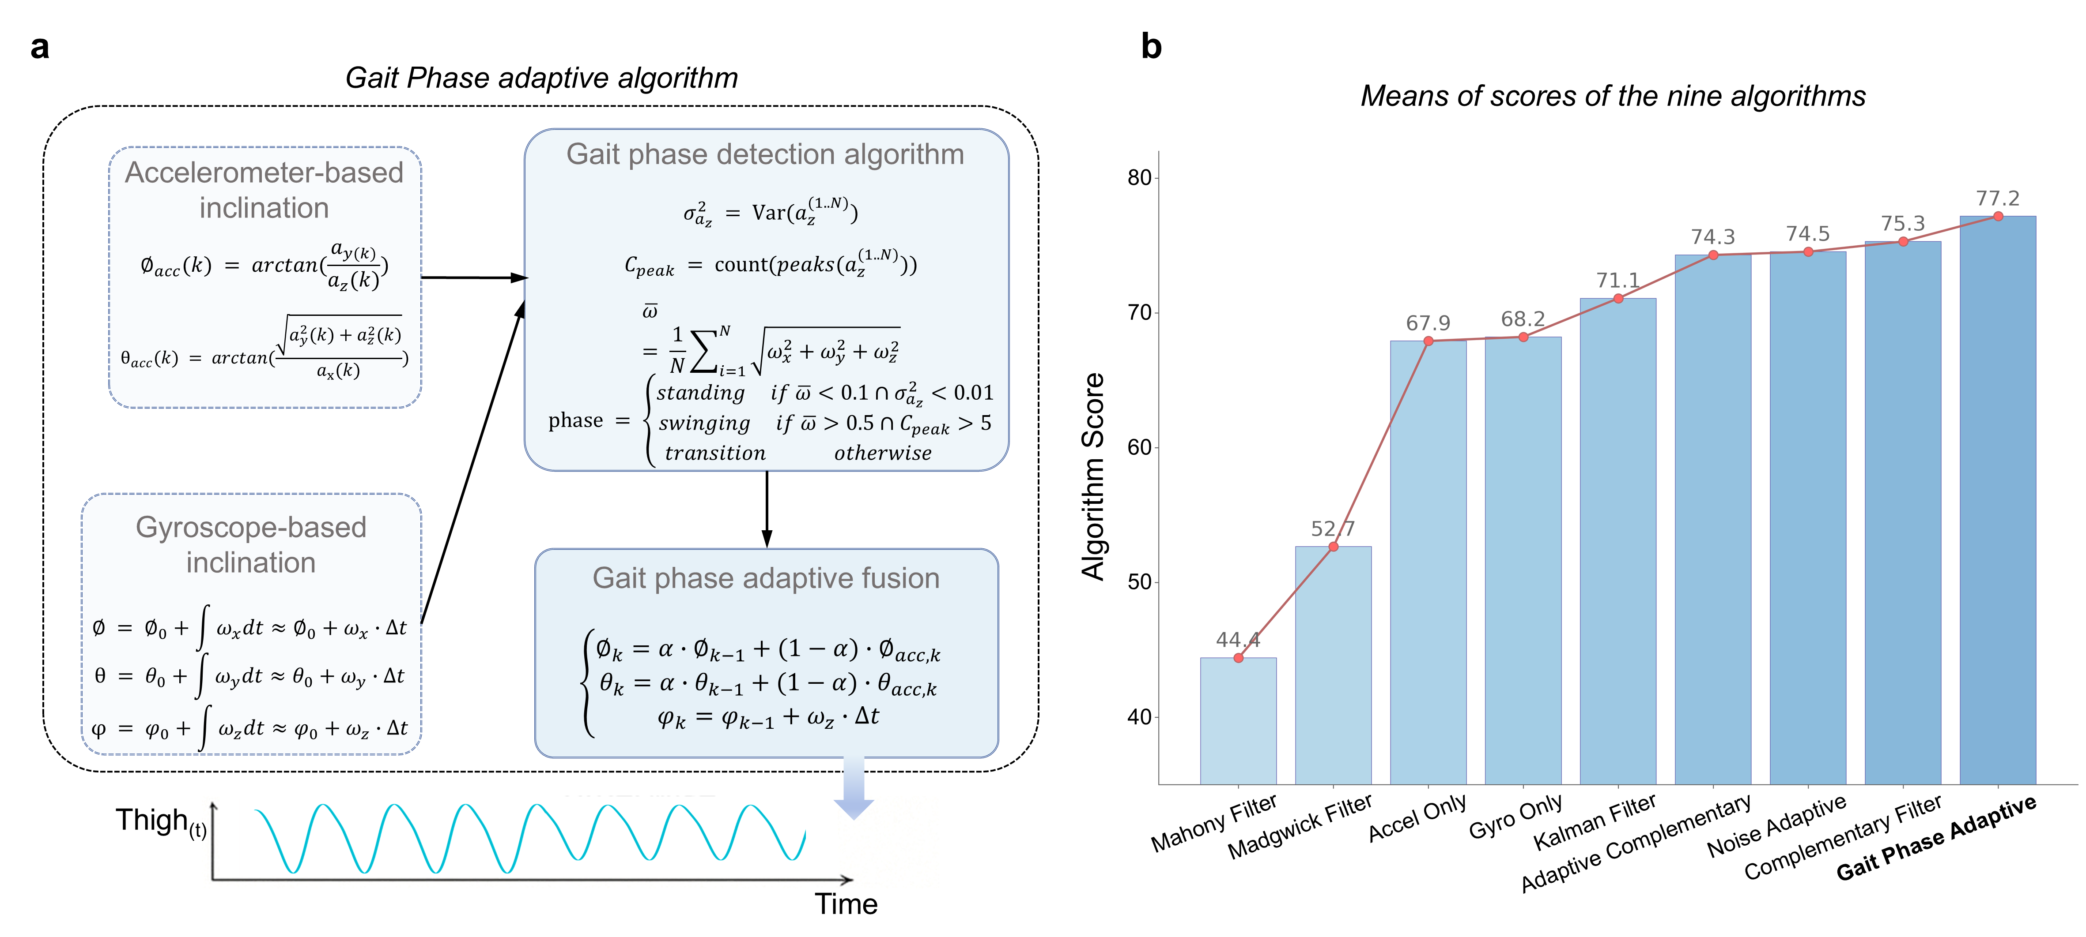
Supplementary Fig. 3 Gait Phase Adaptive algorithm (GPA).
To achieve accurate thigh-angle reconstruction with a single mid-thigh IMU under heterogeneous gait dynamics, we developed a Gait Phase Adaptive (GPA) fusion framework. As shown in Fig. a, GPA estimates thigh inclination using two complementary cues: an accelerometer-based inclination that is robust to long-term drift but sensitive to dynamic accelerations, and a gyroscope-based integration that captures rapid motion but accumulates drift over time. GPA first performs lightweight gait-phase detection (stance, swing, and transition) using signal variance and peak-related features, and then applies phase-dependent fusion to adapt the weighting between the two inclination estimates. Specifically, the fusion emphasizes accelerometer-derived inclination during low-dynamic stance to suppress drift, while prioritizing gyroscope integration during high-dynamic swing to preserve responsiveness, yielding a continuous and drift-resilient thigh-angle trajectory. We benchmarked GPA against eight representative orientation-estimation methods, and the mean composite scores across datasets show that GPA achieves the highest overall performance among the nine algorithms evaluated (Fig. b), supporting the benefit of explicitly incorporating gait-phase information into single-IMU sensor fusion.

Supplementary Note 4. Dynamic time-warping–based similarity analysis
To quantify the kinematic agreement between the thigh-angle trajectories reconstructed by the flexible patch, the commercial IMU system, and the optical motion-capture reference, we employed a dynamic time-warping (DTW)–based similarity metric. For each walking trial, hip flexion–extension trajectories were first time-normalized to 0–100% gait cycle and amplitude-expressed in degrees, as described in the main text. The optical motion-capture signal in a given condition was taken as the reference waveform $r=[r_{1},…,r_{N}]^{T}$, whereas the corresponding patch-derived and commercial-IMU trajectories were denoted $s^{\text{patch}}$and $s^{\text{comm}}$, respectively.
DTW was used to allow elastic, non-linear alignment between two gait waveforms that may differ slightly in local timing while preserving their overall shape. Given two sequences $r$and $s$of lengths $N$and $M$, we first construct an $N×M$cost matrix $C$with elements
$$C(i,j)=∣r_{i}-s_{j}∣,1≤i≤N, 1≤j≤M,$$representing the pointwise absolute difference between samples. A cumulative cost matrix $D$is then computed recursively as
$$D(1,1)=C(1,1),D(i,1)=C(i,1)+D(i-1,1),D(1,j)=C(1,j)+D(1,j-1), \\ D(i,j)=C(i,j)+min⁡\{D(i-1,j), D(i,j-1), D(i-1,j-1)\},$$for $i>1,j>1$. The optimal warping path $P=\{(i_{k},j_{k})\}_{k=1}^{L}$is obtained by back-tracking from $\left(N , M\right)$to $\left(1 , 1\right)$along the direction of minimal cumulative cost. The DTW distance between $r$and $s$is defined as the mean local misfit along this path,
$$DTW(r,s)=\frac{1}{L}\sum_{k=1}^{L}{∣}r_{i_{k}}-s_{j_{k}}∣.$$This quantity can be interpreted as the average pointwise absolute difference between the two waveforms after optimally compensating for local phase shifts.
To cast the DTW distance into a dimensionless similarity index in $\left[0 , 1\right]$, we normalized it with respect to a simple “null” waveform. Specifically, for each reference gait trajectory $r$we defined a zero-motion baseline $z=[0,…,0]^{T}$of the same length and computed the corresponding DTW distance $DTW(r,z)$. This distance represents the maximal mismatch between the reference and a trivial constant-zero signal under the chosen metric. The similarity between $r$and an arbitrary waveform $s$was then defined as
$$S(r,s)=1-\frac{DTW(r,s)}{DTW(r,z)},$$and expressed as a percentage,
$$S_{\%}(r,s)=100×S(r,s).$$By construction, $S_{\%}≈0\%$indicates that the tested waveform is no closer to the reference than the zero-motion baseline, whereas $S_{\%}≈100\%$corresponds to nearly perfect agreement. Waveforms that are slightly better than the baseline but not perfectly matched yield intermediate values.
In practice, DTW distances and similarity scores were computed in Python using a custom implementation (DTWD-similarity.py), which also applied light Savitzky–Golay smoothing (window length 5 samples, polynomial order 2) to the reference optical waveform prior to analysis to reduce high-frequency noise without distorting the gait cycle shape. For each participant and walking condition, we computed $S_{\%}(r,s^{\text{patch}})$and $S_{\%}(r,s^{\text{comm}})$using the optical trajectory as $r$. The values reported in the main text (97.79% for the patch and 96.36% for the commercial IMU system) correspond to the mean similarity scores averaged across all tested conditions. These results indicate that the single-sensor flexible patch reproduces the reference hip kinematics with very high fidelity and, on average, marginally surpasses the multi-IMU commercial system in DTW-based waveform similarity.

Supplementary Note 5. Gait analysis and computational methods
This note details the signal-processing and analytical procedures used to extract gait events and derive spatiotemporal gait parameters from bilateral foot kinematics.
5.1. Signal representation and preprocessing
Bilateral foot trajectories were represented as discrete time series sampled at frequency $f_{s}$($Δt=1/f_{s}$):
$$p_{R}[k]=(x_{R}[k], y_{R}[k], z_{R}[k]),p_{L}[k]=(x_{L}[k], y_{L}[k], z_{L}[k]),k=0,…,N-1,$$
where $y[k]$denotes the vertical component (foot height). A steady-walking analysis window $\left[k_{s} , k_{e}\right]$was selected to exclude start/stop transients and turning. To suppress high-frequency jitter while preserving peak timing, the vertical trajectories were smoothed using a Savitzky–Golay filter:
$$\tilde{y}[k]=SG(y[k]; L,d),$$
where $L$is the window length and $d$is the polynomial order. Vertical velocity was then computed by finite differences:
$$v[k]=\frac{\tilde{y}[k+1]-\tilde{y}[k]}{Δt},k=k_{s},…,k_{e}-1.$$
To reduce dependence on units and inter-subject variability, $v[k]$was optionally normalized by robust statistics:
$$\hat{v}[k]=\frac{v[k]-median(v)}{MAD(v)+ε},MAD(v)=median(∣v-median(v)∣),$$
with a small $ε$added for numerical stability. Event detection can be performed equivalently on $v[k]$or $\hat{v}[k]$; the latter is preferred when scaling differs across recordings.
5.2. Gait event detection (SO and FC)
For each limb, two events per gait cycle were extracted from the vertical velocity pattern: swing onset (SO) and foot contact (FC). SO corresponds to the initiation of foot lift-off and is characterized by an upward acceleration of the foot, which appears as a prominent positive peak in vertical velocity. FC corresponds to the termination of swing and re-contact with the ground, which occurs during the descending phase and is captured by a negative extremum or a near-zero transition following negative velocity.
Local extrema were identified using the standard discrete conditions:
$$\text{local maximum at }k: \hat{v}[k-1]<\hat{v}[k]≥\hat{v}[k+1], \\ \text{local minimum at }k: \hat{v}[k-1]>\hat{v}[k]≤\hat{v}[k+1].$$
To avoid double counting due to oscillations, a refractory constraint was enforced such that consecutive events of the same type were separated by at least
$$N_{min}=\left\lfloor f_{s}T_{min}\right\rfloor$$
samples, where $T_{min}$is the minimum physiologically plausible interval.
Swing onset (SO). A sample $k$was accepted as SO when it satisfied
$$\hat{v}[k]>θ_{SO},k\text{ is a local maximum},Δk>N_{min},$$
where $θ_{SO}$is a positive threshold and $Δk$denotes the distance from the last accepted SO.
Foot contact (FC). For each detected SO at $k_{SO,i}$, FC was searched within the interval $\left(k_{SO,i} , k_{SO,i+1}\right)$. Two complementary criteria were used:
- Minimum-based FC (preferred): the dominant negative extremum during the descending phase was selected as FC if
$$\hat{v}[k_{FC}]<-θ_{FC},k_{FC}\text{ is a local minimum},k_{SO,i}<k_{FC}<k_{SO,i+1}.$$
- Near-zero fallback (for soft landings): if the negative extremum criterion was not met (e.g., heavily damped landing), FC was defined as the first near-zero transition after a negative phase:
$$∣\hat{v}[k_{FC}]∣<θ_{0},\hat{v}[k_{FC}-1]<0,k_{SO,i}<k_{FC}<k_{SO,i+1}.$$5.3. Cycle construction and validity screening
Detected events were paired to form gait cycles by enforcing the ordering constraint:
$$k_{SO,i}<k_{FC,i}<k_{SO,i+1}.$$
Physiological plausibility was further ensured by bounding swing time and cycle time:
$$T_{swing,i}=(k_{FC,i}-k_{SO,i})Δt∈[T_{swing}^{min}, T_{swing}^{max}], \\ T_{cycle,i}=(k_{SO,i+1}-k_{SO,i})Δt∈[T_{cycle}^{min}, T_{cycle}^{max}].$$
Cycles that violated ordering or duration constraints (e.g., due to missed events or transient artifacts) were discarded. Incomplete cycles at the beginning and end of the analysis window were excluded to avoid boundary bias.
5.4. Temporal gait parameters
For each valid cycle $i$, temporal parameters were computed as:
$$T_{swing,i}=(k_{FC,i}-k_{SO,i})Δt, \\ T_{stance,i}=(k_{SO,i+1}-k_{FC,i})Δt, \\ T_{cycle,i}=(k_{SO,i+1}-k_{SO,i})Δt.$$The stance-phase ratio (duty factor) was then defined by:
$$R_{stance,i}=\frac{T_{stance,i}}{T_{cycle,i}},R_{swing,i}=1-R_{stance,i}.$$For each subject and condition, reported values were obtained by averaging across cycles after validity screening.
5.5. Spatial gait parameters
Spatial parameters were derived from the foot-position trajectories at event indices. Step length for cycle $i$was computed as the displacement between successive swing onsets of the same limb:
$$L_{step,i}={∥p[k_{SO,i+1}]-p[k_{SO,i}]∥}_{2}.$$
When vertical drift or inconsistent scaling in the vertical axis was present, a planar step length was used:
$$L_{step,i}^{planar}=\sqrt{\left(x_{i+1}-x_{i})^{2}+(z_{i+1}-z_{i})^{2}\right.}.$$
If needed, mean walking speed over the analysis window can be estimated as:
$$v_{walk}=\frac{\sum_{i}{L_{step,i}}}{(k_{e}-k_{s})Δt}.$$
5.6. Statistical summaries and quality control
For each parameter $X$(e.g., $T_{cycle},R_{stance},L_{step}$), central tendency and variability were summarized across valid cycles using mean and standard deviation. Robust outlier suppression can be performed using a MAD-based criterion:
$$X∈\left[median\left(X\right)-3MAD\left(X\right), \text{median(X)+3MAD(X)}\right].$$
Additionally, the analysis assumes that the $y$-axis corresponds to the true vertical direction; when acquisition frames differ, coordinate alignment should be applied prior to event detection to ensure the physical interpretation of $\tilde{y}[k]$and $v[k]$.

Supplementary Note 6. Joint-angle analysis and computational methods
This note describes the biomechanical definitions, calibration strategy, and post-processing procedures used to compute sagittal-plane lower-limb joint angles (hip, knee, and ankle) from tracked anatomical landmarks.
6.1. Landmark representation and planar assumption
For each time sample $k=0,…,N-1$(sampling frequency $f_{s}$, $Δt=1/f_{s}$), the tracked landmark positions were denoted as
$$r_{H}[k]=(z_{H}[k], y_{H}[k]),r_{K}[k]=(z_{K}[k], y_{K}[k]),r_{A}[k]=(z_{A}[k], y_{A}[k]),$$
where $H$, $K$, and $A$represent hip, knee, and ankle (or foot/ankle marker), respectively. The analysis focused on the sagittal plane $\left(z , y\right)$, where $y$is the vertical axis and $z$is the forward–backward axis. The 2D planar assumption is appropriate when the motion is predominantly flexion/extension and out-of-plane excursions are comparatively small.
Two segment vectors were defined:
$$u[k]=r_{K}[k]-r_{H}[k]\text{(thigh vector)},v[k]=r_{A}[k]-r_{K}[k]\text{(shank vector)}.$$
Their magnitudes are
$$∥u[k]∥=\sqrt{\left(z_{K}-z_{H})^{2}+(y_{K}-y_{H})^{2}\right.},∥v[k]∥=\sqrt{\left(z_{A}-z_{K})^{2}+(y_{A}-y_{K})^{2}\right.}.$$6.2. Coordinate smoothing and numerical stability
To reduce jitter in tracked coordinates while preserving movement timing, each coordinate component (e.g., $y_{H}[k]$, $z_{H}[k]$, etc.) was optionally smoothed using a Savitzky–Golay filter:
$$\tilde{y}[k]=SG(y[k];L,d),\tilde{z}[k]=SG(z[k];L,d),$$where $L$is the window length and $d$is the polynomial order. All subsequent computations used the smoothed coordinates.
For angle computations involving $arccos⁡(⋅)$, the argument was clamped to $\left[-1,1\right]$to avoid numerical issues:
$$clip(x)=min⁡(1,max⁡(-1,x)).$$6.3. Hip angle (sagittal thigh inclination)
The hip flexion/extension angle was computed from the orientation of the thigh segment in the sagittal plane. A robust definition uses $atan2$to avoid quadrant ambiguity:
$$ϕ_{thigh}[k]=atan2(z_{K}[k]-z_{H}[k], y_{K}[k]-y_{H}[k]),$$
where $ϕ_{thigh}$is the thigh inclination relative to the vertical axis (in radians). Converting to degrees:
$$θ_{hip}[k]=ϕ_{thigh}[k]⋅\frac{180}{π}.$$
(Under small-angle conditions, $θ_{hip}≈arcsin⁡\left(\frac{z_{K}-z_{H}}{∥u∥}\right)⋅\frac{180}{π}$, which is algebraically consistent with a sine-based implementation.)
Sign convention. Hip flexion can be defined as positive by choosing the forward axis direction and applying a sign correction (Section 6.6) when walking direction reverses.
6.4. Knee angle (inter-segment included angle)
The knee angle was computed as the included angle between the thigh and shank vectors:
$$θ_{knee}[k]=arccos⁡\left(clip\left(\frac{u[k]⋅v[k]}{∥u[k]∥ ∥v[k]∥}\right)\right)⋅\frac{180}{π}.$$
This definition yields an anatomical “included angle” that increases as the limb becomes more extended (depending on convention). If a flexion angle is preferred (flexion increasing with bending), it can be defined as
$$θ_{knee}^{flex}[k]={180}^{∘}-θ_{knee}[k],$$and the chosen convention should be used consistently across all analyses.
6.5. Ankle angle (relative orientation of shank and foot)
Ankle dorsiflexion/plantarflexion can be expressed as the relative angle between shank and foot orientations. First, define shank inclination:
$$ϕ_{shank}[k]=atan2(z_{A}[k]-z_{K}[k], y_{A}[k]-y_{K}[k]).$$If an explicit toe marker $r_{T}[k]$is available, the foot orientation is
$$ϕ_{foot}[k]=atan2(z_{T}[k]-z_{A}[k], y_{T}[k]-y_{A}[k]),$$and the ankle angle is
$$θ_{ankle}[k]=(ϕ_{shank}[k]-ϕ_{foot}[k])⋅\frac{180}{π}.$$If a toe marker is unavailable, foot orientation can be approximated from the ankle height relative to a baseline foot reference and a known/entered foot length $L_{foot}$:
$$ϕ_{foot}[k]≈arctan⁡\left(\frac{y_{A}[k]-y_{0}}{L_{foot}}\right),$$where $y_{0}$is the baseline foot height (estimated from an initial standing segment; Section 6.6). The ankle angle is then computed using the same relative-angle form above, with sign chosen to match the dorsiflexion-positive convention:
$$θ_{ankle}[k]≈\left(ϕ_{shank}[k]-ϕ_{foot}[k]\right)⋅\frac{180}{π}.$$(If the acquisition coordinate system uses the opposite forward direction, $ϕ_{shank}$and/or $ϕ_{foot}$should be sign-corrected consistently; Section 6.6.)
6.6. Static calibration and direction-consistent sign correction
(i) Baseline zeroing (static calibration).
To remove subject-specific offsets (camera alignment, marker placement bias, and posture offsets), each joint angle was baseline-corrected using a short initial calibration segment $K_{0}$(e.g., first $M$samples under quiet standing):
$${\overset{ˉ}{θ}}_{j}=\frac{1}{M}\sum_{k∈K_{0}}{θ_{j}}[k],θ_{j}^{cal}[k]=θ_{j}[k]-{\overset{ˉ}{θ}}_{j},$$where $j∈\{hip,knee,ankle\}$.
(ii) Walking-direction reversal correction.
In out-and-back walking trials, the forward axis in the image/world frame effectively flips between passes, which reverses the sign of orientation-based angles. To maintain a consistent anatomical sign convention (e.g., hip flexion positive), we used a piecewise sign factor:
$$s[k]∈\{+1,-1\},s[k]=(-1)^{m}\text{ for }k∈(k_{c,m}, k_{c,m+1}],$$where $\left\{k_{c,m}\right\}$are detected corner/turn indices (pass boundaries). Orientation-type angles were corrected as
$$θ_{j}^{dir}[k]=s[k]⋅θ_{j}^{cal}[k],$$and the same $s[k]$was applied consistently across hip/shank/foot orientation terms to preserve relative-angle definitions at the ankle.
6.7. Gait-cycle segmentation and time normalization of angle waveforms
Joint-angle waveforms were summarized at the stride level using gait events defined in Supplementary Note 5. For a stride $i$bounded by consecutive swing onset events $k_{SO,i}$and $k_{SO,i+1}$, the stride-normalized time variable is
$$τ=\frac{k-k_{SO,i}}{k_{SO,i+1}-k_{SO,i}}∈[0,1].$$The angle trajectory within the stride was resampled to a fixed grid $τ_{n}=n/(N_{τ}-1)$($n=0,…,N_{τ}-1$, typically $N_{τ}=101$) via interpolation:
$$θ_{j,i}(τ_{n})=Interp(θ_{j}^{dir}\left[k\right], k∈\left[k_{SO,i},k_{SO,i+1}\right]).$$Mean and variability envelopes were then computed across strides:
$$μ_{j}(τ_{n})=\frac{1}{N_{s}}\sum_{i=1}^{N_{s}}{θ_{j,i}}(τ_{n}),σ_{j}(τ_{n})=\sqrt{\frac{1}{N_{s}-1}\sum_{i=1}^{N_{s}}{(}θ_{j,i}(τ_{n})-μ_{j}(τ_{n}))^{2}}.$$6.8. Derived kinematic features and quality control
For each stride $i$and joint $j$, standard kinematic features were extracted:
- Range of motion (ROM):
$${ROM}_{j,i}=\underset{τ∈[0,1]}{max⁡}θ_{j,i}(τ)-\underset{τ∈[0,1]}{min⁡}θ_{j,i}(τ).$$
- Peak flexion/extension angles:
$$θ_{j,i}^{max}=\underset{τ}{max⁡}θ_{j,i}(τ),θ_{j,i}^{min}=\underset{τ}{min⁡}θ_{j,i}(τ).$$
Strides were excluded if (i) segment lengths $∥u[k]∥$or $∥v[k]∥$approached zero (tracking failure), (ii) the $arccos⁡$argument was frequently out-of-range before clipping (indicative of severe noise), or (iii) the resulting angles exceeded physiologically plausible limits. Robust outlier filtering across strides can be performed using a MAD criterion analogous to Supplementary Note 5.

Supplementary Note 7. EMG analysis and computational methods
This note describes the signal-processing pipeline and quantitative metrics used to analyze surface electromyography (sEMG) recorded during walking. The procedures aim to obtain physiologically meaningful, comparable activation envelopes across subjects and conditions, while minimizing artifacts and phase misalignment.
7.1. Signal representation and synchronization
Let $e_{m}[n]$denote the raw sEMG signal of muscle $m$sampled at frequency $f_{e}$($Δt_{e}=1/f_{e}$), for $n=0,…,N_{e}-1$. When kinematics and gait events were sampled at a different rate $f_{k}$, time bases were aligned using timestamp synchronization (if available) or by resampling onto a common time grid:
$$t_{e}[n]=nΔt_{e},t_{k}[k]=kΔt_{k}, \\ e_{m}(t_{k})=Interp(e_{m}(t_{e}), t_{k}),$$
where $Interp(⋅)$denotes interpolation (e.g., linear or cubic) and ensures that event indices from Supplementary Note 5 can be applied consistently to EMG.
7.2. Artifact handling and baseline correction
Motion artifacts and electrode drift dominate the low-frequency region and can bias envelope estimation. A high-pass filter was applied to remove baseline wander:
$$e_{m}^{HP}[n]=HP(e_{m}[n]; f_{HP}),$$
with $f_{HP}$typically in the range 10–30 Hz (higher values are more aggressive in suppressing motion artifacts).
Power-line contamination at 50/60 Hz (and harmonics) was addressed using notch filtering when necessary:
$$e_{m}^{notch}[n]=Notch(e_{m}^{HP}[n]; f_{line}),f_{line}∈\{50,60\}\text{ Hz}.$$7.3. Band-pass filtering and rectification
The EMG spectrum primarily lies within a mid-frequency band; therefore, we applied a band-pass filter:
$$e_{m}^{BP}[n]=BP(e_{m}[n]; f_{low}, f_{high}),$$
where typical choices are $f_{low}≈20$Hz and $f_{high}≈450$Hz for sEMG (adjusted based on device bandwidth and noise conditions). To avoid phase distortion in timing-related analyses, a zero-phase implementation (forward–backward filtering) was used when available.
The filtered signal was then full-wave rectified:
$$r_{m}[n]=∣e_{m}^{BP}[n]∣.$$7.4. Envelope extraction (RMS / low-pass)
Muscle activation was quantified by the EMG envelope extracted from the rectified signal. Two equivalent formulations are commonly used:
(i) Moving-window RMS envelope. For a window length $W$samples (window duration $T_{W}=WΔt_{e}$):
$${RMS}_{m}[n]=\sqrt{\frac{1}{W}\sum_{i=0}^{W-1}{r_{m}^{2}}[n-i]}.$$(ii) Low-pass envelope. Alternatively, the rectified signal can be low-pass filtered:
$$a_{m}[n]=LP(r_{m}[n]; f_{env}),$$where $f_{env}$is typically 3–10 Hz for gait-level activation profiles. In practice, RMS and low-pass envelopes converge when $T_{W}$and $f_{env}$are chosen consistently; the RMS approach is explicit and robust for reporting.
7.5. Amplitude normalization (between-subject comparability)
To compare muscle activation across subjects and sessions, the envelope amplitude was normalized. When maximum voluntary isometric contraction (MVIC) trials were available for muscle $m$, the normalization factor was defined as the peak (or high-percentile) envelope during MVIC:
$$A_{m}^{MVIC}={Percentile}_{p}(a_{m}^{MVIC}[n]),p∈[95,100],$$and the normalized activation was
$${\tilde{a}}_{m}[n]=\frac{a_{m}[n]}{A_{m}^{MVIC}}.$$If MVIC was not available or unreliable, an within-trial normalization can be used (e.g., normalize by the maximum envelope across the analyzed walking segment):
$$A_{m}^{trial}=\underset{n∈W}{max⁡}a_{m}[n],{\tilde{a}}_{m}[n]=\frac{a_{m}[n]}{A_{m}^{trial}},$$where $W$denotes the steady-walking window.
7.6. Gait-cycle segmentation and phase normalization of EMG
EMG envelopes were summarized at the stride level using gait events from Supplementary Note 5. For stride $i$bounded by consecutive swing-onset indices $k_{SO,i}$and $k_{SO,i+1}$(mapped to EMG time indices), a normalized phase variable was defined as
$$τ=\frac{t-t_{SO,i}}{t_{SO,i+1}-t_{SO,i}}∈[0,1].$$The normalized activation curve was resampled onto a fixed grid $τ_{n}=n/(N_{τ}-1)$($N_{τ}$ typically 101):
$${\tilde{a}}_{m,i}(τ_{n})=Interp({\tilde{a}}_{m}(t), \text{t }\text{∈}\text{ [}t_{SO,i}\text{,}t_{SO,i+1}\text{]).}$$Ensemble mean and variability were computed across $N_{s}$strides:
$$μ_{m}(τ_{n})=\frac{1}{N_{s}}\sum_{i=1}^{N_{s}}{{\tilde{a}}_{m,i}}(τ_{n}),σ_{m}(τ_{n})=\sqrt{\frac{1}{N_{s}-1}\sum_{i=1}^{N_{s}}{(}{\tilde{a}}_{m,i}(τ_{n})-μ_{m}(τ_{n}))^{2}}.$$7.7. Quantitative EMG metrics
From stride-normalized activation ${\tilde{a}}_{m,i}(τ)$, we extracted:
(i) Integrated EMG (iEMG) per stride
$${iEMG}_{m,i}=\int_{0}^{1}{{\tilde{a}}_{m,i}}(τ) dτ ≈ \sum_{n}{{\tilde{a}}_{m,i}}(τ_{n})Δτ,Δτ=\frac{1}{N_{τ}-1}.$$(ii) Peak activation
$${\tilde{a}}_{m,i}^{max}=\underset{τ∈[0,1]}{max⁡}{\tilde{a}}_{m,i}(τ).$$(iii) Activation timing (center of activity, CoA)
To quantify when activation concentrates within a cycle, CoA was computed using a circular-statistics formulation to avoid boundary artifacts:
$$θ_{n}=2πτ_{n},C=\sum_{n}{{\tilde{a}}_{m,i}}(τ_{n})cos⁡θ_{n},S=\sum_{n}{{\tilde{a}}_{m,i}}(τ_{n})sin⁡θ_{n}, \\ {CoA}_{m,i}=atan2\left(S,C\right) \text{∈}\text{ (}-π,π], τ_{m,i}^{CoA}\text{=}\frac{{CoA}_{m,i}}{2π}\text{(mod 1).}$$(iv) Co-contraction index (CCI) for antagonist pairs (optional)
For an agonist–antagonist pair $\left(m_{1} , m_{2}\right)$, co-contraction over the cycle can be defined as
$${CCI}_{i}=\frac{\int_{0}^{1}{min⁡(}{\tilde{a}}_{m_{1},i}(τ),{\tilde{a}}_{m_{2},i}(τ)) dτ}{\int_{0}^{1}{max⁡(}{\tilde{a}}_{m_{1},i}(τ),{\tilde{a}}_{m_{2},i}(τ)) dτ},$$which ranges from 0 (no overlap) to 1 (complete overlap).
7.8. Quality control and exclusion criteria
EMG segments were flagged for exclusion if they exhibited: (i) saturation/clipping, (ii) prolonged dropouts, (iii) extreme baseline drift not removable by high-pass filtering, or (iv) implausible broadband noise dominance. Additionally, strides were excluded if the corresponding gait-event segmentation failed (Supplementary Note 5) to ensure consistency across EMG and kinematics.

Supplementary Table 1. Clinical characteristics of the patients
Subject | Age | Gender  (years) | Height  (cm) | Weight  (kg) | Duration (years) | UPDRS3 | Modified Hoehn Yahr Scale | Education Level (years)
1 | 54 | Male | 177 | 72 | 1 | 4 | 1 | 15
2 | 66 | Female | 155 | 56 | 2 | 15 | 1 | 15
3 | 68 | Female | 162 | 69 | 5 | 40 | 3 | 6
4 | 52 | Female | 160 | 58 | 5 | 31 | 3 | 6
5 | 63 | Female | 147 | 52.5 | 3 | 16 | 3 | 9
6 | 61 | Female | 150 | 63 | 4 | 7 | 2 | 6
7 | 50 | Male | 173 | 65 | 10 | 13 | 2 | 9
8 | 53 | Male | 168 | 61.5 | 12 | 14 | 3 | 12
9 | 74 | Male | 158 | 63 | 2 | 7 | 2 | 6
10 | 54 | Female | 155 | 58 | 14 | 54 | 3 | 9
11 | 69 | Male | 167 | 62.5 | 12 | 16 | 1.5 | 9
12 | 75 | Female | 155 | 54 | 3 | 35 | 3 | 6
13 | 52 | Female | 163 | 55 | 3 | 20 | 1.5 | 12
14 | 68 | Male | 168 | 65 | 6 | 49 | 3 | 6
15 | 59 | Male | 171 | 68 | 10 | 40 | 3 | 12
16 | 58 | Female | 152 | 54 | 1 | 16 | 1 | 9
17 | 55 | Female | 156 | 60 | 5 | 48 | 3 | 12
18 | 71 | Female | 156 | 60 | 1 | 15 | 1 | 12
19 | 63 | Female | 158 | 63 | 1 | 26 | 1 | 9
20 | 61 | Male | 169 | 68 | 2 | 32 | 3 | 12
21 | 54 | Female | 155 | 56 | 14 | 54 | 1.5 | 9
22 | 69 | Male | 167 | 64 | 12 | 16 | 3 | 6
23 | 80 | Female | 153 | 53 | 3 | 35 | 1.5 | 6
24 | 52 | Male | 170 | 66 | 3 | 20 | 3 | 12
25 | 78 | Male | 165 | 63 | 6 | 28 | 1.5 | 9
26 | 59 | Female | 157 | 58 | 15 | 49 | 1 | 12
27 | 58 | Male | 169 | 67 | 1 | 16 | 4 | 9
28 | 55 | Female | 156 | 59 | 5 | 42 | 4 | 6
29 | 63 | Female | 158 | 60 | 3 | 31 | 2 | 12
30 | 73 | Male | 166 | 65 | 9 | 22 | 1.5 | 9
31 | 54 | Male | 172 | 68 | 1 | 11 | 1 | 12
32 | 56 | Female | 154 | 55 | 3 | 22 | 3 | 6
33 | 68 | Female | 160 | 62 | 6 | 40 | 3 | 9
34 | 54 | Male | 168 | 64 | 5 | 48 | 4 | 6
35 | 53 | Female | 159 | 57 | 6 | 31 | 2 | 12

