Appendix A
No Echo Chamber Vignette


Echo Chamber Vignette


Appendix B
Approval Certificate

XXXX University of Technology Human Research Ethics Committee Approval certificate
29/07/2025
The ethics application for your project Perceptions of Cancel Culture has been approved.
Chief Investigator: xxxx
Ref: 20258845-22053

Approved Duration: 29/07/2025 to 29/07/2027
I refer to the ethical review of the above project protocol by XXXX Human Research Ethics Committee (SUHREC) or its sub-committees.
I am pleased to advise that, as submitted to date, the project may proceed in line with standard on-going ethics clearance conditions outlined below.
The approved duration is as shown above unless an extension request is subsequently approved.
All human research activity undertaken under XXXX auspices must conform to XXXX and external regulatory standards, including the National Statement on Ethical Conduct in Human Research (2023) and with respect to secure data use, retention and disposal.
The named XXXX Chief Investigator/Supervisor remains responsible for any personnel appointed to or associated with the project being made aware of ethics clearance conditions, including research and consent procedures or instruments approved. Any change in Chief Investigator/Supervisor, and addition or removal of other personnel/students from the project, requires timely notification and SUHREC endorsement.
The above project has been approved as submitted for ethical review by or on behalf of SUHREC. Amendments to approved procedures or instruments ordinarily require prior ethical appraisal/clearance from SUHREC for approval. SUHREC must be notified immediately or as soon as possible thereafter of (a) any serious or unexpected adverse effects on participants and any redress measures; (b) proposed changes in protocols; and (c) unforeseen events which might affect continued ethical acceptability of the project.
At a minimum, an annual report on the progress of the project is required as well as at the conclusion (or abandonment) of the project. A duly authorised external or internal audit of the project may be undertaken at any time. Please forward this approval certificate to relevant members of the project team.
The following investigators have been approved to work on the project:
Chief Investigator
xxx
Associate Investigators
xxxx
Student Investigators
xxxx
Please contact the XXXX Research Ethics Office if you have any queries.
Regards,
Ms Leanne Clinch
on behalf of
Research Ethics Office
XXXX University of Technology
P: | E:
Appendix C: Descriptive and Assumption Output

Split file Descriptives

Gender
Source |  |  | Frequency | Percent | Valid Percent | Cumulative Percent
Prolific | Valid | 1 | 34 | 50.7 | 50.7 | 50.7
Prolific | Valid | 2 | 32 | 47.8 | 47.8 | 98.5
Prolific | Valid | 3 | 1 | 1.5 | 1.5 | 100.0
Prolific | Valid | Total | 67 | 100.0 | 100.0
REP | Valid | 1 | 16 | 27.1 | 27.1 | 27.1
REP | Valid | 2 | 41 | 69.5 | 69.5 | 96.6
REP | Valid | 3 | 1 | 1.7 | 1.7 | 98.3
REP | Valid | 4 | 1 | 1.7 | 1.7 | 100.0
REP | Valid | Total | 59 | 100.0 | 100.0

Ethnicity
Source |  |  | Frequency | Percent | Valid Percent | Cumulative Percent
Prolific | Valid | 1 | 37 | 55.2 | 55.2 | 55.2
Prolific | Valid | 3 | 7 | 10.4 | 10.4 | 65.7
Prolific | Valid | 4 | 17 | 25.4 | 25.4 | 91.0
Prolific | Valid | 5 | 2 | 3.0 | 3.0 | 94.0
Prolific | Valid | 7 | 1 | 1.5 | 1.5 | 95.5
Prolific | Valid | 8 | 1 | 1.5 | 1.5 | 97.0
Prolific | Valid | 10 | 1 | 1.5 | 1.5 | 98.5
Prolific | Valid | 11 | 1 | 1.5 | 1.5 | 100.0
Prolific | Valid | Total | 67 | 100.0 | 100.0
REP | Valid | 1 | 32 | 54.2 | 54.2 | 54.2
REP | Valid | 2 | 1 | 1.7 | 1.7 | 55.9
REP | Valid | 3 | 4 | 6.8 | 6.8 | 62.7
REP | Valid | 4 | 17 | 28.8 | 28.8 | 91.5
REP | Valid | 5 | 1 | 1.7 | 1.7 | 93.2
REP | Valid | 7 | 1 | 1.7 | 1.7 | 94.9
REP | Valid | 11 | 3 | 5.1 | 5.1 | 100.0
REP | Valid | Total | 59 | 100.0 | 100.0

Student status
Source |  |  | Frequency | Percent | Valid Percent | Cumulative Percent
Prolific | Valid | 1 | 9 | 13.4 | 13.4 | 13.4
Prolific | Valid | 2 | 58 | 86.6 | 86.6 | 100.0
Prolific | Valid | Total | 67 | 100.0 | 100.0
REP | Valid | 1 | 59 | 100.0 | 100.0 | 100.0

Condition
Source |  |  | Frequency | Percent | Valid Percent | Cumulative Percent
Prolific | Valid | Echo chamber | 39 | 58.2 | 58.2 | 58.2
Prolific | Valid | No echo chamber | 28 | 41.8 | 41.8 | 100.0
Prolific | Valid | Total | 67 | 100.0 | 100.0
REP | Valid | Echo chamber | 34 | 57.6 | 57.6 | 57.6
REP | Valid | No echo chamber | 25 | 42.4 | 42.4 | 100.0
REP | Valid | Total | 59 | 100.0 | 100.0
Descriptives

Condition
 |  | Frequency | Percent | Valid Percent | Cumulative Percent
Valid | Echo chamber | 73 | 57.9 | 57.9 | 57.9
Valid | No echo chamber | 53 | 42.1 | 42.1 | 100.0
Valid | Total | 126 | 100.0 | 100.0

Student status
 |  | Frequency | Percent | Valid Percent | Cumulative Percent
Valid | 1 | 68 | 54.0 | 54.0 | 54.0
Valid | 2 | 58 | 46.0 | 46.0 | 100.0
Valid | Total | 126 | 100.0 | 100.0

Gender
 |  | Frequency | Percent | Valid Percent | Cumulative Percent
Valid | 1 | 50 | 39.7 | 39.7 | 39.7
Valid | 2 | 73 | 57.9 | 57.9 | 97.6
Valid | 3 | 2 | 1.6 | 1.6 | 99.2
Valid | 4 | 1 | .8 | .8 | 100.0
Valid | Total | 126 | 100.0 | 100.0

Ethnicity
 |  | Frequency | Percent | Valid Percent | Cumulative Percent
Valid | 1 | 69 | 54.8 | 54.8 | 54.8
Valid | 2 | 1 | .8 | .8 | 55.6
Valid | 3 | 11 | 8.7 | 8.7 | 64.3
Valid | 4 | 34 | 27.0 | 27.0 | 91.3
Valid | 5 | 3 | 2.4 | 2.4 | 93.7
Valid | 7 | 2 | 1.6 | 1.6 | 95.2
Valid | 8 | 1 | .8 | .8 | 96.0
Valid | 10 | 1 | .8 | .8 | 96.8
Valid | 11 | 4 | 3.2 | 3.2 | 100.0
Valid | Total | 126 | 100.0 | 100.0

Assumption testing-Normality
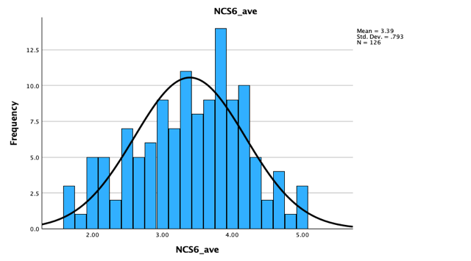
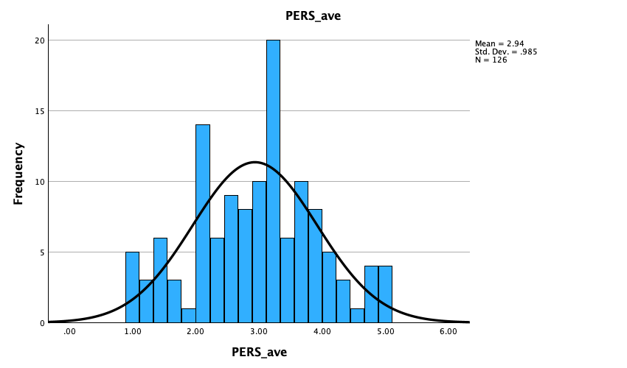

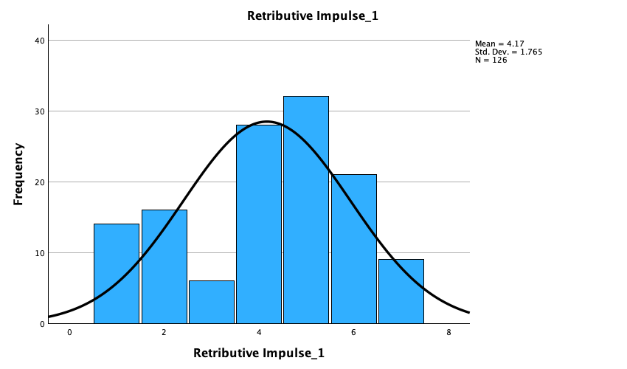
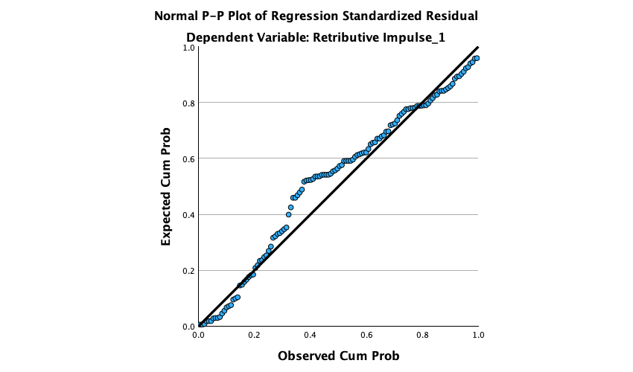
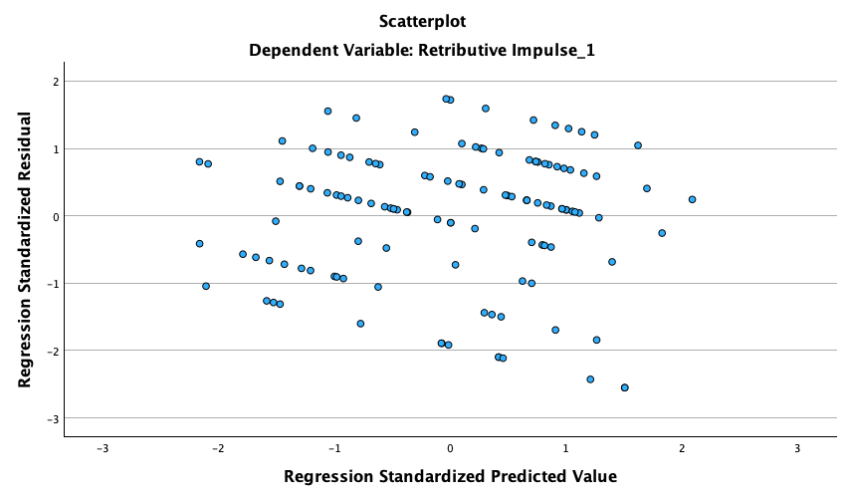

Collinearity Diagnosticsª
Model | Dimension | Eigenvalue | Condition Index | Variance Proportions
 |  |  |  | (Constant) | PERS_ave | NCS6_ave | New_con
1 | 1 | 3.526 | 1.000 | .00 | .01 | .00 | .02
1 | 2 | .371 | 3.081 | .00 | .03 | .01 | .88
1 | 3 | .083 | 6.533 | .01 | .70 | .23 | .02
1 | 4 | .020 | 13.429 | .98 | .27 | .76 | .08

Coefficientsª
Model |  | Unstandardized Coefficients |  | Standardized Coefficients | t | Sig. | Collinearity Statistics
 |  | B | Std. Error | Beta | t | Sig. | Tolerance | VIF
1 | (Constant) | 2.956 | .854 |  | 3.461 | <.001
1 | PERS_ave | .349 | .151 | .195 | 2.313 | .022 | .983 | 1.017
1 | NCS6_ave | -.153 | .187 | -.069 | -.821 | .413 | .986 | 1.015
1 | New_con | 1.219 | .301 | .342 | 4.057 | <.001 | .977 | 1.024

Appendix D: Mediation and Moderation Output
Mediation
Run MATRIX procedure:

***************** PROCESS Procedure for SPSS Version 4.2 *****************

Written by Andrew F. Hayes, Ph.D. www.afhayes.com
Documentation available in Hayes (2022). www.guilford.com/p/hayes3

**************************************************************************
Model : 4
Y : RetImpul
X : New_con
M : Anger_EC

Sample
Size: 126

**************************************************************************
OUTCOME VARIABLE:
Anger_EC

Model Summary
R R-sq MSE F df1 df2 p
.1419 .0201 2.0391 2.5464 1.0000 124.0000 .1131

Model
coeff se t p LLCI ULCI
constant 2.8491 .1961 14.5252 .0000 2.4608 3.2373
New_con .4112 .2577 1.5958 .1131 -.0988 .9213

Standardized coefficients
coeff
New_con .2862

**************************************************************************
OUTCOME VARIABLE:
RetImpul

Model Summary
R R-sq MSE F df1 df2 p
.5992 .3590 2.0298 34.4469 2.0000 123.0000 .0000

Model
coeff se t p LLCI ULCI
constant 1.7166 .3217 5.3370 .0000 1.0800 2.3533
New_con .9109 .2597 3.5072 .0006 .3968 1.4251
Anger_EC .6226 .0896 6.9493 .0000 .4453 .8000

Standardized coefficients
coeff
New_con .5160
Anger_EC .5068

************************** TOTAL EFFECT MODEL ****************************
OUTCOME VARIABLE:
RetImpul

Model Summary
R R-sq MSE F df1 df2 p
.3277 .1074 2.8039 14.9136 1.0000 124.0000 .0002

Model
coeff se t p LLCI ULCI
constant 3.4906 .2300 15.1758 .0000 3.0353 3.9458
New_con 1.1670 .3022 3.8618 .0002 .5689 1.7651

Standardized coefficients
coeff
New_con .6611

************** TOTAL, DIRECT, AND INDIRECT EFFECTS OF X ON Y **************

Total effect of X on Y
Effect se t p LLCI ULCI c_ps
1.1670 .3022 3.8618 .0002 .5689 1.7651 .6611

Direct effect of X on Y
Effect se t p LLCI ULCI c'_ps
.9109 .2597 3.5072 .0006 .3968 1.4251 .5160

Indirect effect(s) of X on Y:
Effect BootSE BootLLCI BootULCI
Anger_EC .2560 .1809 -.0555 .6538

Partially standardized indirect effect(s) of X on Y:
Effect BootSE BootLLCI BootULCI
Anger_EC .1450 .1019 -.0310 .3694

*********************** ANALYSIS NOTES AND ERRORS ************************

Level of confidence for all confidence intervals in output:
95.0000

Number of bootstrap samples for percentile bootstrap confidence intervals:
5000

NOTE: Standardized coefficients for dichotomous or multicategorical X are in
partially standardized form.

------ END MATRIX -----

Emotional Reactivity Moderated Mediation
Run MATRIX procedure:

***************** PROCESS Procedure for SPSS Version 4.2 *****************

Written by Andrew F. Hayes, Ph.D. www.afhayes.com
Documentation available in Hayes (2022). www.guilford.com/p/hayes3

**************************************************************************
Model : 7
Y : RetImpul
X : New_con
M : Anger_EC
W : PERS_ave

Sample
Size: 126

**************************************************************************
OUTCOME VARIABLE:
Anger_EC

Model Summary
R R-sq MSE F df1 df2 p
.3127 .0978 1.9083 4.4065 3.0000 122.0000 .0056

Model
coeff se t p LLCI ULCI
constant 2.7811 .1913 14.5383 .0000 2.4024 3.1598
New_con .5045 .2510 2.0104 .0466 .0077 1.0013
PERS_ave .5339 .1906 2.8018 .0059 .1567 .9111
Int_1 -.2596 .2544 -1.0202 .3097 -.7632 .2441

Product terms key:
Int_1 : New_con x PERS_ave

Covariance matrix of regression parameter estimates:
constant New_con PERS_ave Int_1
constant .0366 -.0366 -.0046 .0046
New_con -.0366 .0630 .0046 -.0020
PERS_ave -.0046 .0046 .0363 -.0363
Int_1 .0046 -.0020 -.0363 .0647

Test(s) of highest order unconditional interaction(s):
R2-chng F df1 df2 p
X*W .0077 1.0408 1.0000 122.0000 .3097
----------
Focal predict: New_con (X)
Mod var: PERS_ave (W)

Conditional effects of the focal predictor at values of the moderator(s):

PERS_ave Effect se t p LLCI ULCI
-.9847 .7601 .3601 2.1108 .0368 .0473 1.4729
.0000 .5045 .2510 2.0104 .0466 .0077 1.0013
.9847 .2489 .3490 .7133 .4770 -.4419 .9398

Moderator value(s) defining Johnson-Neyman significance region(s):
Value % below % above
.0307 43.6508 56.3492
-1.3526 12.6984 87.3016

Conditional effect of focal predictor at values of the moderator:
PERS_ave Effect se t p LLCI ULCI
-1.9356 1.0069 .5596 1.7992 .0745 -.1010 2.1148
-1.7251 .9523 .5123 1.8587 .0655 -.0619 1.9665
-1.5146 .8976 .4664 1.9247 .0566 -.0256 1.8208
-1.3526 .8556 .4322 1.9796 .0500 .0000 1.7112
-1.3040 .8430 .4222 1.9966 .0481 .0072 1.6788
-1.0935 .7883 .3804 2.0721 .0404 .0352 1.5415
-.8830 .7337 .3420 2.1453 .0339 .0567 1.4107
-.6725 .6791 .3081 2.2039 .0294 .0691 1.2890
-.4619 .6244 .2804 2.2267 .0278 .0693 1.1795
-.2514 .5698 .2609 2.1838 .0309 .0533 1.0863
-.0409 .5151 .2515 2.0483 .0427 .0173 1.0130
.0307 .4965 .2508 1.9796 .0500 .0000 .9931
.1696 .4605 .2533 1.8179 .0715 -.0410 .9619
.3802 .4058 .2661 1.5251 .1298 -.1210 .9326
.5907 .3512 .2885 1.2175 .2258 -.2198 .9222
.8012 .2966 .3183 .9316 .3534 -.3336 .9267
1.0117 .2419 .3538 .6837 .4955 -.4585 .9424
1.2223 .1873 .3934 .4760 .6349 -.5916 .9661
1.4328 .1326 .4360 .3042 .7615 -.7306 .9958
1.6433 .0780 .4808 .1622 .8714 -.8739 1.0299
1.8538 .0233 .5273 .0443 .9648 -1.0205 1.0671
2.0644 -.0313 .5750 -.0544 .9567 -1.1695 1.1069

Data for visualizing the conditional effect of the focal predictor:
Paste text below into a SPSS syntax window and execute to produce plot.

DATA LIST FREE/
New_con PERS_ave Anger_EC .
BEGIN DATA.
.0000 -.9847 2.2554
1.0000 -.9847 3.0155
.0000 .0000 2.7811
1.0000 .0000 3.2856
.0000 .9847 3.3068
1.0000 .9847 3.5557
END DATA.
GRAPH/SCATTERPLOT=
PERS_ave WITH Anger_EC BY New_con .

**************************************************************************
OUTCOME VARIABLE:
RetImpul

Model Summary
R R-sq MSE F df1 df2 p
.5992 .3590 2.0298 34.4469 2.0000 123.0000 .0000

Model
coeff se t p LLCI ULCI
constant 1.7166 .3217 5.3370 .0000 1.0800 2.3533
New_con .9109 .2597 3.5072 .0006 .3968 1.4251
Anger_EC .6226 .0896 6.9493 .0000 .4453 .8000

Covariance matrix of regression parameter estimates:
constant New_con Anger_EC
constant .1035 -.0289 -.0229
New_con -.0289 .0675 -.0033
Anger_EC -.0229 -.0033 .0080

****************** DIRECT AND INDIRECT EFFECTS OF X ON Y *****************

Direct effect of X on Y
Effect se t p LLCI ULCI
.9109 .2597 3.5072 .0006 .3968 1.4251

Conditional indirect effects of X on Y:

INDIRECT EFFECT:
New_con -> Anger_EC -> RetImpul

PERS_ave Effect BootSE BootLLCI BootULCI
-.9847 .4733 .2582 -.0006 1.0133
.0000 .3141 .1710 .0170 .6946
.9847 .1550 .2328 -.2638 .6672

Index of moderated mediation:
Index BootSE BootLLCI BootULCI
PERS_ave -.1616 .1793 -.5252 .1934

Pairwise contrasts between conditional indirect effects (Effect1 minus Effect2)
Effect1 Effect2 Contrast BootSE BootLLCI BootULCI
.3141 .4733 -.1591 .1766 -.5171 .1904
.1550 .4733 -.3183 .3532 -1.0342 .3808
.1550 .3141 -.1591 .1766 -.5171 .1904

*********************** ANALYSIS NOTES AND ERRORS ************************

Level of confidence for all confidence intervals in output:
95.0000

Number of bootstrap samples for percentile bootstrap confidence intervals:
5000

W values in conditional tables are the mean and +/- SD from the mean.

NOTE: The following variables were mean centered prior to analysis:
PERS_ave

------ END MATRIX -----

Need for Cognition Moderated Mediation
Run MATRIX procedure:

***************** PROCESS Procedure for SPSS Version 4.2 *****************

Written by Andrew F. Hayes, Ph.D. www.afhayes.com
Documentation available in Hayes (2022). www.guilford.com/p/hayes3

**************************************************************************
Model : 7
Y : RetImpul
X : New_con
M : Anger_EC
W : NCS6_ave

Sample
Size: 126

**************************************************************************
OUTCOME VARIABLE:
Anger_EC

Model Summary
R R-sq MSE F df1 df2 p
.1875 .0352 2.0407 1.4818 3.0000 122.0000 .2229

Model
coeff se t p LLCI ULCI
constant 2.8768 .1974 14.5717 .0000 2.4860 3.2677
New_con .3910 .2591 1.5091 .1339 -.1219 .9040
NCS6_ave -.3038 .2379 -1.2773 .2039 -.7747 .1670
Int_1 .4184 .3245 1.2893 .1997 -.2240 1.0609

Product terms key:
Int_1 : New_con x NCS6_ave

Covariance matrix of regression parameter estimates:
constant New_con NCS6_ave Int_1
constant .0390 -.0390 -.0052 .0052
New_con -.0390 .0671 .0052 -.0019
NCS6_ave -.0052 .0052 .0566 -.0566
Int_1 .0052 -.0019 -.0566 .1053

Test(s) of highest order unconditional interaction(s):
R2-chng F df1 df2 p
X*W .0131 1.6622 1.0000 122.0000 .1997
----------
Focal predict: New_con (X)
Mod var: NCS6_ave (W)

Conditional effects of the focal predictor at values of the moderator(s):

NCS6_ave Effect se t p LLCI ULCI
-.7934 .0591 .3695 .1598 .8733 -.6724 .7905
.0000 .3910 .2591 1.5091 .1339 -.1219 .9040
.7934 .7230 .3611 2.0024 .0475 .0082 1.4378

Moderator value(s) defining Johnson-Neyman significance region(s):
Value % below % above
.9552 92.0635 7.9365
.4855 73.0159 26.9841

Conditional effect of focal predictor at values of the moderator:
NCS6_ave Effect se t p LLCI ULCI
-1.7262 -.3312 .6226 -.5320 .5957 -1.5638 .9014
-1.5508 -.2578 .5714 -.4512 .6526 -1.3889 .8732
-1.3753 -.1844 .5213 -.3538 .7241 -1.2163 .8475
-1.1999 -.1110 .4727 -.2348 .8147 -1.0468 .8247
-1.0244 -.0376 .4262 -.0882 .9298 -.8813 .8061
-.8490 .0358 .3826 .0936 .9256 -.7215 .7931
-.6736 .1092 .3428 .3186 .7506 -.5695 .7879
-.4981 .1826 .3086 .5918 .5550 -.4282 .7935
-.3227 .2560 .2817 .9088 .3652 -.3017 .8137
-.1472 .3294 .2646 1.2452 .2155 -.1943 .8532
.0282 .4028 .2591 1.5549 .1226 -.1100 .9157
.2036 .4763 .2659 1.7908 .0758 -.0502 1.0027
.3791 .5497 .2843 1.9335 .0555 -.0131 1.1124
.4855 .5942 .3002 1.9796 .0500 .0000 1.1884
.5545 .6231 .3121 1.9966 .0481 .0053 1.2408
.7299 .6965 .3470 2.0069 .0470 .0095 1.3835
.9054 .7699 .3873 1.9879 .0491 .0032 1.5365
.9552 .7907 .3994 1.9796 .0500 .0000 1.5814
1.0808 .8433 .4313 1.9553 .0528 -.0105 1.6971
1.2563 .9167 .4780 1.9177 .0575 -.0296 1.8630
1.4317 .9901 .5268 1.8795 .0626 -.0527 2.0329
1.6071 1.0635 .5770 1.8430 .0678 -.0788 2.2058

Data for visualizing the conditional effect of the focal predictor:
Paste text below into a SPSS syntax window and execute to produce plot.

DATA LIST FREE/
New_con NCS6_ave Anger_EC .
BEGIN DATA.
.0000 -.7934 3.1179
1.0000 -.7934 3.1770
.0000 .0000 2.8768
1.0000 .0000 3.2679
.0000 .7934 2.6358
1.0000 .7934 3.3588
END DATA.
GRAPH/SCATTERPLOT=
NCS6_ave WITH Anger_EC BY New_con .

**************************************************************************
OUTCOME VARIABLE:
RetImpul

Model Summary
R R-sq MSE F df1 df2 p
.5992 .3590 2.0298 34.4469 2.0000 123.0000 .0000

Model
coeff se t p LLCI ULCI
constant 1.7166 .3217 5.3370 .0000 1.0800 2.3533
New_con .9109 .2597 3.5072 .0006 .3968 1.4251
Anger_EC .6226 .0896 6.9493 .0000 .4453 .8000

Covariance matrix of regression parameter estimates:
constant New_con Anger_EC
constant .1035 -.0289 -.0229
New_con -.0289 .0675 -.0033
Anger_EC -.0229 -.0033 .0080

****************** DIRECT AND INDIRECT EFFECTS OF X ON Y *****************

Direct effect of X on Y
Effect se t p LLCI ULCI
.9109 .2597 3.5072 .0006 .3968 1.4251

Conditional indirect effects of X on Y:

INDIRECT EFFECT:
New_con -> Anger_EC -> RetImpul

NCS6_ave Effect BootSE BootLLCI BootULCI
-.7934 .0368 .2108 -.3607 .4767
.0000 .2435 .1710 -.0574 .6110
.7934 .4502 .2707 -.0176 1.0345

Index of moderated mediation:
Index BootSE BootLLCI BootULCI
NCS6_ave .2605 .2169 -.1471 .7153

Pairwise contrasts between conditional indirect effects (Effect1 minus Effect2)
Effect1 Effect2 Contrast BootSE BootLLCI BootULCI
.2435 .0368 .2067 .1721 -.1167 .5675
.4502 .0368 .4134 .3442 -.2334 1.1350
.4502 .2435 .2067 .1721 -.1167 .5675

*********************** ANALYSIS NOTES AND ERRORS ************************

Level of confidence for all confidence intervals in output:
95.0000

Number of bootstrap samples for percentile bootstrap confidence intervals:
5000

W values in conditional tables are the mean and +/- SD from the mean.

NOTE: The following variables were mean centered prior to analysis:
NCS6_ave

------ END MATRIX -----

Appendix E: Emotion check related Output

Group Statistics
 | New_con | N | Mean | Std. Deviation | Std. Error Mean
Emotion check_1 | 1.00 | 73 | 3.26 | 1.444 | .169
Emotion check_1 | .00 | 53 | 2.85 | 1.406 | .193
Emotion check_2 | 1.00 | 73 | 3.38 | 1.533 | .179
Emotion check_2 | .00 | 53 | 2.81 | 1.388 | .191
Emotion check_3 | 1.00 | 73 | 3.66 | 1.693 | .198
Emotion check_3 | .00 | 53 | 3.06 | 1.703 | .234
Emotion check_4 | 1.00 | 73 | 2.08 | 1.431 | .168
Emotion check_4 | .00 | 53 | 1.85 | 1.099 | .151
Emotion check_5 | 1.00 | 73 | 1.44 | .816 | .096
Emotion check_5 | .00 | 53 | 1.47 | 1.120 | .154
Emotion check_6 | 1.00 | 73 | 3.18 | 1.670 | .195
Emotion check_6 | .00 | 53 | 3.06 | 1.748 | .240

Independent Samples Test
 |  | t-test for Equality of Means
 |  | t | df | Significance |  | Mean Difference | Std. Error Difference | 95% Confidence Interval of the Difference
 |  | t | df | One-Sided p | Two-Sided p | Mean Difference | Std. Error Difference | Lower | Upper
Emotion check_1 | Equal variances assumed | 1.596 | 124 | .057 | .113 | .411 | .258 | -.099 | .921
Emotion check_1 | Equal variances not assumed | 1.603 | 113.883 | .056 | .112 | .411 | .257 | -.097 | .920
Emotion check_2 | Equal variances assumed | 2.151 | 124 | .017 | .033 | .572 | .266 | .046 | 1.099
Emotion check_2 | Equal variances not assumed | 2.186 | 118.056 | .015 | .031 | .572 | .262 | .054 | 1.091
Emotion check_3 | Equal variances assumed | 1.962 | 124 | .026 | .052 | .601 | .306 | -.005 | 1.207
Emotion check_3 | Equal variances not assumed | 1.960 | 111.824 | .026 | .052 | .601 | .307 | -.007 | 1.208
Emotion check_4 | Equal variances assumed | .992 | 124 | .162 | .323 | .233 | .235 | -.232 | .698
Emotion check_4 | Equal variances not assumed | 1.034 | 123.581 | .152 | .303 | .233 | .225 | -.213 | .679
Emotion check_5 | Equal variances assumed | -.193 | 124 | .423 | .847 | -.033 | .172 | -.375 | .308
Emotion check_5 | Equal variances not assumed | -.184 | 90.167 | .427 | .854 | -.033 | .181 | -.393 | .326
Emotion check_6 | Equal variances assumed | .395 | 124 | .347 | .693 | .121 | .307 | -.487 | .730
Emotion check_6 | Equal variances not assumed | .392 | 109.132 | .348 | .695 | .121 | .310 | -.492 | .735

Homogeneity of Variance Test
 |  | Levene's Test for Equality of Variances
 |  | F | Sig.
Emotion check_1 | Equal variances assumed | .783 | .378
Emotion check_2 | Equal variances assumed | 1.130 | .290
Emotion check_3 | Equal variances assumed | .064 | .801
Emotion check_4 | Equal variances assumed | 2.849 | .094
Emotion check_5 | Equal variances assumed | .504 | .479
Emotion check_6 | Equal variances assumed | .858 | .356

Independent Samples Effect Sizes
 |  | Standardizerª | Point Estimate | 95% Confidence Interval
 |  | Standardizerª | Point Estimate | Lower | Upper
Emotion check_1 | Cohen's d | 1.428 | .288 | -.068 | .643
Emotion check_1 | Hedges' correction | 1.437 | .286 | -.068 | .639
Emotion check_1 | Glass's delta | 1.406 | .292 | -.067 | .649
Emotion check_2 | Cohen's d | 1.474 | .388 | .031 | .744
Emotion check_2 | Hedges' correction | 1.483 | .386 | .030 | .740
Emotion check_2 | Glass's delta | 1.388 | .412 | .048 | .773
Emotion check_3 | Cohen's d | 1.697 | .354 | -.003 | .710
Emotion check_3 | Hedges' correction | 1.708 | .352 | -.003 | .705
Emotion check_3 | Glass's delta | 1.703 | .353 | -.009 | .711
Emotion check_4 | Cohen's d | 1.302 | .179 | -.176 | .533
Emotion check_4 | Hedges' correction | 1.310 | .178 | -.175 | .530
Emotion check_4 | Glass's delta | 1.099 | .212 | -.145 | .567
Emotion check_5 | Cohen's d | .955 | -.035 | -.389 | .319
Emotion check_5 | Hedges' correction | .961 | -.035 | -.386 | .317
Emotion check_5 | Glass's delta | 1.120 | -.030 | -.383 | .324
Emotion check_6 | Cohen's d | 1.703 | .071 | -.283 | .425
Emotion check_6 | Hedges' correction | 1.713 | .071 | -.281 | .422
Emotion check_6 | Glass's delta | 1.748 | .070 | -.285 | .423
a. The denominator used in estimating the effect sizes.
Cohen's d uses the pooled standard deviation.
Hedges' correction uses the pooled standard deviation, plus a correction factor.
Glass's delta uses the sample standard deviation of the control (i.e., the second) group.

Descriptive Statistics
 | N | Range | Minimum | Maximum | Mean | Std. Deviation | Variance
Emotion check_1 | 126 | 6 | 1 | 7 | 3.09 | 1.437 | 2.064
Emotion check_2 | 126 | 6 | 1 | 7 | 3.14 | 1.495 | 2.235
Emotion check_3 | 126 | 6 | 1 | 7 | 3.40 | 1.717 | 2.947
Emotion check_4 | 126 | 6 | 1 | 7 | 1.98 | 1.302 | 1.696
Emotion check_5 | 126 | 6 | 1 | 7 | 1.45 | .952 | .906
Emotion check_6 | 126 | 6 | 1 | 7 | 3.13 | 1.697 | 2.880
Valid N (listwise) | 126

Group Statistics
 | New_con | N | Mean | Std. Deviation | Std. Error Mean
PERS_ave | 1.00 | 73 | 2.8432 | .96578 | .11304
PERS_ave | .00 | 53 | 3.0629 | 1.00533 | .13809
NCS6_ave | 1.00 | 73 | 3.3265 | .76247 | .08924
NCS6_ave | .00 | 53 | 3.4843 | .83286 | .11440
pun_atti | 1.00 | 73 | 4.2616 | 1.16484 | .13633
pun_atti | .00 | 53 | 3.7170 | .89523 | .12297

Independent Samples Test
 |  | t-test for Equality of Means
 |  | t | df | Significance |  | Mean Difference | Std. Error Difference | 95% Confidence Interval of the Difference
 |  | t | df | One-Sided p | Two-Sided p | Mean Difference | Std. Error Difference | Lower | Upper
PERS_ave | Equal variances assumed | -1.239 | 124 | .109 | .218 | -.21967 | .17731 | -.57062 | .13129
PERS_ave | Equal variances not assumed | -1.231 | 109.518 | .110 | .221 | -.21967 | .17846 | -.57334 | .13401
NCS6_ave | Equal variances assumed | -1.103 | 124 | .136 | .272 | -.15779 | .14306 | -.44095 | .12537
NCS6_ave | Equal variances not assumed | -1.088 | 106.150 | .140 | .279 | -.15779 | .14509 | -.44545 | .12986
pun_atti | Equal variances assumed | 2.847 | 124 | .003 | .005 | .54466 | .19132 | .16599 | .92333
pun_atti | Equal variances not assumed | 2.967 | 123.566 | .002 | .004 | .54466 | .18360 | .18126 | .90807

Homogeneity of Variance Test
 |  | Levene's Test for Equality of Variances
 |  | F | Sig.
PERS_ave | Equal variances assumed | .014 | .904
NCS6_ave | Equal variances assumed | .890 | .347
pun_atti | Equal variances assumed | 3.684 | .057

Independent Samples Effect Sizes
 |  | Standardizerª | Point Estimate | 95% Confidence Interval
 |  | Standardizerª | Point Estimate | Lower | Upper
PERS_ave | Cohen's d | .98256 | -.224 | -.578 | .132
PERS_ave | Hedges' correction | .98855 | -.222 | -.574 | .131
PERS_ave | Glass's delta | 1.00533 | -.219 | -.574 | .139
NCS6_ave | Cohen's d | .79275 | -.199 | -.553 | .156
NCS6_ave | Hedges' correction | .79758 | -.198 | -.550 | .155
NCS6_ave | Glass's delta | .83286 | -.189 | -.544 | .167
pun_atti | Cohen's d | 1.06016 | .514 | .153 | .872
pun_atti | Hedges' correction | 1.06662 | .511 | .152 | .867
pun_atti | Glass's delta | .89523 | .608 | .233 | .978
a. The denominator used in estimating the effect sizes.
Cohen's d uses the pooled standard deviation.
Hedges' correction uses the pooled standard deviation, plus a correction factor.
Glass's delta uses the sample standard deviation of the control (i.e., the second) group.

Appendix F: Power Analysis
