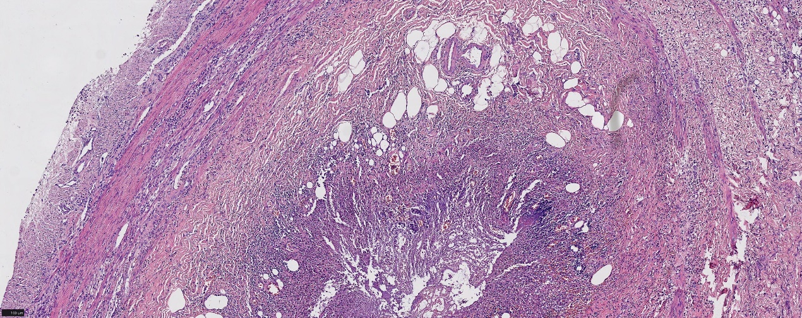
Fig 1. Pathology of uncomplicated appendicitis: The mucosa and submucosa exhibit inflammatory changes. The entire appendiceal wall is densely infiltrated by neutrophils and shows marked congestion and edema. The lumen is congested and contains inflammatory exudate. (HEx100)

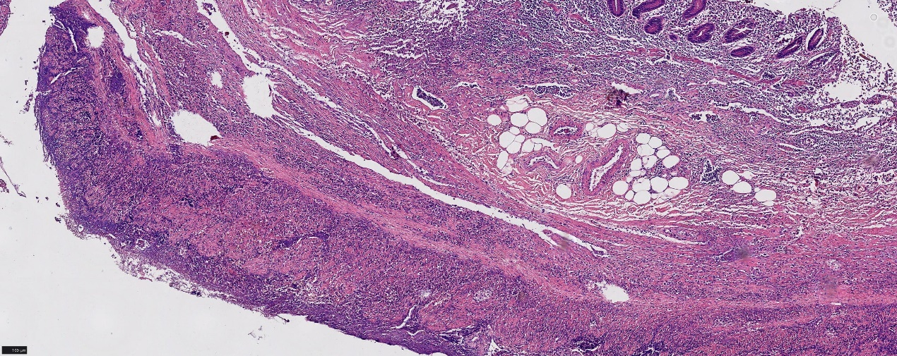
Fig 2. Pathology of complicated appendicitis: The mucosa and submucosa demonstrate lymphoid hyperplasia. The entire appendiceal wall is edematous and densely infiltrated by neutrophils, accompanied by vascular proliferation. Extensive coagulative necrosis is evident within the muscularis propria and serosa. (HEx100)

