Methods for characterization of atomic-scale field emission point-electron-source

Shuai Tang¹, Mingkai Gou¹, Yingzhou Hu¹, Jie Tang², Yan Shen¹, Yu Zhang¹, Lu-chang Qin², Ningsheng Xu¹, Richard G. Forbes³, Shaozhi Deng¹*

¹State Key Laboratory of Optoelectronic Materials and Technologies, Guangdong Province Key Laboratory of Display Material and Technology, School of Electronics and Information Technology, Sun Yat-sen University, Guangzhou 510275, China

²Faculty of Materials and Manufacturing, Beijing University of Technology, Beijing 100124, China

³School of Mathematics and Physics, University of Surrey, Guildford, Surrey GU2 7XH, United Kingdom

Corresponding Author E-mail: stsdsz@mail.sysu.edu.cn

ELECTRONIC SUPPLEMENTARY MATERIAL
Background theoretical information

1. Introduction
The aim of this supplementary document is to bring together in a single place most of the background material needed to fully understand the calculations in this paper, with appropriate references to original derivations and discussions. The material here includes: theoretical data and equations; discussions of how the various parameters involved are derived and defined; discussion of how characterisation parameters are extracted; and some other relevant material.

In order to make a distinction between the electric fields associated with Coulomb-type electrostatics and the electrical component of a travelling electromagnetic wave, a Coulomb-type electrical field is always called here an electrostatic (ES) field.

As in the main paper, this document uses the so-called electron emission sign convention, in which electrostatic fields, electron currents and electron current densities are regarded as positive, even though they would be negative in conventional textbook electrostatics. The symbol F is used to denote the negative of conventional textbook electrostatic field: F is thus positive in most circumstances affecting field electron emission (FE). Strictly, the conventional classical electrostatic name for F is "electrostatic potential gradient (ESPG)", but this note follows the usual FE-literature convention of calling F the "field".

As in the main paper, all equations are defined within the modern system, introduced in the 1970s and now called the International System of Quantities (ISQ), in which the electric constant ε₀ appears in Coulomb's Law. However, extensive use is made of so-called FE customary units. These customary units are fully and permanently compatible with ISQ equations. The main features of customary units are that: energy is expressed in eV; charge is expressed in eV V^{–1}; current is expressed in A; distance is expressed in nm or m (depending on the context); and mass is expressed in eV nm^{–2} s².

In these notes, electron emission induced by a negative ES field is termed "field electron emission". Other names in literature use are "field emission" and "electron field emission". The abbreviation "FE" is regarded as standing for any of these equivalent names.

2. Fundamental physical constants
FE theory makes use of the following fundamental constants: the elementary (positive) charge, e; the electric constant (aka the vacuum electric permittivity), ε₀; the electron rest mass in free space, m_{e}; Planck's constant, h_{P}; Planck's constant divided by 2π,  ; and the Boltzmann constant, k_{B}. The May 2019 values [R1] of these constants have been used. The Electronic Supplementary Material (ESM2) to Ref. [R2] records values of these constants, both in SI units and in FE customary units.

3. Universal constants and related parameters
The following universal constants and related parameters, tabulated in [R2], form part of the background to the main paper.
The Schrödinger-equation constant for an electron (κ_{e}), the Sommerfeld electron supply constant (z_{S}), first (a) and second (b) Fowler-Nordheim (FN) constants, the factor 4πε₀ and the Schottky constant (c) are universal constants defined and given (to 7 sig. figs) as follows:
κ_{e} ≡ (2m_{e})^{1/2}/  ≅ 5.123168 eV^{–1/2} nm^{–1} ; (E1)
z_{S} ≡ 4πem_{e}/h_{P}³ ≅ 1.618311×10¹⁴ A m^{–2} eV^{–2} ; (E2)
a ≡ e³ /8πh_{P} ≅ 1.541453 μA eV V^{–2} ; (E3)
b ≡ (4/3)(2m_{e})^{1/2}/e ≅ 6.830890 eV^{–3/2} V nm^{–1} ; (E4)
4πε₀ ≅ 0.694 4615 eV V^{–2} nm ; (E5)
c ≡ (e³/4πε₀)^{1/2} ≅ 1.199985 eV V^{–1/2} nm^{1/2} . (E6)
The constant κ_{e} was defined by Fowler and Nordheim [R3]. The constant z_{S} is associated with the statistical mechanics of the Sommerfeld model (e.g., see [R4]). The constant b emerges when determining the transmission probability for a triangular or approximately triangular potential-energy (PE) barrier (see Appendix A1). The constant a then emerges when a double integration is made over the energies of free-electron-metal internal energy states, in order to derive an expression for local emission current density (LECD) (see Section 11.1 below)). The factor 4πε₀ is internationally defined to be the constant that appears in the ISQ version of Coulomb's law. The constant c arises in connection with the Schottky-Nordheim barrier (see below) via the equation
Δ_{S} = cF^{1/2}, (E7)
where Δ_{S} is the "Schottky reduction" (of the barrier to electron escape) caused by an ES field of magnitude F.

The following combinations of universal constants are useful:
2κ_{e} ≅ 10.24624 eV^{–1/2} nm^{–1}; (E8)
ab² ≅ 7.192493 A eV^{–2} nm^{–2} ; (E9)
2/3b ≅ 9.759588×10^{–2} eV^{3/2} (V/nm)^{–1}; (E10)
c² ≅ 1.439965 eV² V^{–1} nm; (E11)
bc² ≅ 9.836239 eV^{1/2}. (E12)

The following parameters, involving the local work function φ, need to be evaluated:
Scaling parameter, η ≡ bc²φ^{–1/2} ≅ 9.836 ⋅ (eV/φ)^{1/2} . (E13)
Combination, ab²φ² ≅ 7.1925 ⋅ (φ/eV)² ⋅ (A nm^{–2}) . (E14)
The accuracy of these last two parameters depends on the accuracy with which φ is known.

4. Smooth planar metal emitter (SPME) methodology
The simplest theoretical treatments of FE use planar models that aim to describe FE from metals. Emission is modelled as taking place from the smooth planar surface of a Sommerfeld-type metal model. Atomic structure and atomic-level wave-functions are disregarded. This approach is sometimes called smooth planar metal emitter (SPME) methodology.

5. Basic definitions relating to electron energies
Denote the direction normally outwards from the Sommerfeld model surface by z, and call the electron-energy component associated with motion in the z-direction the electron normal-energy. The electron-energy component parallel to the model surface is purely kinetic in nature and is termed the electron parallel-energy. The electron total-energy is the sum of these components.
In FE theory it is convenient to measure both total-energy and normal-energy from the emitter Fermi level. Energies measured in this way are denoted by ε_{tot} and ε_{n}, respectively. Parallel energy is denoted by ε_{p}. Clearly, ε_{tot}=ε_{n}+ε_{p}. For consistency, electron potential energy (PE), denoted here by U_{e}, must also be measured from the Fermi level. Figure S1 shows electron normal-energy plotted against distance z, and illustrates some of these definitions. It also shows the local work function φ and the zero-field barrier height H applicable to an electron approaching the model surface with normal energy ε_{n}. Clearly H=φ–ε_{n} .

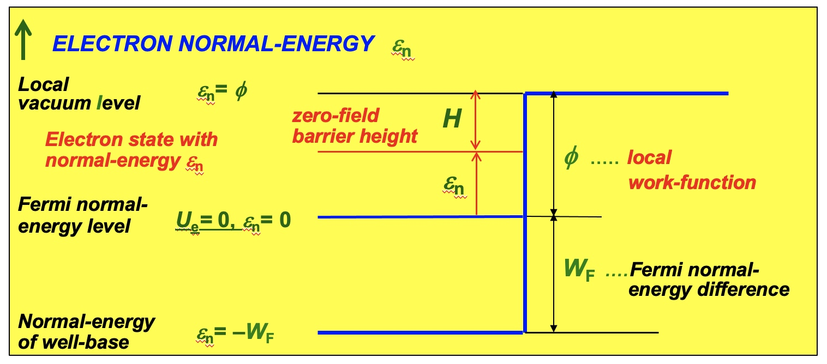
Fig. S1: To illustrate definitions of energies. Note that: H≡φ–ε_{n} .

.
6. Motive energies for the "exactly triangular" (ET) and "Schottky-Nordheim" (SN) barriers
In this planar geometry, electron transmission barriers are defined by the difference between the electron potential energy U_{e}(z) and the electron normal-energy ε_{n}. This energy difference is called here the electron motive energy and denoted by M(Η,F,z).

For local surface "field" F, the motive energy M^{ET}(Η,F,z) for an exactly triangular (ET) PE barrier of zero-field height H is given by
M^{ET}(H,F,z) ≡ Η – eFz . (E15)
The ET barrier takes electrostatic effects into account, but disregards an exchange-and-correlation (E&C) interaction between the escaping electron and the emitter. When this E&C interaction is modelled by a classical image PE, the motive energy M^{SN}(Η,F,z) for the resulting Schottky-Nordheim (SN) PE barrier is given by
M^{SN}(Η,F,z) ≡ Η – eFz – e²/16πε₀z . (E16)
Figure 2 below illustrates these barriers. For the special case where the zero-field barrier height is equal to the local work function φ, the parameter H in the above equations is replaced by φ.

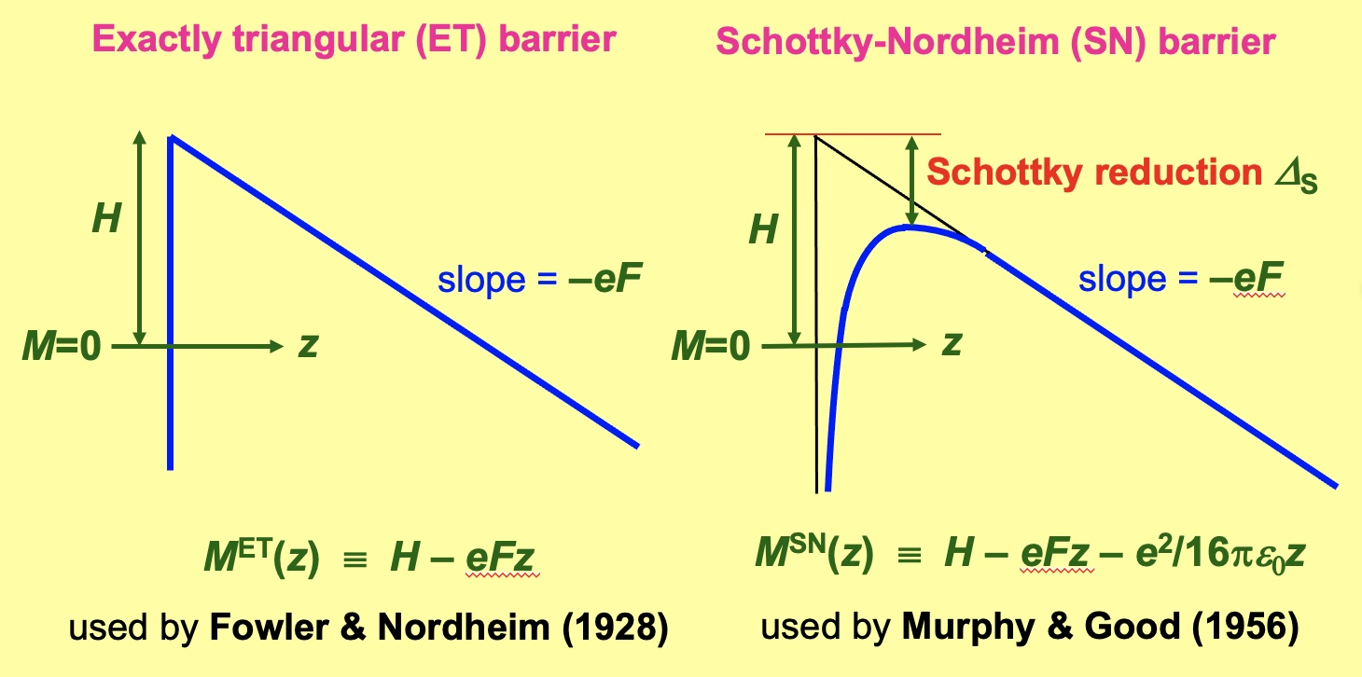
Fig. S2: To illustrate the forms of the ET and SN PE barriers.

7. Schottky reduction, reference field, scaled field and Nordheim parameter
As noted above, the effect of the image-PE term in eq. (E16) is to reduce the height of the zero-field barrier by an amount Δ_{S} called here the Schottky reduction and given by
Δ_{S} = cF^{1/2}, (E17)
where c is the Schottky constant defined above.

In the case of a SN barrier of zero-field height Η, the local "field" F_{H} necessary to reduce the barrier to zero is obtained by setting Δ_{S}=Η, yielding
F_{H} = c^{–2}H². (E18)
The so-called local scaled field (f_{H}) for a SN barrier of zero-field height Η is a positive dimensionless parameter that is related to the local "field" F by
f_{H} ≡ F/F_{H} = c²H^{–2}F . (E19)

In the case of a SN barrier of zero-field height φ, the "field" F_{φ} is the "field" necessary to pull the top of the SN barrier down to the Fermi level. This field has also been denoted by the symbol F_{R} and called the reference field. The related scaled field for a SN barrier of zero-field height φ is a positive dimensionless parameter given by
f_{φ} ≡ F/F_{φ} = c²φ ^{–2}F . (E20)
When no confusion is possible, the subscript "_{φ} " is normally dropped. In what follows, plain "f" always means "f_{φ}". This scaled field for a SN barrier of zero-field height φ plays an important role in modern FE theory.

Instead of scaled fields, many treatments of the SN barrier in FE literature (particularly older treatments) use the Nordheim parameters y and y_{F}, for SN barriers of zero-field height H and φ, respectively. These parameters are defined as follows:
y ≡ cΗ^{–1}F^{1/2} = f_{Η}^{1/2} ; (E21)
y_{F} ≡ cφ ^{–1}F^{1/2} = f_{φ}^{1/2} . (E22)
As indicated below, use of scaled fields rather than Nordheim parameters is considered mathematically superior. Scaled fields are used in the modern theory presented here.

8. Gamow factor and the simple-JWKB formalism for transmission probability
Terminology. The probability that an electron approaching the emitter surface from the inside will escape, either by tunnelling through a surface barrier or by passage over the top of the barrier, is called here the transmission probability. This term is now in strongly preferred over the term "transmission coefficient" occasionally used, because this latter name is ambiguous, in that it is also sometimes used to refer to the transmission amplitude. The general notation "D" for transmission probability, which was used by Fowler and Nordheim [R3] and by Landau and Lifschitz [R5] is preferred over the notation "T" sometimes used (particularly in theoretical papers), since this allows the symbol T to be used for thermodynamic temperature.

Gamow factor. For a PE barrier defined by Η and F, the modern Gamow factor G(H,F) [R6,R7] is a dimensionless mathematical-modelling parameter defined in terms of M(Η,F,z) by
G(Η,F) ≡ 2κ_{e} ∫{M(H,F,z)}^{1/2}dz , (E23)
where the integral is taken "across the barrier", in the range of z where M≥0, i.e. between the zeros of M(H,F,z).

In older work, an universal constant g_{e} was defined by g_{e}≡2κ_{e} and appeared in eq. (E23), but the introduction of an extra symbol was subsequently considered unnecessary.

Obviously, the precise mathematical form of G(Η,F) will depend on the barrier form chosen and hence on the precise mathematical form of the motive energy M(H,F,z). However, some mathematical results apply to all planar-barrier forms and it is convenient to first state results for a "general planar barrier" (GPB).

Given an expression for G(Η,F), there are four different mathematical formalisms ("transmission formalisms") [R8] that could be used to derive an expression for the barrier transmission probability D(H,F). The simplest of these is the so-called simple-JWKB (sJWKB) formalism (also called the "first-order JWKB formalism"). In this formalism the transmission probability for a barrier of zero-field height H is given by
D(Η,F) ∼ exp[–G(Η,F)] . (E24)
All widely used versions of planar FE theory use this sJWKB formalism in their derivations.
In FE, G(Η,F) has also been called the "barrier strength" [high G = strong barrier = low D].

9. Decay width at the (zero-temperature) Fermi level
An important parameter in FE theory, in particular in relation to the optical properties of needle-like FE sources, is the so-called decay-width at the (zero-temperature) Fermi level. This parameter is denoted here by d_{F}, though often just by "d" in the literature (and sometimes in other ways). Although algebraic expressions for d_{F} (or d_{F}^{–1}) can be found in the literature, it is difficult to find a precise definition of what the symbol d_{F} is intended to represent.
The authors' view is that (in planar FE theory) d_{F} should in principle be defined by the equation:
$d_{F}^{-1} ≡{(∂lnD/{∂ε}_{n})}_{F}|_{{(ε}_{n}=0)} = -{(∂lnD/∂H)}_{F}|_{(H=ϕ)}$. (E25)
When defined in this way, the theoretically estimated value of d_{F} depends both on the form assumed for the tunnelling barrier and on the formalism used to estimate transmission probability. Thus, when the Landau & Lifshitz (LL) formalism [R8] is applied to the general planar barrier (GPB), the transmission probability D(H,F) and the corresponding estimate of d_{F} are given (at a general level) by
D(H,F)[LL+GPB] = P^{GPB}exp[–G^{GPB}] , (E26)
d_{F}^{–1}[LL+GPB] = – (∂lnP^{GPB}/∂H)_{F} |_{(H=φ)} + (∂G^{GPB}/∂H)_{F} |_{(H=φ)} , (E27)
where P^{GPB} is a pre-factor of order unity. For the ET barrier, an expression for P^{ET} has been derived (e.g., [R3,R9]). For the SN barrier, P^{SN} can be estimated numerically [R10], but (at present) there is no known analytical form. The situation as regards other barriers is not examined here.

However, if the usual sJWKB formalism is used instead, then the prefactor term is not present and we get
D(H,F)[sJWKB+GPB] = exp[–G^{GPB}(H,F)] , (E28)
D(φ,F)[sJWKB+GPB] = exp[–G^{GPB}(φ,F)] , (E29)
d_{F}^{–1}[sJWKB+GPB] = (∂G^{GPB}/∂H)_{F} |_{(H=φ)} . (E30)
In FE literature, this last expression is what is normally used to define "decay width", and is what will be used here. In what immediately follows, the simpler notation "d_{F}^{GPB}" will be used.

It needs to be remembered, however, that decay-width values predicted in this way are approximations. These approximate values are expected to be "more than good enough for most current technological purposes", but there is no good knowledge of precisely how big any errors might be.

10. General-form equation for local emission current density in "deep-tunnelling" conditions
The term "in deep-tunnelling conditions" implies that most or nearly all electrons escape by tunnelling at normal-energy levels significantly below the top of the PE barrier.

Derivations of related equations use: (a) the electron statistical mechanics of the Sommerfeld model (including Fermi-Dirac statistics); (b) either the Landau&Lifshitz or the simple-JWKB transmission formalism (but usually the latter); and (c) a specific barrier form. The s-JWKB formalism will be used here. However, statistical aspects of the theory apply to all barrier forms, so initially theory will be developed for a general planar barrier (GPB).

10.1 Electron statistical behaviour in the Sommerfeld model
Consider a geometrical plane inside a metal modelled by the Sommerfeld model, and consider electrons approaching the plane that have energy components ε_{n} and ε_{p} normal and parallel to the plane, respectively. It can be shown (e.g., [R11]) that the contribution d²Z_{sup}, to the electron-current density (considered positive) approaching the plane, made by electrons in the small energy ranges dε_{n}, dε_{p}, is
d²Z_{sup} = f_{F-D}(T,ε_{tot}) ⋅ z_{S} dε_{n},dε_{p} , (E31)
where z_{S} is the universal constant, defined above, now called the Sommerfeld electron supply constant, and f_{F-D}(T,ε_{tot}) is the Fermi-Dirac distribution function, where T is thermodynamic temperature. In the present context, f_{FD}(T,ε_{tot}) is conveniently expanded in the form
f_{F-D}(T,ε_{tot}) = 1/[1+exp{(ε_{n}+ε_{p})/k_{B}T}] . (E32)

Each electron state makes a contribution to the local emission current density (LECD) J_{L}(φ,T,F). Thus, a two-dimensional integration of d²Z_{sup} over ε_{n} and ε_{p} is needed. However, since (in a free-electron model) the transmission probability depends on normal-energy but not on parallel-energy, the double integral over energy can be split into two steps, as follows.

10.2 Integration over parallel-energy to give N(T,ε_{n})
First, an integral over ε_{p} is performed to give a function denoted below by N(T,ε_{n}). (Surprisingly, the integral does have an exact analytical solution, as may be shown by differentiating the expression in the second equation below.)
$N\left(T,ε_{n}\right)=z_{S}\int_{0}^{∞}{1/[1+exp⁡\{(}ε_{n}+ε_{p})/k_{B}T\}]dε_{p}$
$= {-z}_{S}k_{B}T{\left[ln⁡[1+exp⁡\{(-ε_{n}-ε_{p})/k_{B}T\}]\right]}_{ε_{p}=0}^{ε_{p}=∞}$
$= z_{S}k_{B}Tln[1+exp⁡\{-ε_{n}/k_{B}T\}]$. (E33)
This function N(T,ε_{n}) is the incident electron-current density per unit normal-energy range, and is called here the incident normal-energy distribution (i-NED).

Older discussions of emission theory used a slightly different function, denoted here by N(old), that is related to N(T,ε_{n}) by
N(old) = N(T,ε_{n})/e . (E34)
This function N(old) was called the "supply function". It is considered better modern practice (more consistent with other aspects of emission theory) to "put e into N", rather than show it separately.

10.4 Integration over normal-energy to give J_{L}(φ,T,F)
The following integral over normal-energy then gives the LECD for a general planar barrier:
$J_{L}^{GPB}\left(ϕ,T,F\right)=\int_{-W_{F}}^{∞}{N\left(T,ε_{n}\right)∙D^{GPB}\left(ϕ,F,ε_{n}\right)}dε_{n}$, (E35)
where, as shown in Fig. S1, W_{F} is a positive parameter that is the difference in normal-energy between the Fermi level and the base of the Sommerfeld well. In most practical cases, the transmission-probability expression is very small for ε_{n}-vales near (–W_{F}) and below, so with negligible error the lower limit of integration can be taken as –∞.

To carry out the integration and obtain an algebraic result, usual practice is to formally Taylor-expand G^{GPB} about the Fermi level, and retain only the first-order term. This yields
$D^{GPB}\left(ϕ,F,ε_{n}\right) ≈exp[-G^{GPB}\left(ϕ,F,0\right)-{(∂G^{GPB}/∂ε_{n})}_{ϕ,F}∙ε_{n}]$ , (E36)
$D^{GPB}\left(ϕ,F,ε_{n}\right) ≈ D_{F}^{GPB}(ϕ,F) exp[ε_{n}/d_{F}^{GPB}]$, (E37)
where subscript "F" labels a value "taken at the Fermi level" (or, equivalently, taken for a barrier of zero-field height φ), and parametric dependences are omitted for notational simplicity.

With all the above approximations, eq. (E35) becomes
$J_{L}^{GPB}\left(ϕ,T,F\right)=z_{S}D_{F}^{GPB}\int_{-∞}^{∞}{k_{B}Tln[1+exp⁡\{-ε_{n}/k_{B}T\}]∙exp[ε_{n}/d_{F}^{GPB}]}dε_{n}$. (E38)
This integral can be solved exactly by first integrating by parts (which reduces it to a standard form), and then applying a formula from a handbook of standard integrals. The details are lengthy and slightly messy, cannot easily be found in published literature, and are recorded elsewhere [R12]. The outcome is a simple "general" (or "abstract") planar formula for the LECD, namely
$J_{L}^{GPB}\left(ϕ,T,F\right)={λ_{T}^{GPB}z}_{S}{{∙(d}_{F}^{GPB})}^{2}D_{F}^{GPB}$, (E39)
where the temperature correction factor $λ_{T}^{GPB}$ for the general planar barrier is given by
$λ_{T}^{GPB}= πp^{GPB}/sin(πp^{GPB})$, (E40)
and the Swanson-Bell parameter p^{GPB} for the general planar barrier is given by
$p^{GPB}≡k_{B}T/d_{F}^{GPB}$. (E41)
In the limit of zero temperature $λ_{T}^{GPB}→1$, and the zero-temperature form of the GPB equation for LECD is obtained.

Note that the form of (E39) allows a simple physical explanation of this equation. The first three terms can be collected into an effective local incident electron-current density, $Z_{F}^{GPB}$, thus
${{Z_{F}^{GPB}= λ}_{T}^{GPB}z}_{S}{{∙(d}_{F}^{GPB})}^{2}$ , (E42)
enabling eq. (E39) to be written in the "abstract" form
$J_{L}^{GPB}\left(ϕ,T,F\right)=Z_{F}^{GPB}D_{F}^{GPB}$. (E43)
Equation (E43) shows that the LECD is given by the product of the "transmission probability at the Fermi level" and the "effective local incident electron-current density"; eq. (E42) shows that $Z_{F}^{GPB}$ is the product of the "incident electron-current density per unit area of (ε_{n},ε_{n}) energy space z_{S}" and the "effective area of energy space $λ_{T}^{GPB}{{∙(d}_{F}^{GPB})}^{2}$" from which the emitted electron-current is drawn.

Also note that using only the first-order term in Taylor expansion (E36) is an approximation that gets increasingly weak as |ε_{n}| increases. The issues involved have been discussed by Gadzuk and Plummer [R13]. In particular, see their Fig. 4.

11. The LECD equations for the ET and SN barriers

11.1 Derivation of the elementary FE equation for LECD
The elementary (EL) FE equation is based on the s-JWKB formalism and the ET barrier. From equations above, we find that
G^{ET}(H,F) = bH^{3/2}/F ; (E44)
G_{F}^{ET} = bφ^{3/2}/F ; (E45)
D_{F}^{ET} = exp[–bφ^{3/2}/F] ; (E46)
d_{F}^{ET} = (2/3b)φ^{–1/2}F ; (E47)
From (E2) and (E47) we find (after some algebraic manipulation):
z_{S}⋅(d_{F}^{ET})² = (4z_{S}/9b²)φ^{–1}F² = (e³/8πh_{P}) φ^{–1}F² ≡ aφ^{–1}F² . (E48)
where a is the first FN constant, as defined above. The elementary (zero-temperature) FE equation is thus given by
$J_{L}^{EL}\left(ϕ,F\right)=aϕ^{-1}F^{2}exp[-bϕ^{3/2}/F]$. (E49)

There does exist a finite-temperature version of the elementary equation, obtained by multiplying eq. (E49) by an ET version of factor (E40), but nowadays this is rarely or never used.

11.2 The "21st Century" version of the 1956 Murphy-Good FE equation for LECD
Murphy-Good (MG) type equations are based the s-JWKB formalism and the SN barrier. Evaluation of integral (E23) for the SN barrier leads to a result of the form
G^{SN}(H,F) = v(H,F) ⋅ bH^{3/2}/F , (E50)
where v(H,F) is a mathematical correction factor.

This factor v(H,F) can be expressed in terms of a single "auxiliary variable". This can be either the variable y defined above, which is the so-called "legacy approach", or the variable f_{H} defined above, which is the so-called "21st Century approach". The "legacy approach" was developed in the 1950s by Murphy and Good [R14], following earlier work by Burgess, Kroemer and Houston (BKH) [R15] and Dyke and Trolan [R16], with a useful overview then given by Good and Müller [R17]. The "21st Century approach" was developed by Forbes and Deane in a series of papers in 2006 to 2008, including [R18–20], with an overview given later, in [R21].

Although, the "legacy approach" is still in widespread use in FE literature in 2026, the "21st Century approach" is mathematically superior and is used here. Reasons for strongly preferring the modern approach are discussed in [R21]. One objective has been to define and separate the pure mathematics involved, which has several technological applications, from the mathematics specifically involved in modelling electron transmission across the SN barrier.

When the "21st Century approach" is applied to the SN barrier, eq. (E50) is written in the more precise form
G^{SN}(H,F) = v_{FD}(f_{H}) ⋅ bH^{3/2}/F , (E51)
where v_{FD}(f_{H}) is a particular modelling application of a special mathematical function (SMF) v_{FD}(x) introduced by Forbes and Deane and discussed further below.

Applying definition (E30) to the SN barrier, noting that v_{FD}(f_{H}) is an indirect function of H, yields
${(d_{F}^{SN})}^{-1}= {(∂G^{SN}/∂H)}_{F}|_{H=ϕ} =\{v_{HD}(f_{H})+(2/3)H {(∂v_{HD}/∂H)}_{F}|_{H=ϕ}\}∙(3/2){bH}^{1/2}F^{-1}$. (E52)
The term ${H (∂v_{HD}/∂H)}_{F}$ can be transformed by using the relation
${H (∂v_{HD}/∂H)}_{F}= {(∂v_{HD}/∂f_{H})}_{F} ∙H {(∂f_{H}/∂H)}_{F}$ . (E53)
From definition (E19) above, we get
$H {(∂f_{H}/∂H)}_{F}=-2c^{2}H^{-2}= -2 f_{H}$. (E54)
Hence the bracketed term in eq. (52) becomes
$\{v_{HD}\left(f_{H}\right)-(4/3)f_{H} {(∂v_{HD}/∂f_{H})}_{F}|_{H=ϕ}\}.$ (E55)
By introducing a new SMF $t_{FD}(x)$ defined in terms of $v_{FD}(x)$ by
$t_{FD}\left(x\right) ≡ v_{FD}\left(x\right)-(4/3) x (∂v_{HD}/∂x)$ , (E56)
we see that term (E55) becomes
$t_{FD}\left(f_{H}\right)|_{H=ϕ}$ = $t_{FD}(f_{ϕ})$ . (E57)

At this point the subscript on $f_{ϕ}$ can be dropped, using the convention that f means $f_{ϕ}$ . Hence
d_{F}^{SN} is given by
$d_{F}^{SN}={\{t_{FD}(f)\}}^{-1}∙(2/3b)ϕ^{-1/2}F = {\{t_{FD}(f)\}}^{-1}∙d_{F}^{ET}$ . (E58)
It is then clear, from comparisons with equations above, that the "21st Century" version of the Murphy-Good finite-temperature equation for LECD is
$J_{L}^{MGT}\left(ϕ,T,F\right)=λ_{T}^{SN} t_{FD}^{-2}\left(f\right) aϕ^{-1}F^{2}exp[-v_{FD}(f)∙bϕ^{3/2}/F]$. (E59)
where $λ_{T}^{SN}$ is the SN-barrier form of the temperature correction factor, obtained by putting GPB→SN in eqns (E39) to (E41). The zero-temperature form of this equation is
$J_{L}^{MG0}\left(ϕ,F\right)=t_{FD}^{-2}\left(f\right) aϕ^{-1}F^{2}exp[-v_{FD}(f)∙bϕ^{3/2}/F]$. (E60)

12. Regime of applicability of the Murphy-Good finite temperature FE equation for LECD
The question arises of the regime of applicability of eq. (E59). Figure S3 is a slightly corrected and reduced version (prepared by Dr M.M. Allaham) of a "regime diagram" originally prepared by Murphy and Good [R14, see their Fig. 6], but with scaled field f plotted on the horizontal axis rather than local "field" F.
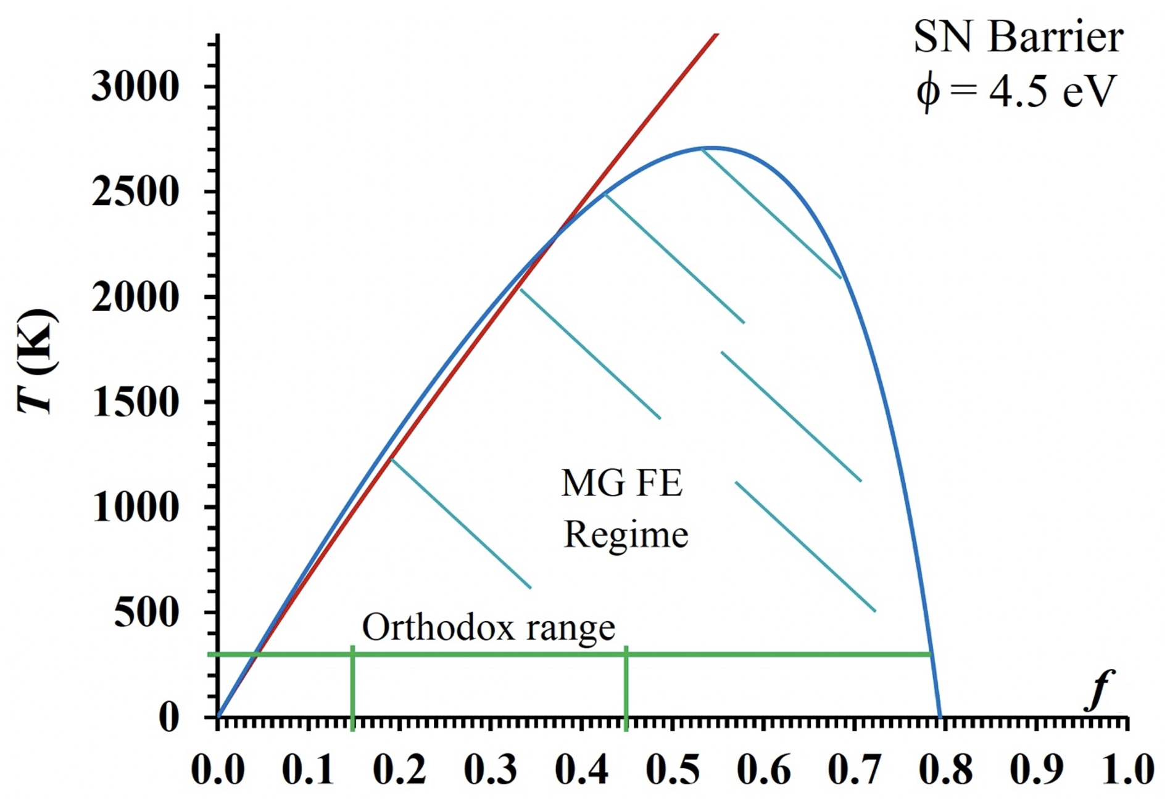
Fig. S3. To illustrate the regime of validity of eq. (E59). According to Murphy and Good [R14], the equation is considered adequately valid within the area inside both the red and blue curves. For a metal with φ= 4.5 eV, F is related to f by F ≈ (14.06 V/nm)⋅f . This version of the diagram, was prepared by Dr M.M. Allaham, and closely resembles the diagram published as Fig. 3b in Ref. [R22].

According to Modinos [R23, discussion following his eq. (1.56)], on the boundary of the emission regime the error in using eq. (E59), as compared with a more exact SPME calculation, varies between 15% and 40% .
The emission regime (i.e. LECD regime) shown in Fig. 3 has been called by various names, including "FE regime", "MG FE regime", "cold field electron emission (CFE) regime" (despite the fact eq. (E59) is valid to quite high temperatures), and "Fowler-Nordheim FE regime". Our view is that possibly the best name would be "Murphy-Good deep-tunnelling FE regime (MG DTFE regime)".

13. The Forbes-Deane (FD) special mathematical functions
A special mathematical function (SMF) is a well-defined mathematical function that has well-defined values for every value of its argument. Simple examples are "sin" and "exp". More complicated examples are the Airy functions and the complete elliptical integrals. There exists an international typesetting convention, used here, that symbols for special mathematical function are typeset upright.

The so-called "21st Century" approach to formulating SN barrier theory and applying it to the analysis of FE current-voltage measurements involves both: (a) the function v_{FD}(x), introduced above, and (b) a set of related functions, defined below. The whole group of functions (including related functions not defined in this document) can be called the Forbes-Deane (FD) special mathematical functions. The SMF v_{FD}(x) can be called the principal Forbes-Deane special mathematical function, since all the other FD SMFs are derived from v_{FD}(x). Since, mathematically, the SMF v_{FD}(x) is a special solution of the Hypergeometric Differential Equation first proposed by Euler but extensively investigated by Gauss, it is convenient to call x the Gauss variable.

The FD SMFs of interest to the main paper, other than v_{FD}(x), are defined as follows. For notational simplicity, here and in some places below, the subscript "FD" is omitted.
u_{FD}(x) ≡ – dv/dx , (E61)
t_{FD}(x) ≡ v_{FD}(x) – (4/3) x dv/dx = v_{FD}(x) + (4/3) x u_{FD}(x) , (E62)
s_{FD}(x) ≡ v_{FD}(x) – x dv/dx = v_{FD}(x) + x u_{FD}(x) . (E63)
r_{FD}(η,x) ≡ exp[η ⋅ u_{FD}(x)] . (E64)
η is considered an abstract mathematical parameter here, but "goes over" to the parameter η defined by eq. (E13) when these functions are applied to modelling FE from free-electron metals.

There exist BKH equivalents of these functions. These equivalents use the Nordheim parameter y as the independent variable. These BKH equivalents are in widespread use in the literature, but are not used in the main paper or in this supplementary material.

14. Algebraic expressions for v_{FD}(x)
Because the SMF v_{FD}(x) is a special solution of the Gauss HDE. it follows (from the mathematical properties of the Gauss HDE) that there exist many exactly-equivalent exact definitions of this SMF. An exact analytical definition does exist (see [R20]), but this involves mathematical functions unfamiliar to most scientists and engineers and is thus of limited use. To generate useful approximations, it is convenient to start from an exact series expansion derived in Ref. [R20]. The lowest-order terms of this are
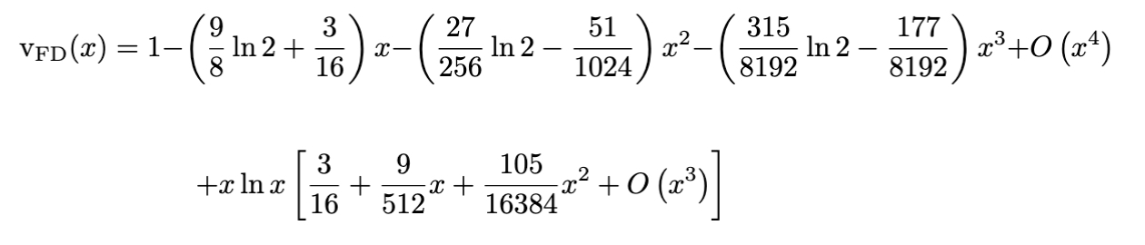 (E65)
Recurrence formulae for determining higher-order terms are given in [R20].

Note that v_{FD}(x) is mathematically unusual, in that (like elliptic integrals) its best series definition needs two infinite series.

By dividing the first series in eq. (E65) by (1–x), this series definition can be put in the "second form"
$v_{FD}\left(x\right)=\left(1-x\right)\left\{1+P^{\left(∞\right)}(x)\right\}+\left(xlnx\right)∙Q^{\left(∞\right)}\left(x\right)$, (E66)
where P^{(∞)}(x) and Q^{(∞)}(x) are both infinite power series.

A high-precision (HP) approximation formula for v_{FD}(x) is based on the form of the series in eq. (E66), but uses a finite number of terms, as below. An HP formula for u_{FD}(x), as below, uses a related argument.
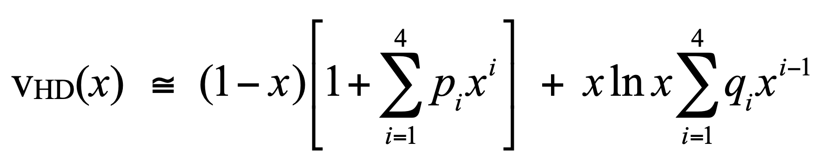 (E67)

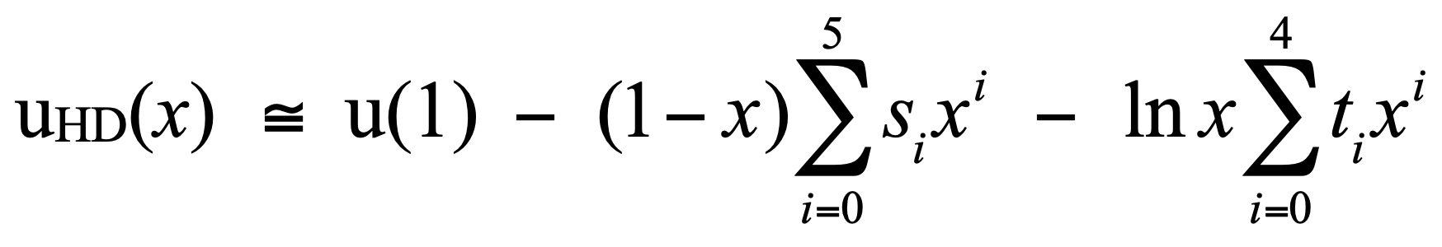 (E68)

Best-fit values for the coefficients in these formulae were obtained (by Dr J.H.B. Deane) by standard numerical fitting techniques and are shown in Table S1 below. Over the range 0≤x≤1 (but not outside this range), the magnitude of the maximum error in these formulae is 8×10^{–10}. [This error is determined by comparison with computer algebra results, which are estimated to have a default accuracy of about 30 decimal places.]

Table S1. Constants for use in connection with equations (E67) and (E68).
I | p_{i} | q_{i} | s_{i} | t_{i}
0 | - | - | 0.053 249 972 7 | 0.187 5 [=3/16]
1 | 0.032 705 304 46 | 0.187 499 344 1 | 0.024 222 259 59 | 0.035 155 558 74
2 | 0.009 157 798 739 | 0.017 506 369 47 | 0.015 122 059 58 | 0.019 127 526 80
3 | 0.002 644 272 807 | 0.005 527 069 444 | 0.007 550 739 834 | 0.011 522 840 09
4 | 0.000 089 871 738 11 | 0.001 023 904 180 | 0.000 639 172 865 9 | 0.003 624 569 427
_{a} | ₋ | ₋ | –0.000 048 819 745 89 | ₋
u(1) = u_{HD}(x=1) = 3π/8√2 ≅ 0.8330405509

High-precision formulae for all the Forbes-Deane SMFs, and for various related functions used in FE theory, have been implemented on a downloadable spreadsheet [R24,R25].

The "simple good approximation" (or "FD06 approximation"), v_{FD06}(x). There also exists a so-called "simple good approximation" for v_{FD}(x), namely
v_{FD}(x) ≈ v_{FD06}(x) = 1 – x + (1/6)xlnx . (E69)
This approximation was discovered in 2006 [R18], before the more precise formulae above were developed. This "simple good approximation" is less precise than the formulae set out above, but is simpler to use and seems good enough for most technological purposes.
Over the range 0≤x≤1, v_{FD06}(x) has an absolute accuracy better than 0.0024 and relative accuracy better than 0.33%.

Older approximations. In past literature there also exist a large number (about 15) of other relevant approximations. These can be mathematically transformed into approximations for v_{FD}(x) or v_{FD}(f) . Most of these approximations have been compared, as approximations for v_{FD}(f), in [R26]. Over the range 0.15≤f≤0.45, which is the "pass" range for the orthodoxy test [R27], the simple good approximation is superior to all other published approximations other than a particular form of optimised 3-term approximation due to Forbes and Deane [R19]. The high-precision approximations are significantly superior to all other published approximations.

15. Simple good approximations for the Forbes-Deane SMFs
Simple good approximations for the Forbes-Deane SMFs are obtained by applying definitions (E61–64) to eq. (E69). This results in the formulae:
v_{FD06}(x) = 1 – x + (1/6)xlnx ; (E70)
u_{FD06}(x) = 5/6 – (1/6)lnx ; (E71)
t_{FD06}(x) = 1 + (1/9)x – (1/18)xlnx ; (E72)
s_{FD06}(x) = 1 – (1/6)x ; (E73)
r_{FD06}(η,x) = exp[η ⋅ {5/6– (1/6)lnx}] . (E74)
These approximations have been used in the main paper.

16. "Experiment-oriented" FE equations relating measured current to measured voltage
Notional emission area for the SN barrier. The next stage is to develop (for the SN barrier) an expression for measured current I_{m} in terms of measured voltage V_{m}. The first step is to carry out an integration of the LECD over the surface of the emitter. Obviously, real emitters are post-like or needle-like, and surface curvature will in principle affect both the supply of electrons to the emitter surface and the transmission probability. Basic approaches assume the planar emission approximation, which postulates that (in the integration) it is a sufficient approximation to take as the LECD at surface location "L" the chosen planar FE equation (here the MG FE equation), using the local work function φ_{L} and local surface "field" F_{L} at location "L". This approximation is adequately valid if the emitter is "not too sharp". Opinions currently differ as to how sharp is "too sharp". Our thinking is that the approximation becomes of deteriorating validity as the apex radius of curvature reduces below about 20–50 nm.

This integration yields a so-called notional electron-emission current I_{n}^{MGT}. By choosing a characteristic location "C" at which the LECD is particularly high [which implies that (φ_{C}^{3/2}/F_{C}) is relatively low], this result can be put in the form
I_{n}^{MGT} = A_{nC}^{SN} J_{C}^{MGT}(φ_{C},Τ,F_{C}), (E75)
where A_{nC}^{SN} is a notional emission area, as derived by assuming a SN barrier, with a particular choice of location "C". In principle, the value of A_{nC}^{SN} depends on the choice of "C" and on various other emitter-related parameters, including emitter shape.

For simplicity in modelling, post and needle-like emitters are usually taken as cylindrically symmetric, and across-surface variations in local work-function are disregarded. (This is the uniform work-function approximation.) Hence the subscript on φ is usually omitted. In these circumstances location "C" is at the emitter apex.

Characteristic formal emission area for the SN barrier. I_{n}^{MGT} is not an accurate prediction of measured emission current I_{m} because many factors have been left out (in particular, atomic effects). Hence we introduce a prediction uncertainty factor λ (size unknown) and write
I_{m} = λ I_{n}^{MGT} = λ A_{nC}^{SN} J_{C}^{MGT} ≡ A_{fC}^{SN} J_{C}^{MGT}, (E76)
where the characteristic formal emission area (derived by assuming a SN barrier), A_{fC}^{SN}, is provisionally given by
A_{fC}^{SN} = λ A_{nC}^{SN}. (E77)

However, because the values and functional dependences of λ are seriously unknown, this is not a helpful definition for modelling or for data analysis. It is better to define the formal emission area A_{fC}^{SN} in the following way. First, the kernel current density $J_{k}^{MG}$ for the MG FE equation is defined by omitting the $t_{FD}^{-2}\left(f\right)$ term from eq. (E60) to give
$J_{k}^{MG}\left(ϕ,F\right)=aϕ^{-1}F^{2}exp[-v_{FD}(f)∙bϕ^{3/2}/F]$. (E78)
The formal emission area A_{fC}^{SN} is then regarded a parameter derived from experiment, given by
$A_{fC}^{SN}≡I_{m}/J_{kC}^{MG}$ , (E79)

Voltage-to-local-field conversion factor (CF). The next step is to define the relationship between measured voltage V_{m} and the characteristic local field F_{C} (equivalent, in models with cylindrical symmetry, to apex local field). This relationship is written here in the form
F_{C} = β_{C}V_{m} , (E80)
where β_{C} is the characteristic (voltage-to-local-field) conversion factor (CF) defined via this equation

EMG equation for I_{m}(V_{m}). The equation for I_{m} as a function of V_{m} can then be written in the form
I_{m}^{EMG} = A_{fC}^{SN} aφ^{–1}(β_{C}V_{m}) ² exp[–v_{FD}(f_{C}) bφ^{3/2}/ β_{C}V_{m}] . (E81)
This equation has been called the "extended" or "experiment-oriented" Murphy-Good (EMG) FE equation (for measured current as a function of measured voltage).
The effect of this "experiment-oriented" approach has been to "sweep into the formal area" the small correction terms associated with temperature and with the Taylor expansion of G^{SN}, where they join the much larger correction terms hidden in the formal emission area, in particular those associated with the neglect of effects due to atomic wave-functions. Thus the interpretation of measured current-voltage characteristics is split into two tasks: the accurate extraction of formal area values from experiments; and the physical interpretation of these values. Due to gaps in our understanding of quantum mechanics and/or how best to apply it, amongst other things, full interpretation of these values is not possible at present, but A_{fC}^{SN} could be a a useful empirical parameter in research-and-development contexts.

Characteristic formal emission area for the ET barrier. If an exactly triangular (ET) barrier is assumed, rather than a SN barrer, then an argument similar to that above leads to the following definition for the characteristic formal emission area (derived by assuming an ET barrier), A_{fC}^{ET}:
A_{fC}^{ET} ≡ I_{m} /J_{C}^{EL}, (E82)
where J_{C}^{EL} is the characteristic LECD given by the elementary FE equation, with (as before) the characteristic location being taken at the emitter apex in the simplest emitter models.

17. Analysis of Fowler-Nordheim plots using the Extended Murphy-Good FE equation
An FE system in which there is no leakage current and the conversion factor β_{C} is constant, independent of measured voltage V_{m}, is said to be electronically ideal. Conventional methods of FE data-analysis, including Fowler-Nordheim (FN) plots, may yield spurious results if the FE system and the resulting data are not electronically ideal. The need for validity tests is discussed below. The data analysis method discussed in this section assumes that the FE system that generated the data is electronically ideal.

It is best practice to make experimental Fowler-Nordheim plots by using the measured current-voltage data, and this is assumed here.

In so-called Fowler-Nordheim (FN) coordinates, eq. (E81) takes the form
L_{FN}^{EMG} ≡ ln{I_{m}^{EMG}/V_{m}²} = ln{A_{fC}^{SN} aφ^{–1}β²} – v_{FD}(f_{C}) bφ^{3/2}/ βV_{m} (E83)
This equation describes a slightly curved line (more so at the high-voltage end).

The tangent method of FN plot analysis was introduced in 1953 by Burgess, Kroemer and Houston [R15]. A modified version of the original method is used here. In this approach, the line fitted to the experimental data points is modelled as a tangent to eq. (E83), taken at the (unknown) voltage value V_{t} at which this tangent is parallel to the straight line fitted to the experimental points.

Strictly, the straight line fitted to the experimental points should be regarded as a chord to eq. (E83) and a small correction should be applied to the tangent method (see [R28]). However, the size of the correction is small and it is almost always disregarded.

This value V_{t} is termed the fitting value of V_{m}. As shown below, V_{t} corresponds to a particular (but initially unknown) fitting value f_{t} of characteristic scaled field f_{C}.

It follows that, at the fitting point, the tangent to eq. (E83) can be written in the form
L^{tan} = ln{R^{tan}(f_{t})} + S^{tan}(f_{t}) / V_{m} . (E84)
It can be shown (see Appendix A2) that the slope S^{tan}(f_{t}) of this tangent is given by
S^{tan}(f_{t}) = – s_{FD}(f_{t}) ⋅ bφ^{3/2}/β_{C} , (E85)
where the fitting value s_{FD}(f_{t}) of the slope correction factor s_{FD}(f_{C}) is a particular value of the SMF s_{FD}(x) defined earlier.

The parameter ln{R^{tan}(f_{t})} gives the value of L_{FN} at which the tangent intersects the vertical (1/V_{m}=0) axis. It can be shown [R29] that R^{tan}(f_{t}) can be written in the form
R^{tan}(f_{t}) = r_{FD}(φ,f_{t}) A_{f}^{SN} aφ^{–1}β_{C}² , (E86)

where the fitting value r_{FD}(φ,f_{t}) of the intercept correction factor r_{FD}(φ,f_{C}) is a particular value of the SMF r_{RD}(η,x) defined earlier.

For notational simplicity, define r_{t}≡ r_{RD}(φ,f_{t}) and s_{t}≡ s_{FD}(f_{t}). Combining (E85) and (E86) then yields
R^{tan}(f_{t}) ⋅{S^{tan}(f_{t})}² = A_{f}^{SN} ⋅ (abφ²) ⋅ (r_{t}s_{t}²). (E87)

Let the straight line fitted to the experimental FN plot have the form
L^{expt} = ln{R^{expt}} + S^{expt}/V_{m} . (E88)
By identifying the experimental slope and intercept with the slope and intercept of the theoretical tangent, the following extraction formulae are obtained:
β^{extr}[SN] = – s_{t} bφ^{3/2} / S^{expt} ; (E89)
${{\{A}_{f}^{SN}\}}^{extr} = Λ_{FN}^{SN} { [R}^{expt}{{ (S}^{expt})}^{2}]$, (E90)
where the area extraction parameter, $Λ_{FN}^{SN}$, for a FN plot, assuming a SN barrier, is given by
$Λ_{FN}^{SN}$= 1/[(ab²φ²) ⋅ (r_{t}s_{t}²)]. (E91)
These formulae apply to both single-tip field electron emitters (STFEs) and to large-area field electron emitters (LAFEs). For LAFEs, an additional step is possible, in that one can derive an extracted value for the formal area efficiency (assuming an SN barrier), $α_{f}^{SN}$. If the "macroscopic area" (or "footprint") A_{M} has been recorded, then this extracted value is given by:
${{\{α}_{f}^{SN}\}}^{extr} = {{\{A}_{f}^{SN}\}}^{extr}/A_{M}$. (E92)
This parameter ${{\{α}_{f}^{SN}\}}^{extr}$ is a measure of the fraction of the emitter's macroscopic area that is emitting electrons. It is not an accurate measure, but is a characterisation parameter that could be useful in Research-and-Development contexts.

18. Evaluation of the fitting parameters
It remains to determine suitable values for the various fitting parameters. The relevant equations are as follows. From definition (E20), with f_{φ} set equal to f_{t}, and definition (E80), with all parameters subscripted "t", we obtain
f_{t} = (c²φ ^{–2} V_{t}) ⋅ β_{t} . (E93)
From eq. (E89) we have
β_{t} = – s_{t} bφ^{3/2} / S^{expt} . (E94)
with s_{t} estimated, as earlier, via the relation
s_{t} ≡ s_{FD06}(x=f_{t}) . (E95)

It can be seen that in eq. (E93) there are two unknowns, V_{t} and β_{t}. In older work, normal practice was to choose a specific value for s_{t} (often 0.95) from which everything else can be determined. In the present work a different approach is taken, namely a specific value is chosen for V_{t}, a starting value β_{start} is chosen for the conversion factor, and an iterative process is used to determine good-precision values for f_{t}, s_{t} and other relevant parameters.

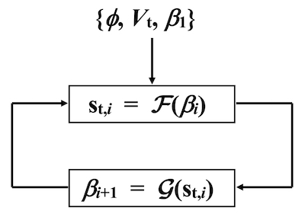
Fig. S4. To illustrate the iteration loop in the authors' data-analysis program.

The iteration loop is illustrated in Fig. S4 and involves the two components
s_{t,i} = F(β_{ι}) = s_{FD06}(f_{t,i}), with f_{t,i} = {c²φ ^{–2} V_{t}}⋅β_{i} , (E96)
β_{i+1} = G(s_{t,i} ) = – s_{t,i} ⋅{bφ^{3/2}/S^{expt}}. (E97)
Here, i is the iteration variable (i ≥1), β_{i}, f_{t,i} and s_{t,i} are the ith estimates of β, f_{t} and s_{t}, and F(β_{ι}) and G(s_{t,i} ) are the modelling functions shown. For notational simplicity here, all labels other than "t" and "i" have been removed.

We choose some particular value in the measured voltage range to be an estimate of the fitting value V_{t}. To start the iteration we set β₁ equal to a chosen starting-value β_{start}. In practice, it is found sufficient to take β_{start} = 10^{–3} nm^{–1}, The iteration rapidly converges, and is stopped when the incremental change in β is less than 10^{–4}. The resulting estimates of the fitting parameters can then be used to extract characterization parameters.

The process is then repeated for a set of values of V_{t} chosen systematically from across the measured-voltage range.

The output of the program shows how the various calculated parameters depend on the value assumed for the fitting voltage. The further analysis of this data is described in Section 2.3 of the main paper.

19. Overview of downloadable program
A program has been developed that implements this iteration loop in the context of using a FN plot to analyse current-voltage-type input data. The program then goes on to extract emitter characterization parameters. A separate part of the program is available to calculate the FE total-energy distribution, as a function of work function, temperature and field. The high-level structure of the main program option is as shown in Table S2.

Table S2. Effective high-level structure of main programme option
1. | Select assumed value of local work function φ
2. | Read in experimental I_{m}(V_{m}) data
4. | Fit regression line to FN plot of input data, and extract values of S^{expt} and R^{expt}
5. | Use range of measured-voltage values to decide estimates of fitting voltage V_{t} to be assessed.
6. | For each chosen fitting-value estimate V_{t} , run steps 7 to 10
7. | Run iteration loop to find related fitting values of f_{t}, s_{t} and r_{t} and extracted value of β
8. | Extract related value of formal emission area A_{f}^{SN}
9. | Calculate, for chosen value of V_{t} and related extracted value of β, the related extracted  value of field F and the related extracted value of decay width d_{F}
10. | Calculate corresponding value of practical brightness, using eq. (9) in main paper
11. | Report results in graphical form as functions of chosen fitting voltage

20. Interpretation of formal emission area $A_{f}^{SN}$
It needs to be understood that the formal emission area $A_{f}^{SN}$ is not an accurate estimate of "true emission area" (however this is defined), but is a "catch all" parameter that also includes effects due to the following: limitations of Murphy-Good theory, including all quantum-mechanical limitations, especially neglect of effects due to atomic-level wave-functions and neglect of effects due to emitter electronic band structure; temperature effects; effects related to the first-order Taylor expansion of G^{SN}, effects due to work-function variability across the surface; emitter shape effects of various kinds; and accuracy-limitations of FN-plot analysis.

It will probably be many years (possibly 20 years or more) before we achieve an understanding of FE theory that is good enough to allow accurate extraction of "true emission area" (however this is defined) from experimental data by using FN-plot or similar techniques.

Notwithstanding this, both ${{\{A}_{f}^{SN}\}}^{extr}$ and ${{\{α}_{f}^{SN}\}}^{extr}$ are considered to be useful empirical parameters that (particularly in the context of Research and Development) can be used to compare the emission properties of different emitters.

Slightly better precision in extraction of formal emission area $A_{f}^{SN}$ can in principle be obtained (for electronically ideal systems) if a so-called Murphy-Good plot is used, rather than a FN plot. Details are given in [R30]. This approach was considered beyond the scope of the present work, but could usefully be investigated in future work.

21. Extraction of parameters from FN plots using exactly-triangular-barrier theory
As above, the remarks in this Section apply only to FE systems and data that are electronically ideal.

Arguments broadly similar to those above, but somewhat simpler, can be applied to the exactly triangular (ET) barrier. These result in the following extraction equations for characterization parameters:
β^{extr}[ET] = – bφ^{3/2} / S^{expt}, (E98)
${{\{A}_{f}^{ET}\}}^{extr} = Λ_{FN}^{ET} { [R}^{expt}{{ (S}^{expt})}^{2}]$, (E99)
where the area extraction parameter, $Λ_{FN}^{ET}$, for a FN plot, assuming an ET barrier, is given by
$Λ_{FN}^{ET}$= 1/[(ab²φ²)]. (E100)

As can be seen, the results for the ET barrier are obtained from those for the SN barrier by setting s_{t}=1 and r_{t}=1. For the conversion factor the difference is typically about 5%. But for formal emission areas, the ET-barrier approach yields formal emission areas that are typically about a factor of 100 (or more) greater than those derived used the SN-barrier approach. Thus, theoretical expectation is that significant error is involved in emission-area extraction when the ET-barrier approach is used.

22. The need for validity checks
22.1 The causes of non-ideality
As already indicated, the data-analysis methods discussed here will yields correct results only if the FE system and associated current-voltage data are "electronically ideal". Aspects of this concept can be understood by reference to the idealised circuit diagram shown as Fig. S5.

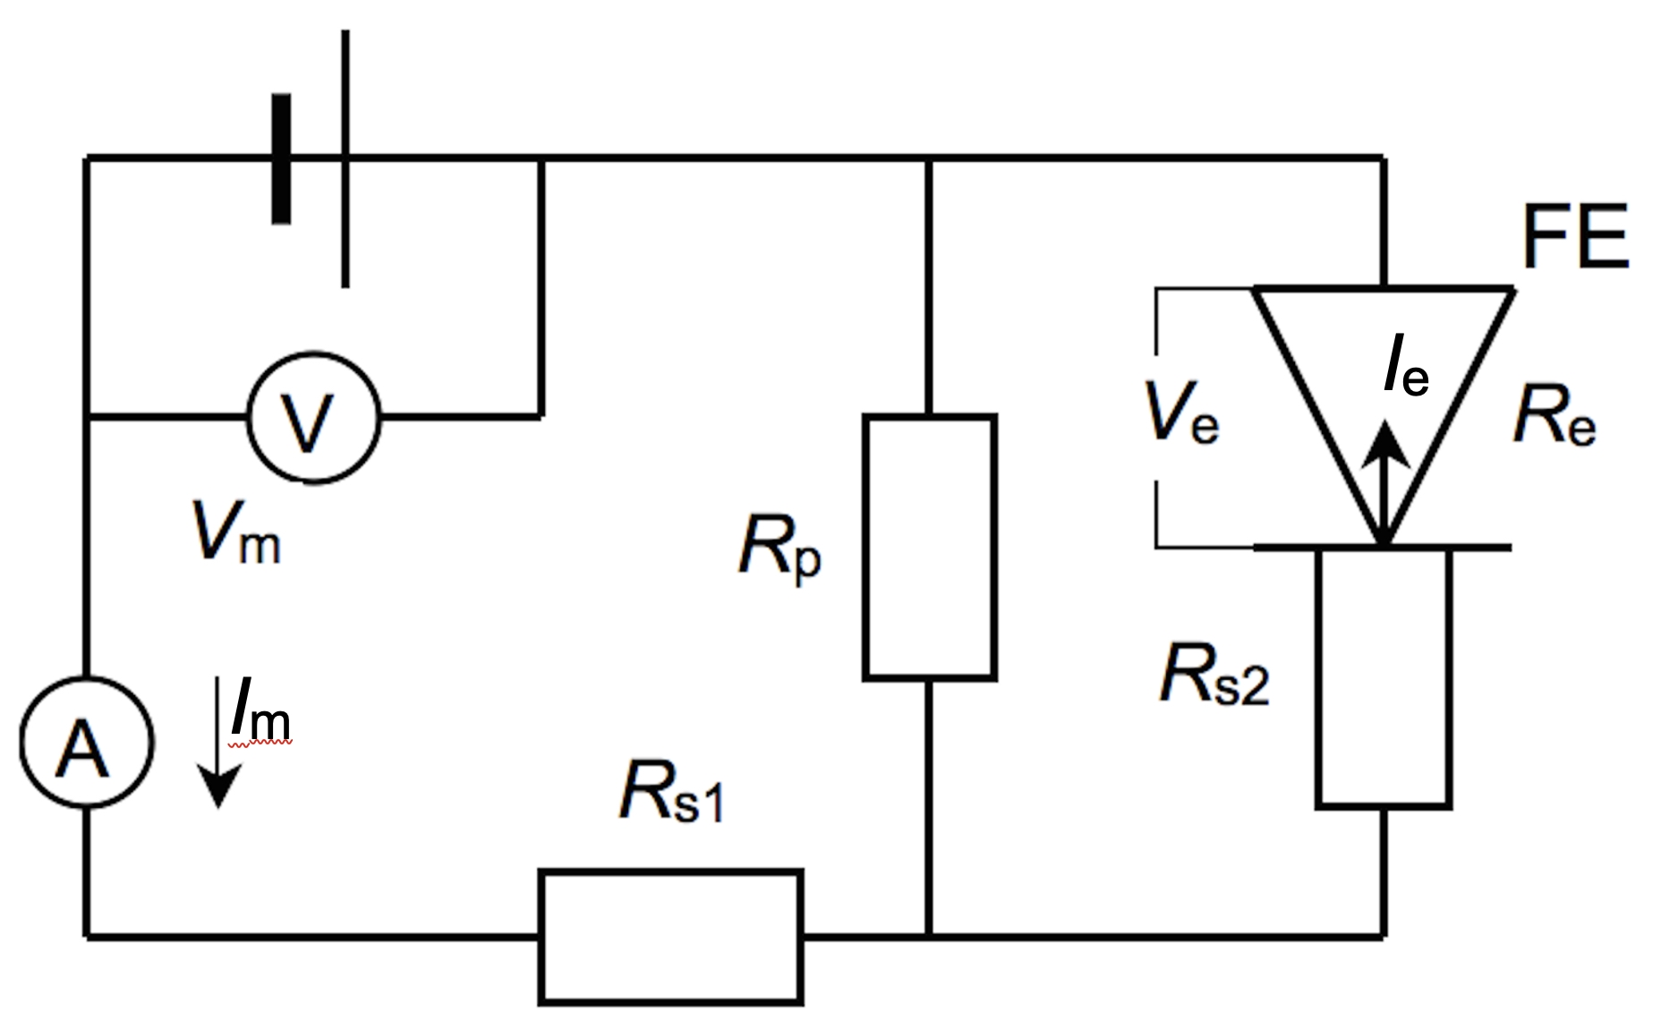

Fig. S5 Idealised circuit diagram of a FE system. For precise definitions of the emission voltage V_{e} and emission current I_{e} see text. Note that this diagram uses the electron emission convention in which electron currents are treated as positive, even though they would be negative in conventional electricity theory.

In this circuit diagram, the emission voltage V_{e} is the voltage between the counter-electrode and the characteristic location "C" on the surface of the emitter apex region. V_{e} is a positive quantity in the circumstances of field electron emission. The emission current I_{e} is the electron-current that passes from the emitter apex region to the counter-electrode. The emission resistance R_{e}≡ V_{e}/I_{e}, and is a function of V_{e} (and also of the effective area of emission). R_{e} is high for low values of V_{e}, but steadily decreases as V_{e} increases.

A FE system is called electronically ideal if: (1) I_{e}=I_{m}; and (2) V_{e}=V_{m}. The first condition requires that the parallel resistance R_{p} be very large (in comparison with the (R_{s2}+R_{e}), so that there is no leakage current through R_{p}. The second condition requires that the total series resistance (R_{s1}+R_{s2}) be very small in comparison with R_{e}. The first condition can often be implemented by suitable system design. The second condition can sometimes be difficult to achieve, particularly with non-metallic emitters that have relatively high resistivity.

Because the value of R_{e} falls off with increasing V_{e}, it is possible for a FE system to be electronically ideal in the lower part of its measured operating voltage (V_{m}) range, but to become non-ideal at higher operating voltages, typically causing a Fowler-Nordheim plot made using measured data to "bend downwards" at the left-hand (high-voltage) side.

There are also other situations, such as the presence of field emitted vacuum space-charge (FEVSC), that can cause non-ideality. A more comprehensive discussion, identifying 12 forms of "system complication", i.e. 12 potential causes of non-ideality, is provided in Ref. [R31]. However, it is thought by one of us (RGF) that the commonest (though not the only) cause of observed non-ideality is probably voltage loss along the shank of the emitter. Many papers seem not to recognise this as a possibility.

There are thought to be many published FE papers that state spurious values of characterization parameters because their original data are not electronically ideal. Hence, before carrying out detailed data analysis it is advisable to check that the FE system being used is electronically ideal (or nearly so), at least over a significant part of the measured voltage range. It is also useful to report in presentations and papers that this has been done.

Relevant validity checks are: (1) that the chosen data-analysis plot is "nearly linear"; and (2) that the system passes the Orthodoxy Test [R27]. For detailed discussion see [R32]. For a spreadsheet for applying the Orthodoxy Test, see supplementary material for [R27]. A webtool for applying the Test is under development [R22,R33].

If the Orthodoxy Test has not been carried out before detailed data analysis, there is now a simplified version of the test (provisionally called the "magic emitter test" [R31]), but likely to end up as called the "implausible field-values test") that can be applied after data analysis, if information is available both about the highest macroscopic-field value used in the experiments and about an extracted dimensionless field enhancement factor (FEF). This "magic emitter" test may also be useful when reviewing papers or testing the validity of published FEF values. A merit of all the tests is that they can easily be applied by graduate students without needing assistance from their supervisors.

Appendix A1: Derivation of expression for Second FN Constant b
The simplest method of deriving an expression for the Second FN Constant is to apply the sJWKB formalism to the ET barrier. From eq. (E15), the motive energy for an ET barrier of zero-field height H, in the presence of local "field" F, is
M^{ET}(H,F,z) ≡ Η – eFz . (A1.1)
The range of integration needed (where the motive energy is ≥0) is from z=0 to z=H/eF. Hence, from eq. (E23), the Gamow factor for the ET barrier is
$G^{ET}=2κ_{e}\int_{0}^{H/eF}{{(H-eFz)}^{1/2}dz} = -(4/3)(κ_{e}/eF){{[(H-eFz)}^{3/2}]}_{0}^{H/eF}$
$= (4/3)(κ_{e}/e)H^{3/2}/F$. (A1.2)
From eq. (E1), κ_{e} ≡ (2m_{e})^{1/2}/. It follows that expression (A1.2) can be rewritten in the form
$G^{ET} = bH^{3/2}/F$, (A1.3)
where b is an universal constant defined by
b ≡ (4/3)(2m_{e})^{1/2}/e . (A1.4)
This constant, b, also emerges in more complicated treatments, either of the ET barrier or of approximately triangular barriers.

Appendix A2: Derivation of expressions for slope correction function s_{FD}(f_{C}) and for SMF s_{FD}(x)
From eq. (E82), when the (theoretical) EMG FE equation is applied to a needle or post-like emitter and is plotted in I_{m}(V_{m})-type FN coordinates, then it takes the form
L_{FN}^{EMG} ≡ ln{I_{m}^{EMG}/V_{m}²} = ln{A_{fC}^{SN} aφ^{–1}β_{C}²} – v_{FD}(f_{C}) bφ^{3/2}/ β_{C}V_{m} , (A2.1)
This equation describes a slightly curved line (more so at the high-voltage end).

If any weak field dependences in φ or in A_{fC}^{EMG} are disregarded, then––at any specific value of V_{m}^{–1} (and hence some specific value of f_{C})––the slope S^{theor}(V_{m}^{–1}) of eq. (A2.1)––and hence the slope of the tangent to this curve, taken at this value of V_{m}^{–1}, is given by
S^{tan}(V_{m}^{–1}) ≡ dL_{FN}/d(V_{m}^{–1}) = – (∂{v_{FD}(f_{C}) ⋅ V_{m}^{–1}}/∂{V_{m}^{–1}})_{φ} ⋅ bφ ^{3/2}/β_{C}
= –[ v_{FD}(f_{C}) + V_{m}^{–1} (∂{v_{FD}(f_{C})}/∂{V_{m}^{–1}})_{φ}] ⋅ bφ ^{3/2}/β_{C}. (A2.2)
where the fact that v_{FD}(f_{C}) is an indirect function of measured voltage has been taken into account. Further, since d(V_{m}^{–1}) = – V_{m}^{–2}dV_{m} , eq. (A2.2) becomes
S^{tan}(V_{m}^{–1}) = – [v_{FD}(f_{C}) – V_{m} (∂{v_{FD}(f_{C})/∂V_{m})_{φ}] ⋅ bφ ^{3/2}/β_{C}. (A2.3)

From the relations f_{C}=F_{C}/F_{φ} and F_{φ}=β_{C}V_{m,φ} it is possible to define a reference measured voltage V_{m,φ} at which a SN barrier of zero-field height φ is reduced to zero, and deduce that:
V_{m} = f_{C} V_{m,φ} ; and dV_{m} = V_{m,φ} df_{C} . (A2.4)
Hence: V_{m}/dV_{m} = f_{C}/df_{C} , (A2.5)
and eq, (A2.3) can be rewritten as
S^{tan}(V_{m}^{–1}) = – [v_{FD}(f_{C}) – f_{C} (∂{v_{FD}(f_{C})/∂f_{C})_{φ}] ⋅ bφ ^{3/2}/β_{C} . (A2.6)

The expression in square brackets can be identified as a particular application of the SMF s_{FD}(x) defined by eq. (E63), and hence can be represented by the symbol s_{FD}(f_{C}). Thus eq. (A2.6) becomes written
S^{tan}(V_{m}^{–1}) = – s_{FD}(f_{C}) ⋅ bφ ^{3/2}/β_{C}. (A2.7)

References

[R1] E. Tiesinga, P.J. Mohr, D.B. Newell, and B.N. Taylor, "CODATA recommended values of the fundamental physical constants: 2018", Rev. Mod. Phys. 93 (2021) 025010. https://doi.org/10.1103/RevModPhys.93.025010
[R2] R.G. Forbes and J.H.B. Deane, "Transmission coefficients for the exact triangular barrier: an exact general analytical theory that can replace Fowler & Nordheim’s 1928 theory", Proc. R. Soc. Lond. A 467 (2011) 2927–2947. https://doi.org/10.1098/rspa.1928.0091 See Electronic Supplementary Material, Section ESM 2.
[R3] R.H. Fowler and L Nordheim, "Electron emission in intense electric fields", Proc. R. Soc. Lond. A 119 (1928) 173–181. https://doi.org/10.1098/rspa.1928.0091
[R4] R.G. Forbes, "Use of energy-space diagrams in free-electron models of field electron emission", Surf. Interface Anal. 36 (2004) 395–401. See Appendix. Note that there is a typographic error in eq. (14), in that the value of z_{S} is given incorrectly: the correct value is given by eq. (E2) above. https://doi.org/10.1002/sia.1900
[R5] L.D. Landau and E.M. Lifschitz, Quantum Mechanics (Third Edition) (Butterworth-Heinemann, Oxford, 1977).
[R6] This modern factor is named "in honour" of Gamow. It does not actually appear in his original paper [R7], which was more concerned with the form of the transmitted wave-function. The original Gamow factor was given by the unnumbered equation after eq. (4) in [R7], which is a statement about transmission amplitude rather than transmission probability.
[R7] G. Gamow, "Quantum theory of the atomic nucleus": English translation of Z. Phys. 51
(1928) 204, originally accessed via http://web.ihep.su/dbserv/compas/src/gamow28/eng.pdf, but now no longer accessible.
[R8] R.G. Forbes: "On the need for a tunneling pre-factor in Fowler-Nordheim tunneling theory", J. Appl. Phys. 103 (2008) 114911. https://doi.org/10.1063/1.2937077
[R9] R.G. Forbes and J.H.B. Deane, " Transmission coefficients for the exact triangular barrier: an exact general analytical theory that can replace Fowler & Nordheim’s 1928 theory", Proc. R. Soc. Lond. A 467 (2011) 2927–2947. https://doi.org/10.1098/rspa.2011.0025
[R10] A. Mayer, J.H.B. Deane and R.G. Forbes. "Use, in Fowler-Nordheim-type equations, of accurate solution of the Schrödinger equation for the Schottky-Nordheim barrier", Poster, 23rd International Vacuum Nanoelectronics Conf., Palo Alto, July 2010.
https://doi.org/10.13140/RG.2.2.23683.71204
[R11] See Appendix to [R4].
[R12] R.G. Forbes and J.H.B. Deane, "Simplified re-derivation of the Murphy-Good pre-exponential correction factors", Poster, 2017 30th Intern. Vacuum Nanoelectronics Conf. (IVNC), Regensberg, July 2017. https://doi.org/10.13140/RG.2.2.19351.68003
[R13] J.W. Gadzuk and E.W. Plummer. "Field emission energy distribution (FEED", Rev. Mod. Phys. 454 (1973) 487–548. https://doi.org/10.1103/RevModPhys.45.487
[R14] E.L. Murphy and R.H. Good, "Thermionic emission, field emission and the transition region", Phys. Rev. 102(1956) 1464–1473. https://doi.org/10.1103/PhysRev.102.1464
[R15] R.E. Burgess, H. Kroemer and J.M. Houston, "Corrected values of Fowler-Nordheim field emission functions v(y) and s(y)", Phys. Rev. 90 (1953) 515.
https://doi.org/10.1103/PhysRev.90.515
[R16] W.P. Dyke and W.W. Dolan, " Field emission", Adv. Electronics Electron Phys. 8 (1956) 89–185. https://doi.org/10.1016/S0065-2539(08)61226-3
[R17] R.H. Good and E.W. Müller, "Field emission", in: S. Flugge (ed.) Encyclopedia of Physics, Vol. XX1 (Springer Verlag, Berlin, 1956), pp. 176–231.
[R18] R.G. Forbes, "Simple good approximations for the special elliptic functions in standard Fowler-Nordheim tunnelling theory for a Schottky-Nordheim barrier", Appl. Phys. Lett. 89 (2006) 113122. https://doi.org/10.1063/1.2354582
[R19] R.G. Forbes and J.H.B. Deane, "Reformulation of the standard theory of Fowler-Nordheim tunneling and cold field electron emission", Proc. R. Soc. Lond. A 463 (2007) 2907–2927. https://doi.org/10.1098/rspa.2007.0030
[R20] J.H.B. Deane and R.G. Forbes, "The formal derivation of an exact series expansion for the Principal Schottky-Nordheim Barrier Function v, using the Gauss hypergeometric differential equation", J. Phys. A: Math. Theor. 41 (2008) 395301. [Note that, in later discussions, the symbol l' used in this paper has been replaced by the symbol x.]
https://doi.org/10.1088/1751-8113/41/39/395301
[R21] R.G. Forbes, "Renewing the mainstream theory of field and thermal electron emission". Chapter 9 (pp. 387–447) in: G. Gaertner, W. Knapp and R.G. Forbes (eds) Modern Developments in Vacuum Electron Sources (Springer Nature, Switzerland, 2020).
https://doi.org/10.1007/978-3-030-47291-7_9
[R22] M.M. Allaham, R.G. Forbes, A. Knápek, D. Sobola, D. Burda, P. Sedlák, and M.S. Mousa, "Interpretation of field emission current–voltage data: Background theory and detailed simulation testing of a user-friendly webtool", Mater. Today Commun. 21 (2022) 103654. https://doi.org/10.1016/j.mtcomm.2022.103654
[R23] A. Modinos, Field, Thermionic and Secondary Electron Emission Spectroscopy (Plenum, New York, 1984) (Reprinted, unchanged, by Springer, 2013).
https://doi.org/10.1007/978-1-4757-1448-7
[R24] R.G. Forbes, "Spreadsheet for high-precision evaluation of the field emission special mathematical functions, November 2023 (v2311)", Technical Report on ResearchGate, November 2023. https://doi.org/10.13140/RG.2.2.29426.68801/2
[R25] R.G. Forbes, "Notes on Spreadsheet for high-precision implementation of the field emission special mathematical functions, November 2311 (v2311)", Technical Report on ResearchGate, November 2023. https://doi.org/10.13140/RG.2.2.21405.08169/1
[R26] R.G. Forbes and J.H.B. Deane, "Comparison of approximations for the principal Schottky-Nordheim barrier function v(f), and comments on Fowler-Nordheim plots", J. Vac. Sci. Technol. B 28 (2010) C2A33–C2A42. https://doi.org/10.1116/1.3363858
[R27] R.G. Forbes, "Development of a simple quantitative test for lack of field emission orthodoxy", Proc. R. Soc. Lond. A 469 (2013) 20130271.
https://doi.org/10.1098/rspa.2013.0271
[R28] R.G. Forbes and J.H.B. Deane, "Refinement of the extraction-parameter approach for deriving formal emission area from a Fowler-Nordheim plot", Poster, 30th International Vacuum Nanoelectronics Conf., Regensburg, July 2017. https://doi.org/10.13140/RG.2.2.33297.74083
[R29] R.G. Forbes, A. Fischer and M.S. Mousa, "Improved approach to Fowler-Nordheim plot analysis", J. Vac. Sci. Technol. B 31 (2013) 02B103. https://doi.org/10.1116/1.4765080
[R30] R.G. Forbes, "The Murphy-Good plot: a better method of analysing field emission data",
R. Soc. Open Sci. 6 (2019) 190912. https://doi.org/10.1098/rsos.190912
[R31] R.G. Forbes, "Proposal that interpretation of field emission current-voltage characteristics should be treated as a specialized form of electrical engineering", J. Vac. Sci. Technol. B 41 (2023) 028501. https://doi.org/10.1116/6.0002478
[R32] R.G. Forbes, "Field emission: applying the 'magic emitter' validity test to a recent paper, and related research-literature integrity issues", J. Vac. Sci. Technol. B 41 (2023) 042807.
https://doi.org/10.1116/6.0002739
[R33] M.M. Allaham, R.G. Forbes, A. Knápek, M.S. Mousa, Field emission analysis software [online], 2020. Webtool available at https://fieldemissionanalysis.weebly.com/.

