Supplementary information
Cocktail-Inspired All-in-One Magnetofluidic Cartridge Platform for Versatile Nucleic Acid Testing
Tianping Zhou, Changding Li, Xiaoye Huo, Guangyang Gou, Deyong Chen, Junbo Wang *, and Nan Li*
T. Zhou, C. Li, X. Huo, G. Gou, D. Chen, J. Wang, N. Li
State Key Laboratory of Transducer Technology, Aerospace Information Research Institute, Chinese Academy of Sciences, Beijing 100190, China
T. Zhou, C. Li, D. Chen, J. Wang
School of Electronic, Electrical and Communication Engineering, University of Chinese Academy of Sciences, Beijing 100049, China
D. Chen, J. Wang
School of Future Technology, University of Chinese Academy of Sciences, Beijing 100049, China
Tianping Zhou and Changding Li contributed equally to this work.
E-mail: linan2022@aircas.ac.cn, jbwang@mail.ie.ac.cn
Supplementary information contents:
Figure S1. Design details and parameters of the magnetofluidic cartridge
Figure S2. Assembly process of the magnetofluidic cartridge
Figure S3. Evaluation of paraffin wax layer function between lysis and wash solutions in the cartridge
Figure S4. Contact angle measurements
Figure S5. Measurement of surface tension and contact angle for various oils and buffers
Figure S6. Compatibility of elution magnetic beads with PCR mixture and performance comparison between Type A cartridge and manual method.
Figure S7. Optimization of lysis time
Figure S8. Optimization of magnetic bead volume
Figure S9. Optimization of washing cycle
Figure S10. Preliminary optimization of elution time
Figure S11. Optimization of elution time
Figure S12. Compatibility test of magnetic bead elution with one-pot RT-RPA CRISPR mixture
Figure S13. Optimization of paraffin wax layer thickness in Type B cartridge
Figure S14. Original elution time optimization for Type B cartridge
Figure S15. Original reaction temperature optimization for Type B cartridge
Figure S16. Original reverse transcriptase concentrations optimization for Type B cartridge
Figure S17. Original Cas12a/gRNA concentrations optimization for Type B cartridge
Figure S18. Original reporter concentrations optimization for Type B cartridge
Figure S19. Original sensitivity testing of Type A cartridge for IA
Figure S20. Original sensitivity testing of Type A cartridge for IB
Figure S21. Original sensitivity testing of Type A cartridge for SARS-CoV-2
Figure S22. Original sensitivity testing of Type B cartridge for SARS-CoV-2
Figure S23. Original clinical sample detection results of Type A cartridge
Figure S24. Original clinical sample detection results of Type B cartridge
Figure S25. The results of temperature calibration
Figure S26. The results of the fluorescence calibration
Theoretical model oil‒water interfaces
Table S1. Comparison of different microfluidic control methods
Table S2. Comparison of different magnetofluidic systems
Table S3. Sequences of RPA primers, Cas12-guide RNAs, fluorogenic reporter
Video S1. Automated processing on Type A cartridge for multiplex PCR
Video S2. Automated processing on Type B cartridge for one-pot RT-RPA-CRISPR
Video S3. Vibration platform test of oil-water phase separation stability
Video S4. Shake-proof test of paraffin wax layer stability in cartridge
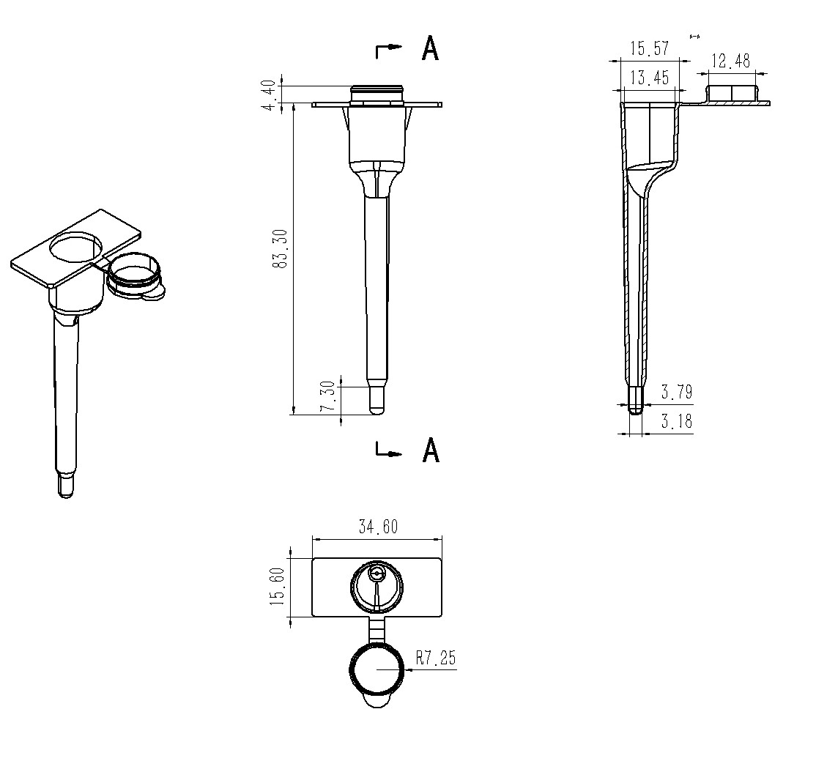
Figure S1. Design details and parameters of the magnetofluidic cartridge. The cartridge height and the chamber diameter are indicated in the figure.
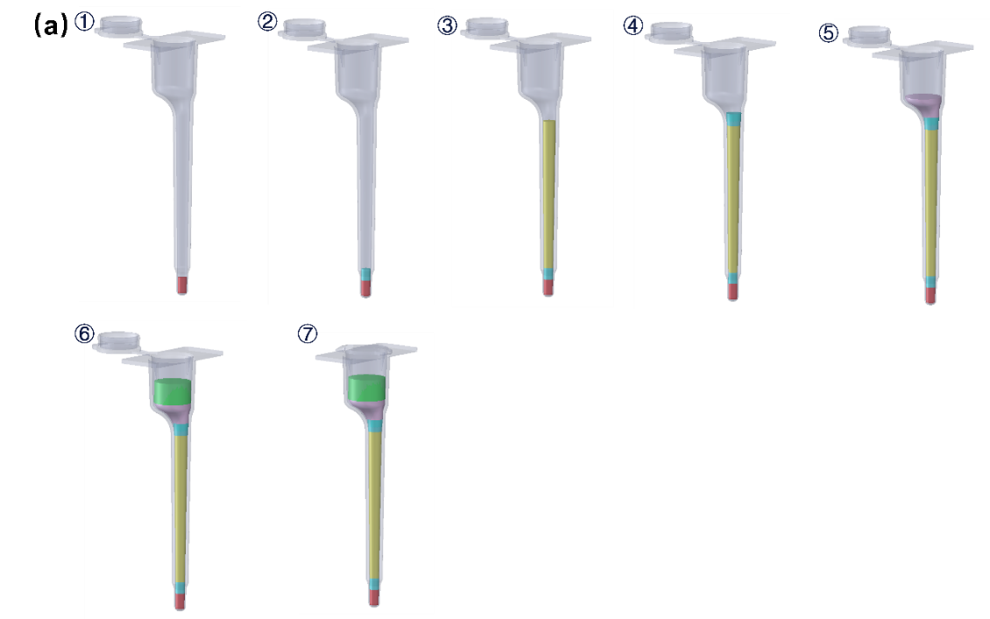
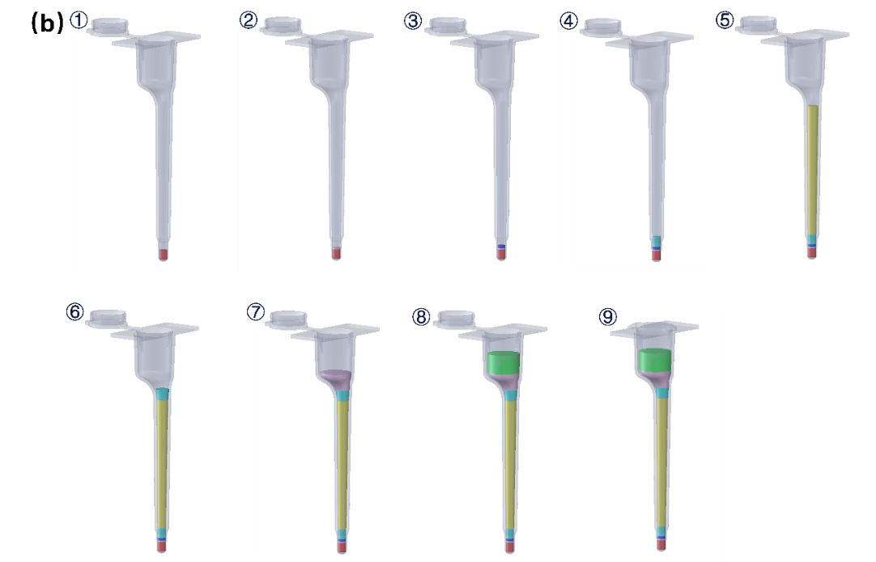
Figure S2. Assembly process of the magnetofluidic cartridge. (a) Type A. (1) Add the reaction mixture. (2) Add silicone oil. (3) Add wash buffer. (4) Add silicone oil. (5) Add melted paraffin wax. (6) Add mixture of sample, lysis buffer, and magnetic beads. (7) Close the cartridge lid. (b) Type B. (1) Add the reaction mixture. (2) Add a small amount of melted paraffin wax. (3) Add elution buffer. (4) Add silicone oil. (5) Add wash buffer. (6) Add silicone oil. (7) Add melted paraffin wax. (8) Add mixture of sample, lysis buffer, and magnetic beads. (9) Close the cartridge lid.
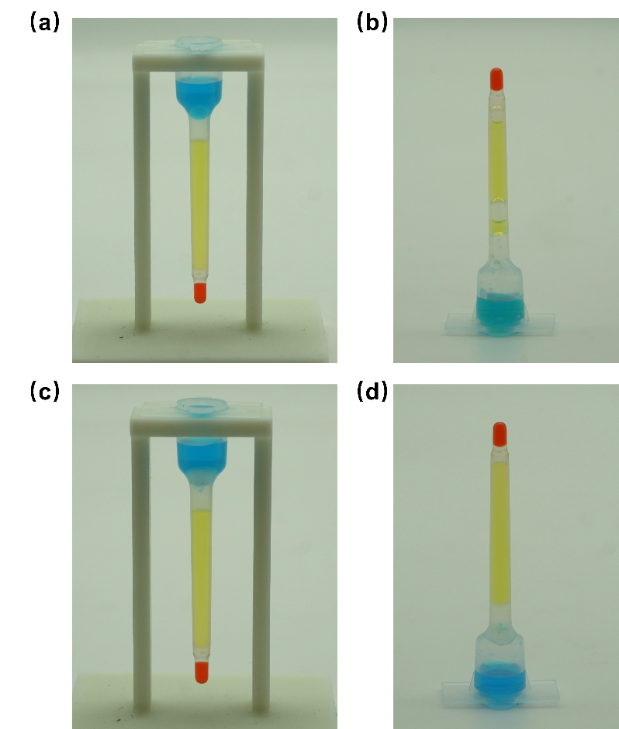
Figure S3. Evaluation of paraffin wax layer function between lysis and wash buffers in the cartridge. (a) Magnetofluidic cartridge without paraffin layer, upright. (b) Magnetofluidic cartridge without paraffin layer, inverted for 1 hour — phase separation unstable. (c) Magnetofluidic cartridge with paraffin layer, upright. (d) Magnetofluidic cartridge with paraffin layer, inverted for 1 hour — phase separation stable.
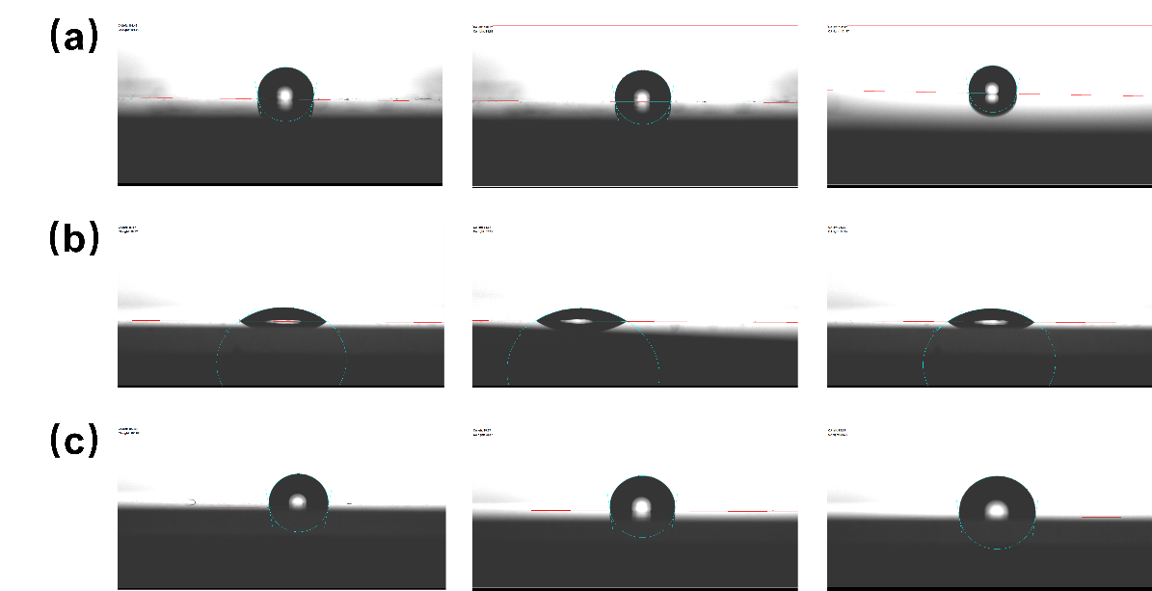
Figure S4. Contact angle measurements. Contact angle was measured by an optical contact angle and contour analysis system (OCAH200, DataPhysics Instruments, Germany) (a) Water contact angle on polypropylene surface: approximately 100.6°. (b) Water contact angle on unmodified glass surface: approximately 36°. (c) Water contact angle on hydrophobic-modified glass surface: approximately 99°, similar to polypropylene. Each measurement was repeated three times.
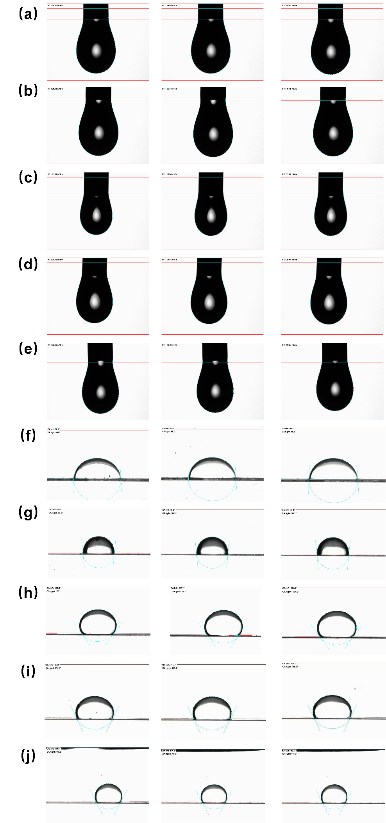
Figure S5. Measurement of surface tension and contact angle for various oils and buffers. Surface tension and contact angle were measured for mineral oil, paraffin oil, silicone oil, washing buffer, and lysis buffer using an optical contact angle and contour analysis system (OCAH200, DataPhysics Instruments, Germany). Panels (a)–(e) show raw surface tension data: mineral oil (34.47 mN/m), paraffin oil (35.11 mN/m), silicone oil (21.05 mN/m), washing buffer (28.52 mN/m), and lysis buffer (28.94 mN/m), averaged from three independent measurements. Using the Girifalco-Good equation¹, interfacial tensions were calculated as follows: mineral oil–lysis buffer (31.83 mN/m), paraffin oil–lysis buffer (32.17 mN/m), mineral oil–washing buffer (25.31 mN/m), paraffin oil–washing buffer (31.64 mN/m), and silicone oil–washing buffer (25.07 mN/m). Panels (f)–(j) present raw contact angle measurements on polypropylene surfaces for the corresponding interfaces: mineral oil–lysis buffer (87.43°), paraffin oil–lysis buffer (95.37°), mineral oil–washing buffer (127.13°), paraffin oil–washing buffer (115.5°), and silicone oil–washing buffer (117.17°), each averaged over three independent tests.
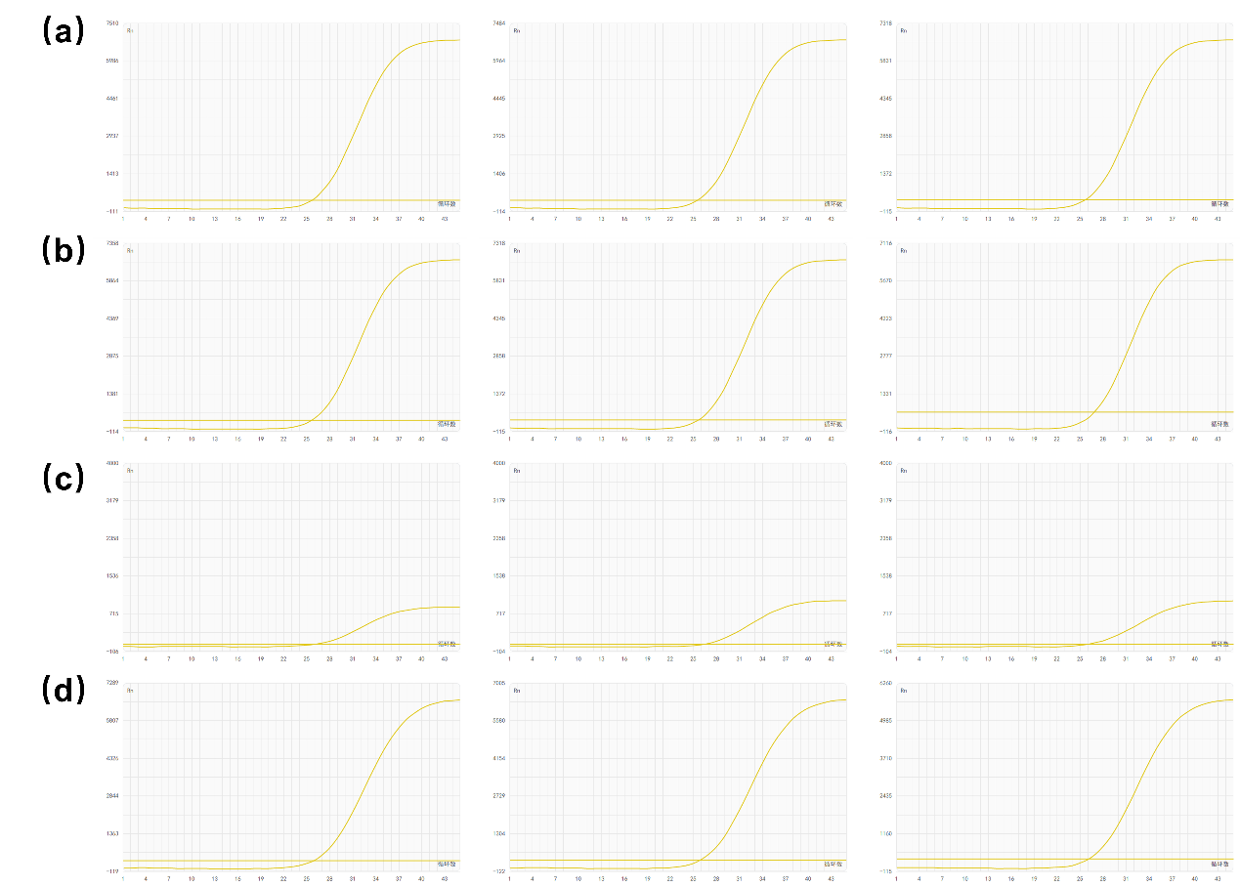
Figure S6. Compatibility of elution magnetic beads with PCR mixture and performance comparison between Type A cartridge and manual method. (a) Manual nucleic acid extraction: magnetic beads eluted with elution buffer, then mixed with PCR mixture for amplification. (b) Manual extraction: magnetic beads eluted directly with PCR mixture, beads removed before amplification; results consistent with elution buffer eluted method. (c) Manual extraction: magnetic beads eluted directly with PCR mixture, amplified with beads present; reaction inhibited. (d) Type A cartridge nucleic acid extraction: magnetic beads eluted with PCR mixture, beads removed before amplification; results consistent with manual method.
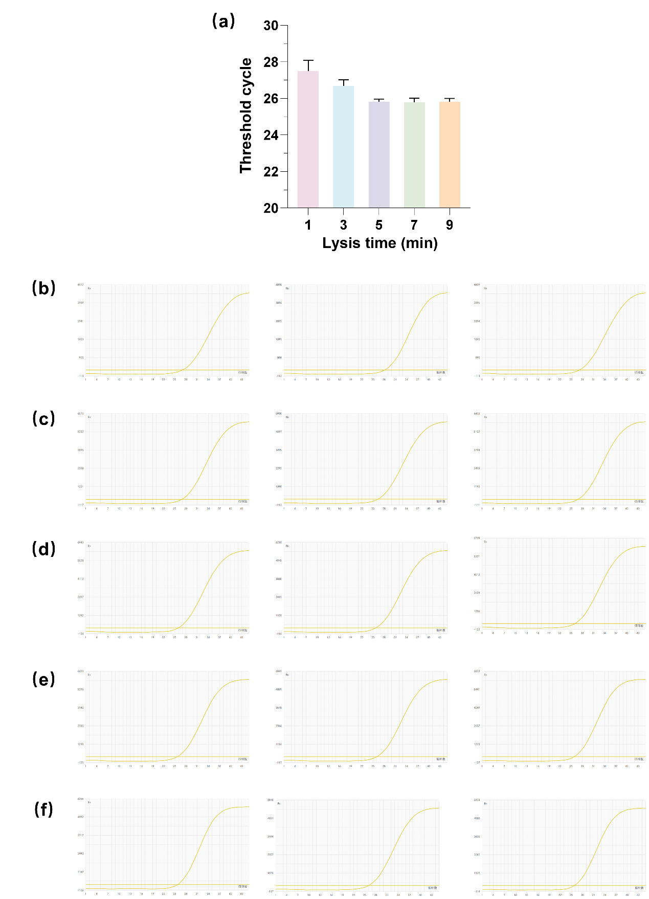
Figure S7. Optimization of lysis time. (a) Summary bar graph of lysis time optimization, showing statistical analysis from three replicates per condition. Results indicated limited statistical significance. (b)–(f) Raw data for lysis times of 1, 3, 5, 7, and 9 minutes, respectively.
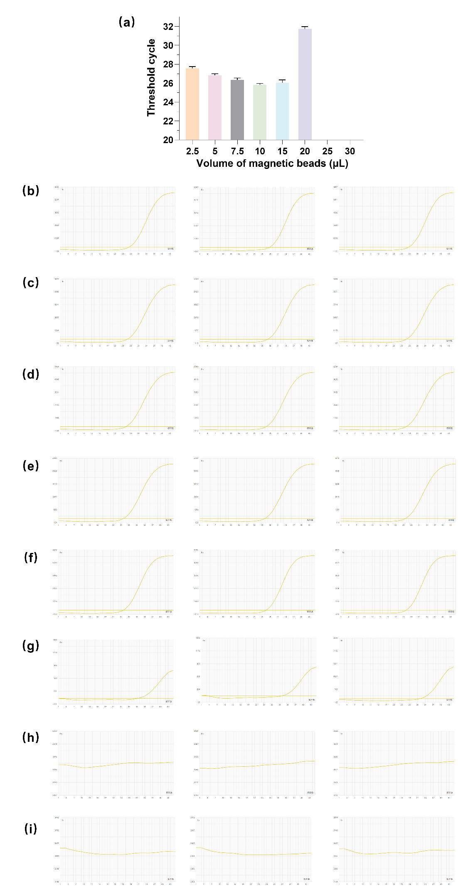
Figure S8. Optimization of magnetic bead volume. (a) Summary bar graph of magnetic bead volume optimization, showing statistical analysis from three replicates per condition. Results indicated limited statistical significance. (b)–(i) Raw data for magnetic bead volume of 2.5, 5, 7.5, 10, 15, 20, 25 and 30 µL, respectively.
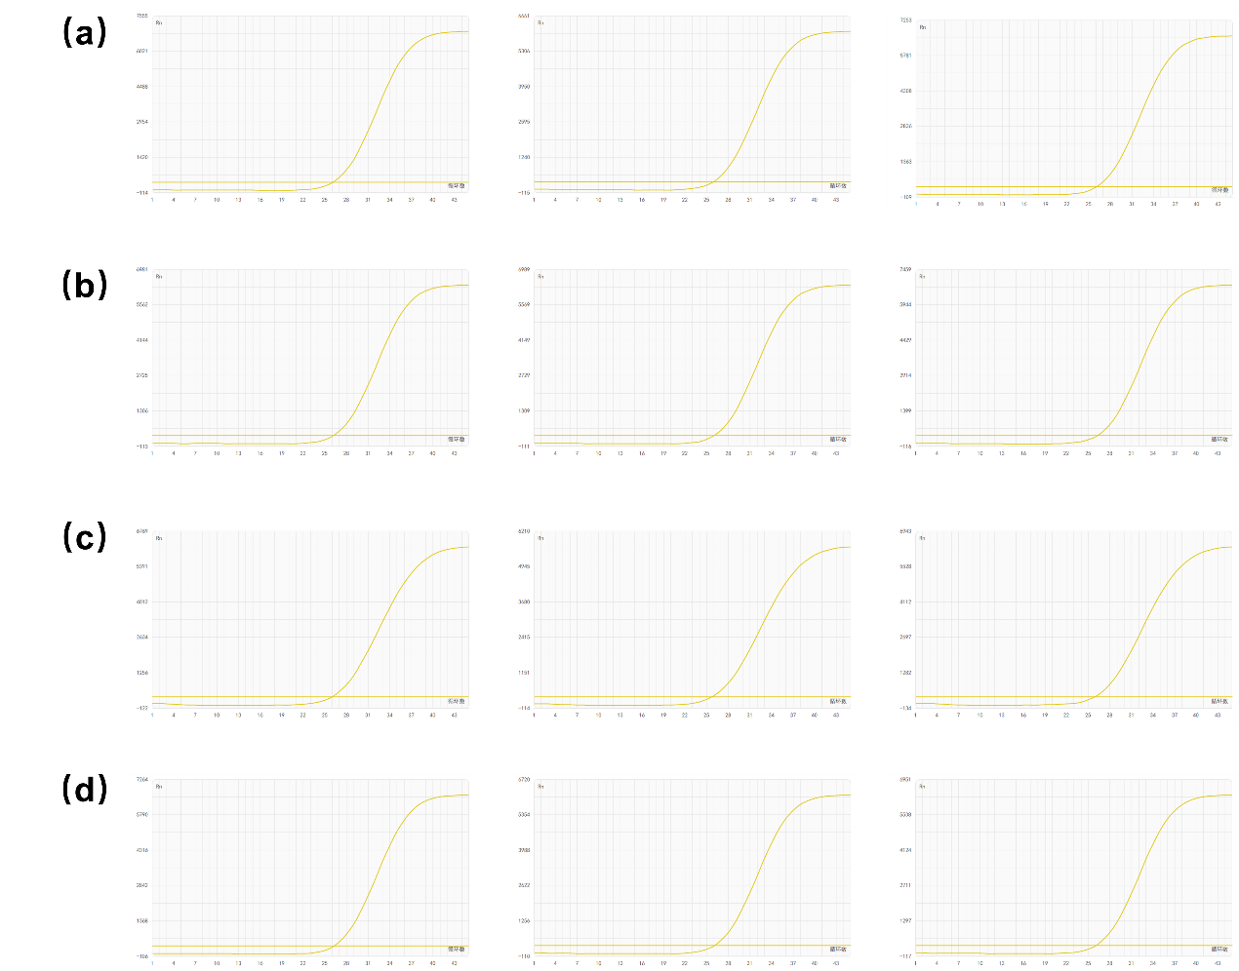
Figure S9. Optimization of washing cycle. (a)–(d) Raw data for washing cycle of 1, 2, 3 and 4, respectively. Each measurement was performed in triplicate.
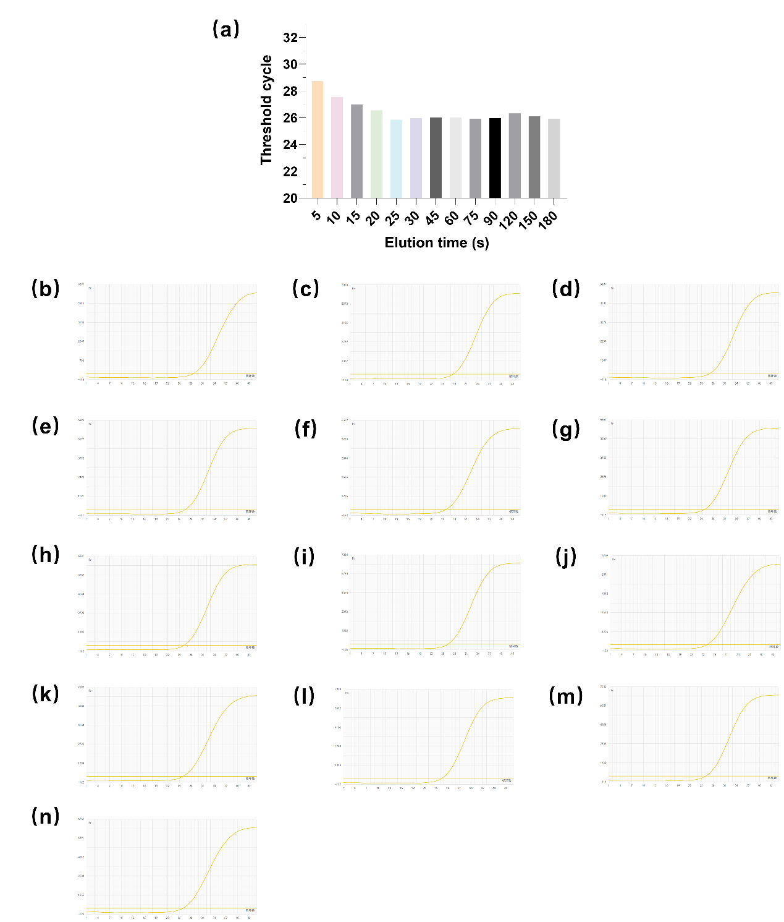
Figure S10. Preliminary optimization of elution time. (a) Summary bar graph of elution time optimization, showing statistical analysis from three replicates per condition. Results indicated limited statistical significance. (b)–(n) Raw data for elution time of 5, 10, 15, 20, 25, 30, 45, 60, 75, 90, 120, 150 and 180 seconds, respectively.
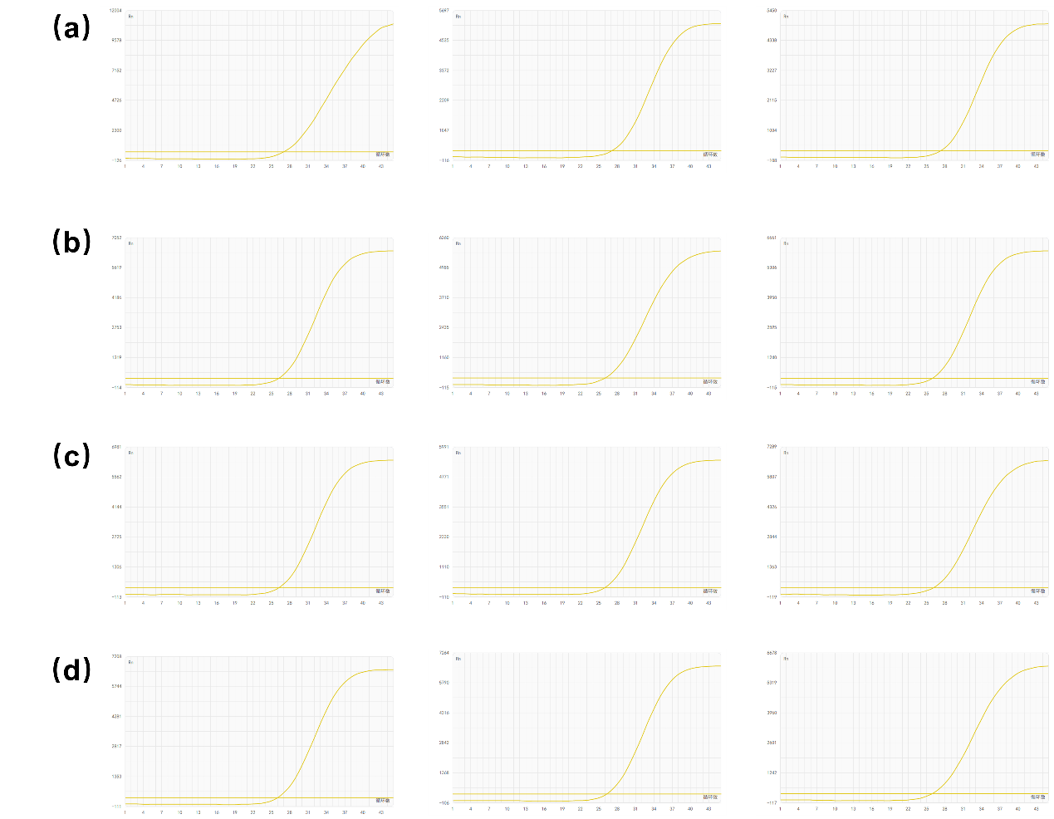
Figure S11. Optimization of elution time. Each condition was tested in triplicate. (a) 15 seconds. (b) 30 seconds. (c) 45 seconds. (d) 60 seconds.
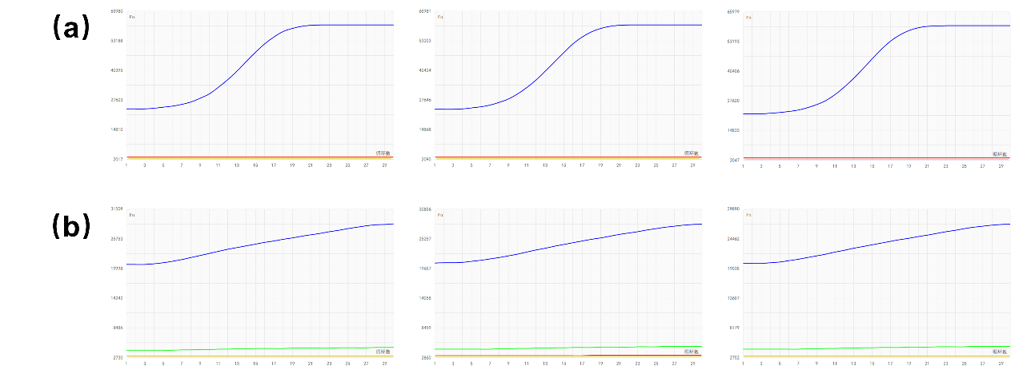Figure S12. Compatibility test of magnetic bead elution with one-pot RT-RPA CRISPR mixture. (a) Magnetic beads were first eluted with elution buffer, which was then mixed with the RT-RPA CRISPR buffer for the reaction. (b) Magnetic beads were directly eluted in the RT-RPA CRISPR system for detection. Each reaction was performed in triplicate.
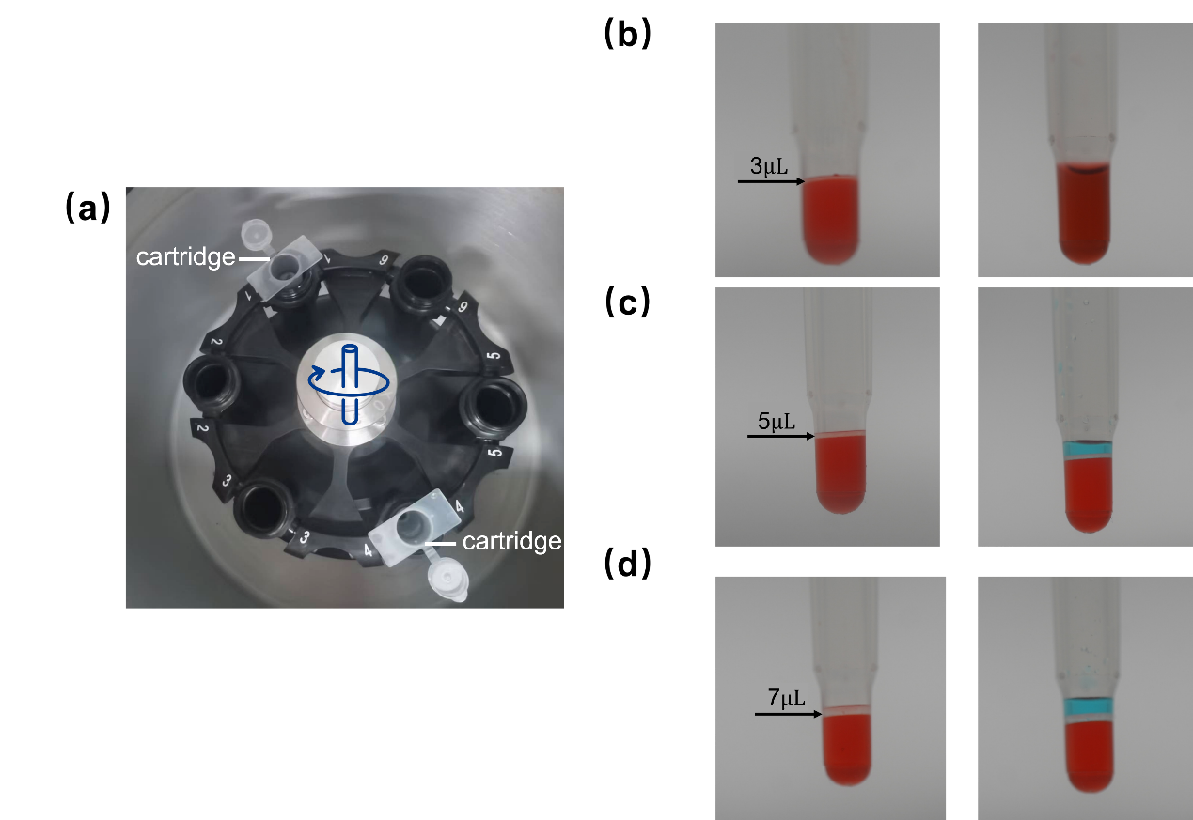
Figure S13. Optimization of paraffin wax layer thickness in Type B cartridge. (a) The cartridge was spun at high speed in a centrifuge to cool, and solidify the paraffin wax layer. (b) A 3 µL wax layer failed to reliably separate the elution and amplification solutions. (c) A 5 µL wax layer successfully maintained stable separation between the elution and amplification solutions. (d) A 7 µL wax layer also provided stable separation between the two solutions.
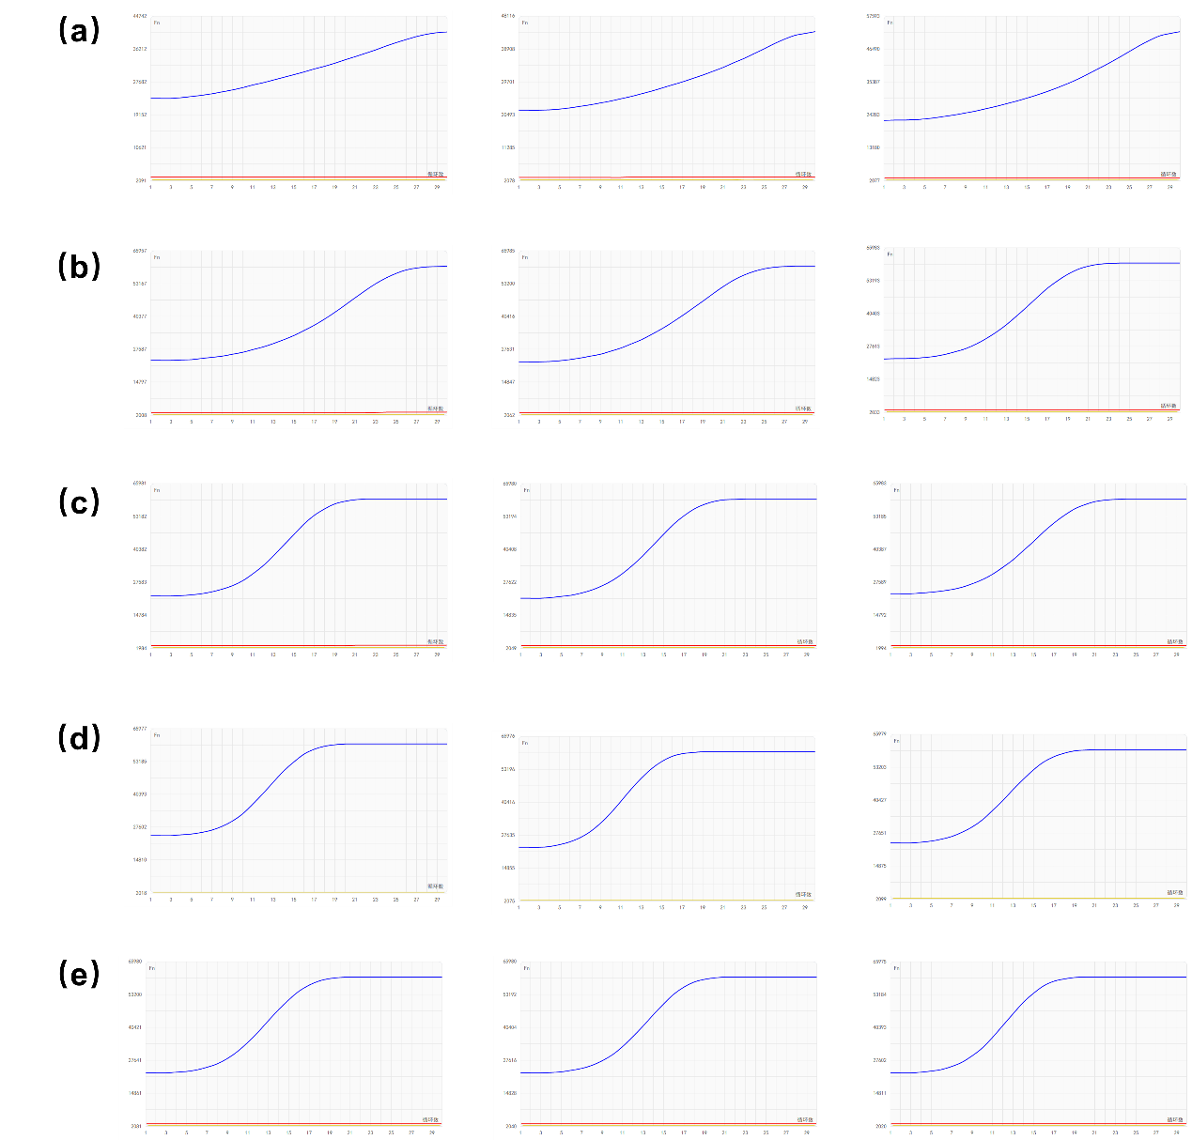
Figure S14. Original elution time optimization for Type B cartridge. Elution times tested were 15, 30, 60, 90, and 120 seconds. Each condition was performed in triplicate. Panels show results for (a) 15 s, (b) 30 s, (c) 60 s, (d) 90 s, and (e) 120 s.
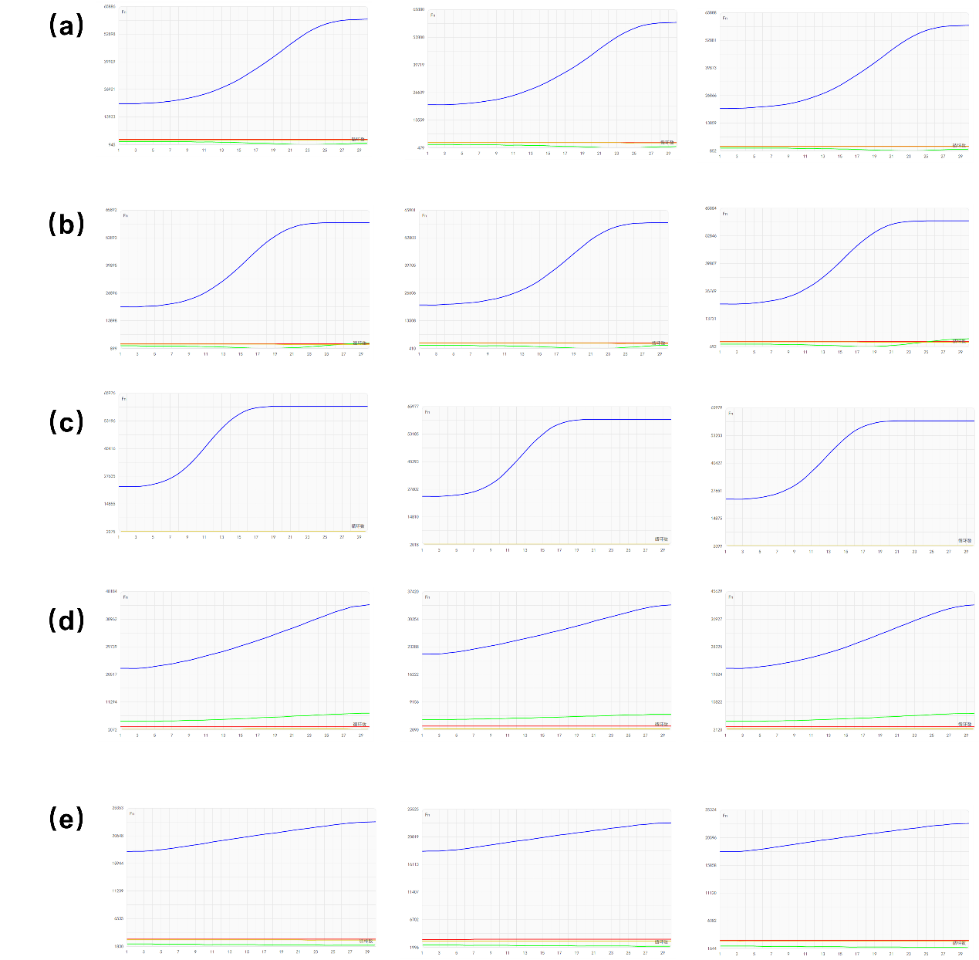
Figure S15. Original reaction temperature optimization for Type B cartridge. Temperatures tested were 40°C, 42°C, 44°C, 46°C, and 48°C. Each condition was performed in triplicate. Panels show results for (a) 40°C, (b) 42°C, (c) 44°C, (d) 46°C, and (e) 48°C.

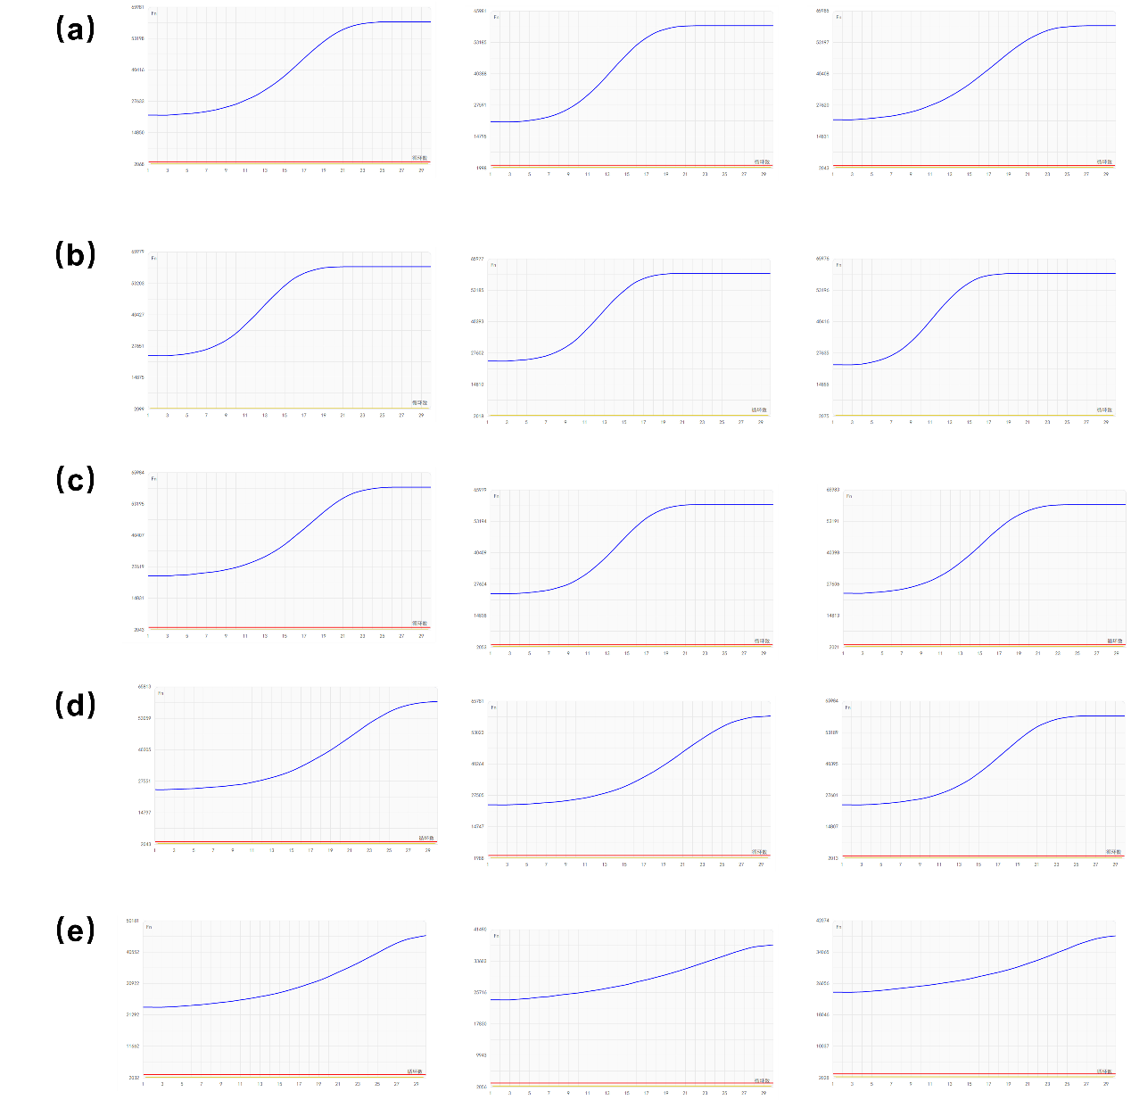
Figure S16. Original reverse transcriptase concentrations optimization for Type B cartridge. Concentrations tested were 0.4, 0.8, 1.2, 1.6, and 2.0 U/μL. Each condition was performed in triplicate. Panels show results for (a) 0.4 U/μL, (b) 0.8 U/μL, (c) 1.2 U/μL, (d) 1.6 U/μL, and (e) 2.0 U/μL.
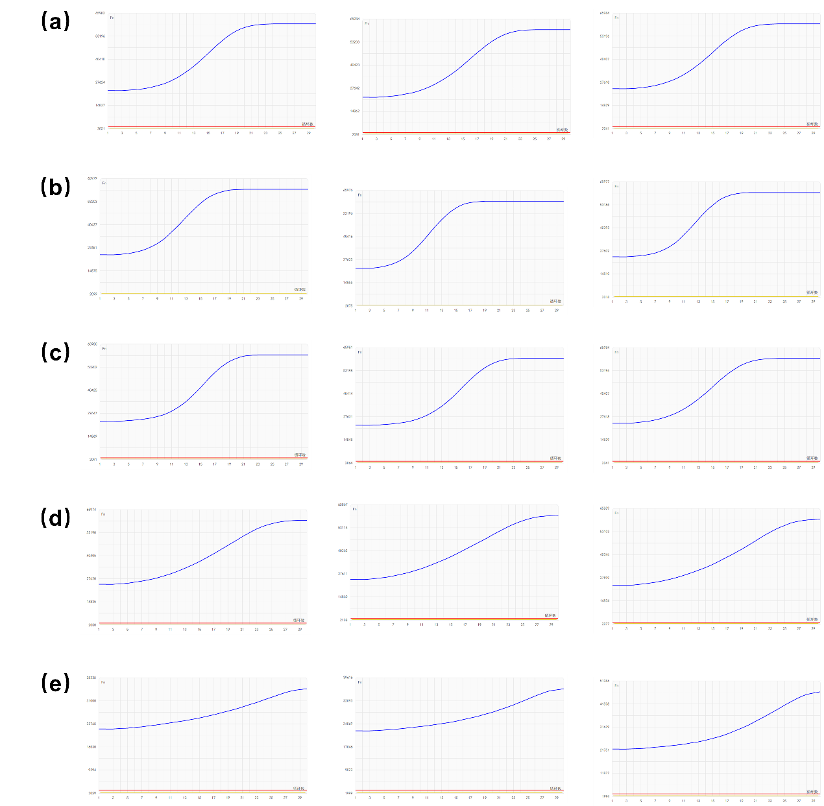
Figure S17. Original Cas12a/gRNA concentrations optimization for Type B cartridge. Concentration pairs (Cas12a/gRNA) tested were 0.16/0.08, 0.32/0.16, 0.48/0.24, 0.64/0.32, and 0.80/0.40 μM. Each condition was performed in triplicate. Panels show results for (a) 0.16/0.08 μM, (b) 0.32/0.16 μM, (c) 0.48/0.24 μM, (d) 0.64/0.32 μM, and (e) 0.80/0.40 μM.
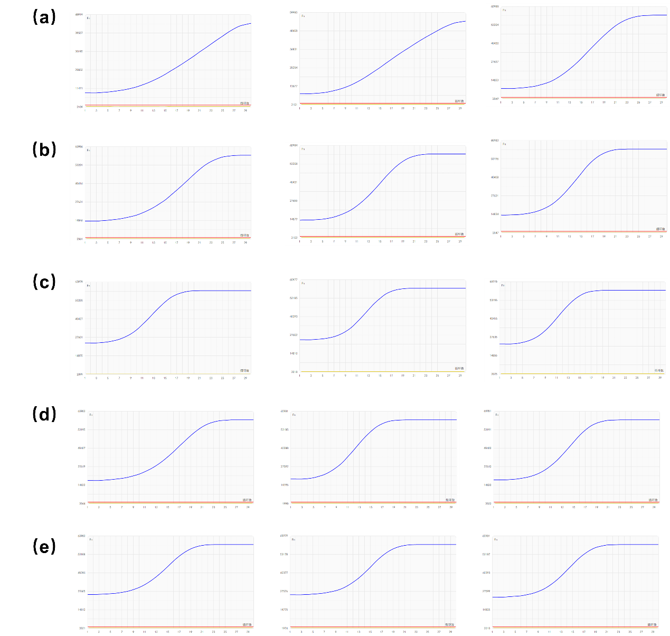
Figure S18. Original reporter concentrations optimization for Type B cartridge. Reporter concentrations tested were 1, 2, 3, 4, and 5 μM. Each condition was performed in triplicate. Panels show results for (a) 1 μM, (b) 2 μM, (c) 3 μM, (d) 4 μM, and (e) 5 μM.
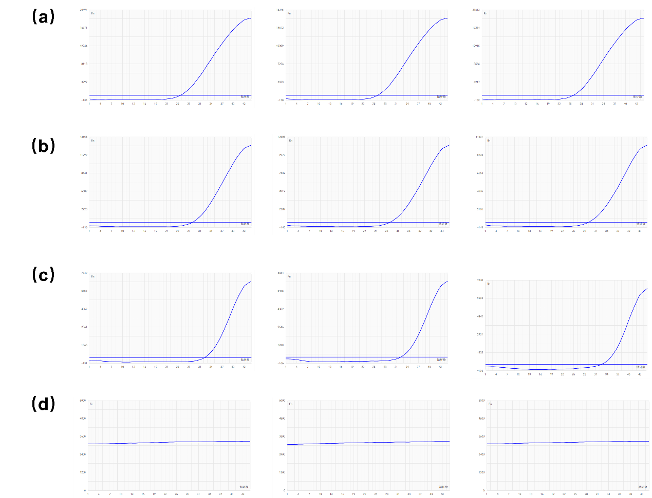
Figure S19. Original sensitivity testing of Type A cartridge for IA. Tested concentrations were 10, 1, 0.1, and 0.01 copies/µL. Each measurement was performed in triplicate. Panels show results for (a) 10 copies/µL, (b) 1 copy/µL, (c) 0.1 copies/µL, and (d) 0.01 copies/µL.
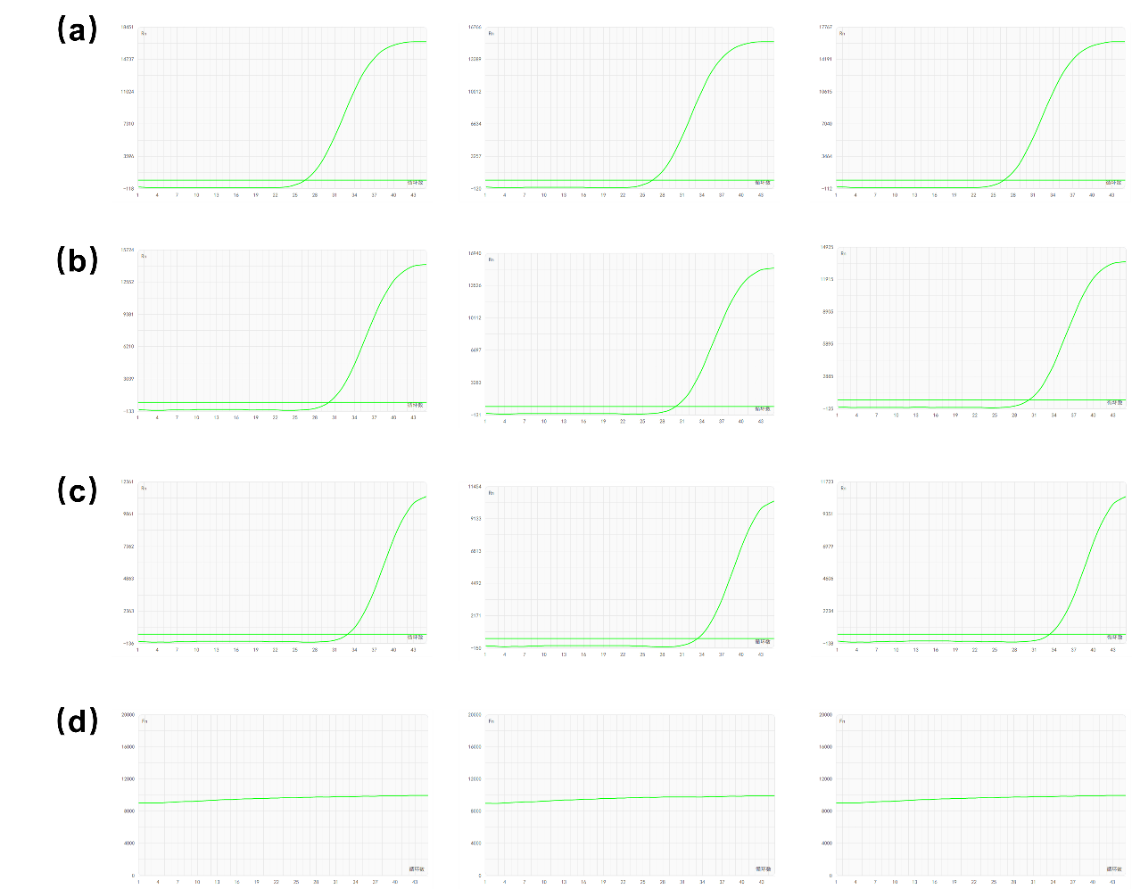
Figure S20. Original sensitivity testing of Type A cartridge for IB. Tested concentrations were 10, 1, 0.1, and 0.01 copies/µL. Each measurement was performed in triplicate. Panels show results for (a) 10 copies/µL, (b) 1 copy/µL, (c) 0.1 copies/µL, and (d) 0.01 copies/µL.
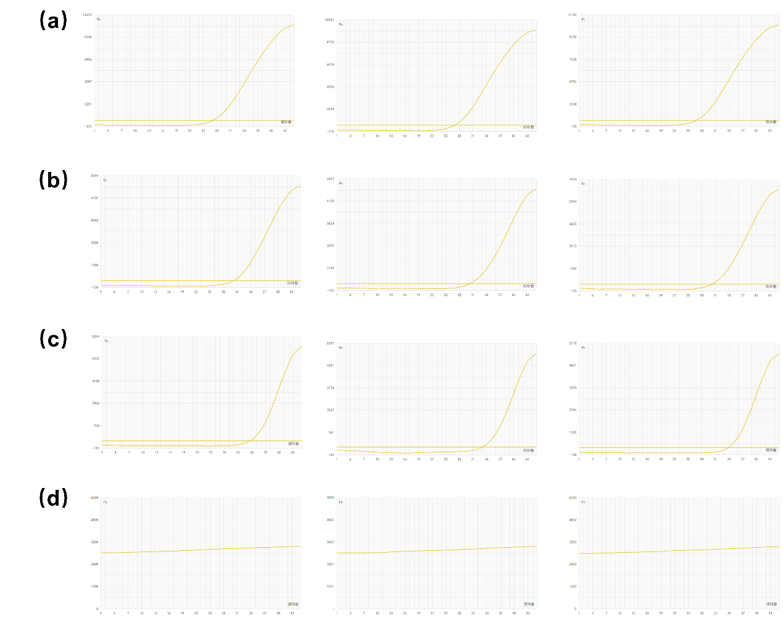
Figure S21. Original sensitivity testing of Type A cartridge for SARS-CoV-2. Tested concentrations were 10, 1, 0.1, and 0.01 copies/µL. Each measurement was performed in triplicate. Panels show results for (a) 10 copies/µL, (b) 1 copy/µL, (c) 0.1 copies/µL, and (d) 0.01 copies/µL.
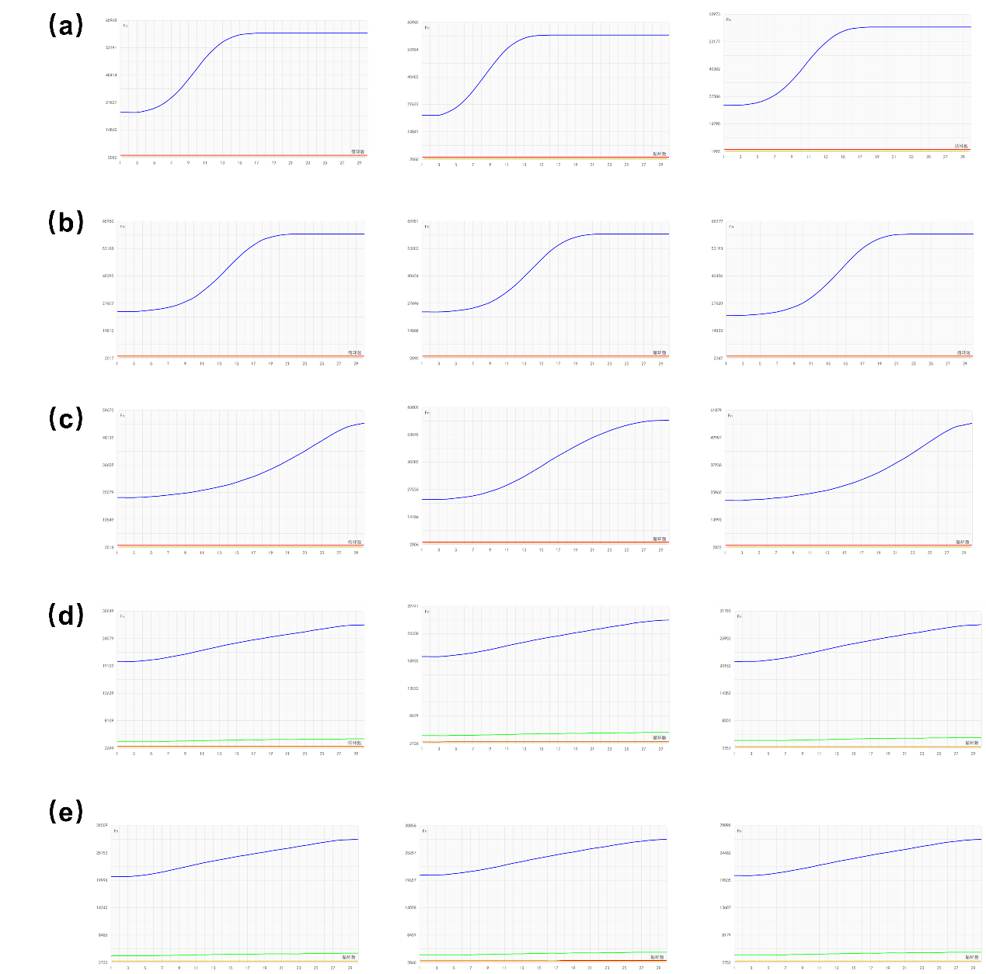
Figure S22. Original sensitivity testing of Type B cartridge for SARS-CoV-2. Tested concentrations were 10, 1, 0.1, and 0.01 copies/µL. Each measurement was performed in triplicate. Panels show results for (a) 10 copies/µL, (b) 1 copy/µL, (c) 0.1 copies/µL, (d) 0.01 copies/µL and (e) negative control.
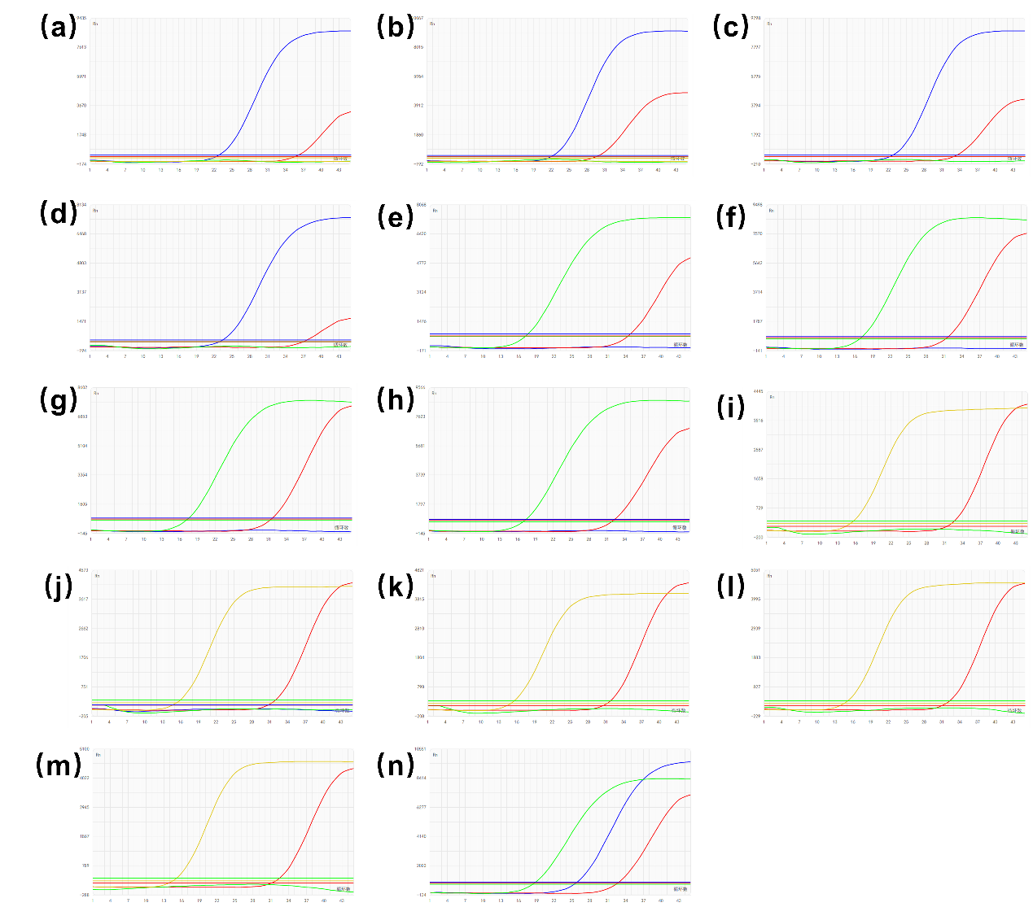
Figure S23. Original clinical sample detection results of Type A cartridge. Results for clinical positive samples 1 through 14 are shown in panels (a) to (n), respectively.
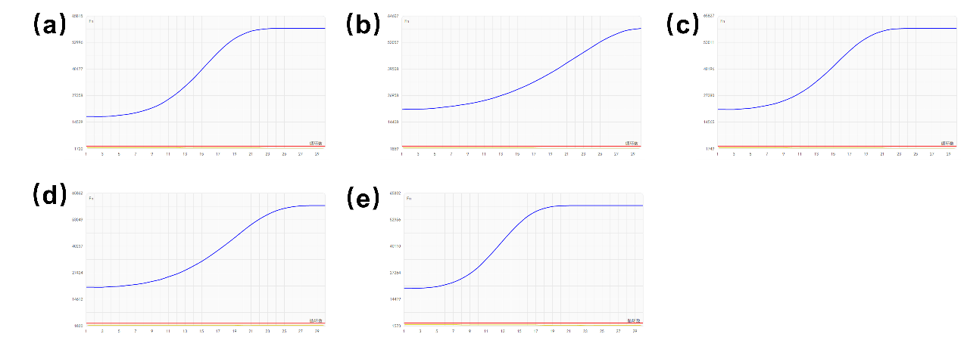
Figure S24. Original clinical sample detection results of Type B cartridge. Results for clinical SARS-CoV-2 positive samples, (a) sample 9, (b) sample 10, (c) sample 11, (d) sample 12, and (e) sample 13.
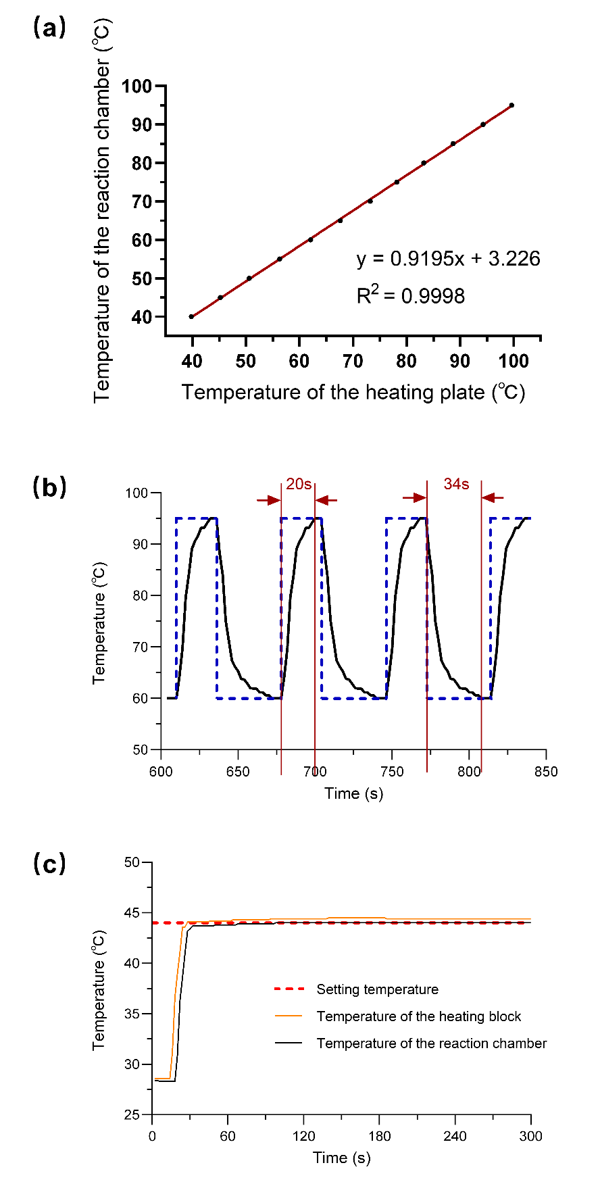
Figure S25. The results of temperature calibration. A multiplex temperature recorder (MT-X16, Shenzhen Shenhua Electronics, Shenzhen, China) was used to evaluate performance of the heating module at room temperature (28℃). A thermocouple (T-Type, Shenzhen Shenhua Electronics, Shenzhen, China) was embedded in the reaction chamber, which was filled with silicone grease (K-5211, Guangdong Hengda New Materials, Huizhou, China). (a) The calibration curve between the temperature of the heating block and the temperature of the chamber. The curve was well fitted to a linear equation with an R2 equal to 0.9998. (b) Thermal cycling profile. The black line shows the temperature of the heating block, the blue dotted line is the set temperature as a function of time, and the red line shows the temperature of the reaction chamber. The temperature ramp rates were 1.75°C/s for heating and 1.03°C/s for cooling. (c) The setting temperature, and the temperature of the heating block and the reaction chamber as functions of time during the heating process of the CRISPR-Cas-assisted RT-RPA assay. It took less than 30 seconds for the reaction chamber to reach the setting 44°C and the temperature fluctuations were less than 0.1°C, which could guarantee the success of reaction.
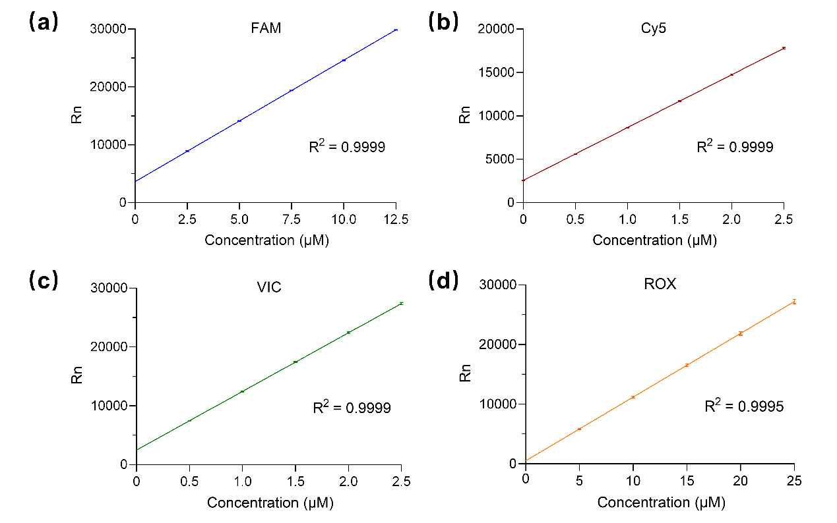
Figure S26. The results of the fluorescence calibration. To characterize the fluorescence detection module, the following calibration fluorescent probes (BIOLIGO, Shanghai, China) were prepared at specified concentrations and pipetted into the reaction chamber of the chip: FAM (AKSDFT001, 0–12.5 μM), Cy5 (AKSDCT001, 0–2.5 μM), VIC (AKSDVT001, 0–2.5 μM), and ROX (AKSDRT001, 0–25 μM). Signal intensity of each concentration was measured ten times. (a) FAM. (b) Cy5. (c) VIC. (d) ROX. The figures show the linear relationship between the measured fluorescence intensity and the concentration of each calibration fluorescent probe. The error bars represent the variations in signal intensity across repeated measurements.
Theoretical model oil‒water interfaces
Force Analysis for Concave Meniscus (θ > 90°)
When the contact angle θ > 90°, a concave meniscus forms. For the fluid element of radius dx in the upper liquid yields the gravitational force:
G =${ ρ}_{\text{A}} g \text{d}V$
and the buoyant force:
${\text{F}}_{\text{B}}= { ρ}_{\text{B}} g \text{d}V$
Regarding the contact interface, the interfacial tension at this location is given by:
$F=2πr σ_{\text{AB}} cosθ$
Therefore, the interfacial tension force acting on the fluid element of radius dx is:
$${\text{F}}_{\text{σ}}=2πr σ_{\text{AB}} cosθ \frac{{(\text{d}x)}^{2}}{r^{2}}$$
Where ${ ρ}_{\text{A}}$ and ${ ρ}_{\text{B}}$ are the densities of the upper and lower liquids, respectively, $g$ is the gravitational acceleration, $σ_{\text{AB}}$​ denotes the interfacial tension between the two liquid phases, and $θ$ represents the contact angle between the two liquid phases formed at the container wall.
Stability requires interfacial tension to counteract density-driven instability:
$${\text{F}}_{\text{σ}}≥G-{\text{F}}_{\text{B}}$$
which means:
$2πr σ_{\text{AB}} cos\text{θ} \frac{{(\text{d}x)}^{2}}{r^{2}}≥{ ρ}_{\text{A}} g \text{d}V-{ ρ}_{\text{B}} g \text{d}V$
where the volume element is given by:
$\text{d}V=\frac{2π{\text{(}\text{d}x)}^{3}}{3}$
Thus, we obtain:
$2πr σ_{\text{AB}} cos\text{θ} \frac{{(\text{d}x)}^{2}}{r^{2}}≥\frac{{( ρ}_{\text{A}}-{ ρ}_{\text{B}}) g · 2π{\text{(}\text{d}x)}^{3}}{3}$
Rearranging the equation, we obtain:
$\text{d}x≤\frac{3 σ_{\text{AB}} cosθ }{{(ρ}_{\text{A}}-ρ_{\text{B}})gr}$
This indicates that, for the infinitesimal fluid element of radius dx in the lower liquid, surface tension under this condition is sufficient to counteract its tendency to float upward.
Integrating dx from 0 to r yields:
$r≤\frac{3 σ_{\text{AB}} cosθ }{{(ρ}_{\text{A}}-ρ_{\text{B}})gr}$
which simplifies to:
$r≤\sqrt{\frac{3 σ_{\text{AB}} cosθ }{{(ρ}_{\text{A}}-ρ_{\text{B}})g} }$
Force Analysis for Convex Meniscus (θ < 90°)
When the contact angle θ < 90°, a convex meniscus forms. For the fluid element of radius dx in the lower liquid yields the gravitational force:
G =${ ρ}_{\text{B}} g \text{d}V$
and the buoyant force:
${\text{F}}_{\text{B}}$ =${ ρ}_{\text{A}} g \text{d}V$
Regarding the contact interface, the interfacial tension at this location is given by:
$F=-2πr σ_{\text{AB}} cosθ$
Therefore, the interfacial tension force acting on the fluid element of radius dx is:
$${\text{F}}_{\text{σ}}=-2πr σ_{\text{AB}} cosθ \frac{{(\text{d}x)}^{2}}{r^{2}}$$
Where ${ ρ}_{\text{A}}$ and ${ ρ}_{\text{B}}$ are the densities of the upper and lower liquids, respectively, $g$ is the gravitational acceleration, $σ_{\text{AB}}$​ denotes the interfacial tension between the two liquid phases, and $θ$ represents the contact angle between the two liquid phases formed at the container wall.
Stability requires interfacial tension to counteract density-driven instability:
$${\text{F}}_{\text{σ}}≥{\text{F}}_{\text{B}}-G$$
which means:
$-2πr σ_{\text{AB}} cos\text{θ} \frac{{(\text{d}x)}^{2}}{r^{2}}≥{ ρ}_{\text{A}} g \text{d}V-{ ρ}_{\text{B}} g \text{d}V$
where the volume element is given by:
$\text{d}V=\frac{2π{\text{(}\text{d}x)}^{3}}{3}$
Thus, we obtain:
$-2πr σ_{\text{AB}} cos\text{θ} \frac{{(\text{d}x)}^{2}}{r^{2}}≥\frac{{( ρ}_{\text{A}}-{ ρ}_{\text{B}}) g · 2π{\text{(}\text{d}x)}^{3}}{3}$
Rearranging the equation, we obtain:
$\text{d}x≤\frac{-3 σ_{\text{AB}} cosθ }{{(ρ}_{\text{A}}-ρ_{\text{B}})gr}$
This indicates that, for the infinitesimal fluid element of radius dx in the lower liquid, surface tension under this condition is sufficient to counteract its tendency to float upward.
Integrating dx from 0 to r yields:
$r≤\frac{-3 σ_{\text{AB}} cosθ }{{(ρ}_{\text{A}}-ρ_{\text{B}})gr}$
which simplifies to:
$r≤\sqrt{\frac{-3 σ_{\text{AB}} cosθ }{{(ρ}_{\text{A}}-ρ_{\text{B}})g} }$
For the silicone oil-wash buffer interface, the condition for maintaining stability is:
$r≤\sqrt{\frac{-3×25.07mN/m× cos117.17° }{0.19g/mL×9.8m/s^{2}} }≈4.28mm$
For the mineral oil-wash buffer interface, the condition for maintaining stability is:
$r≤\sqrt{\frac{-3×25.31mN/m× cos127.13° }{0.07g/mL×9.8m/s^{2}} }≈8.17mm$
For the paraffin oil-wash buffer interface, the condition for maintaining stability is:
$r≤\sqrt{\frac{-3×31.64mN/m× cos115.5° }{0.08g/mL×9.8m/s^{2}} }≈7.22mm$
For the mineral oil-lysis buffer interface, the condition for maintaining stability is:
$r≤\sqrt{\frac{3×31.83mN/m× cos87.43° }{\frac{0.1g}{mL}×\frac{9.8m}{s^{2}}} }≈2.1mm$
For the paraffin oil- lysis buffer interface, the condition for maintaining stability is:
$r≤\sqrt{\frac{-3×32.17mN/m× cos95.37° }{0.09g/mL×9.8m/s^{2}} }≈3.2mm$

Table S1. Comparison of different microfluidic control methods.
Control methods | Product | Full integration | Detection method | Sample volume ($μL$) | Detection time (min) | Sensitivity  (copies/mL) | Target quantity | Easy to assemble | Cost  ($)
Pump-valve | GeneXpert² | Yes | Filter membrane-based extraction, PCR | 300 | 30 | 400 | 4 | Complex | 7.97
Membrane extrusion | Filmarray³ | Yes | Magnetic bead-based extraction, PCR | 300 | 45 | 160 | 20 | Complex | 300
Centrifugal | Disc-shaped chip⁴ | Yes | Filter membrane-based extraction, LAMP | 200 | 45 | 150 | 6 | Easy | 15
Electro-wetting | ePlex⁵ | Yes | Magnetic bead-based extraction, PCR | 200 | 90 | 1000 | 20 | Complex | 177
Micro-diaphragm | Onestart⁶ | Yes | Magnetic bead-based extraction, PCR | 4000 | 90 | 1000 | 21 | Complex | 100
Gravity-driven | Accula⁷ | No | Heat lysis, PCR | 25 | 30 | 150 | 2 | Easy | 20
Magneto-fluidic | This work | Yes | Magnetic bead-based extraction, PCR or CRISPR-RT-RPA | 1000 | 30-60 | 100 | 6 | Very Easy | 0.1

Table S2. Comparison of different magnetofluidic systems.
System | Detection method | Automated | Sample volume ($μL$) | Detection  time (min) | Target quantity | Sensitivity  (copies/mL) | Cost ($)
POC-CRISPR⁸ | Magnetic bead-based extraction, CRISPR-RT-RPA | Yes | 100 | 30 | 1 | 1000 | Cartridge:8.14  Device:3535.41
Droplet platform⁹ | Magnetic bead-based extraction, PCR | Yes | 50 | 30 | 4 | 2000 | Cartridge:4.22  Device:1076.9
AnyMDx¹⁰ | Magnetic bead-based extraction, LAMP | Yes | 10 | 40 | 1 | 600 | Cartridge:1.14  Device:176
NAT-on-USB¹¹ | Magnetic bead-based extraction, LAMP | Yes | 100 | 60 | 1 | 210 | Cartridge:3.3  Device:69.43
LIAMT¹² | Magnetic bead-based extraction, CRISPR-RT-RPA | No | 60 | 60 | 1 | 63900 | Cartridge:5
Up and down chip¹³ | Magnetic bead-based extraction, RT-RAA | No | 20 | 100 | 1 | 250 | /
Chip-based PCR strategy¹⁴ | Magnetic bead-based extraction, PCR | No | / | 70 | 12 | 10000 | /
Saliva-STAT¹⁵ | Magnetic bead-based extraction, LAMP | Yes | 500 | 80 | 1 | 200 | Device:100
This work | Magnetic bead-based extraction, PCR or CRISPR-RT-RPA | Yes | 1000 | 40 | 6 | 100 | Cartridge:0.1  Device:700

Reference
1. Girifalco, L. A. et al. A theory for the estimation of surface and interfacial energies. I. derivation and application to interfacial tension. J. Phys. Chem. 61, 904–909 (1957). https://doi.org/10.1021/j150553A013.
2. Raja, S. et al. Technology for automated, rapid, and quantitative PCR or reverse transcription-PCR clinical testing. Clin. Chem. 51, 882–890 (2005). https://doi.org/10.1373/clinchem.2004.046474.
3. Poritz, M. A. et al. FilmArray, an automated nested multiplex PCR system for multi-pathogen detection: development and application to respiratory tract infection. PLoS ONE 6, e26047 (2011). https://doi.org/10.1371/journal.pone.0026047.
4. Xing, W. et al. A highly automated mobile laboratory for on-site molecular diagnostics in the COVID-19 pandemic. Clin. Chem. 67, 672–683 (2021). https://doi.org/10.1093/clinchem/hvab027.
5. Schmitz, J. E. et al. The GenMark ePlex®: another weapon in the syndromic arsenal for infection diagnosis. Future Microbiol. 13, 1697–1708 (2018). https://doi.org/10.2217/fmb-2018-0258.
6. Huang, E. et al. A fully automated microfluidic PCR-array system for rapid detection of multiple respiratory tract infection pathogens. Anal. Bioanal. Chem. 413, 1787–1798 (2021). https://doi.org/10.1007/s00216-021-03171-4.
7. Greenleaf, M. N. et al. Designing for simplicity: lessons from Mesa Biotech for microfluidic entrepreneurs and early-stage companies. Lab. Chip 22, 1469–1473 (2022). https://doi.org/10.1039/d2lc00081d.
8. Chen, F.-E. et al. Point-of-care CRISPR-Cas-assisted SARS-CoV-2 detection in an automated and portable droplet magnetofluidic device. Biosens. Bioelectron. 190, 113390 (2021). https://doi.org/10.1016/j.bios.2021.113390.
9. Trick, A. Y. et al. Point-of-care platform for rapid multiplexed detection of SARS-CoV-2 variants and respiratory pathogens. Adv. Mater. Technol. 7, 2101013 (2022). https://doi.org/10.1002/admt.202101013.
10. Choi, G. et al. A field-deployable mobile molecular diagnostic system for malaria at the point of need. Lab. Chip 16, 4341–4349 (2016). https://doi.org/10.1039/c6lc01078d.
11. Liu, T. et al. Fingerpick blood-based nucleic acid testing on a USB interfaced device towards HIV self-testing. Biosens. Bioelectron. 209, 114255 (2022). https://doi.org/10.1016/j.bios.2022.114255.
12. Li, Z. et al. Palm-sized lab-in-a-magnetofluidic tube platform for rapid and sensitive virus detection. Adv. Sci. 11, 2310066 (2024). https://doi.org/10.1002/advs.202310066.
13. Huang, D. et al. Magnetofluid-integrated biosensors based on DNase-dead Cas12a for visual point-of-care testing of HIV-1 by an up and down chip. Lab. Chip 23, 4265–4275 (2023). https://doi.org/10.1039/d3lc00558e.
14. Li, J. et al. Simultaneous detection of multiple respiratory pathogens using an integrated microfluidic chip. Anal. Chem. 96, 13768–13776 (2024). https://doi.org/10.1021/acs.analchem.4c00990.
15. Boegner, D. J. et al. Saliva-STAT: Sample-to-answer saliva test for COVID-19. Sens. Actuators B Chem. 421, 136510 (2024). https://doi.org/10.1016/j.snb.2024.136510.

Table S3. Sequences of RPA primers, Cas12-guide RNAs, fluorogenic reporter⁸.
Component | Sequence (5' → 3')
RPA Forward primer | AGGCAGCAGTAGGGGAACTTCTCCTGCTAGAAT
RPA Reverse primer | TTGGCCTTTACCAGACATTTTGCTCTCAAGCTG
Cas12a-guide RNA1 | UAAUUUCUACUAAGUGUAGAUCAUCACCGCCAUUGCCAGCC
Cas12a-guide RNA2 | UAAUUUCUACUAAGUGUAGAUUUGCUGCUGCUUGACAGAUU
Fluorogenic reporter | /Alex647N/TTATT/IAbRQSp/

