Supplementary Information for“Thermal-induced dielectric response in mechanically durable polyvinylidene fluoride/kapok encapsulated polyethylene glycol composite films”
Yutie Gongª, Zhenzhen Liª, Hairong Li^{b}, Wenqi Wuª, Xianglin Pei^{c}, Junyang Tuª, Weijie Zhouª, Ming Jiang^{a,*}, Wei Gong^{c,*}
ª Key Laboratory of Textile Fiber and Products (Ministry of Education), School of Materials Science and Engineering, Wuhan Textile University, Wuhan 430200, PR China
^{b} Mechanical Metrology Division, Hubei Institute of Measurement and Testing Technology, Wuhan 430223, PR China
^{c} School of Materials and Architectural Engineering, Guizhou Normal University, Guiyang 550025, PR China.
The first two authors contributed equally to this work.
Correspondence to M. Jiang (mjiang@wtu.edu.cn) or W. Gong (gongw@gznu.edu.cn)

Supporting Information

Figure S1 X-ray diffraction curves of KF, PEG800, PEG2k, PEG10k.

Table S1 Thermal analysis of the PVDF/KF/PEG with varying molecular weights
Sample | Melting |  |  |  | Crystallization
Sample | T_{m}(on)/℃ | T_{m}/℃ | T_{m}(end)/℃ | ΔH_{m}  /Jꞏg⁻¹ | T_{c}(on)/℃ | T_{c}/℃ | T_{c}(end)/℃ | ΔH_{c}  /Jꞏg⁻¹
PEG800 | 17.8 | 29.9 | 37.7 | 122.78 | 27.0 | 21 | 11.7 | 118.99
PEG2k | 42.4 | 53.1 | 57.2 | 181.82 | 37.6 | 29.8 | 24.9 | 179.81
PEG10k | 57.5 | 61.6 | 67.9 | 255.78 | 41.9 | 36.1 | 27.3 | 254.63
KF/PEG800 | 17.8 | 33.2 | 38.8 | 27.19 | 23.9 | 19.4 | 10.5 | 27.06
KF/PEG2k | 47.7 | 55.9 | 64.5 | 34.76 | 35.3 | 30.4 | 23.3 | 35.7
KF/PEG10k | 54.4 | 62.3 | 74.8 | 48.05 | 49.9 | 39.4 | 34.3 | 42.24
PVDF/KF/PEG800 | 27.8 | 33.1 | 38.0 | 18.32 | 24.0 | 19.8 | 14.2 | 17.65
PVDF/KF/PEG2k | 49.6 | 56.1 | 61.3 | 27.19 | 37.4 | 33.4 | 27.7 | 28.44
PVDF/KF/PEG10k | 56.6 | 63.5 | 70.1 | 33.18 | 45.6 | 38.8 | 32.1 | 33.14

(c)
(d)
(a)
(b)
Figure S2 DSC cooling (a, c) and heating (b, d) curves of pristine PEG800, PEG2k, PEG10k, and their shape-stabilized KF/PEG fibers.
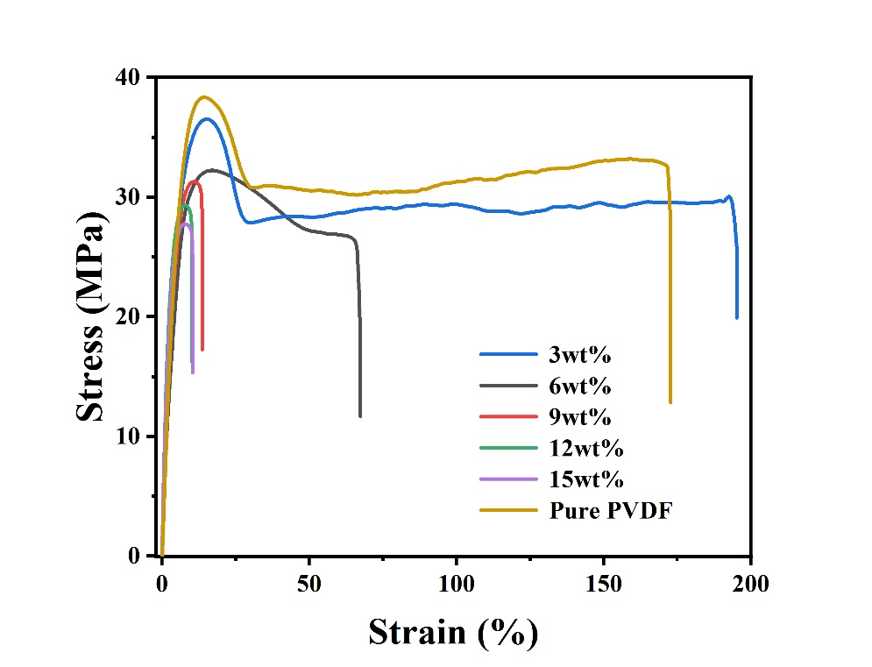
Figure S3 Stress-strain curve of PVDF/KF/PEG composite films containing different KF content.

Figure S4 Admittances of PVDF/KF, PVDF/KF/PEG800, PVDF/KF/PEG2k and PVDF/KF/PEG10k at 1000 Hz.

Table S2 Dielectric transition-temperature data of PVDF/KF/PEG800, PVDF/KF/PEG2k, PVDF/KF/PEG10k
Sample | T_{heating}/℃ | T_{cooling}/℃ | Width of the dielectric hysteresis loop
PVDF/KF/PEG800 | 29.2 | 23.6 | 5.6
PVDF/KF/PEG2k | 49.9 | 37.8 | 12.1
PVDF/KF/PEG10k | 60.8 | 42.7 | 18.1

