Supplementary Information for“Thermal-induced dielectric response in mechanically durable polyvinylidene fluoride/tubular kapok fiber encapsulated polyethylene glycol composite films”
Wenqi Wuª, Xianglin Pei^{b}, Hairong Li^{c}, Junyang Tuª, Qiong Liª, Weijie Zhouª, Yutie Gongª, Ming Jiang^{a,*}, Wei Gong^{b,*}
ª State Key Laboratory for New Textile Materials & Advanced Processing Technology, School of Materials Science and Engineering, Wuhan Textile University, Wuhan 430200, PR China
^{b} School of Materials and Architectural Engineering, Guizhou Normal University, Guiyang 550025, PR China.
^{c} Mechanical Metrology Division, Hubei Institute of Measurement and Testing Technology, Wuhan 430223, PR China
Correspondence to M. Jiang (mjiang@wtu.edu.cn) or W. Gong (gongw@gznu.edu.cn)
Supporting Information

Figure S1 X-ray diffraction curves of PEG800, PEG 2K, PEG10K.

Table S1The proportion of PEG in KF/PEG800、KF/PEG2k and KF/PEG10k composite fibers
Sample | PVDF/KF/PEG800 | PVDF/KF/PEG2k | PVDF/KF/PEG10k
Residual carbon rates (wt%) | 27.5 | 31 | 24
PEG content（wt%） | 17.3 | 16.6 | 10.9

Table S2 Thermal analysis of the PVDF/KF/PEG with varying molecular weights
Sample | Melting |  |  |  | Crystallization
Sample | T_{m}(on)/℃ | T_{m}/℃ | T_{m}(end)/℃ | ΔH_{m}  /J*g⁻¹ | T_{c}(on)/℃ | T_{c}/℃ | T_{c}(end)/℃ | ΔH_{c}  /J*g⁻¹
PEG800 | 17.8 | 29.9 | 37.7 | 122.78 | 11.7 | 21 | 27.0 | 118.99
PEG2k | 42.4 | 53.1 | 57.2 | 181.82 | 24.9 | 29.8 | 37.6 | 179.81
PEG10k | 57.5 | 61.6 | 67.9 | 255.78 | 27.3 | 36.1 | 41.9 | 254.63
KF/PEG800 | 14.0 | 19.6 | 24.6 | 18.32 | 2.8 | 7.9 | 15.2 | 17.65
KF/PEG2k | 49.9 | 53.8 | 64.5 | 48.05 | 23.3 | 30.4 | 37.3 | 42.24
KF/PEG10k | 51.8 | 61.9 | 65.8 | 27.19 | 28.7 | 34.4 | 40.8 | 28.44
PVDF/KF/PEG800 | 27.8 | 33.1 | 38.0 | 27.34 | 14.2 | 19.8 | 24.0 | 27.06
PVDF/KF/PEG2k | 49.6 | 56.1 | 61.3 | 33.18 | 27.7 | 33.4 | 37.4 | 33.14
PVDF/KF/PEG10k | 56.6 | 63.5 | 70.1 | 34.76 | 32.1 | 38.8 | 45.6 | 35.7

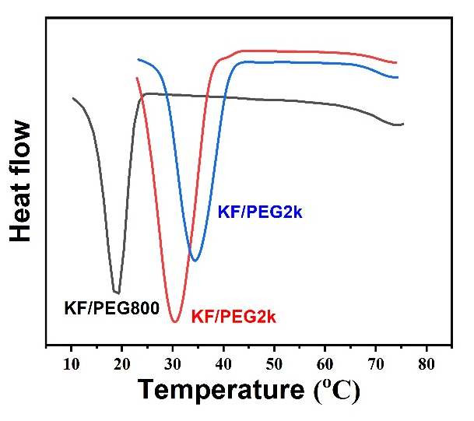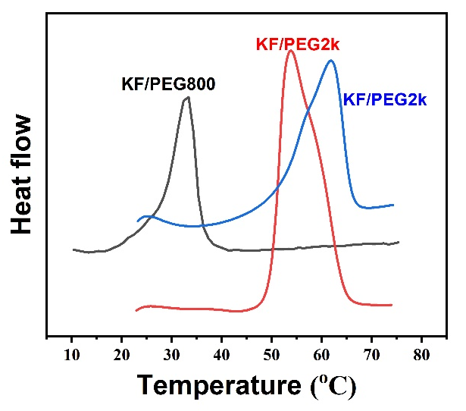
(d)
(c)
(b)
(a)
Figure S2 DSC cooling (a, c) and heating (b, d) curves of pristine PEG800, PEG2k, PEG10k, and their shape-stabilized KF/PEG fibers.
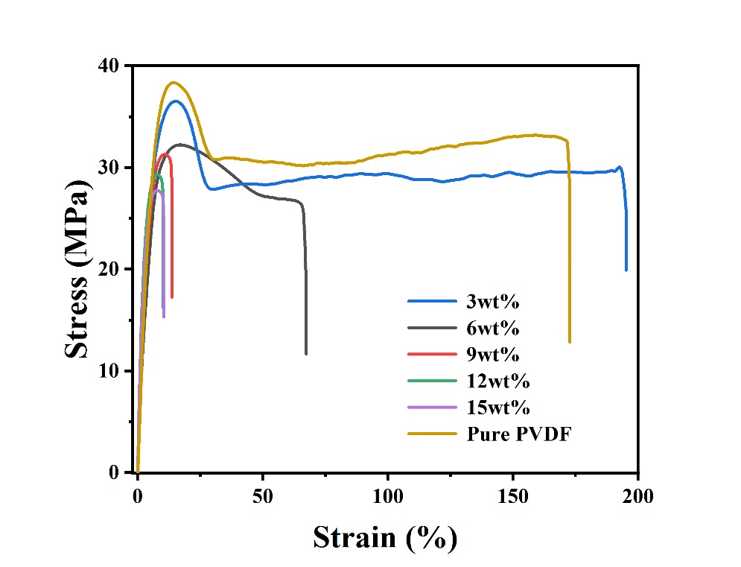
Figure S3 Stress-strain curve of PVDF/KF composite film with different KF content.

Figure S4 The admittance of PVDF/KF, PVDF/KF/PEG800, PVDF/KF/PEG2k and PVDF/KF/PEG10k Composite materials at 1kHz.

Table S3 PVDF/KF/PEG800, PVDF/KF/PEG2k, PVDF/KF/PEG10k composite dielectric transition-temperature data
Sample | T_{heating}/℃ | T_{cooling}/℃ | Width of the dielectric hysteresis loop
PVDF/KF/PEG800 | 11.5 | 10.8 | 0.7
PVDF/KF/PEG2k | 44.1 | 34.5 | 9.6
PVDF/KF/PEG10k | 60.0 | 43.5 | 16.5

