Supplementary Information

Binding and Toxicological Insights into Direct Yellow 8 and Bovine Serum Albumin: Fluorescence Quenching and Cytotoxicity Studies
Babita Bisht¹, Sangeeta², Pinki Dey³, Praveen K. Kujur⁴, Avinash Singh⁵, Shahnoor Ali⁶, Sandeep⁷, Deepa Bisht⁸, Sanjay Pant¹, Mohan Singh Mehata^{9*}
¹Photophysics Laboratory, Department of Physics, Centre of Advanced Study, D.S.B. Campus, Kumaun University, Nainital, 263002, India,
²School of Computational and Integrated Sciences, ⁴Cancer Biology Laboratory, School of Life Sciences, ⁷School of Life Sciences, Jawaharlal Nehru University, New Delhi-110067 India
³School of Biotechnology and Biomolecular Sciences, University of New South Wales, Sydney 2033, Australia
⁵Department of Electrical and Computer Engineering, University of Houston, Houston, Texas
⁶Centre for Applied Research in Electronics (CARE), IIT Delhi, Hauz Khas, New Delhi-110016, India
⁸ Department of Mathematics, Uttrakhand Open University, Behind Transport Nagar, Teenpani Bypass Road, Haldwani, Nainital, 263139, India
⁹Laser Spectroscopy Laboratory, Department of Applied Physics, Delhi Technological University, Bawana Road, Delhi, 110042, India
Corresponding author: msmehata@gmail.com

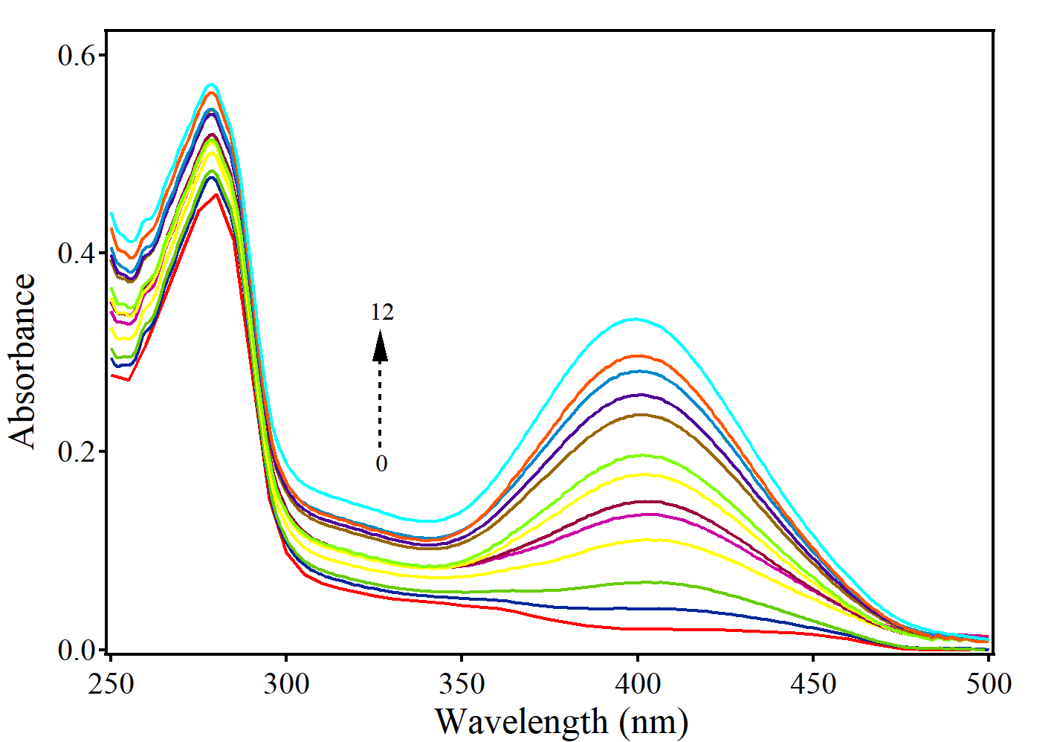

Figure S1: Absorption spectra of BSA in the presence of varying concentrations of DY8 (1 µM – 12 µM). A new band begins to appear at 400 nm, corresponding to the principal absorption band of DY8.

