A High-Salt Diet Promotes Colitis by Remodeling the Gut Microbiota Toward a Virulent, Osmotolerant State
Wenjie Zhang^{a,b,†}, Yang Gao^{b,†}, Qiaoyu Ling^{c,b,†}, Xiaochen Zhuª, Wanrong Luo^{d,e}, Ren Maoª, Xueting Wuª, Wenhua Laiª, Ali H. A. Elbehery^{f}, Minhu Chen^{a,g}, Zhihui Chen^{c,*}, Rui Feng^{a,*}, Yijun Zhu^{b,*}
ª Department of Gastroenterology, the First Affiliated Hospital, Sun Yat-sen University, Guangzhou, Guangdong, China
^{b} Institute of Precision Medicine, the First Affiliated Hospital, Sun Yat-sen University, Guangzhou, Guangdong, China
^{c} Department of Gastrointestinal Surgery Center, the First Affiliated Hospital, Sun Yat-sen University, Guangzhou, Guangdong, China.
^{d} Department of Cardiovascular & Metabolic Sciences, Lerner Research Institute, Cleveland Clinic, Cleveland, OH, USA
^{e} Center for Microbiome and Human Health, Cleveland Clinic, Cleveland, OH, USA
^{f} Department of Microbiology and Immunology, Faculty of Pharmacy, University of Sadat City, Sadat City, Egypt
^{g} Shenzhen Qianhai Taikang Hospital, Shenzhen, Guangdong, China
† These authors contributed equally
* These authors contributed equally
Corresponding author
Zhihui Chen, M.D, PhD
Department of Gastrointestinal Surgery Center, the First Affiliated Hospital, Sun Yat-sen University
No.58 Zhongshan Er Road, Guangzhou, China 510080
Tel: +86 (20)-87755766
Email: chzhhui@mail.sysu.edu.cn
Rui Feng, M.D, PhD
Department of Gastroenterology, the First Affiliated Hospital, Sun Yat-sen University
No.58 Zhongshan Er Road, Guangzhou, China 510080
Tel: +86 (20)-87755766
Email: fengr7@mail.sysu.edu.cn
Yijun Zhu, PhD
Institute of Precision Medicine, the First Affiliated Hospital, Sun Yat-sen University.
No.1 Zhongshan Er Road, Guangzhou, China 510080
Tel: +86 8760 6870 (ext) 1209
Email: zhuyj67@mail.sysu.edu.cn
Leading author: zhuyj67@mail.sysu.edu.cn (Y.Z.)
Competing Interest Statement: The authors declare no competing interests.
Keywords: Western diet; osmotic stress; coevolution; environmental adaptation; Halorubrum
This PDF file includes:
Supporting text
Supplementary Figures 1 to 6
Legends for Supplementary Table 1 to 3
SI References
Other supporting materials for this manuscript include the following:
Supplementary Table 1 to 3

Supporting Information Text

Supplementary Methods
Faecal DNA extraction, archaea targeted amplicon sequencing and data processing
Total microbial genomic DNA was extracted from faecal samples using the magnetic bead-based MagPure FFPE DNA/RNA Kit (Magen Biotechnology, D6364-02) and quantified spectrophotometrically (Implen GmbH, NanoPhotometer N60). Archaeal community profiling was performed following the protocol of Koskinen et al. (2017)¹. Briefly, the archaea-specific 16S rRNA gene region was amplified in a nested PCR approach. First PCR used archaea-specific primers 344F (5′-ACGGGGYGCAGCAGGCGCGA-3′) and 915R (5′-GTGCTCCCCCGCCAATTCCT-3′) with the following program: 95°C for 4 min; 95°C for 15 s, 30 cycles, 55°C for 30 s, and 72°C for 45 s; and a final extension at 72°C for 5 min. Amplicons were gel-purified, and 1 µL of the eluate was used as template for a second, barcoding PCR with primers 349F (5′-GYGCASCAGKCGMGAAW-3′) and 519R (5′-TTACCGCGGCKGCTG-3′) under similar cycling conditions except annealing temperature at 60°C. Final libraries were purified with AMPure XP beads (Beckman Coulter), quantified, and sequenced on an Illumina HiSeq 2500 platform by Personalbio (Shanghai, China). Raw sequences were quality-filtered, trimmed to 140 bp, and processed using the DADA2² in QIIME 2 (v2021.11) ³ to infer amplicon sequence variants (ASVs). Chimeric sequences were removed, and taxonomic classification was performed against the SILVA database (v138.1)⁴.
Droplet digital PCR (ddPCR) for Methanobrevibacter and Halorubrum
For absolute quantification of Methanobrevibacter and Halorubrum, total fecal DNA was analyzed via ddPCR using the marker genes mcrA⁵ and rpoB⁶, respectively. Reference sequences were retrieved from the JGI/IMG database (https://img.jgi.doe.gov/). Primers and hydrolysis probes were designed using PrimerQuest (https://sg.idtdna.com/PrimerQuest) and validated for specificity via BLAST analysis (NCBI; http://www.ncbi.nlm.nih.gov/BLAST/). Primers and probes are shown below:
mcrA: Forward 5′-TGGTGCAGCTAACGTATTCTC-3′,
Reverse 5′-CTTGAGCGATACCAGCGTATT-3′,
Probe 5′-[FAM]-TACGCAATGAACGTAGGTCACCAAGG-[BHQ1]-3′
rpoB: Forward 5′-GACCAGATCAGCTTCGACAA-3′,
Reverse 5′-GGAGCCCTGGTTCATCAC-3′,
Probe 5′-[HEX]-AGAACTTCGTCGTCGCCGTGATG-[BHQ1]-3′
A 20 µL ddPCR reaction mixture was composed of 10 µL of ddPCR Supermix for Probes (no dUTP; Bio-Rad, 1863024), 900 nM of each primer, 250 nM of probe, ~100 ng of template DNA, and nuclease-free water to volume. Droplets were generated in a QX200 Droplet Generator (Bio-Rad) using DG8 Cartridges (Bio-Rad, 1864008) following manufactures instructions. Thermal cycling was performed in a C1000 Touch Thermal Cycler (Bio-Rad) under the following conditions: 95°C for 5 min; 40 cycles of 95°C for 30 s, 56°C for 45 s and 60°C for 45 s; 98°C for 10 min; 12°C for infinite. Droplets were read on a QX200 Droplet Reader (Bio-Rad) and analysed with QuantaSoft Analysis Pro software (v 1.7.4.0917). Non-template controls (nuclease-free water) were included to assess background, and positive controls consisted of genomic DNA from Methanobrevibacter smithii CCAM68 and Halorubrum lacusprofundi ATCC 49239.
Mouse fecal metagenomics sequencing
Fecal DNA was extracted using the FastPure Stool DNA Isolation Kit (MJYH, Shanghai, China) according to the manufacturer’s instructions. Extracted DNA was fragmented to an average size of approximately 350 bp using a Covaris M220 ultrasonicator (Gene Company Limited, China) for paired‑end library preparation. Libraries were constructed with the NEXTFLEX Rapid DNA‑Seq Kit (Bioo Scientific, Austin, TX, USA). Qualified libraries were pooled and sequenced on an Illumina NovaSeq 6000 platform (Illumina, San Diego, USA) at Majorbio Bio‑Pharm Technology Co., Ltd. (Shanghai, China). The metagenomic sequencing data generated in this study have been deposited in the European Nucleotide Archive (ENA) (BioProject: PRJEB110203).
Summarisation of bacterial salt-stress response genes
A multi-tiered search strategy was employed to identify these proteins in reference genomes (Supplementary Table 1). For multi-gene clusters, a “Cassette Search” was used to profile salt-stress response operons against HMP reference genomes. For genes with established KO or COG annotations, a “Function Profile” was performed across all selected genomes. Remaining single-gene proteins were identified via a BLAST search against HMP genomes using characterized protein sequences as queries with E-value 1e-20. Due to the broad substrate specificity of many Betaine-Choline-Carnitine (BCC) high-affinity ATP-binding cassette (ABC) transporters and the high sequence similarity (>30%) yet unpredictable substrate recognition of Betaine-Choline-Carnitine Transporters (BCCT) family members, we classified all identified ABC (excluding the unique two-subunit OpuF system) and BCCT homologues into two functional groups for subsequent analysis⁷. ProP, a proline/betaine transporter, is present in both Gram⁺ and Gram⁻ bacteria, however, with different architectures. Gram⁻ ProP shares domain structure (PF08946, PF00083) with the glycine betaine/proline/ectoine/pipecolic acid transporter OusA and was therefore grouped with OusA for analysis. In contrast, Gram⁺ ProP (PF07690) was analysed separately. The proline symporters OpuE and PutP, both containing the PF00474 domain, were combined in a functional group for analysis.
Faecal microbiota transplantation (FMT)
Donor Mice. Mice were randomly allocated to two donor groups (n=5 per group). The experimental group received a high-salt, high-protein (HSHP) diet containing 4% NaCl in chow and 1% NaCl in drinking water. The control group received a normal-salt, high-protein (NSHP) diet and plain water. Both groups were maintained for four weeks prior to euthanasia. A 5-mm segment of the distal colon, located approximately 1 cm proximal to the rectum, was excised and fixed in Carnoy's solution.
Recipient Mice for High Protein Diet FMT. Recipient mice were on high-protein, normal-salt diet throughout the experiment. All recipient mice (n=6) received a broad-spectrum antibiotic cocktail ⁸ in drinking water for 4 days and prior to FMT to deplete endogenous microbiota. On the days of FMT (day -2 to day 1), 10 faecal pellets from each donor group were homogenized in 1.5 mL sterile PBS, vortexed, and allowed to settle. Recipients received 200 µL of the resulting supernatant via oral gavage on four consecutive days. Two days after initiating FMT, colitis was induced by providing drinking water supplemented with 1.5–2% dextran sulfate sodium (DSS; MP Biomedicals, 0216011080) ad libitum for 6 days, followed by a 2-day recovery period with water. Mice were then euthanized by cervical dislocation, and colons were harvested for histological analysis.
Recipient Mice for Chow Diet FMT. A parallel FMT experiment was conducted using donor mice fed either a high-salt, normal-chow diet (HSD) or a normal-chow diet (NSD). The protocol was identical to that described above, except that recipient mice were maintained on an NSD background throughout the experiment.
Bacteria whole genome sequencing
E. coli CD09 was cultured in LB medium at 37°C to late exponential phase. Genomic DNA was extracted using the QIAamp DNA Mini Kit (Qiagen, Hilden, Germany) following the manufacturer’s instructions. DNA purity and concentration were assessed using a NanoDrop spectrophotometer (Thermo Fisher Scientific, Waltham, USA) and a Qubit 4.0 fluorometer (Thermo Fisher Scientific, Waltham, USA).
A hybrid sequencing approach combining Illumina short‑read and Nanopore long‑read platforms was employed for genome assembly. For Nanopore sequencing, libraries were prepared using the SQK‑LSK109 kit (Oxford Nanopore Technologies, UK) and sequenced on a PromethION platform with FLO‑MINSP6 flow cells. For Illumina sequencing, paired‑end libraries were constructed using the ALFA‑SEQ DNA Library Prep Kit (FINDROP, NDI001E) and sequenced on a NovaSeq 6000 platform (Illumina, San Diego, USA) at Magigene (Guangdong, China). The genome was assembled de novo using Unicycler v0.4.9b ⁹ with the default hybrid assembly pipeline, combining Nanopore long reads for scaffolding and Illumina short reads for polishing. Annotation was performed using Prokka ¹⁰ . The complete genome sequence has been deposited in ENA (BioProject: PRJEB110203).
Bacteria monocolonisation
Mice were randomly divided into two groups (n=5) and maintained on normal chow diet. Mice received Abx-water for 4 days and subsequently were subsequently administered the clinical isolate E. coli CD09 from this study or E. coli MG1655 via oral gavage (1.0 × 10⁹ cfu/200 µL) daily for 5 consecutive days. DSS was supplied in drinking water at 2.5% (w/v) for 8 days. Mice were monitored daily for body weight, stool consistency and stool bleeding. The Disease Activity Index (DAI) was determined as previously described¹¹. Mice were euthanized by cervical dislocation after 8 days of DSS treatment. The whole colon of the mice was flushed with phosphate-buffered saline. 5-mm piece of the distal colon roughly 1 cm proximal to the rectum was excised and fixed in 10% buffered formalin, processed, and embedded in paraffin for histologic analyses.
Sections of 5 µm were stained with H&E for histologic diagnosis. H&E-stained slides were examined and documented using an Olympus BX63 Microscope (Olympus Corporation, Japan). To evaluate inflammation, H&E-stained colonic tissue sections were scored using the following measures¹²: tissue damage (none = 0; extensive damage deep into the bowel wall = 3), lamina propria inflammatory cell infiltration (infrequent = 0; transmural cell infiltrations = 3). The histological damage score is the sum of two individual scores.
Fluorescence in situ hybridization (FISH)
Paraffin-embedded, Carnoy-fixed tissue sections were dewaxed and rehydrated for FISH. Sections were incubated at 55°C for 1.5 hours, then processed through xylene and a graded ethanol series, with tissue integrity confirmed microscopically. Hybridization was performed using a pre-warmed incubation buffer (0.9 M NaCl, 20 mM Tris-HCl pH 7.4, 0.1% SDS, 25% formamide) containing the universal bacterial probe EUB338-Cy3 (IGE Biotechnology) at 47°C for 1 hour in a humidified chamber, followed by three washes. Sections were subsequently stained with 40 µg/mL FITC-conjugated UEA-1 (fluorescein isothiocyanate–labeled Ulex europaeus agglutinin I) (GeneTex, GTX01512) for 1 hour at 4°C, washed, and mounted with antifade mounting medium containing DAPI (Abcam, AB104139) for nuclear counterstaining prior to imaging.
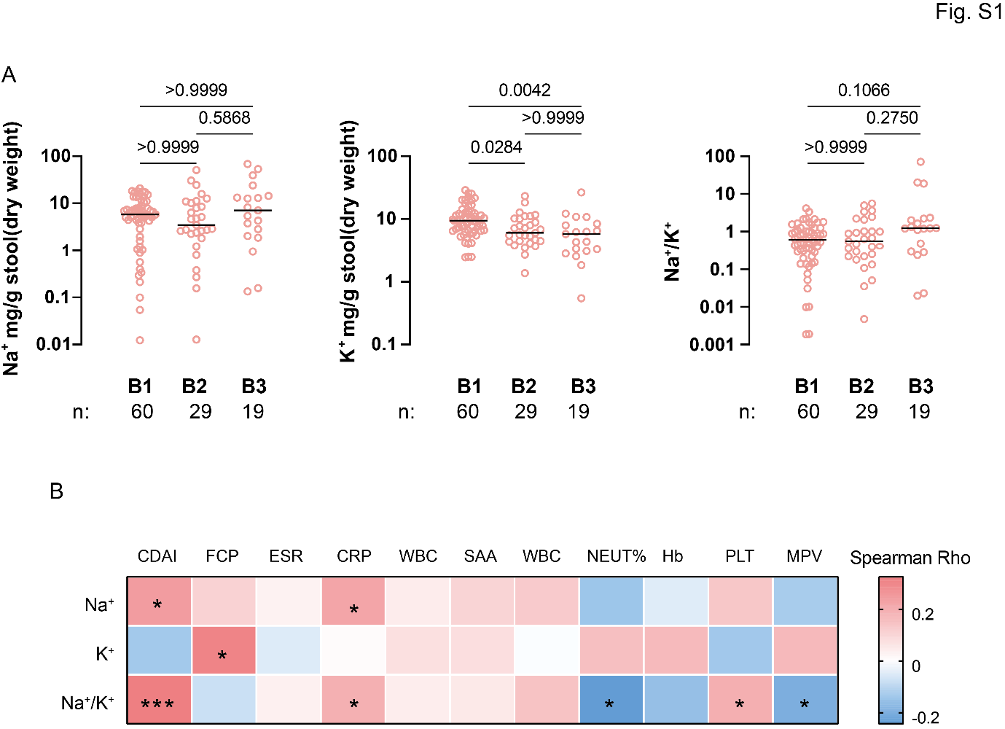Supplementary Figure 1. Association of faecal electrolyte levels with disease behaviour and clinical inflammation in CD patients.

(A) Distribution of faecal Na⁺, K⁺, and Na⁺/K⁺ ratio across different disease behaviour phenotypes in Crohn's disease (CD).
(B) Correlation of faecal electrolyte levels with standard clinical inflammation markers. Abbreviations: CDAI, Crohn's Disease Activity Index; FCP, fecal calprotectin; ESR, erythrocyte sedimentation rate; CRP, C-reactive protein; SAA, serum amyloid A; WBC, white blood cell count; NEUT%, neutrophil percentage; Hb, hemoglobin; PLT, platelet count; MPV, mean platelet volume.
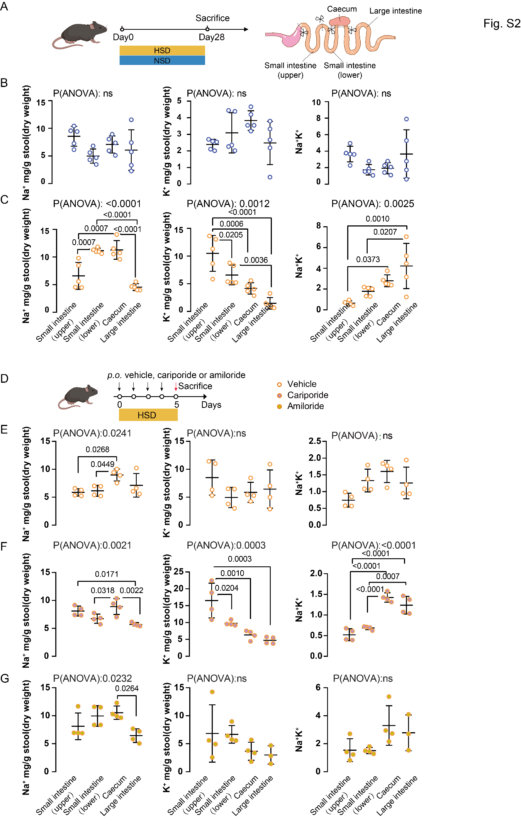
Supplementary Figure 2. Luminal Na⁺/K⁺ imbalance in CD is driven by dietary salt intake and impaired host Na⁺ absorption.

(A-C) Schematic diagram showing the HSD challenge experimental design and sampling timeline (A). Intestinal Na⁺, K⁺, and Na⁺/K⁺ ratios along the gastrointestinal tract of mice fed a NSD (B) or HSD diet (C). Mean ± SD. Each point represents an individual mouse.
(D-F) Schematic diagram showing the experimental design and sampling timeline (D). Intestinal Na⁺, K⁺, and Na⁺/K⁺ ratios along the gastrointestinal tract of mice fed a HSD and administered with vehicle (E), cariporide (F), or amiloride hydrochloride (G). Mean ± SD.

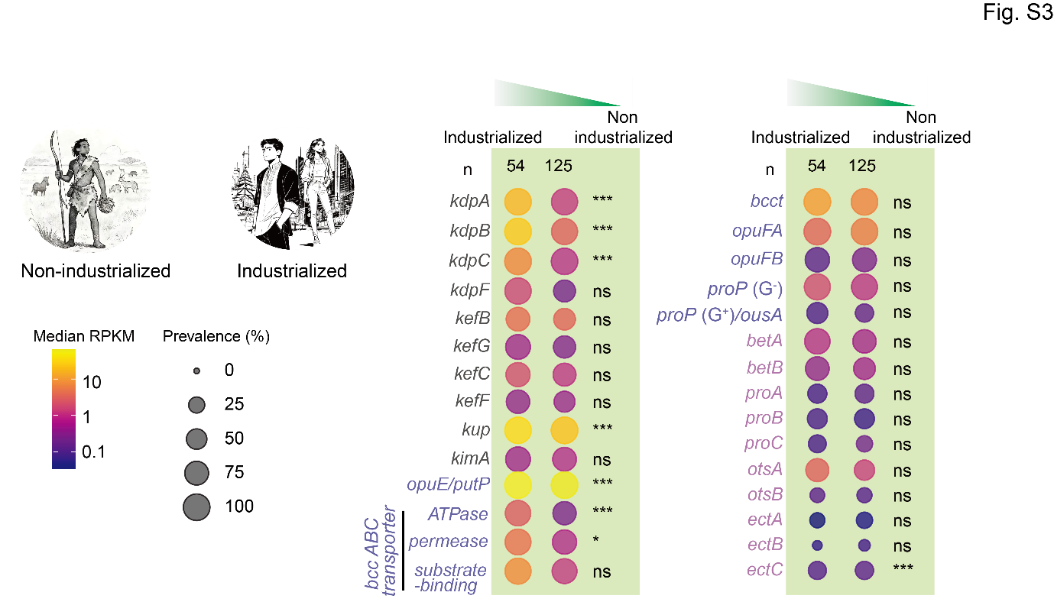
Supplementary Figure 3. The gut microbiome in industrialised population is enriched with bacterial salt-stress response genes.

Dot size represents the prevalence of a gene within a group, and color indicates the mean gene abundance (RPKM). G⁻, Gram-negative; G⁺, Gram-positive; bcc ABC transporter, betaine-choline-carnitine ABC transporter.Data adapted from Carter et al (2023)¹³.

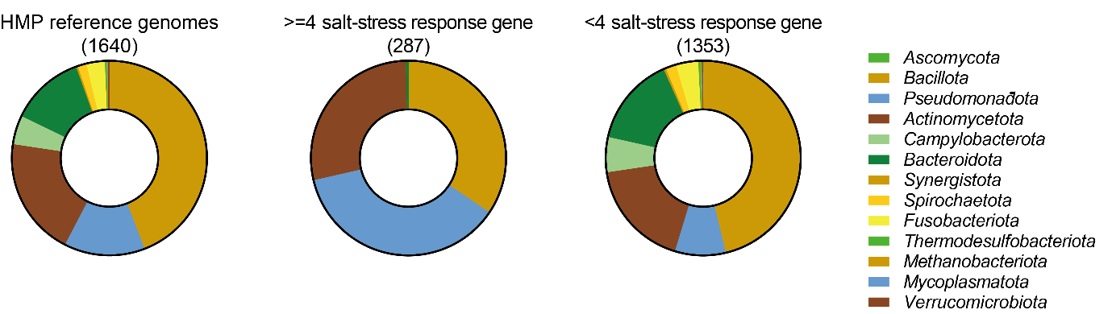
Supplementary Figure 4. Phylogenetic distribution of bacteria salt-stress response genes in Human Microbiome Project (HMP) reference genomes.

Pie charts show the phylum-level composition of 1,640 HMP reference genomes (left), the distribution of genomes encoding four or more (middle) and fewer than four (right) salt-stress response genes. See Supplementary table 2 for detailed gene information.

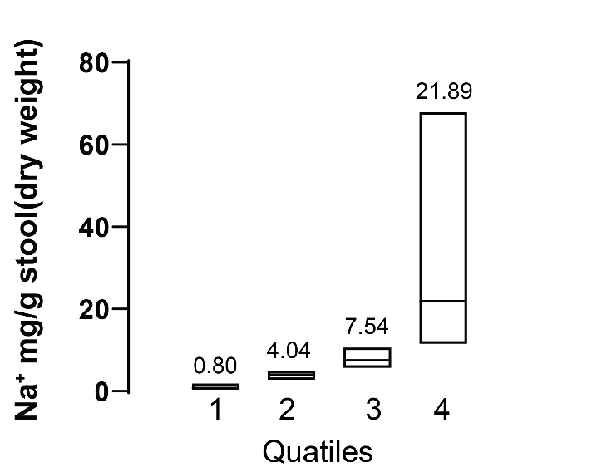
Supplementary Figure 5. Distribution of faecal Na⁺ concentrations of CD individuals across quartiles. Values represent the mean for each quartile.

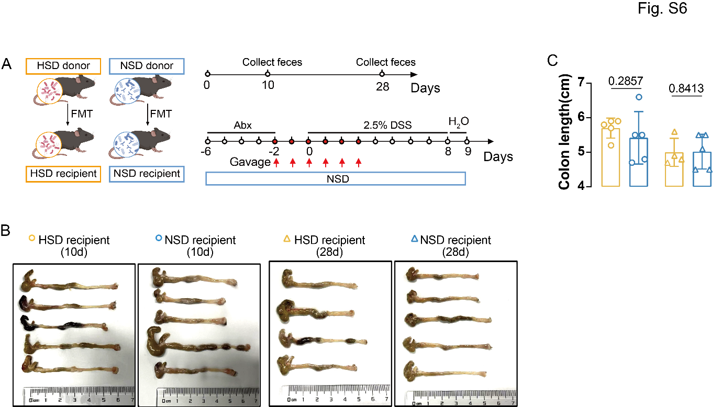
Supplementary Figure 6. The high-salt, normal chow diet adapted gut microbiome did not exacerbate colitis.

(A-C) Experimental design for faecal microbiota transplantation (FMT), showing timeline and sampling at two time points (days 10 and 28) from HSD-fed donors (A). Following FMT and DSS challenge, representative colon morphology (B), and colon length measurements (C) of recipient mice at endpoint. Mean ± SD.

Supplementary tables
Supplementary Table 1. Gene names, corresponding UniProt and Pfam identifiers, and bioinformatic search rules for bacterial salt-stress response genes.
Supplementary Table 2. Phylogenetic distribution of genomes harboing salt-stress response genes across 1640 reference genomes of the Human Microbiome Project (HMP). IMG gene IDs are provided.
Supplementary Table 3. Salt-response genes in bacterial strains tested for growth. Locus tags are provided.

SI References
1. Koskinen, K., et al. First Insights into the Diverse Human Archaeome: Specific Detection of Archaea in the Gastrointestinal Tract, Lung, and Nose and on Skin. mBio 8(2017).
2. Callahan, B.J., et al. DADA2: High-resolution sample inference from Illumina amplicon data. Nature methods 13, 581-583 (2016).
3. Bolyen, E., et al. Reproducible, interactive, scalable and extensible microbiome data science using QIIME 2. Nature biotechnology 37, 852-857 (2019).
4. Chuvochina, M., et al. SILVA in 2026: a global core biodata resource for rRNA within the DSMZ digital diversity. Nucleic acids research (2025).
5. Scanlan, P.D., Shanahan, F. & Marchesi, J.R. Human methanogen diversity and incidence in healthy and diseased colonic groups using mcrA gene analysis. BMC microbiology 8, 79 (2008).
6. Case, R.J., et al. Use of 16S rRNA and rpoB genes as molecular markers for microbial ecology studies. Applied and environmental microbiology 73, 278-288 (2007).
7. Ziegler, C., Bremer, E. & Kramer, R. The BCCT family of carriers: from physiology to crystal structure. Molecular microbiology 78, 13-34 (2010).
8. Nemet, I., et al. A Cardiovascular Disease-Linked Gut Microbial Metabolite Acts via Adrenergic Receptors. Cell 180, 862-877 e822 (2020).
9. Collaborators, G.B.D.R.F. Global burden and strength of evidence for 88 risk factors in 204 countries and 811 subnational locations, 1990-2021: a systematic analysis for the Global Burden of Disease Study 2021. Lancet 403, 2162-2203 (2024).
10. Seemann, T. Prokka: rapid prokaryotic genome annotation. Bioinformatics 30, 2068-2069 (2014).
11. Feng, R., et al. Gut Microbiome-Generated Phenylacetylglutamine from Dietary Protein is Associated with Crohn's Disease and Exacerbates Colitis in Mouse Model Possibly via Platelet Activation. Journal of Crohn's & colitis 17, 1833-1846 (2023).
12. Wirtz, S., et al. Chemically induced mouse models of acute and chronic intestinal inflammation. Nature protocols 12, 1295-1309 (2017).
13. Carter, M.M., et al. Ultra-deep sequencing of Hadza hunter-gatherers recovers vanishing gut microbes. Cell 186, 3111-3124 e3113 (2023).

