1. Basic Myopia Knowledge
A Kruskal-Wallis test revealed significant differences in basic myopia knowledge scores across the eight cities (H = 77.44, df = 7, P < 0.001). See Figure 1 for the results of pairwise comparisons.
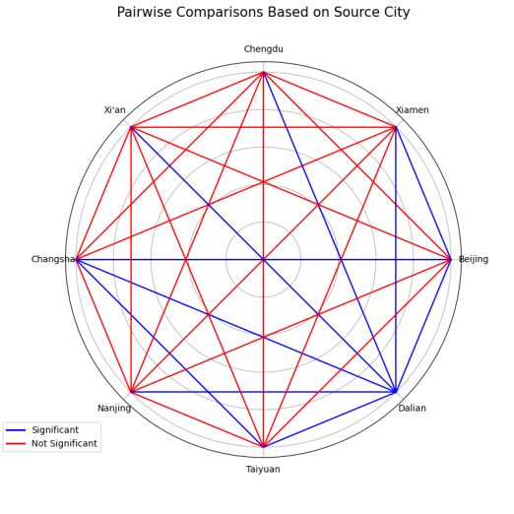
Figure 1 Pairwise comparisons of basic myopia knowledge across eight cities.
Dalian demonstrated the highest knowledge level (median = 40.5, IQR = 36.0–47.0), significantly outperforming most other cities in pairwise comparisons (Bonferroni-corrected P < 0.05). Beijing (median = 40.0, IQR = 36.0–46.0) and Taiyuan (median = 39.0, IQR = 31.3–44.8) also showed relatively high scores, while Nanjing ranked lowest (median = 36.0, IQR = 32.0–42.0). Full city rankings are presented in Table 1.

Table 1 Median [IQR] of basic myopia knowledge scores by city
City | Median [IQR]
Dalian | 40.5 [36.0–47.0]
Beijing | 40.0 [36.0–46.0]
Xiamen | 39.0 [34.0–46.0]
Taiyuan | 39.0 [31.3–44.8]
Changsha | 39.0 [33.0–46.0]
Xi'an | 38.0 [32.0–43.0]
Chengdu | 38.0 [34.0–46.0]
Nanjing | 36.0 [32.0–42.0]

2. 0.01% Atropine Eye Drops

0.01% Atropine Eye Drops-related knowledge: No significant differences were detected across cities (P > 0.05).
0.01% Atropine Eye Drops-related behavior: Significant inter-city differences were observed (H = —, df = 7, P < 0.005). Beijing exhibited the highest behavioral adherence (median = 21.0, IQR = 15.0–24.0), significantly outperforming both Nanjing (median = 15.0, IQR = 13.0–15.0; adjusted P < 0.005) and Xiamen (median = 16.0, IQR = 15.0–17.0; adjusted P < 0.05). No other pairwise comparisons reached statistical significance after Bonferroni correction. See Figure 2 for the results of pairwise comparisons.
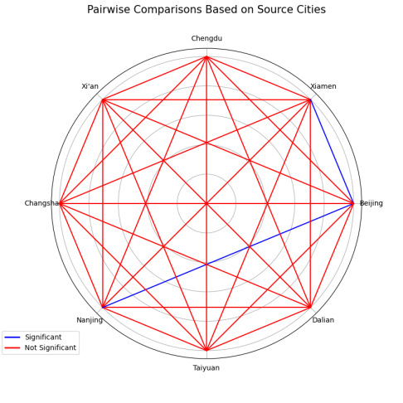
Figure 2 Pairwise comparisons of 0.01% atropine eye drops-related behavior across eight cities.
Table 2 Median [IQR] of atropine behavior scores by city
City | Median [IQR]
Beijing | 21.0 [15.0–24.0]
Xi'an | 17.0 [5.0–17.0]
Changsha | 17.0 [15.0–17.0]
Xiamen | 16.0 [15.0–17.0]
Taiyuan | 16.0 [14.5–17.0]
Nanjing | 15.0 [13.0–15.0]
Dalian | 14.0 [13.0–17.0]
Chengduª | —
a: n=3, identical scores

3. Spectacles
Spectacles-related knowledge: Significant differences were found across cities (H = 39.72, df = 7, P < 0.001). Dalian scored highest (median = 40.0, IQR = 32.0–40.0) and significantly outperformed all other cities except Taiyuan (adjusted P < 0.05). Changsha ranked lowest (median = 26.5, IQR = 24.0–32.0). See Figure 3 for the results of pairwise comparisons.
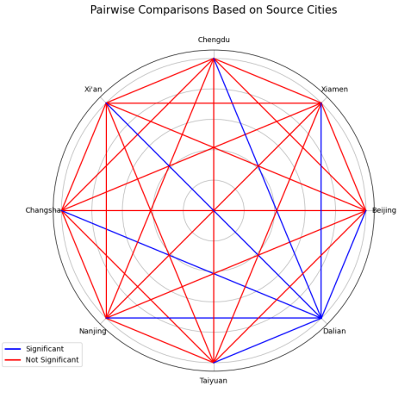
Figure 3 Pairwise comparisons of spectacle knowledge across eight cities.
Spectacles-related attitude: No significant differences were detected (P > 0.05).
Spectacles-related bahavior: Significant inter-city differences emerged (H = 35.95, df = 7, P < 0.001). Dalian again showed the highest adherence (median = 14.0, IQR = 12.0–15.0), significantly exceeding Changsha (median = 10.5, IQR = 9.0–12.3; adjusted P < 0.001), Taiyuan (median = 13.0, IQR = 10.0–15.0; adjusted P < 0.05), and Beijing (median = 12.5, IQR = 11.0–15.0; adjusted P < 0.05). See Figure 4 for the results of pairwise comparisons.
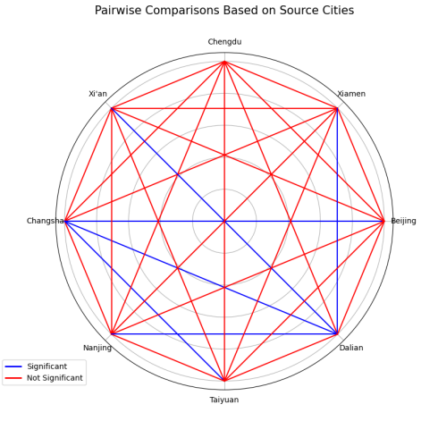
Figure 4 Pairwise comparisons of spectacle behavior across eight cities.
Table 3 Median [IQR] of spectacle knowledge and behavior scores by city
City | Knowledge | Behavior
Dalian | 40.0 [32.0–40.0] | 14.0 [12.0–15.0]
Taiyuan | 32.0 [24.0–40.0] | 13.0 [10.0–15.0]
Beijing | 31.0 [25.0–35.0] | 12.5 [11.0–15.0]
Xiamen | 29.0 [24.0–36.0] | 12.0 [10.0–14.0]
Xi'an | 29.0 [24.0–35.0] | 12.0 [9.0–14.0]
Chengdu | 28.0 [24.0–38.5] | 12.0 [9.0–14.5]
Nanjing | 28.0 [24.0–34.0] | 11.0 [9.0–13.0]
Changsha | 26.5 [24.0–32.0] | 10.5 [9.0–12.3]

4. Contact Lenses
Contact lenses-related knowledge: No significant differences were detected across cities (P > 0.05).
Contact lenses-related attitude: Significant differences were observed (H = 16.09, df = 7, P < 0.05). Taiyuan (median = 29.0, IQR = 29.0–29.8) and Dalian (median = 26.5, IQR = 22.3–30.0) scored highest, while Changsha ranked lowest (median = 19.0, IQR = 17.5–20.8). Only the Changsha–Dalian comparison remained significant after Bonferroni correction (adjusted P < 0.05). See Figure 5 for the results of pairwise comparisons.
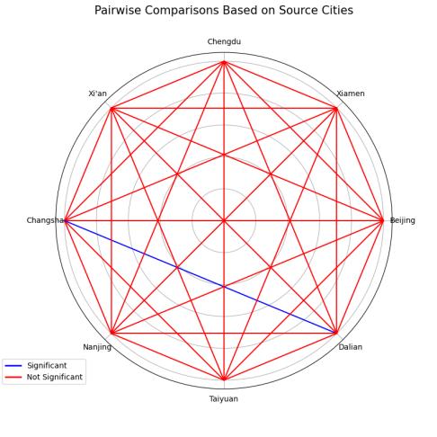
Figure 5 Pairwise comparisons of contact lens attitude across eight cities.
Contact lenses-related behavior: Significant inter-city differences were found (H = 22.30, df = 7, P < 0.005). Taiyuan (median = 19.5, IQR = 19.5–20.0) and Dalian (median = 19.0, IQR = 16.0–20.0) demonstrated the highest adherence. Only the Nanjing–Dalian comparison remained significant after Bonferroni correction (adjusted P < 0.05). See Figure 6 for the results of pairwise comparisons.
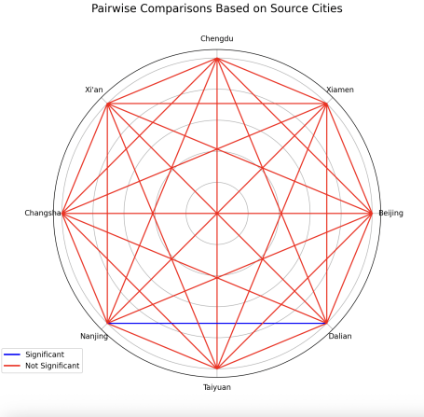
Figure 6 Pairwise comparisons of contact lens behavior across eight cities.
Table 4 Median [IQR] of contact lens attitude and behavior scores by city
City | Attitude | Behavior
Taiyuan | 29.0 [29.0–29.8] | 19.5 [19.5–20.0]
Dalian | 26.5 [22.3–30.0] | 19.0 [16.0–20.0]
Beijing | 25.0 [21.5–29.0] | 19.0 [16.0–19.0]
Chengdu | 24.0 [19.0–26.0] | 15.0 [14.0–17.0]
Xi'an | 22.0 [18.0–30.0] | 18.0 [18.0–18.0]
Nanjing | 21.5 [18.0–28.0] | 16.0 [16.0–17.0]
Xiamen | 21.0 [21.0–24.8] | 17.0 [17.0–17.8]
Changsha | 19.0 [17.5–20.8] | 15.0 [13.8–16.8]

