Supplementary table 1. List of “4+7” policy-related drugs included in this study.
Category | Generic name
“4+7” List drugs | Atorvastatin, Amlodipine, Irbesartan, Irbesartan Hydrochlorothiazide, Fosinopril, Lisinopril, Losartan, Rosuvastatin, Enalapril, Escitalopram, Olanzapine, Risperidone, Paroxetine, Dexmedetomidine, Levetiracetam, Gefitinib, Pemetrexed Disodium, Imatinib, Entecavir, Tenofovir Disoproxil, Cefuroxime Axetil, Clopidogrel, Montmorillonite, Flurbiprofen, Montelukast
Alternative drugs | Allisartan Isoproxil, Amlodipine, Amlodipine Besylate and Atorvastatin Calcium, Amlodipine Besylate and Benazepril, Olmesartan Medoxomil, Olmesartan Medoxomil and Amlodipine, Olmesartan medoxomil and Hydrochlorothiazide, Benazepril, Benazepril and Hydrochlorothiazide, Felodipine, Fluvastatin Sodium, Compound Captopril, Captopril, Candesartan Cilexetil and Hydrochlorothiazide, Candesartan Cilexetil, Lisinopril and Hydrochlorothiazide, Ramipril, Lovastatin, Losartan and Hydrochlorothiazide, Perindopril, Perindopril arginine and amlodipine besylate, Perindopril and Indapamide, Pitavastatin Calcium, Pravastatin Sodium, Telmisartan, Telmisartan and Hydrochlorothiazide, Nifedipine, Valsartan, Valsartan and Amlodipine, Valsartan and Hydrochlorothiazide, Simvastatin, Xuezhikang, Enalapril and Folic Acid, Ezetimibe and Simvastatin, Zhibitai, Zhibituo, Levoamlodipine, Aripirazole, Bupropion, Amisulpride, Oxcarbazepine, Magnesium Valproate, Valproate Sodium, Duloxetine, Perphenazine, Vortioxetine, Fluvoxamine, Haloperidol, Fluoxetine, Carbamazepine, Quetiapine, Lamotrigine, Risperidone, Tiapride, Chlorpromazine, Clozapine, Midazolam, Paliperidone, Paroxetine, Ziprasidone, Trazodone, Sertraline, Sulpiride, Topiramate, Venlafaxine, Penfluridol, Citalopram, Afatinib, Icotinib, Osimertinib, Dasatinib, Erlotinib, Nilotinib, Adefovir Dipivoxil, Tenofovir Alafenamide, Lamivudine, Telbivudine, Cefalexin, Cefprozil, Cefdinir, Cefuroxime Axetil, Cefaclor, Cefixime, Cefadroxil, Aspirin, Tiolopidine, Ticagrelor, Cilostazol, Loperamide, Albumini Tannas, Berberine, Parecoxib Sodium, Diclofenao Sodium, Ketorolac Tromethamine, Pemirolast potassium, Pranlukast hydrate

Supplementary table 2. Difference-in-difference analysis for the changes of DSI of policy-related drugs in different post-“4+7” policy periods among different healthcare settings.
 | Tertiary hospitals |  |  |  | Secondary hospitals |  |  |  | PHCs
 | Period 1 | Period 2 | Period 3 |  | Period 1 | Period 2 | Period 3 |  | Period 1 | Period 2 | Period 3
Bid-winning products
Constant, β₀ | 1.021*** | 1.021*** | 1.021*** |  | 1.021*** | 1.021*** | 1.021*** |  | 1.055*** | 1.055*** | 1.055
Treat, β₁ | -0.024 | -0.043*** | -0.025 |  | -0.011 | -0.016 | -0.024 |  | -0.066** | -0.022 | -0.044
Group, β₂ | 0.028 | 0.028 | 0.028 |  | -0.016 | -0.016 | -0.016 |  | 0.007 | 0.007 | 0.007
Treat*Group, β₃ | -0.292*** | -0.260*** | -0.266*** |  | -0.270*** | -0.235*** | -0.220*** |  | -0.213 *** | 0-.242*** | -0.218
R² | 0.880 | 0.883 | 0.868 |  | 0.883 | 0.859 | 0.848 |  | 0.856 | 0.830 | 0.835
Non-winning products
Constant, β₀ | 0.965*** | 0.965*** | 0.965*** |  | 1.032*** | 1.032*** | 1.032*** |  | 1.070*** | 1.070*** | 1.070***
Treat, β₁ | 0.018 | 0.034** | 0.015 |  | 0.026 | 0.063*** | 0.054*** |  | 0.161*** | 0.230*** | 0.216**
Group, β₂ | 0.081*** | 0.081*** | 0.081*** |  | 0.006 | 0.006 | 0.006 |  | -0.018 | -0.018 | -0.018
Treat*Group, β₃ | 0.134*** | 0.150*** | 0.166*** |  | 0.130*** | 0.142** | 0.224*** |  | -0.046 | -0.044 | -0.047
R² | 0.935 | 0.939 | 0.915 |  | 0.918 | 0.894 | 0.969 |  | 0.561 | 0.726 | 0.663
“4+7” List drugs
Constant, β₀ | 1.036*** | 1.036**** | 1.036*** |  | 1.016*** | 1.016*** | 1.016*** |  | 1.030*** | 1.030*** | 1.030***
Treat, β₁ | -0.005 | 0.026* | 0.004 |  | 0.020 | 0.042** | 0.045** |  | 0.048** | 0.087*** | 0.070*
Group, β₂ | 0.019 | 0.019 | 0.019 |  | 0.019* | 0.019* | 0.019* |  | 0.020 | 0.020 | 0.020
Treat*Group, β₃ | 0.015 | 0.026 | 0.019 |  | 0.005 | 0.029 | 0.032* |  | -0.027 | -0.004 | 0.010
R² | 0.191 | 0.470 | 0.271 |  | 0.338 | 0.653 | 0.768 |  | 0.236 | 0.616 | 0.530
Alternative drugs
Constant, β₀ | 0.989*** | 0.989*** | 0.989*** |  | 0.981*** | 0.981*** | 0.981*** |  | 1.011*** | 1.011*** | 1.011***
Treat, β₁ | 0.067*** | 0.103*** | 0.075*** |  | 0.030* | 0.046** | 0.047*** |  | -0.001 | 0.006 | 0.013
Group, β₂ | 0.026 | 0.026 | 0.026 |  | 0.005 | 0.005 | 0.005 |  | -0.022 | -0.022 | -0.022
Treat*Group, β₃ | 0.031 | 0.007 | 0.075** |  | 0.004 | -0.023 | -0.020 |  | 0.035 | 0.029 | 0.032*
R² | 0.523 | 0.549 | 0.699 |  | 0.204 | 0.235 | 0.264 |  | 0.180 | 0.202 | 0.274
Overall policy-related drugs
Constant, β₀ | 1.019*** | 1.019*** | 1.019*** |  | 1.018*** | 1.018*** | 1.018*** |  | 1.030*** | 1.030*** | 1.030***
Treat, β₁ | 0.035** | 0.074*** | 0.042* |  | 0.053** | 0.077*** | 0.070** |  | 0.030* | 0.057*** | 0.053*
Group, β₂ | 0.022 | 0.022 | 0.022 |  | -0.004 | -0.004 | -0.004 |  | -0.005 | -0.005 | -0.005
Treat*Group, β₃ | 0.010 | -0.002 | 0.034 |  | -0.050* | -0.055** | -0.046* |  | -0.019 | -0.018 | -0.015
R² | 0.413 | 0.623 | 0.612 |  | 0.368 | 0.577 | 0.521 |  | 0.135 | 0.418 | 0.370
Note: ***p-value <0.001, **p-value <0.01, *p-value <0.05. PHCs, primary healthcare centers.

Supplementary figure 1. Purchase volume, purchase expenditures, and DDDc of policy-related drugs in the pilot group vs control group in the months prior and after the “4+7” policy
(a) all medical institutions
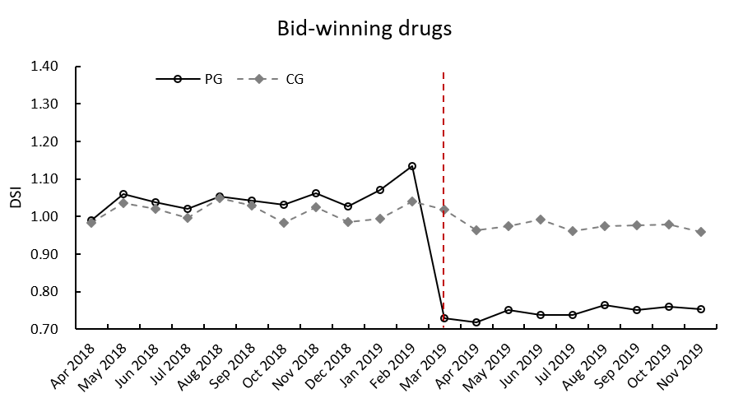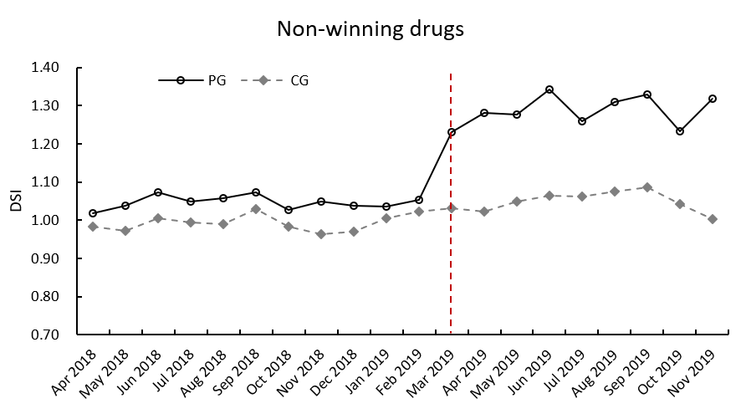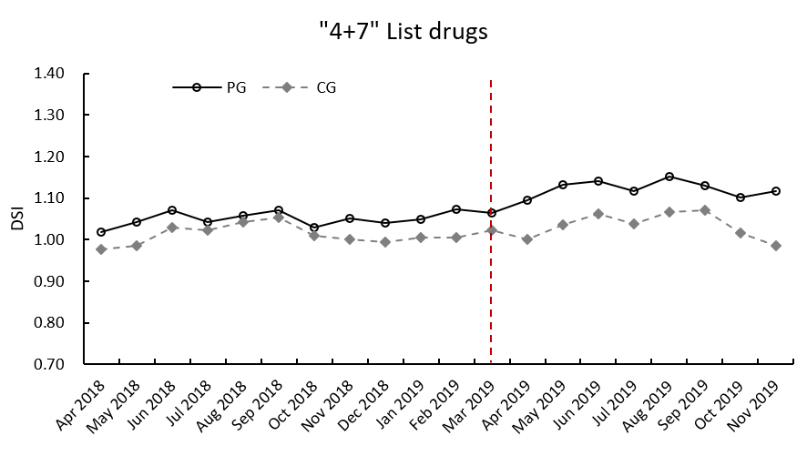
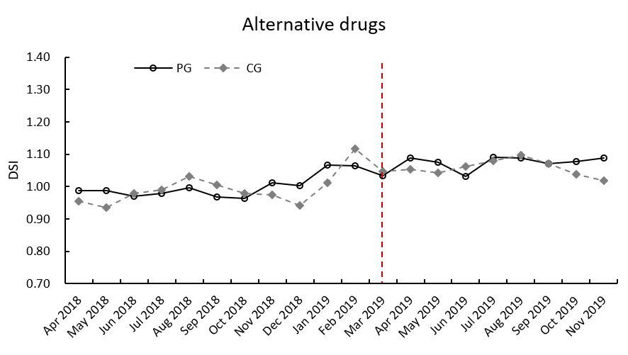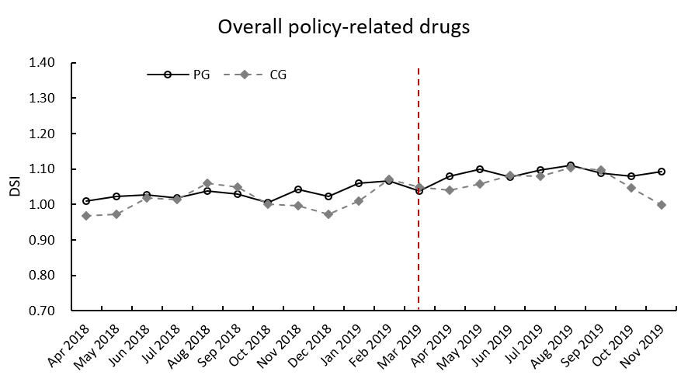
(b) different levels of medical institution
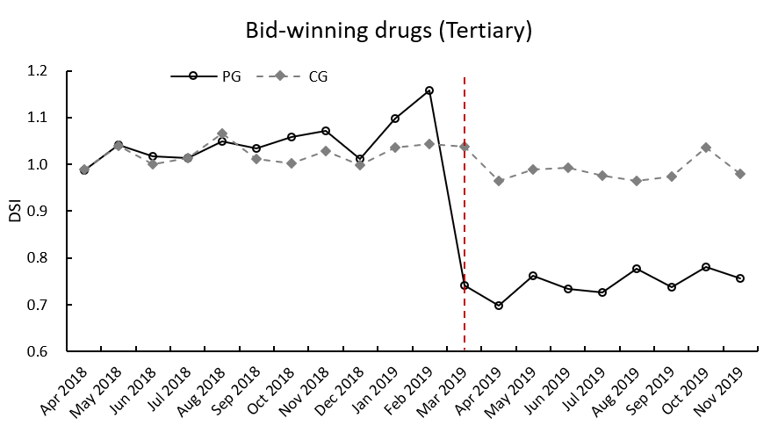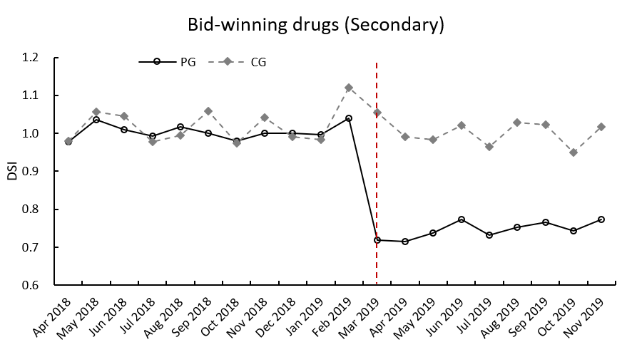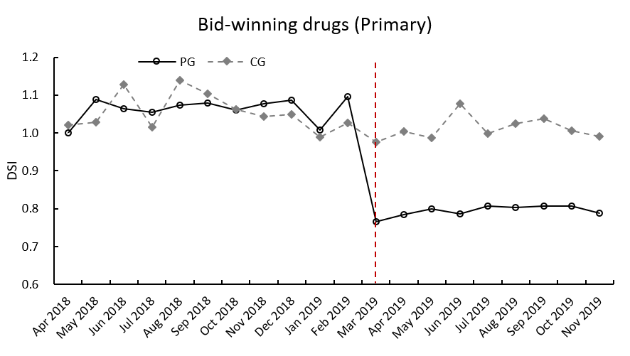
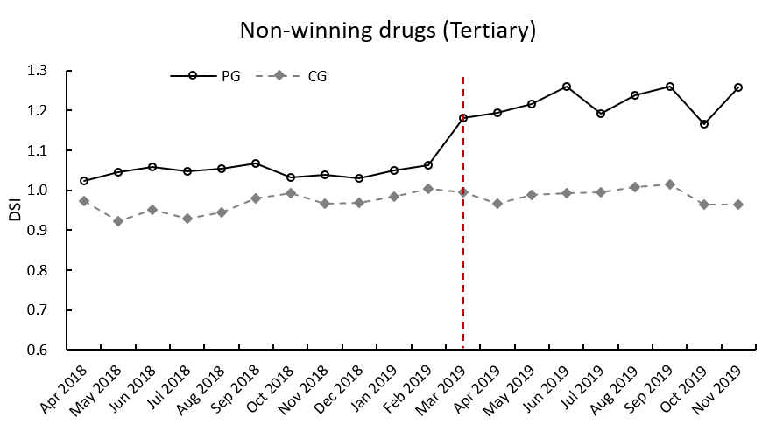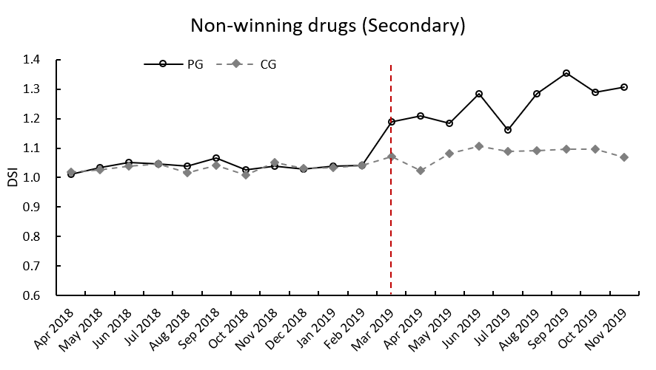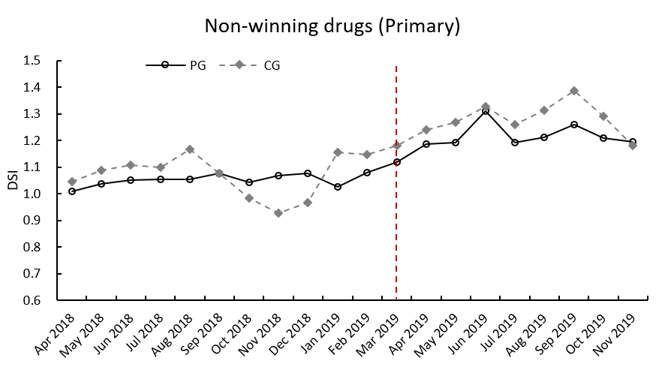
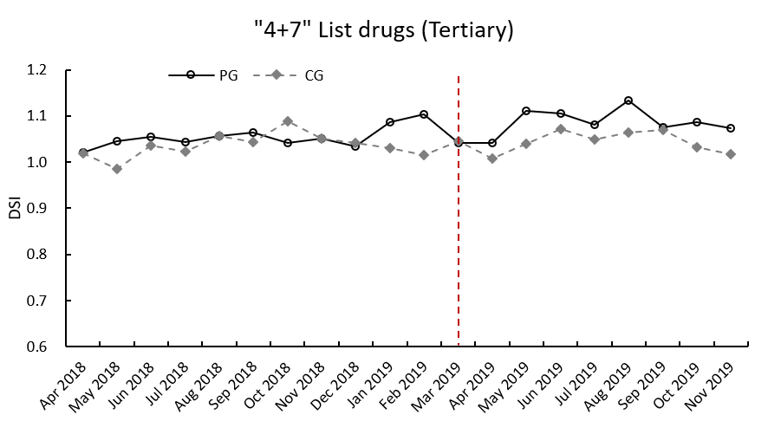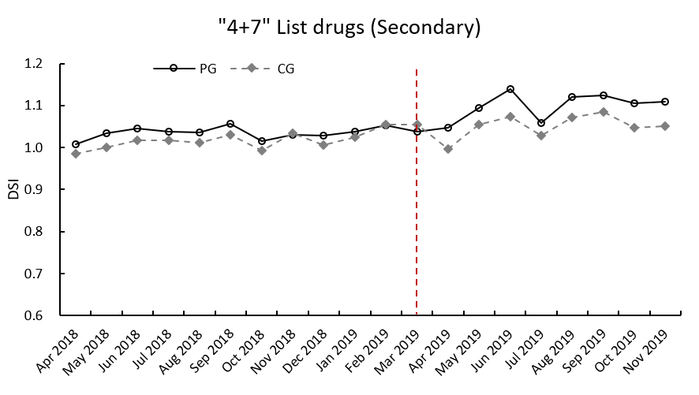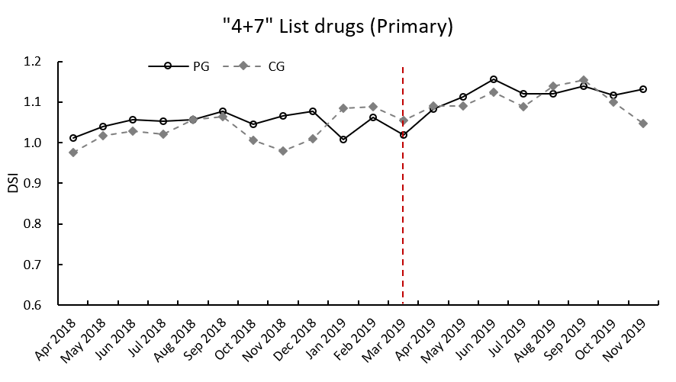
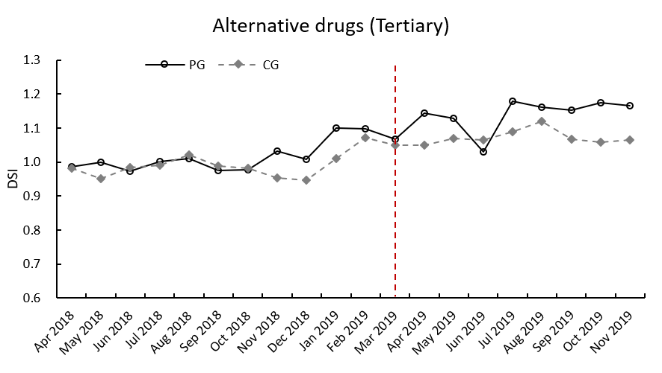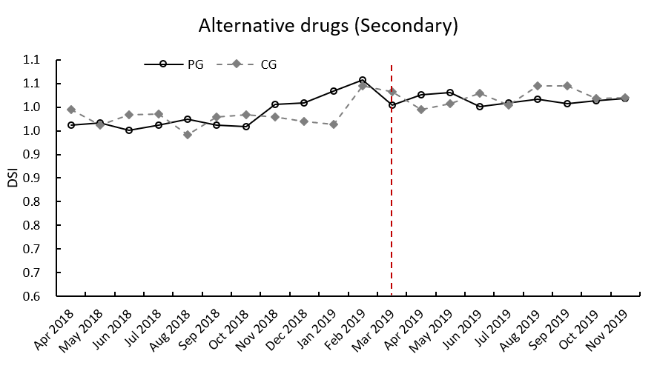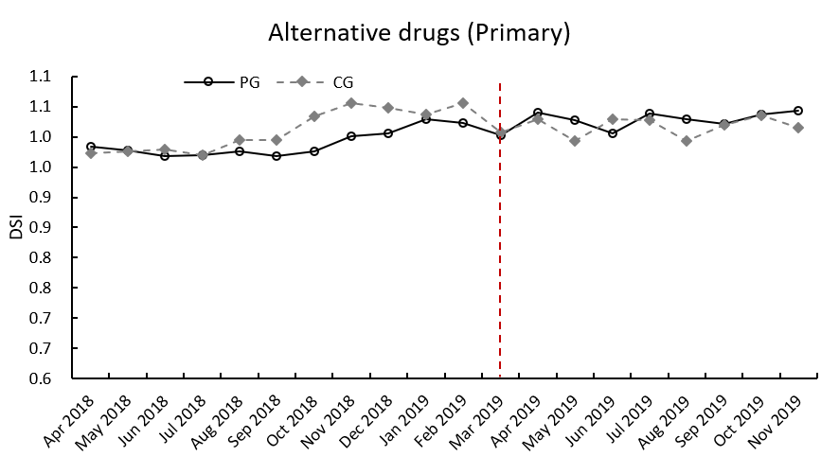
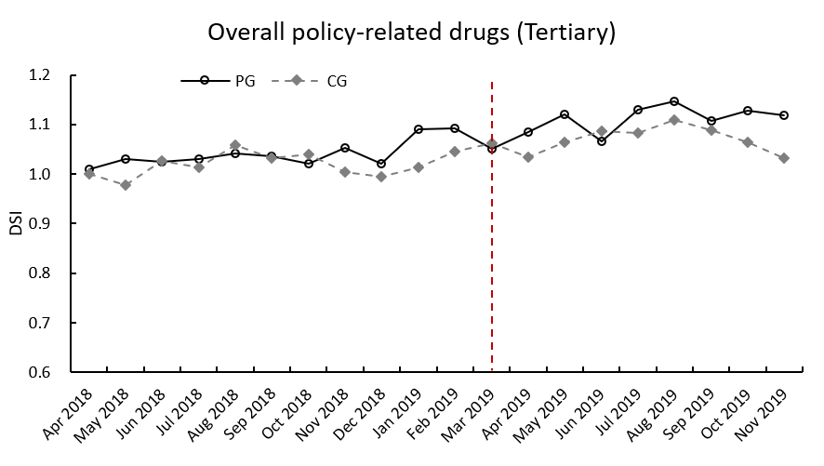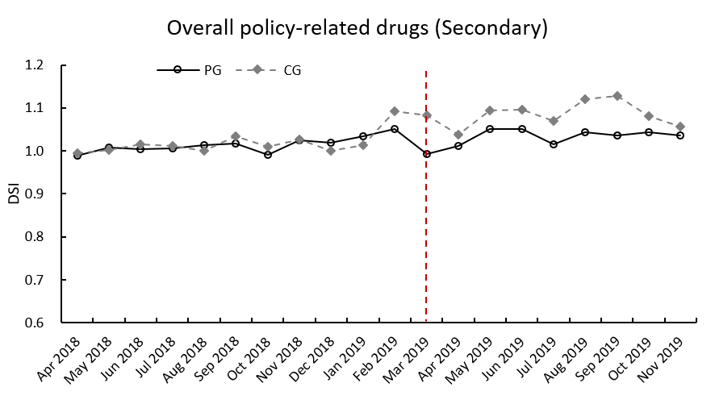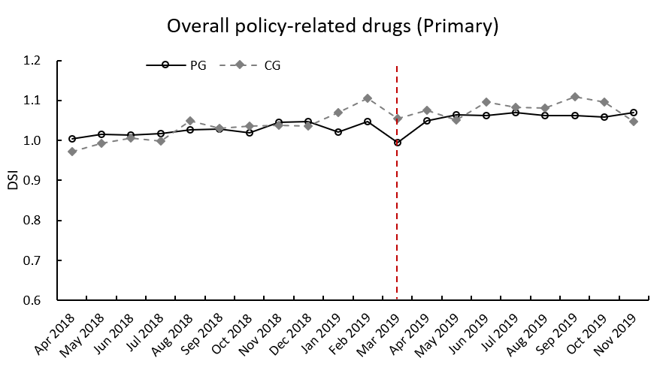
(c) different ATC categories
